LIFE ORIENTATION
LIFE ORIENTATION GRADE 12 TERM 4 CONTROLLED ASSESSMENT PACK

SUBJECT | LIFE ORIENTATION
GRADE | 12
ASSESSMENT TASK | LIFE ORIENTATION GRADE 12 TERM 4 CONTROLLED ASSESSMENT PACK
MARKS | 50
TIME | 1 hour

Educator approval required before classroom use.

INSTRUCTIONS AND INFORMATION
1. This is a practical performance assessment task.
2. The learner performs the task under educator supervision.
3. The educator records observable evidence against the assessment instrument.
4. Written or oral reflection may be assessed only where it supports the performance evidence.
5. Safety and performance-space readiness must be checked before the task begins.

SOURCE MATERIAL
SOURCE 1: Official-paper exemplar: Data Table
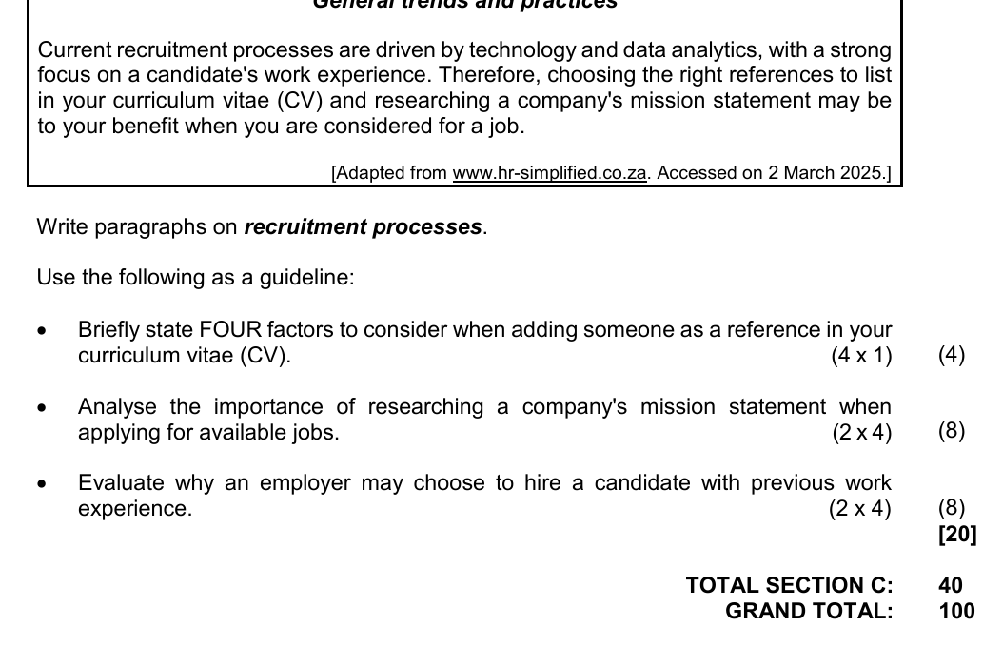
Paper: Life Orientation Paper 1 Afrikaans September 2025 | Page: 10 | Source Type: data_table
SOURCE 2: Official-paper exemplar: Data Table

Paper: Life Orientation Paper 1 English September 2025 | Page: 10 | Source Type: data_table
SOURCE 3: Official-paper exemplar: Text Extract
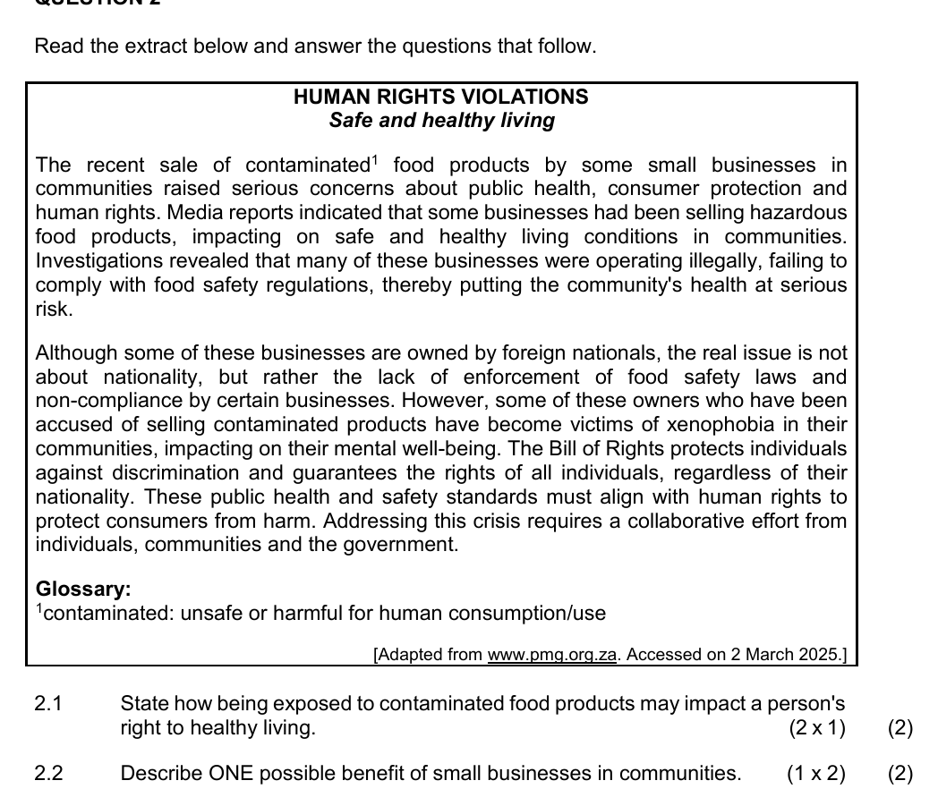
Paper: Life Orientation Paper 1 Afrikaans September 2025 | Page: 6 | Source Type: text_extract

PERFORMANCE ASSESSMENT TASK

SECTION A: SCENARIO ANALYSIS
Brief: Use the scenario and respond with practical judgement.
Context: Scenario: A Grade 12 learner faces choices linked to integrated Life Orientation CAT and portfolio consolidation.
1.1 Identify the main issue in the scenario and explain why it matters. (5)
1.2 Discuss TWO possible consequences of an unhealthy or irresponsible choice. (6)
1.3 Recommend TWO support strategies and justify each one. (8)

SECTION B: DECISION AND REFLECTION
Brief: Keep reflection appropriate and non-private.
Context: Reflection focus: scenario analysis, reflection and supervised evidence collation.
2.1 Evaluate a responsible decision using evidence from the scenario. (8)
2.2 Create a brief action plan with three safe, realistic steps. (8)

SECTION C: PORTFOLIO EVIDENCE
Brief: Complete the supervised evidence item.
Context: Portfolio focus: final reflective task with educator-marked rubric evidence.
3.1 Complete a portfolio entry showing what evidence an educator can assess. (15)

ASSESSMENT INSTRUMENT
Criterion | Marks | Descriptor
Subject accuracy and terminology | 12 | Uses accurate concepts and terminology.
Evidence, data or source use | 12 | Uses supplied evidence appropriately.
Reasoning and explanation | 12 | Shows logical, grade-appropriate reasoning.
Communication and completion | 14 | Answers are clear, complete and structured.

