LIFE SCIENCES
LIFE SCIENCES GRADE 12 TERM 2 CONTROLLED ASSESSMENT PACK

SUBJECT | LIFE SCIENCES
GRADE | 12
ASSESSMENT TASK | LIFE SCIENCES GRADE 12 TERM 2 CONTROLLED ASSESSMENT PACK
MARKS | 50
TIME | 1 hour

Educator approval required before classroom use.

INSTRUCTIONS AND INFORMATION
1. Read all instructions carefully.
2. Answer all questions or complete all activities as instructed.
3. Show all working where calculations, planning, diagrams or explanations are required.
4. Use the space provided by the educator, answer booklet or learner task book.
5. Write neatly and clearly.

SOURCE MATERIAL
SOURCE 1: Official-paper exemplar: Data Table
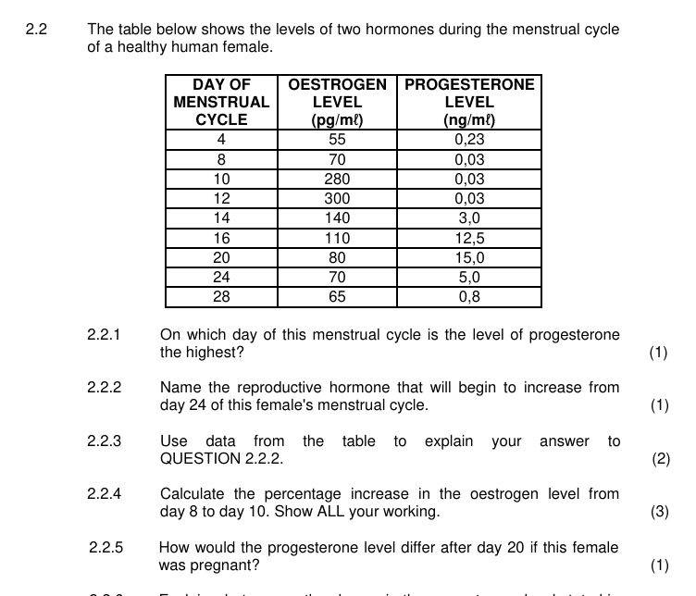
Paper: Life Sciences P1 November 2024 | Page: 10 | Source Type: data_table
SOURCE 2: Official-paper exemplar: Diagram Or Model
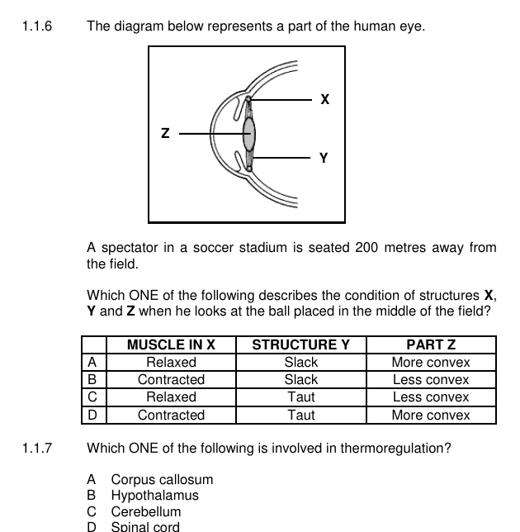
Paper: Life Sciences P1 November 2024 | Page: 4 | Source Type: diagram_or_model
SOURCE 3: Official-paper exemplar: Graph Or Chart
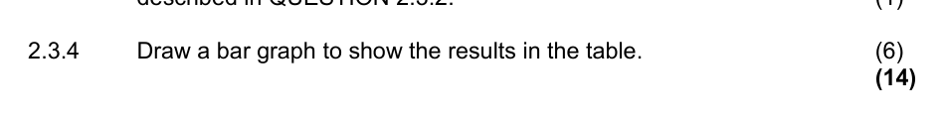
Paper: Life Sciences P1 November 2025 | Page: 10 | Source Type: graph_or_chart

QUESTIONS

QUESTION 1: SECTION A: CONCEPTS AND DATA
Instructions: Use the supplied data, diagram or graph.
Stimulus: Data/diagram stimulus linked to reproduction, homeostasis and response to the environment.
1.1. Define one key concept from the term focus. (2)

1.2. Describe the trend or relationship shown by the supplied data. (5)

1.3. Explain the process or principle using correct terminology. (8)

1.4. Calculate or infer a result from the supplied values and show working where needed. (5)

QUESTION 2: SECTION B: INVESTIGATION DESIGN
Instructions: Critique method, variables and evidence.
Stimulus: Investigation focus: diagram interpretation, feedback loops and investigation design.
2.1. State a suitable aim or hypothesis for the investigation. (3)

2.2. Identify independent, dependent and controlled variables. (6)

2.3. Evaluate validity and reliability and suggest one improvement. (6)

QUESTION 3: SECTION C: APPLICATION
Instructions: Use subject knowledge and supplied evidence.
Stimulus: Application focus: data-based explanation of biological regulation and reproduction.
3.1. Answer an integrated explanation question using evidence from the stimulus. (15)

