MATHEMATICS
MATHEMATICS GRADE 12 TERM 1 CONTROLLED ASSESSMENT PACK

SUBJECT | MATHEMATICS
GRADE | 12
ASSESSMENT TASK | MATHEMATICS GRADE 12 TERM 1 CONTROLLED ASSESSMENT PACK
MARKS | 50
TIME | 1 hour

Educator approval required before classroom use.

INSTRUCTIONS AND INFORMATION
1. Read all instructions carefully.
2. Answer all questions or complete all activities as instructed.
3. Show all working where calculations, planning, diagrams or explanations are required.
4. Use the space provided by the educator, answer booklet or learner task book.
5. Write neatly and clearly.
6. Do not use a calculator unless the educator allows it.

SOURCE MATERIAL
SOURCE 1: Official-paper exemplar: Diagram Or Model
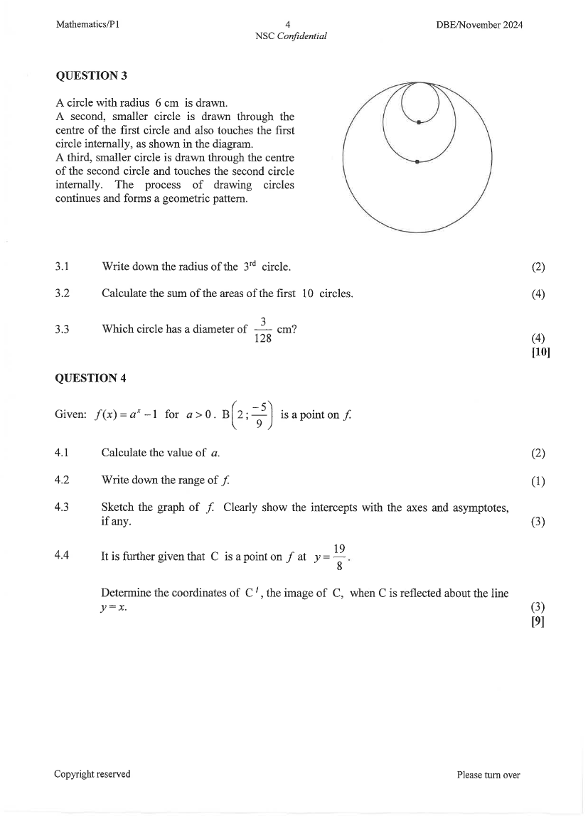
Paper: Mathematics P1 November 2024 | Page: 4 | Source Type: diagram_or_model
SOURCE 2: Official-paper exemplar: Graph Or Chart

Paper: Mathematics P1 November 2024 | Page: 4 | Source Type: graph_or_chart
SOURCE 3: Official-paper exemplar: Data Table
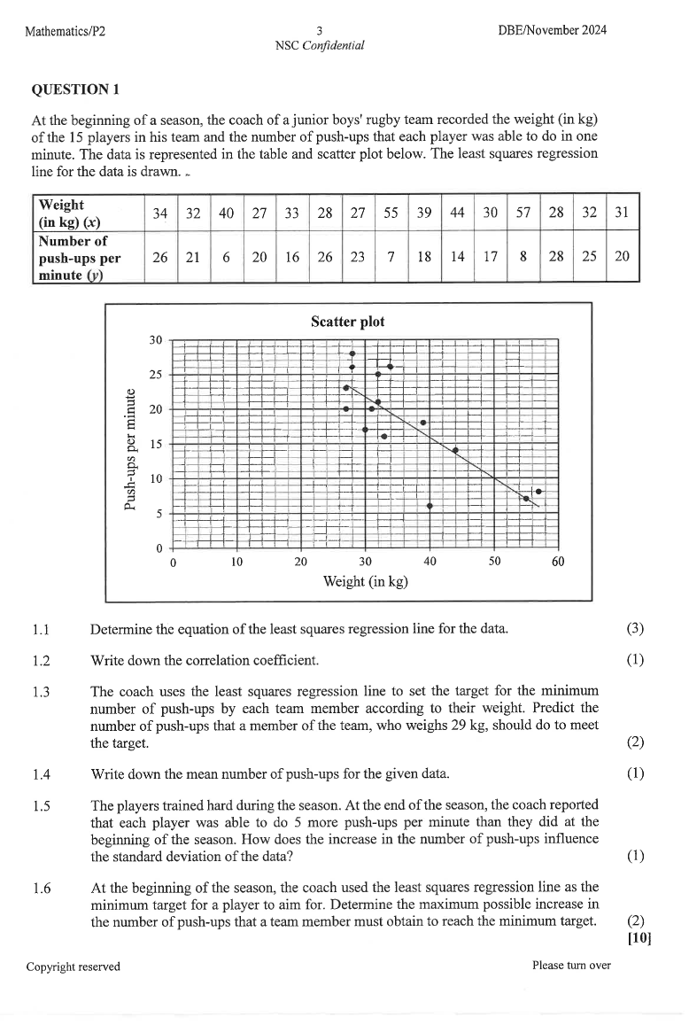
Paper: Mathematics P2 November 2024 | Page: 3 | Source Type: data_table

QUESTIONS

QUESTION 1: SECTION A: CONCEPTS AND PROCEDURES
Instructions: Show all working.
Stimulus: Topic focus: functions, algebra, equations and financial mathematics.
1.1. Solve a routine problem linked to the stated term focus and show all algebraic working. (6)

1.2. Interpret the supplied graph, table or diagram and state the meaning of one key feature. (6)

1.3. Complete a multi-step calculation using the supplied values and units. (8)

QUESTION 2: SECTION B: PROBLEM SOLVING
Instructions: Use the workspace and justify each step.
Stimulus: Problem context: graphs, transformations, inverses and interpretation of parameters.
2.1. Set up and solve a non-routine problem from the term context. (10)

2.2. Justify one method step or proof statement. (5)

QUESTION 3: SECTION C: INTEGRATED APPLICATION
Instructions: Combine concepts from the term pack.
Stimulus: Integrated focus: multi-step problem solving with method marks and final answer checks.
3.1. Answer an integrated application question and comment on the reasonableness of the result. (15)

