MATHEMATICS
MATHEMATICS GRADE 12 TERM 4 CONTROLLED ASSESSMENT PACK

SUBJECT | MATHEMATICS
GRADE | 12
ASSESSMENT TASK | MATHEMATICS GRADE 12 TERM 4 CONTROLLED ASSESSMENT PACK
MARKS | 50
TIME | 1 hour

Educator approval required before classroom use.

INSTRUCTIONS AND INFORMATION
1. Read all instructions carefully.
2. Answer all questions or complete all activities as instructed.
3. Show all working where calculations, planning, diagrams or explanations are required.
4. Use the space provided by the educator, answer booklet or learner task book.
5. Write neatly and clearly.
6. Do not use a calculator unless the educator allows it.

SOURCE MATERIAL
SOURCE 1: Official-paper exemplar: Diagram Or Model
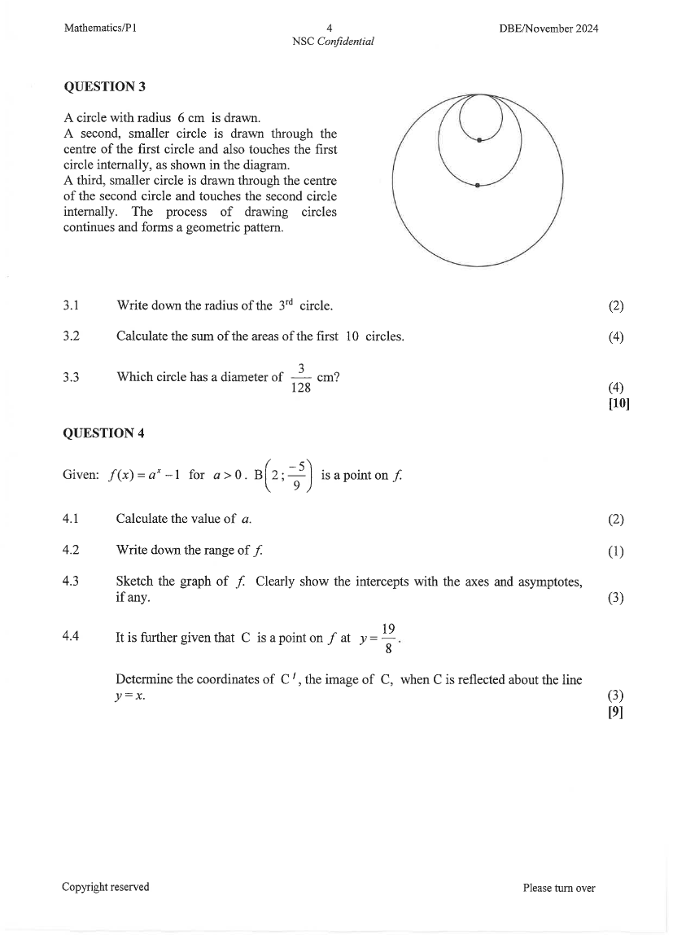
Paper: Mathematics P1 November 2024 | Page: 4 | Source Type: diagram_or_model
SOURCE 2: Official-paper exemplar: Graph Or Chart

Paper: Mathematics P1 November 2024 | Page: 4 | Source Type: graph_or_chart
SOURCE 3: Official-paper exemplar: Data Table
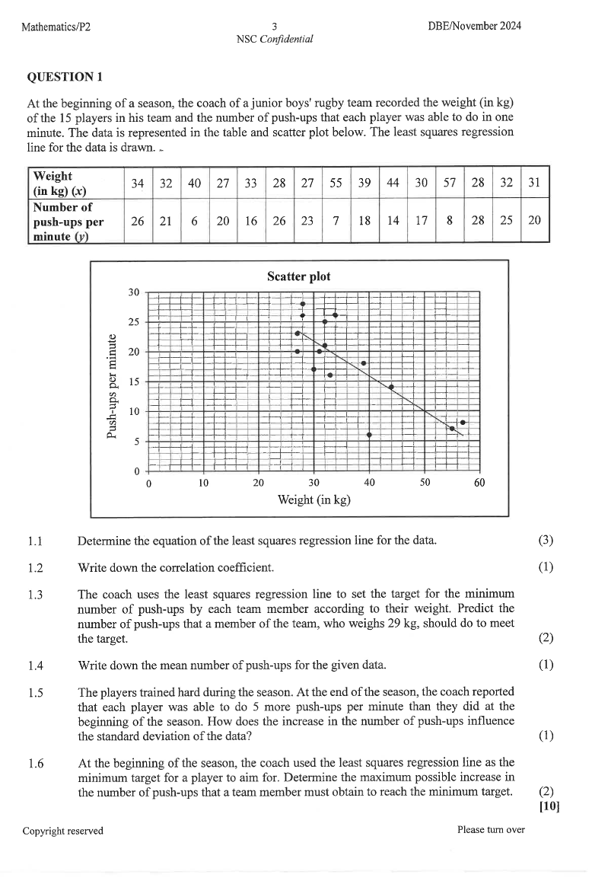
Paper: Mathematics P2 November 2024 | Page: 3 | Source Type: data_table

QUESTIONS

QUESTION 1: SECTION A: CONCEPTS AND PROCEDURES
Instructions: Show all working.
Stimulus: Topic focus: final integrated Mathematics examination practice.
1.1. Solve a routine problem linked to the stated term focus and show all algebraic working. (6)

1.2. Interpret the supplied graph, table or diagram and state the meaning of one key feature. (6)

1.3. Complete a multi-step calculation using the supplied values and units. (8)

QUESTION 2: SECTION B: PROBLEM SOLVING
Instructions: Use the workspace and justify each step.
Stimulus: Problem context: functions, calculus, geometry, trigonometry, statistics and probability.
2.1. Set up and solve a non-routine problem from the term context. (10)

2.2. Justify one method step or proof statement. (5)

QUESTION 3: SECTION C: INTEGRATED APPLICATION
Instructions: Combine concepts from the term pack.
Stimulus: Integrated focus: cross-topic problem solving and proof readiness.
3.1. Answer an integrated application question and comment on the reasonableness of the result. (15)

MARKING GUIDELINE

TASK 1: SECTION A: CONCEPTS AND PROCEDURES
1.1. Solve a routine problem linked to the stated term focus and show all algebraic working. (6)
- Correct method.
- Accurate simplification.
- Final answer stated.
1.2. Interpret the supplied graph, table or diagram and state the meaning of one key feature. (6)
- Feature identified.
- Mathematical meaning explained.
1.3. Complete a multi-step calculation using the supplied values and units. (8)
- Values substituted.
- Steps logical.
- Answer with unit.

TASK 2: SECTION B: PROBLEM SOLVING
2.1. Set up and solve a non-routine problem from the term context. (10)
- Correct representation.
- Valid strategy.
- Accurate conclusion.
2.2. Justify one method step or proof statement. (5)
- Relevant theorem/rule.
- Reasoning clear.

TASK 3: SECTION C: INTEGRATED APPLICATION
3.1. Answer an integrated application question and comment on the reasonableness of the result. (15)
- Correct plan.
- Accurate working.
- Reasonableness comment.

RUBRIC
Criterion | Marks | Descriptor
Subject accuracy and terminology | 12 | Uses accurate concepts and terminology.
Evidence, data or source use | 12 | Uses supplied evidence appropriately.
Reasoning and explanation | 12 | Shows logical, grade-appropriate reasoning.
Communication and completion | 14 | Answers are clear, complete and structured.

EDUCATOR REVIEW CHECKLIST
- Confirm CAPS term and topic fit before classroom use.
- Insert or approve final source material where the pack requests educator-supplied sources.
- Check mark allocation, memo wording and learner level.
- Confirm visuals are suitable and not treated as official source material unless sourced separately.

