GEOGRAPHY
GRADE 10 GEOGRAPHY TERM 1 SOURCE RESPONSE: SETTLEMENT CHANGE

SUBJECT | GEOGRAPHY
GRADE | 10
ASSESSMENT TASK | GRADE 10 GEOGRAPHY TERM 1 SOURCE RESPONSE: SETTLEMENT CHANGE
MARKS | 50
TIME | 1 hour

Educator approval required before classroom use.

INSTRUCTIONS AND INFORMATION
1. Read all instructions carefully.
2. Answer all questions or complete all activities as instructed.
3. Show all working where calculations, planning, diagrams or explanations are required.
4. Use the space provided by the educator, answer booklet or learner task book.
5. Write neatly and clearly.

VISUAL MATERIAL
FIGURE 1: Map Extract And Settlement Data
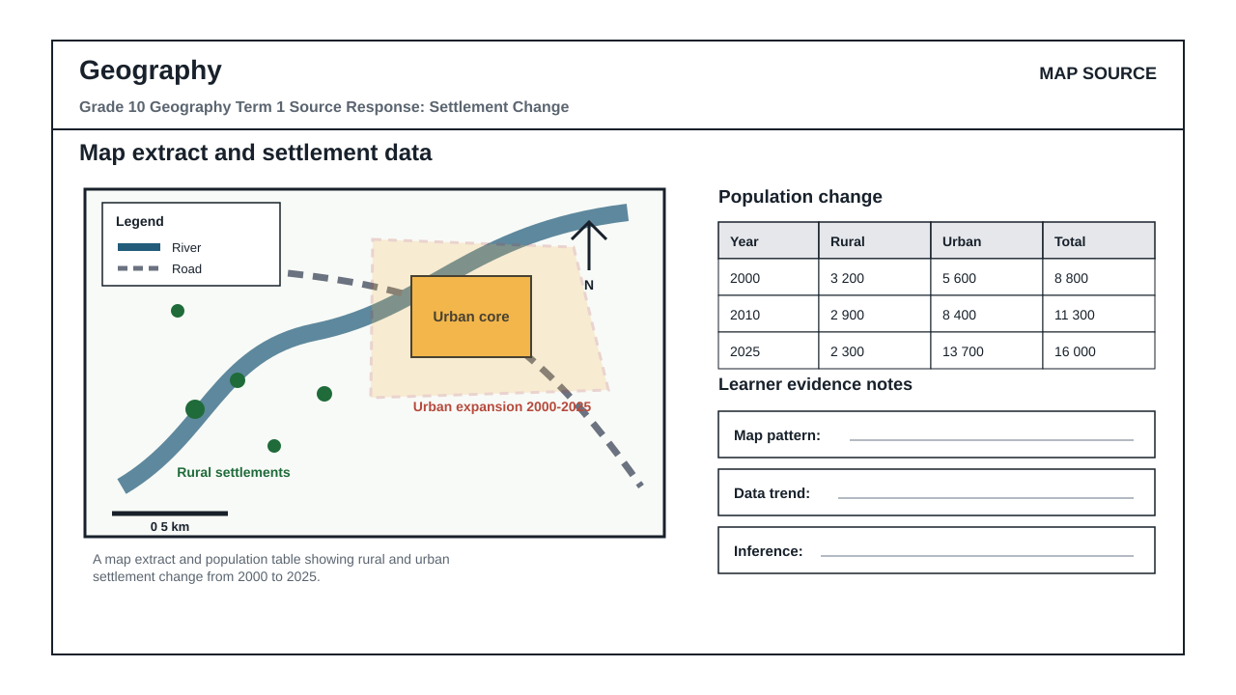

QUESTIONS

QUESTION 1: MAP AND DATA RESPONSE
Instructions: Use the map extract and population table to answer the questions. Refer to map evidence and data trends where required.
Stimulus: A map extract and population table showing rural and urban settlement change from 2000 to 2025.
1.1. Identify one spatial pattern shown by the map extract. (5)
__________________________________________________________________________________
__________________________________________________________________________________
1.2. Use the population table to describe the urban trend between 2000 and 2025. (10)
__________________________________________________________________________________
__________________________________________________________________________________
__________________________________________________________________________________
__________________________________________________________________________________
1.3. Explain how the map and table together show settlement change. (15)
__________________________________________________________________________________
__________________________________________________________________________________
__________________________________________________________________________________
__________________________________________________________________________________
1.4. Suggest one planning response and justify it using evidence from the sources. (20)
__________________________________________________________________________________
__________________________________________________________________________________
__________________________________________________________________________________
__________________________________________________________________________________

MARKING GUIDELINE

TASK 1: MAP AND DATA RESPONSE
1.1. Identify one spatial pattern shown by the map extract. (5)
- Credit one accurate map pattern supported by map features.
1.2. Use the population table to describe the urban trend between 2000 and 2025. (10)
- Credit correct use of table values and trend language.
1.3. Explain how the map and table together show settlement change. (15)
- Credit linked map and data evidence with a clear explanation.
1.4. Suggest one planning response and justify it using evidence from the sources. (20)
- Credit a feasible planning response justified from map/data evidence.

RUBRIC
Criterion | Marks | Descriptor
Map evidence | 10 | Correctly identifies and uses spatial evidence from the map.
Data interpretation | 10 | Accurately reads values/trends from the population table.
Linked explanation | 15 | Connects map and data evidence in a coherent explanation.
Justified response | 15 | Provides a feasible, evidence-based planning response.

EDUCATOR REVIEW CHECKLIST
- Confirm CAPS topic and term fit.
- Confirm map/data values are appropriate.
- Confirm marks reconcile.

