GEOGRAPHY
GRADE 10 GEOGRAPHY TERM 1 SOURCE RESPONSE: SYNOPTIC WEATHER

SUBJECT | GEOGRAPHY
GRADE | 10
ASSESSMENT TASK | GRADE 10 GEOGRAPHY TERM 1 SOURCE RESPONSE: SYNOPTIC WEATHER
MARKS | 50
TIME | 1 hour

Educator approval required before classroom use.

INSTRUCTIONS AND INFORMATION
1. Read all instructions carefully.
2. Answer all questions or complete all activities as instructed.
3. Show all working where calculations, planning, diagrams or explanations are required.
4. Use the space provided by the educator, answer booklet or learner task book.
5. Write neatly and clearly.

VISUAL MATERIAL
FIGURE 1: Synoptic Weather Map And Data
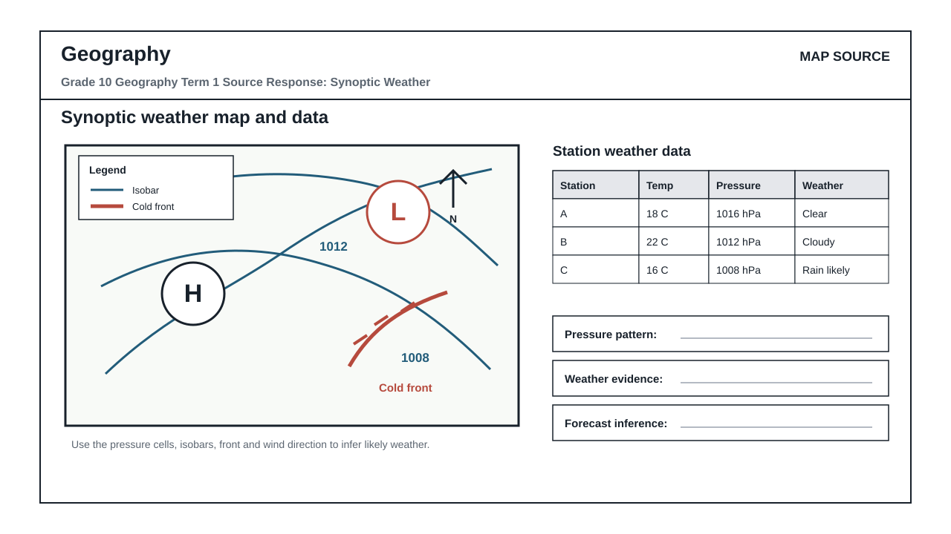

QUESTIONS

QUESTION 1: MAP AND DATA RESPONSE
Instructions: Use the map extract and data table to answer the questions. Refer to visual evidence where required.
Stimulus: A synoptic weather map and station weather data showing pressure cells, isobars and a cold front.
1.1. Identify one pattern shown by the map extract. (5)
__________________________________________________________________________________
__________________________________________________________________________________
1.2. Use the data table to describe the main trend. (10)
__________________________________________________________________________________
__________________________________________________________________________________
__________________________________________________________________________________
__________________________________________________________________________________
1.3. Explain how the map and table together support a conclusion. (15)
__________________________________________________________________________________
__________________________________________________________________________________
__________________________________________________________________________________
__________________________________________________________________________________
1.4. Suggest one response and justify it using evidence from the sources. (20)
__________________________________________________________________________________
__________________________________________________________________________________
__________________________________________________________________________________
__________________________________________________________________________________

MARKING GUIDELINE

TASK 1: MAP AND DATA RESPONSE
1.1. Identify one pattern shown by the map extract. (5)
- Credit one accurate pattern supported by visual features.
1.2. Use the data table to describe the main trend. (10)
- Credit correct use of values and trend language.
1.3. Explain how the map and table together support a conclusion. (15)
- Credit linked map and data evidence.
1.4. Suggest one response and justify it using evidence from the sources. (20)
- Credit feasible response justified from visual evidence.

RUBRIC
Criterion | Marks | Descriptor
Map evidence | 10 | Correctly identifies and uses spatial/weather-map evidence.
Data interpretation | 10 | Accurately reads values/trends from the table.
Linked explanation | 15 | Connects map and data evidence in a coherent explanation.
Justified response | 15 | Provides a feasible, evidence-based response.

EDUCATOR REVIEW CHECKLIST
- Confirm CAPS topic and term fit.
- Confirm map/data values are appropriate.
- Confirm marks reconcile.

