USER GUIDE · VERSION 1.1
SizaniConnect
How to use the food relief system of Sizani Community Food Network NPC: for site coordinators, volunteers, operations managers, donors and administrators.

Live system | https://sizaniconnect-bb7315.azurewebsites.net
Software release | v1.1.0
Client | Sizani Community Food Network NPC (case-study client)
Prepared by | Team Ubunye (Group 13): Byron Bousfield (ST10445541)
Module | INSY7315 Information Systems 3E (WIL), Task 3
Date | October 2026

Every person, household and donor shown in this guide is synthetic demonstration data.

Contents
1. About this guide 4
1.1 How to read the instructions 4
2. Getting started 5
2.1 What you need 5
2.2 Opening SizaniConnect 5
2.3 Activating your account 5
2.4 Signing in and out 6
2.5 Finding your way around 7
2.6 My account: your password and recovery codes 8
2.7 If you forget your password 9
3. Site coordinators 12
3.1 Your overview 12
3.2 Registering a household 12
3.3 After registering 14
3.4 Printing a household card 15
3.5 Finding a household 16
3.6 Running a distribution day 17
3.7 Approving a second parcel 20
3.8 Volunteer shifts at your site 21
4. The event desk 22
4.1 Opening the desk 22
4.2 Recording a collection 22
4.3 Scanning a card with the camera 23
4.4 When a card cannot be used 24
4.5 When the signal drops 26
5. Volunteers 29
5.1 Signing up for a shift 29
5.2 Checking in 29
5.3 Your shifts, and withdrawing 29
6. Operations managers 31
6.1 Your overview 31
6.2 Verifying households 31
6.3 Suspending, reinstating and archiving 32
6.4 Scheduling a distribution event 33
6.5 Donations and receipts 34
6.6 Stock 36
6.7 The monthly report 38
7. Donors 40
8. Administrators 41
8.1 Adding a user 41
8.2 Helping someone who is locked out 42
8.3 When someone leaves 42
8.4 Data retention: removing personal data for good 43
8.5 Distribution sites 45
8.6 The audit log 46
9. When something goes wrong 48
9.1 Messages and what to do 48
9.2 Frequently asked questions 49
10. Glossary 51
Appendix A. Technical setup (for IT support) 52
A.1 Requirements 52
A.2 Running it with Docker (quickest) 52
A.3 Running it without Docker 52
A.4 Configuration settings 53
A.5 Deploying to Azure 53
A.6 Checking that it works 53
A.7 Emergency administrator access 54
A.8 Backups, failures and rollback 54
Appendix B. Event desk quick card 55

1. About this guide
SizaniConnect replaces the paper registers, WhatsApp shift lists and delivery-note spreadsheets that Sizani Community Food Network used to run food relief from its six distribution sites. It keeps one record of who is registered, what was handed to whom, which stock it came from and who was on duty.
This guide explains every screen, one role at a time. You only need to read the chapters for your own role, plus chapter 2 (getting started) and chapter 9 (when something goes wrong).
Table 1. Which chapters to read
If you are a... | You use SizaniConnect to... | Read
Site coordinator | Register households, run distribution days at your site, approve exceptional second parcels | Chapters 2, 3, 4 and 9
Volunteer | Sign up for shifts, check in, and record collections at the event desk | Chapters 2, 4, 5 and 9; Appendix B
Operations manager | Verify households, schedule events, capture donations, manage stock, produce the monthly report | Chapters 2, 6 and 9 (and 3 and 4, which you can also do)
Donor | See where your donations went and print receipts | Chapters 2 and 7
Administrator | Manage accounts, sites, the audit trail and the removal of personal data | Chapters 2, 8 and 9; Appendix A
IT support | Install, configure, deploy and recover the system | Appendix A

1.1 How to read the instructions
- Words in bold are exactly what you see on the screen: a button, a link, a field or a menu item.
- Numbered steps are done in order. The numbered yellow markers on a screenshot match the numbered list under it.
- Screenshots come from a laptop unless the caption says phone. On a phone the same screen is stacked in one column and the menu is behind the Menu button.
- Boxes marked Tip, Important or Warning point out shortcuts, rules the system enforces, and actions that cannot be undone.

2. Getting started

2.1 What you need
Table 2. Equipment
Item | What works | Notes
Phone | Android phone with Chrome (screen at least 360 pixels wide), or an iPhone with Safari | For the event desk and shifts. Low-cost phones are fine: the desk was tested with the processor slowed six times.
Laptop or desktop | Current or previous version of Chrome, Edge, Firefox or Safari | For registration, reports, stock and administration.
Internet | Mobile data or Wi-Fi | Pages are small. When the connection drops, the screen says so (section 4.6).
Camera (optional) | The phone's back camera | To scan household cards. A USB or Bluetooth barcode scanner also works: it types into the code box.
Printer (optional) | Any printer | For household cards, receipts and the monthly report.

There is nothing to install. SizaniConnect runs in the web browser.

2.2 Opening SizaniConnect
- Open your browser and go to https://sizaniconnect-bb7315.azurewebsites.net.
- Bookmark the page. On a phone, use the browser menu and choose Add to Home screen so it opens like an app.
Note. For evaluation, the live system holds synthetic demonstration data and five demonstration accounts (Appendix A.2). Real staff accounts are created by an administrator (section 8.1).

2.3 Activating your account
An administrator creates your account. You then receive a one-time activation link, by email or handed to you by the administrator. It expires after 72 hours.
- Open the activation link. The Choose your password page appears.
- Type a new password in New password, and again in Type it again. Use at least 12 characters; a short phrase such as Sunflowers on Friday 7 is easier to remember than a jumble. Very common passwords and passwords containing your email address are refused.
- Select Save password, then Sign in now.
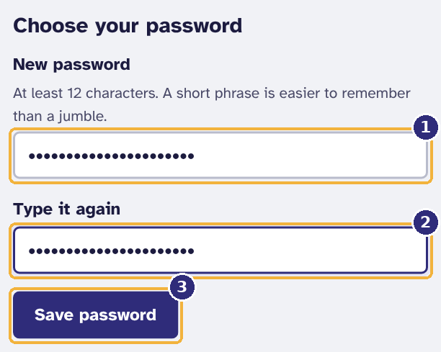
Figure 1. Choosing your password the first time
1 Your new password (at least 12 characters)
2 The same password again
3 Save it, then sign in

2.4 Signing in and out
- Type your Email and Password.
- Select Sign in. You arrive at the start page for your role.
- To sign out, select Sign out at the bottom of the menu (on a phone, open Menu first).
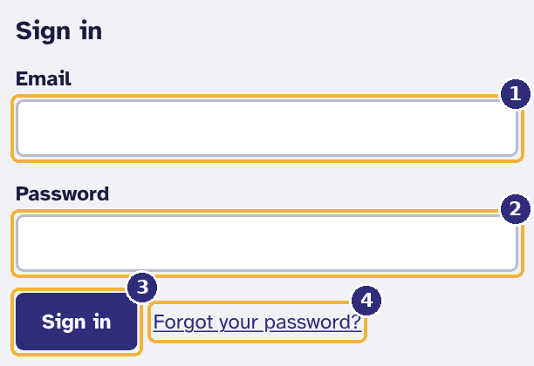
Figure 2. The sign-in page
1 Your email address
2 Your password
3 Sign in
4 If you have forgotten your password

Important. After five wrong passwords in 15 minutes the account is locked for 15 minutes. This protects you if someone tries to guess your password. Wait, or use one of the options in section 2.7.

You stay signed in on that device for up to seven days unless you sign out. Always sign out on a shared phone or computer.

2.5 Finding your way around
Every screen has the same layout. The menu on the left lists only the screens your role can use, so what you see depends on who you are.
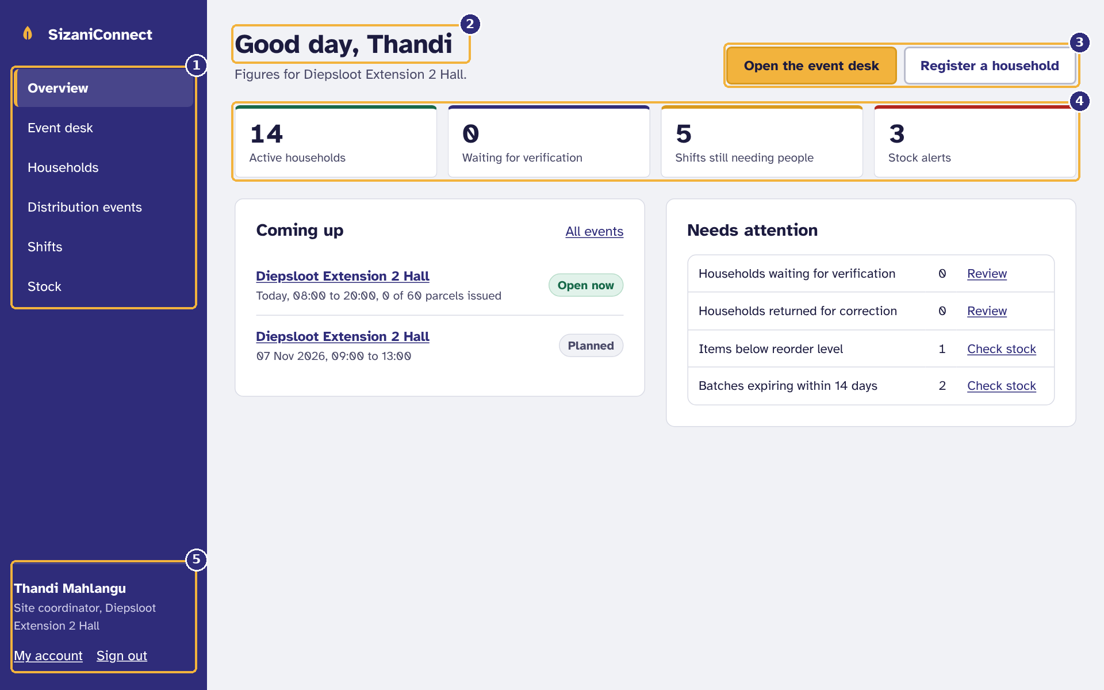
Figure 3. Finding your way around: a site coordinator's start page
1 The menu shows only the screens your role uses
2 The page you are on
3 The main things to do from here
4 Figures for your site
5 Who is signed in, My account and Sign out

On a phone, the menu is hidden behind the Menu button at the top right, so the screen stays free for the work.
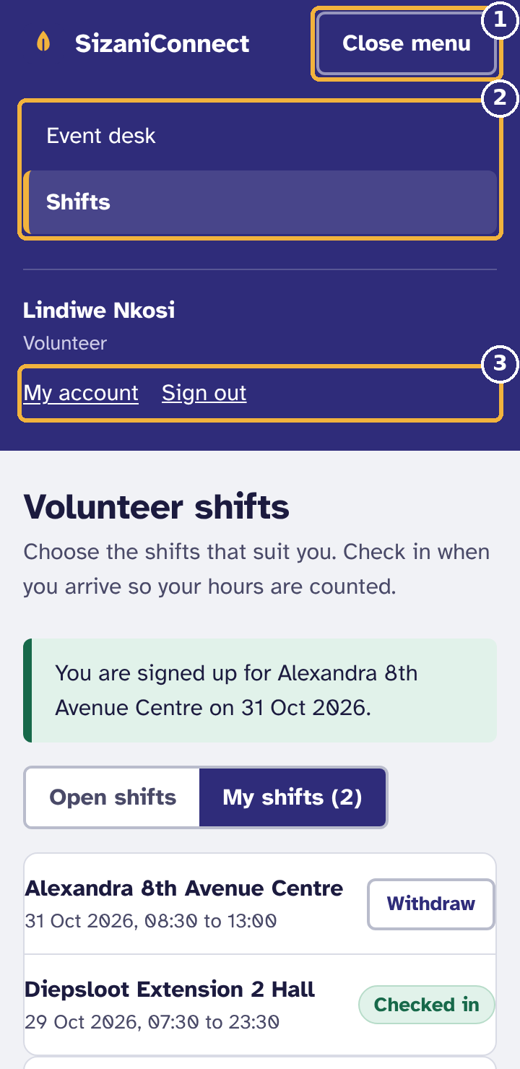
Figure 4. The menu on a phone
1 Menu opens and closes here
2 Your screens
3 My account and Sign out

2.6 My account: your password and recovery codes
Select My account at the bottom of the menu to see your details, change your password and create recovery codes. Your name, email, role and cellphone number can only be changed by an administrator.

Changing your password
- Under Change your password, type your Current password.
- Type the New password twice and select Change password.
- Any other phone or computer signed in as you is signed out. The one you are using stays signed in, and an email confirms the change.

Creating recovery codes
Recovery codes let you choose a new password yourself when you have forgotten it, even if email is not working. Everyone can create them; administrators should do so on their first day (the start page reminds them until they have).
- Under Recovery codes, select Create recovery codes.
- Type your password and select Create my codes. Ten codes appear.
- Select Download as a text file or Print, and keep them somewhere private, not on the same phone you sign in with.
- Select I have saved them. The codes are never shown again.
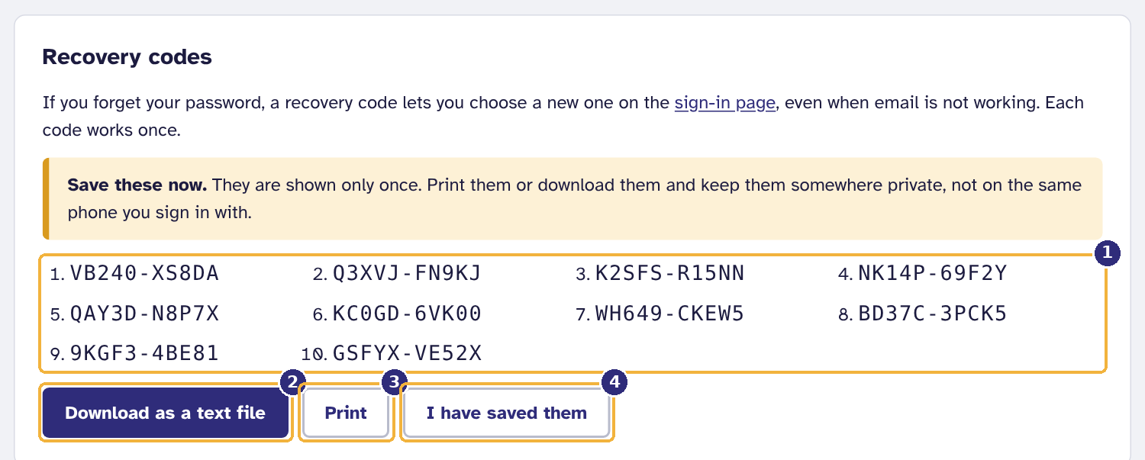
Figure 5. Your recovery codes, shown once
1 Ten codes: each works once
2 Save them as a file
3 Or print them
4 Hide them when you are done

Each code works once. My account shows how many are left. Creating a new set makes the old codes stop working.

2.7 If you forget your password
There are three ways back in. Try them in this order.

Option 1: an emailed link
- On the sign-in page select Forgot your password?
- Type your email and select Send reset link. Open the link in the email within 30 minutes and choose a new password.
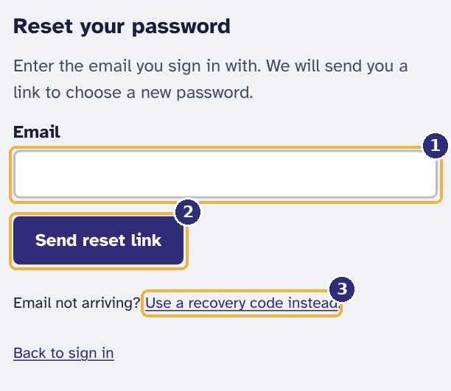
Figure 6. Asking for a reset link
1 The email you sign in with
2 Send the link
3 No email? Use a recovery code

For security the page always says a link is on its way, even if the email address has no account.

Option 2: a recovery code
- On the Reset your password page select Use a recovery code instead.
- Type your Email, one Recovery code (capitals and the dash are optional), and a new password twice.
- Select Save new password. The page says how many codes you have left. Sign in with the new password.
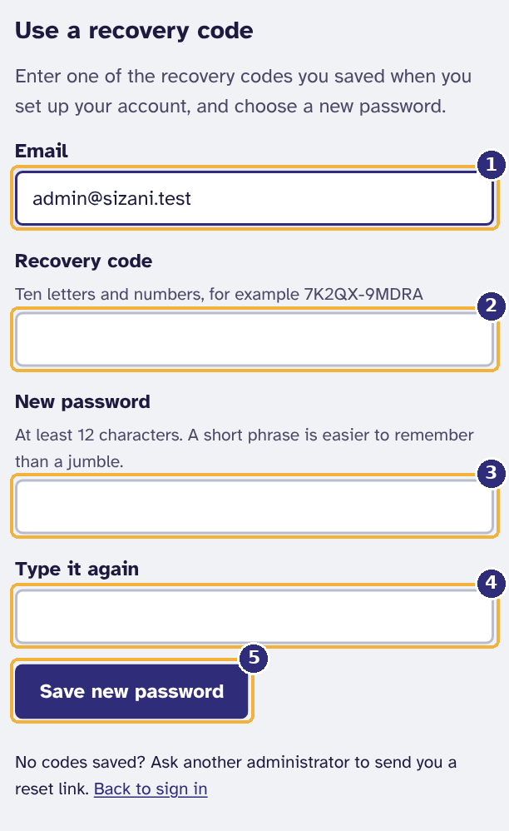
Figure 7. Resetting a password with a recovery code
1 Your email address
2 One of your saved recovery codes
3 A new password of at least 12 characters
4 The same password again
5 Save

Important. A wrong recovery code counts as a wrong password: after five, the account locks for 15 minutes.

Option 3: ask an administrator
An administrator can send you a reset link from the Users screen (section 8.2). It lasts 24 hours. If the administrator is the one locked out, another administrator can do the same for them, and IT support has a last-resort procedure (Appendix A.7).

3. Site coordinators
As a site coordinator you register households, run distribution days at your own site and decide the rare exceptions at the desk. You can see households from every site, but you can only register for, and run events at, your own site.

3.1 Your overview
Your start page shows the figures for your site and what is waiting for you.
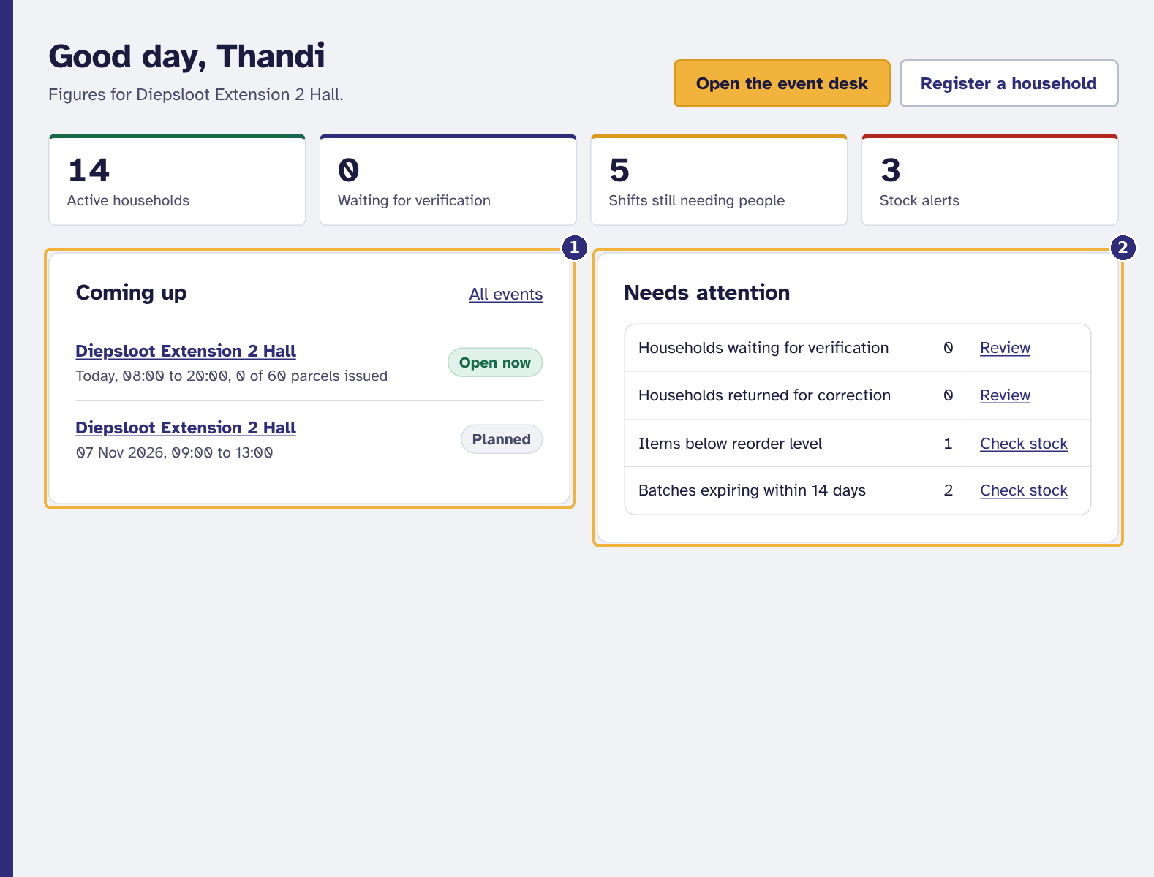
Figure 8. The overview: what needs attention today
1 Distribution days coming up at your site
2 Work waiting for you, with a link to each list

- Open the event desk appears when an event at your site is open today.
- Each line under Needs attention links to the list it counts: households waiting for verification or returned for correction, and stock that is low or expiring.

3.2 Registering a household
- Select Households, then Register a household (or use the button on the overview).
- Under Head of household, type the Full name and the ID or passport number. The number is checked against every site for a duplicate and then thrown away: only a one-way code is kept, so the number itself cannot leak.
- Type a Cellphone number if they have one (see the rules below). Collects at is fixed to your site.
- Type the Street address and Suburb.
- Under Who lives in the household, give the head of household's first name and age group, then select Add a person for each other member, with their first name, age group and relationship. The parcel size follows the number of people: 1 to 2 small, 3 to 5 medium, 6 or more large.
- Select Register household.
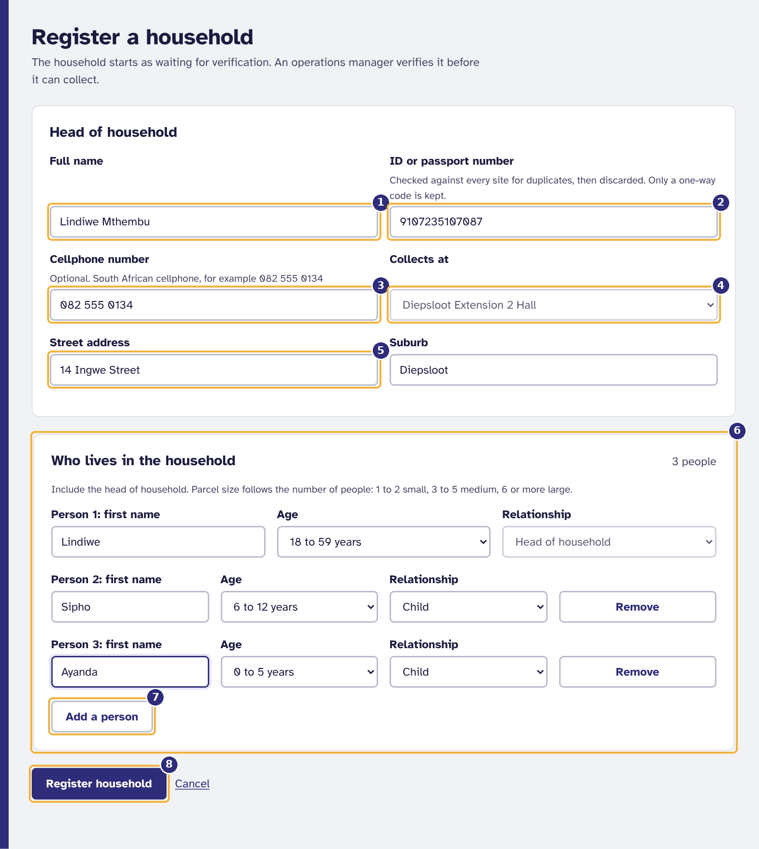
Figure 9. Registering a household
1 Head of household's full name
2 ID or passport number: checked for duplicates, then discarded
3 Cellphone number (optional)
4 The site they collect from (your own site)
5 Street address and suburb
6 Everyone in the household, including the head
7 Add another person
8 Register

Cellphone numbers
Only South African cellphone numbers are accepted. You can type them in any usual way (082 555 0134, 0825550134, +27 82 555 0134); they are stored in one standard form and always shown as 082 555 0134. When you move to the next field, a mistake is pointed out straight away:
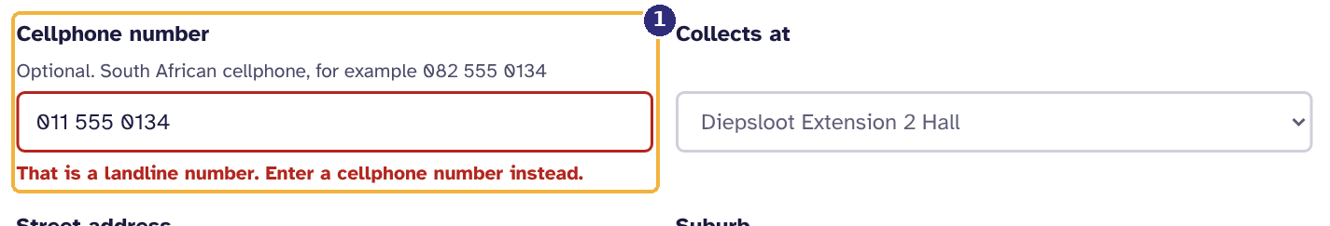
Figure 10. A landline is refused as soon as you leave the field
1 The message says what is wrong and what to enter instead

Table 3. Cellphone messages
You typed | What you see | Why
011 555 0134 | That is a landline number. Enter a cellphone number instead. | Numbers starting 01 to 05 are landlines.
0800 123 456 | Numbers starting 080 are not cellphone numbers. | Toll-free (080), share-call (086) and internet (087) numbers cannot receive an SMS.
082 555 013 | A cellphone number has 10 digits, for example 082 555 0134. | A digit is missing or extra.
+44 20 7946 0958 | Only South African cellphone numbers (+27) can be used. | Foreign numbers are not supported.

If the person is already registered
One person may hold only one live registration across all six sites (business rule BR-01). If the ID number is already registered, the system stops you and links to the existing household instead.
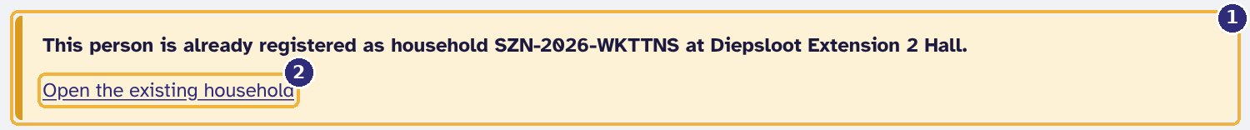
Figure 11. The same person cannot be registered twice, at any site
1 The household this person already belongs to
2 Open it instead of registering again

3.3 After registering
The household page opens with its new reference code. The household is Waiting for verification: an operations manager must check proof of address and verify it before it can collect (section 6.2). The person who registered a household can never verify it.
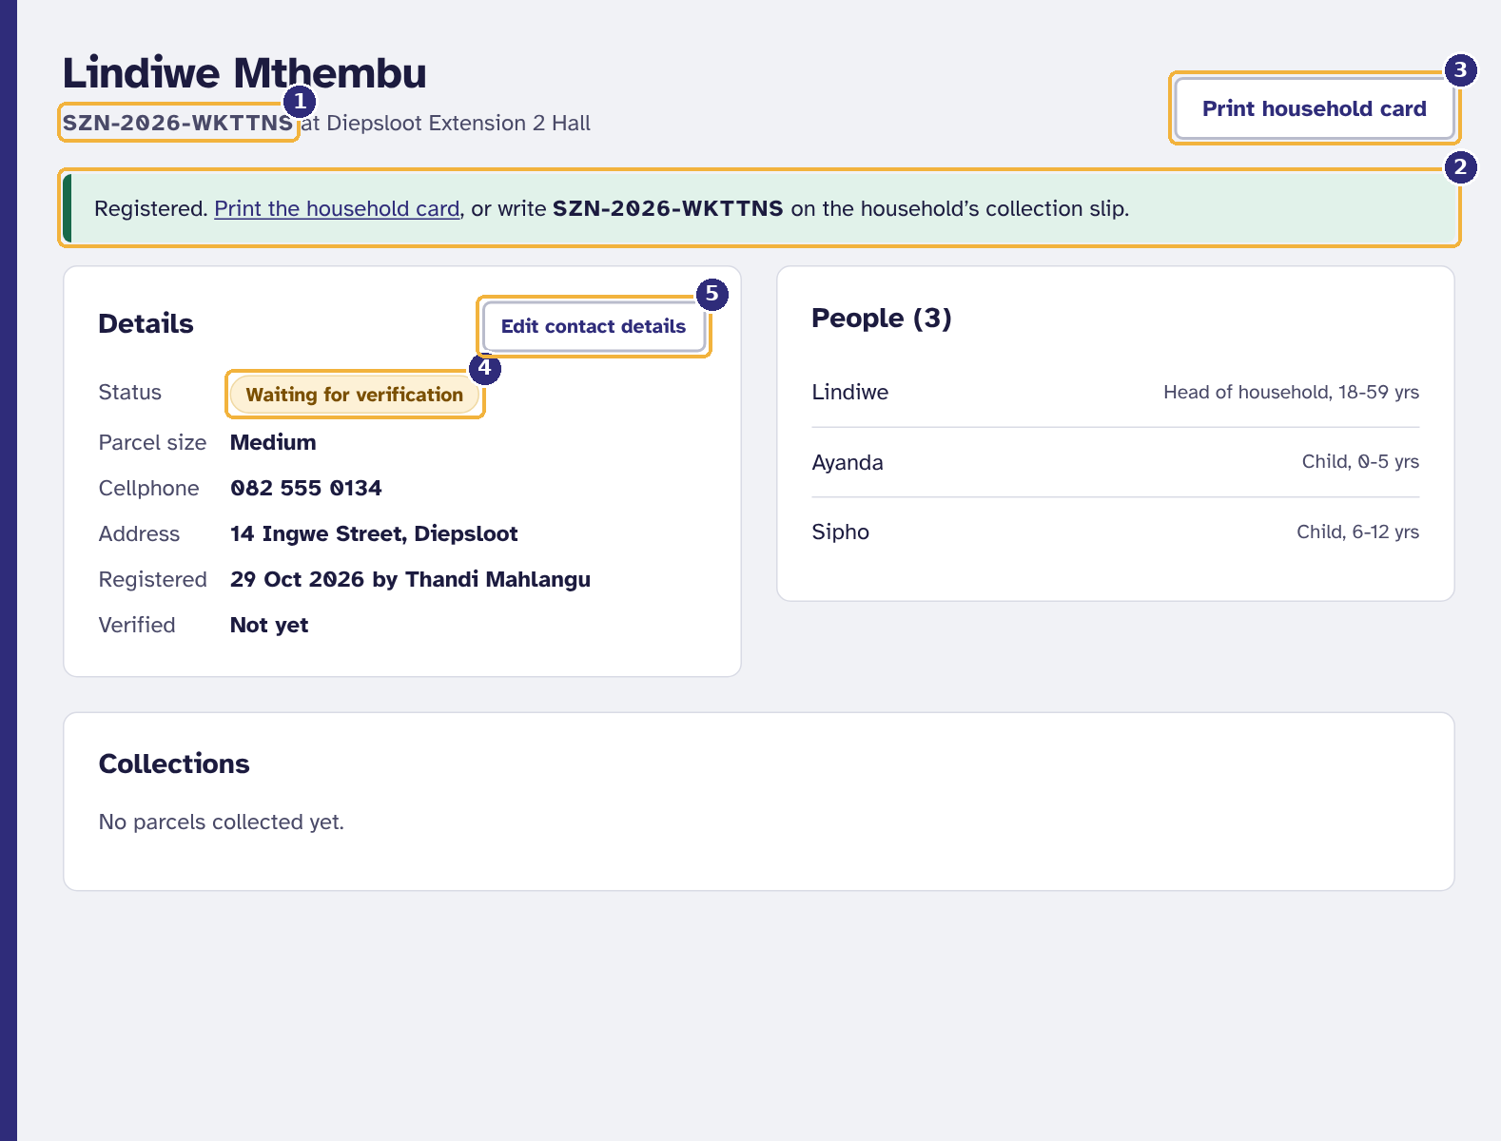
Figure 12. A newly registered household
1 Its reference code
2 Print the household card now, or write the code on a slip
3 Print household card
4 Status: an operations manager must verify it before it can collect
5 Correct the contact details if needed

- Edit contact details corrects the cellphone number or address while the household is active, waiting, or returned for correction.
- If an operations manager returns the household for correction, the reason is shown at the top. Fix the details, then select Resubmit for verification.
- You can Suspend a household at your site with a reason, for example while a concern is checked. Only an operations manager can reinstate it.

3.4 Printing a household card
Every household should carry a card. The QR code on it is what the event desk scans, and the reference code underneath can always be typed instead.
- On the household page select Print household card (also linked from the message shown after registering).
- Select Print card. Print on card or thick paper and cut along the dashed border; the card is bank-card size.
- Give the card to the household and ask them to bring it every time.
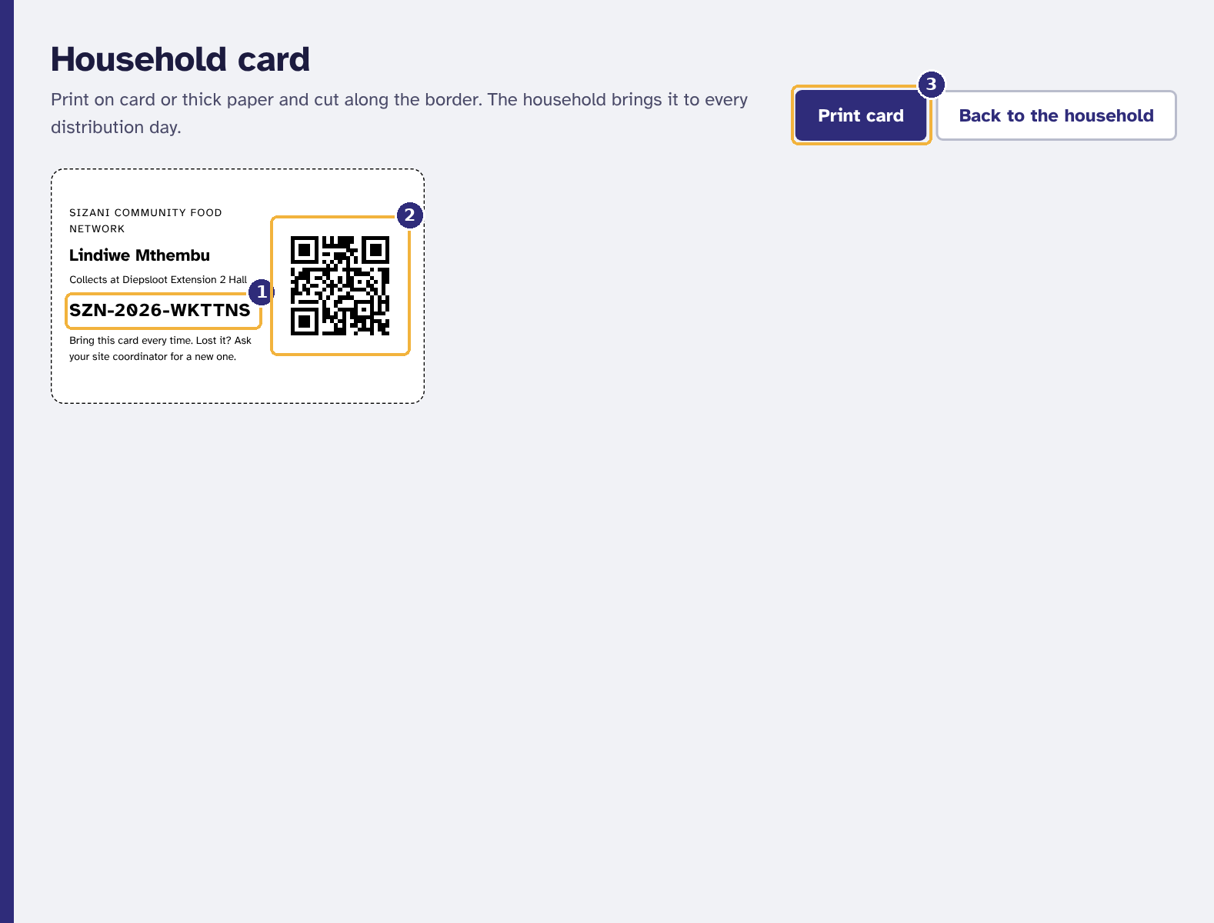
Figure 13. The household card, ready to print
1 The reference code, which can always be typed instead
2 The QR code the event desk scans
3 Print

Tip. If a card is lost, print another one from the same page. The code does not change.

3.5 Finding a household
- Select Households.
- Type part of a name, a reference code or a suburb in Search and select Search. Use Status to show, for example, only households waiting for verification.
- Select a reference code to open the household.
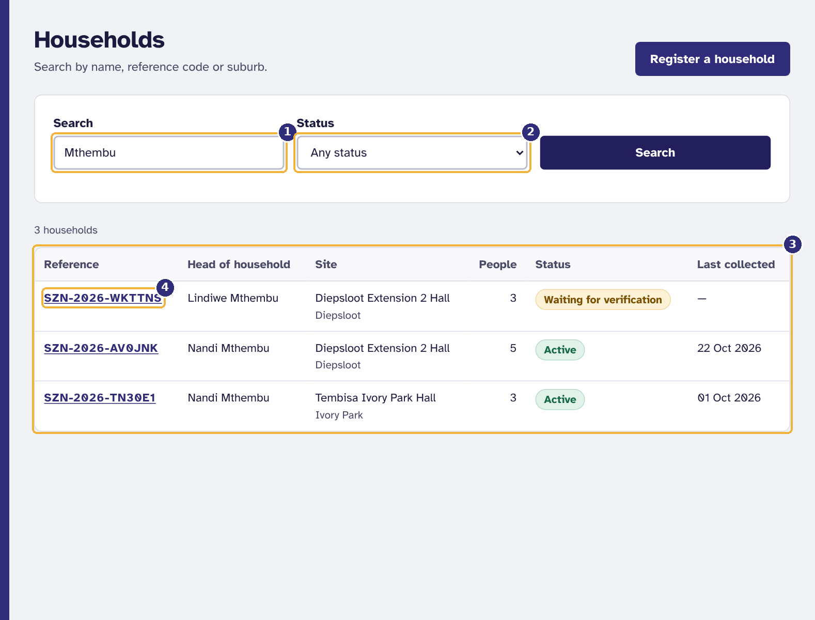
Figure 14. Finding a household
1 Search by name, reference code or suburb
2 Narrow to one status
3 Matching households
4 Open a household

3.6 Running a distribution day
A distribution event moves through fixed stages. Only the buttons for the next stage appear, so you cannot skip one.
Table 4. The stages of a distribution event
Stage | Who moves it on | What happens
Planned | Operations manager schedules it | Volunteers can sign up for its shifts.
Stocked | Operations manager selects Mark as stocked | Parcels are packed. Stock levels are checked first.
Open | You select Open event on the day | Only possible once the required number of volunteers have checked in (BR-07). The event desk starts working.
Closed | You select Close event | No more collections can be recorded.
Reconciled | You select Reconcile | You count the parcels that actually left and explain any difference.

- Select Distribution events. Today and upcoming lists your site's events; Past 90 days shows earlier ones.
- Select the date of the event to open it.
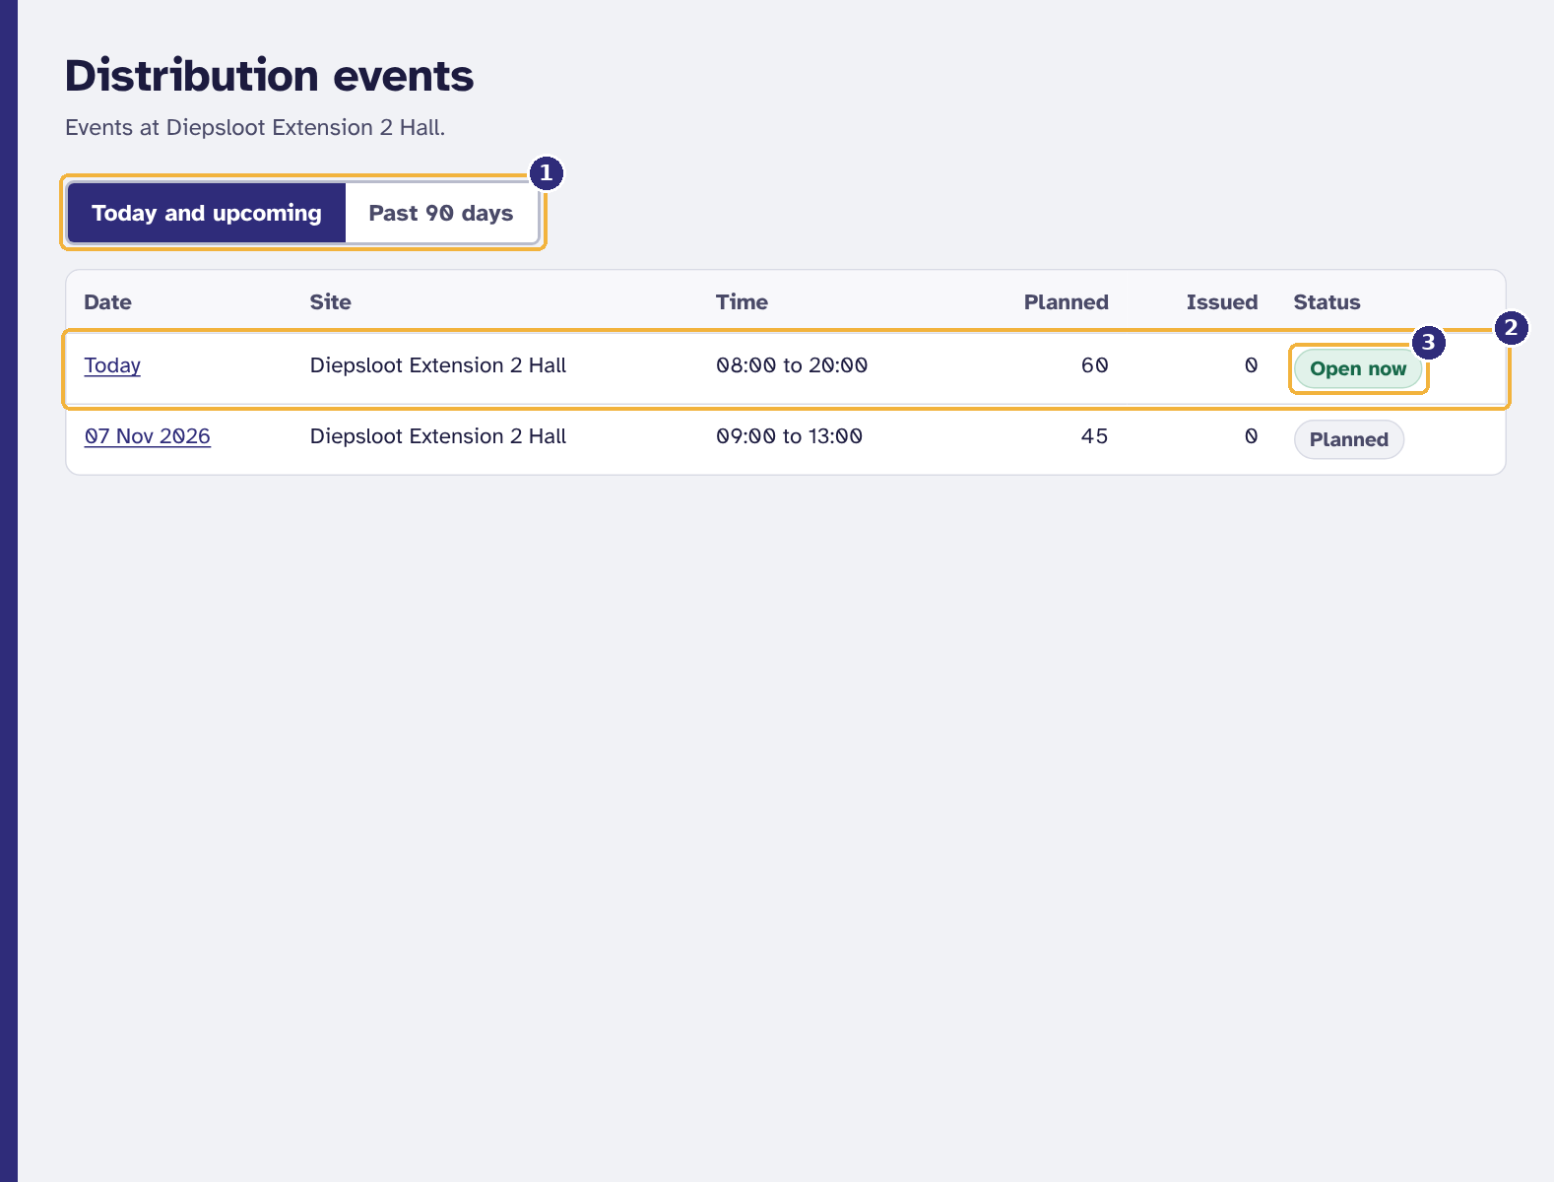
Figure 15. Distribution events at your site
1 Coming up, or the last 90 days
2 Today's event
3 Its status

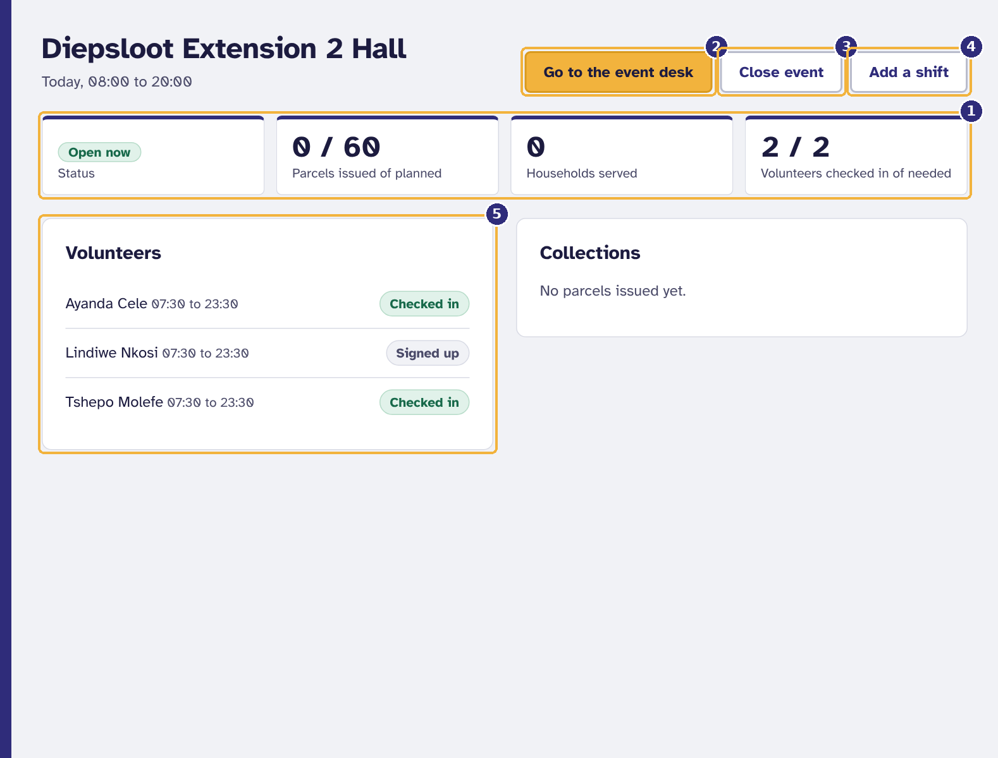
Figure 16. An open distribution event
1 Status, parcels issued, households served, volunteers checked in
2 Go to the event desk
3 Close the event when the queue is done
4 Add a volunteer shift
5 Who is on duty

Closing and reconciling
- When the queue is finished, select Close event.
- Count the parcels that actually left the site and select Reconcile.
- Type the number in Parcels counted. If it differs from what was recorded, explain why in the box that appears.
- Select Save reconciliation. The result is kept on the event and in the monthly report.
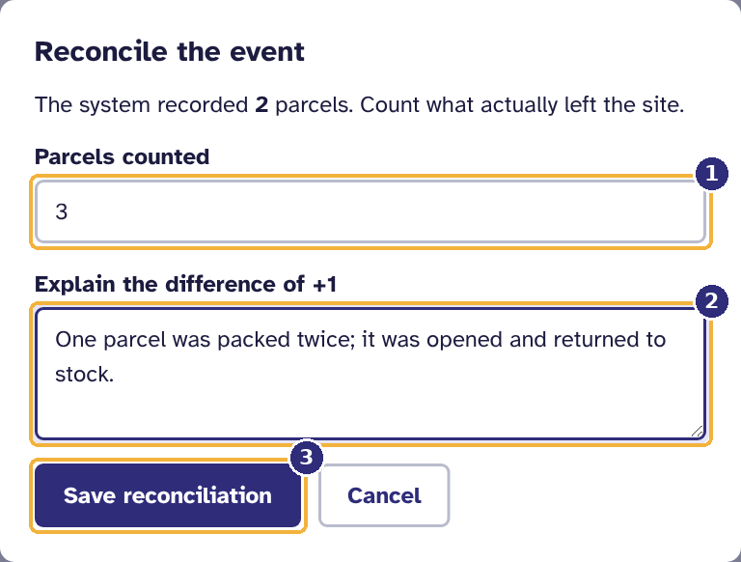
Figure 17. Reconciling: the physical count against what was recorded
1 Parcels counted at the end of the day
2 If the numbers differ, explain why
3 Save

3.7 Approving a second parcel
A household can collect only once per event (BR-04). In a genuine exception, such as a parcel stolen on the way home, a site coordinator can approve a second parcel at the desk:
- Find the household at the event desk. The desk shows Already collected.
- Type the reason in Override reason (at least 10 characters). It is kept permanently in the audit log and appears in the monthly report as an override.
- Select Approve a second parcel.
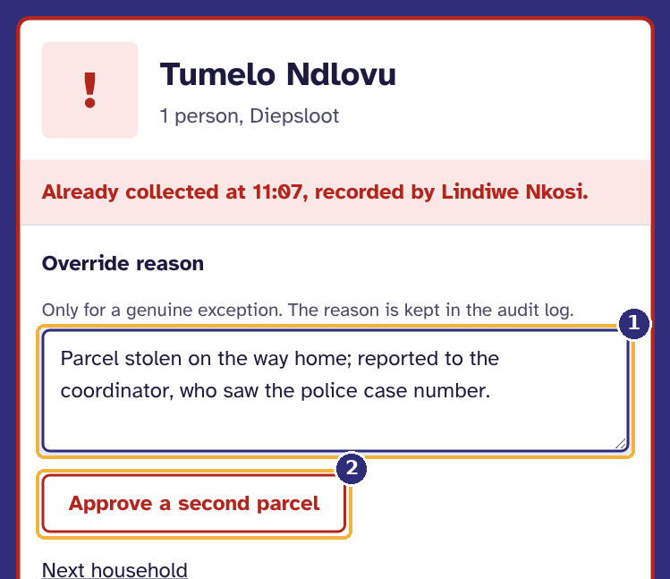
Figure 18. A coordinator approving a second parcel
1 The reason, kept in the audit log
2 Approve a second parcel

Volunteers do not see this option; the desk tells them to ask the site coordinator.

3.8 Volunteer shifts at your site
You can add shifts to your site's planned, stocked or open events (section 6.5 shows the form), and see who is on duty on the event page. You can also sign up for and check in to shifts yourself under Shifts, as described in chapter 5.

4. The event desk
The event desk is the screen used most, usually on a phone with a queue waiting. It answers one question for each household: may they collect a parcel, and which one? Volunteers, site coordinators and operations managers can use it while an event is open.

4.1 Opening the desk
- Select Event desk in the menu. If one event is open, the desk for it opens. If more than one is open, choose the one you are working at.
- If no event is open, the desk says so. Ask the site coordinator to open today's event.
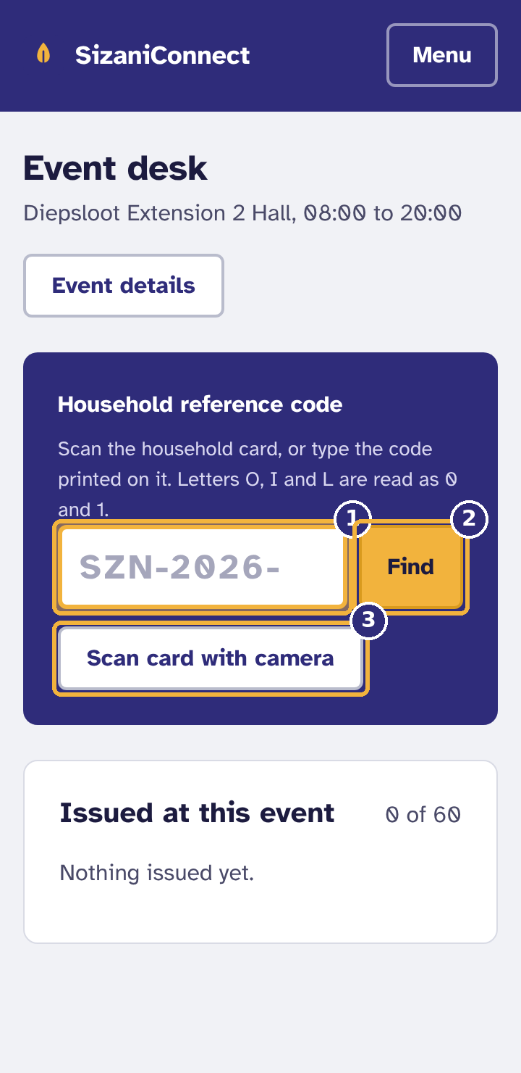  Figure 19. The event desk on a phone  1 Type the code from the card, or scan it  2 Find  3 Or scan the card with the phone's camera | 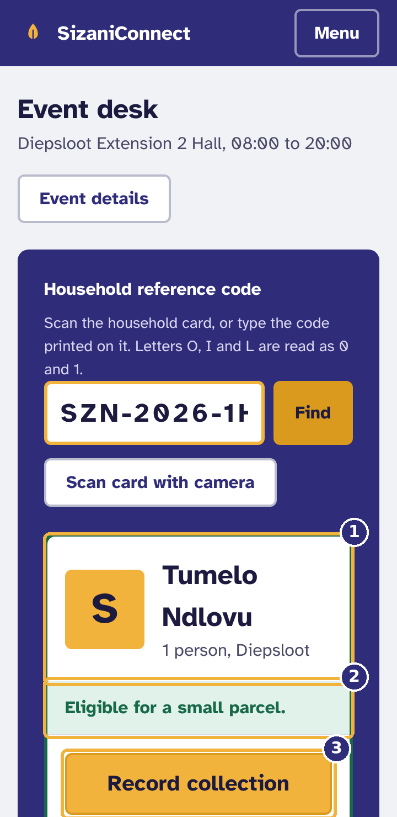  Figure 20. An eligible household  1 Who it is, and how many people  2 The verdict: eligible, and the parcel size  3 Record the collection, then hand over the parcel

4.2 Recording a collection
- Scan the household card, or type the reference code in Household reference code and select Find. Letters O, I and L are read as 0 and 1, so common misreadings still work.
- Read the verdict. A green verdict shows the household, the number of people and the parcel size.
- Select Record collection, then hand over the parcel size shown. The desk lists what was taken from stock, first to expire first out.
- Select Next household, or simply scan the next card.
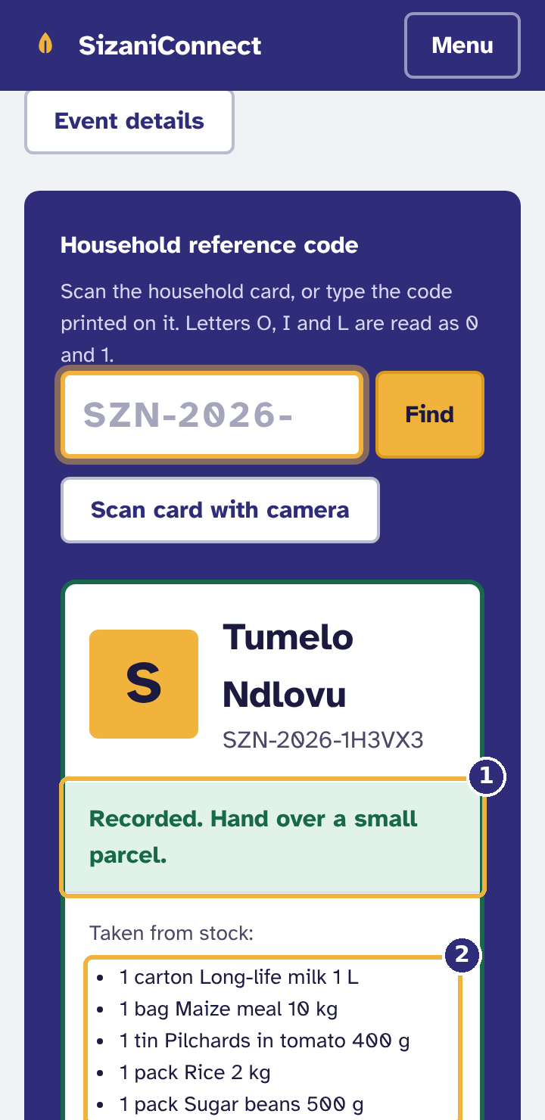  Figure 21. Recorded  1 Which parcel to hand over  2 What was taken from stock (first to expire, first out) | 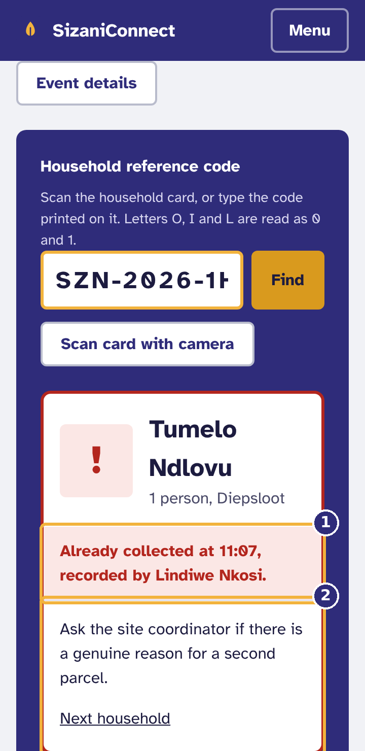  Figure 22. Already collected at this event  1 When, and who recorded it  2 What to do: no second parcel without the coordinator

Table 5. Desk verdicts
Verdict | Meaning | What to do
Eligible for a small / medium / large parcel | The household may collect. | Record the collection, then hand over that size.
Already collected at 10:56, recorded by ... | This household collected at this event already. | Do not hand over a parcel. Refer them to the site coordinator.
Cannot collect: household is waiting for verification / suspended / archived | The household is not active. | Do not hand over a parcel. Refer them to the site coordinator.
No household has this code | The code is wrong or the card belongs elsewhere. | Check the card and try again, or search for the household by name (staff).

4.3 Scanning a card with the camera
- Select Scan card with camera. The first time, allow the browser to use the camera.
- Hold the card flat, in good light, about a hand's length from the phone, so the QR code fills the yellow box.
- When the card is read, the camera closes and the verdict appears.
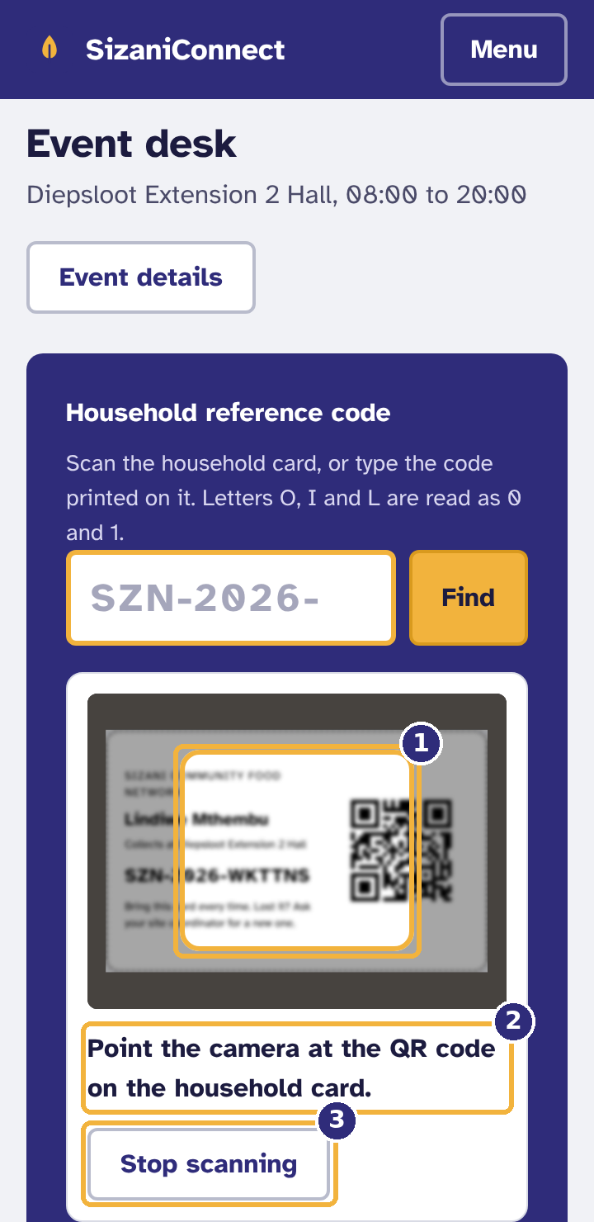
Figure 23. Scanning a card with the camera
1 Fill this box with the QR code
2 What the scanner is doing
3 Stop, and type the code instead

- On most Android phones the phone's own built-in reader is used. On other browsers a small reader (about 50 KB) downloads the first time.
- If no card is read in 20 seconds, scanning stops with advice. Select Try the camera again, or type the code.
- Scanning also stops when you switch to another app, so the camera is never left running.
- A USB or Bluetooth barcode scanner works without the camera button: click in the code box and scan.

4.4 When a card cannot be used
Before anything is sent, the desk checks what was scanned or typed. A creased or dirty card, a QR code from something else (a poster, a payment code), or half a code is explained on the spot. After two failed tries in a row, the desk suggests typing the code printed on the card instead.
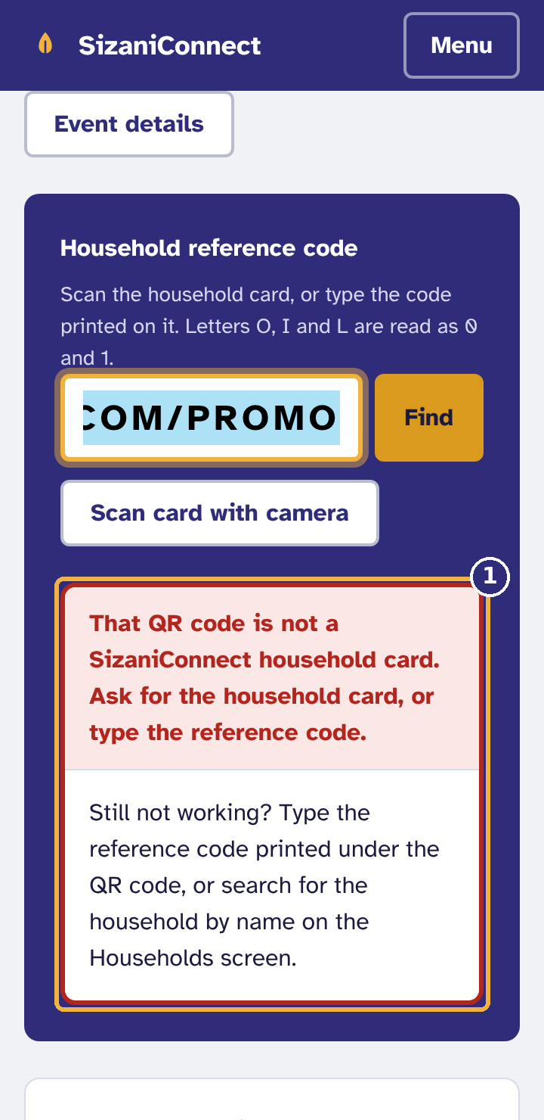
Figure 24. A card that cannot be used
1 Why it was refused, and after two tries, what to do instead

Table 6. Card and camera messages
Message | Cause | What to do
The card could not be read correctly. It may be creased, dirty or partly covered. | Part of the QR code was misread, or a scanner dropped characters. A check character on the card catches this. | Scan again with the card flat and well lit, or type the code printed under the QR code.
That QR code is not a SizaniConnect household card. | A different QR code or barcode was scanned. | Ask for the household card, or type the reference code.
That is not a SizaniConnect card: what was scanned is far too long. | Long text was scanned or pasted. | Type the reference code printed on the card.
That is not a complete reference code. Codes look like SZN-2026-7K2QX9. | Part of a code was typed. | Check the card and type the whole code.
Camera permission was refused. | The browser was told not to use the camera. | Type the code, or allow the camera for this site in the browser settings.
No camera was found / the camera is being used by another app. | No camera, or another app holds it. | Close the other app and try again, or type the code.

4.5 When the signal drops
A yellow banner at the top of the screen appears as soon as the phone goes offline or SizaniConnect cannot be reached, and disappears by itself when the connection is back.
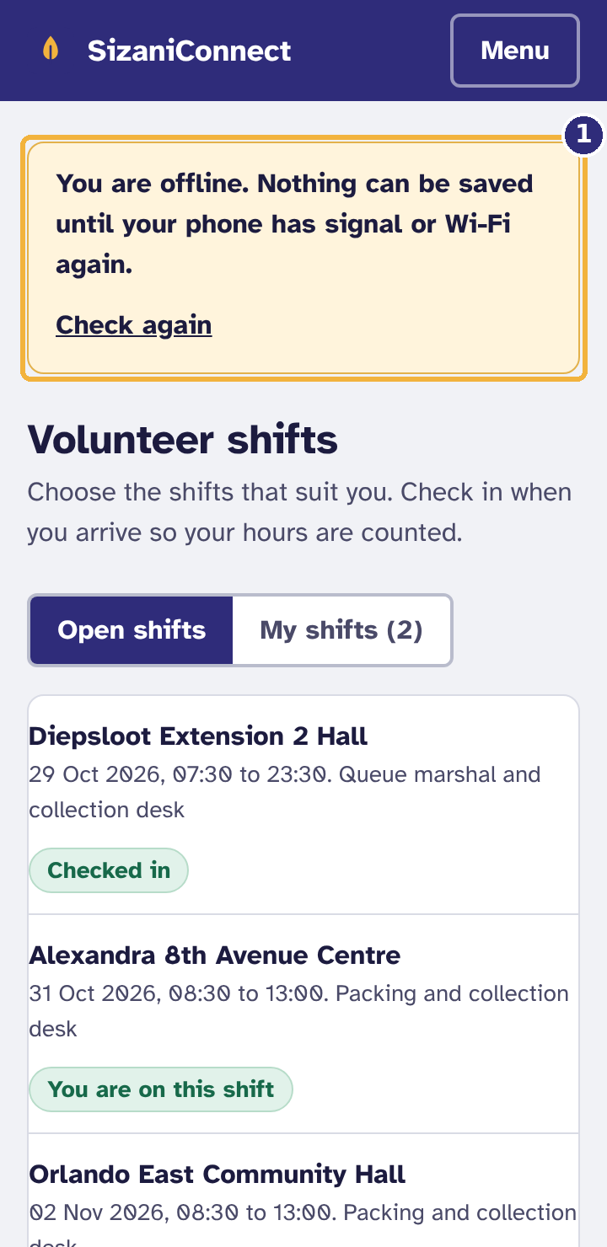  Figure 25. No signal  1 Shown as soon as the phone goes offline; it disappears when the signal returns | 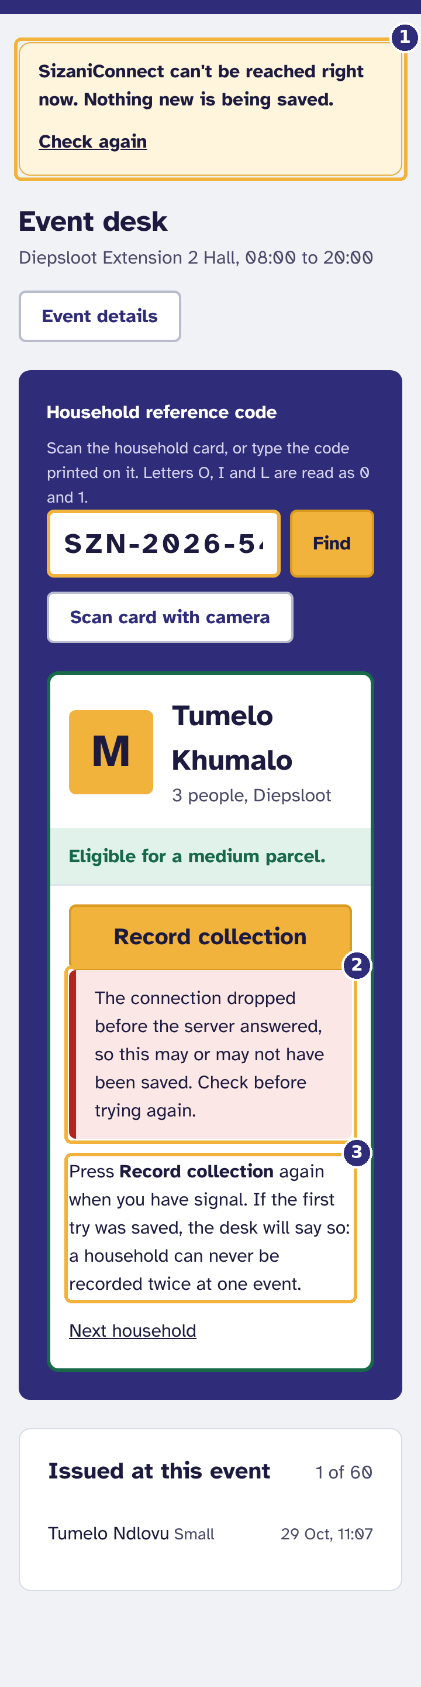  Figure 26. The connection dropped while saving  1 The banner: the system cannot be reached  2 Whether it was saved is unknown  3 Pressing again is always safe

If the connection drops while you are recording a collection, the desk cannot know whether the server received it, so it says so. Press Record collection again once you have signal. This is always safe: the system will never record a household twice at one event. If the first try had been saved, the desk tells you so, and you hand over one parcel only.
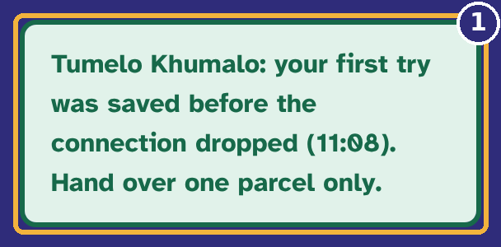
Figure 27. Pressing again after the signal returns
1 It had been saved: hand over one parcel only

Important. If there is no signal at all for a long time, use the site's paper fallback register and enter the collections when the signal returns.

5. Volunteers
As a volunteer you choose your shifts, check in when you arrive, and record collections at the event desk (chapter 4). Your start page is Shifts.

5.1 Signing up for a shift
- Select Shifts. Open shifts lists the shifts in the next three weeks at every site, with the places left.
- Select Sign up next to the shift you want. A message confirms it.

5.2 Checking in
From one hour before your shift starts (BR-10), a banner at the top of Shifts shows Check in now. Select it when you arrive, so your hours are counted and the coordinator knows you are there. An event can only open once enough volunteers have checked in.

5.3 Your shifts, and withdrawing
- Select My shifts to see the shifts you signed up for and the ones you recently served.
- To withdraw, select Withdraw next to the shift. This is possible until 24 hours before it starts; after that, phone your site coordinator so they can find cover.
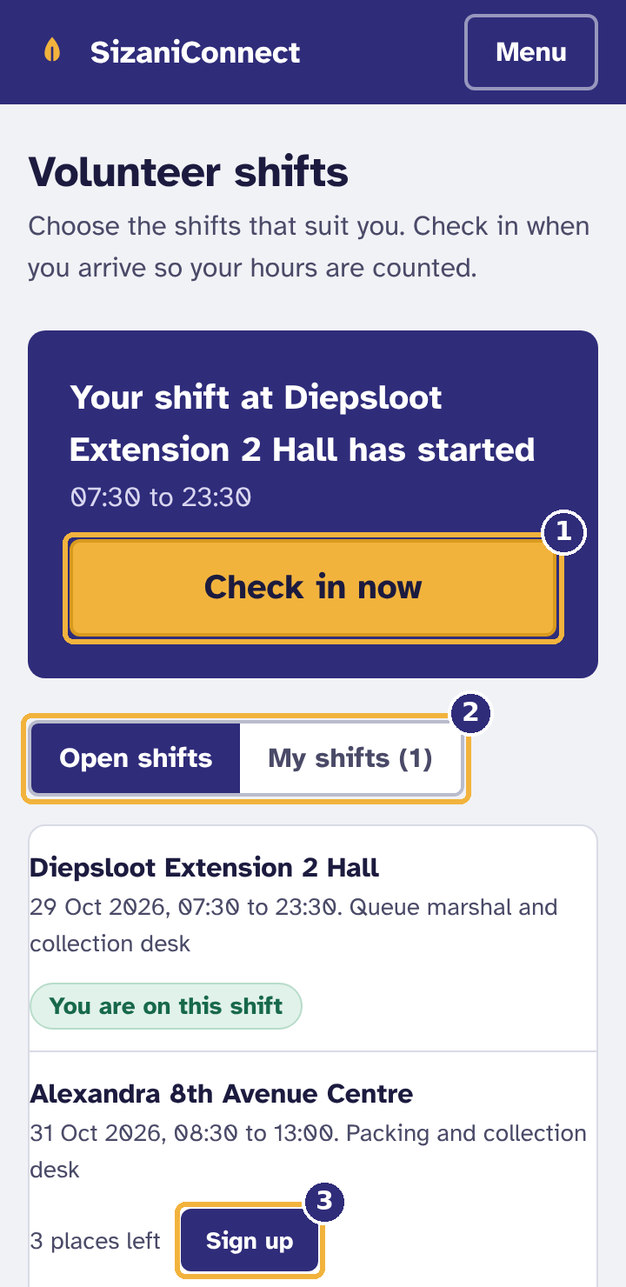  Figure 28. Shifts on a phone  1 Check in when you arrive  2 Open shifts, or only yours  3 Sign up for a shift | 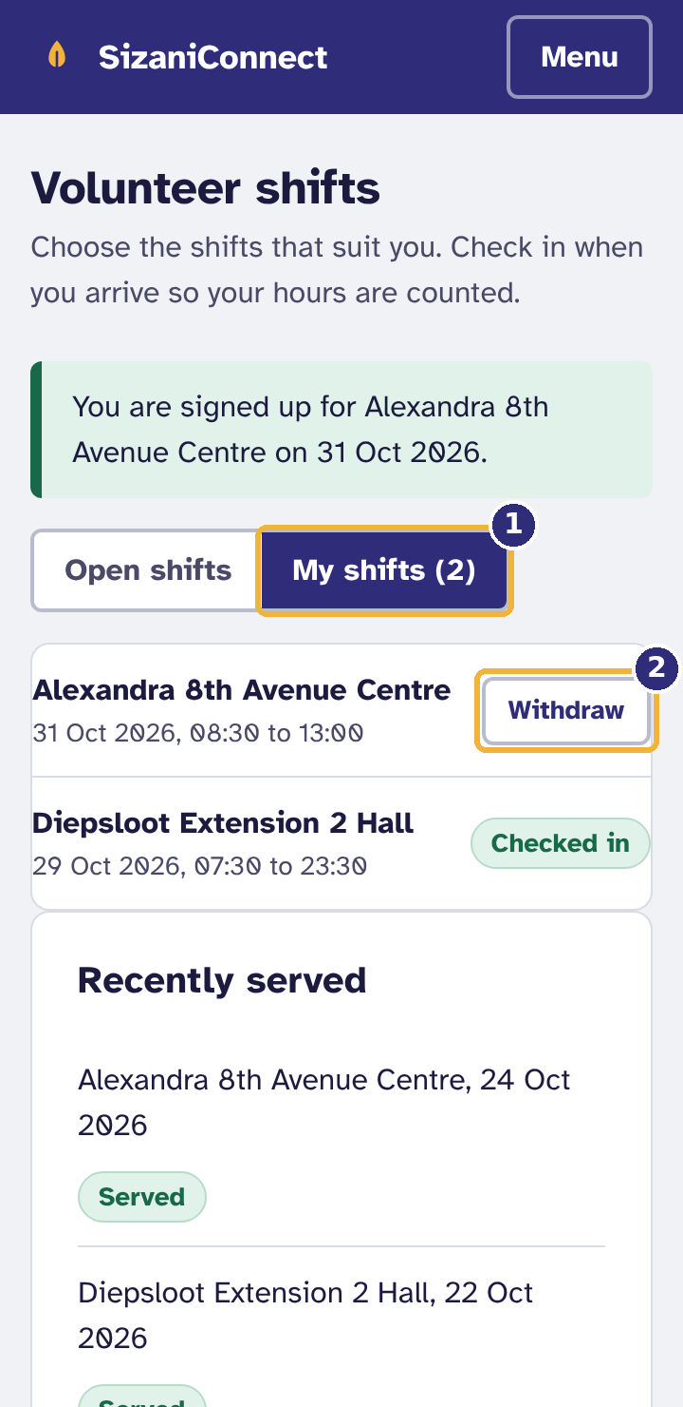  Figure 29. Your shifts, and how to withdraw  1 My shifts  2 Withdraw (until 24 hours before; after that, phone your coordinator)

6. Operations managers
As an operations manager you work across all six sites: you verify households, schedule distribution days, capture donations, manage stock and produce the monthly report. You can also register households and use the event desk.

6.1 Your overview
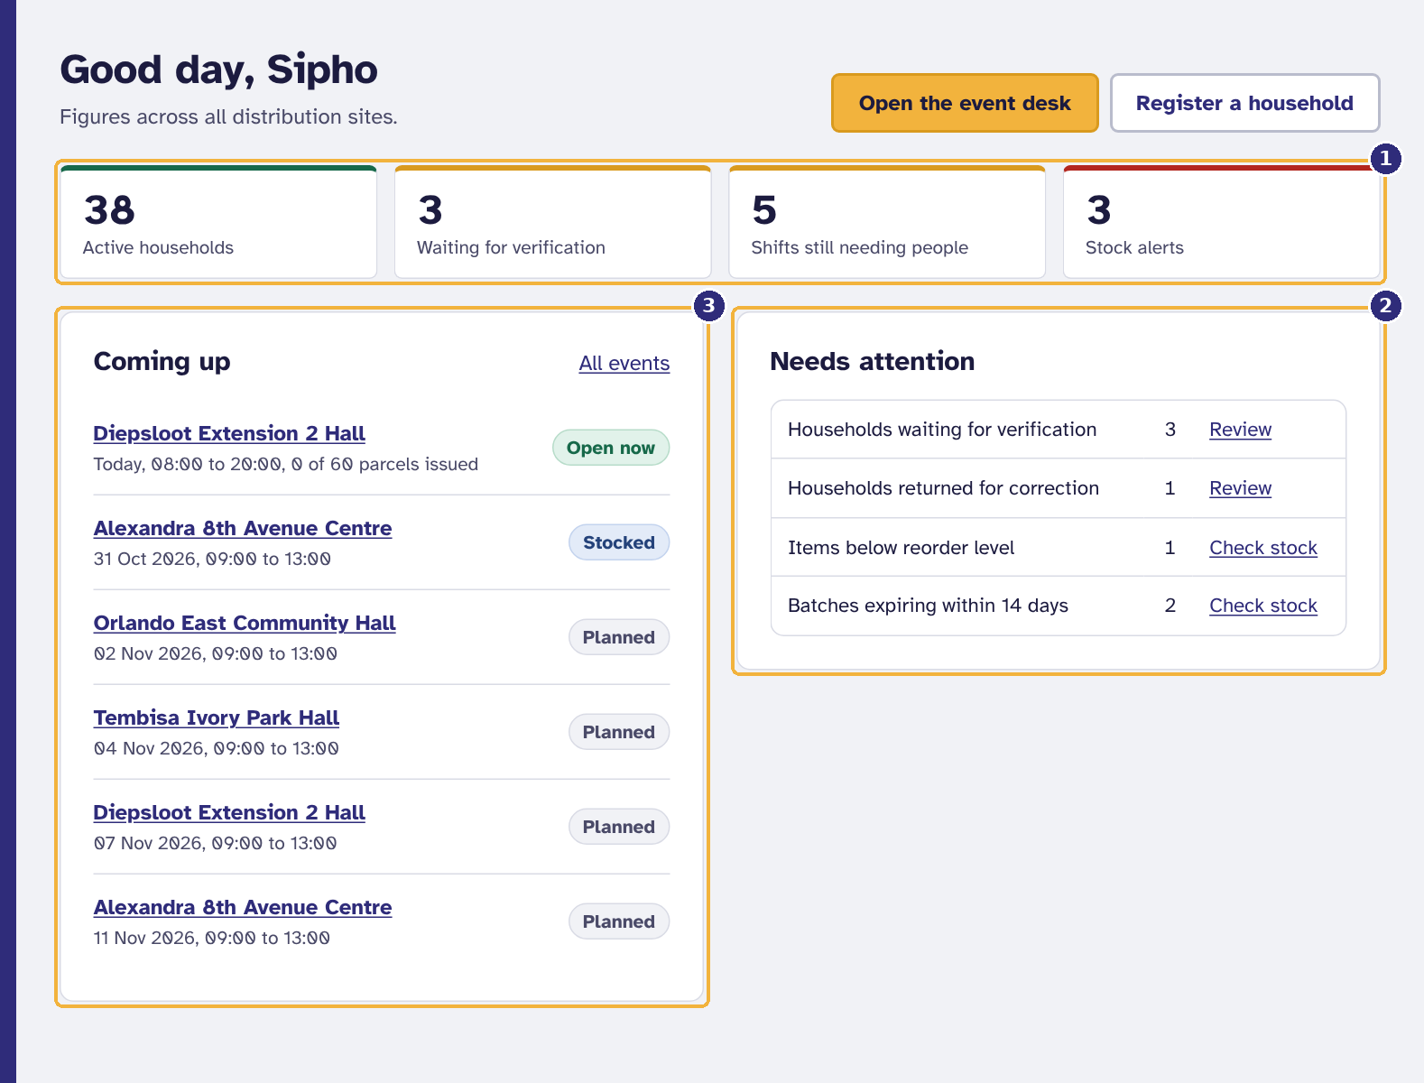
Figure 30. The operations manager's overview: all sites
1 Figures across all sites
2 Households to verify, stock to act on
3 Every site's coming distribution days

6.2 Verifying households
- From Needs attention, select Review next to Households waiting for verification, or filter Households by status.
- Open the household and check the proof of address the coordinator has seen.
- Select Verify household and confirm. The household becomes Active and can collect from now on.
- If something is wrong, select Return for correction and give a reason; the coordinator sees it and resubmits.
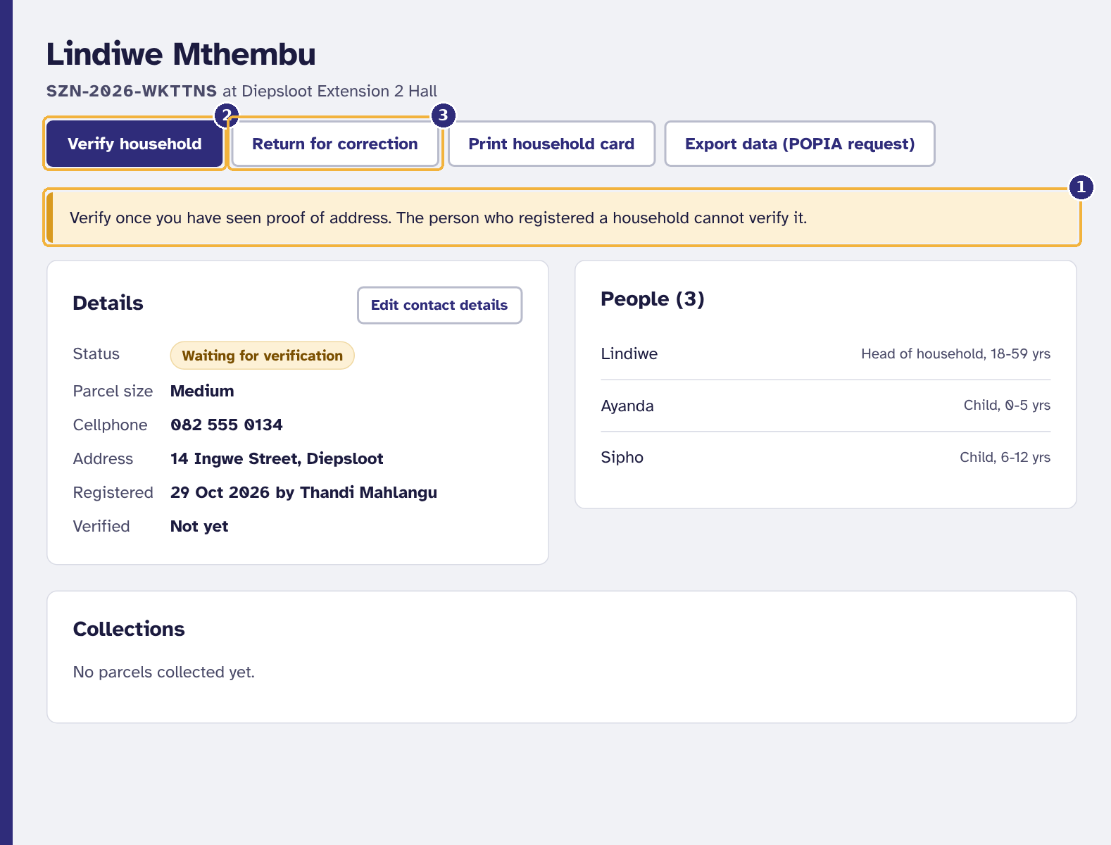
Figure 31. Verifying a household
1 Check proof of address first; you cannot verify a household you registered yourself
2 Verify household
3 Or send it back with a reason

Important. The person who registered a household cannot verify it (four-eyes check). If you registered it yourself, another operations manager must verify it.

6.3 Suspending, reinstating and archiving
- Suspend stops a household collecting while a concern is checked. A reason of at least five characters is required and the household is told it.
- Reinstate makes a suspended household active again.
- Archive ends a registration, for example when a family moves away. The person can register again later.
- Archive inactive households on the Households screen archives every household that has not collected for 12 months (BR-08), after a confirmation.
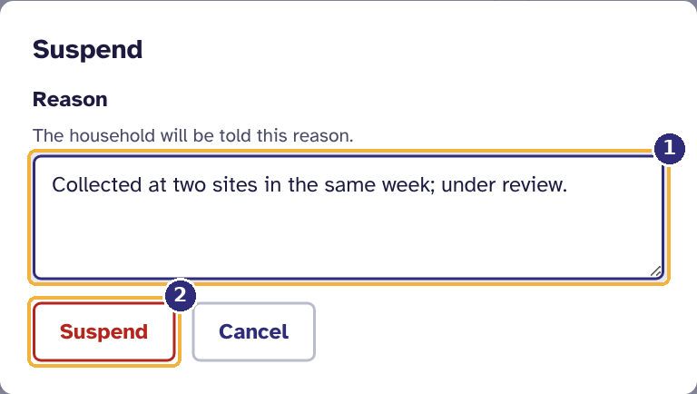
Figure 32. Suspending a household, with a reason
1 The reason (the household is told it)
2 Suspend

Archived households are anonymised 24 months after archiving by an administrator (section 8.4).

A household asks what is held about them
On the household page select Export data (POPIA request). A file with everything held about that household downloads, and the request is recorded in the audit log. Identity numbers are not in it because they are never stored.

6.4 Scheduling a distribution event
- Select Distribution events, then Schedule an event.
- Choose the Site and Date, the Starts and Ends times, the number of Planned parcels (the site's capacity is shown) and the Volunteers needed to open.
- Select Schedule event.
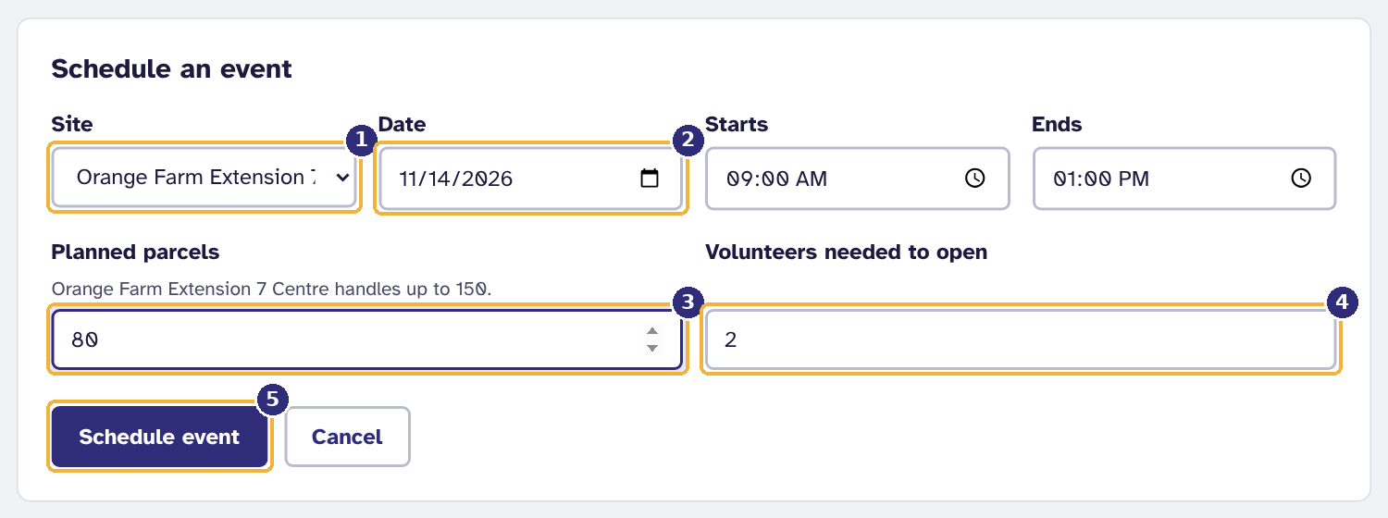
Figure 33. Scheduling a distribution event
1 Site
2 Date
3 How many parcels to prepare
4 Volunteers who must check in before it can open
5 Schedule event

On the event page:
- Add a shift publishes a volunteer shift with times, the number of people needed and what they will do. Volunteers can sign up straight away.
- Mark as stocked confirms that parcels are packed. If stock is short, the shortfall per item is listed instead.
- Cancel event cancels a planned or stocked event with a reason.
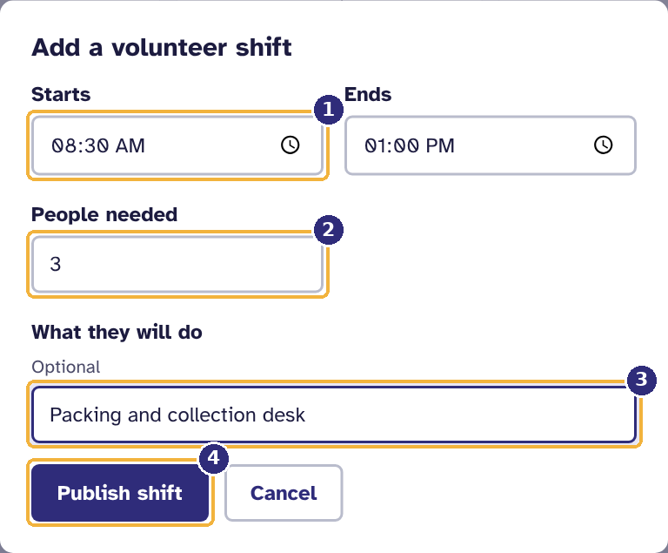  Figure 34. Adding a volunteer shift to an event  1 Start and end times  2 How many volunteers  3 What they will do  4 Publish: volunteers can sign up straight away | 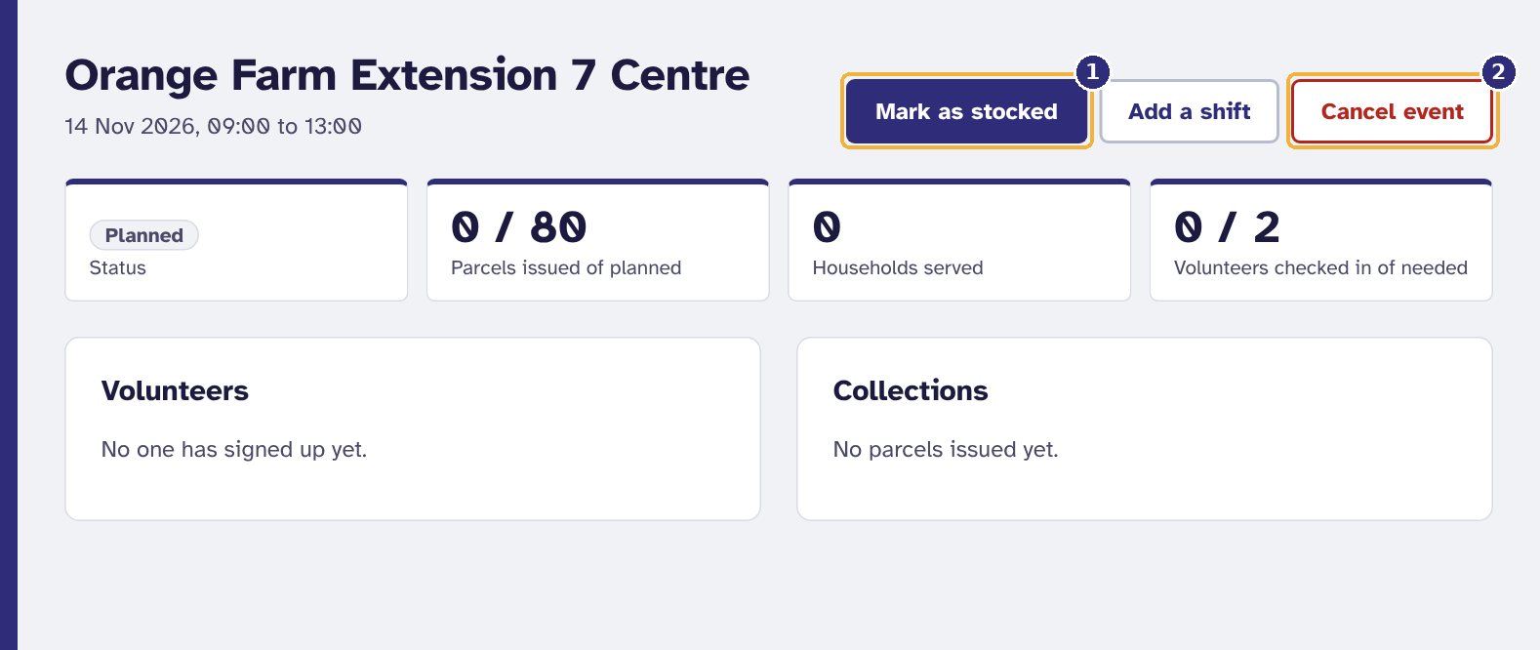  Figure 35. A planned event: mark it stocked when the parcels are packed  1 Mark as stocked  2 Cancel, with a reason

6.5 Donations and receipts
- Select Donations, then Capture a donation.
- Choose the Donor (or New donor... to add one) and the date Received on.
- Choose Money and type the amount, or Goods (in kind) and add each item with its Quantity and Best before date. Use Add another item for more lines.
- Select Save donation. Goods go straight into stock as batches that remember their donor, and a numbered receipt is created.
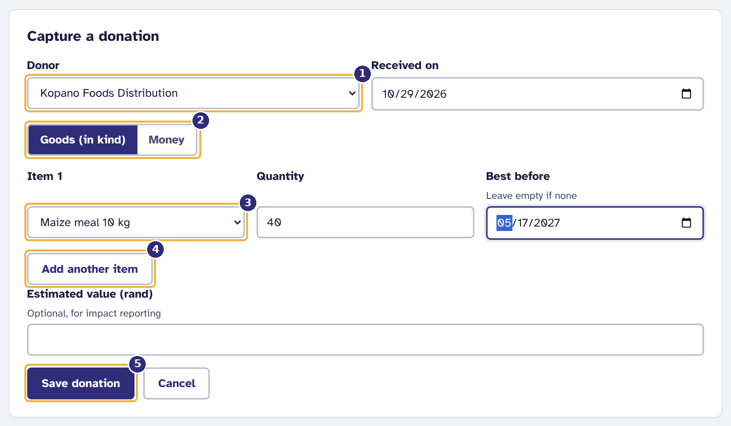
Figure 36. Capturing a donation of goods
1 Who gave it (or add a new donor)
2 Cash, or goods
3 Each item, with quantity and best-before date
4 More items
5 Save: the goods go into stock and a receipt is made

Open any donation's receipt number to view, print or save the receipt as a PDF. Donors can open their own receipts in their portal.
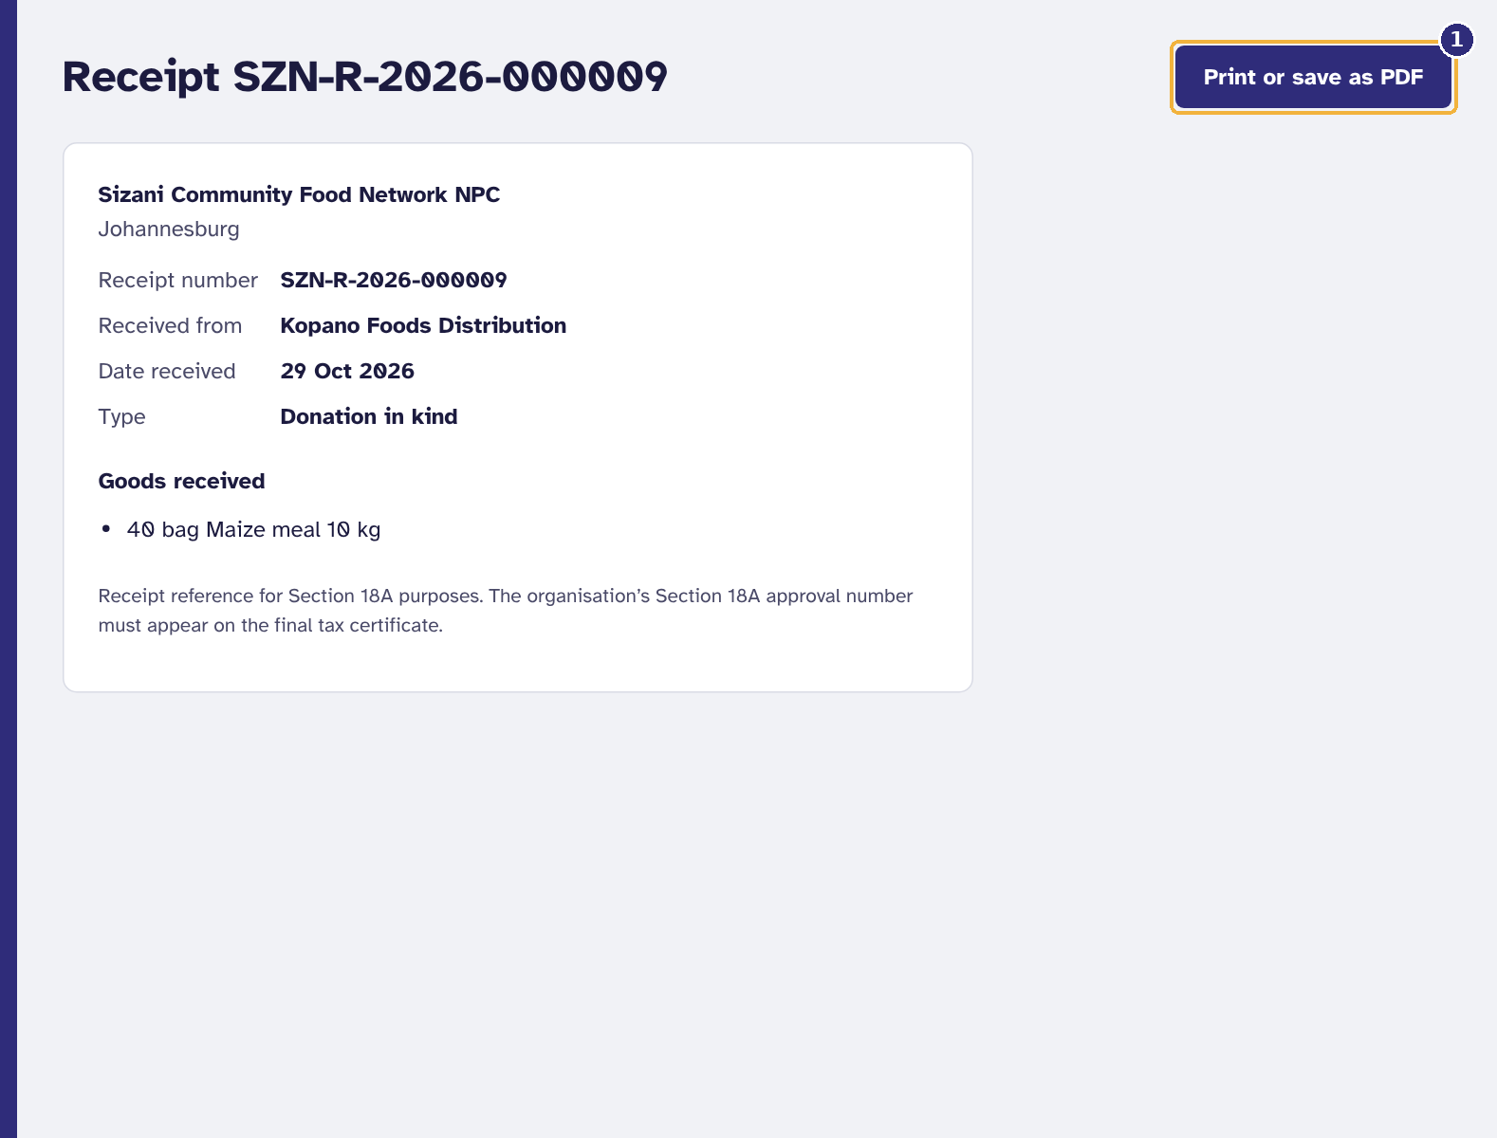
Figure 37. A donation receipt
1 Print it or save it as a PDF

6.6 Stock
Stock shows what can still be issued. Expired stock is never counted and never issued; parcels always draw from the batch that expires first.
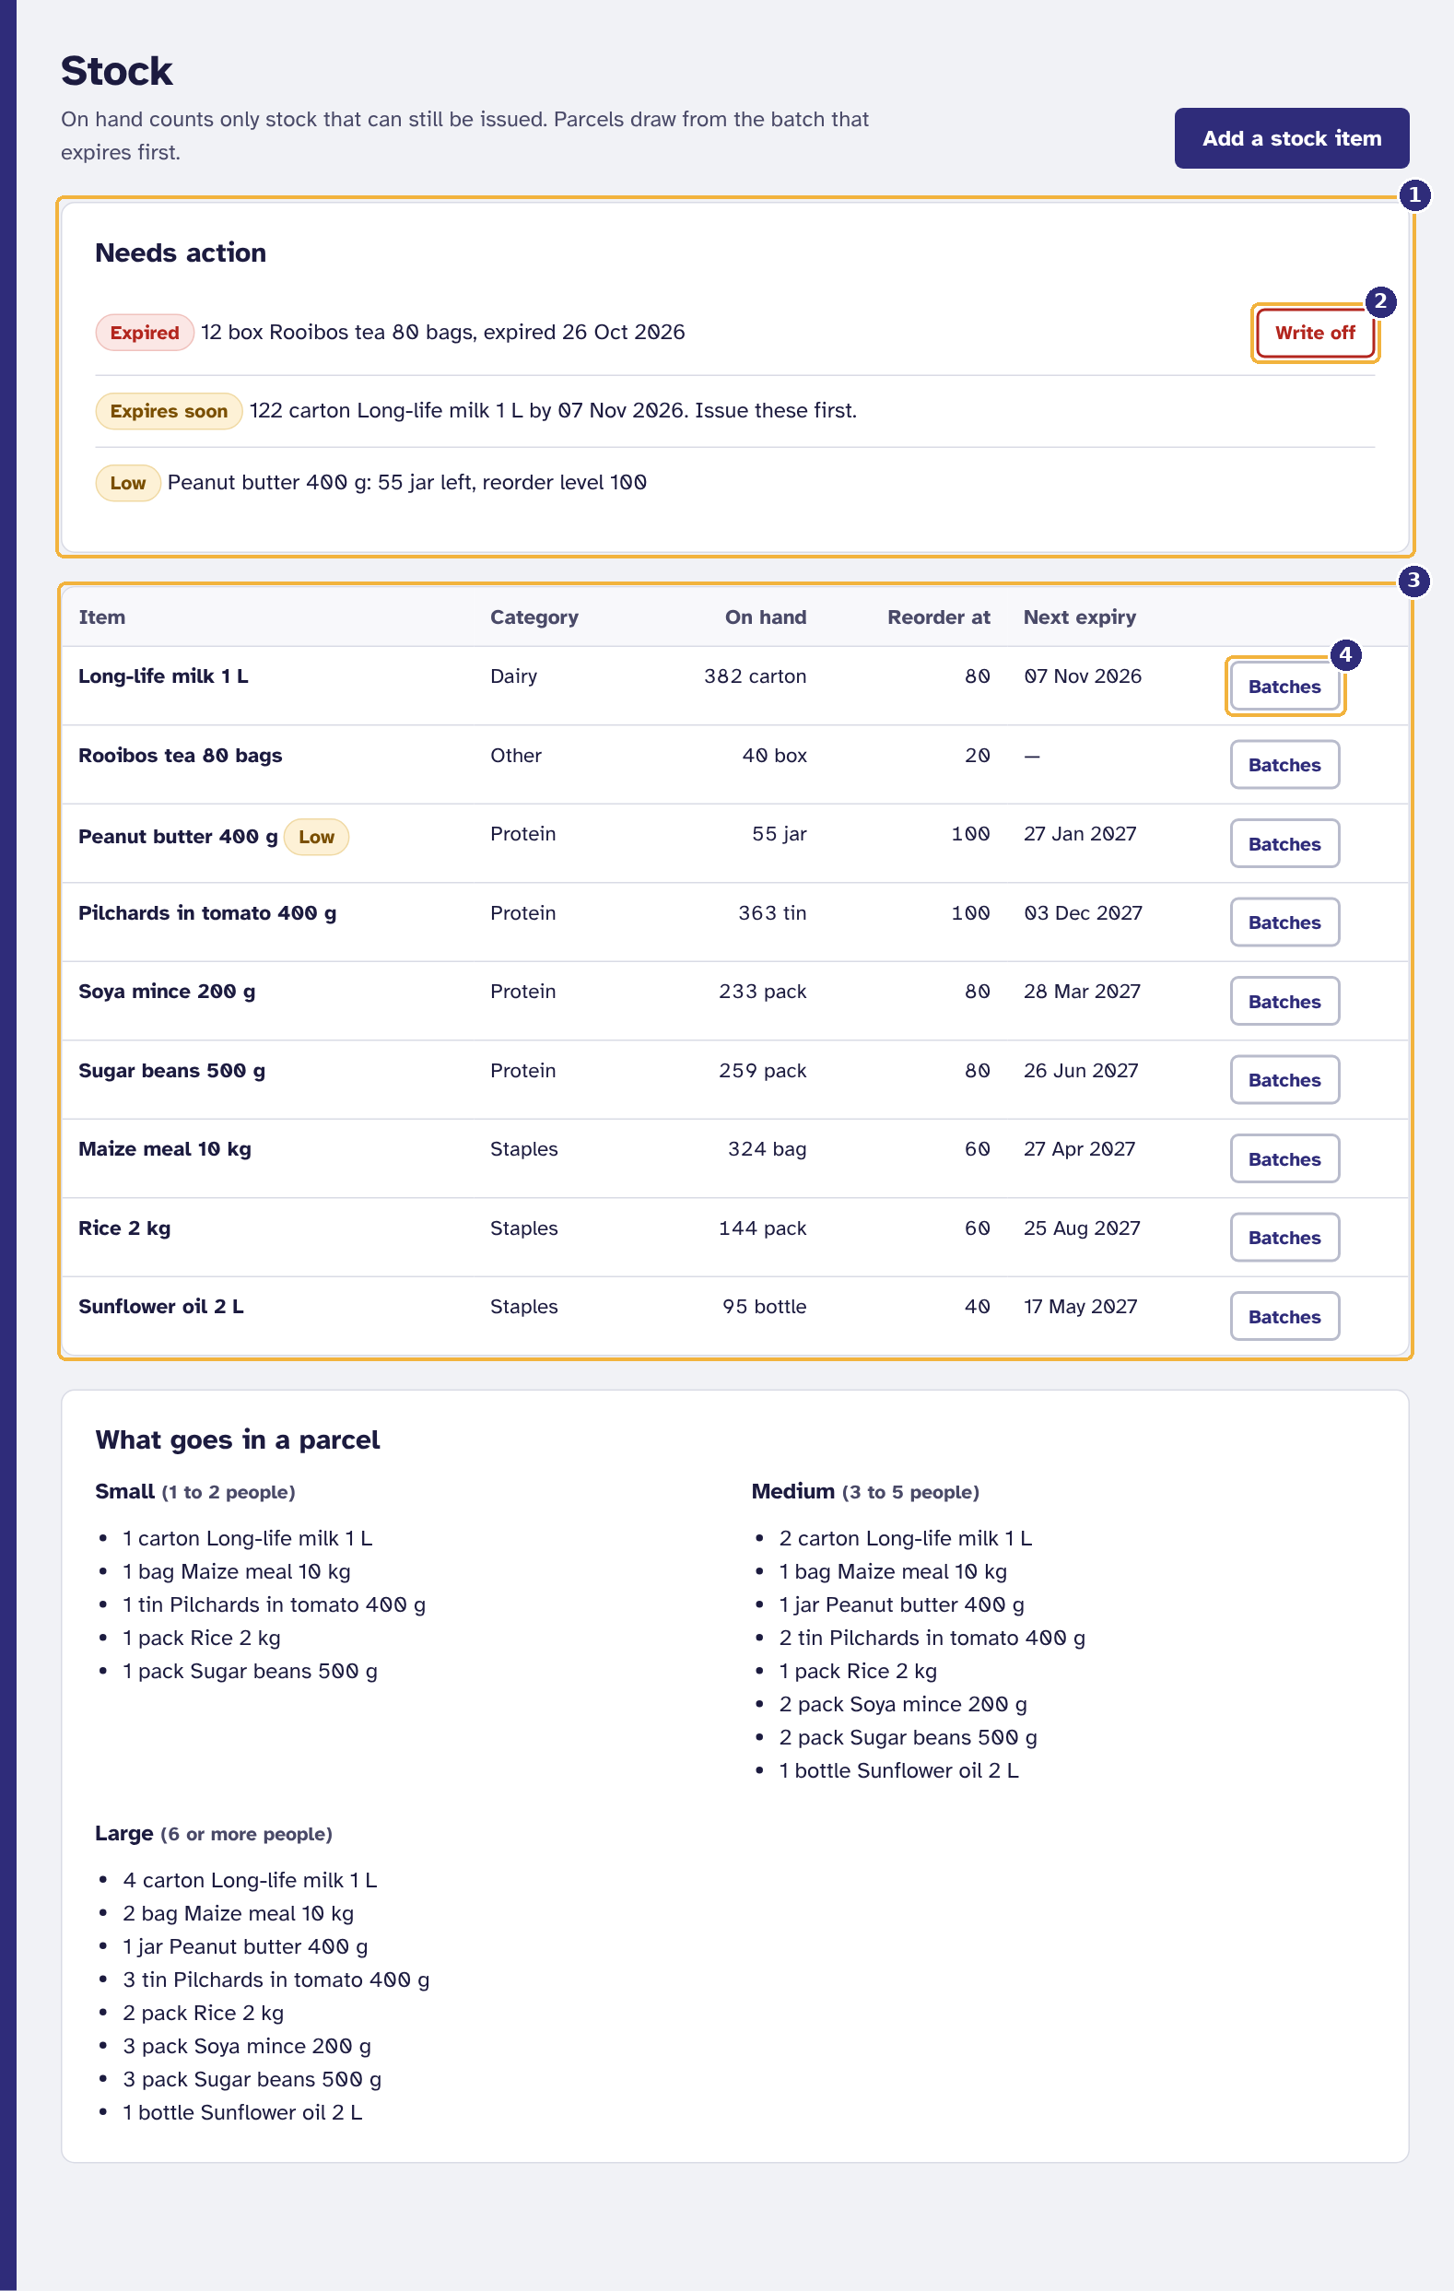
Figure 38. Stock
1 Expired, expiring and low stock
2 Write off expired stock
3 What is on hand, item by item
4 See the batches behind an item

- Needs action lists expired batches, batches expiring within 14 days, and items below their reorder level.
- Write off removes an expired batch with a reason; the write-off is kept in the stock ledger.
- Batches shows each batch behind an item: where it came from, what is left and when it expires.
- Add a stock item adds a new kind of item, with its category, unit and reorder level.
- What goes in a parcel shows the contents of each parcel size.
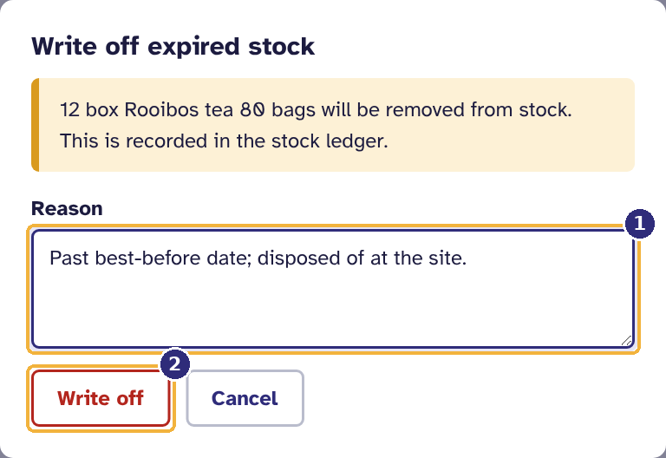  Figure 39. Writing off expired stock  1 The reason  2 Write off | 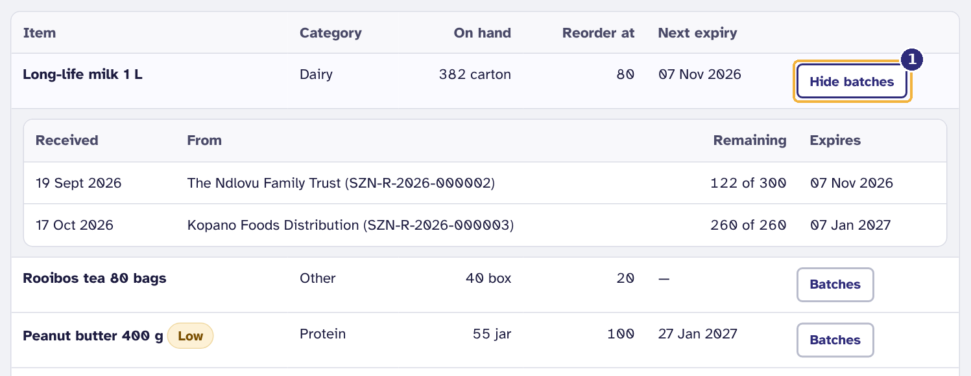  Figure 40. The batches behind one item  1 Hide again

6.7 The monthly report
- Select Reports.
- Choose the Month. The totals and the site-by-site table update. Households that visited more than one site are counted once.
- Select Download CSV for a spreadsheet, or Print or save as PDF for the board.
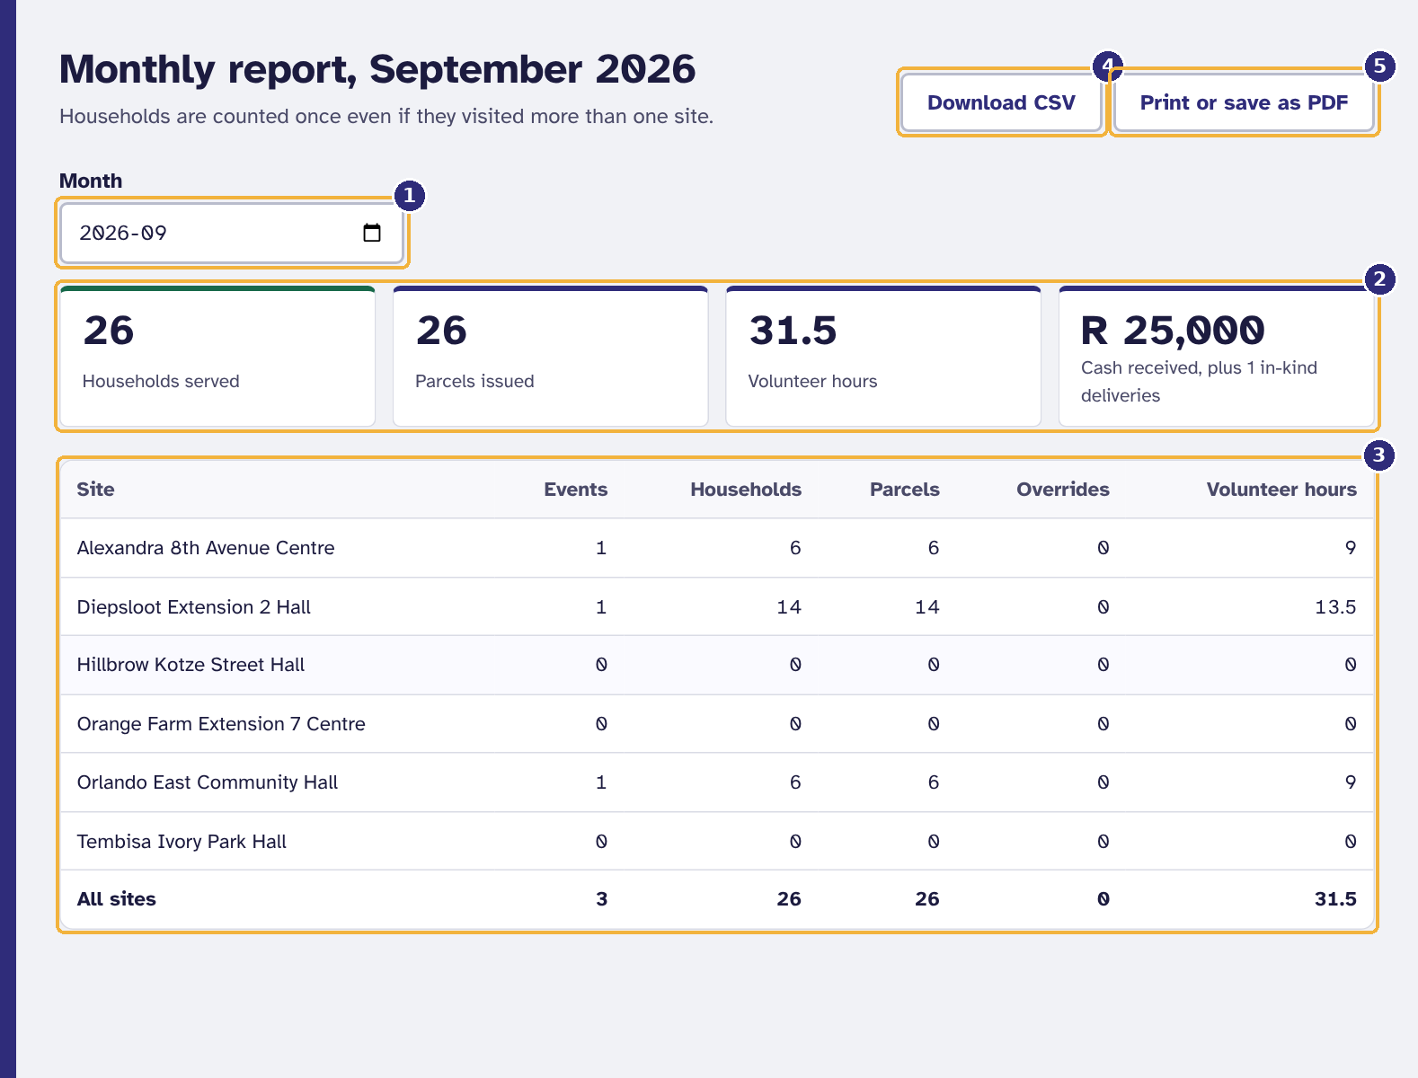
Figure 41. The monthly report
1 Choose the month
2 The totals
3 Site by site
4 Download for a spreadsheet
5 Print, or save as PDF for the board

7. Donors
If your organisation donates to Sizani, an administrator can give you a donor account. You see only your own donations; nobody else's.
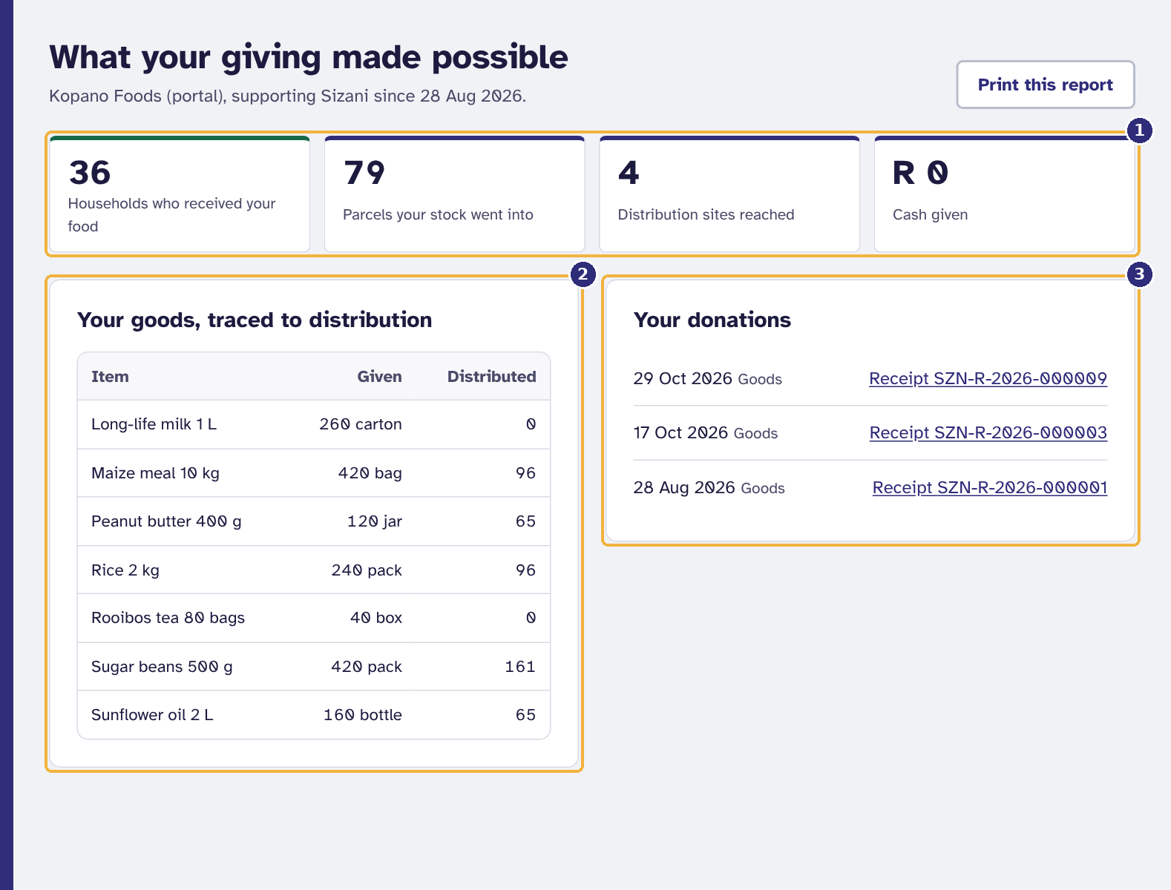
Figure 42. What a donor sees
1 What your giving made possible
2 Each item you gave, and how much has been handed out
3 Your donations and their receipts

- The figures show how many households received food from your donations, how many parcels your stock went into, and how many sites it reached.
- Your goods, traced to distribution shows each item you gave and how much has been handed out so far.
- Select a receipt under Your donations to view it, then Print or save as PDF. Print this report prints the whole page.

8. Administrators
As an administrator you manage who can use the system, the distribution sites, the audit trail, and the removal of personal data when it is no longer needed. Create your recovery codes first (section 2.6); your start page reminds you until you have.
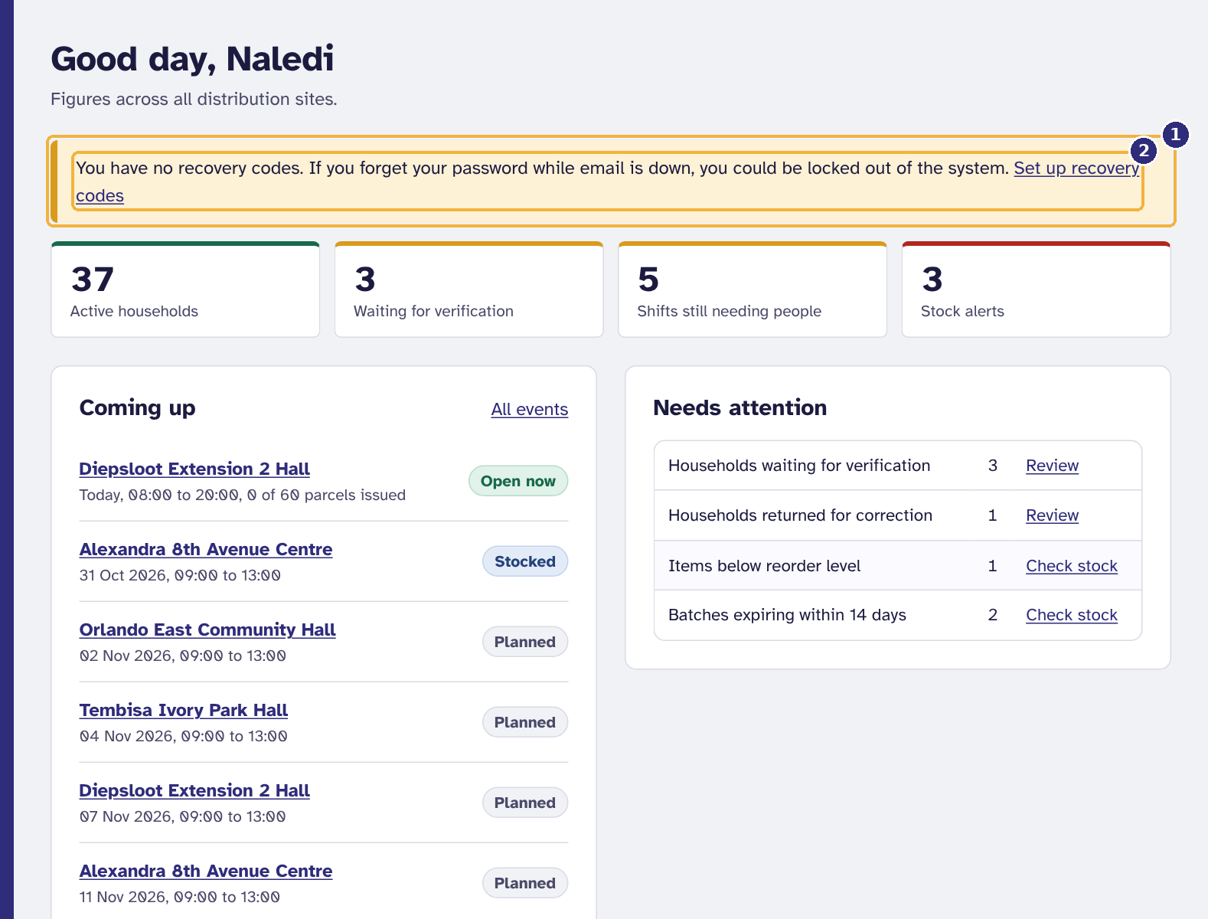
Figure 43. The reminder administrators see until they have recovery codes
1 Reminder: no recovery codes yet
2 Go straight to My account to create them

8.1 Adding a user
- Select Users.
- Under Add a user, type the Full name, Email and, optionally, Cellphone number.
- Choose the Role. A site coordinator also needs a Site; a donor account needs a Donor record.
- Select Create account.
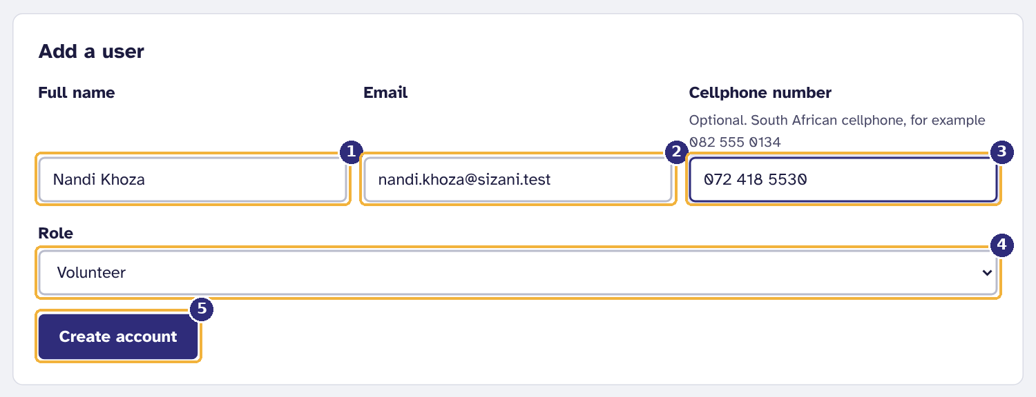
Figure 44. Adding a user
1 Full name
2 Email address: the activation link goes here
3 Cellphone number (optional, South African)
4 Role: decides which screens they see
5 Create the account

The person receives an activation link by email to choose their own password (section 2.3). Nobody, including you, ever sees their password. When email is not set up, the link is shown to you instead: give it to the person yourself, in person or by phone.
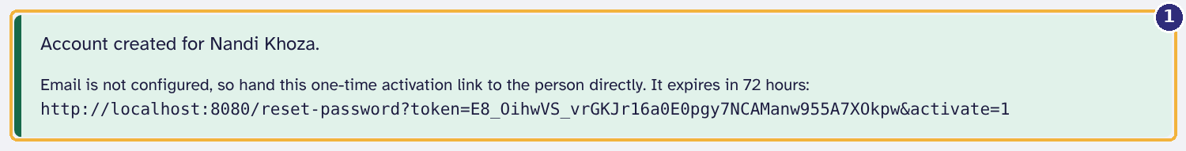
Figure 45. When email is not set up, the activation link is shown to hand over
1 Give this link to the person, in person or by phone

8.2 Helping someone who is locked out
Select Send reset link next to the person on the Users screen. They receive a link valid for 24 hours, or, without email, the link is shown for you to pass on. This also works for another administrator, which is why there should always be at least two.
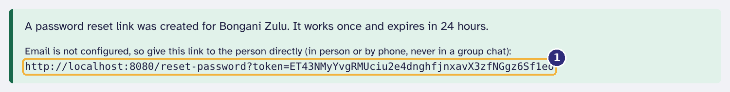
Figure 46. Sending a reset link to someone who is locked out
1 The link to pass on: it works once and lasts 24 hours

8.3 When someone leaves
When a volunteer retires or a staff member resigns, offboard them on the same day. Removing their personal data is a separate, second step (section 8.4), so a mistake can still be undone.
- On Users, select Offboard next to the person.
- Read what will happen, choose Why are they leaving? (Retired, Resigned, Contract or role ended, or Other) and select Offboard.
- Read the confirmation. It says how many upcoming shift places were freed, warns you if a site has been left without a coordinator, and gives the date by which to erase the personal data.
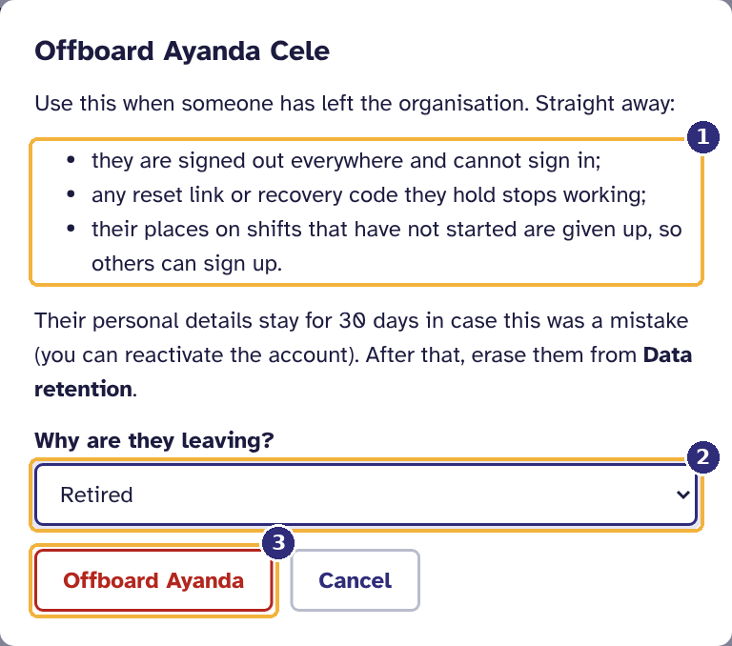
Figure 47. Offboarding someone who has left
1 What happens straight away
2 Why they are leaving
3 Offboard

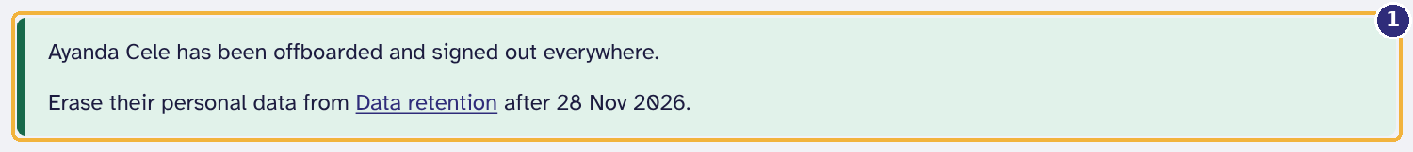
Figure 48. After offboarding
1 What was done, and when to erase the personal data

Straight away the person is signed out everywhere, cannot sign in, and any reset link or recovery code they hold stops working. Within 30 days you can still select Reactivate if this was a mistake. You cannot offboard yourself, and the last active administrator cannot be offboarded.

8.4 Data retention: removing personal data for good
POPIA requires personal information to be kept only as long as it is needed. Data retention shows what is due and removes it.
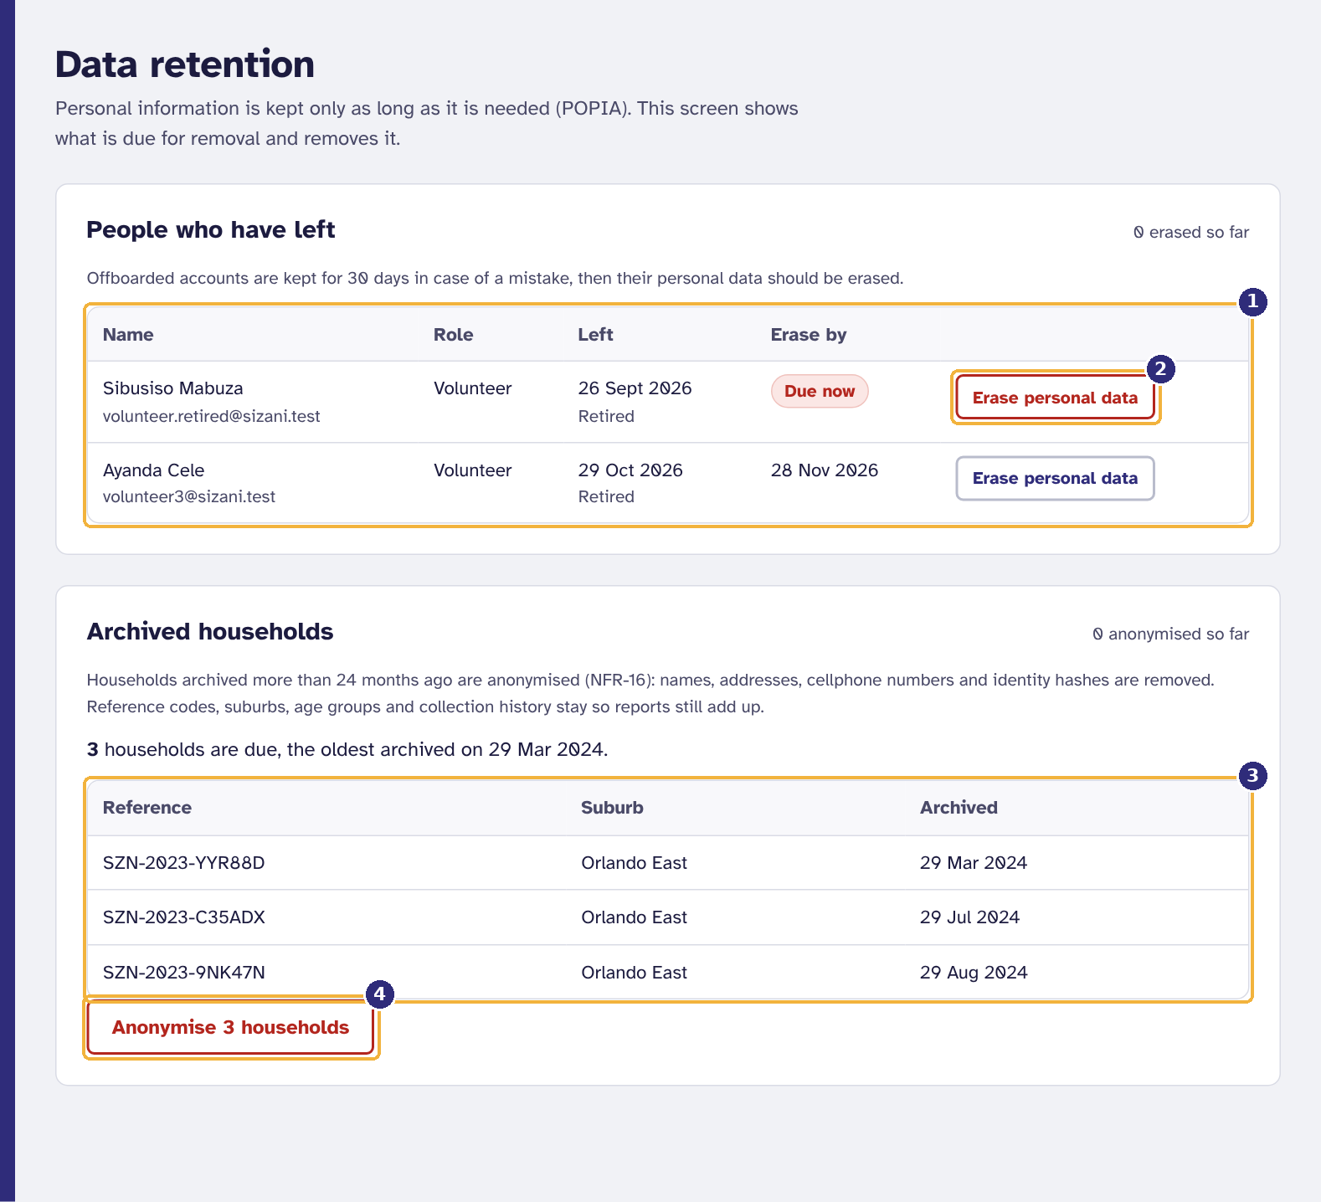
Figure 49. The Data retention screen
1 People who have left, with the date their data must be erased by
2 Erase one person's personal data
3 Households archived more than 24 months ago
4 Anonymise them all at once

Erasing a person who has left
- Under People who have left, find the person. Due now means the 30-day grace period is over.
- Select Erase personal data.
- Type the person's email address exactly to confirm, and select Erase permanently.
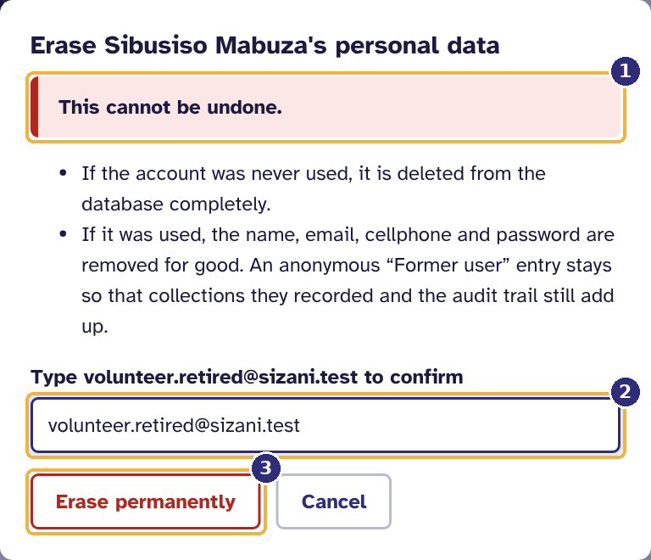
Figure 50. Erasing a leaver's personal data
1 This cannot be undone
2 Type their email address to confirm
3 Erase permanently

What happens next depends on whether the account was ever used:
- Never used (for example, an account that was never activated): it is deleted from the database completely.
- Used (they signed in, recorded collections or worked shifts): their name, email, cellphone number and password are removed for good. An anonymous "Former user" entry stays, because the collections they recorded and the audit trail must still add up. Nothing in it identifies the person.
Warning. Erasing cannot be undone, not even by restoring a backup through the normal rollback procedure.

Anonymising archived households (NFR-16)
- Under Archived households, check the list of households archived more than 24 months ago.
- Select Anonymise and confirm with Anonymise now.
Names, addresses, cellphone numbers and identity codes are removed. Reference codes, suburbs, age groups and collection history stay, so past reports still add up. The household page then says when its details were removed.

8.5 Distribution sites
Sites lists the six distribution sites. Use Add a site for a new one, with its name, suburb and the most parcels it can handle per event. Close site stops new events being scheduled there without losing its history; Reopen site reverses it.
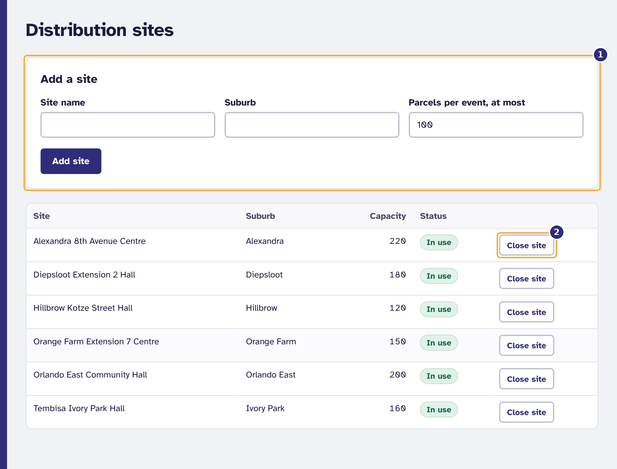
Figure 51. Distribution sites
1 Add a site
2 Close a site that is no longer used

8.6 The audit log
Audit log shows every change to beneficiary, user and stock records, newest first: who did it, when, and what. Use Show to see one kind of record. Entries cannot be edited or deleted by anyone; the database refuses. Personal details are not copied into it, only which fields changed.
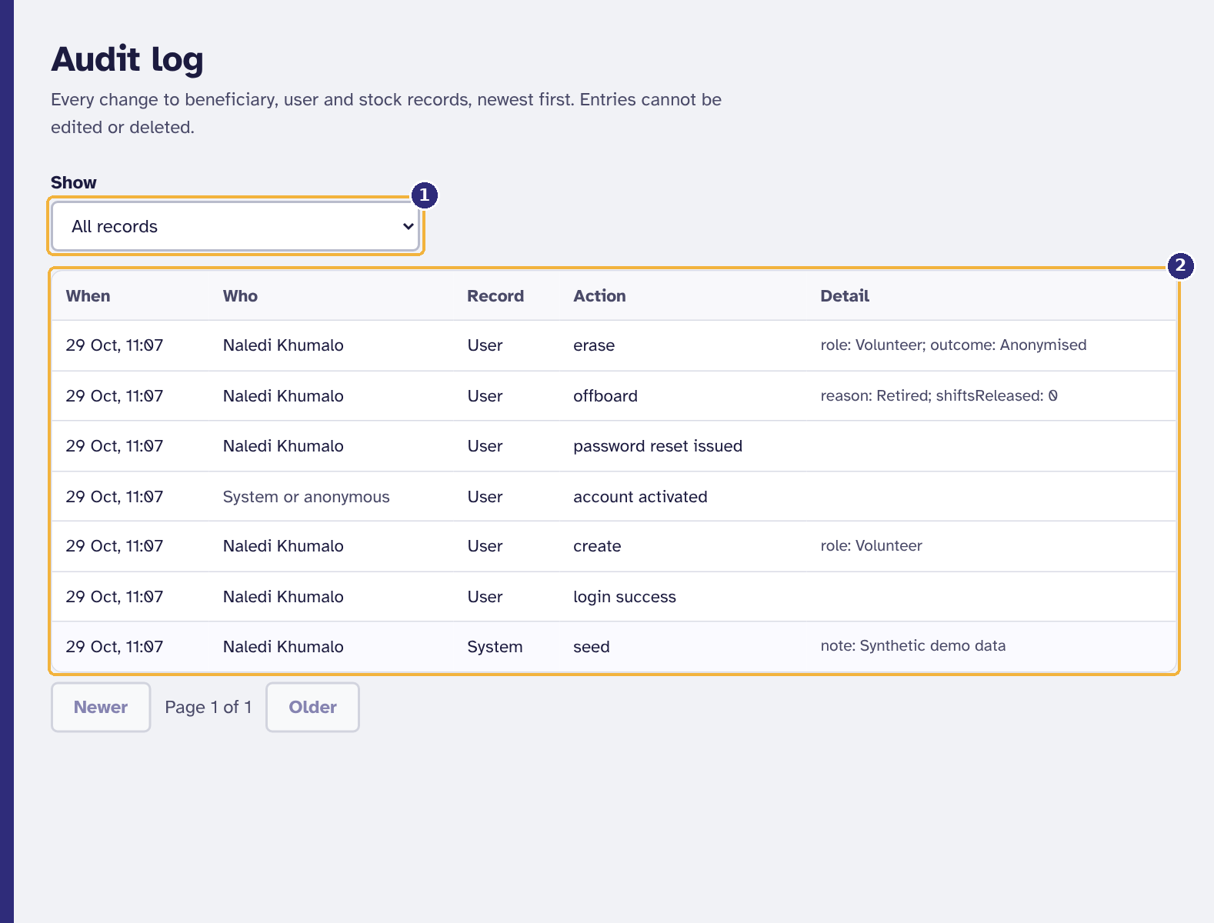
Figure 52. The audit log
1 Show one kind of record
2 Who did what, and when: newest first

9. When something goes wrong

9.1 Messages and what to do
Every message in SizaniConnect says what happened and what to do next. The most common ones:
Table 7. Messages, their meaning and what to do
Message | What it means | What to do
Email or password is incorrect. | The email or password does not match an active account. | Check for typing mistakes and Caps Lock. After five tries the account locks for 15 minutes; see section 2.7.
Too many failed attempts. Try again after 15 minutes. | The account is locked to stop password guessing. | Wait 15 minutes, or ask an administrator for a reset link.
Your session has expired. Sign in again. | You were signed in on this device more than seven days ago. | Sign in again.
Your session was ended for security reasons. Sign in again. | Your sign-in was used from two places at once, so both were ended. | Sign in again, then change your password (section 2.6).
This link has expired or has already been used. | A reset or activation link is single-use and time-limited. | Request a new link (section 2.7), or ask an administrator.
Some fields need attention. | One or more fields are wrong; each has its own message underneath. | Correct the fields marked in red and save again.
This person is already registered ... | The ID number belongs to a live household (BR-01). | Open the existing household instead (section 3.2).
A household must be verified by someone other than the person who registered it. | Four-eyes check. | Ask another operations manager to verify it.
Your role does not allow this action. | The screen or action belongs to another role. | Ask someone with the right role, or an administrator if your role is wrong.
Can't reach SizaniConnect. Check your mobile data or Wi-Fi. | No connection to the server. | Check the signal; the page retries reads once by itself.
The connection dropped ... may or may not have been saved. | A save was sent but no answer came back. | Check, or at the desk simply press the button again (section 4.5).
The server took too long to answer. | No answer within 20 seconds, often a weak signal. | Move to better signal and try again.
The system cannot reach its database right now, so nothing was saved. | The database is restarting or unreachable. | Try again in a minute. If it lasts more than five minutes, tell IT support.
The database is out of storage space, so nothing can be saved. | Storage is full; pages still show but nothing saves. | Tell IT support straight away (Appendix A.8). Use the paper register meanwhile.
The system is very busy. / The database took too long to answer. | A short overload. | Wait a few seconds and try again.
Too many requests. Wait a minute and try again. | Protection against automated traffic. | Wait a minute.
Something went wrong on our side. | An unexpected error. It has been logged. | Try again. If it keeps happening, tell your administrator what you were doing.

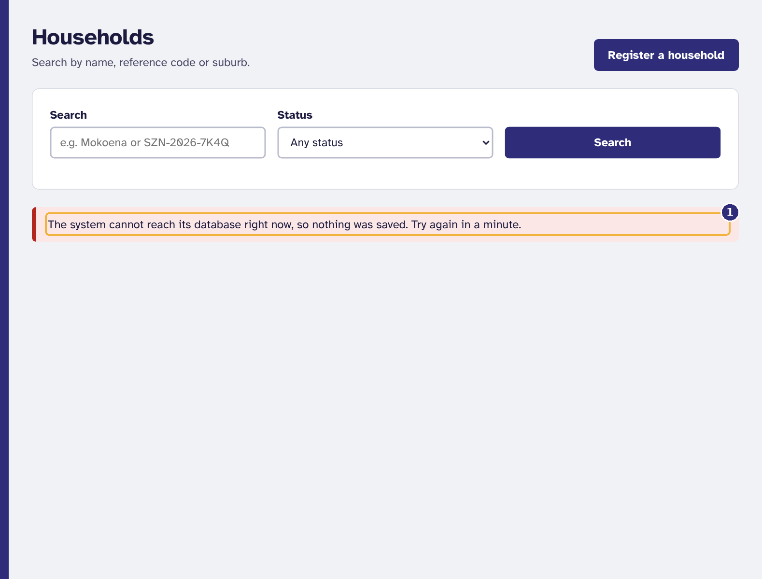
Figure 53. How a message from the server appears
1 What happened, and what to do

9.2 Frequently asked questions
I cannot see a screen that a colleague can see.
The menu shows only the screens for your role. If your role is wrong, ask an administrator to change it.
The event desk says no event is open.
The site coordinator opens the event once enough volunteers have checked in. Check that you have checked in under Shifts.
The site coordinator cannot open the event.
Open event needs the event to be stocked and the minimum number of volunteers checked in. The event page shows how many have checked in of the number needed.
Check in now does not appear.
Check-in opens one hour before the shift starts, and only for a shift you signed up for.
I cannot withdraw from a shift.
Withdrawing closes 24 hours before the start. Phone your site coordinator so they can find cover.
A household has lost its card.
Find the household under Households and print a new card (section 3.4). The code stays the same.
A household is registered at the wrong site.
Households collect at their own site. Ask an operations manager to archive the wrong registration so the person can be registered at the right site.
The camera does not open.
Allow the camera for the site in the browser settings. Camera scanning needs the secure address (https). Typing the code always works.
Why is my cellphone number refused?
Only South African cellphone numbers are accepted: 10 digits starting 06, 07 or 081 to 085. See section 3.2.
Can I undo an offboarding?
Yes, within 30 days: select Reactivate on Users. Once the personal data is erased, it cannot be undone.
Who can see beneficiaries' details?
Staff roles only. Volunteers at the desk see only the name, number of people and suburb; donors see only totals.
Does SizaniConnect work offline?
No. It needs a connection, but it tells you at once when the connection is lost and never records a collection twice. Keep the paper fallback register for long outages.

10. Glossary
Table 8. Terms used in this guide
Term | Meaning
Audit log | A permanent record of who changed what and when. It cannot be edited.
Batch | A quantity of one stock item received together, with one expiry date and, for donations, one donor.
Distribution event | One distribution day at one site, from planning to reconciliation.
Event desk | The screen that decides whether a household may collect, and records it.
FEFO | First expiry, first out: parcels always use the stock that expires soonest.
Household card | A bank-card-size card with the household's QR code and reference code.
Offboarding | Stopping the account of someone who has left. Their data is erased later.
Override | A second parcel at one event, approved by a site coordinator with a reason.
POPIA | The Protection of Personal Information Act, 4 of 2013.
Reconciliation | Comparing the parcels physically counted after an event with those recorded.
Recovery code | A single-use code that lets you choose a new password without email.
Reference code | A household's unique code, for example SZN-2026-7K2QX9.
Verification | An operations manager confirming a new household's details before it can collect.

Appendix A. Technical setup (for IT support)
This appendix is for whoever installs, runs or supports SizaniConnect. The source code is at https://github.com/ByronBousfield1/sizaniconnect; docs/DEPLOYMENT.md there has the full Azure procedure and runbook.

A.1 Requirements
Table 9. Software needed
Component | Version | Used for
Node.js | 22 LTS | Running and building the API and the web app
PostgreSQL | 16 | The database (any managed PostgreSQL 16 service works)
Git | Any recent | Getting the code
Docker Desktop (optional) | Any recent | Running everything with one command
Azure subscription (for hosting) | Azure for Students is enough | App Service B1 and PostgreSQL Flexible Server B1ms

A.2 Running it with Docker (quickest)
- Install Docker Desktop and start it.
- Get the code: git clone https://github.com/ByronBousfield1/sizaniconnect.git then cd sizaniconnect.
- Run docker compose up --build and wait for "SizaniConnect API listening".
- Open http://localhost:8080 and sign in with a demonstration account below.
Table 10. Demonstration accounts (password Sizani-Demo-2026), also on the live site
Email | Role
coordinator@sizani.test | Site coordinator, Diepsloot
volunteer@sizani.test | Volunteer
ops@sizani.test | Operations manager
donor@sizani.test | Donor (Kopano Foods)
admin@sizani.test | Administrator

A.3 Running it without Docker
- Install Node.js 22 and PostgreSQL 16, and create an empty database.
- In api: copy .env.example to .env and set DATABASE_URL; run npm install then npm run dev. Migrations and demonstration data load on first start.
- In web: run npm install then npm run dev, and open http://localhost:5173.

A.4 Configuration settings
Table 11. Application settings
Setting | Required | Purpose
DATABASE_URL | Yes | PostgreSQL connection string
DATABASE_SSL | Production | true to require TLS with certificate checks
JWT_SECRET | Production | At least 32 random characters; signs sign-in tokens
ID_HASH_PEPPER | Production | At least 32 random characters; keys the identity-number hash and recovery codes. Never change it after go-live, or duplicate checks stop working
APP_BASE_URL | Yes | The public address, used in links
SMTP_URL, MAIL_FROM | No | Email for activation, reset and notices. Without them links are shown on screen
SEED_DEMO_DATA, SEED_DEMO_PASSWORD | No | Load demonstration data into an empty database
USER_ERASURE_GRACE_DAYS | No | Days before an offboarded account is due for erasure (default 30)
HOUSEHOLD_RETENTION_MONTHS | No | Months after archiving before anonymisation (default 24, NFR-16)
SKIP_MIGRATIONS | No | true only during a database rollback (A.8)
RATE_LIMIT_PER_MINUTE, AUTH_RATE_LIMIT_PER_MINUTE | No | Request limits per address (defaults 1,000 and 10)

A.5 Deploying to Azure
- In Azure Cloud Shell, run SUFFIX=yourname7315 bash infra/azure-setup.sh. It creates the App Service plan, the production and staging web apps and the database, with TLS, a firewall that admits only the web apps, storage auto-grow and a health check.
- In GitHub, add the variables AZURE_WEBAPP_NAME_PRODUCTION and AZURE_WEBAPP_NAME_STAGING, the secrets AZURE_PUBLISH_PROFILE_PRODUCTION and AZURE_PUBLISH_PROFILE_STAGING, and a production environment with a required reviewer.
- Push the develop branch to deploy to staging, and main to deploy to production after approval. The pipeline runs every test first and checks the health endpoint afterwards.

A.6 Checking that it works
- Health check: open /api/v1/health. "status":"ok" means the database is reachable and writable; degraded means read-only (storage full); down means unreachable.
- Automated tests: npm test in api (unit and integration tests against PostgreSQL), npm test in web, and npx playwright test in e2e (browser and accessibility tests).

A.7 Emergency administrator access
If every administrator is locked out, no recovery code is left and email is not working, someone with access to the Azure portal can issue a one-time link:
- In the Azure portal open the production web app, then Development Tools, SSH, Go.
- Run cd /home/site/wwwroot then node dist/db/cli.js recover-admin admin@example.org with the administrator's email.
- Give the printed link to the administrator in person or by phone. It works once, for 30 minutes, only for an active administrator account, and the use is recorded in the audit log.

A.8 Backups, failures and rollback
- The database is backed up automatically every day and kept for seven days, with point-in-time restore.
- If the health check reports degraded (storage full), raise the storage size under the database server's Compute + storage in the portal; saving resumes within a minute.
- To roll back a release, run the Deploy workflow in GitHub on the previous release tag. Release v1.1.0 changed the database in a way v1.0 cannot use, so going back to v1.0 also needs node dist/db/cli.js rollback --to 001_initial_schema.sql, with SKIP_MIGRATIONS=true set first. docs/DEPLOYMENT.md, section 7, gives every step.

Appendix B. Event desk quick card
Print this page for the desk.
Table 12. The event desk on one page
Step | What to do
1. Check in | Shifts → Check in now (from one hour before your shift).
2. Open the desk | Menu → Event desk. No event open? Ask the site coordinator.
3. Find the household | Scan the card (Scan card with camera, or a barcode scanner), or type the code and press Find.
4. Read the verdict | Green: eligible, shows the parcel size. Red: do not hand over; refer to the coordinator.
5. Record, then hand over | Record collection, then hand over exactly the size shown.
Card will not scan | Flatten it, better light, scan again. Still not? Type the code printed under the QR code.
Signal dropped while saving | Press Record collection again when signal returns. It can never record twice.
Already collected | Never hand over a second parcel yourself. Only the site coordinator can approve one.

