# Object 1. Water Tanks

## Description

In the water industry, tanks play a fundamental role in the storage, treatment, and distribution of water. These tanks are structures designed to contain large volumes of water and are used in a variety of applications, ranging from potable water supply systems to wastewater treatment plants.

|  |  |  |
| --- | --- | --- |
| **Nodes** | **Alarms** | **Maintenance** |
| Water Level | Nivel Alto: 90  Nivel Bajo: 10 |  |
| Pressure | Presión Alta: 80psi  Presión Baja: 20psi |  |
| Temperature | Temperatura Alta:40ºC  Temperatura Baja:5ºC |  |
| pH | pH Alto: 8.5  pH Bajo: 6.5 |  |
| Water flow | Caudal Alto:500 l/min  Caudal Bajo:50 l/min |  |
| Clorine Level | Nivel Cloro Alto: 0.2ppm  Nivel Cloro Bajo: 2ppm |  |
| Electrical Conductivity | Conductividad Alta: 1500 µS/cm.  Conductividad Baja: 500 µS/cm. |  |

## Appearance

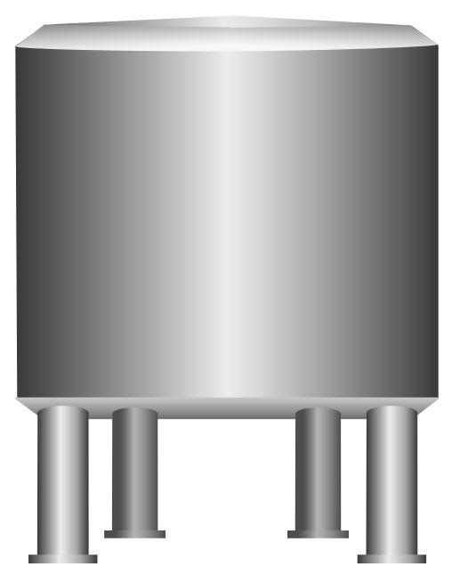

**Option 1.** Water Tank 1

## Object Features