# Object 1. Water Tanks

## Description

In the water industry, tanks play a fundamental role in the storage, treatment, and distribution of water. These tanks are structures designed to contain large volumes of water and are used in a variety of applications, ranging from potable water supply systems to wastewater treatment plants.

|  |  |  |
| --- | --- | --- |
| **Nodes** | **Alarms** | **Maintenance** |
| Water Level | High Level: 90  Low Level: 10 | Tank Overal Inspection |
| Pressure | High Pressure : 80psi  Low Pressure : 20psi | Tank Cleaning |
| Temperature | High Temperature:40ºC  Low Temperature:5ºC | Tank Coating and Painting |
| pH | High pH: 8.5  Low Bajo: 6.5 | Overflow and Ventilation Inspection |
| Water Flow | High Flow:500 l/min  Low Flow:50 l/min | Valve and Fitting Maintenance |
| Chlorine Level | High Chlorine level: 0.2ppm  Low Chlorine level : 2ppm | Tank Purging |
| Electrical Conductivity | High Conductivity: 1500 µS/cm.  Low Conductivity : 500 µS/cm. |  |

## Appearance

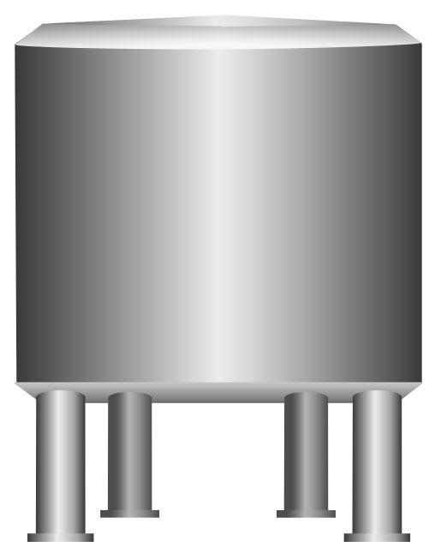

**Option 1.** Water Tank 1

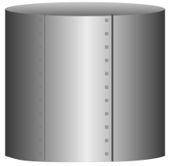

**Option 3.** Water Tank 3

**Option 2.** Water Tank 2

## Object Features

# Object . Power Meters

## Description

Power meters are sophisticated electronic devices that accurately measure and monitor electrical parameters within a power system. They provide real-time data on voltage, current, power factor, energy consumption, and more. Power meters are vital for optimizing energy usage, improving efficiency, and making informed decisions in various industries and settings.

## Appearance

**Option 1.** Power Meter 1

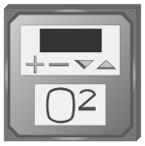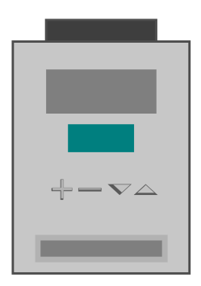

**Option 2.** Power Meter 2

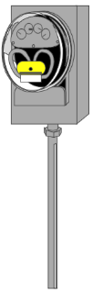

**Option 3.** Power Meter 3

## Object Features

|  |  |  |
| --- | --- | --- |
| **Nodes** | **Alarms** | **Maintenance** |
| Active Power | High Active Power: 1000  Low Active Power : 400 | Regular Calibration |
| Aparent Power | High Aparent Power: 1500  Low Ac Aparent tive Power : 1300 | Firmware Updates |
| Current L1 | High Current L1: 1000  Low Current L1 : 0 | Physical Inspection and Cleaning |
| Current L2 | High Current L2: 1000  Low Current L2 : 0 | Environmental Checks |
| Current L3 | High Current L3: 1000  Low Current L3: 0 | Electrical Connections Inspection |
| Energy | High Energy: 2000  Low Energy: 1000 | Check Backup Power/Battery |
| Frecuency | High Frecuency: 100  Low Frecuency: 0 |  |
| Power Factor | High Power Factor: 1  Low Power Factor : 0 |  |
| Reactive Power | High Aparent Power: 600  Low Ac Aparent tive Power : 400 |  |
| Voltage_L1 | High Voltage L1: 500  Low Voltage L1 : 380 |  |
| Voltage_L2 | High Voltage L2: 500  Low Voltage L2 : 380 |  |
| Voltage_L3 | High Voltage L3: 500  Low Voltage L3 : 380 |  |

# Object . Electric Motors

## Description

Electric motors are fundamental components within the automation industry, powering a wide range of machinery and processes. These devices convert electrical energy into mechanical motion, enabling automation systems to perform tasks with precision and efficiency. Electric motors are utilized in various applications, from conveyor belts and robotic arms to pumps, fans, and manufacturing equipment.

## Appearance

**Option 1.** Electric_Motor_1

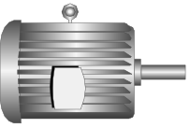

**Option 3.** Electric_Motor_3

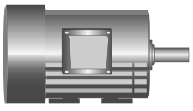

**Option 2.** Electric_Motor_2



## Object Features

|  |  |  |
| --- | --- | --- |
| **Nodes** | **Alarms** | **Maintenance** |
| Voltage | High Voltage : 440  Low Voltage : 360 | Regular Inspections |
| Current | High Current: 24  Low Current : 16 | Lubrication |
| Temperature | High Temperature: 80  Low Temperature : 0 | Bearing Maintenance |
| Vibration | High Vibration: 2.5  Low Vibration : 0.5 | Alignment Checks |
| RPM | High RPM: 2000  Low RPM: 500 | Cleaning |
| Power Factor | High Power Factor: 1  Low Power Factor: 0.85 | Sealing and Gasket Checks |
| Torque | High Torque: 120  Low Torque: 80 | Balancing |

# Object . Diesel Generators

## Description

Diesel generators are electromechanical systems that convert the chemical energy in diesel fuel into mechanical energy through internal combustion, which is then transformed into electrical energy via an alternator. Utilizing advanced control algorithms and automation technology, these generators offer variable load capacities and high-efficiency performance, making them ideal for a myriad of applications—from serving as standby power in hospitals and data centers to providing primary power in off-grid locations and construction sites.

## A heater with a tank on top Description automatically generatedAppearance

**Option 1.** Diesel_Generator_1

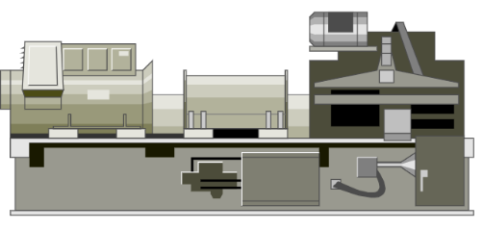

**Option 2.** Diesel_Generator_2

## Object Features

|  |  |  |
| --- | --- | --- |
| **Nodes** | **Alarms** | **Maintenance** |
| Engine Oil Pressure | High Voltage : 70  Low Voltage : 20 | Oil and Filter Change |
| Coolant Temperature | High Current: 210  Low Current : 140 | Cooling System Inspection |
| Fuel Level | High Temperature: 95  Low Temperature : 15 | Fuel System Cleaning |
| Output Voltage | High Vibration: 528  Low Vibration : 432 | Air Filter Replacement |
| RPM | High RPM: 1980  Low RPM: 1620 | Electrical System Check |
| Gas Temperture | High Power Factor: 538  Low Power Factor: 149 | Load Bank Testing |

# Object . Spherical Storage Tank

## Description

Spheres are typically used to store below ambient temperature liquids and pressurized gases such as ammonia, propylene, LPG, butadiene, etc. Most (or many) spheres operate at low temperatures with -50°C (-58°F) as a lower limit. Gases are stored under pressure at a temperature lower than their liquefaction temperature.

## Appearance

**Option 1.** Spherical _Tank_1

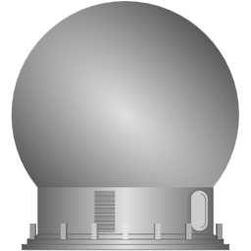

**Option 3.** Spherical _Tank_3

**Option 2.** Spherical _Tank_2

## Object Features

|  |  |  |
| --- | --- | --- |
| **Nodes** | **Alarms** | **Maintenance** |
| Level | High level : 90  Low level : 20 | Check level control system, and obstructions |
| Temperature | High Temperature: 210  Low Temperature : 140 | Ensure heating and cooling systems are working properly |
| Presure | High Pressure: 95  Low Pressure : 15 | Perform pressure test |
| Leak detection | On - Off | Perform leak inspection |
| Vibration level | On - Off | Conduct vibration analysis |
|  |  |  |
|  |  |  |

# Object . Water Clarifier

## Description

In wastewater treatment, a water clarifier serves a crucial role in the primary treatment process. It is used to remove suspended solids and settle out impurities from the wastewater before further treatment or discharge. The primary purpose of using a water clarifier in wastewater treatment is to:

* **Separate Solids.**
* **Improve Water Quality**

## Appearance

**Option 3.** Water_Clarifier_3

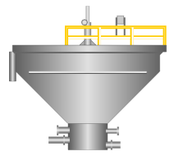

**Option 1.** Water_Clarifier_1

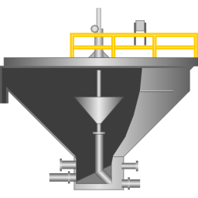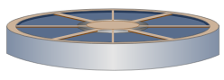

**Option 2.** Water_Clarifier_2

## Object Features

|  |  |  |
| --- | --- | --- |
| **Nodes** | **Alarms** | **Maintenance** |
| Water Flow rate | High: 110 m3/s  Low: 70 m3/s | Flow Sensor calibration |
| Turbidity | High: 5 NTU  Low : 2 NTU | Turbidity Sensor cleaning |
| Chemical Dosage | High: 120%  Low: 80% | Chemical Stock check and refill |
| Sludge depth | High: 70%  Low: 20% | Sludge removal |
| pH | High: 9.0  Low: 6.0 | pH sensor calibration |

# Object . Hand valves

## Description

Valves are vital mechanical devices designed to regulate, control, and manipulate the flow of fluids, gases, or other substances within a pipeline or process system. These versatile components play a pivotal role across various industries, ensuring the efficient and safe operation of processes, from simple domestic applications to complex industrial systems.

## Appearance

**Option 1.** Hand valve 1

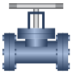

**Option 2.** Hand valve 2



**Option 3.** Hand valve 3

## Object Features

|  |  |  |
| --- | --- | --- |
| **Nodes** | **Alarms** | **Maintenance** |
| Pressure (PSI or Bar) | High Pressure : 110 PSI (or 110 Bar)  Low Pressure: 90 PSI (or 90 Bar) | Calibrate pressure sensors |
| Temperature  (°C or °F) | High Temperature: 40°C  Low Temperature: 0°C | Calibrate temperature sensors |
| Flow Rate  (GPM or m³/h) | High Flow : 110 GPM  Low Flow : 90 GPM | Inspect for blockages |
| Valve Position  (% Open/Closed) | High Valve: 95% open  Low Valve: 0% Open | Lubricate valve stems |
| Control Signal  (mA or V) | High Control Signal:22 mA  Low Control Signal:18 mA | Calibrate signal sensors. |
| Fluid Composition  (% or ppm of specific constituents) | High Composition: 110 ppm  Low Composition : 90 ppm | Analyze the fluid |

# Object . Conveyor belt

## Description

## A conveyor belt in industrial plants is a mechanical system consisting of a continuous loop of moving belts, rollers, or chains used to transport materials or products from one location to another within a manufacturing or processing facility. Conveyor belts are a fundamental component of material handling systems in various industries, including manufacturing, mining, agriculture, food processing, and distribution centers. They offer a highly efficient and automated means of moving goods, raw materials, or components along a production or assembly line.

## Appearance

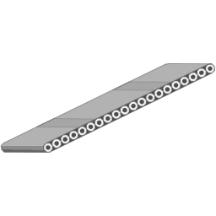

**Option 1.** Conveyor Belt

## Object Features

|  |  |  |
| --- | --- | --- |
| **Nodes** | **Alarms** | **Maintenance** |
| **Belt Speed** | High: 6 m/s  Low: 1 m3/s | Belt Lubrication |
| Motor RPMs | High: 120 rpm  Low: 40 rpm | Motor regular inspections |
| Belt Temperature | High: 80 ºC  Low: 15 ºC | Thermal monitoring |
| Status ON/OFF |  |  |
| Energy consumption | High: 10 kWh  Low: 0 kWh | Power factor analysis |

# Object . Boiler

## Description

An industrial boiler is a specialized piece of equipment designed to generate steam or hot water for various industrial processes. These boilers are used in a wide range of industries and applications, providing a critical source of energy and heat for manufacturing, power generation, heating, and more.

Boliers are used for:

* Steam Generation
* Power Generation
* Heating applications
* Industrial Processes
* Steam Cleaning
* Beverage
* Food
* Chemical
* Hospitals

## Appearance

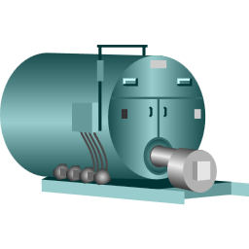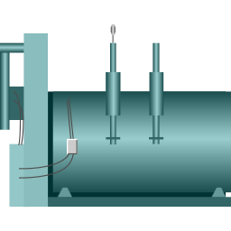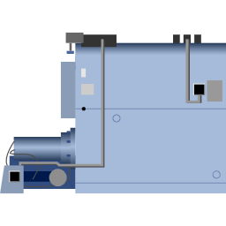

**Option 3.** Boiler 3

**Option 2.** Boiler 2

**Option 1.** Boiler 1

## Object Features

|  |  |  |
| --- | --- | --- |
| **Nodes** | **Alarms** | **Maintenance** |
| Pressure | High: 20 bar  Low: 8 bar | Inspect Pressure Relief Valves |
| Temperature | High: 330 ºC  Low: 270 ºC | Inspect thermocouples sensors. |
| Water Level | High: 95%  Low: 20% | Test water control system |
| Fuel Level | High: 95%  Low: 20% | Check fuel tank and fuel level sensors. |
| CO Level | High: 110 ppm  Low: 0 | Inspect emission control systems. |
| Air Flow Rate | High: 220 m3/h  Low: 180 m3/h | Inspect dampers |

# Object . Separator

## Description

Separators are essential machines used in the food industry for various purposes, such as the separation of liquids from solids, different phases of liquids, and even sorting of solids based on size or density. They find use in dairy processing for skimming milk, in breweries for separating wort from spent grains, in the oil industry for separating oil from water, and many other applications. The primary aim is to achieve a high degree of purity in the products and to optimize the overall efficiency and quality of production.

## A white machine with a cylinder Description automatically generatedAppearance

**Option 3.** Separator_3

**Option 1.** Separator_1

**Option 2.** Separator_2

## Object Features

|  |  |  |
| --- | --- | --- |
| **Nodes** | **Alarms** | **Maintenance** |
| Conveyor Speed (m/min) | High: 20 m/min  Low: 5 m/min | Daily Visual Inspection |
| Vibration Level | High: 5 mm/s  Low: 0.5 mm/s | Check Conveyor Belt Tension and Alignment |
| Particle Size (mm) | High: 10 mm  Low: 1 mm | Lubricate Bearings |
| Hopper Level | High: 2.5 meters  Low: 0.5 meters | Vibration Analysis |
| Motor Current (Ampere) | High: 20 A  Low: 5 A | Particle Size Calibration |
| Ambient Temperature | High: 40°C  Low: 0°C | Hopper Inspection |

# Object . Air Handling Unit

## Description

An industrial air handling unit (AHU) is a crucial component of heating, ventilation, and air conditioning (HVAC) systems in large commercial and industrial buildings. Its primary function is to regulate and circulate air within the building, maintaining a comfortable and safe environment for occupants.

Key features and functions of an industrial air handling unit include:

* Air Circulation
* Air Filtration
* Temperature regulation
* Humidity Control
* Mixing fresh and recirculated air
* Fan systems
* Energy efficiency

## Appearance

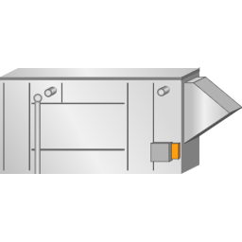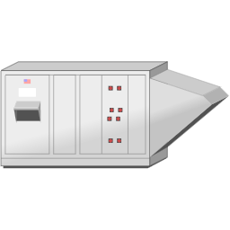

**Option 1.** AHU_1

**Option 2.** AHU_2

**Option 2.** AHU_3

## Object Features

|  |  |  |
| --- | --- | --- |
| **Nodes** | **Alarms** | **Maintenance** |
| Temperature_Out | High: 30 ºC  Low: 15 ºC | Temperature Sensors Calibration |
| Humidity_Out | High: 90%  Low: 60% | Humidity sensors calibration |
| Motor Current | High: 35 amps  Low: 0 amps | Coil Cleaning |
| Filter Differencial Presura | High: 0.2 bar  Low: 0 bar | Air Filters Cleaning |
| Fan Speed | High: 65 rpms  Low: 30 rpms | Electric Motor Bearing inspection |
| Status |  |  |