**Parallel Programming Exercise 10 – 4**

|  |  |
| --- | --- |
| **Author:** | 許秉倫 (b05901011@ntu.edu.tw) |
| **Student ID** | B05901011 |
| **Department** | 電機系 |

(If you and your team member contribute equally, you can use (co-first author), after each name.)

# Problem and Proposed Approach

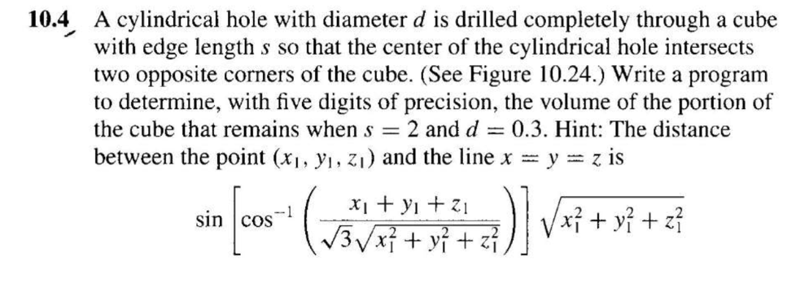

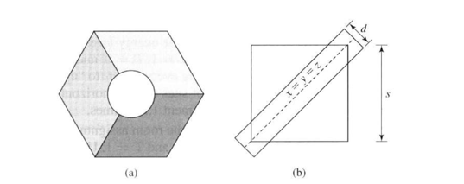

I use “monte carlo” method. Randomly sample many points in the cube and then calculate how much percentage do the points sit in the solid region. The estimated volume is equal to this ratio multiplying cube volume.

(Brief your problem, and give your idea or concept of how you design your program.)

# Theoretical Analysis Model

(Try to give the time complexity of the algorithm, and analyze your program with iso-efficiency metrics)

$$Time complexity: X\frac{n}{p}+λlogp=>O(\frac{n}{p}+logp)$$

$$n≥C*p*logp \\ scalability function:\frac{M\left(f\left(p\right)\right)}{p}=logp$$

# Performance Benchmark

(Give your idea or concept of how you design your program.)

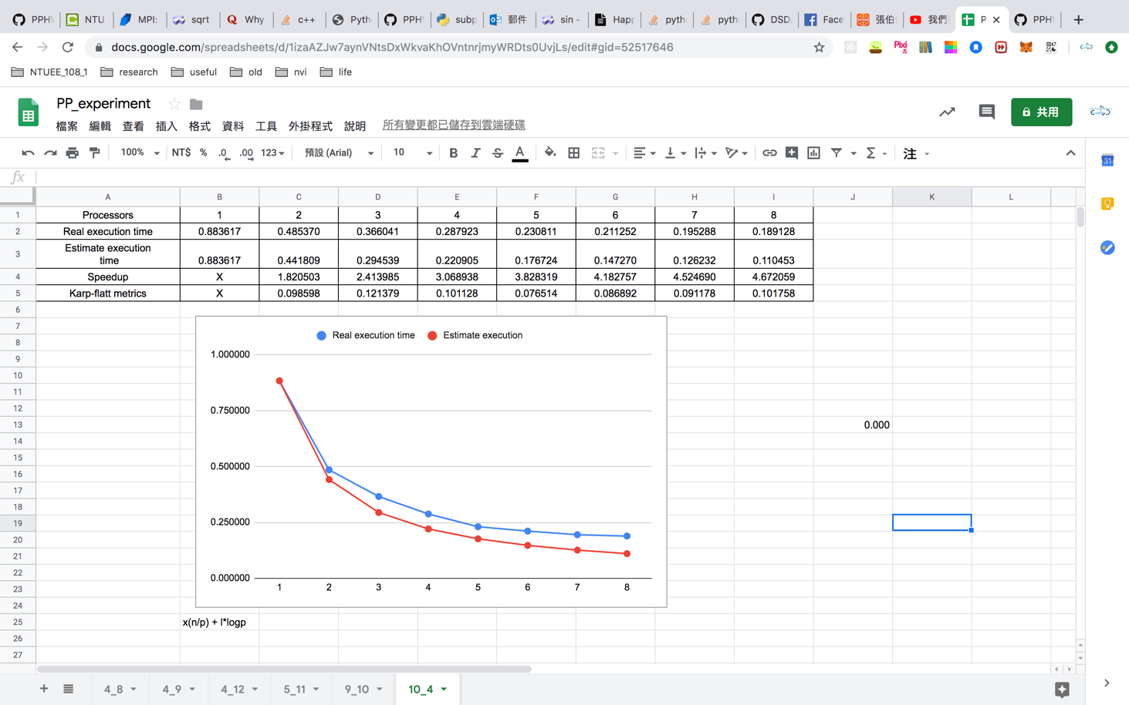

Figure 1. The performance of diagram

# Conclusion and Discussion

1. The speedup increases with the number of processors.
2. I cannot find better way.
3. It does not impact on the performance too much.
4. The overhead is small because k value is small. The scalability is good.

(Discuss the following issues of your program

1. What is the speedup respect to the number of processors used?
2. How can you improve your program further more
3. How does the communication and cache affect the performance of your program?
4. How does the Karp-Flatt metrics and Iso-efficiency metrics reveal?

)

**Appendix(optional):**

(If something else you want to append in this file, like picture of life game)