**Parallel Programming Exercise 4 – 12**

|  |  |
| --- | --- |
| **Author:** | 許秉倫 (b05901011@ntu.edu.tw) |
| **Student ID** | B05901011 |
| **Department** | 電機系 |

(If you and your team member contribute equally, you can use (co-first author), after each name.)

# Problem and Proposed Approach

利用給定的公式，近似出pi的值。

我的做法是將summation的那一項拆給不同的processor去算，最後reduce再由p0算出結果。

(Brief your problem, and give your idea or concept of how you design your program.)

# Theoretical Analysis Model

(Try to give the time complexity of the algorithm, and analyze your program with iso-efficiency metrics)

$$Time complexity= O(\frac{n}{p}+λlogp)$$

$$n≥Cplogp \\ scalibility function= \frac{M\left(Cplogp\right)}{p}=Clogp$$

# Performance Benchmark

(Give your idea or concept of how you design your program.)

我把n設為10^9，才比較能看出差異

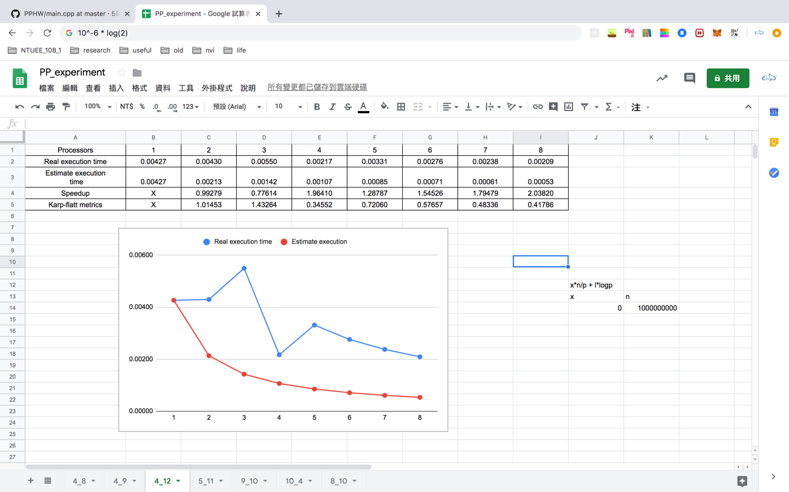

Figure 1. The performance of diagram

# Conclusion and Discussion

1. Speedup未必隨p而上升，可見communication所佔的比重不小
2. 減少計算的步驟
3. 由k值和speedup可知，communication佔了不少比例
4. Overhead佔不少比例；有良好的scalibility

(Discuss the following issues of your program

1. What is the speedup respect to the number of processors used?
2. How can you improve your program further more
3. How does the communication and cache affect the performance of your program?
4. How does the Karp-Flatt metrics and Iso-efficiency metrics reveal?

)

**Appendix(optional):**

(If something else you want to append in this file, like picture of life game)