**Parallel Programming Exercise 4 – 8**

|  |  |
| --- | --- |
| **Author:** | 許秉倫 (b05901011@ntu.edu.tw) |
| **Student ID** | B05901011 |
| **Department** | 電機系 |

(If you and your team member contribute equally, you can use (co-first author), after each name.)

# Problem and Proposed Approach

計算1~10^6中，有幾對相鄰的奇數恰好都是質數。

我修改sieve的sample code，讓每個processor自己計算組內共有幾對。

但這樣做是不對的，還需要handle兩個相鄰奇數在不同processor的問題，我的做法是，除了第一個processor以外，把每個processor的左界+2，這樣就能確保算到臨界的點。

(Brief your problem, and give your idea or concept of how you design your program.)

# Theoretical Analysis Model

Same as sieve version 1

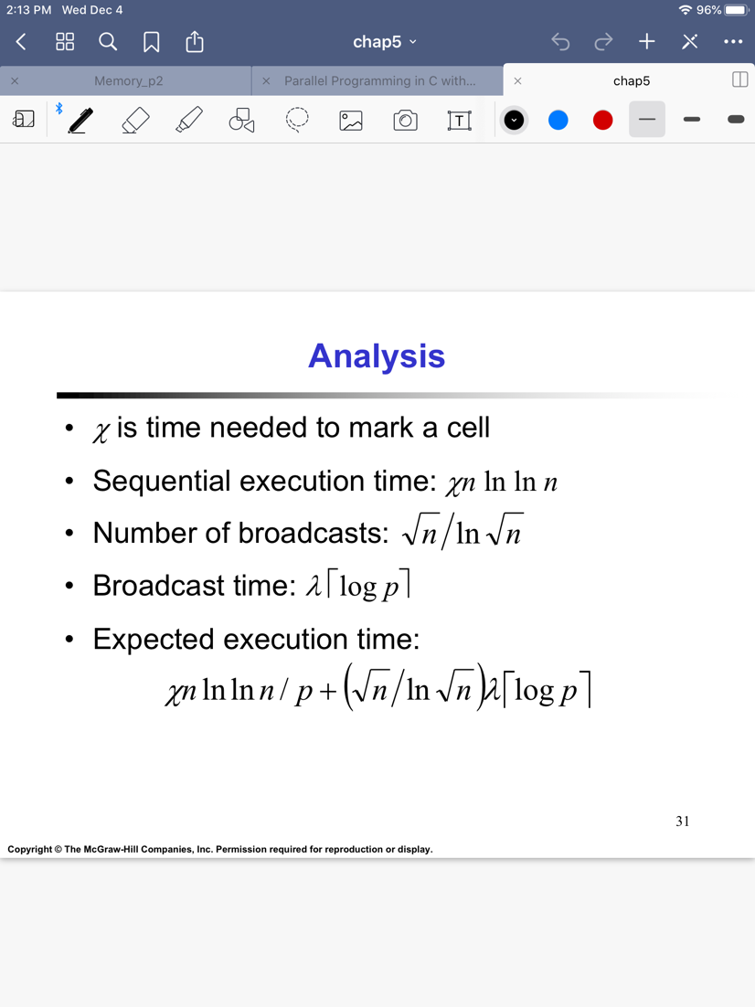

$$n^{\frac{3}{2}}>C plogp \\ n>{(Cplogp)}^{\frac{2}{3}} \\ \frac{M\left(f\left(p\right)\right)}{p}=\frac{{Cplogp}^{\frac{2}{3}}}{p}$$

(Try to give the time complexity of the algorithm, and analyze your program with iso-efficiency metrics)

# Performance Benchmark

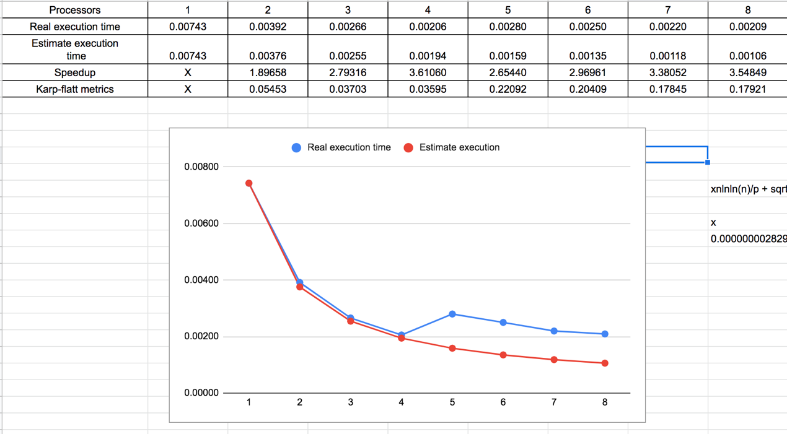

Figure 1. The performance of diagram

(Give your idea or concept of how you design your program.)

# Conclusion and Discussion

1. Speedup未必隨著p增加持續上升
2. 可以套用sieve的improve方法，例如把偶數去掉
3. 由圖中可觀察得知，當p越大時，時間未必越短，因為communication所花的時間也上升了
4. K值上升，告訴我們overhead是影響速度的主因。他有良好的scalability。

(Discuss the following issues of your program

1. What is the speedup respect to the number of processors used?
2. How can you improve your program further more
3. How does the communication and cache affect the performance of your program?
4. How does the Karp-Flatt metrics and Iso-efficiency metrics reveal?

)

**Appendix(optional):**

(If something else you want to append in this file, like picture of life game)