**Parallel Programming Exercise 5 – 11**

|  |  |
| --- | --- |
| **Author:** | 許秉倫 (b05901011@ntu.edu.tw) |
| **Student ID** | B05901011 |
| **Department** | 電機系 |

(If you and your team member contribute equally, you can use (co-first author), after each name.)

# Problem and Proposed Approach

（感謝張凱捷同學的幫忙！)

題目：計算 $\sum_{k=0}^{n}{\frac{1}{k}}$, n = 1000000, to 100 digits of precision.

作法：將n個數字平均拆給各個processors作運算，如果單純用double的話，沒辦法算到100位，所以我用「大數除法」來做運算，將digit存在array裡面，模擬長除法的流程以計算出商。

Ans: 14.392726722865723631381127493188587676644800137443116534184334581295850751799535682981759472191007083

(Brief your problem, and give your idea or concept of how you design your program.)

# Theoretical Analysis Model

n is the number of sequence.

d is the number of digits.

p is the number of processors.

Sequential time complexity: $O(n*d)$

Parallel time complexity: $O(\frac{n}{p}*d+logp)$

Scalability function:

$$n*d<C*p*logp \\ n<C*p*logp*\frac{1}{d} \\ \frac{M\left(f\left(p\right)\right)}{p}=C*logp*1/d$$

(Try to give the time complexity of the algorithm, and analyze your program with iso-efficiency metrics)

# Performance Benchmark

(Give your idea or concept of how you design your program.)

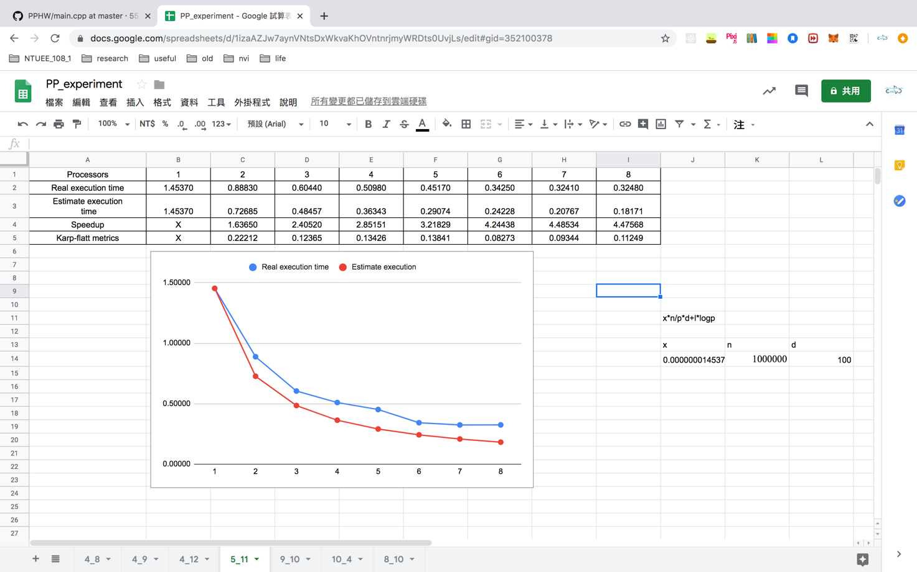

# Conclusion and Discussion

1. The speedup increases with the number of processors.
2. 原本我是讓array中的一個item存6個digits，如果把它調成更多個可以更快。
3. Seq part佔的比例比較大，communication相對來說不大。
4. K隨p而下降，代表seq part佔不小的比例，根據Part2算的scalability function可知這個model有良好的scalability。

(Discuss the following issues of your program

1. What is the speedup respect to the number of processors used?
2. How can you improve your program further more
3. How does the communication and cache affect the performance of your program?
4. How does the Karp-Flatt metrics and Iso-efficiency metrics reveal?

)

**Appendix(optional):**

(If something else you want to append in this file, like picture of life game)