**Parallel Programming Exercise 8 – 10**

|  |  |
| --- | --- |
| **Author:** | 許秉倫 (b05901011@ntu.edu.tw) |
| **Student ID** | B05901011 |
| **Department** | 電機系 |

(If you and your team member contribute equally, you can use (co-first author), after each name.)

# Problem and Proposed Approach

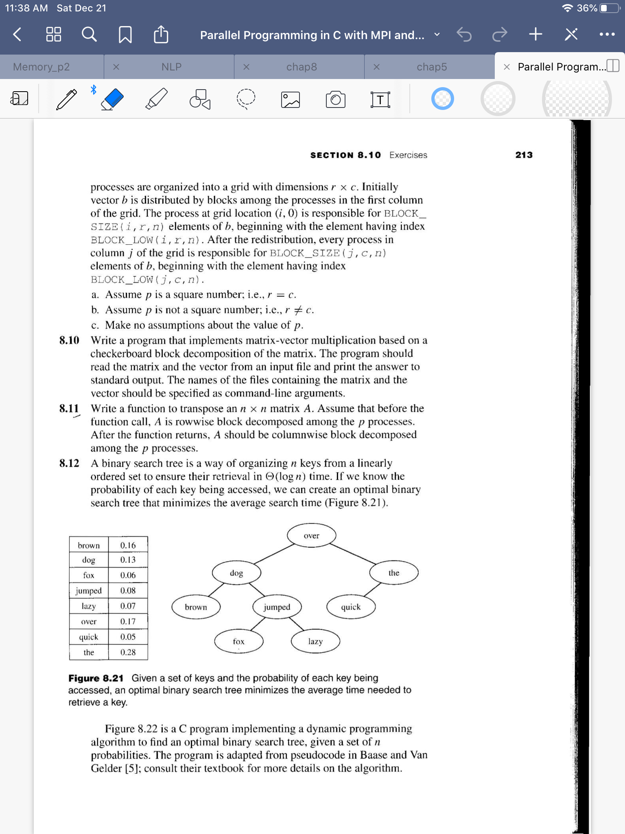

I use the “checkerboard” method described in the textbook.

(Brief your problem, and give your idea or concept of how you design your program.)

# Theoretical Analysis Model

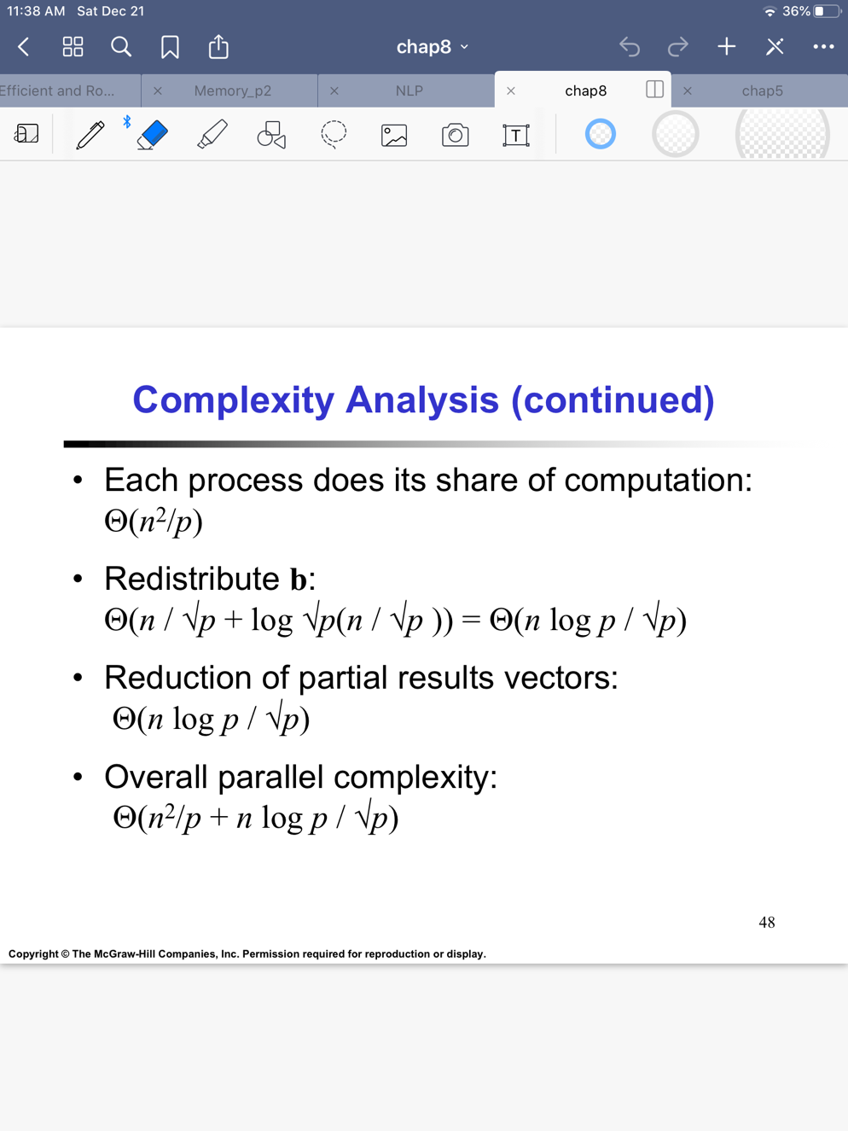

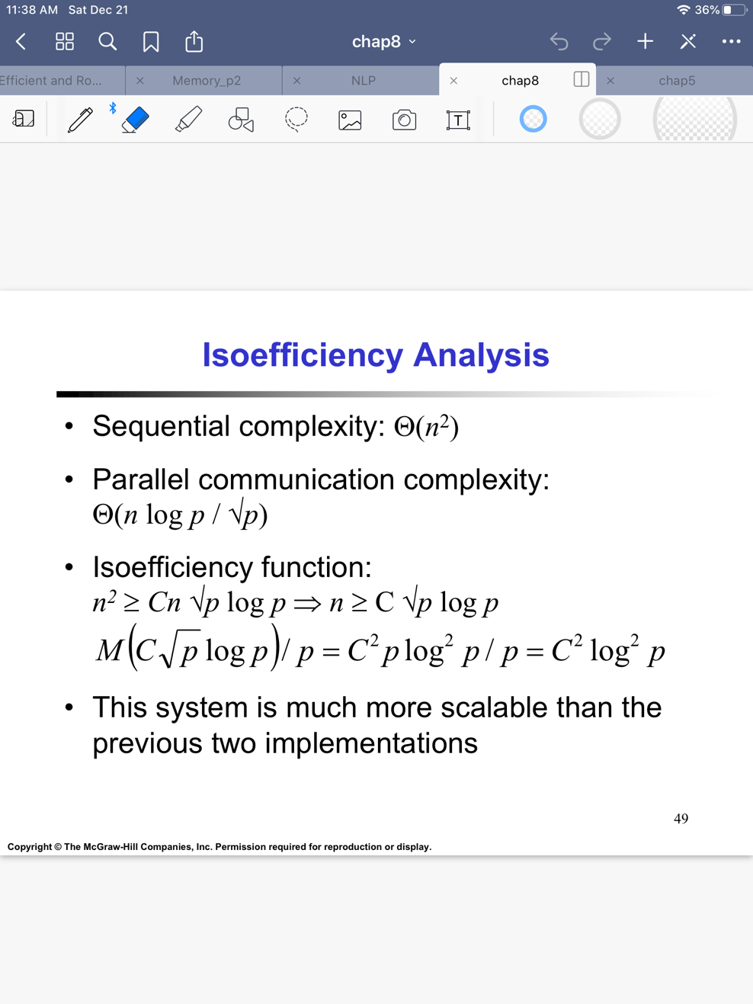

(Try to give the time complexity of the algorithm, and analyze your program with iso-efficiency metrics)

# Performance Benchmark

(Give your idea or concept of how you design your program.)

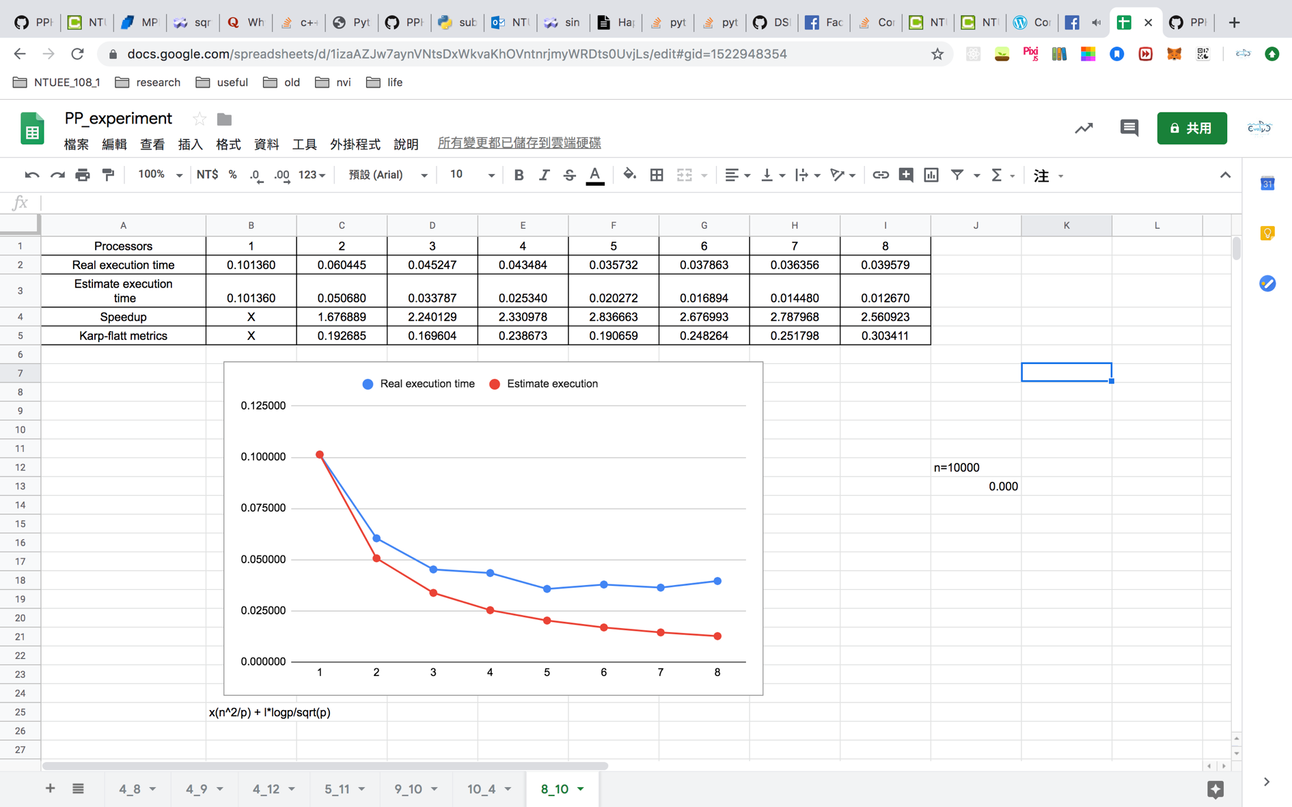

# Conclusion and Discussion

1. The speedup mostly increases with the number of processors.
2. Reduce the number of computation.
3. According to the blue line, overhead counts for a large part for this program.
4. K reveals that overhead counts for a large part for this program. I reveals that this program has great scalability.

(Discuss the following issues of your program

1. What is the speedup respect to the number of processors used?
2. How can you improve your program further more
3. How does the communication and cache affect the performance of your program?
4. How does the Karp-Flatt metrics and Iso-efficiency metrics reveal?

)

**Appendix(optional):**

(If something else you want to append in this file, like picture of life game)