**Parallel Programming Exercise 9 – 10**

|  |  |
| --- | --- |
| **Author:** | 許秉倫 (b05901011@ntu.edu.tw) |
| **Student ID** | B05901011 |
| **Department** | 電機系 |

(If you and your team member contribute equally, you can use (co-first author), after each name.)

# Problem and Proposed Approach

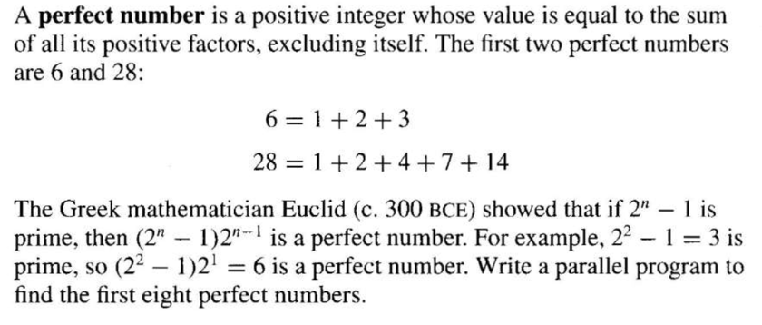

I use the “interleave” method. For the ith processor, it is responsible for n == i, i+p, i+2p…

The final result is

*6*

*28*

*496*

*8128*

*33550336*

*8589869056*

*137438691328*

*2305843008139952128*

(Brief your problem, and give your idea or concept of how you design your program.)

# Theoretical Analysis Model

There are totally n numbers. For each number, we should compute $\sqrt{2^{n}-1}$ times to verify whether it is a prime. After applying parallel technique, the complexity becomes

$$O(\frac{n}{p}*\sqrt{2^{n}} )$$

I print the perfect number in each processor respectively, so there are no communication between processor. Therefore, we can’t not compute iso-efficiency metric.

(Try to give the time complexity of the algorithm, and analyze your program with iso-efficiency metrics)

# Performance Benchmark

(Give your idea or concept of how you design your program.)

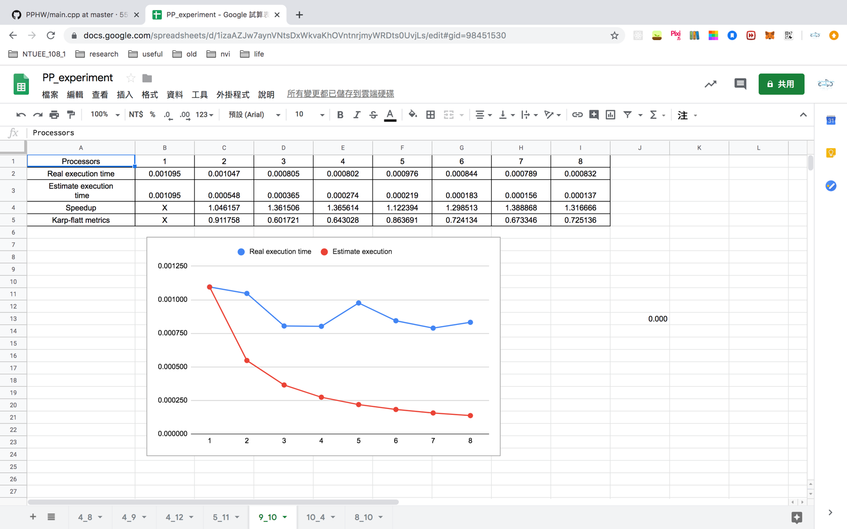

Figure 1. The performance of diagram

# Conclusion and Discussion

1. Speed-up會隨著processor浮動，可能是因為有隱藏的overhead
2. 把判斷是否為質數的那個函數也平行化
3. Real跟Estimated差距極大，可推測出overhead對程式影響甚劇
4. 由K值可推測出overhead佔了相當大的比例

(Discuss the following issues of your program

1. What is the speedup respect to the number of processors used?
2. How can you improve your program further more
3. How does the communication and cache affect the performance of your program?
4. How does the Karp-Flatt metrics and Iso-efficiency metrics reveal?

)

**Appendix(optional):**

(If something else you want to append in this file, like picture of life game)