NYCU Pattern Recognition, Homework 4

**311552034, 林柏翰**

**Part. 1, Coding (50%)**:

1. (10%) Implement K-fold data partitioning.

1. (10%) Set the kernel parameter to 'rbf' and do grid search on the hyperparameters **C** and. **gamma** to find the best values through cross-validation. Print the best hyperparameters you found. Note that we suggest using K=5 for the cross-validation.

1. (10%) Plot the results of your SVM's grid search. Use "gamma" and "C" as the x and. y axes, respectively, and represent the average validation score with color. Below image is just for reference.

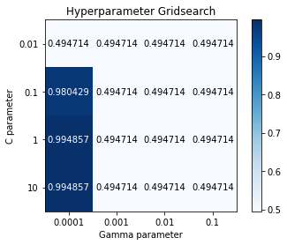

1. (20%) Train your SVM model using the best hyperparameters found in Q2 on the entire training dataset, then evaluate its performance on the test set. Print your testing accuracy.

**Part. 2, Questions (50%):**

1. (10%) Show that the kernel matrix should be positive semidefinite is the necessary and sufficient condition for to be a valid kernel.

1. (10%) Given a valid kernel , explain that is also a valid kernel. (Hint: Your answer may mention some terms like ____ series or ____ expansion.)

1. (20%) Given a valid kernel , prove that the following proposed functions are or are not valid kernels. If one is not a valid kernel, give an example of that the corresponding is not positive semidefinite and show its eigenvalues.

1. Consider the optimization problem

State the dual problem. (Full points by completing the following equations)

= ___ (x - 2)^2 + λ[(x + 4)(x - 1) – 3]_____________

= _____ 2(x - 2) + λ(2x + 3)________________

when ,

= _____ (4 - 3λ)/(2 + 2λ)___________

=

[(4 - 3λ) / (2 + 2λ) - 2]^2 + λ{[(4 - 3λ) / (2 + 2λ)) + 4][((4 - 3λ) / (2 + 2λ)) – 1]– 3}