Task (1)

Documentation

1. Bluepill Pinout

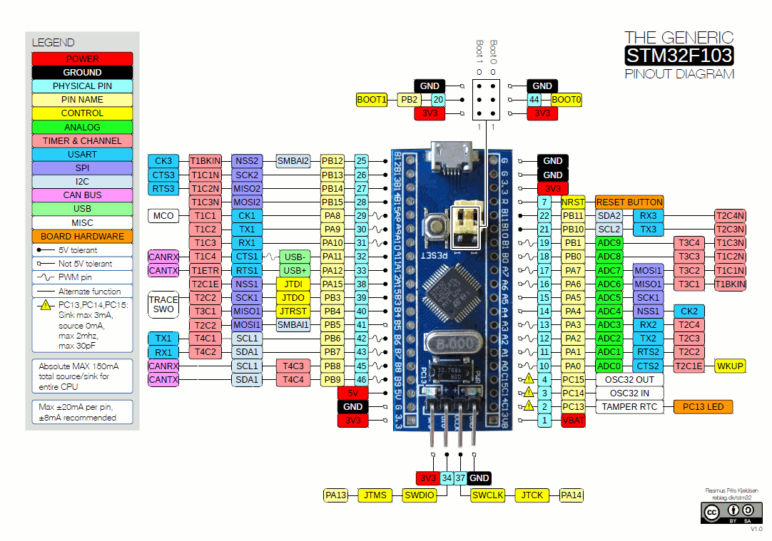

The **LM324** is a popular quad operational amplifier (op-amp) integrated circuit (IC). It contains **four independent op-amps** **in a single package**.

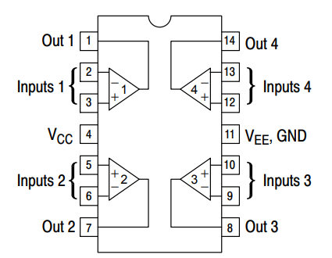

The **L293D** is a dual H-bridge motor driver integrated circuit that allows you to control the speed and direction of two DC motors or a bipolar stepper motor by managing current flow through two independent coils.



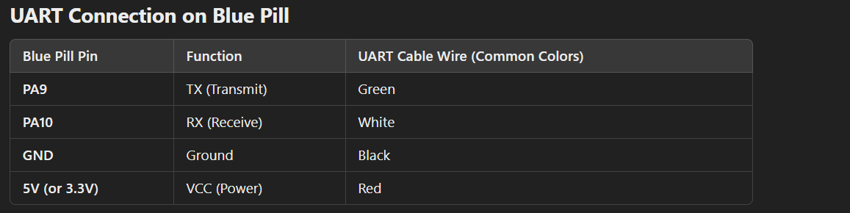

**DC Motor vs. Stepper Motor – Pinout Comparison**

* **DC Motor:**
  + **Wiring:** Typically has 2 wires. One Coil.
  + **Control:** Requires 2 outputs (via an H-bridge) to set direction; a PWM signal can modulate speed.
* **Stepper Motor (Bipolar):**
  + **Wiring:** Has 4 wires (2 coils).
  + **Control:** Needs 4 outputs (using 2 H-bridges) to independently control current direction in each coil for precise stepping.

What’s the H-Bridge?

It’s a circuit used to control the speed and direction of a DC Motor.

It consists of 4 switches

It can be used to:

1. Control the speed.
2. Control the direction.
3. Can be used as the stopping mechanism.

As for the speed, to use the H-bridge to control the speed of the DC Motor, we have to used switches that can be controlled using signal with the feature of PWM (Pulse Width Modulation).

i.e., by controlling the duty cycle we control the speed of the motor.

As for the direction Control, we can use different combinations of the switches to run the DC motor in both directions.

Finally, as for the stopping mechanism, we can apply the source volage to both terminals of the motor. This can also be done by applying the ground to both terminals.

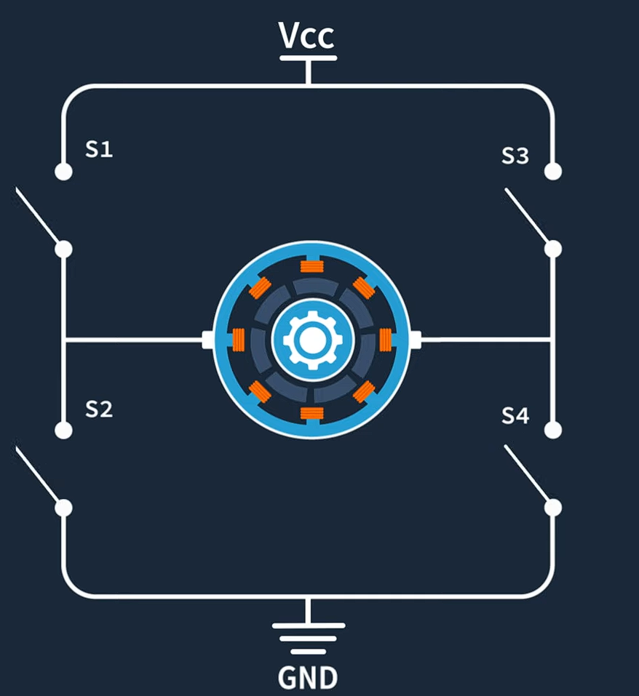

The Slide Switch:

It has three pins.

It connects the middle pin to either one of the peripheral pins.

Meaning it switches between to circuits.

Servo Motor

A typical servo has three wires:

* **Power (Vcc):** Usually 5V.
* **Ground (GND).**
* **Control Signal:** Receives the PWM signal.

**PWM Signal Details:**

* **Frequency:** Usually around **50 Hz** (20 ms period).
* **Pulse Width:**
  + **~1 ms** pulse positions the servo at one extreme.
  + **~1.5 ms** centers the servo.
  + **~2 ms** pulse moves it to the opposite extreme.
* The exact pulse width corresponding to an angle can vary between servos.

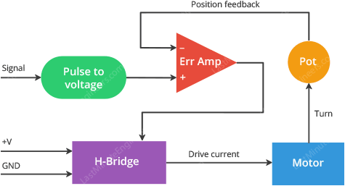

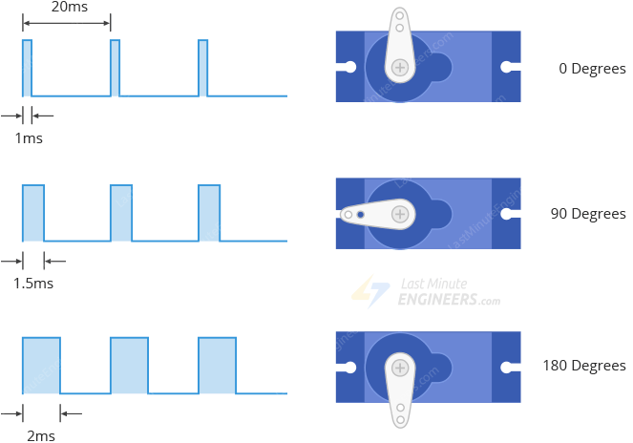

**Servo** **pinout**:

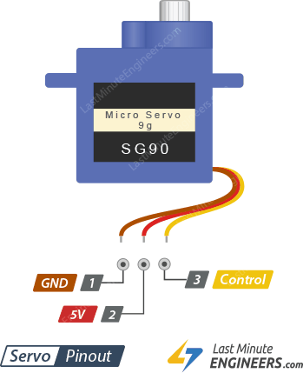

Voltage Regulator:

**Definition and Purpose:**

A voltage regulator is an electronic component used to **reduce and stabilize** the voltage supplied to a circuit, ensuring a constant output voltage despite variations in the input voltage or load conditions.

**Key Characteristics:**

1. **Voltage Reduction and Stabilization:**
   * Maintains a steady voltage output to protect sensitive electronic components.
   * Prevents fluctuations that could cause malfunctions or damage.
2. **Inability to Increase Voltage:**
   * Standard voltage regulators can only step down or regulate voltage but **cannot increase** it.
   * If voltage boosting is required, a **boost converter** or a switching regulator like a DC-DC converter must be used.

As for the polarity protection it means adding a diode to the circuit to protect the circuit when the source polarities are switched. Also adding a switch to control.

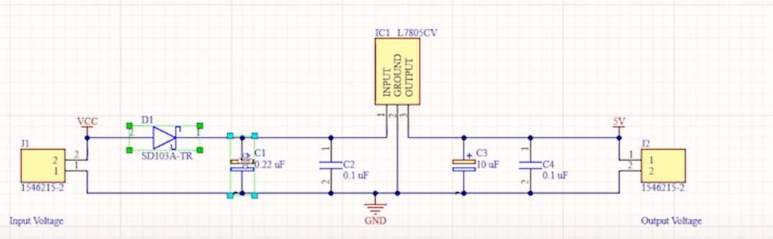

IR Sensor:

It consist of:

* 1. IR Transmitter.
  2. IR Receiver.
  3. A Resistor for each.

The circuit Description:

The Transmitter transmits IR Rays given a 3.3 voltage.

The Receiver (5V) accepts this IR Rays and changes its resistance accordingly. Thus, changing the value of the voltage between its terminals.

The signal of the voltage of the Receiver is the output of the sensor.

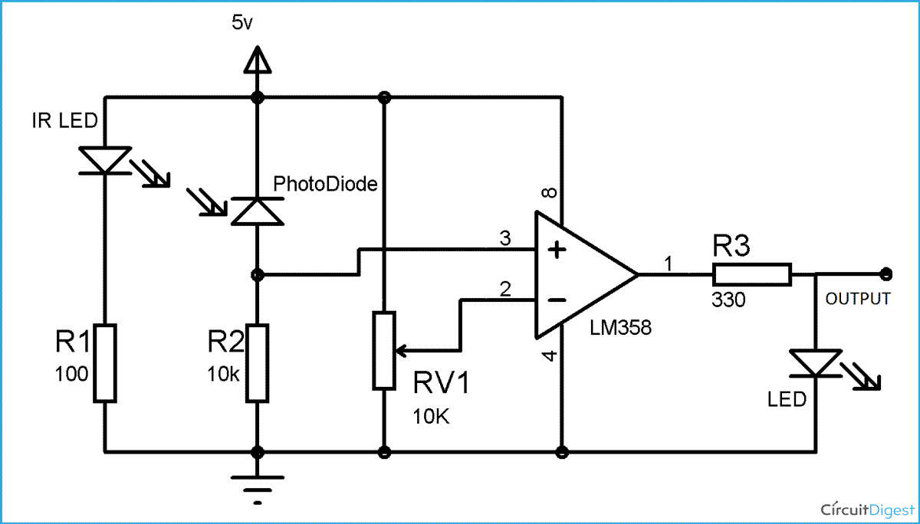

The Role of the Comparator:

How to make a comparator with OP-amp.

Ans: no feedback loop.

Input + Vref

The main use of the Comparator in this case is to do Analog to Digital Conversiton.

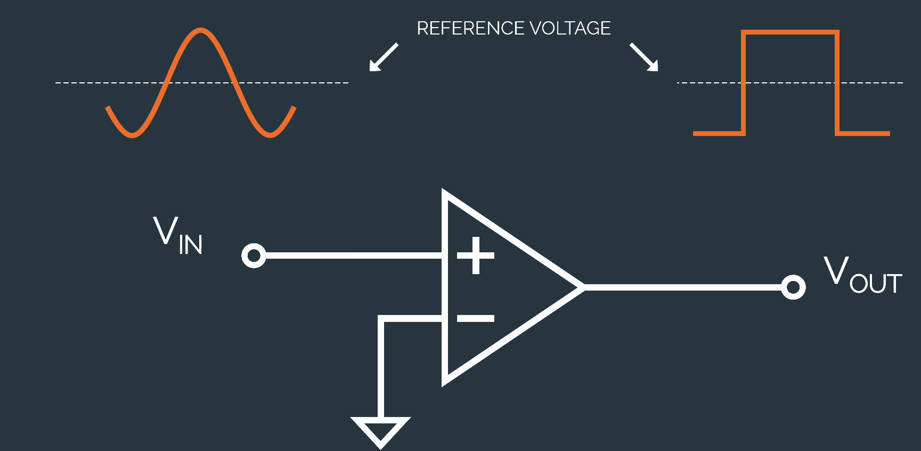

Comparator circuit for varying input:

Ans: comparator circuit with hysteresis.

What does that mean?

It means introducing a feedback form the comparator’s output to the input using a resistor.

This results in less noise in the transition of voltage levels of the output

