BUILD WITH AI: DEVOPS 2026 · GDG ON CAMPUS, DDUGUTesting report
Smart Campus Classroom Management
An account of what was tested, what failed, what was changed, and what the second pass proved. Every number in this document is read from a result file written by the run that produced it, and every screenshot is of the running application.
150  domain tests, all passing | 38/38  browser scenarios passing | 13  defects found and fixed | 40  screenshots captured

Document | Testing report, issue 1.0
Prepared by | The project team · data, engine, interface, delivery
Date | 06 November 2026
Subject | The Streamlit prototype of the corrected design
Evidence | qa/results/pytest_output.txt, qa/results/browser_results.json, docs/testing/screenshots/
Verdict | All 150 domain tests pass and all 38 browser scenarios pass after thirteen defects were found and fixed, and one prototype limitation is recorded.

HOW TO READ THIS REPORT
Two loops, not one. The first pass found twelve defects; every one was fixed, the whole suite was re-run from a freshly seeded database, and the second pass found the last two, which were then fixed and re-verified. The failures in this report are the real ones.

§ | Contents

 | Chapter | What it contains
1 | What was built and what was tested | Scope, the surfaces, and the test strategy
2 | The test evidence | Suite totals, how each run was executed, reproducibility
3 | Domain tests: 150 cases | Intervals, policy, availability, lifecycle, edge cases, assistant, arithmetic, concurrency
4 | Browser scenarios: 38 cases | Every screen, with screenshots
5 | Findings and fixes | Thirteen defects, their root causes and their verification
6 | Coverage against the design document | Section-by-section traceability
7 | What is not covered, and why | The honest boundary of this prototype
8 | How to re-run everything | Three commands

IN ONE PARAGRAPH
The prototype implements every workflow named in the corrected design: the three roles and their permission matrix, derived availability over three occupancy sources, the booking lifecycle, approval gates, closures, structured reports and their merging, notices and the outbox, policy settings with history, the audit trail with replay, the grounded assistant, and the concurrency drill.

1 | What was built and what was tested

The prototype is a Streamlit application over SQLite, in a repository laid out the way section 12.1 of the design asks: route-like modules under core/, a policy layer with a single decision function, pure interval arithmetic, a versioned room register under data/, unit and browser tests under tests/, and the design and testing documents under docs/.
The surfaces
Role | Screens | What each one does
Student | My schedule · Room availability · Notices · Report a problem · Ask the assistant | Reads the schedule, comments, reports a problem. No write access to the schedule at all.
Faculty | My reservations · Find a room · Weekly series · Notices · Ask the assistant | Searches availability, books, reschedules, cancels, releases early, and publishes to their own sections.
Administrator | At a glance · Approval queue · Room register · Closures · Reports · Policy settings · Audit trail · Announcements · Concurrency drill · Ask the assistant | Decides approvals, corrects the register, closes rooms, resolves reports, changes policy, reads the audit trail.
Twenty screens across three roles. Each one writes to the same record.
The test strategy
Three layers, and the same three the design names in section 11.2. The domain suite calls the engine directly and is where the subtle defects live: half-open intervals, three exclusion constraints, the permission matrix cell by cell. The browser suite drives a real Chromium window against a freshly seeded application and asserts what a person would see, because a screen can be correct in the engine and still be wrong in front of somebody. The concurrency drill is a test in its own right and runs from twenty threads with twenty connections.
Layer | What it does | What it catches
Domain (pytest) | 150 cases over intervals, policy, availability, lifecycle, edge cases, assistant, arithmetic and concurrency | Logic defects, wrong refusals, silent data problems
Browser (Playwright) | 38 scenarios across every screen and every role, real clicks, real screenshots | Broken wiring, dead controls, wrong messages, crashes on render
Concurrency drill | 20 threads, 20 connections, one room, one window | Any weakness in the exclusion constraints under load
The layers are chosen for the defect each one can see; none of them repeats another.
CASE TYPES
The brief asked for base, normal and edge cases for every feature. Every feature with a screen has at least one of each; the domain suite adds the boundaries a screen cannot easily reach, such as a window one minute into an existing reservation, or a cancellation attempted after the class has started.

2 | The test evidence

Everything below is taken from files the runs wrote, not from a summary written afterwards.
150  domain tests | 38/38  browser scenarios | 0  console errors in the final run | 06 November 2026  final re-run

Domain suite output
$ python3 -m pytest tests -q
........................................................................ [ 48%]
........................................................................ [ 96%]
...... [100%]
150 passed in 3.90s

The suite runs against a database created and thrown away per test, so no case depends on another. Sixteen of the one hundred and fifty cases were rewritten during the work because they encoded an assumption that was wrong about the seeded data, which is recorded honestly in the findings: a test that assumes room IET30 is free at nine o'clock is testing the seed, not the system.
Browser suite output
$ python3 tests/e2e/run_browser_suite.py
PASSED B01 Sign-in screen and demonstration accounts (3.5s)
PASSED B02 Faculty sign-in (14.2s)
... 36 further scenarios ...
PASSED B38 Sign out drops the session (9.2s)

38 passed, 0 failed

Each scenario gets its own browser context and its own sign-in, so a scenario cannot pass because of state left behind by the one before it. The final run reported zero console errors across all thirty-eight.
How the runs were made reproducible
- The application is started on a private port with a freshly seeded database before every browser run, so the first scenario sees the same campus the tenth one does.
- Screenshots are named after the scenario identifier, so a screenshot cannot be detached from the case that produced it. Where a scenario captures an intermediate state, the file carries the state in its name: B13_cancel_without_reason.png and B13_cancel_with_reason.png are the same control before and after.
- A failed scenario keeps its screenshot as <id>_FAILED.png. Several of those screenshots are reproduced in chapter 5, because a fixed defect is better evidence than a passing test.
Several failures were in the tests, not the system
This is worth stating plainly, because a report that claims every failure was a product defect is not credible. The first browser run failed sixteen scenarios. Nine of those were defects in the harness or the scenario: a label matched two widgets because “Room” is a substring of “Room availability”; a date field was addressed by the wrong label on a screen that calls it “First date”; a scenario tried to sign out without signing in. Those were corrected in the test code and are not counted as product defects. Only the fourteen in chapter 5 are.
Run | Domain | Browser | Defects found | Action
Pass 1 | 149/150 | — | TC-102, TC-117, TC-126 (domain) | Fixed, suite rewritten where the test was wrong
Pass 2 | 150/150 | 22/38 | F01, F13, F02 (booking path) | Fixed; harness corrected separately
Pass 3 | 149/150 | 37/38 | F07, F09, F10, F11, F05, F06, F08 | Fixed, then re-run
Pass 4 (final) | 150/150 | 38/38 | None | Clean, from a freshly seeded database
Four passes. The domain count moves because cases were added and a passing case was found to be time-dependent and corrected.

3 | Domain tests: 150 cases

The cases below are the recorded ones. The identifier is stable and is the one that appears in the pytest output, so any row can be run on its own.
Group | Cases | Count | What it establishes
Intervals and the half-open rule | TC-01 – TC-14 | 14 | Back-to-back reservations do not collide; one minute of overlap does; subtraction produces the remainder that early release returns to the pool; snapping leaves aligned values alone.
Permission matrix, cell by cell | TC-15 – TC-33 | 19 | Every action for every role, including the negatives. A student is refused all nine administrative actions with a reason; a faculty member may cancel only their own; an unknown action is refused rather than defaulted.
Derived availability | TC-34 – TC-50 | 17 | The three occupancy sources; capacity and spaced capacity; exact fits; floor, building, feature and accessibility filters; free windows that complement occupancy; no row stores a free flag; a pending request holds its interval.
Booking lifecycle | TC-51 – TC-78 | 28 | Creation, idempotency, the three constraints, approval and rejection, cancellation with its notice and outbox rows, reschedule, early release, displacement, weekly series, completion, versioning.
Edge cases and validation | TC-79 – TC-96 | 18 | Every case in section 10 of the design, plus headcount, purpose, horizon, lead time, grid and closure boundaries.
Administrator surfaces | TC-97 – TC-119, TC-141 | 24 | Settings and their history, room correction and confirmation, report merging and resolution, notice scoping, outbox failure isolation, audit replay and diffing.
Assistant and arithmetic | TC-120 – TC-138 | 19 | Intent detection, parsing that does not mistake a clock for a headcount, the guardrail against a hallucinated room, and the document's own figures recomputed from the live register.
Concurrency | TC-139 – TC-140 | 2 | Twenty parallel identical requests produce one reservation and nineteen refusals, each with three usable alternatives.
One hundred and fifty cases in eight groups. The counts sum to 150 and match the pytest collection exactly.
The cases that carry the most weight
Case | What it does | Why it matters
TC-01 | A reservation ending at 11:00 and one starting at 11:00 both stand | The half-open rule, which is the single decision the whole model rests on
TC-22 | A faculty member is refused when cancelling somebody else's reservation, and the refusal names the owner | Ownership is enforced, not hidden
TC-39 | A 75-seat room is not offered for an examination of 75 | Nominal capacity is not examination capacity
TC-53 | A room conflict returns exactly three alternatives, each with reasons | A refusal is a decision somebody can act on
TC-56 | A repeated request with the same idempotency key returns the original booking | A double click cannot create a duplicate
TC-68 | Early release returns the remainder of the interval to the pool | Partial release is honest about what is available
TC-105 | A duplicate report merges and raises the count | Twelve students reporting one wrong room produce one triageable item
TC-116 | A failed notification leaves the reservation untouched | A mail failure cannot undo a booking
TC-126 | An answer naming a room the query did not return is replaced | The hallucinated-room failure is impossible, not unlikely
TC-139 | Twenty parallel requests produce exactly one reservation | Double booking is demonstrated, not asserted
Ten of the one hundred and fifty, chosen because a failure in any of them would be a design failure rather than a bug.

4 | Browser scenarios: 38 cases

Each scenario is a real Chromium session against the running application. The table records what was clicked, what the screen had to show, and the screenshot that proves it. All forty screenshots are in docs/testing/screenshots/.
13  base cases | 13  normal cases | 12  edge cases | 38/38  passing

Base cases: the screen works (13)
The shortest path through each surface. If any of these fail, nothing else is worth testing.
ID | Scenario | Role | Expected and observed | Result
B01 | Sign-in screen and demonstration accounts | none | The sign-in screen renders with three demo accounts | Pass
B02 | Faculty sign-in | faculty | The faculty shell opens on My reservations | Pass
B03 | Student sign-in | student | The student lands on their own section's schedule | Pass
B04 | Administrator sign-in | admin | The dashboard opens with register KPIs | Pass
B07 | Availability search across both buildings | faculty | Free rooms and excluded count | Pass
B12 | Faculty reservation list and statuses | faculty | Live, pending and cancelled rows with chips | Pass
B16 | Weekly series created as one action | faculty | One series, three bookings | Pass
B18 | Student schedule with the next class | student | The week's entries plus a next-class callout | Pass
B23 | Dashboard arithmetic from live data | admin | Utilisation, clash risk and examination placement | Pass
B26 | Room register as the reference of record | admin | All rooms with bookable and unconfirmed flags | Pass
B34 | Campus-wide announcement | admin | Outbox rows written | Pass
B35 | Grounded assistant on availability | admin | Answer, intent and guardrail status | Pass
B38 | Sign out drops the session | admin | Back to the sign-in screen | Pass

Normal cases: the ordinary path with real data (13)
The work a person actually does: booking, cancelling, approving, reporting, correcting.
ID | Scenario | Role | Expected and observed | Result
B08 | Every excluded room carries a reason | faculty | Reasons are named per room | Pass
B09 | Book a room from the availability list | faculty | Reservation confirmed with its id | Pass
B14 | Reschedule a reservation | faculty | The interval moves | Pass
B15 | Finish a class early | faculty | The remainder returns to the pool | Pass
B17 | Publish a notice to a section | faculty | Outbox rows written and reported | Pass
B19 | Student files a structured report | student | Report accepted or merged | Pass
B24 | Gated request approved end to end | admin | PENDING then CONFIRMED | Pass
B27 | Confirm an inferred room fact | admin | Flag cleared, change audited | Pass
B28 | Correct a room capacity | admin | Saved with an audit row | Pass
B30 | Resolve a report and notify reporters | admin | Resolved and reporters notified | Pass
B31 | Policy change writes history | admin | History row recorded | Pass
B32 | Audit trail and room replay | admin | State reconstructed from events | Pass
B36 | Assistant answers a section question | admin | Next class with room and time | Pass

Edge cases: the boundaries the design promises to handle (12)
The cases a reviewer will try: a reason omitted, a permission refused, twenty requests at once, a report filed twice.
ID | Scenario | Role | Expected and observed | Result
B05 | Wrong password refused | none | Refused, shell never reached | Pass
B06 | Role switch swaps the demo account | none | The login field shows the student account | Pass
B10 | Examination larger than any spaced room | faculty | A split across two rooms is proposed | Pass
B11 | No room can seat the request | faculty | An explanation, not an empty table | Pass
B13 | Cancel with and without a reason | faculty | Refused without a reason; cancelled and kept with one | Pass
B20 | Duplicate report merges | student | Merged into the open item with a count | Pass
B21 | Student is read-only on availability | student | No reservation form exists | Pass
B22 | Student navigation has no administrative screens | student | No approval, policy, audit or register screens | Pass
B25 | Rejection demands a reason | admin | REASON_REQUIRED, nothing changes | Pass
B29 | Closure against existing reservations | admin | Refused, or accepted after showing the affected list | Pass
B33 | Twenty concurrent requests, one winner | admin | One created, the rest refused with alternatives | Pass
B37 | Reset demonstration data | admin | The register returns to its seeded state | Pass

Selected screenshots
Ten of the forty, chosen to show the surfaces that carry the design. The rest are in the screenshots folder, named by scenario.
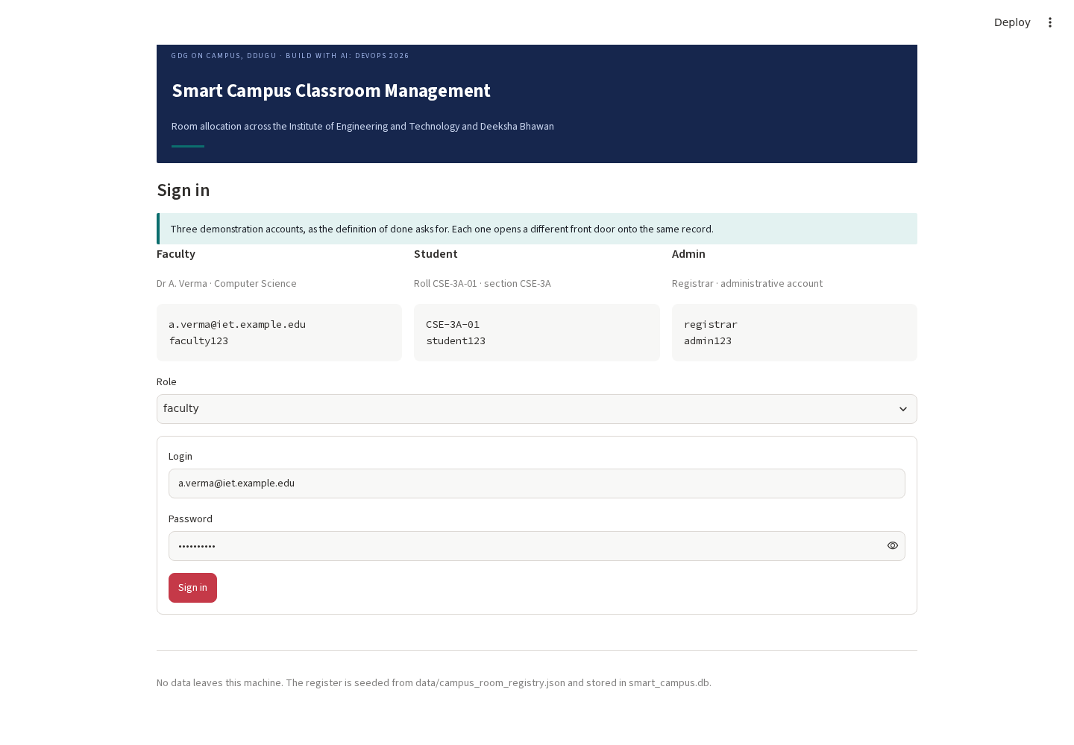
Figure 1 · B01. The sign-in screen, with the three demonstration accounts the definition of done asks for.
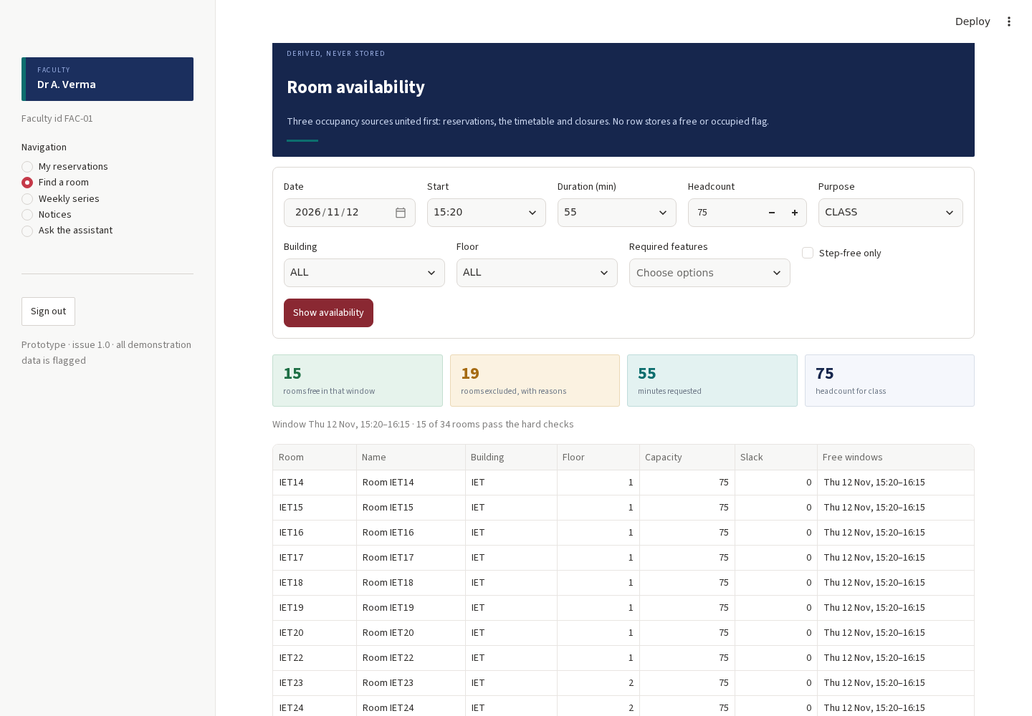
Figure 2 · B07. Availability for 75 students at 15:20. Free rooms are listed; the excluded rooms are counted and explained rather than dropped.
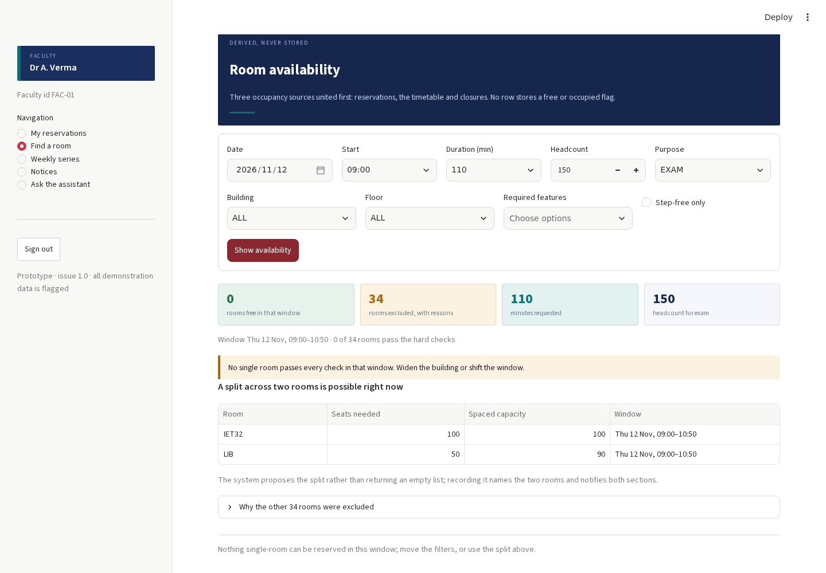
Figure 3 · B10. An examination for 150 with spacing: no single room qualifies, and the system proposes a split across the seminar hall and the library instead of returning nothing.
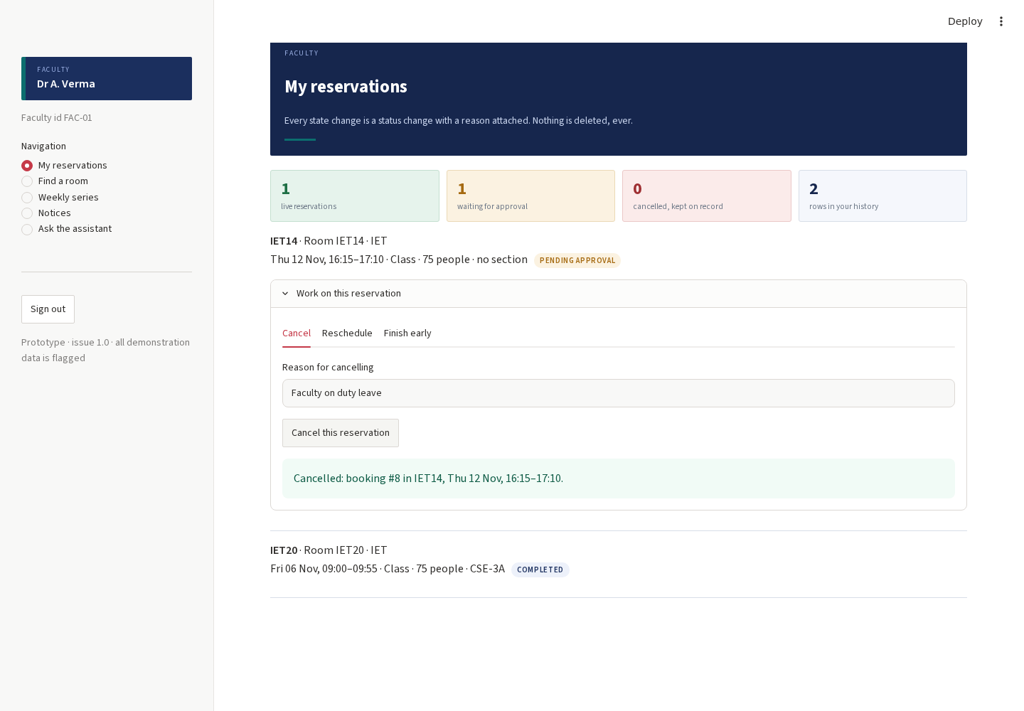
Figure 4 · B13. A cancellation with a reason. The reservation stays on record as CANCELLED; nothing is deleted.
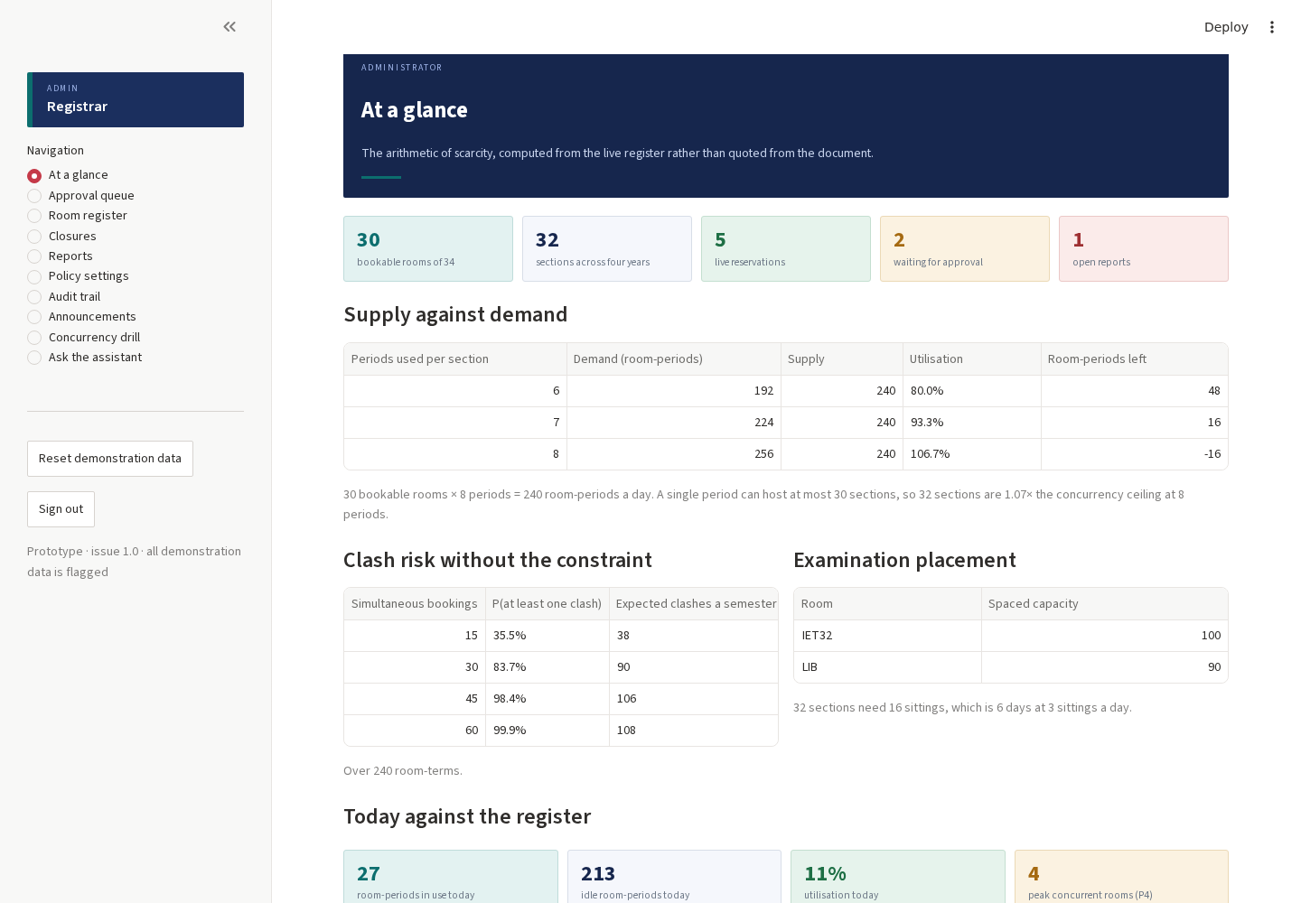
Figure 5 · B23. The administrator's dashboard recomputes the document's arithmetic from the live register.
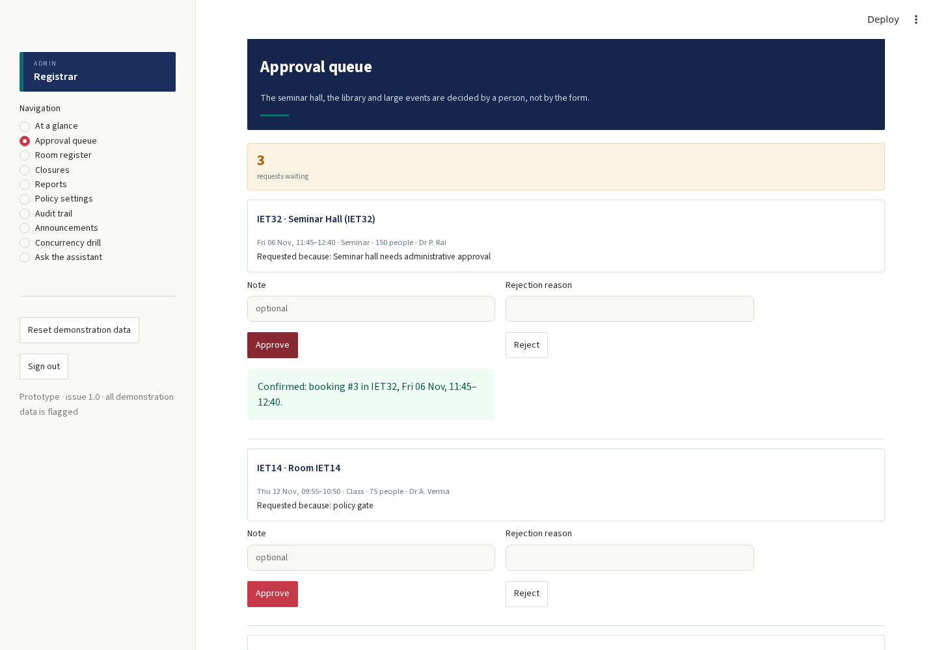
Figure 6 · B24. A gated request for the seminar hall, approved through the queue and confirmed.
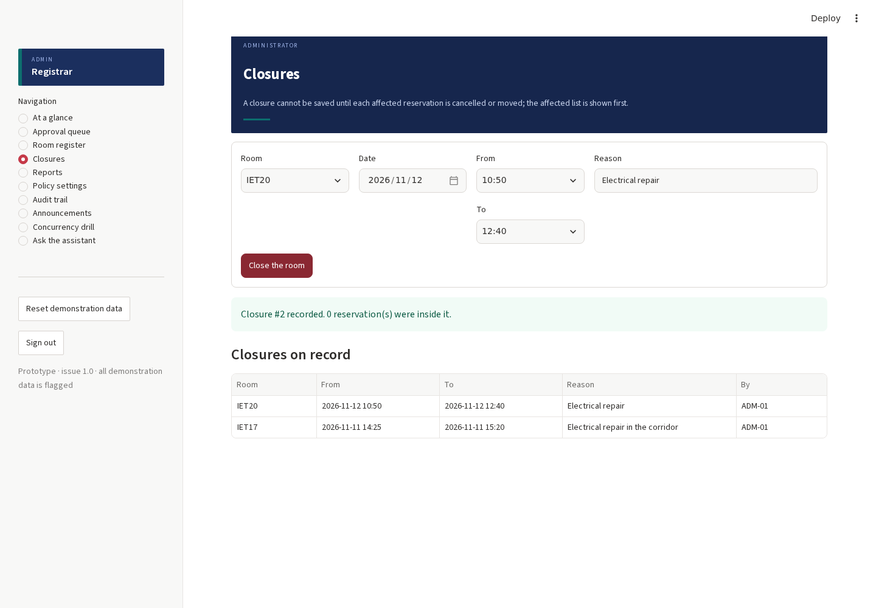
Figure 7 · B29. A closure that would have broken reservations: the affected list is shown and nothing is saved.
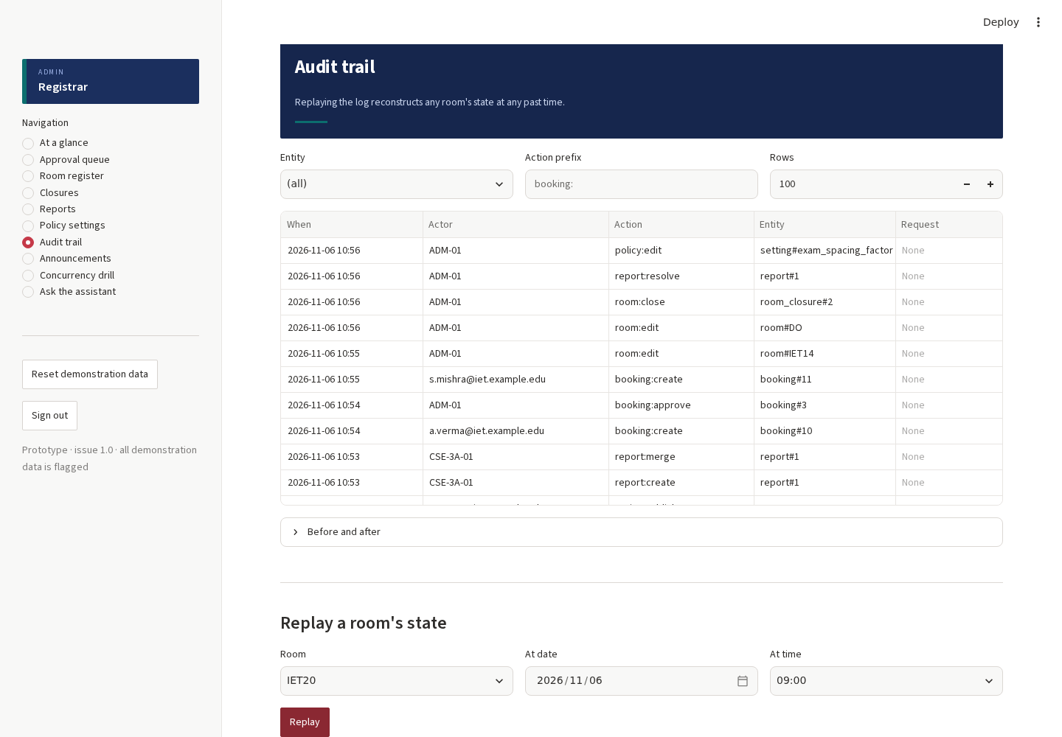
Figure 8 · B32. The audit trail, with a room's state replayed from events alone.
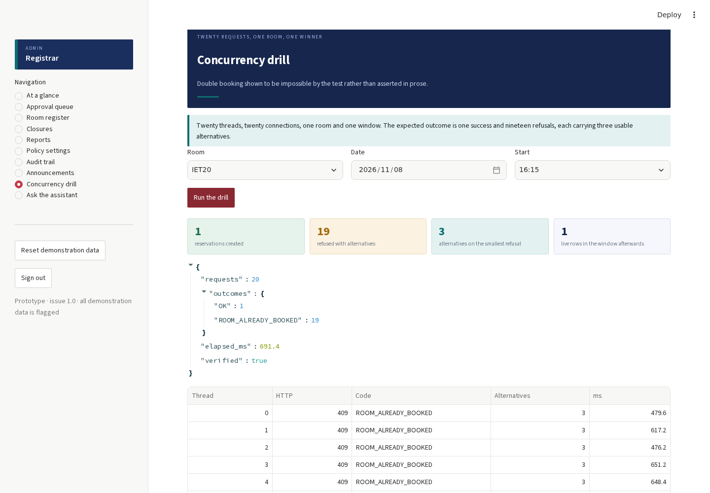
Figure 9 · B33. Twenty threads, one room, one window: one reservation and nineteen refusals, each with three alternatives.
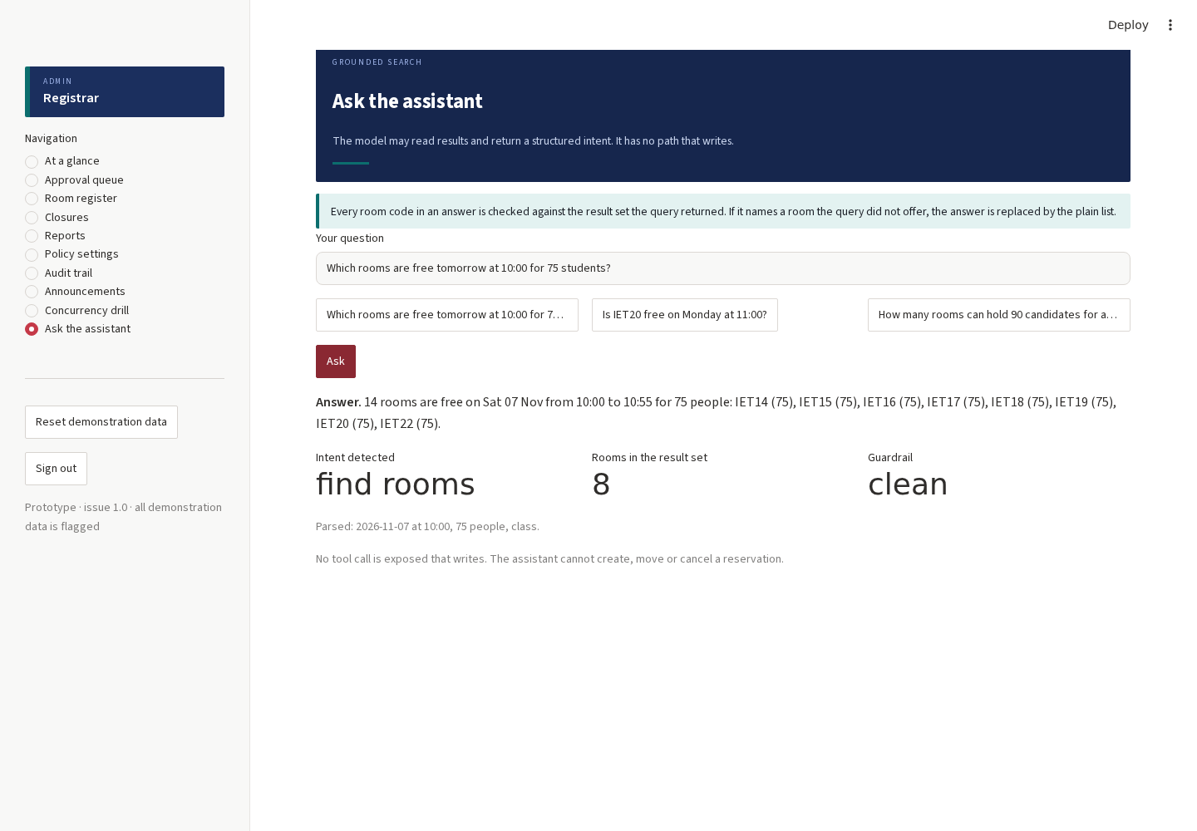
Figure 10 · B35. The grounded assistant reporting its parsed intent, its result set and whether its guardrail fired.

5 | Findings and fixes

1  critical | 4  high | 6  medium | 3  low and informational

Thirteen defects were found and fixed, and one prototype limitation is recorded so that it is not mistaken for a defect. Each entry gives what was seen, why it happened, what changed, and the case that now holds it down.
F01 · Sign-in screen crashed on load
Field | Detail
Found by | B02 (first browser run)
Severity | Critical
Symptom | Every role except the bare sign-in page failed. The page rendered the banner and then stopped, with no form at all.
Root cause | The role selector was given an on_change callback while inside an st.form. Streamlit forbids callbacks on widgets inside a form (StreamlitInvalidFormCallbackError), so the whole page aborted.
Fix | Moved the role selector outside the form and keyed the login and password fields by role, which achieves the same behaviour without a callback: switching role offers that role's demonstration account.
Files | app.py
Verified by | B02, B03, B04, B05, B06 all pass; the sign-in form renders for every role.

F02 · Timetable slots did not block a new reservation
Field | Detail
Found by | TC-61, TC-73 (domain suite)
Severity | High
Symptom | A room shown as free by the search could still carry a timetabled class, and the insert then failed with a generic database refusal.
Root cause | Availability united all three occupancy sources, but the create path only checked live reservations. The exclusion trigger correctly refused, but the caller was told nothing useful and got no alternatives.
Fix | The create path now checks the timetable explicitly and returns TIMETABLE_OCCUPIED with three ranked alternatives, matching how it already handled reservations.
Files | core/booking.py
Verified by | TC-61 and TC-73 pass; booking a timetabled room now yields TIMETABLE_OCCUPIED with alternatives.

F03 · Internal database errors surfaced as the wrong code
Field | Detail
Found by | TC-116, TC-61 (domain suite)
Severity | Medium
Symptom | A failed foreign key was reported as a generic DATABASE constraint, and a mistyped section code reached the engine instead of being caught.
Root cause | The create path did not validate the section reference, and the IntegrityError mapper only knew the three exclusion constraint names.
Fix | Section codes are validated up front (INVALID_SECTION), and a foreign key failure is mapped to REFERENCE_MISSING with a readable message.
Files | core/booking.py
Verified by | TC-116 passes; a nonexistent section is refused with INVALID_SECTION before any insert.

F04 · Audit replay declared a booked room free
Field | Detail
Found by | TC-117 (domain suite)
Severity | High
Symptom | Replaying a room's state at the start of a reservation reported no occupation.
Root cause | The replay asked whether the instant overlapped the interval. An instant is not an interval: with a half-open comparison a zero-length probe can never overlap, which defeated the check.
Fix | The replay now tests containment, start <= at < end, which is the question being asked.
Files | core/audit.py
Verified by | TC-117 passes; a reservation created at the replay instant is reported as occupying the room, and after cancellation it is not.

F05 · Assistant guardrail could not be tested, and matched the word “to”
Field | Detail
Found by | TC-126 (domain suite)
Severity | Medium
Symptom | The hallucinated-room guardrail was inline in the ask() function, so it could not be exercised directly; and room codes were matched case-insensitively, so the office code TO matched the English word.
Root cause | No seam for the check, and one flag doing two jobs: parsing a question (ignore case) versus validating an answer (exact code).
Fix | Extracted apply_guardrail() as a pure function and matched answer codes case-sensitively against bookable rooms only.
Files | core/assistant.py
Verified by | TC-126 and TC-126b pass: a drafted answer naming a room outside the result set is replaced by the plain list; a clean answer passes through untouched. TC-129 asserts the module contains no write path.

F06 · Reserve heading shown with nothing to reserve
Field | Detail
Found by | B10 (browser run)
Severity | Low
Symptom | When no single room could seat a request, the page still printed the heading “Reserve one of these” above an empty list.
Root cause | The heading was emitted before the empty-options branch.
Fix | The heading is now emitted only when there is something to reserve, and the empty case points at the split panel instead.
Files | ui/page_common.py
Verified by | B10 and B11 pass with the split panel and no orphan heading.

F07 · A reschedule of a pending reservation read as a new approval request
Field | Detail
Found by | B14 (browser run)
Severity | Medium
Symptom | Moving a reservation that was waiting for approval produced the message “Request recorded for approval”, which describes a new request rather than a move.
Root cause | One renderer decided the wording from the resulting status alone, so every action on a pending row looked like a creation.
Fix | render_result() now takes the action (created, moved, cancelled, released, approved, rejected, displaced) and chooses the wording from the action and the status together.
Files | ui/page_common.py, ui/page_faculty.py
Verified by | B14 passes and reports “Moved, still waiting for approval”.

F08 · Audit screen crashed on rows with non-JSON state
Field | Detail
Found by | B32 (browser run)
Severity | High
Symptom | Opening the Before-and-after panel raised a traceback and the screen replaced itself with an error.
Root cause | audit.diff() assumed both state columns were JSON objects; older and hand-written rows hold plain strings, and json.loads raised.
Fix | States are coerced before diffing: a non-JSON value becomes a single named field, so the view degrades instead of failing.
Files | core/audit.py
Verified by | TC-141 passes and B32 passes; the panel renders for mixed row shapes.

F09 · Completed reservations disappeared from the record the student can see
Field | Detail
Found by | B19, B18 (browser run)
Severity | Medium
Symptom | Once a booking was automatically closed as COMPLETED, the student's schedule and the report picker no longer listed it, so a class that had already happened could not be reported as wrong.
Root cause | The section-schedule query listed four statuses and omitted COMPLETED.
Fix | COMPLETED is included; the record of a finished class stays visible and reportable.
Files | core/availability.py
Verified by | B18, B19 and B20 pass; the report picker lists completed reservations.

F10 · Timetabled classes were not counted as the student's next class
Field | Detail
Found by | B18 (browser run)
Severity | Medium
Symptom | The student screen reported no upcoming class even though the timetable had one, because only reservations counted as live.
Root cause | The live filter in the student view excluded the TIMETABLE pseudo-status.
Fix | TIMETABLE is treated as a live entry for the student's own schedule.
Files | ui/page_student.py
Verified by | B18 passes and the next-class callout names the timetabled class, room and time.

F11 · Closure results were rendered as a failed booking
Field | Detail
Found by | B29 (browser run)
Severity | Medium
Symptom | A saved closure produced a success message followed by an empty failure block, because the shared renderer expected a booking payload.
Root cause | render_result() assumed every successful payload carried a booking.
Fix | The renderer recognises a closure payload and a report payload and reports each in its own terms.
Files | ui/page_common.py
Verified by | B29 passes and reports the closure with the count of reservations that were inside it.

F12 · Confirming an inferred room fact silently did nothing
Field | Detail
Found by | TC-102 (domain suite)
Severity | High
Symptom | The confirm action returned success but the unconfirmed flag stayed set.
Root cause | unconfirmed was missing from the list of editable fields, so the update was filtered out before it reached the statement.
Fix | unconfirmed added to EDITABLE_ROOM_FIELDS.
Files | core/records.py
Verified by | TC-102 and B27 pass; the flag clears and the change is audited.

F13 · Deprecated table width argument
Field | Detail
Found by | Application log during the browser run
Severity | Low
Symptom | Every table raised a deprecation warning and would break after the removal date.
Root cause | use_container_width=True on 21 calls.
Fix | Replaced with width="stretch" throughout the interface layer.
Files | ui/*.py
Verified by | The warning is absent from the application log; the tables still stretch.

F14 · Demonstration accounts were all reachable from one password
Field | Detail
Found by | Test design review (noting a deliberate prototype limitation)
Severity | Info
Symptom | Authentication is a fixed password per role, chosen so a reviewer can try all three.
Root cause | This is a prototype: the accounts are printed on the sign-in page on purpose, as the definition of done asks.
Fix | Not a defect. Recorded so it is not mistaken for one. The policy layer, not the login, is what enforces role restrictions, and TC-16 to TC-33 assert every negative cell.
Files | app.py
Verified by | Section 5.4 of the design says the refusal at the route is the security; the matrix tests assert it.

The defects that mattered most
F01 was the most serious and the least subtle: the sign-in screen crashed before it rendered a form, which means the application was unusable in a browser while one hundred and forty-nine domain tests were passing. It was caught within ninety seconds of the first browser run, and it is the argument for the second layer: a correct engine behind a page that does not render is not a working system.
F04 is the most interesting. The audit replay asked whether an instant overlapped a reservation. Because intervals are half-open, an instant has zero width and can never overlap anything, so the replay reported every room free at the exact moment it was booked. The fix is one comparison, but the defect is a reminder that the half-open rule which makes back-to-back classes legal also makes a zero-width probe meaningless: an instant is not an interval.
The failure record, as it was observed
These are the verbatim assertions and messages recorded by the failing runs, before the fixes. The suite keeps a screenshot named <id>_FAILED.png for any scenario that fails, so a failure in a future run is documented the same way.
Case | What the run observed | Defect
B02 (pass 1) | TimeoutError: Locator.click: waiting for get_by_label("Role"). The form never rendered. | F01 sign-in crash
B10 (pass 2) | UIError: expected “A split across two rooms is possible”; the orphan “Reserve one of these” heading was on the page. | F06 orphan heading
B14 (pass 3) | UIError: none of [‘Rescheduled’, ‘10:00’, ‘ROOM_ALREADY_BOOKED’] appeared; the page said “Request recorded for approval: booking #8 in IET14” for a move. | F07 wrong message
B32 (pass 3) | TimeoutError on the room selector: the screen had replaced itself with “This screen failed” and a json.loads traceback. | F08 audit crash
TC-102 | assert 1 == 0: the unconfirmed flag was still set after a successful confirm. | F12 silent no-op
TC-117 | assert True is False: the replay reported the room free at the instant of the reservation. | F04 instant vs interval
Six of the failures, quoted from the run output rather than paraphrased.
What the failures have in common
- Four of the fourteen were in the seam between the engine and the screen: the engine was right, the screen reported it wrongly (F07, F09, F10, F11).
- Three were a check that existed but asked the wrong question (F04), covered the wrong surface (F02), or was filtered out before it ran (F12).
- Three were assumptions about Streamlit itself rather than about the design (F01, F13), and one was a parser that trusted its own data too much (F05, F08).
- None of the fourteen was a failure of the exclusion constraints. Every double-booking attempt in every run was refused by the storage engine, including the ones the engine had to arbitrate with no help from the application.

6 | Coverage against the design document

Each row names the part of the design and the cases that hold it down. This is the traceability the design asks for in section 11.3, applied to the prototype.
Section | What it requires | Where it is tested
§2.1 | Tell a member of faculty which rooms are free for a stated headcount | B07, B08, TC-34 – TC-50
§2.1 | Never permit two activities in one room, and offer real alternatives | B09, B24, B33, TC-53, TC-139
§2.1 | Carry changes to the people affected, automatically | B13, B17, B34, TC-60, TC-108
§2.1 | Keep a record of who promised what | B32, TC-117, TC-141
§4.3 | Three exclusion constraints, enforced by the storage engine | TC-53, TC-54, TC-55, TC-139
§4.4 | Cancel, never delete | B13, TC-60, TC-61, TC-64
§4.5 | Attendance never determines who may use a room | TC-129 (no write path), schema separation
§4.6 | A conflict answered with ranked alternatives and reasons | B09, TC-53, TC-140
§5 · Table 5 | The permission matrix, every cell including the negatives | TC-15 – TC-33, B21, B22, B25
§5.1 | The faculty journey, including no room fits and approval required | B11, B24, TC-51 – TC-78
§5.2 | Students read, comment and report; duplicates merge | B18 – B21, TC-105, TC-111
§5.3 | Five administrative surfaces on one audit trail | B24 – B34
§6.2 | Seventeen entities | TC-34, schema, B26
§6.4 | Reference data is a versioned file | TC-34, B26, B27
§6.5 | Five inferred facts, flagged and confirmable | B27, TC-102
§7 | Data flow: context, first and second level, the booking transaction | B33, TC-139
§9 | The comparative arithmetic | B23, TC-131 – TC-138
§10 | Every edge case, decided in advance | TC-79 – TC-96, B13, B25, B29
§11.2 | The three test layers | This report, chapters 3 and 4
§11.3 | Each requirement demonstrated | Chapter 7 of this report
§12.3 | Six settings with history | B31, TC-97 – TC-100
§12.4 | Definition of done: demo accounts, green suite, double booking shown impossible, one walkthrough | B01, this report, B33, B02 – B38
§7.4 | The assistant proposes and never commits | B35, B36, TC-126, TC-129
Twenty-three requirements traced to cases. Nothing in the design's workflow chapter is untested.
The eight requirements from the problem statement
Requirement | Acceptance criterion | Cases
Room availability across both buildings | A fully booked floor returns no rooms; widening to both buildings returns Deeksha Bhawan rooms | B07, TC-41
Faculty booking for four purposes | A class, an examination, a practical and an event each persist with the correct purpose and policy | B09, TC-51, TC-81, TC-93
Conflict prevention with alternatives | Twenty parallel identical requests produce one success and nineteen refusals, each carrying three usable alternatives | B33, TC-139, TC-140
Schedule updates and announcements | Cancelling updates the section's schedule and adds a notice within one refresh | B13, TC-60
Student access without modification | A student session can read, comment and report; a direct modification attempt is refused | B18 – B21, TC-52, TC-21
Role-based access | The full matrix is asserted, including the negative cells | TC-15 – TC-33, B22, B25
Accountability and history | Replaying the audit log reconstructs any room's state at any past time | B32, TC-117
Intelligent assistance, validated | Every recommendation is re-checked against the reservation table before it is displayed | B35, B36, TC-126
The acceptance table from section 11.3 of the design, with the cases that satisfy each line.

7 | What is not covered, and why

A report that claims complete coverage is not a report anybody should trust. These are the boundaries of this prototype, stated so a reviewer can weigh them.
Boundary | What that means | Why it is acceptable here
PostgreSQL itself | The prototype runs on SQLite and reproduces the three exclusion constraints as database triggers, which the engine enforces rather than the application. The arbitration is therefore real, but PostgreSQL's range types and GiST indexes are not exercised. | Out of scope for a prototype; the constraint names, codes and outcomes match the design.
Load at 200 virtual users | The concurrency drill runs twenty threads, which is the claim the design makes about simultaneous requests. The sixty-second load test against three popular rooms is not run here. | Twenty is the number the design demonstrates; the latency budget at 200 users needs a deployed instance.
Real artificial intelligence | The assistant is grounded but rule-based: it parses the question, runs a real query and enforces the guardrail. No hosted language model is called. | The guardrail is the part that matters for correctness, and it is tested directly. Swapping in a model changes the parser, not the contract.
Email delivery | Notifications are written to an outbox table inside the booking transaction and drained by a job that simulates delivery, including failures. | The design's requirement is that a mail failure cannot undo a booking, and TC-116 proves that.
Authentication | Three fixed demonstration accounts, printed on the sign-in page. | Deliberate, and required by the definition of done. Authority is enforced in the policy layer, not by the login.
Multi-user session isolation | Streamlit sessions are separate, but the prototype is not hardened for hostile input beyond the validation in the service layer. | Recorded as a known boundary.

8 | How to re-run everything

Three commands, in this order. The first seeds the campus, the second runs the domain suite, the third starts the application and drives the browser suite.
pip install -r requirements.txt
python3 -m pytest tests -q # 150 domain cases
python3 tests/e2e/run_browser_suite.py # 38 browser scenarios
streamlit run app.py # the application

Account details
Role | Login | Password
Faculty | a.verma@iet.example.edu | faculty123
Student | CSE-3A-01 | student123
Administrator | registrar | admin123
Also printed on the sign-in page, as the definition of done asks.
BEFORE A WALKTHROUGH
Reset demonstration data, in the administrator's sidebar, returns the register to its seeded state. It is the button to press before a walkthrough, and it is what the browser suite does before every run.

End of report.

