ENSF-381: Full Stack Web Development Laboratory
Lab04

GitHub Link:

Group information:
Omar Al-Mahfoodh UCID# 30254262
Javier Dal Monte Casoni UCID# 30257072

Exercise 1: Exploring JavaScript Fundamentals

1A: Variable Declaration

Variable Declarations (var, let, const):

var x = 10;
let y = 20;
const z = 30;

Observation - Reassigning let:

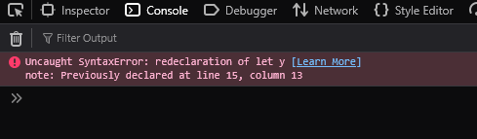

Observation - Reassigning const:

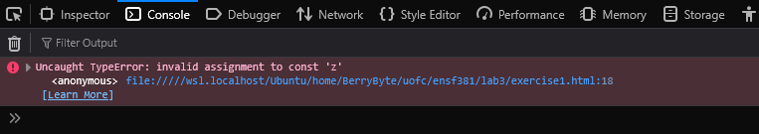

Try...Catch Block Code:

<script>
var x = 10;
let y = 20;
const z = 30;
try {
x = 15;
y = 25;
z = 35;
} catch (error) {
console.error("Error: cannot reassign const")
}
</script>

Console Output:

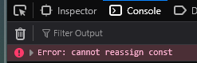

1B: String Operations

Code Implementation:

let string1 = "Hello, World!"
let string2 = "JavaScript is fun!"

length1 = string1.length; // Getting the length of string1
console.log("Length of string1: " + length1);

concatenatedString = string1 + " " + string2; // Concatenating string1 and string2
console.log("Concatenated String: " + concatenatedString);

var string3 = string2.replace("fun", "awesome"); // Replacing "fun" with "awesome" in string2
console.log("String 3: " + string3);

Console Output:

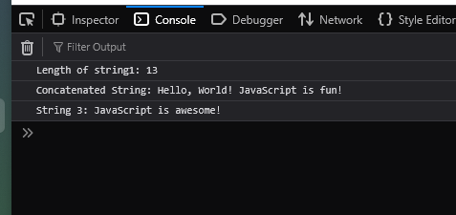

1C: String Templates

Template Literal Code:

let name = "Alice"
let age = 25
let message = `My name is ${name} and I am ${age} years old.`
console.log(message)

Console Output:

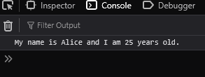

1D: Iteration

Loop Implementation:

const students = ["Alice", "Tom", "Charlie"]
const ages = [19, 21, 20]

for (let index = 0; index < students.length; index++) {
const student = students[index];
const age = ages[index];
console.log(`My name is ${student} and I am ${age} years old.`);
}

Console Output:

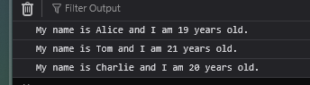

1E: Working with Dates

Date Code:

year = current_date.getFullYear();
month = current_date.getMonth() + 1; // Months are zero-indexed, so 1 for correction
weekday = current_date.toLocaleDateString('en-US', { weekday: 'long' }); // weekday name in English
season = (month >= 3 && month <= 5) ? "Spring" :
(month >= 6 && month <= 8) ? "Summer" :
(month >= 9 && month <= 11) ? "Autumn" : "Winter";

console.log("Year: " + year);
console.log("Month: " + month);
console.log("Weekday: " + weekday);
console.log("Season: " + season);

Console Output:

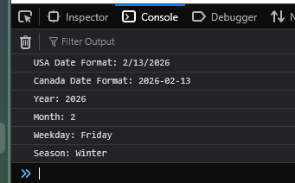

Exercise 2: Building a Simple Calculator

2A: Declaring Functions

Function Definitions (add and subtract):

function add(a, b){
return a + b;
}
function subtract(a, b){
return a - b;
}

Test Results:
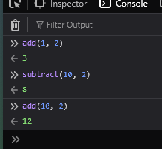

2B: Using Default Parameters

Modified Functions:

function add(a, b=5){
return a + b;
}
function subtract(a, b=5){
return a - b;
}

Observation:

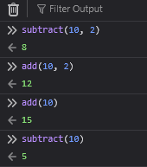

2C: Implementing Arrow Functions

// arrow syntax
const add = (a, b=5) => a + b;
const subtract = (a, b=5) => a - b;
const multiply = (a, b=5) => a * b;
const divide = (a, b=5) => b === 0 ? "Error: Division by zero is not allowed." : a / b;

Observation:
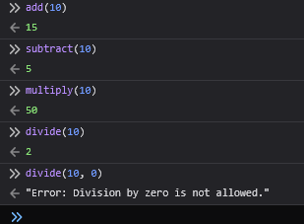

2D: Understanding Callback Functions

Calculator Function Code:

<h1>JavaScript Lab Exercise 2</h1>
<script>
/*
function add(a, b=5){
return a + b;
}
function subtract(a, b=5){
return a - b;
}

*/

// arrow syntax
const add = (a, b=5) => a + b;
const subtract = (a, b=5) => a - b;
const multiply = (a, b=5) => a * b;
const divide = (a, b=5) => b === 0 ? "Error: Division by zero is not allowed." : a / b;

function calculator(num1, num2, operation) {
return operation(num1, num2);
}

Test Results:

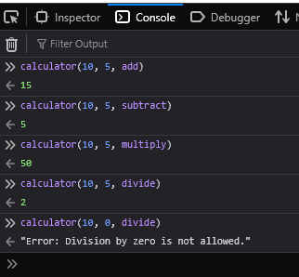

Exercise 3: Managing Data with JavaScript

3A: Arrays and Basic Methods

Array Code:

let classRoster = ["Alice", "Tom", "Charlie", "Diana", "Evan"];
console.log("Initial Array: " + classRoster);

// To string
classRoster = classRoster.toString();
console.log("Converted to String : " + classRoster);

// To array
classRoster = classRoster.split(",");

classRoster.push("Fionna");
classRoster.push("Nancy");

removedStudent = classRoster.shift(); // Remove Alice
console.log("Removed Student: " + removedStudent);

console.log("Updated Class Roster: " + classRoster);

Console Outputs:

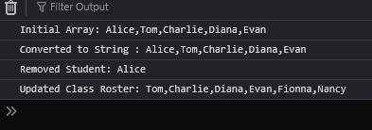

3B: Objects with Nested Structures

Object Code:

// --- ENSF 381 -- Lab 3 Exercise 3, A ---

let classRoster = ["Alice", "Tom", "Charlie", "Diana", "Evan"];
//console.log("Initial Array: " + classRoster);

// To string
//classRoster = classRoster.toString();
//console.log("Converted to String : " + classRoster);

// To array
//classRoster = classRoster.split(",");

classRoster.push("Fionna");
classRoster.push("Nancy");

removedStudent = classRoster.shift(); // Remove Alice
//console.log("Removed Student: " + removedStudent);

//console.log("Updated Class Roster: " + classRoster);

// --- ENSF 381 -- Lab 3 Exercise 3, B ---
classInfo = Object();
classInfo.className = "ENSF381: Full-Stack Web Development";
classInfo.instructor = "Dr. Smith";
classInfo.students = classRoster;
classInfo.details = Object();
classInfo.details.semester = "Winter";
classInfo.details.year = 2026;
classInfo.schedule = ["Monday", "Wednesday", "Friday"];

classInfo.instructor = "Dr. Abdellatif" // Update instructor name

console.log("Class Name: " + classInfo.className);
console.log("Instructor: " + classInfo.instructor);
console.log("Students: " + classInfo.students);
console.log("Semester: " + classInfo.details.semester);
console.log("Year: " + classInfo.details.year);
console.log("Schedule: " + classInfo.schedule);

// Destructuring
// className and students into variables
const { className, students } = classInfo;
console.log("Destructured Class Name: " + className);
console.log("Destructured Students: " + students);

// semester and year into variables
const { details: { semester, year } } = classInfo;
console.log("Destructured Semester: " + semester);
console.log("Destructured Year: " + year);

// first 2 students into variables
const [student1, student2, ...remainingStudents] = students;
console.log("First Student: " + student1);
console.log("Second Student: " + student2);
console.log("Remaining Students: " + remainingStudents);

Console Outputs:

