1. Write a program to get the following output.

Hey there,

I am “*some data*”! (assign a variable and print the variable data)

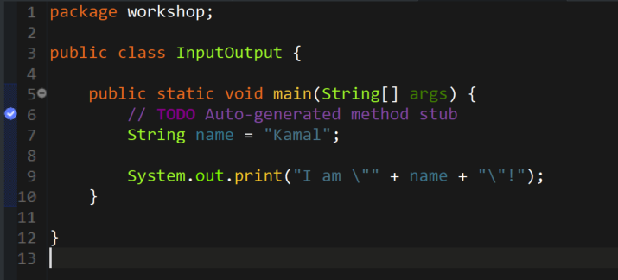

OUTPUT:



1. Write a program to print the difference and product of numbers 45 and 32.

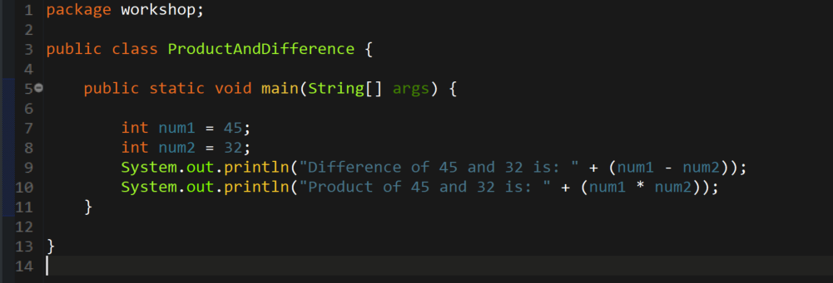

OUTPUT:

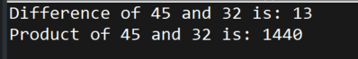

1. Write a Java program to print an int, a double, and a char on the screen.

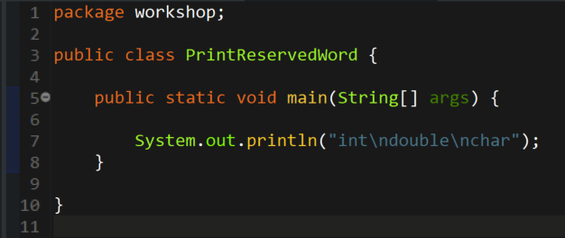

OUTPUT:

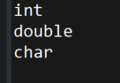

1. Write a program to calculate the area of a triangle.

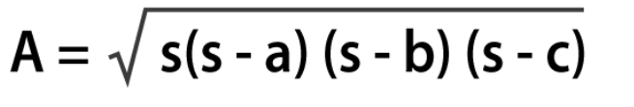

Where s is the semi-perimeter of the triangle s = (a+b+c)/

2

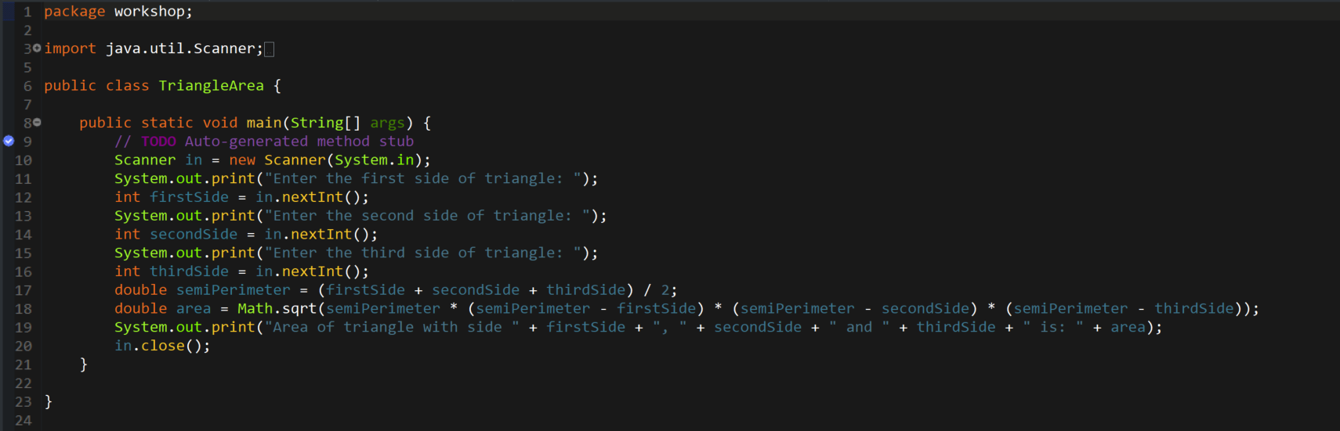

OUTPUT:

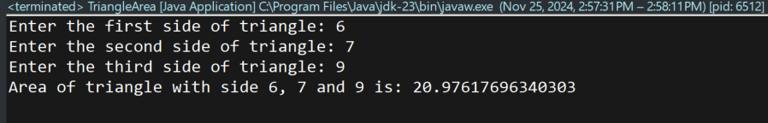

1. Write a Java program to calculate the area of a square. Prompt the user to enter the length of one side and then display the result. Ensure that the program handles user input as a double data type.

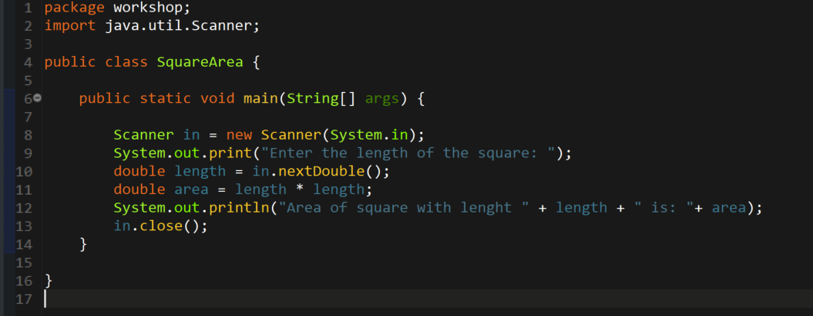

OUTPUT:

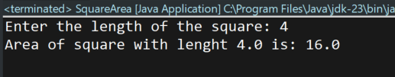

1. Create a Java program that converts a temperature in Celsius to Fahrenheit. Prompt the user to enter the temperature in Celsius, perform the conversion using the formula (F = C \* 9/5 + 32), and display the result as a double.

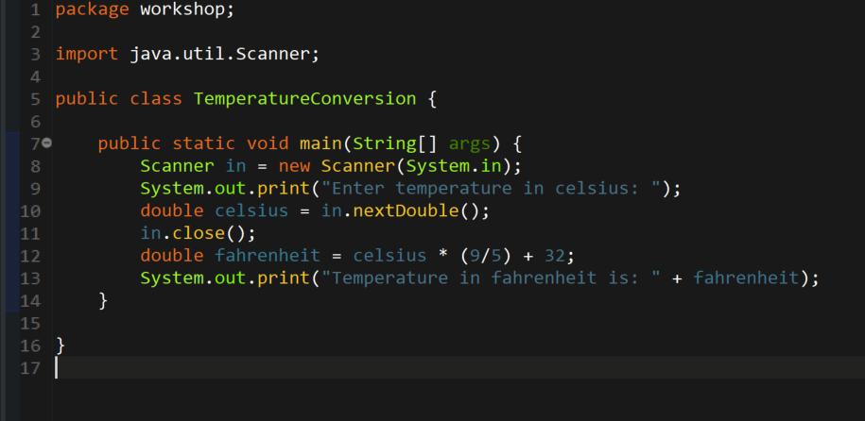

OUTPUT:

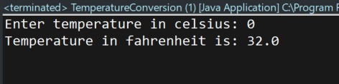

1. Develop a Java program that calculates the volume of a cylinder. Prompt the user to enter the radius and height of the cylinder and then display the result. Ensure that the program uses appropriate data types for calculation and output.

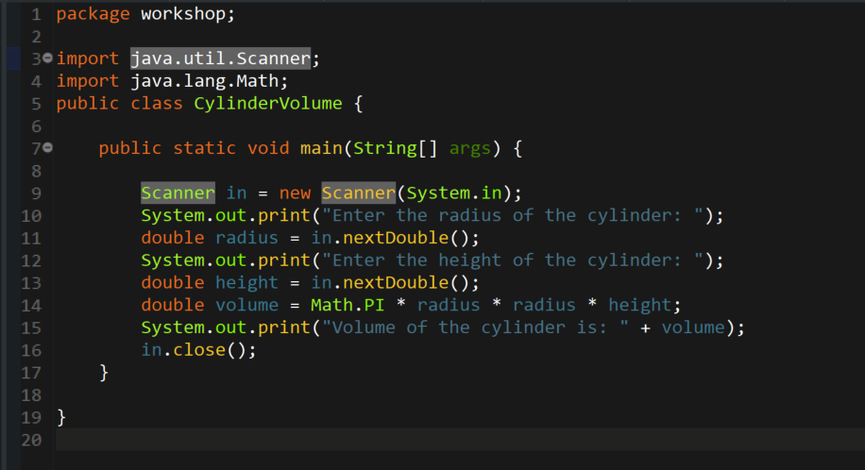

OUTPUT:

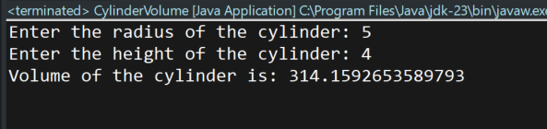

1. Write a Java program that calculates the simple interest on a loan. Prompt the user to enter the principal amount, the rate of interest, and the time period. Calculate and display the interest amount as a double.

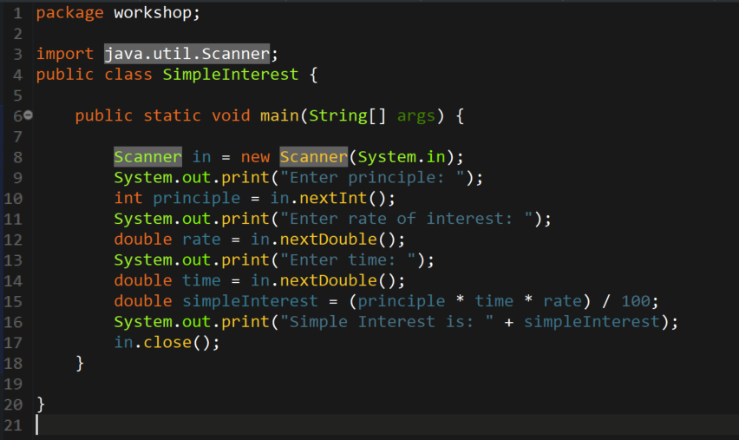

OUTPUT:

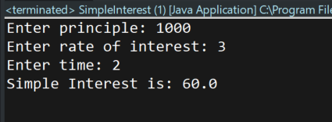

1. Create a Java program that takes two integer inputs from the user, performs all basic arithmetic operations (addition, subtraction, multiplication, and division) on these numbers, and displays the results.

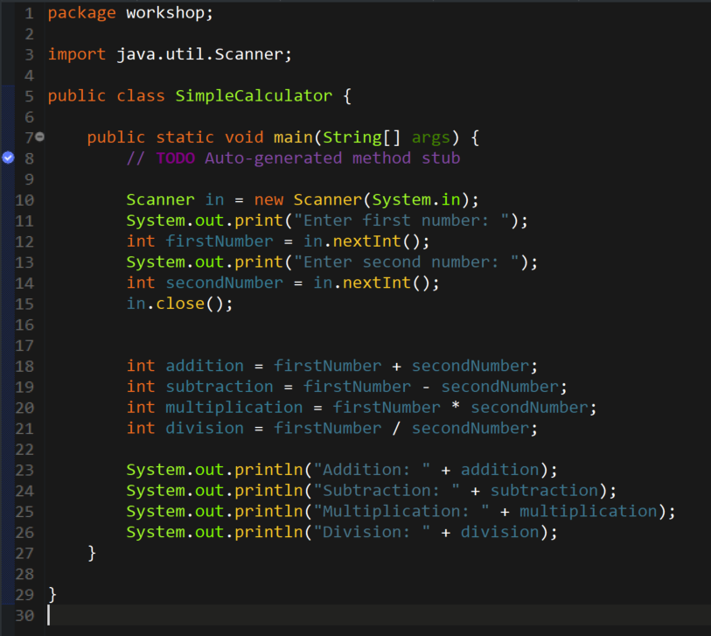

OUTPUT:

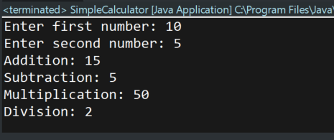

1. Write a Java program that calculates the perimeter of a rectangle. Prompt the user to enter the length and width of the rectangle, and then display the result. Use appropriate data types for calculation and output.

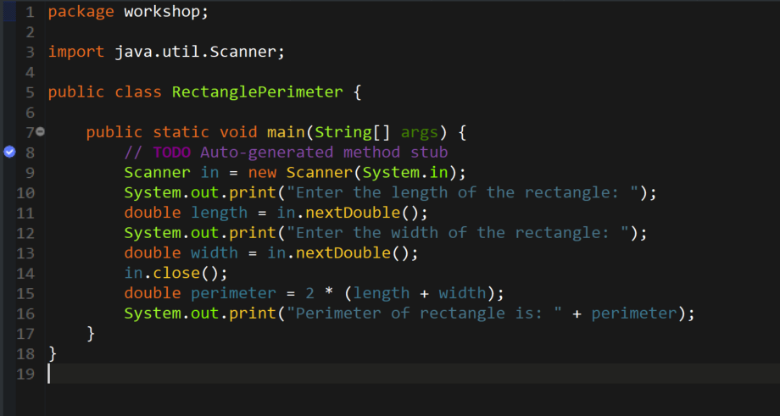

OUTPUT:

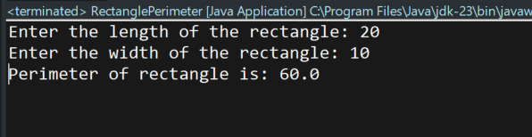

1. Develop a Java program that converts miles to kilometers. Prompt the user to enter the distance in miles and display the equivalent distance in kilometers as a double.

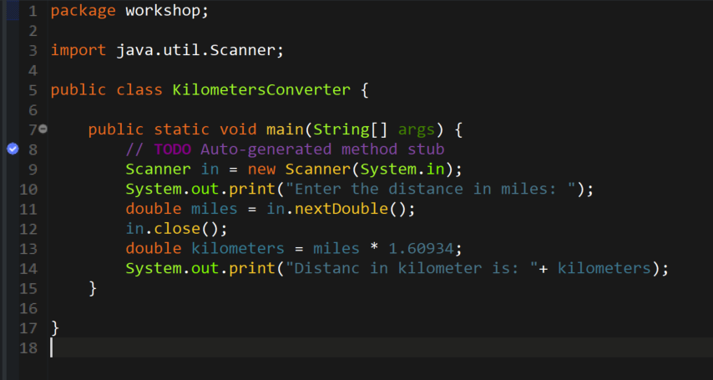

OUTPUT:

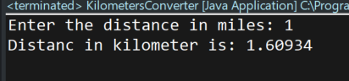

1. Create a Java program that computes the area of a circle. Prompt the user to enter the radius and display the result as a double. Use the formula (Area = π \* r \* r) for the calculation.

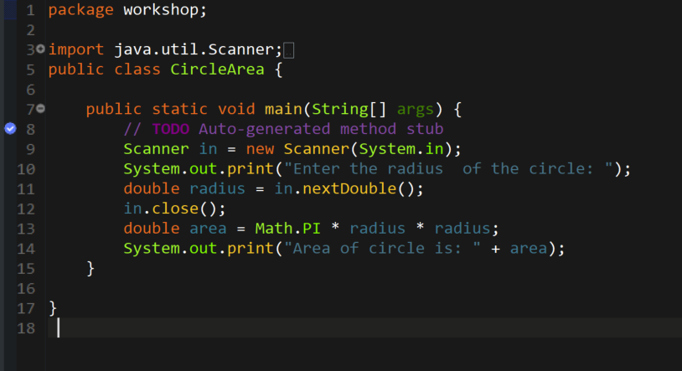

OUTPUT:

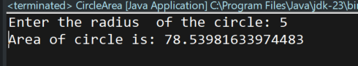

1. Develop a Java program that calculates the total cost of purchasing a given quantity of items at a certain price per item. Prompt the user to enter the quantity and price, and display the total cost as a double.

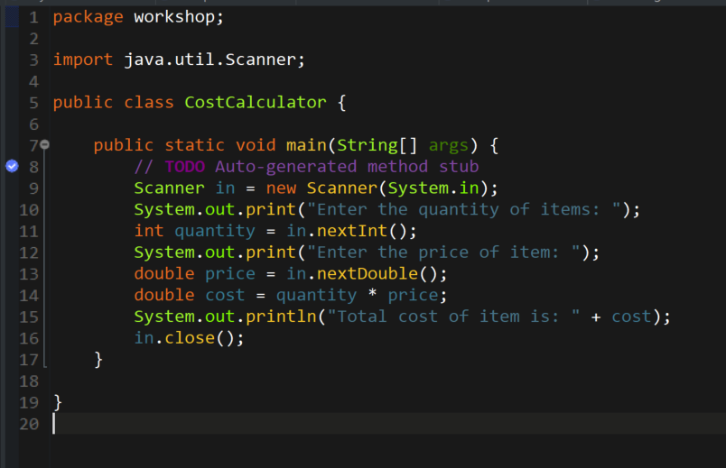

OUTPUT:

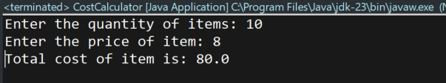

1. Write a Java program that converts a given amount of money in U.S. dollars to another currency (e.g., rupees). Prompt the user to enter the amount and the exchange rate, and display the converted amount as a double.

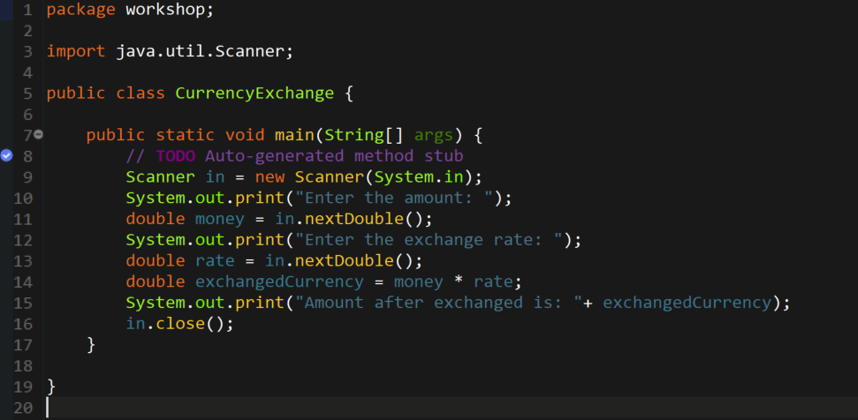

OUTPUT:

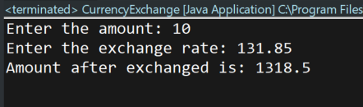

1. Create multiple Person objects using different constructors and print their details.

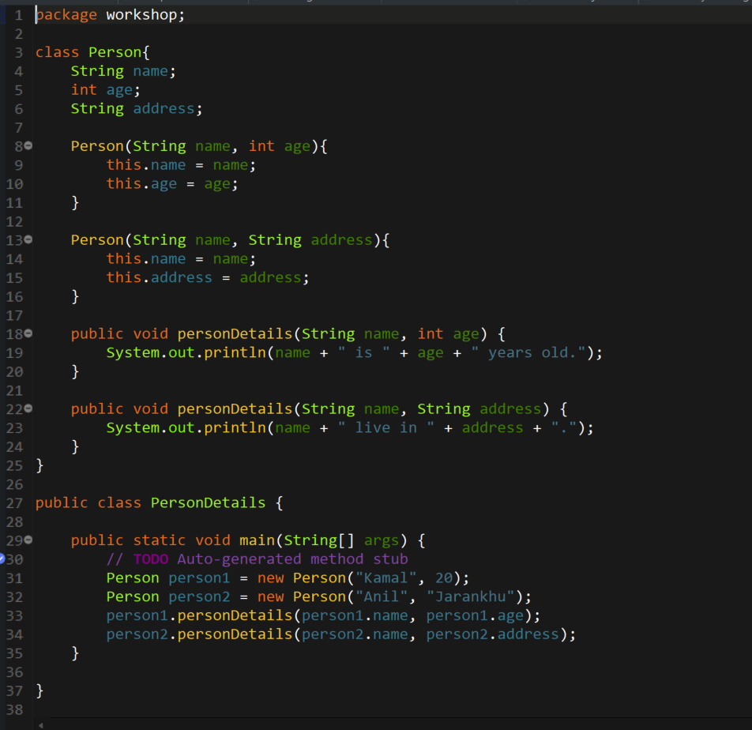

OUTPUT:

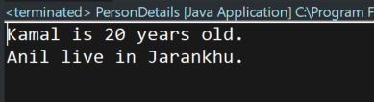

1. Create a Book class with fields title, author, and year. Override the toString() method to return a formatted string representation of a Book object.

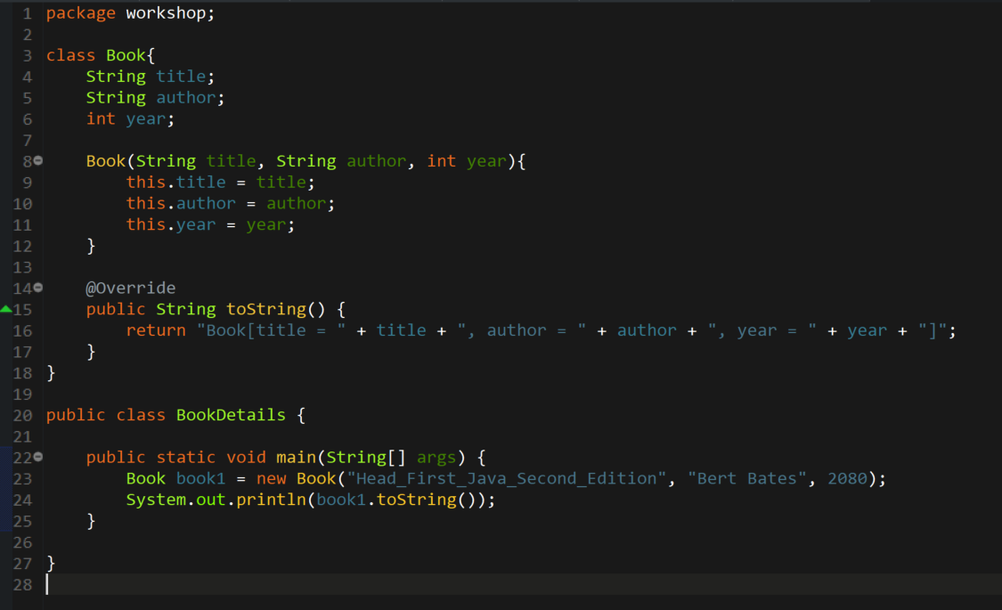

OUTPUT:

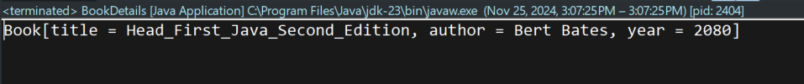

1. Create a class Rectangle with fields for width and height. Add a constructor to initialize these fields. Override the toString() method to return the rectangle's dimensions in a readable format.

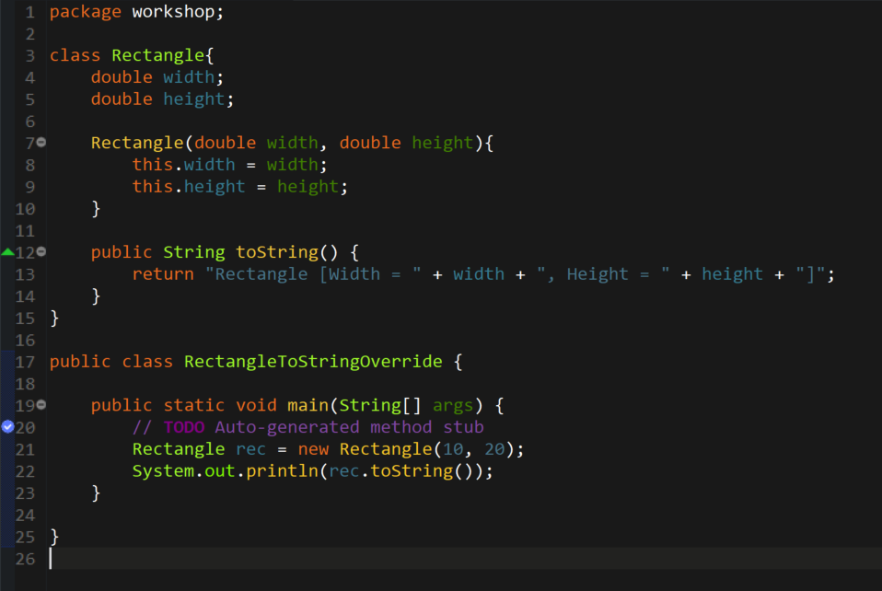

OUTPUT:

