### **Project Scenario**

You are tasked with creating a simple Java-based Student Management System for week 8 practice. The system will include basic functionality for adding student information, displaying student records, and calculating average grades. Your Git repository will store these files, and you will be working on the repository to practice Git commands.

1. **Initializing a Git Repository:**

* **Scenario:** You’ve started a Java project for the Student Management System. The first thing you need to do is initialize a Git repository.
* **Task:** Write the Git command to initialize a new repository. You should also create a file called Main.java with the following code:

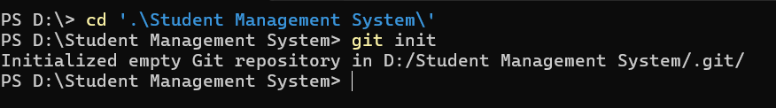

1. **Staging Files for Commit:**

* **Scenario:** You’ve created a new Java file Student.java that contains the class definition for a student. The class has a name and age attribute, along with a constructor.
* **Task:** Write the Git command to stage the Student.java file.

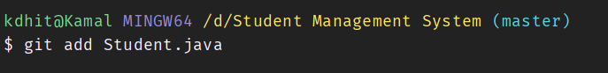

1. **Committing Changes:**

* **Scenario:** You made changes to Student.java, adding getter methods for name and age. Now, you are ready to commit these changes.
* **Task:** Write the Git commands to commit the changes to Student.java with the message “Added getter methods to Student class.”

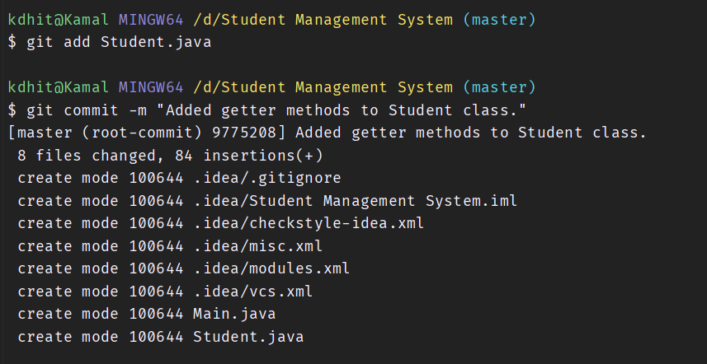

1. **Creating and Switching Branches:**

* **Scenario:** You want to add a new feature for calculating student grades in a new class GradeCalculator.java. To avoid interfering with the main branch, you decide to create a new branch.
* **Task:** Write the Git commands to create a new branch named feature-grade-calculator and switch to it.

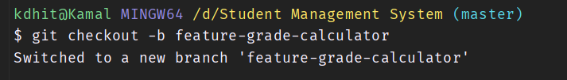

1. **Pushing Changes to GitHub:**

* **Scenario:** After making changes to GradeCalculator.java, you want to push your branch to GitHub.
* **Task:** Write the Git command to push the feature-grade-calculator branch to your GitHub repository.

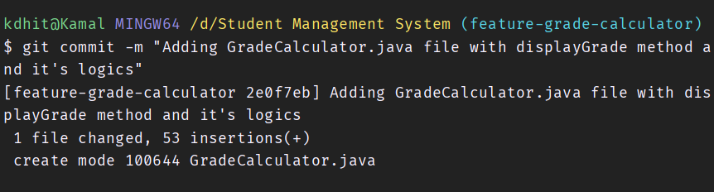

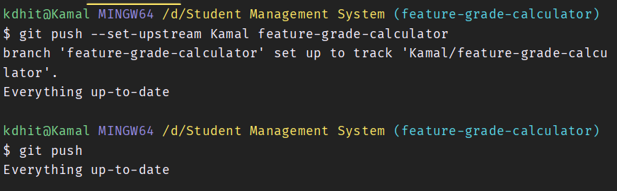

1. **Cloning a Repository:**

* **Scenario:** Your friend from another group project has created a similar Java project and you want to contribute to it. They have shared the repository URL with you.
* **Task:** Write the Git command to clone their repository to your local machine. Assume the URL is <https://github.com/ramlal/hck-w7>

