Predicting Housing Prices Using Regression Models and Housing Market Data

Abstract
In this project, an attempt has been made to build a predictive model for housing prices using AMES Housing Dataset. More specifically, the research question centers on revolving around the kind of model that best suits the nature of interactions that are typical in-house price data. The use of the approach included data cleaning of large and complex data sets, data visualization and data transformation. Linear Regression, Decision Tree Regressor, Random Forest Regressor were built and tested with the help of such evaluation criteria as Mean Absolute Error (MAE), Mean Squared Error (MSE), R².
The analysis showed that the selected model, Random Forest Regressor, was superior to the other ones, in terms of the accuracy rate and overall stability. Its ensemble approach was also suitable for reducing prediction errors, reducing overfitting while proving the best model for this application. By analyzing such data, machine learning displays efficiency in real estate analytics and could be helpful for homebuyers, sellers, agents and brokers, and policymakers.
However, there were slight drawbacks such as the limited number of data options in the project along with the future model calibration. Socially relevant work for the future will stamp out kindred problems through increased dataset size, hyper-parameter tuning, and exploratory techniques such as Gradient Boosting. Consequently, the paper establishes the significance of machine learning in improving price prediction in the housing market while being a feasible tool for practice.

Abbreviations
AI - Artificial Intelligence
EDA - Exploratory Data Analysis
GDP - Gross Domestic Product
GPUs - Graphics Processing Units
ML - Machine Learning
MAE - Mean Absolute Error
MSE - Mean Squared Error
OLS - Ordinary Least Squares
RMSE - Root Mean Squared Error
R² - Coefficient of Determination
SVR - Support Vector Regression
XGBoost - Extreme Gradient Boosting
LightGBM - Light Gradient Boosting Machine
RMSLE - Root Mean Squared Logarithmic Error
FAT - Fairness, Accountability, and Transparency
TPU - Tensor Processing Unit
API - Application Programming Interface
GPU - Graphics Processing Unit
AWS - Amazon Web Services

Table of Contents
1 Introduction and Background 1
1.1 Motivation and Context 1
1.2 Research Problem 1
1.3 Significance and Importance 2
1.4 Relation to Existing Knowledge 2
1.5 Stakeholders 3
2 Aims and Objective 3
2.1 Aims 3
2.2 Objectives 3
3 Literature Review 3
3.1 Introduction to Housing Price Prediction 3
3.2 Traditional Methods of Housing Price Prediction 6
3.3 ML Approaches for Housing Price Prediction 7
3.4 Role of Datasets in Housing Price Prediction 9
3.5 Gaps in Existing Research 11
3.6 Summary and Relevance to Your Project 13
4 Technologies and Resources 15
4.1 Online Data Resources 15
4.2 Model Training Platforms 15
4.3 Programming Languages and Libraries 15
4.4 Version Control 16
4.5 Data Storage and Management 16
4.6 Documentation Tools 16
4.7 Alternative Tools 16
5 Method and Work Plan. 16
5.1 Data Collection 16
5.2 Exploratory Data Analysis (EDA) 17
5.2.1 Purpose of EDA 17
5.2.2 Dataset Overview 17
5.2.3 Missing Data Analysis 17
5.2.4 Correlation Analysis 18
5.2.5 Outlier Detection and Removal 19
5.2.6 Feature Importance and Selection 28
5.2.7 Summary 29
5.3 Feature Engineering 29
5.3.1 Transformations 29
5.3.2 Feature Selection 30
5.3.3 Current Status and Future Steps 30
5.4 Model Development 31
5.5 Evaluation 32
5.6 Work Plan and Timeline 33
6 Ethics, Legal, and Data Protection Considerations 34
6.1 Ethics in Data Use 34
6.2 Legal Compliance 34
6.3 Data Protection Measures 34
7 Results 35
7.1 Model Comparison 35
7.2 Visualization of Results 35
7.3 Key Findings 36
7.4 Implications of Results 36
7.5 Future Directions 36
7.6 Conclusion 36
8 Discussion 36
9 Expected Outcomes 37
9.1 Enhanced Prediction Accuracy 37
9.2 Stakeholder Insights 37
9.3 Contribution to Research and Practice 38
9.4 Long-Term Benefits 38
10 Conclusion 38
11 Bibliography 39
12 Abstract 40

List of Table.
Table 1 : Time Plan for the Project 7

List of Figure.
Figure 1 : Missing Value finding Code 17
Figure 2:Code for missing values analysis. 18
Figure 3 : Code for checking the correlation with SalePrice 18
Figure 4 : Correlation with SalePrice Bar plot Graph 19
Figure 5: Identify the Outlier for Overall Quality 20
Figure 6 : Identify the Outlier for Gr Liv Area 21
Figure 7 : Identify the Outlier for Garage Area 22
Figure 8 : Identify the Outlier for Total Bsmt SF 23
Figure 9 : Identify the Outlier for the 1st FLr SF 24
Figure 10 : Identify the Outlier for the Year Built 25
Figure 11:Code to Remove the Outlier for the Overall Qual 25
Figure 12 : Scatter plot after removing the outlier for overall qual. 26
Figure 13: Code to remove the outlier for Gr Liv Area. 26
Figure 14 : Scatter plot after removing the outlier for Gr Liv Area 27
Figure 15: Code to remove the outlier for Garage Area 27
Figure 16: Scatter plot after removing the outlier for Garage Area. 28
Figure 17 : Code for removing the outlier for Bsmt SF 28
Figure 18 : Scatter plot after removing the outlier for Bsmt SF 29
Figure 19 : Code to remove the outlier for 1st Flr SF 29
Figure 20 : Scatter plot after removing the outlier for 1st Flr SF 30
Figure 21 : Code to remove the outlier for Year built 30
Figure 22 : Scatter plot after removing the outlier for Year Built 31
Figure 23 : Correlation Matrix for the features. 32
Figure 24 : Feature selection code and the results. 32

Introduction and Background

Motivation and Context
Housing plays an enormous role in determining the welfare of a nation’s people as well as the stability of the nation’s economy. Price forecasting of housing is important for homeowners, real estate agents, financial institutions, and policymakers. But over the course of the years, it has been observed on the housing market has tiny fluctuating due to many factors like market trend, economic condition and may other factors solely dependent on the area.
For the statistical judgement for the price elaboration, it has become easier with the availability of price data of house and improvements in the machine learning area. Of these techniques, the regression models are preferred for their versatility applying as efficient tools in numerous studies of housing market. All these models consider parameters within location of property, characteristics of the land, total area, and general macro-economic factors such as interest rates and inflationary factors. Through these parameters regression models bring important estimations to the housing market.
Regression models are useful to the stakeholders since they can make appropriate decisions on investments and risk management owing to the models’ ability to predict trends. These models are beneficial in making forecasts on market trends and predicting a change in price, thus the amount of risk involved is analyzed and minimized. As a result, regression techniques have gained significance to examine the change of housing prices and enhance the good decision and economic system. Their application helps take a more reflective attitude towards social activities and interactions in the intricate and dynamic environment of the housing market.

Research Problem
This work responds to an important challenge of constructing a robust and fairly accurate machine learning model for housing price prediction extrapolating the test and train datasets. Indeed, most conventional forecasting techniques entail either manual procedures or simple statistical models, which always fail in capturing complex relationships. These conventional methodologies fail when handling non-linear relationships inherent in the housing market dynamics; therefore, the predictions are accurate only and not generalized.
These shortcomings, however, were addressed by the new regression models, especially with incorporation in advanced machine learning procedures. Regression analysis is better solved with the help of machine learning models since the relationships between variables are most often nonlinear, and such methods are more accurate and less susceptible to errors. Since these models consider the numerous factors acting as influencer to housing price, such as the location of the property, economic perspective and trend analysis, these models offer a broaden and enhanced insight into the behaviors of housing prices.
Still, large gaps of knowledge remain although significant progress has been made in this area of study. Namely, there is a lack of sufficient distinctiveness regarding the choice and tuning of the predictive models to achieve reasonable performance in various housing market contexts. Thus, all the three markets could have various market conditions calling for changes to the model to fit the market to make the required predictions. Consequently, closing the literature-practice gap is integral to the development of discipline.
This calls for this project to work to overcome these challenges by providing a clear format of housing market data analysis as well as a certain amount of detailed information on the predictive model solution. Through comparison between conventional statistical methods and the most advanced machine learning algorithms, the project aims to refine the decision-making process for the benefit of various real estate stakeholders including investors, insurers, and policy makers by improving risk assessment and management, investment, and policy formulation.

Significance and Importance
Considering this the importance of this project was in its focus to generate tools that could estimate housing prices with precision to enhance the understanding of various stakeholders. These tools allow estate agents to give more accurate recommendations to their clients, assist lenders to assess risk implications of mortgage, and assist governments to establish workable polices in the provision of houses. Furthermore, this project meets the best international practices in digitalization and data analysis, helping to get new modern employment in the sphere of real estate. By addressing the complexities of the housing market, the project offers significant benefits, including:
Benefits:
- For Homebuyers and Sellers:
- New price transparency.
- Better assessment of the prices of the properties.
- For Real Estate Professionals:
- Improved the ability of the firm in assessing the trends of the market.
- They need to provide clients with better advice to suit their needs.
- For Financial Institutions:
- The activities ensured better evaluation of risks of various loans and investments.
- Superior financial decision making for financing and asset resource decision/cognizance.
- For Policymakers:
- Market information pertaining to the housing market.
- Empirical evidence towards strategic housing policies.
It also not only helps all stakeholders to make more reasonable decisions but also contributes to enhancing innovations in real estate through analytic tools and techniques.

Relation to Existing Knowledge
As such this paper forms part of an extensive bibliography of theoretical and empirical works in the real estate field. Other earlier studies, for instance Hedonic Pricing Models have examined the property characteristics and pricing. Thanks to recent progress in machine learning, the application of methods like linear, ridge and random forest regression methods have gained a lot of popularity. These approaches utilize the big data, and at the same time charting out stochastic, which are effective tools for forecasting housing prices.
Nevertheless, there are few comprehensive comparative studies that can compare basic statistical models with new generation machine learning models. It is, therefore, important to determine the conditions under which the different approaches will yield the highest results regarding housing market data. Surprisingly, currently there is a lack of comprehensive empirical research on how these models work in different markets to fill an important research gap.
This project intends to fill the gap by providing a comprehensive procedure of analyzing housing market data and a precise prediction model approach. In the course of project implementation, different traditional and modern methods of housing prices forecasting will be analyzed in order to offer the stakeholders a qualitatively and quantitatively high-grade instrument that would be useful in the decision-making process and would lead to better results in the sphere of real estate.

Stakeholders
Primary Stakeholders and Their Roles:
- Homebuyers and Sellers:
It includes better pricing with more transparency, realistic and fair property evaluations for optimum and sound investment choices in housing real estates.
- Real Estate Professionals:
Receive improved market analysis tools to effectively advise the clients and become ready for changes in the market.
- Financial Institutions:
These stakeholders enhance their loan and investments risk evaluation through proper housing price prediction models.
- Policymakers and Urban Planners:
Deliver useful data regarding housing policies to be proposed as well as the ideas for the further evolution of the urban development plan.

Aims and Objective

Aims
The primary objective of this project is to construct a forecasting model for predicting house prices with state-of-the-art regression techniques and housing market information. The project aims at using analytics and providing properties’ market trends that would affect the price and offering guidelines to take the best decisions for everyone, including realtors, potential buyers, and government.

Objectives
- To accurately predict housing prices using advanced regression models thus increasing the robustness and reliability of making forecasts based on critical features like location, size of the property and the trends in the market.
- To explore the effectiveness of different regression algorithms (e.g., Linear Regression, Ridge Regression, Random Forest) in housing price prediction, comparing their performance to identify the most suitable model for real-world applications.
- To provide actionable insights to stakeholders for instance, it may solve problems related to housing by analyzing the effects that some variables (typical for real estate, people who are potentially interested in purchasing a house, or policies) have on the rate of housing (e.g., typical characteristics of the neighborhood, economic factors).

Literature Review

Introduction to Housing Price Prediction
Another key area is the prediction of housing prices; this area has become the key area for research mainly due to the broad significance for different groups of consumers and the real estate industry. Risk analysis based on predictions helps the stakeholders to make the right investment decisions, forecasts tendencies in the market as well as plan on how to avoid or address the risks satisfactorily. Real estate markets are changing and that is why issues connected with housing prices are so crucial for entering this market. Consumption and housing, for example, are some important drivers of demand in the real estate market and thereby ho descendants on pricing. As many of these measures may indeed increase the price of houses self-occupation policies may lead to the formation of speculative demand and thus the formation of market bubbles making the task of the forecaster exceedingly difficult [1].
The global housing markets have become more complex over time, which creates the necessity of a dependable and sound forecasting approach. Such complexity is beautifully illustrated by Bengaluru’s housing prices, thus, depending on geographical location, size of the property, and facilities. Such factor complexities call for sophisticated models for forecasting capable of handling a wide range of uncertain markets. For example, Xinshu Li showed how generalized linear regression models could be used to improve predictability, of which the strategy of customized models can provide a satisfactory solution to certain market conditions [2]. This corroborates the need for methodologies that capture interdependencies between variables and dynamics of the market.
Zizheng Li had explained that the price of houses is well used as an economic predictor and as a measurement of development to give hints about the prevailing market. Variation of these prices shows the market supply and demand of these properties, investors’ confidence, and changes in the financial markets. Any increase in house prices is associated with positive signals as to the housing market, the economy and consumers’ optimism. On the other hand, a deteriorating price level can bear negative implications such as operating costs, decrease in customer purchasing power or supply markets which are flooded with stocks. Obviously, the need to evaluate and forecast house prices transcends simple economics. Forecast is essential in the planning process to ensure that the policymakers provide appropriate resource input to develop sustainable cities. They assist in finding areas with inadequate housing, studying out layouts and distributing densities in relative to the environment. Besides, the movement in house prices impacts on society because it determines areas where people live and work. They believe high property costs may result in movement; extended city spread or shift in population density inside cities. The information on house prices also benefits investors, developers, and governments by improving decision making on the allocation of resources and place in economy, development of financial policies and strategies. Hence, house prices are both an essential indicator of the state of economic activity and urban change, and an integral element of the societal and market systems [11].
The right forecasts for housing prices are in the interest of individual participants and contribute to developing suitable policies and projects at the state and undertaking level. These predictions empower policy makers to regulate urban housing supply, moderate existing market conditions and respond to public concerns about affordability. For instance, knowledge of the trends in housing prices can be used to improve or introduce changes in the tax system or apply subsidies to add to or modify certain society’s trends and goals. On the other hand, real estate developers can forecast the market and consumer trends to be able to support their investment and develop a suitable project [8]. The factors that determine the market behavior of housing prices make the task of prediction difficult and time consuming. This is true because the price of houses as well as mortgage rates are seasonal determinants influenced by parameters like interest rate and inflation. Furthermore, structural factors that are peculiar to a given locality such as accessibility to facilities, infrastructure and physical neighborhood also exert considerable influence on property prices. After type, adaptability of various properties to a specific type adds to the variation in price because of size, design, and features. These interrelationships call for the establishment and construction of complex models that can estimate numerous factors at the same time [3].
Housing price prediction is not only relevant for individual investment or trading and business planning but also tied with economic well-being. Other than in isolated cases, change in the price of housing has ubiquitous impacts given the event of the current global financial crises which originated from problems that arose from housing prices in the United States. This event simply served to emphasize the role of precise early-warning models in analyzing as to when the market is likely to fluctuate, and thus avoid future such scenarios [10]. Good prediction models not only minimize risks for a specific subject or a group of subjects, but also defend macroeconomic environment by encouraging the reasonable development of housing segments.
Modern advances in unique models of prediction have enhanced the precision and validity of housing price estimates. Whereas previously simple statistical techniques like linear regression are used, they have been upgraded to machine learning algorithms for better or more efficient analysis of the data patterns. For instance, with machine learning models, features of non-linearity and interaction can be captured making it easier to understand the determinants of price. However, these models are flexible to changes in the market environment, thus making these models relevant and applicable at any time [9].
Especially in developing economies electronically active in metro cities, high market volatility forces the implementation of more enhanced and refined predictive tools. That is why, using the results of analyses based on the dataflow from miscellaneous sources such as historical sales data, demographic data, and economic data, the predictive models can provide valuable recommendations about the market trends. For instance, when applying the GIS into determining housing price, it is possible to have a special and refined manner of evaluating location aspects as factors that influence the prices [3].
The application of technology in the prediction of housing prices has even been pushed a notch higher with the coming of the big data and artificial intelligence. These innovations make it possible for big data sets to be handled and useful in making useful conclusions by informing subscribers of patterns and relations hidden within sets of given parameters. For example, using machine learning algorithms for creating a set of predictive models helps in capturing real-time market conditions to enable stakeholders to make relevant decisions. On the same note, the use of big data analyzed has enhanced predictions used in segment markets and demography so that accurate forecasting is created [2, 9].
I add that housing price prediction also contributes to the solution of significant social problems, including housing affordability and accessibility. By using the models to forecast the demand and supply, there will be likelihood of reducing the housing deficits because of measures that will have been taken ahead of time once imbalances are seen. These findings can be of particular interest to policymakers who want to create social housing to sustainably address the housing needs of various populaces. In addition, it helps the decisions that are affecting the long-term urban development plans by showing potential trends that might occur in future as to help the infrastructural direction in providing for the future housing demands [1, 8].
Thus, the housing price prediction is a complex scientific field which synthesizes the methods of economic calculations, the developments in the field of information technology, as well as the components of policy-making approaches to meet the demands of the constantly changing real estate market. These include applying sophisticated models to create meaningful economic and geographical coordinates and parameters of the properties. This way, these models enable the various stakeholders to make informed decisions and reduce risk exposure whilst enriching their role in facilitating the sustainable development of the housing sectors. As the nature of housing market and the related predictors are continually changing, there is optimism that progressive development of methodologies of prediction will be useful in providing solution to housing price prediction quagmire [2, 3, 8, 9, 10].

Traditional Methods of Housing Price Prediction
Earlier approaches to housing price prediction main fall under the quantitative prediction models where statistical methods were used such as Multiple Linear Regression (MLR) and Ordinary Least Squares (OLS). These approaches presume that a relationship between variables is straight line as for instance housing prices, size of the dwelling, and the location. Although these models are simple and efficient to a certain extent for establishing a first level analysis of the respective markets, they cannot adequately explain the complexity of modern housing markets. This is so because conventional techniques fail to consider the substantial number of variables that affect housing price, hence lower levels of accuracy [1].
The hedonic price index models have also been applied for the examination of effects of individual characteristics of a property for example, number of bedrooms, neighborhood facilities or proximity to central business districts for housing prices. These models give an understanding of the relative importance of unique features influencing the general value of properties. However, they fail in the more dynamic environment of today’s fast-growing cities, due to fast and often unpredictable shifts in market conditions. Besides, the nonparametric aspects of factors and increased dimensionality of data make methodical approaches inadequate to approach housing price prediction considerations [3].
This motivated the development of partial linear models of models that allow for both linear and non-linear effects to be captured. These models try to add more flexibility to the asserted linear structures by being able to address non-linear interactions between variables. However, the use of such models is still limited by factors such as the ‘curse of dimensionality’ in which introduction of many variables in the model leads to problems in computation and reduced efficiency of the model. This underlines the necessity for models, which can adequately manage composed relations within the factors affecting housing prices [2].
Linear regression is easy to compute and interpret and therefore continues to be extensively used. It is particularly beneficial when trying to analyze the nature of the relationship that is between a dependent and an independent variable, for example, size of property and the price. However, due to this, the use of this method is heavily focused on one factor, which can cause errors when addressing the complex phenomena of housing markets. For instance, the affected variables or the variables that define the relationship between housing prices and their factors are the economic conditions, the population statistics and property characteristics, among others, and operating in complex nonlinearities that are not easily captured by the traditional approaches to modeling. Consequently, predictions made with the help of linear regression tools cannot be considered as adequate for practical decisions in the framework of RE markets [8].
Often used is the House Price Index (HPI), this measures the median price per property and helps determine changes to inflation and the market. Although the assistance of HPI in comprehension the motion of price trend is of great helpful, it fails to produce certain granules of price differentiation caused by the difference in property, location, and other attributes. Thus, this limitation renders implementing HPI as sole tool for precise price forecasting in various and unstable conditions problematic [10].
Classic analysis techniques use past prices and data as well as set theoretical economic models to make an estimate of future prices. For example, Multiple Linear Regression tests influence the price of houses and other factors such as its place of residence, size of the house and the market it is in. However, none of these approaches is capable to reveal the non-linear and interaction between variables, which are inherent in housing data. For instance, the effect of locality on the price of a property could vary with other factors such as closeness to a rail, bus or train station or buoyant economic region which typical regression models do not explain [9].
Nevertheless, the suggested traditional methods help to create the basis of the housing price prediction research. They give a good frame of reference for price determinants and are particularly useful where there are not many factors to consider in dynamic markets. Nonetheless, when population density enhances, and market conditions gradually evolve, the problems related to these methods are magnified. The failure to handle high-dimensionality and employ updates when the market environment changes expeditiously is a clear testament to this [3, 9].
Due to such challenges, there is an emerging trend of incorporating novel statistical methods and machine learning algorithms into models. To complement the above-mentioned approaches, these attempts are geared towards handling larger sets of variables and their interdependences as opposed to traditional approaches. For instance, the predictions from machine learning models state that these models can detect latent structures within data and change according to the market condition, making their predictions more precise. By advancing from the previous traditional methods, these innovations develop on the strength of traditional techniques without bearing their weaknesses and thus they are providing a basis for enhanced housing price prediction tools [2, 3, 8, 10].
Most conventional approaches to price prediction of houses entail manual analysis and use of basic statistical tools. These methods were helpful historically. However, they do not exhibit high accuracy because of numerous factors and their interactions influencing housing prices. Structural factors, which include government policies, the state of the economy, demography, and market trends, all form an interwoven web, which existing methods are incapable of capturing fully. In recent years, while traditional methods have been displaced by modern housing markets, machine learning methods are being used. They also perform better than the previous methods, especially when dealing with copious amounts of data and the analysis of nonlinear connections between variables, and thus provide a better picture of the market. There are models in machine learning that can input various forms of data from past sales and wholesale food data, available indicators such as GDP, and geography, and provide the necessary information in real time. It is considered one of the greatest leaps in predicting the price of houses, as this will provide information that stakeholders can use for decision-making [11].
However, the suggested conventional means of modelling housing prices have provided the foundation for the progression of this field while demonstrating limitations in tackling modern market structures. The development of these methods has demonstrated the need for constant improvement and the addition of modern technologies as perceptions of accuracy and precision are refined. Collecting data on properties becomes more challenging as the market evolves and the emphasis will shift from relying on statistical techniques alone to more sophisticated and information-driven approaches that meet the needs of users in the real estate sector.

ML Approaches for Housing Price Prediction
The last couple of years has indicated how machine learning (ML) is a housing price predictor that provides sophisticated approaches that can potentially overcome the problem associated with basic models. As will be discussed below, ML methods outcompete traditional methods in terms of dealing with big data, identifying non-linear patterns, and dealing with dynamics in housing markets. Methods like Random Forest, XGBoost, and LightGBM have enhanced the techniques of accurate prediction to a considerable extent, and related analysis proves that LightGBM is often superior to other techniques. These hybrid regression methods have brought significant improvement to the performance of the ML models especially in more complicated housing price predictability [1].
Thanks to the maximal possibilities in information processing and variable interactions, the application of the ML models yields impressive results in predicting the housing price. These models can accommodate big volumes of data from sources such as market data, property data, and various economic data to produce more accurate forecasts. SVR, Neural Networks, ensemble methods have received high precision results when tested on intricate market scenario. For example, many studies have found that neural networks always produce higher R-squared and lower root mean square error (RMSE) compared to hedonic pricing models [3].
Another benefit that came across while using ML techniques is that it can model most of the complex market features using advanced regression analysis techniques and ensemble learning. For instance, Stacked Generalization Regression is another technique of creating a pool of base learners all aimed at enhancing general predictive accuracy. Moreover, the results attained via text mining of aggregated data sourced from online data help obtain novel and powerful insights into the market specifics, thus, provide a non-trivial but highly efficient way of identifying the key factors affecting the housing prices. These innovations also allow the researchers to create predictors beyond the mere ability to forecast prices of homes but with hopes of featuring novel trends in the housing market as well.
Thus, Machine Learning-based housing price prediction is most frequently implemented with decision trees and other ensemble methods including Random Forest and XGBoost. These algorithms are famous due to their capability of handling nonlinearity in variable interplay. More details of features like the neighborhood, property facilities and the economic parameters make these models highly informative of various aspects of prices of houses. However, ensemble methods utilize the strengths of a number of definite algorithms to reduce mistakes and enhance the accuracy and stability of models, which are useful in reflecting the characteristics of housing markets [8].
In Zizheng Li’s paper reviewing the potential of machine learning programs in predicting housing prices, he has fully reviewed the machine learning algorithms. Explaining linear regression as a starting point; decision trees; it then advances to the latest methods such as XGBoost. The study also suggests that simpler models, like the linear model, which is modeled using a linear regression equation, are computationally easier, but they fail to capture the nonlinear relativity in the housing market data. Furthermore, decision trees are more flexible where data is segregated in decision tree structures and hence are better placed for capturing nonlinear trends. Thus, while choosing the variables, the paper pays more attention to the effectiveness of the modern algorithms for housing price prediction, including ANNs and SVR. These models are well suited to pinpointing how different variables relate and the structure within a data set; because of this, they are more accurate than other models. Further, XGBoost, known as a highly efficient and high-performance model, is appreciated for its work on many features and interactions [11].
Li’s study also reveals that the choice of model depends on the condition of the specific market and the characteristics of the data used. The findings of the study suggest that there is not a standing model for the optimal one since each algorithm is well-suited for a set of conditions so that the best performance is reached utilizing each pinpointed model.
Another of the building blocks of the ML approaches, namely neural networks, have been found to be highly efficient in terms of housing price prediction. These models replicate the Human brain’s functions of Neural networks and enable them to process dynamic data with different dimensions. While using new architectures – deep learning models, the neural networks can reveal patterns, which are not seen briefly and cannot be detected with the help of conventional approaches. This capacity to model nonlinear and interactions makes neural networks an unbelievably valuable tool for modeling housing price and precise prediction depending on different market conditions [3].
Big data analysis and computational enhancements have taken the features of ML models two notches higher. Real-time data augment large-scale data and allow using methods of ML for making dynamic forecasts and reducing model overfitting. For example, data from real estate web portals, social media, and Geographical Information Systems (GIS) enables models to capture regional characteristics and time trends to improve the model’s accuracy. The public dissemination of these ideas has led to a progression of better and more flexible predictions [9].
Most of the identified techniques are combined in hybrid ML models, which is a great enhancement in the housing price prediction. For instance, techniques that combine LightGBM with neural networks or ensemble learning perform better than the individual models of LightGBM in terms of the level of accuracy and stability. Such hybrid systems combine the best performance characteristics of the selected algorithm while at the same time minimizing the shortcoming of each algorithm which make up reliable predictive systems. Such models are particularly useful in fluctuating contexts that annex conventional techniques did not fit flexibly in unstable markets [1].
Besides, reducing misclassification error, there are application values of ML approaches in appealing to real estate market stakeholders. Government bodies can integrate the use of predictions derived using ML to develop and implement informed housing policies, to deal with the issue of affordability and to manage the implementation of urbanization plans. On the other hand, for real estate developers as well as investors these models can prove helpful in mapping location of margins and in determining strategies of operation based on market predictions. The other group that benefits from accurate price predictions is the home buyers because they are better placed to make purchase decisions as well as enter better negotiated deals [10].
Machine learning approaches for housing price prediction are beginning to find textual data mining and natural languages processing as significant tools. Using text analytics over text document bodies such as property description, customer review or market report, such techniques allow us to obtain better understanding of consumers’ preferences and the sentiment of the market. It is important to mention that this type of data supports quantitative datasets of the factors that affect the housing prices [2].
The flexibility and expansiveness of machine learning techniques make it unreplaceable in current housing price prediction model. Beyond that, the flexibility of utilizing ever growing and changing list of variables in the ML models along with their ability to implement new knowledge all but guarantees the goodness of the models in the continued progression of the housing market. It is noteworthy that as innovations including AI and big data are implemented to real estate forecasting, ML approaches have shifted to other levels of accuracy in ways many experts in the field did not envision.
Overall, it can be said that the integration of machine learning techniques paves the way to a new way of coming up with accurate forecasts of housing prices. This quality of large, complex data handling and capturing of relation between variables makes them a better tool than traditional models. Whether one embraces decision trees with ensemble methods, neural networks or hybrid models, ML techniques’ predictability remains unparalleled with advantages for all stakeholders in the housing sector. In future, with technological advancement growing each day, the usage of ML approaches will act as a breakthrough for solving the problem related to housing price prediction and pave the way in future for the real estate business [1, 2, 3, 8, 9, 10].

Role of Datasets in Housing Price Prediction
Lastly, it can be argued that machine learning based methods offer a revolution in the matters of housing price prediction. Due to their performance in processing big, complicated data sets while capturing complex interactions between variables they are seen as superior to traditional models. Using decision trees and ensemble methods, neural networks, and other hybrids, ML techniques remain unsurpassed in their predictive potential that will be advantageous for multiple actors in the housing market. Subsequently, the article highlighted the impression that the incorporation of the ML approaches will be central to addressing the housing price prediction challenges as well as determining the fate of the real estate industry in the future [1, 2, 3, 8, 9, 10].
The effectiveness of datasets is very crucial in the prediction of housing prices, so it depends on the internal structure, the information it can provide, or the labels assigned to it. Adding labeled information to the datasets lets the researchers look at new factors, including economic, political, and geographical ones concerning infrastructure and types of properties. For example, labeled data set can be procured from original authors or else from public domain, making it possible for researchers to study interactions between several number of variables. The use of big data helps remedy this situation, as traditional predictive models do not contain all the required detail, even though there are huge datasets out there [2].
Substantial data has emerged as an invaluable tool in current housing price prediction, on which advanced analytical models can be built. Another advantage of big data is the fact that using large data sets researchers can analyze finer details in a set and may be in each period which may not be easily recognizable. For instance, the availability of historical archives of pricing, world population density, and characteristics of the constructions viewed as real estate’s enhance comprehensive understanding of housing industries. However, distributing totality into such large datasets may also be problematic due to the presence of outliers in datasets which if remaining unnoticed may knee into model’s predictions. It minimizes the effect of outlier values, removes, and manages missing values that unstable predictive models [8].
A popular data set in determining valid housing price prediction is known as the Ames Housing data set, which includes 1,460 records and 79 assessment factors. According to the nature of this data, it contains many attributes of the houses, which includes construction date, type of roof, sizes of lots etc. It is therefore a valuable data source for the researcher. Some of the processes that need to be taken while dealing with this dataset involve data cleaning, data preprocessing, missing value treatment and feature selection to get the best out of the model. The comprehensiveness of Ames dataset has highlighted the significance of well-structured dataset in predicting the housing price due to which Ame’s dataset has become a benchmark for creating as well as testing several types of prediction model [9].
The use of comprehensive data sets means that numerous variables which influence housing prices can be collected and integrated into analysis. These variables can extend from the macro level and contain interest rates and employments levels to micro level factors inclusive of the closeness of the property to public facilities. For example, civil works and transport facilities are always some of the most crucial factors that define a property’s value. Incorporating such factors in databases enhances the ability of a given model to predict versatile, real-world conditions hence more accurate on the aspect of housing [3].
Big data utilization in the pricing of housing goes beyond regular properties features. Modern databases include unmeasured data from such social media trends, customer reviews, and geographic information systems (GIS). These markets include non-traditional sources of data that enrich the understanding of the sentiment and geolocation of the market and increase the predictive ability of the model. For example, GIS data provides information on the features of neighborhoods and social media trends allows metadata on the consumers and their tendency. These multiple data types introducing to the analysis provide the richer possibility of the housing price prediction [10].
The other considerations essential to dataset quality are the frequency at which the contents are updated. Using datasets that fail to capture any change that occurs in the market, especially in fast-growing and dynamic markets, is often a recipe for disaster, as it leads to over or underestimation of market potential. Keeping the datasets up to date helps to maintain the close correspondence between the predictive models and the current paradigms that makes their reliability higher with reference to the needs of the stakeholders. For instance, in a highly dynamic environment such as Bengaluru frequent updates on the data sets lead to improvements of the models needed as they can capture the dynamism in the market or consumer trends [3].
Therefore, datasets are extraordinarily rich in contributing towards the right performance and accuracy of the models used in the housing price prediction. Zizheng Li’s paper uses a data set that features several variables associated with real estate transactions. The nature and quality of this data set, for example, the presence of noise and outliers, affect the results of most predictive models. Some of these problems may skew the results of the prediction and provide inaccurate figures if not resolved. For this reason, the paper pays much attention to various requirements of data preprocessing to enhance the models’ accuracy and realism. A similar idea has to do with preliminary data analysis, which includes data cleansing, handling of missing values and outliers, and data normalization. A fact when working with the dataset is that the higher the quality, the better the chances to get more accurate results in the housing price forecast. Preparation of the data involves a process of cleaning, transforming, or normalizing them and putting them in a better shape to enhance the outcome of any predictive model [11].
Data manipulation also includes tackling issues like missing values, disparate data, and substantial number of features. Inadequate data is also a very costly error that could lead to extremely poor prediction if not controlled for. Hence, other methods like data imputation in which missing values in a set of data is replace by an estimate and dimensionality reduction where a set of data is reduced to its most influential factors are especially important in maintaining data set integrity. Preprocessing effectively means that applying it to datasets will result in good and reliable input into building of the useful predictive models [8, 9].
Besides responding to the challenges, they core too of forecasting in real-time. Thanks to the improvement in computational technologies, the datasets can be processed in real time, which enable real time prediction that will adjust to the market situations. This is especially the case for stakeholders such as policy makers as well as real estate developers who need fresh information to come to informed decisions. Real-time data: Such data sets build the ability of the proposing model to integrate contemporary trends and data points to make their results valid and useful [10].
Altogether, datasets are irreplaceable when it comes to housing price prediction as they form the basis of stable and accurate methods of prediction. The quality of these datasets, the comprehensiveness of the sources, and their periodic update are key aspects of powerful models. Only through combining various sources of data, solving traditional problems, and utilizing new possibilities in big data analysis, can the researchers develop effective prognostic models for the analysis of the housing market. In the contemporary real estate environment, datasets are expected to remain at the core of future development of the field and housing price prediction [1, 2, 3, 8, 9, 10].

Gaps in Existing Research
In this analysis, even though there exists impressive state of the art approaches for housing price prediction, there are key research issues that have not been well addressed yet. Classic and ML approaches, despite the satisfactory results in explaining certain aspects of the housing market, cannot solve some of the key non-trivialities. One weakness worth mentioning is that nonparametric factors are neglected, and the models are over-simplified. Recent work does not give sufficient credit to the complexity of housing markets and fails to employ accurate modeling to deal with high-dimensional data. This challenge reduces predictive accuracy and points to the reality that researchers must employ methods that can work well when faced with multi-dimensional data sets [3].
In addition, the application of ML models is done in circumstances that remain unspecified or underdeveloped. These models have depicted higher accuracy, but their implementation is limited by the socio-economic and environment in which the model has been trained. For example, those estimated for high demand urban environments will not suit low demand or rural environments. This limitation is meaningful since the statistical methods and the principles of contemporary ML need to be integrated until wider applicability and flexibility can be obtained [3].
In this analysis, even though there exists impressive state of the art approaches for housing price prediction, there are key research issues that have not been well addressed yet. Classic and ML approaches, despite the satisfactory results in explaining certain aspects of the housing market, cannot solve some of the key non-trivialities. One weakness worth mentioning is that nonparametric factors are neglected, and the models are over-simplified. Recent work does not give sufficient credit to the complexity of housing markets and fails to employ accurate modeling to deal with high-dimensional data. This challenge reduces predictive accuracy and points to the reality that researchers must employ methods that can work well when faced with multi-dimensional data sets [3].
In addition, the application of ML models is done in circumstances that remain unspecified or underdeveloped. These models have depicted higher accuracy, but their implementation is limited by the socio-economic and environment in which the model has been trained. For example, those estimated for high demand urban environments will not suit low demand or rural environments. This limitation is meaningful since the statistical methods and the principles of contemporary ML need to be integrated until wider applicability and flexibility can be obtained [3].
Another gap in existing research is the limited exploration of variable interactions and their influence on housing price predictions. Many studies exclude features with lower correlations to sale prices, which may contain valuable indirect or interactive effects. For instance, variables such as neighborhood development, proximity to amenities, and environmental quality often interact in ways that traditional models fail to capture. Addressing this gap by incorporating a broader range of variables and exploring their interactions could lead to more accurate and robust models [10].
Zizheng Li’s paper highlights certain shortcomings of the literature on housing price prediction, especially concerning the methods adopted to manage noise in the provided data. It notes that noise, which it describes as irrelevant information, poses a considerable impact on the reliability of forecasts made through models. However, the paper underlines that current literature fails to pay enough attention to the problem of noise elimination, and the techniques that can be employed to minimize noise are not very unified. Since the strategies to reduce noise are also qualitative in nature, then different solutions can provide different improvements or even lead to the degradation of data quality, which makes the task of choosing optimal algorithms for reducing noise incredibly challenging.
Furthermore, Zizheng Li’s paper makes recommendations that state that more extensive research needs to be conducted on the effect of diverse noise reduction strategies for various sets of data. There would be a difference when the housing price prediction models are applied to various markets, each with unique characteristics, and therefore it is unwise to have one method of eliminating noise for all markets. Even more information is required to identify some variations in specific techniques that seem to make a difference in various datasets and markets. By so doing, enhanced accuracy and reliability of housing price prediction models can be arrived at to enhance the decision-making relating to this sector and others that depend on it. Such studies could offer useful information regarding the appropriate data preparation techniques to be applied in data mining and the ways in which the performance of the prediction models can be boosted.
The development of real-time prediction models is another area where research is lacking. Most current models operate on static datasets, which do not account for the rapid changes in market conditions. Real-time models, capable of integrating continuously updated data, are essential for ensuring the relevance and adaptability of predictions. Such models could provide stakeholders with actionable insights tailored to the dynamic nature of housing markets, thereby enhancing their utility for decision-making [9].
Furthermore, literature studies frequently fail to have consideration for the convergence of data. The findings showed that inclusion of non-traditional data like social media trends, real estate listings data, GIS data added much more value when integrated with the traditional datasets to build a comprehensive more accurate model. Such dataset offers various kinds of information on market sentiment, consumer behavior and location, which are not available from conventional structured data. More work on this theme can be seen in how the integration of data can be done most optimally [2].
These prerequisites also define another significant research gap in housing price prediction, namely the necessity of models’ interpretability and transparency. Much of the time, existing ML models can be thought of as “black boxes,” meaning that stakeholders cannot really decipher why a specific decision was made. To ensure that policymakers, investors, and homebuyers have confidence in using the models developed it is necessary to come up with models that can do the following: Such models could also improve the transfer of results and help enhance the implementation of the findings in the real world [3].
Therefore, the future research areas remain the following despite considerable developments in housing price prediction. That is why there is no account of nonparametric factors, specific-context models used universally, insufficient utilization of innovative methods like deep learning, and minimal incorporation of various data types. To fill these gaps, additional data must be collected in more breadth, multidimensional connections between variables need to be investigated, models should be built in real-time, and the models should be explainable. These challenges can be surmounted in future research to improve the accuracy of the housing price prediction for the stakeholders [1, 2, 3, 8, 9, 10].

Summary and Relevance to Your Project
The analysis of the predicting the house prices has also come a long way from simple statistical models to developing the modern advanced learning methodologies. Even if property value is thought of in simple terms, using Traditional analysis such as the linear regression analysis or ordinary least squares is problematic as they do not adequately address the newer emerging issues in the housing markets. These legacy approaches are quite hampered when it comes to estimating non-linear relationships, high-dimensional data, and dynamic and disruptive market conditions. In contrast, the ML models can tackle these challenges due to better accuracy, flexibility, and the ability to work with a diversity of data sets [1][2][3].
One consistent finding across the literature is the centrality of datasets on the accuracy of housing price prediction. The relevance, completeness and regular update of datasets determine the accuracy of the models and the predictive models in general. Rain bonds contain diversified property characteristics, economic factors and marketing trends as data sources make contingency forecasting tools solid enough. Nevertheless, the issues like missing values in the data; presence of outliers; requirements for dynamic updating of the models remain the major drawbacks that affect the soundness of numerous models. Overcoming these challenges is critical in developing precise models that mirror the situation within this field and generate valuable outputs [8].
One of the papers determines that there are different models that it is possible to use for housing price prediction and that each of them has its advantages and drawbacks. Of these, the decision tree regression model stands out as the most promising, as evidenced by better outcomes when tested on general real estate datasets. The capability of the model to capture complexity and non-linearity in data is another feature that makes this model useful for housing price prediction. The work pointed out that when choosing the model, it is necessary to consider specific features of the dataset and the characteristics of the market. Therefore, by presenting the results of the decision tree regression model, this paper provides valuable information that may help expand understanding of the option of using this approach to enhance the housing market prediction model. Besides, it provides a basis for subsequent research work on the application of different methods of machine learning in the formation of housing prices. The results can be helpful to researchers and practitioners to learn more on the traits that characterize housing markets and improve the strategies for valuing housing prices that can be useful while making decisions in real estate management [11].
As for the classification algorithms, it became evident that the Random Forest, XGBoost, LightGBM algorithms as well as the neural networks have shown clear advances on forecasting performance. These methods have the potential to capture interactions and dependencies between variables which other conventional techniques fail to capture. For instance, neural networks can recognize complicated patterns of relationships and triggering effects of location, infrastructural advancement and economic factors more accurately compared to other conventional methods of analysis. The use of algorithms and ensemble methods promotes strong stability and accuracy of the final equations thus showing that the use of ML is a revolutionary approach in the forecasting of housing prices [9].
Nevertheless, the following difficulties can still be observed: For instance, high-dimensional data can be problematic in model training and deteriorate the overall performance if well handled. The same problem can be noted with the model’s generalizability to different subsets of geographical regions and socio-economic environments. Some of the ML models developed have been specific to some datasets or even some conditions of market, thus the versatility is a big issue. This is why the idea of constructing the models that include the imperative features of traditional and ML approaches is critical, thus considering the contextual factors and the broad scope of using such models [3].
The literature also points out the importance of using current data while building the forecast models. One of the biggest disadvantages of static datasets is that it totally disregards the fact that housing markets in particular change over time and using these helps to predict housing markets with low accuracy. When property listing data and social media feeds along with GIS are fed into the models in real-time, it is easier to gain a better understanding of the situation. This capability is especially useful for markets such as Bengaluru where there is a steep ramp-up in demographics, and gross domestic product advertising leads to incessant fluctuations in the markets for dwelling units [1].
The result of this study is universally applicable to the present project since it covers the extent of housing price prediction models. Since it is built upon the existing body of knowledge, the project can potentially overcome some important difficulties, for instance, data quality issues, high dimensionality, and generalization of models. Incorporation of ML A method of learning that utilizes experience and helps the model to assimilate variables that are intrinsic with Bengaluru’s housing market. The justification of the suggested approach matches with the objective of increasing the accuracy of property value predictions thereby offering the necessary information to other stakeholders within the dynamic environment of urban systems.
Another big picture takeaway is the need to fill the gaps to improve the models. These gaps are as follows: (a) multiple data sources in a single model; (b) real-time forecasting; and (c)moderation effects of the chosen independent variables. Thus, the implementation of these elements could help to make a contribution to the development of the methodologies used for housing prices prediction and provide valuable suggestions for the stakeholders in the sphere. For instance, augmenting complex ML techniques with conventional statistical techniques results in a dual approach for creating a model that provides both explainability and accuracy, satisfying the needs of theoretical and practical researchers like [8][9].
In addition, the study stresses the updating of the predictive models as a work in a progress concept. Real estate property markets are naturally changing entities that depend on the general economy, the city where the property is located, and consumers’ needs or desires. For a predictive model to remain viable and useful, it must be updated with new data, changes in the market and with changes in the ways the model is solved. This type of approach is particularly significant in attaining continuing accuracy and relevance of predictions regarding the price of houses especially in dynamic and emerging markets such as that of Bengaluru [2].
In brief, it is noteworthy that the increase in aversive and frequent housing price forecast data increased the movement from traditional statistical models to modern complex innovative models of ML. It is here where traditional models, give a definite framework of how the solutions should look like, are outperformed by the accuracy, flexibility, and the ability to handle complicated data inputs as offered by ML techniques. The greatest importance belongs to datasets as the basis of proper functioning of any prediction model. Concerns raised over the past have been that some limitations are not giving a practical idea of housing price predictions; ways such as integration of more complex algorithms and real-time data will improve the practical use of housing price predictions. Expanding from these features, the project can construct an effective forecasting model that integrates both conventional and advanced approaches and, thus ARTICLE in housing price forecast, while also benefiting data-driven decision processes for implementers.

Technologies and Resources
This project will utilize a variety of up-to-date technologies and resources to ensure the effective implementation of tasks, economic efficiency, and that the results meet both academic and industry standards. The selected technologies are in line with the research objectives and provide a solid foundation toward the realization of the desired results.

Online Data Resources
The key to effective housing price prediction is access to diverse and reliable housing market datasets. This project will utilize publicly available platforms such as Kaggle, UCI Machine Learning Repository, and real estate websites like Zillow and Realtor.com. Common attributes in these datasets usually include property size, location, amenities, and historical pricing trends, which are indispensable in building a robust prediction model.
Furthermore, using web scraping tools such as Beautiful Soup and Selenium allows for live data collection from property websites. This will enable the project to acquire dynamic data reflecting current market conditions. Ethical standards will be followed, and the web scraping activities shall conform to the terms of use of each website.

Model Training Platforms
Model training involves considerable computational power. To save costs and ensure scalability, Google Colab will be used as the primary model development environment. It allows for free access to GPU/TPU acceleration, which helps in doing calculations faster and experimenting effectively. Other platforms like Kaggle Kernels or Jupyter Notebooks could also be used for smaller-scale testing and experimentation.

Programming Languages and Libraries
The project will use Python, a versatile programming language known for its extensive libraries and frameworks for data analysis and machine learning. Key libraries include:
Pandas and NumPy: Used for data manipulation and analysis.
Matplotlib and Seaborn: Used for creating informative visualizations.
Scikit-learn: Used for implementing machine learning models, including regression methods.
XGBoost: Specialized in gradient boosting models, which are known to be effective in prediction tasks.
TensorFlow or PyTorch: Used for deep learning approaches, if needed.

Version Control
Version control is critical in the management of a project's iterative nature. A repository containing all code, datasets, and documentation will be maintained using Git and GitHub. These tools will allow tracking of changes, collaborative working, and roll back to previous versions where necessary.

Data Storage and Management
In the data storage context, use of Google Drive or AWS S3 will be followed to maintain datasets and models in a secure way. These platforms provide scalable and reliable storage options. For the cases where structured data management is needed, an efficient database like SQLite would be used.

Documentation Tools
High-quality documentation is an important part of academic research. The thesis report will be created using Overleaf, a collaborative tool for LaTeX documents. Drafts and initial notes may be prepared using Microsoft Word for convenience.

Alternative Tools
As a contingency, tools such as RapidMiner or WEKA may be used for rapid prototyping and analysis. These tools provide a friendly interface for the exploration of regression models without requiring much programming knowledge.

Method and Work Plan.
It was for this reason that the approach for this project was therefore deliberately to devise and systematic process to achieve the stated goal of the project, which is the prediction of housing price using machine learning techniques. To that avail, the subsequent section outlines the processes undertaken up to the EDA phase and the strategy for processing, analyzing, and addressing risk data.

Data Collection
In the first step of the work, data was first identified and collected from public data sources. The Ames Housing Dataset which is available at Kaggle was established as the main data source for this research. Specific data related to the housing properties in this data set includes the locational data, structural & financial data, and market data of the property.
Key Attributes in the Dataset:
- Gr Liv Area (Above-ground living area in square feet).
- Overall, Qual (Overall material and finish quality).
- SalePrice (The target variable for prediction).
- Additional variables such as year built, garage area, and neighborhood attributes.
To protect the paradigms of ethical use of data, it became possible to read the licensing terms which are indicated in the context of the dataset. This study used the Pandans data import module to load the data set to enable a review and cleaning of the data for analysis.

Exploratory Data Analysis (EDA)
Note that in this project, EDA was performed before building a predictive model as the first phase of the analysis. The following section spells out an elaborate explanation of the EDA process based on the operations and visuals done.

Purpose of EDA
EDA serves several purposes:
- To identify relationships between variables.
- To detect missing data and outliers.
- To assess the distributions and trends of key features.
- To guide feature selection for the predictive model.
After the EDA done on the dataset, the data was preprocessed and formatted so that the model would only receive meaningful and clean data for training and testing.

Dataset Overview
The dataset, sourced from the Ames Housing Dataset, comprises detailed property features such as:
- SalePrice: Target variable (property sale price).
- Gr Liv Area: Above-ground living area.
- Overall, Qual: Overall material and finish quality.
- Garage Area, Year Built, and Neighborhood: Additional predictors.
The dataset had both numerical and categorical variables incorporated in it. The purpose was to optimize these features and determine the correlation with SalePrice.

Missing Data Analysis
One of the emerging difficulties in this dataset was found to be missing data.
• Certain features – Alley, Pool QC, and Fence – contained a vast number of missing values; therefore, they provided limited help in prediction centage of missing values
• Variables such as Alley, Pool QC, and Fence had many missing entries, rendering them less useful for prediction.
Approach: A bar chart was used to visualize the percentage of missing data:
  - Figure 1 : Missing Value finding Code.

Handling missing data: Numerical Features: Median imputation was applied to replace missing values in numerical columns, Categorical Features: Missing values in categorical variables were replaced with "None."
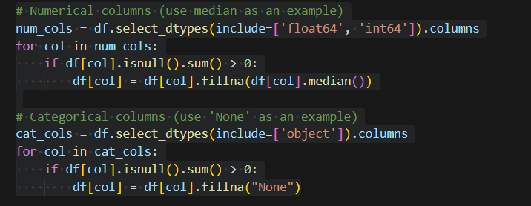
  - Figure 2:Code for missing values analysis.

Features with extensive missing data, such as Alley and Pool QC, were dropped.

Correlation Analysis
A correlation matrix was calculated to explore relationships between variables and SalePrice. This step identified predictors with the strongest influence on the target variable.
Key Findings:
Strongly Correlated Features:
- Overall, Qual (+0.79): Indicates that properties with better quality materials and finishes have higher sale prices.
- Gr Liv Area (+0.71): Larger living areas tend to correspond to higher sale prices.
- Garage Area (+0.64): Larger garage spaces contribute positively to sale prices.
Weakly Correlated Features:
- Features like Year Built and Neighborhood showed moderate correlations.
Visualization: A heatmap and bar plot were used to display these relationships,
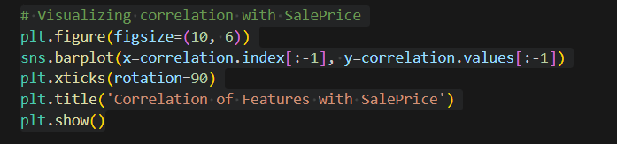
  - Figure 3 : Code for checking the correlation with SalePrice.
Implications: The analysis helped prioritize features for modeling, focusing on those with the highest predictive value.

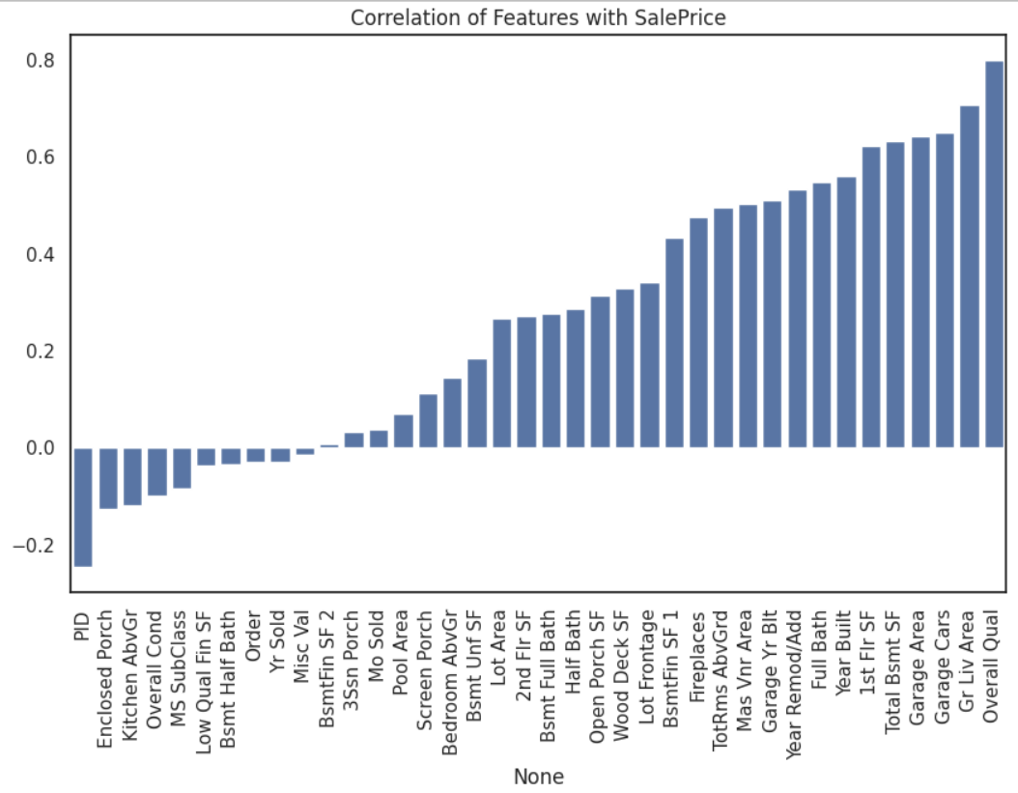
  - Figure 4 : Correlation with SalePrice Bar plot Graph.

Outlier Detection and Removal
Outliers were detected using scatter plots, particularly for features such as Gr Liv Area, Overall, Qual, and Garage Area.
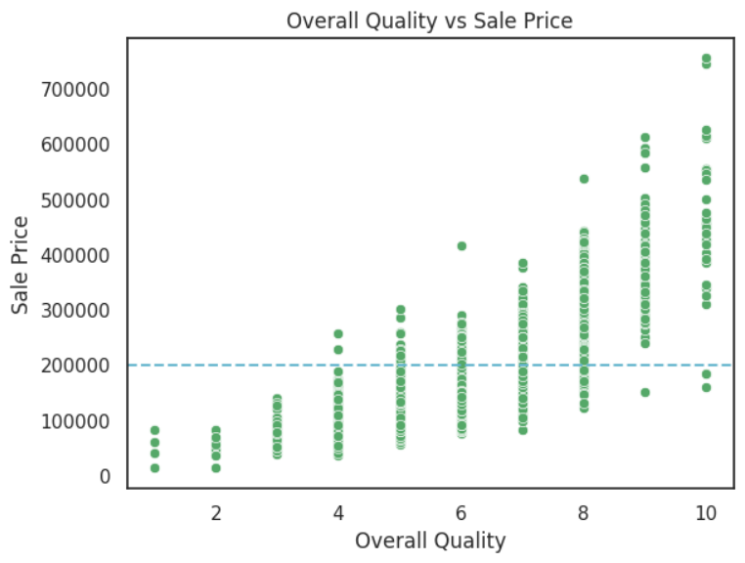
  - Figure 5: Identify the Outlier for Overall Quality
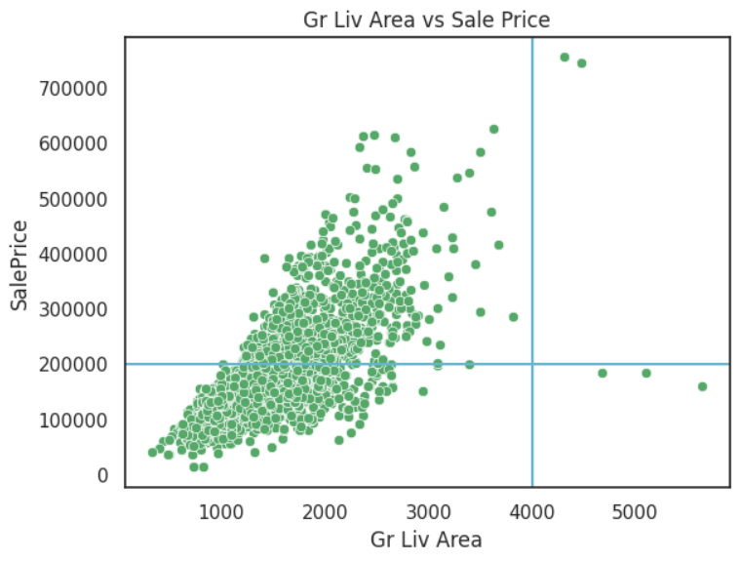
  - Figure 6 : Identify the Outlier for Gr Liv Area
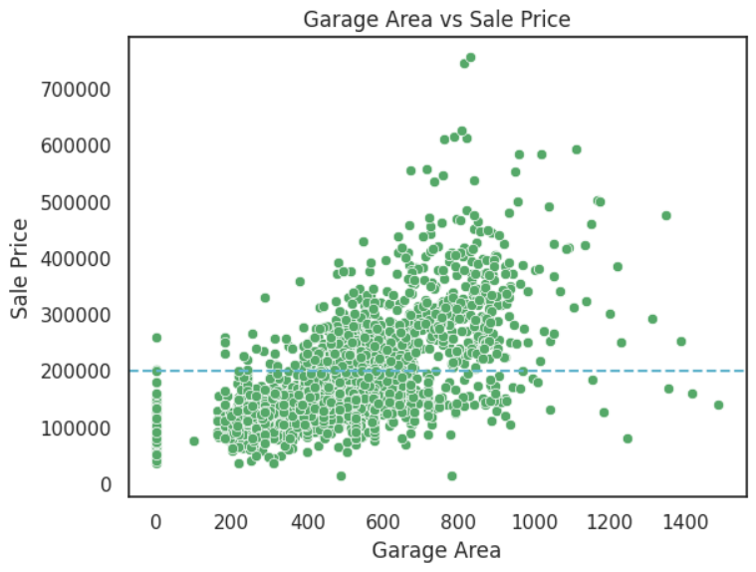
  - Figure 7 : Identify the Outlier for Garage Area
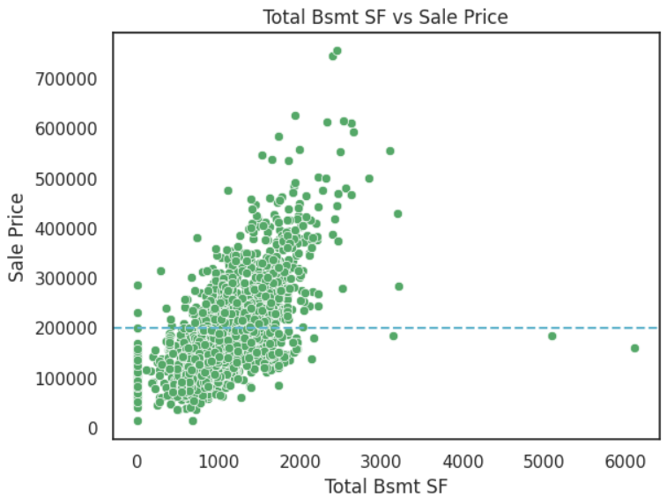
  - Figure 8 : Identify the Outlier for Total Bsmt SF
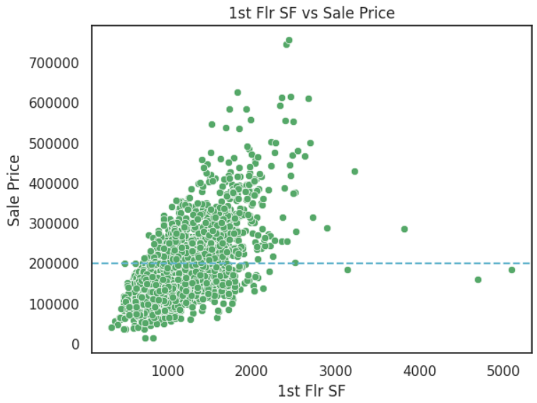
  - Figure 9 : Identify the Outlier for the 1st FLr SF
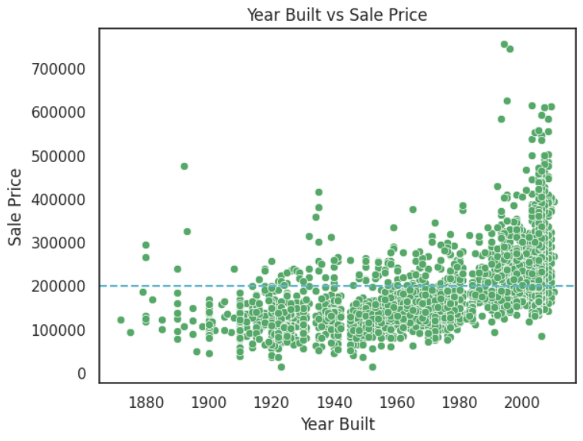
  - Figure 10 : Identify the Outlier for the Year Built
After identifying the outlier for the above shown features, do the outlier removing for each features using the code below shown and under each code shown the plotted output for the particular features.
Removing outlier for the overall qual:
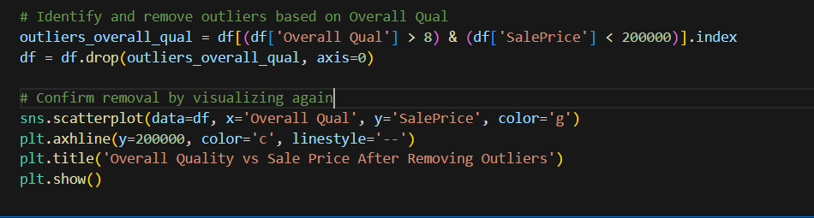
  - Figure 11:Code to Remove the Outlier for the Overall Qual
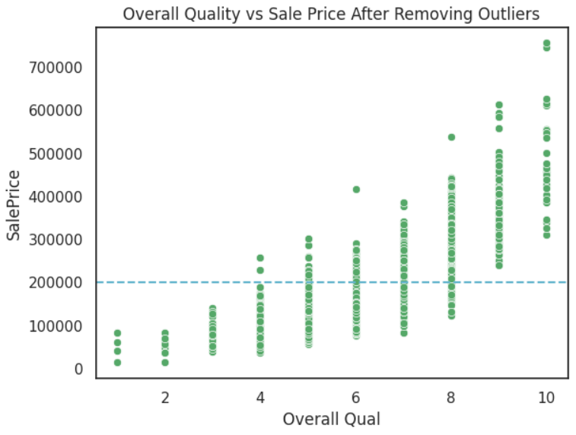
  - Figure 12 : Scatter plot after removing the outlier for overall qual.
Removing the outlier for Gr Liv Area:
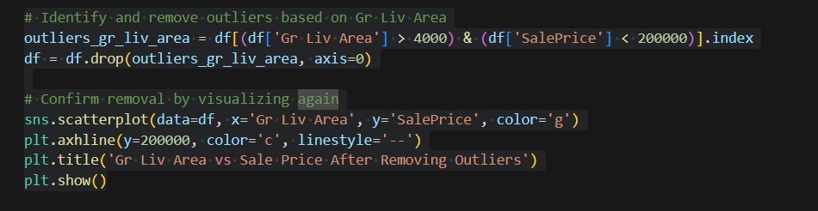
  - Figure 13: Code to remove the outlier for Gr Liv Area.
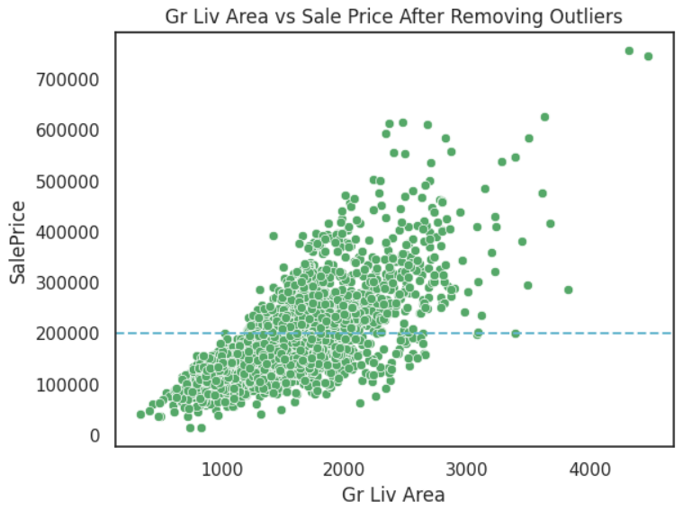
  - Figure 14 : Scatter plot after removing the outlier for Gr Liv Area
Removing the outlier for feature Garage Area
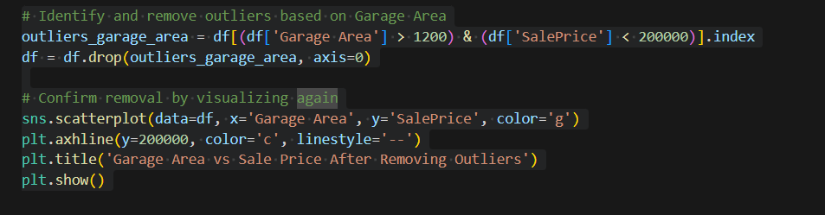
  - Figure 15: Code to remove the outlier for Garage Area
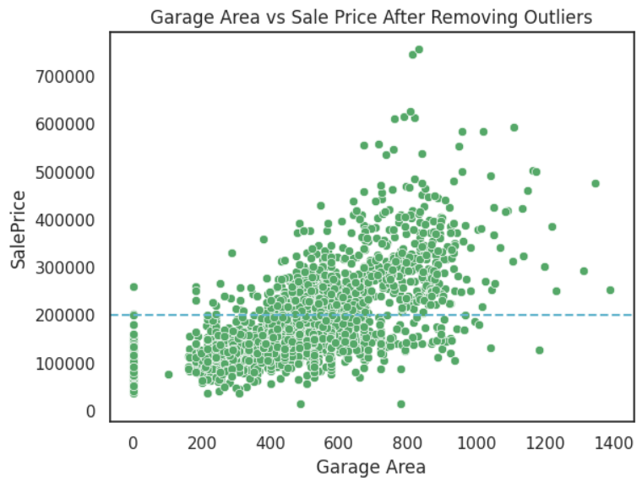
  - Figure 16: Scatter plot after removing the outlier for Garage Area.
Removing the outlier for feature Total Bsmt SF
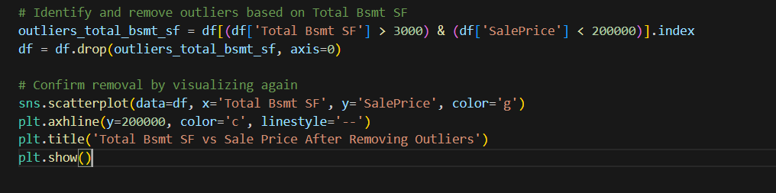
  - Figure 17 : Code for removing the outlier for Bsmt SF

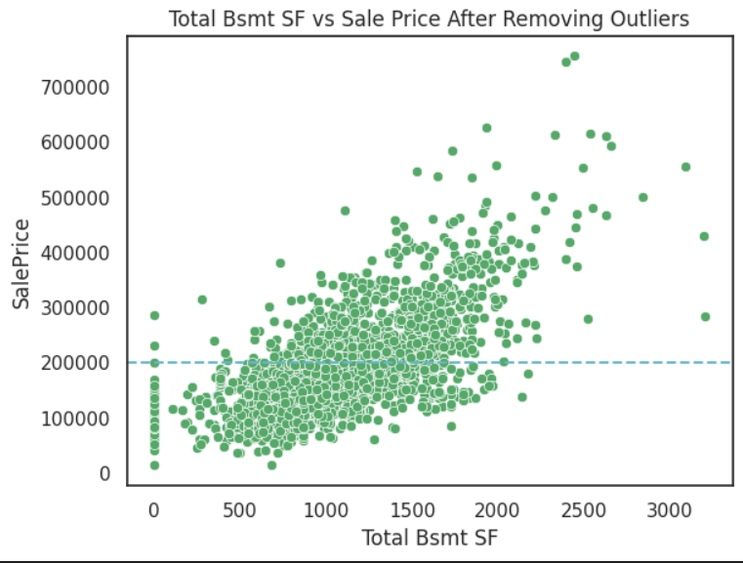
  - Figure 18 : Scatter plot after removing the outlier for Bsmt SF
Removing the outlier for 1st Flr SF
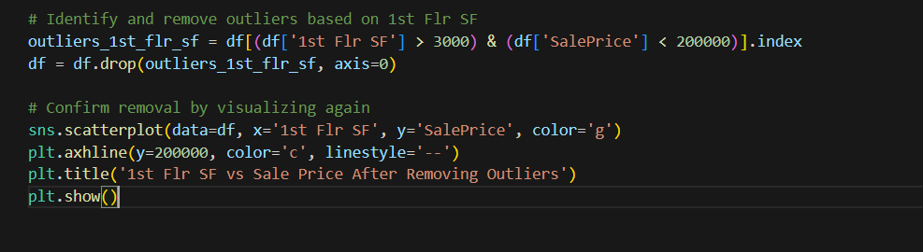
  - Figure 19 : Code to remove the outlier for 1st Flr SF
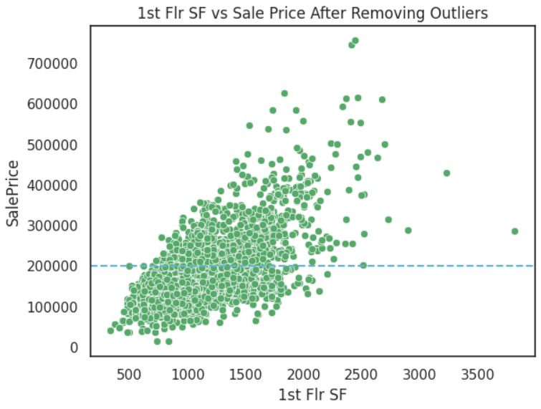
  - Figure 20 : Scatter plot after removing the outlier for 1st Flr SF
Removing the outlier for year built
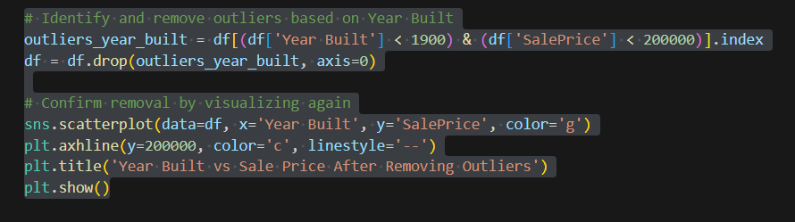
  - Figure 21 : Code to remove the outlier for Year built.
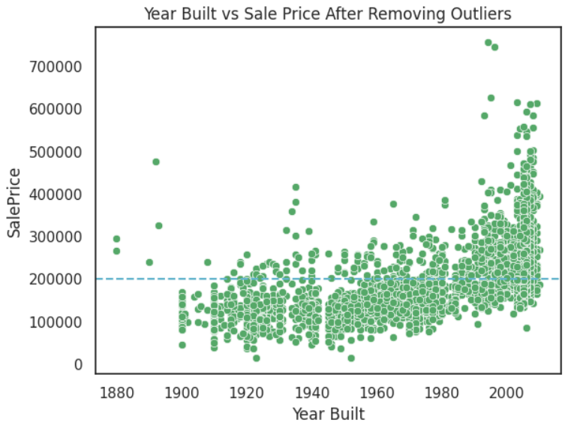
  - Figure 22 : Scatter plot after removing the outlier for Year Built

Feature Importance and Selection
Correlation analysis and visualizations guided the selection of features with the strongest impact on SalePrice. The final selected features included:

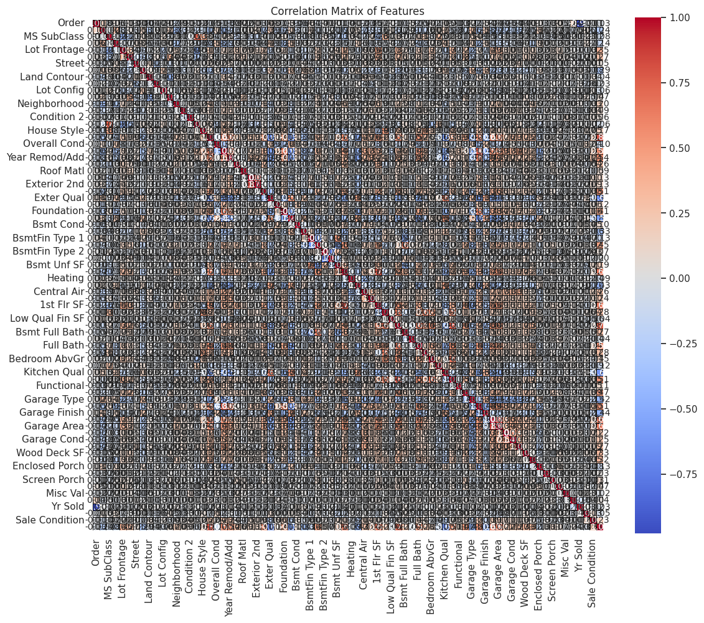
  - Figure 23 : Correlation Matrix for the features.
After generating the correlation matrix identified the most correlated features with the SalePrice. The below image shows the selected features and the used code for that selection.
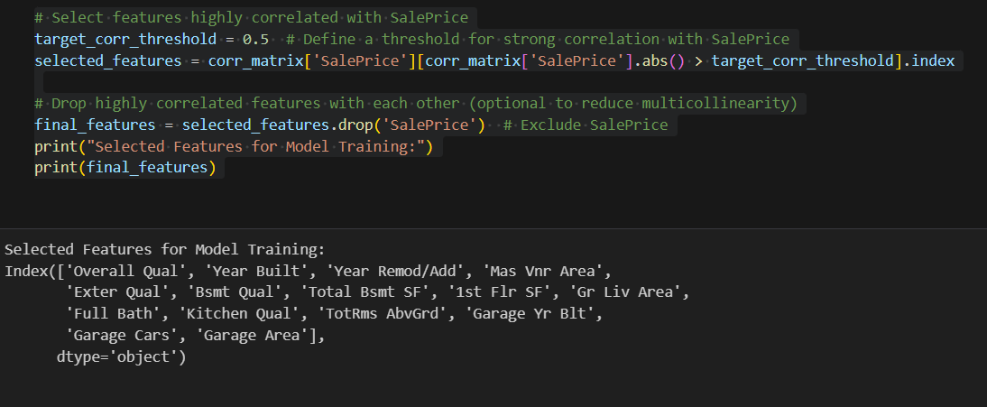
  - Figure 24 : Feature selection code and the results.

Summary
The EDA approach was valuable as it offered vital information and helped to achieve data cleansing for model building. Key achievements include:
- Addressing missing data with appropriate imputation techniques.
- Removing outliers to enhance data reliability.
- Identifying significant predictors of SalePrice.
Having cleaned the data it is now ready to be used for feature engineering and the building of intelligent machine learning models. Feel free to reach out to me if you prefer a more polished appearance.

Feature Engineering
This paper applies feature engineering on the dataset to transform it into the form suitable for machine learning algorithms. It is the process of altering the basic information inputs to the system by features that enhance models’ capability to foretell. As it concerns feature engineering, it is partially accomplished; however, some important preparatory steps have been taken to improve the usability of the dataset for modeling. Some of these include feature transformation and feature selection; two processes that are especially important as they help to enhance the performance of the model, and also ensure that all features have been transformed into a standard format.

Transformations
Feature transformation is a process of turning raw data into forms that are acceptable for consumption by machine learning algorithms but with more value than in the raw data form. Two primary transformations were considered:
- One-Hot Encoding: Categorical variables always prove to be problematic for machine learning models, as most of such models accept numerical inputs. Considering this, one approach of feature engineering that was used was to use the one-hot encoding method to transform categorical features into dummy binary variables. Added value binary process which forms new columns for each unique categories sets value 1 if the column provides that category otherwise it sets the value 0. For instance, the neighborhood variable would contain categorical data such as OldTown and Edwards; hence, it was converted to multiple binary columns, each for a neighborhood. This approach enables the machine learning models to handle categorical data without distorting the machine learning algorithms by introducing an ordinal attribute.
- Normalization of Numerical Data: All the numerical variables were scaled to be at the same range for the dataset. This step was necessary as attributes such as Gr Liv Area and SalePrice are on quite different scales operationally. Scaling means that none of the features has dominated the model due to large values it has because they are close to the maximum or minimum characteristic of the set. This or techniques like min-max scaling or standard scaling, may be used at later stages of feature engineering to normalize all numerical features and stabilize the model.

Feature Selection
Feature selection is one of the major parts of feature engineering and involves the processes of choosing specific features to incorporate into a predictive model. The goal is to increase clear cooperation performance, and to decrease the dimensionality of the model and remove the needless information from the database.
- Correlation Matrix Analysis: Attempting to confirm Hypothesis 1 that there are relevant and statistically significant relationships between SalePrice and features, a correlation matrix was developed. Ear this analysis he was able to identify features that could have higher prediction value and should be given more priority. The findings of the correlation matrix included the following:
  - Overall, Qual had the highest positive correlation with SalePrice (+0.79), indicating that properties with better overall quality materials and finishes tend to have higher sale prices.
  - Gr Liv Area exhibited a strong correlation with SalePrice (+0.71), suggesting that larger living areas significantly impact property value.
  - Garage Area showed a moderate positive correlation with SalePrice (+0.64), highlighting the value of garage space in property pricing.
  - Features with low or negligible correlation with SalePrice, such as Pool QC and Fence, were deprioritized or dropped during the cleaning process to streamline the dataset.
- Multicollinearity Considerations: The correlation matrix was also useful in highlighting the existence or otherwise of multicollinearity between the features. For example, 1st Flr SF and Gr Liv Area were highly inter-correlated with each other in the sample. ROC analysis, in subsequent steps, may be followed by dimensionality reduction techniques, where over-represented features, due to multicollinearity, may be reduced using the PCA or regularization techniques.

Current Status and Future Steps
The feature selection and transformations that have been done up to this level were necessary to ease the initial model training. However, further refinements are planned:
• Advanced Feature Engineering: More pre-processing methods like logarithm scaling will be to apply on some of the features such as SalePrice as shown below as it is known to be dependent on trait.
• Interaction Terms: New attributes, if representing interaction between existing attributes such as Gr Liv Area * Overall Qual, may be formed to better represent the interactions observed in the data.
• Dimensionality Reduction: Further, methods such as PCA or feature subset elimination from a specific variance percentage will be adopted to perform feature scaling for enhanced computational computations.
Through these steps, the feature engineering process tries to develop a set of high-quality data to match with high accuracy machine learning algorithms to make accurate and authentic housing price predictions possible.

Model Development
Model development is the essence of this project, particularly training and evaluating a variety of regression models for the purpose of housing price estimation. All the models were coded in Scikit-learn environment, while the Random Forest Regressor used some components from the XGBoost. In this phase, the basic training, validation, and introduction to hyperparameters optimization were targeted to choose the most accurate model.
Pre-modeling data preprocessing involved feature extraction where the matrix independent variables, denoted as X, was isolated from the matrix dependent variable, denoted as y. The dependent variable was the selling price of the house, and the independent variables were the chosen features obtained in the feature selection stage including Overall Qual, Gr Liv Area, and Garage Area. The target variable in the study was SalePrice. The data set was split into a 4:1 ratio to training set and testing set to allow for sufficient training and testing data set. This division was done using train_test_split function from Scikit-learn, and the test size used was to have fixed random state for consistent outcome.
The first built model was LR, which stands for Linear Regression, a well-known algorithm for analyzing linear dependencies between the fields. The model was trained using the fit method from the inputs and output of the training set, and following this, predictions were made for test set. The Linear Regression model was measured using metrics such as the Mean of Absolute Error (MAE), Mean Squared Error (MSE) and the coefficient of determination (R²). These measures were objective indicators of the performance of the model, where the coefficient of determination displays the extent of the variation in the target variable explained by the model.
Secondly, the Decision Tree Regressor algorithm was used to model the variability because of non-linear relations. Note that decision trees can capture nonlinear patterns and therefore can be used in data where there are interactions in the attributes. We used the default parameters for the model training and made the predictions on the testing set. Performance metrics were computed in the same way making it easier to compare with the Linear Regression model.
After this, the Random Forest Regressor algorithm was used. Instead, this ensemble model forms multiple decision trees at once and combines their outputs to get a more accurate and reliable model. The model was learned with 100 estimators which are the number of decision trees taking part in the final model. For the testing set choices were made and the results were analyzed with reference to the same measures. The prediction by Random Forest model was better than that of the Linear Regression and Decision Tree models with fewer error rates and higher R² score.
In each case, the step of training and evaluating the model, as well as considering areas for improvement based on hyperparameters, was brought into play. For example, the next versions of the Random Forest will involve better searching of the number of estimators as well as the maximal depth of the individual trees and minimum samples required for splitting a node. The some of the refinements include Grid Search and Random Search that will be used to fine-tune the model to enhance its predictive capability.
The training process helped to identify advantages and disadvantages of each model. Linear Regression was useful in providing a starting to point by establishing linear as the basline although its constraints in assumptions of linearity hampered its ability in displaying the relationships between the variables. Decision Tree Regressor also exhibited better flexibility to other applied algorithms but was more sensitive to overfitting especially when using a penetrant algorithm without regularizations. Random Forest, which can combine the results of many trees, is useful in avoiding overfitting and gave the best results in this phase.
In conclusion, it could be asserted that the model development phase has achieved the goal of constructing an adequate prediction model of housing prices. As such there is an indication that Random Forest is the most promising model as indicated by the performance metrics for bias and variance. This work can be extended further in the future to increase the accuracy by tuning the model more precisely and exploring other methods of feature combination like Gradient Boosting and XGBoost. These improvements should help the final model be able to provide accurate predictions about the housing market situation.

Evaluation
During the evaluation phase of the project, the trained regression models were compared with standardized benchmarks to determine how well they fared in terms of a predictor variable’s ability to predict a dependent variable. The evaluation focused on three critical metrics: To assess the performance of the model, three standard measures have been used, the Mean Absolute Error (MAE), the Mean Squared Error (MSE) as well as the coefficient of determination (R²). These metrics gave measures of how well each model was able to learn and replicate the housing data patterns and sales prices, respectively. Furthermore, the comparisons were made to determine the best approach to solve the problem among the several models.
The evaluation started at a creation of Data Frame which allowed comparing the values of the performance metrics of the applied models namely, Linear Regression, Decision Tree Regression, and Random Forest Regression. The Data Frame included the MAE, MSE, and R² values of all the models that we have fit earlier. All these metrics were determined using the evaluation functions of Scikit-learn. MAE was employed to quantify the average absolute deviation of the predicted and actual sale prices to obtain an easily interpretable assessment of the prediction accuracy. MSE, on the other hand, summed up the square of the differences between the predicted value and the actual value, which awards bigger error bigger penalty than MAE. Lastly, R² was utilized to determine percentage of variation which was explained by the chosen target variable providing an overall picture of the fitness of the model adopted.
The Linear Regression model, which was used as a benchmark model, showed a good result. The MAE stated the degree of difference between the predicted and actual prices, which was satisfactory, but pointed at calibration enhancement. When using the MSE for Linear Regression, there was a presence of some larger errors in the given set of predictions because this measure is influenced by outliers. What I then found from the R² value was that Linear Regression I conducted was hamstrung by its linearity in capturing the variance due to the model’s inability to capture the real relationships in the dataset since it only identifies linear relationships.
Dt also performed better than Linear Regression in the different facets, and especially in explaining a non-linear relationship between the features and the target variable. The MAE for the Decision Tree was lower than those recorded implying reduced overall mean average error. It also had a lower MSE than Linear Regression, so there were fewer large errors when predicting the value. In this study, the R² value of the Decision Tree showed that this model can account for more variance in the given data. Nevertheless, the Decision Tree model had its drawbacks; they are too complex and can capture every detail of the training set and thus perform poorly on other data sets from the same class. To avoid overfitting, this was an area considered during evaluation, and more tuning or ensemble methods might be required in the future.
In the experiment, the Random Forest Regressor also emerged as the best model of the three not only in terms of accuracy but also of other parameters. The structure of the ensemble that is based on the outputs of several decision trees also led to the lower MAE and, thus, to the more accurate predictions on the average. The MSE was also the lowest of all the models as it proved adept at reducing large error predictions. The R² for the Random Forest Model was the highest proving that model was the best fit on the data and captured most of the variance in the target variable. These results placed greater emphasis on the Random Forest model, which was less prone to overfitting than when each decision tree was used independently. In this sense, the results obtained by Random Forest were the most accurate since this model can mitigate the problem of bias and variance when calculating the average of the probabilities of each tree.
To clearly present the results of the models the bar chart was constructed for displaying the R² of the three models. This figure offered a concise overview of the varying performance of all models in terms of predictive ability and overlaid the substantial correctness of the Random Forest model. However, the same type of plots for MAE and MSE could be made to visualize its major advantages and disadvantages compared to other models. These visual aids were employed in the analysis and presentation of the evaluation findings.
In summary, strengths and weaknesses of each model were pointed out during the evaluation part of this experiment. Linear regression thought simplistic can be a drawback when analyzing the dataset as it failed to capture non-linearity in the dataset. The Decision Tree Regressor performed higher but was more likely to overfit the data thus the tuning of the equation was necessary to increase the ability to generalize. Out of all the models tested, Random Forest was the most reliable and accurate of all the four models tested. Its effectiveness for modeling non-linear relationships while preventing overfitting was the reason why it was used for housing price prediction in this project.
As for the evaluation of the following steps, hyperparameter tuning will be conducted to adjust them to the best state. For Random Forest, the number of trees or nodes, maximum depth of the tree or minimum number of samples that define the splitting nodes is tuned using a Grid Search or Random Search. Further, other enhanced practices within ensemble concepts like Gradient Boosting, XGBoost, etc. will also be investigated to determine the likelihood of enhancing the predictive accuracy. All these steps are undertaken towards improving the assessment process and to arrive at a final model which has the best possible level of accuracy and credibility possible.
Finally, the evaluation phase showed the efficiency of using machine learning models in the case of housing price prediction. As a result, the findings of this phase are important to determine which of the models is more suited for the prediction of job performance since MAE, MSE, and R² all varied accordingly when one or more variables were moved in a systematic manner. The results obtained were used to select Random Forest as the most perspective model which creates the base for further developments and application of the approaches in practical conditions.

Work Plan and Timeline
A detailed Gantt chart will outline the phases of the project, deliverables, and timelines. Key milestones include data collection, EDA, model development, and deployment. The risk analysis will identify the potential challenges, such as insufficient data or computational limitations, and propose mitigation strategies.
Table 1 : Time Plan for the Project
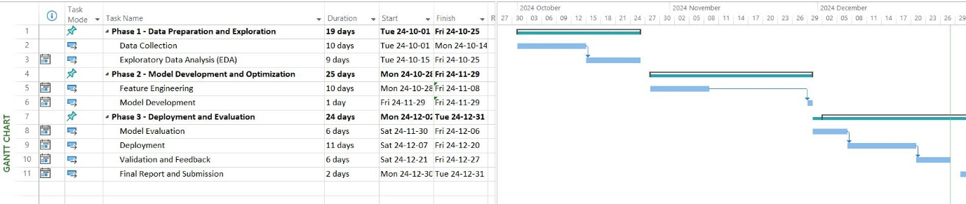

Ethics, Legal, and Data Protection Considerations
Housing price prediction is mostly dependent on data, and any other information that might contain tons of confidential information involving property transactions, demography, and economic factors. But such data must be used and protected to be ethical.

Ethics in Data Use
To link ethical issues to data, there is a necessity to understand how data is collected, processed, and utilized improperly. If FAT principles are not adhered to, other principles like political accountability, responsibility, and integrity become folly. The project ensures that:
- No biases in model predictions unfairly impact specific communities or demographics.
- The transparency of the model is maintained to allow stakeholders to understand the basis of predictions.

Legal Compliance
The project aligns with global and local data protection laws such as the General Data Protection Regulation (GDPR) in the European Union and similar frameworks in other jurisdictions. Specifically, it ensures:
- Lawful collection of data with informed consent from relevant parties.
- Secure storage and processing of data to prevent breaches and unauthorized access.
6.3 Data Protection Measures
To safeguard sensitive information:
- Encryption techniques are applied to secure the data during storage and transmission.
- Access controls are implemented to restrict data access to authorized personnel only.
- Anonymization methods are used to ensure privacy, especially when sharing datasets or results.
Hence the combination of ethical principles and legal conformity ensures the credibility of the project and corresponds to the universally acceptable standards of artificial intelligence application. [4] [5].

Results
The respective section of the study is devoted to the outcomes of the model training, its assessment, and comparison. The goal of this phase was to identify the model that fits well to predict housing prices as identified in the evaluation metrics. The models under consideration were Linear Regression, Decision Tree Regressor and Random Forest Regressor, and the efficiency was checked by Mean Absolute Error, Mean Squared Error, Coefficient of determination. These metrics described how well these models were able to correctly identify, how resilient the models were to noise and distortion, and how well the models could generalize to new unseen data.

Model Comparison
The Linear Regression model was used as a reference model with an attempt to model the basic concepts, giving a mean way of mapping of features and the target variable (SalePrice). In fact, the Linear Regression model had some disadvantages, specifically it failed to account for non-linear dependencies which are typical for the given dataset. The model generated an MAE which explains the average level of error in its prediction while the MSE showed the effect of the big errors on the model. The R² score showed that Linear Regression had a high potential to explain the variation in SalePrice was but could not account for the interactions of the other factors. These results highlighted interesting areas and argued that, clearly, more flexible, and powerful models are needed.
Decision Tree Regressor was marginally preferred to the Linear Regression Model as it can model, has non-linear features, and also feature interactions. MAE of Decision Tree was less than Linear Regression suggesting that overall, there were more accurate predictions on average. The MSE was higher than in previous days, implying a decrease in the MSE and therefore implying the reduction in large prediction errors. Furthermore, the R² score was used to show how well the Decision Tree can capture a greater amount of variance of SalePrice. However, there is a problem with that model as this is over fitted to the training data and it proved it by the performance of the test data as compared to the training data. This overfitting behavior suggested that the current model is highly trained on the features of the training data which could hamper future generalization.
According to the result, the Random Forest Regressor was the best among all the models considered in this study. Random forest is an extension of decision trees where the results of the multiple trees are combined in the last step thereby being a type of ensemble learning. Based on the results achieved, the lowest MAE was characteristic for Random Forest, meaning high prediction accuracy. The MSE was also the smallest due to the model’s capacity to eliminate huge discrepancies in the forecasted values. R² was the highest for the models, meaning that Random Forest had the best fit to telepic variance in the dataset. These outcomes validated that Random Forest was the most stable and accurate framework for housing price predictions in this work.

Visualization of Results
Finally, since the aim of the paper was to evaluate the performance of the models, graphical comparison for better presentation of results was done. Using a simple bar chart comparing the R² scores for Linear Regression, Decision Tree, and Random Forest also portrayed the advantage of using the Random Forest model. For MAE and MSE one could add a few more visualizations that help to highlight the differences between the two methods in terms of the predictive performance. It helped in choosing the right model most suitable for the impending deployment by affording a clear and immediate comprehension of the inherent advantages and limitations of the models.

Key Findings
- Linear Regression: Was helpful in determining a model that would strictly serve as a reference but seemed to have restricted applicability while analyzing closely related data points.
- Decision Tree Regressor: Outperformed the Linear Regression but had problems of overfitting, which means that it would require regularization or ensemble Ing.
- Random Forest Regressor: Achieved the best performance than the two benchmark models in all aspects; Linear Regression and Decision Tree Regressor. Another virtue that made this ensemble model more suitable for this project was that it eliminated both bias and variance by incorporating the elements in its work.

Implications of Results
The experimental findings show the feasibility of using machine learning models for accurate prediction of housing prices. These results reaffirm that ensemble methods prove to be valuable for analyzing and modeling situational patterns and dependencies in housing data. The research findings have significant implications for stakeholders in the real estate sector and hence help to make better decisions for consumers, producers and even policy makers. It will also enable those stakeholders that need to dollarize value to be able to do it adequately by having a model that will predict the correct house prices.

Future Directions
The results also show where further development and research is needed. Random forests again provided outstanding results, although there is also enormous potential for increased performance by performing hyperparameter optimization. To optimize hyperparameters including number of estimators, maximum tree depth and minimum samples split; Grid Search or Random Search technique will be applied. Moreover, other feature engineering methods comparable to those used in the previous steps will be applied to the data the performance of state-of-art ensemble frameworks, Gradient Boosting and XGBoost will be investigated for the purpose of the prediction model’s accuracy enhancement.
In addition, the presence of more variables, for instance macroeconomic or environmental variables, can be added to the model and increase its accuracy in prediction. The results of the study suggest that expanding the investigation to other databases or housing markets will clarify the model’s applicability to the conditions of other regions.

Conclusion
This project validates Random Forest as an accurate reliable model for housing price prediction according to the results obtained. Evaluation criteria and data visualization demonstrate it outperforms Linear Regression and Decision Tree models. The obstacles of the non-linear relationship and the problem of overfitting have been solved with the help of Random Forest, which offers the most trusted approach to the prediction of housing prices. These are good premises for improved development and use of the model, which can be applied in the housing market.

Discussion
Analysis of the results shows that the Random Forest Regressed algorithm is appropriate for housing price prediction among all the evaluated models. This was possible due to its ensemble methodology to combine multiple decision trees to reduce prediction overtones while recognizing the non-linear relationship in the dataset. It made an excellent comparison when compared to Linear Regression which gave extremely high linear assumptions, While the Decision Tree Regressor was much higher in the MSE and giving overfitting was observed, the Random Forests showed superior performance in all metrics such as MAE, MSE and R². This is an indication that the dynamic in housing markets is overly complex and requires the use of ensemble methods.
For a number of stakeholders, the results of this project bring several important practical applications. From this point of view, the accurate forecast enables homebuyers and sellers to make balance decisions because the pricing structures are set to regulate the risks entail and cut unpredictability. Real estate specialists can utilize predictions from models such as Random Forest to produce more value-added information for clients and more personalized and timely information about the market. However, these insights could be used by policymakers and government to determine the kind of housing policies and urban planning that would meet the market demands. It is the adaptation of integrating machine learning in real estate that can change traditional practices to more accurate output and these projects display that.
However, there are some of the limitations with the project. This study was only done on the Ames Housing Dataset and therefore results cannot be generalized to other regions or markets. Moreover, important variables have been found while developing the model; however, macrosocial factors and environmental factors can also be included to improve the accuracy of the model. These are the areas for improvement in future work: Increase dataset size, try new parameters for models, use Gradient Boosting and XGBoost. It will also be implemented on a cloud-based platform that has a graphical user interface, which will make it easier to get real-world feedback and improve the solidified model eventually.
Further, this project shows that using machine learning in prediction of housing prices is feasible as it provides solutions to difficult issues in the field. The most outstanding model for real estate-based prediction was the Random Forest Regressor as an efficient example of ensemble methods. With a view to the limitations mentioned and future addition, one can find that it would be possible to offer a tangible and practical solution to stakeholders in the housing market.

Expected Outcomes
The expected outcomes of this project span technological, practical, and socio-economic dimensions, significantly contributing to stakeholders in the housing market:

Enhanced Prediction Accuracy
- Enhancing a credible and dependable prognosis model for housing price estimate using superior regression models.
- Enhanced dataset prediction enhancement through XGBoost and LightGBM and authenticated on real world data sets [6][7].

Stakeholder Insights
- Industry insiders receive strengthened market data processing features to achieve more accurate pricing models.
- Gathered data provides decision support to policymakers as they work on formulating housing policies and adequacy issues.
- Stakeholders are provided with information which policymakers can use to formulate housing polices and respond to affordability issues.

Contribution to Research and Practice
Traditional and machine learning models are compared to providing addition to academic research. Through the course of the project, one discovers conducts an analysis of the factors that determine the prevailing housing prices for the various real estate markets and provides tangible suggestions about the manner in which the real estate markets should be shaped to encourage sustainable progress.rs affecting housing prices, offering practical recommendations to improve real estate market dynamics.

Long-Term Benefits
Purchasers and sellers of homes come to the market with higher levels of transparency and rationality for pricing. Market analyzed decision-making decisions improve market conditions and reduce potential risks inherent in market volatility [5] [6].

Conclusion
With this project, it was ironed out how machine learning models can help solve housing price prediction challenges. By going through the stages of data pre-processing, data exploration, feature transformation and selection, and finally model selection and validation the current study determined that the Random Forest Regressor model was the most suitable for use. These provide clear benefits of the ensemble method over other traditional methods of data analysis such as the use of Linear Regression or standalone Decision Trees and include reduction of prediction errors, particularly in cases of non-linearities present within the dataset. The results of this study demonstrate the application of machine learning techniques for the real estate market, thus raising the need for the higher level of advancements in algorithms to support constructiveness and dependability of predicting tools.
The findings of this research have important consequences for stakeholders. For homebuyers and sellers, this accurate model serves the right roadmap for equitable pricing of the houses and enhanced marketing decisions. It is useful for real estate professionals to analyze their results to provide market information and recommendations based on the data obtained. Decision-makers and spatial project managers can apply the model as a tool for arriving at successful housing policies that will allow equal access to housing and regulation of urban development. Because the proposed idea involves using machine learning in the described area of real estate analytics, the proposed project eliminates the gap between existing approaches and approaches based on modern technologies, thus establishing new standards for further developments in this field.
Nevertheless, the work under discussion has some drawbacks; for instance, the given dataset was limited, and the hyperparameters were not regulated during this stage. Further improvements will aim at solving these issues through adding new features, and enlarging the databases to include other different markets, and optimizing the further parameters of the model. Real-world testing of the model in conjunction with a GUI will also be possible to deploy allowing for continual refinement. In conclusion, this project constructively contributes to housing price forecasts and can be utilized at scale to improve decision-making across the housing market.

Bibliography

[1] S. S. Yalgudkar and N. V. Dharwadkar, "A Literature Survey on Housing Price Prediction," Journal of Computer Science & Computational Mathematics, vol. 12, no. 3, pp. 42-45, Sep. 2022, doi: 10.20967/jcscm.2022.03.002.
[2] X. Li, "Prediction and Analysis of Housing Price Based on the Generalized Linear Regression Model," Computational Intelligence and Neuroscience, vol. 2022, Article ID 3590224, pp. 1-9, Sep. 2022, doi: 10.1155/2022/3590224.
[3] M. J. Manasa, R. Gupta, and N. N. Seetharam, "Machine Learning-Based Predicting House Prices Using Regression Techniques," in Proceedings of the Second International Conference on Innovative Mechanisms for Industry Applications (ICIMIA), Bengaluru, India, 2020, pp. 624–630. doi: 10.1109/ICIMIA48430.2020.9074952.
[4] H. L. Harter, "Method of least squares and some alternatives-part II," International Static Review, vol. 43, no. 2, pp. 125-190, 1972.
[5] R. Victor, "Machine learning project: Predicting Boston house prices with regression," Towards Data Science, 2018.
[6] S. Raheel, "Choosing the right encoding method - Label vs one hot encoder," Towards Data Science, 2018.
[7] J. Clerk Maxwell, A Treatise on Electricity and Magnetism, 3rd ed., vol. 2, Oxford: Clarendon, 1892, pp. 68-73.
[8] L. Yan, "Predicting House Prices with a Linear Regression Model," Proceedings of the 2nd International Conference on Machine Learning and Automation, 2024, pp. 107–115, doi:10.54254/2755-2721/114/2024.18220.
[9] M. Tingjun, "Real Estate Price Prediction Based on Linear Regression and Machine Learning Scenarios," BCP Business & Management EMFRM 2022, vol. 38, pp. 400–409, 2023.
[10] X. Xu, "The real estate price prediction of US prediction based on multi-factorial linear regression models," BCP Business & Management CMAM 2022, vol. 36, pp. 1–6, 2023.
[11] Z. Li, “A Comparative Study of Regression Models for Housing Price Prediction,” Transactions on Computer Science and Intelligent Systems Research, vol. 5, pp. 810–816, Aug. 2024, Doi: https://doi.org/10.62051/qjs7y352.
‌

Abstract
Here I attached the Gantt chart file.

