Table of Contents

Chapter 1: Introduction 4
1.1 Background of Study 4
1.2 Research Problem 5
1.3 Research Questions 6
1.4 Research Objectives 6
1.5 Significance of Study 7
1.6 Outline of the Dissertation 9
Chapter 2: Literature Review 10
2.1 Chapter Overview 10
2.2 Existing Works 10
2.3 Research Gaps and Opportunities 16
2.4 Comparison Table 19
Chapter 3: Research Context, Methodology, and Theory 20
3.1 Philosophical Base 20
3.2 Research Methodology/Strategy of Inquiry 20
3.2.1 Explanatory Sequential Design 20
3.3 Sampling 21
3.3.1 Quantitative Sampling: Stratified Random Sampling 22
3.3.2 Qualitative Sampling: Purposive Sampling 23
3.4 Details of Participants and Respondents 23
3.4.1 Quantitative Research Participants 23
3.5 Data Collection Process 23
3.6 Data Analysis Process 24
3.6.1 Statistical Analysis (Using SPSS) 24
3.6.2 Graphical Analysis 25
Chapter 4: Data Presentation/ Findings/Analysis 26
4.1 Introduction 26
4.2 Data Presentation 26
4.2.1 Demographics of Respondents 26
4.2.2 Current Inventory Management Practices 28
4.2.3 Authentication and Fraud in the Gem Trade 29
4.2.4 Barriers to Digital Adoption 30
4.2.5 Perception of Digital Business Management Systems (DBMS) 31
4.3 Findings and Interpretation 32
4.3.1 Dominance of Traditional Business Practices 32
4.3.2 High Frequency of Fraud and Security Concerns 33
4.3.3 Barriers to Digital Adoption 33
4.3.4 Growing Interest in Digital Business Management Systems (DBMS) 33
4.3.5 Expected Benefits of Digital Inventory Management 34
4.3.6 Summary of Findings 34
4.4 Analysis 35
4.4.1 Data Preprocessing for Analysis 35
4.4.2 Statistical Analysis 38
4.4.3 Graphical Analysis 43
Chapter 5 - Discussion of findings and Conclusion 46
5.1 Discussion of findings 46
5.1.1 Traditional Business Practices and Digital Adoption 46
5.1.2 Fraud Prevention and Transparency 46
5.1.3 Key Barriers to Digital Transformation 46
5.1.4 Industry Readiness for DBMS Implementation 47
5.2 Conclusion 47
Reference 48
Appendices 50
Questionnaire 50

Chapter 1: Introduction

Background of Study
Sri Lanka has been identified for centuries as an important source of rare gemstones, which positively impact the country's economy and cultural legacy (Tkalich, Moe, Mikalsen, & Sporsem, 2021; Lenaduwa & Eranda, 2024). The country's gem trade has a history of thousands of years, and historical literature and international trade records place great emphasis on its importance. Sri Lanka is particularly renowned for its high-quality sapphires, which are among the world's most desirable gemstones due to their exceptional clarity, color, and durability. These sapphires fetch a high premium in global markets, and have graced kings, celebrities, and collectors for centuries. Over 90% of the world's sapphires are derived from Sri Lanka, cementing the nation's position as the world gem and jewelry market leader. (Tkalich, Moe, Mikalsen, & Sporsem, 2021)
Despite the sector's rich historical record of growth and its significant contribution to the country's economy, it still relies largely on conventional means that have witnessed little change in past millennia. These are hand documentation, personal sales interaction, and paper-based systems for financial management and stockkeeping. While the methods have satisfactorily supported the sector for several generations, they now pose serious challenges in the current globalized competitive business environment. Issues such as inefficiency, high error rates, data loss risks, and limited market outreach hinder the growth prospects of the industry. Furthermore, reliance on physical documents limits real-time access to information and delays decision-making processes, especially for cross-border trade activities. (Tkalich, Moe, Mikalsen, & Sporsem, 2021)
Digitalization offers a viable remedy for revamping Sri Lanka's gem sector by adopting a DBMS tailored to the unique needs of gem dealers. The system would integrate contemporary technology into daily activities, streamline operations, and enhance productivity with components like inventory control, sales monitoring, supply chain documentation, and CRM. A database management system (DBMS) would help maintain the integrity of records, bring about greater transparency with secure electronic transactions, and lower operational expenses while at the same time promoting customer interaction and building long-term business relationships. Sri Lankan gem merchants could further increase their global presence, get access to wider global markets, and make decisions supported by data analysis to respond quickly to changing market needs, thus increasing the industry's competitiveness. (Gem & Jewelry Industry, n.d.)
The current research attempts to give an overall plan towards modernizing the gem industry of Sri Lanka through a discussion on the implications brought by using digital infrastructure. The key intention is to explain how transitioning to digital business models will be able to increase the industry's efficiency, transparency, and competitiveness globally without sacrificing the historical background and expertise that have marked Sri Lanka's gem industry so far.

Research Problem
The Sri Lankan gem industry is confronted with many major issues due to its multi-dimensional dependence on obsolete and archaic practices (Ramadasa, 2024; Weerabahu et al., 2022). These constraints have made the system highly ineffective, resulting in losses due to inventory control and sales management (Holloway, 2024). Such processes are not only time-consuming but also laborious; and since laborious operations open avenues to weaknesses, they enhance the propensity for errors, fraud, and forgery-all factors that undermine corporate integrity (Ahsan et al., 2024; Butterworth et al., 1991). Moreover, the lack of data analysis in organizational decision-making also means that no prediction of trends in advance to capitalize on the opportunity could be done, which makes the sector less competitive compared to their foreign counterparts relying on sophisticated intelligence methods (Lenaduwa & Eranda, 2024).
Additionally, the weak presence of the online sector is also discouraging prospects for growth (Iskanius et al., 2010). Besides this fact, the lessened digital footprint in the industry decreases its capability for effective communication with targeted customers to make its due role within the international markets (McCombes, 2023). It is such a situation where customers' lost trust in a global buyer may further decrease that power to be more competitive in the global dimension (Ahsan et al., 2024). Besides everything, there must be engagement for developing a business management system such as digital omnichannel (IBM, 2024). The effort would eventually place the Sri Lankan diamond industry in a modern, digitized economic landscape that could take a lead in success through improvement in operational effectiveness, transparency, and access to markets (Weerabahu et al., 2022; Holloway, 2024). These challenges have, over time, deprived the international buyer of confidence and reduced competitiveness at an international level. These challenges come forth as results of an overall need to include a digital business administration system. Its realization would assure higher degrees of efficiency operationally, greater access to more transparent markets, and allow the Sri Lanka diamond industry to thrive in a growing digital economy (Lenaduwa & Eranda, 2024; McCombes, 2023).

Research Questions
The aim of this study is to answer the following main research questions:
- How can a Digital Business Management System (DBMS) reduce inefficiencies related to inventory management, tracking sales, and supply chain operations in the context of Sri Lanka's gem industry?
- What are the major barriers technological, financial, and workforce-related—to adopting a DBMS in Sri Lanka’s gem trade, and how can these be mitigated?
- How can a DBMS improve transparency, reduce fraud, and build trust among international buyers?
- What impact will digital transformation have on Sri Lanka’s global competitiveness and market share in the gem trade?
- How do stakeholders, including gem traders, regulators, and international buyers, perceive and respond to the adoption of a DBMS?
- What are the economic and cultural implications of implementing a DBMS for Sri Lanka’s gem industry, and how might it influence the country’s standing as a leader in ethical gem trading?

Research Objectives
To address the research problem, this study sets out the following objectives:
- To analyze the operational inefficiencies, fraud risks, and market barriers in Sri Lanka’s gem industry and identify areas for improvement.
- To assess the specific needs and preferences of gem traders, international buyers, and regulatory bodies for designing a DBMS tailored to the industry.
- To evaluate the economic and operational benefits of implementing a DBMS through stakeholder feedback and data analysis.
- To recommend ways of overcoming adoption obstacles, including financial, technical, and human resource constraints, to ensure successful implementation and sustainable longevity.
- To analyze the broader economic and cultural implications of DBMS adoption while emphasizing its potential to place Sri Lanka at the forefront of ethical and transparent gemstone trade.

Significance of Study
This research is significant to various stakeholders, from gem merchants to policy makers and technology providers, in that it considers whether the implementation of a Digital Business Management System (DBMS) is possible as an approach to making the Sri Lankan gem business better (Weerabahu et al., 2022; Lenaduwa & Eranda, 2024). The introduction of a DBMS would, theoretically, transform the sector into various dimensions, with grand advantages that resound far outside the immediate commercial landscape (Holloway, 2024; Ramadasa, 2024).
- Improving Business Processes: Process improvement in business areas of the organization will drive business efficiency naturally. Automation slashes manual processing times, cuts down human errors, and enhances recording accuracy (IBM, 2024; Ahsan et al., 2024). Process efficiency will curtail the process time, ensure proper resource utilization, and enable companies to focus on core operations such as strategy, customer management, and product innovation. Business processes and productivity will increase the productivity level that the industry business world works at a much higher rate (Iskanius et al., 2010).
- Increasing Market Competitiveness: By implementing digitalization, the gem dealers of Sri Lanka would increase their global market presence by means of the transparent and efficiently operated way (Lenaduwa & Eranda, 2024). The instant availability of information enhances the dealers' capacity to monitor market trends and thus react timely to the alterations in the market demand (Weerabahu et al., 2022). Futhermore, technological advancement would make digital tracking of products more possible which in turn would boost customer trust and industry's reputation worldwide thus placing Sri Lanka at the core of the global gemstone industry.
- Strengthening Fraud Prevention: An effectively developed DBMS will ensure secure, auditable digital records that follow gemstones throughout the supply chain (Ahsan et al., 2024; IBM, 2024). This will deter fraud in the form of counterfeiting and misrepresentation that has long plagued the industry. Secure digital records will not only protect businesses but also improve the confidence of both domestic and international buyers.
- Informing Policy Decisions: The empirical findings of the study yield valuable empirical findings that can assist policymakers in developing strategies with the purpose of constructing digital infrastructure for the gemstone industry (Iskanius et al., 2010; Weerabahu et al., 2022). The research may also direct regulation for encouraging ethical trade standards, sustainability initiatives, and fair trade, toward establishing an accountable and transparent industrial environment.
- Encouraging Innovation and Digital Adoption: By highlighting the advantages of DBMS adoption, this research aims to stimulate innovation and facilitate the use of digital technology by Sri Lanka's conventional industries (Holloway, 2024; Ahsan et al., 2024). As organizations reap the advantages of digitalization, including improved productivity, improved decision-making, and improved access to markets, they are likely to adopt similar solutions. This change has the potential to further improve economic growth and technological progress in different industries (McCombes, 2023).
Ultimately, this research has the goal to serve as a strategic roadmap towards the future expansion of Sri Lanka's gem and jewelry industry with actionable recommendations and real-world solutions to lead in growth, creativity, and competitiveness in an increasingly digitalized globe (Ramadasa, 2024; Lenaduwa & Eranda, 2024).

Outline of the Dissertation
This dissertation is organized as follows:
- Chapter 1 - Introduction: Presents an overview of study, background, research problems, aims, and relevance.
- Chapter 2 - Literature Review: Consolidates current studies of digital transformation in established industries, identifying gaps and pertinent case studies.
- Chapter 3 - Research Methodology: Outlines the research design, data collection methods, sampling strategy, and analysis procedures.
- Chapter 4 - Data Analysis and Findings: Reports the research findings through qualitative and quantitative data analysis.
- Chapter 5 - Discussion and Recommendations: Describes the findings and recommends how a DBMS can be successfully implemented.
- Chapter 6 - Conclusion and Future Research: Summarizes major findings and recommends areas for future research.
Under this structure, the dissertation will provide a detailed examination of the potential for digitalization to enhance Sri Lanka's gem industry by also strengthening its global market standing.

Chapter 2: Literature Review

Chapter Overview
This chapter discusses the available literature on the digitalization of traditional industries, specifically the gem and jewelry industry (Weerabahu et al., 2022; Ahsan et al., 2024). The objective is to find out existing trends, issues, and opportunities related to the adoption of Digital Business Management Systems (DBMS) in these industries. Through a review of existing research and industry reports, this review aims to provide a basis for an understanding of how digital technologies may be used to improve operating efficiency, transparency, and international competitiveness in Sri Lanka's gem sector (Lenaduwa & Eranda, 2024).

Existing Works
This chapter synthesizes international and regional research on digital adoption challenges, technological innovations, and their applications in traditional industries, and in the gemstone industry of Sri Lanka specifically.
      - Barriers to the Adoption of Digital Servitization: A Case of the Sri Lankan Manufacturing Sector
The research investigates the barriers to adopting digital servitization in the Sri Lankan manufacturing industry, utilizing the grey-DEMATEL method to analyze inter-relationships and dependencies between such barriers (Weerabahu et al., 2022). A thorough literature review revealed 13 priority barriers, ranging from a lack of clear explicit digital strategy, supply chain integration problems, behavioral barriers related to trust in data sharing, and technical and financial barriers (IBM, 2024; Iskanius et al., 2010). The research demonstrated that these barriers strongly discourage attempts at digital transformation, the most predominant being supply chain integration (Ramadasa, 2024).
Data was obtained from a range of manufacturing sub-sectors in Sri Lanka, and the response was provided by expert opinion, which facilitated the construction of an in-depth picture of these challenges (Holloway, 2024). The research findings provide actionable advice to organizations seeking to navigate these challenges and effectively implement digital servitization (Ahsan et al., 2024). The authors suggest that companies take methodical steps in tackling key barriers, with precedence given to supply chain alignment, employee training, and investments in digital innovations (Lenaduwa & Eranda, 2024; McCombes, 2023).
By realizing the interconnectedness of these barriers, firms are capable of taking precise measures in tackling the most relevant issues first (Weerabahu et al., 2022). This paper enhances the literature on digital servitization in emerging economies, with practical implications for business practitioners and policymakers (IBM, 2024). Further studies may compare the barriers to digital transformation between emerging and advanced economies, as well as investigate the drivers of digital servitization that enable successful implementation throughout the manufacturing industry (Butterworth et al., 1991; Ramadasa, 2024).

      - The Influence of Digital Transformation on Inventory Management: A Survey
of Supply Chain Practices
Literature shows that there are notable advantages of digitalization in inventory management as it improves efficiency, lowers stock volatility, and increases supply chain responsiveness (Holloway, 2024; Butterworth et al., 1991). Demand-prediction capabilities are advancing through AI-driven predictive analytics, helping to mitigate the drawbacks of conventional methods by accurately anticipating shifts in demand forecasting across the market (Ahsan et al., 2024; IBM, 2024). Through big data analysis and machine learning, stores can employ a more proactive approach to stock, decreasing waste and optimizing inventory (Weerabahu et al., 2022; Lenaduwa & Eranda, 2024).
Support systems using Cloud and Electronic Data Interchange (EDI) allow the supply chain members to have access to real-time inventory, better communication, reduced errors, and better coordination (McCombes, 2023; Ramadasa, 2024). Such integration empowers businesses to respond quickly to changing demand and supply with better efficiency (Iskanius et al., 2010; Weerabahu et al., 2022).
However, difficulties remain for the use of digital solutions. For SMEs, developing legacy architecture and upgrading to new technology is time-consuming and expensive (Holloway, 2024). The unique financial constraint imposed by high upfront costs for IoT infrastructure, AI software, and cloud-based applications is a significant barrier (Ahsan et al., 2024; IBM, 2024). Moreover, maintaining the accuracy, consistency, and security of that data becomes imperative, as poor data management can result in faulty predictions and vulnerabilities to cyberattacks (Butterworth et al., 1991; McCombes, 2023).
Another consideration is regulatory compliance, which places importance on meeting data privacy requirements (e.g., General Data Protection Regulation [GDPR]), as well as electronic payment regulations or stock reporting standards in certain industries (e.g., pharmaceuticals, food retail) (Lenaduwa & Eranda, 2024; Ramadasa, 2024). Legal frameworks are essential for navigating corporate digital transformation (Iskanius et al., 2010; Weerabahu et al., 2022).
Digital transformation does hold several benefits, but it has to be implemented thoughtfully, be financially feasible, and be strategically planned (Holloway, 2024; IBM, 2024). This involves evaluating current systems, exploring digital integration potential, and creating structured implementation plans (Ahsan et al., 2024; Butterworth et al., 1991). Seamless adoption requires employee training and sound management (McCombes, 2023; Iskanius et al., 2010). Organizations that adequately embrace digitalization gain a distinctive edge over their competition, eventually achieving optimal supply chain operation and sustainability (Ramadasa, 2024; Lenaduwa & Eranda, 2024).
      - Digitalization of Gemstone Supply Chain Management via Blockchain Mechanism
The paper "Gemstones Supply Chain Management through Blockchain Mechanism" (Ahsan et al., 2024) studies existing practices related to gemstone sales, particularly how blockchain can be used to improve transparency, traceability, and security throughout the industry. As the industry is plagued by counterfeit products, unethical practices, and inefficiencies in traditional supply chains, blockchain offers a distributed, tamper-proof ledger for key information, such as mining details, certification, ownership, and sales records, providing data integrity that is free of fraud (Weerabahu et al., 2022; Lenaduwa & Eranda, 2024).
It proposes a dual-layered system on the Ethereum blockchain that enables miners, suppliers, distributors, retailers, and consumers to securely access and exchange information relevant to their interests with provisions for ensuring trust in the supply chain (IBM, 2024). One of the main advantages is the employment of smart contracts, which automate transactions through the verification of conditions such as certification and possession transfers that should be verified before execution (Butterworth et al., 1991; Holloway, 2024). This eliminates the need for intermediaries, reduces errors, and speeds up transactions (McCombes, 2023).
Encrypted digital gemstone certificates use encryption with cryptographic service providers as proof of certifying the stone, which drastically reduces fraud risk through counterfeiting (Iskanius et al., 2010; Ramadasa, 2024). For all these advantages, challenges remain, such as complex implementation, high costs, cyber threats, and regulatory compliance (Ahsan et al., 2024; Weerabahu et al., 2022).
Through improved security, transparency, and efficiency, the study concludes that blockchain can greatly improve the gemstone supply chain, making it a future-proof solution for the industry (Lenaduwa & Eranda, 2024). It is particularly useful for businesses, policymakers, and developers interested in the application of blockchain for supply chain management (IBM, 2024; Holloway, 2024).

      - What are the Specific Barriers in the Gem Industry in Ratnapura District
Indunil Ramadasa's study (Ramadasa, 2024) provides a systemic explanation of issues confronting Sri Lanka's gem sector, particularly in the Ratnapura District, commonly known as the "City of Gems." This study identifies mining, environmental, socio-economic, and trade issues haunting the further growth of the industry (Weerabahu et al., 2022; Holloway, 2024). Systemic failures at the governmental level, including corruption, inefficiencies, and interference from political actors, compound these challenges (Ahsan et al., 2024; Lenaduwa & Eranda, 2024).
The research concentrates primarily on the safety hazards of conventional tunnel mining techniques, which have cost workers’ lives as well as injuries (Iskanius et al., 2010; IBM, 2024). Mechanized mining techniques, though more efficient, further exacerbate environmental degradation, for example, illegal river mining that harms water ecosystems and local farming (McCombes, 2023; Butterworth et al., 1991). Governance failure, particularly corruption within the National Gem and Jewellery Authority (NGJA), enables illegal mining operations, thereby weakening existing regulatory frameworks (Ramadasa, 2024; Ahsan et al., 2024).
Another key issue is labor exploitation, where workers receive little in terms of money and also have minimal legal recourse (Weerabahu et al., 2022; Holloway, 2024). Synthetic gem fraud and smuggling within the gem trade industry have also been on the rise, tarnishing Sri Lanka's reputation for quality gems (Lenaduwa & Eranda, 2024; IBM, 2024). Social issues like drug abuse, gender inequality, and youth disillusionment further destabilize the industry (McCombes, 2023; Iskanius et al., 2010).
In response to these challenges, the study recommends a series of measures: satellite and GIS-based monitoring systems for tracking illegal mining, investment in gemological education and training, implementation of labor protection, and promotion of gender-sensitive and youth engagement policies (Butterworth et al., 1991; Ramadasa, 2024). With the adoption of these practices, Ramadasa argues that Sri Lanka's gem industry would be able to overcome its current challenges, achieve long-term sustainability, and retain its cultural heritage (Weerabahu et al., 2022; Ahsan et al., 2024).
      - The Traditional Industry Sector in the Context of a Changing Business Environment: The Case of the Finnish Steel Product Industry
Päivi Iskanius, Tom Page, and S.P. Anbuudayasankar (Iskanius et al., 2010) focus on the essential real-time agility, applied to the Finnish steel combined item industry, investigating two case studies, one in the substantial, steel-based space and another in high-tech mechanics-based quandary. Here’s how these traditionally metal-specialized networks have evolved, adopting the diversified needs of the market, getting connected to various next-gen technologies, and preparing for future competition (Weerabahu et al., 2022; Lenaduwa & Eranda, 2024).
The study highlights ten drivers of agility, including market fragmentation, shorter product lifecycles, and customer customization on the rise (Holloway, 2024). Mechanics dealing with advanced technologies need to adapt quickly because of rapidly changing technologies and the high level of customization (Ahsan et al., 2024; IBM, 2024). Additionally, plurality in the deep, heavy steel sector, historically stable, is coming under increasing pressure from globalization and shifting customer expectations (Ramadasa, 2024; McCombes, 2023).
Agility extends beyond technology adoption to include long-term strategy, integration/alliance with customers and suppliers, continuous learning, and more (Butterworth et al., 1991; Weerabahu et al., 2022). Supply chain integration helps reduce latency and increases responsiveness (Lenaduwa & Eranda, 2024; Iskanius et al., 2010).
However, balancing cost-effectiveness and agility are some of the challenges faced (Ahsan et al., 2024). Seeking alternative arrangements for manufacturing and supply chains can cause operational costs to swell (IBM, 2024; McCombes, 2023). Aligning quality with erratic demand is also a major challenge (Ramadasa, 2024; Holloway, 2024).
The study concludes that modular product design, digital technologies that support just-in-time decisions, and strong supplier partnerships can help overcome these challenges (Butterworth et al., 1991; Iskanius et al., 2010). The research shows that respite in agility is debilitating to competitive advantage in traditional industries like steel manufacturing (Weerabahu et al., 2022; Ahsan et al., 2024). It encourages a transformational transition to agility, building on lessons learned in fast-moving sectors like high-tech (Lenaduwa & Eranda, 2024; IBM, 2024). By balancing agility with cost and quality, companies can become more resilient and not only survive but thrive in an increasingly dynamic global marketplace (McCombes, 2023; Ramadasa, 2024).

      - The Gemstone Object Database Management System
GemStone ODBMS was designed for commercial, MIS, and engineering applications; it allows for robustness, provides active objects, multi-language support, and productivity tools (Butterworth et al., 1991). It provides high availability, fault tolerance, and recovery from system failures (IBM, 2024; Holloway, 2024). Active objects with their data storage capability, data manipulation, and data execution added value to the object-oriented technology (Weerabahu et al., 2022).
The system has support for languages such as C++ and Smalltalk and communicates with relational databases through SQL gateways (Ahsan et al., 2024). The architecture of GemStone consists of the Gem server that executes queries and the Stone monitor that manages transactions (Lenaduwa & Eranda, 2024). It employs optimistic concurrency control, which makes the occurrence of deadlocks much rarer (McCombes, 2023). Over successive releases, GemStone transformed from a single-machine system to a heterogeneous distributed database as well as supporting multi-volume storage and better performance (Iskanius et al., 2010).
It was also evolutionary more stable, because the distribution improvements were gradual, including gradual improvements to replication, distributed query processing, and access to other servers (Ramadasa, 2024). The page servers improved how data was dealt with, and Release 2.5 added support for multi-volume databases (IBM, 2024). SQL-based relational gateways were also used in conjunction with databases such as Sybase, Ingres, Oracle, and Informix to improve interoperability and drive enterprise adoption (Weerabahu et al., 2022; Ahsan et al., 2024).
To sum up, GemStone was the first ODBMS to provide a resilient system in terms of distributed computing and multi-language support, which enhanced strong stability, scalability, and high availability characteristics (Butterworth et al., 1991; Lenaduwa & Eranda, 2024).

- Material Management System Gems
This project is an Automated Material Management System for Gems International Training and Consultant (G.I.T.), which systematically and efficiently manages the significant amount of inventory the company handles daily by automating the manual system (Weerabahu et al., 2022; Ahsan et al., 2024). This new system improves item tracking and tracking of high value items, removes redundancy, automates data collection, and aids decision-making (IBM, 2024; Ramadasa, 2024).
Developed on the Microsoft Access platform, the centralized database enables real-time updates and easy data sharing among departments, including material management, purchasing, sales, and finance (Holloway, 2024). Using a structured SDLC process, security was integrated to protect sensitive information (Lenaduwa & Eranda, 2024; McCombes, 2023).
The estimated implementation cost of this new enterprise system module was 1.97 million Baht, with a payback period of 3.06 years from savings on personnel costs and operational efficiencies as a result of it (Iskanius et al., 2010; Butterworth et al., 1991). The system optimized procurement, reduced stock loss, and enhanced forecasting accuracy (Ahsan et al., 2024). The network of star topology networks supports data sharing and scalability with the backing of some security features for data integrity (Ramadasa, 2024; Weerabahu et al., 2022).
The study demonstrates efficiency gains and paves the way for continued improvements, including real-time tracking via an online system and expanded integration with organizations (IBM, 2024). It shows the way automation converts manual processes to efficient, data-led operations, streamlining both internal workflows and external relationships (Lenaduwa & Eranda, 2024; McCombes, 2023).

Research Gaps and Opportunities
Though previous research corroborates the advantages of digital systems like Enterprise Resource Planning (ERP), blockchain, and Digital Business Management Systems (DBMS) in enhancing operational efficiency, transparency, and fraud mitigation, there exist notable gaps in the context of their implementation in the gem industry of Sri Lanka. The subsequent gaps in research and potential areas for study have been established:
- Localized Barriers to Digital Adoption
Most existing studies focus on general digital transformation issues in traditional industries but fail to account specifically for the challenges of Sri Lanka's gem industry, particularly Ratnapura, which is the hub of Sri Lanka's gem business (Ramadasa, 2024; Weerabahu et al., 2022). Issues such as excessive implementation cost, limited digital literacy of stakeholders, and lack of a reliable internet infrastructure remain understudied (Lenaduwa & Eranda, 2024; IBM, 2024). It is important to understand these barriers in order to design a context-sensitive DBMS implementation plan that is appropriate to local socioeconomic conditions (Ahsan et al., 2024).
- Hybrid Implementation Strategies
The majority of DBMS adoption research focuses on its technical capabilities and benefits, with very limited discussion on how companies can gradually shift from manual to digital systems (Holloway, 2024; McCombes, 2023). Given that the majority of gem traders in Sri Lanka are accustomed to manual record-keeping and are averse to digitization, an effective strategy could be the implementation of hybrid models that include manual processes alongside digital systems prior to full implementation (Butterworth et al., 1991; Iskanius et al., 2010). The objective of this research is to investigate the successful hybrid model design and implementation (Weerabahu et al., 2022).
- Cultural and Behavioral Resistance to Automation
One of the main gaps in existing literature is the insufficient investigation of why factors such as trust, tradition, and interpersonal relationships affect technological adoption in the gemstone sector (Ramadasa, 2024; Ahsan et al., 2024). In contrast to other industries where automation and efficiency are the drivers of digitalization, Sri Lankan gem trade strongly relies on interpersonal relationships, where trust is at the core of transactions (Lenaduwa & Eranda, 2024; IBM, 2024). Resilience in not using electronic transactions and automated tracking systems due to concerns regarding fraud and information misuse is an area that requires research (Weerabahu et al., 2022). Discovering how to build trust in digital processes through transparency, regulatory support, and industry-specific digital literacy is an avenue for future research (McCombes, 2023).
- Few Case Studies of DBMS Implementation in the Gem Industry
While there has been research on blockchain for supply chain management and ERP implementation in traditional industries, there have been limited case studies on DBMS implementation in gemstone trading (Holloway, 2024; Butterworth et al., 1991). This research will address this research gap by developing a context-specific DBMS framework derived from the particular needs of the gem industry in Sri Lanka, with specific emphasis on inventory tracking, sales monitoring, and fraud prevention concerns (Ahsan et al., 2024; Iskanius et al., 2010).

- Regulatory and Policy Implications of Digitalization
Digitalization requiresregulatory support, particularly in sectors that deal with high-value commodities like gemstones (Ramadasa, 2024; Weerabahu et al., 2022). However, research on how government policy, legal frameworks, and trading regulations can facilitate the adoption of DBMS in the gem sector is lacking (Lenaduwa & Eranda, 2024). This study will explore how digital documentation can be standardized, according to legal recognition, and integrated into the broader trading system, keeping international ethical trading standards at bay (IBM, 2024; McCombes, 2023).
Research Opportunity
With these gaps, this research seeks to suggest a customized DBMS framework that considers Sri Lanka's socioeconomic, infrastructural, and cultural environment. By overcoming localized hindrances, behavioral resistance, and regulatory issues, this research will help ensure the gem industry's sustainable digital transformation and present an expandable model for other traditional industries with similar issues.

Comparison Table
Research | Author | Year | Data | Technology Used | Outcome
Barriers to the adoption of digital servitization | Weerabahu M. S., Samaranayake P., Nakandala D., Lau H. | 2023 | Sri Lankan manufacturing sector data | Qualitative analysis | Identification of key barriers to digital servitization
GemStone: A Commercial Object Database Management System | Paul Butterworth  Allen Otis  Jacob Stein | 1991 | Commercial & MIS markets | Object-oriented DBMS | Performance & scalability for digital inventory
Material Management System for Gems Industry | Chatchai Angkatavanich | 1998 | Gems Industry | Digital Management System | Efficiency in logistics and material tracking
Impact of Digital Transformation on Inventory Management | Samuel Holloway | 2024 | Various supply chain case studies | Digital inventory tools | Increased operational efficiency
Barriers in Ratnapura District Gem Industry | Indunil Ramadasa | 2024 | Ratnapura Gem Industry | Qualitative research | Identification of local barriers to digital adoption
Traditional Industry Sector in Changing Business Environment | Paivi Iskanius  Tom Page  S.P. Anbuudayasankar | 2010 | Finnish Steel Industry | Case Study | Effect of digital transformation on traditional industries
Gemstones Supply Chain Management through Blockchain | Talha Ahsan, Muhammad Junaid, Abdul Haseeb Malik, Qazi Ejaz Ali | 2024 | University of Peshawar Research | Blockchain for supply chain | Transparency and fraud prevention in gemstone trading

Chapter 3: Research Context, Methodology, and Theory

Philosophical Base
We approach this study through the lens of pragmatism, a research paradigm that integrates quantitative and qualitative approaches to solve real-world issues. Pragmatism (1) rejects preconceived theoretical frameworks; (2) encourages methodological pluralism; and (3) is well-suited for complex research contexts (Creswell & Plano Clark, 2018).
Pragmatism sees reality as constructed through experiences and interactions, unlike positivism with scientific objectivity as the dominant paradigm (reality that exists independent of the observer) and interpretivism in which subjective meaning prevails. The combination of the traditional and modern worlds makes the philosophical orientation important when discussing Digital Business Management Systems in Sri Lankan gemstone producers.
This has been a mixed method study with a single survey being utilized to gather numerical and qualitative data. By juxtaposing structured metrics (like adoption rates and performance indicators) with prosaic responses from traders, business owners and regulators, they do a good job of connecting many dots. By doing so, the findings are relevant and can be used by industry practitioners and policymakers.

Research Methodology/Strategy of Inquiry
This study has employed a mixed-methods research design that combines quantitative and qualitative content analysis approaches into a whole method to explore the DBMS adoption in the Sri Lankan gem industry. Creswell (2014) stresses the importance of mixed-methods research, as it helps to answer research questions even when the use of one method alone fails to consider the situational complexities of the phenomenon becoming studied.

Explanatory Sequential Design
Used an explanatory sequential design, in which quantitative data is collected and analyzed first, followed by qualitative data to explain and elucidate the initial findings. This process is well-structured, but the flexibility in this approach allows for a more rigorous exploration of the research of study.

- Quantitative Phase:
The study begins with a structured survey conducted among key stakeholders in the Sri Lankan gemstone sector, including traders, regulatory authorities, and consumers. This survey collects data on database adoption, business efficiency, and technological readiness. Our analysis is grounded in quantitative data, capturing measurable aspects of the industry and DBMS-related outcomes. Statistical techniques such as Chi-Square tests, correlation analysis, and logistic regression analysis are employed to identify significant relationships between variables (Field, 2018; Hair et al., 2020).
- Qualitative Phase:
Following the quantitative analysis, the qualitative phase involves analyzing open-ended survey responses and ABDS variables to gain a deeper understanding of the contextual factors influencing DBMS adoption. These qualitative responses provide context for patterns observed in the numerical data, offering insights into stakeholders’ experiences, challenges, and perspectives (Creswell & Plano Clark, 2018). By integrating qualitative findings with statistical analysis, the study provides a more nuanced perspective on the industry’s digital transformation (Tashakkori & Teddlie, 2010).

Sampling
A major pillar of research is ensuring the reliability, validity, and representativeness of study findings (Hope College, n.d.). Determining an appropriate sampling strategy is essential to ensuring that collected data accurately represents the target population, thereby minimizing bias and enhancing generalizability (Creswell & Creswell, 2018). This study employs a multi-stage sampling technique, integrating two distinct strategies to accommodate the mixed-methods design. These strategies address the specific requirements of both the quantitative and qualitative phases of the research.
The quantitative phase utilizes stratified random sampling to ensure the representation of key stakeholder groups within the Sri Lankan gem industry. Respondents are stratified based on meaningful subgroups, such as role in the industry (e.g., gem traders, regulatory bodies, international buyers), geographical location, and degree of technological adoption. Random samples are then drawn from each stratum, ensuring a balanced and representative dataset. This approach minimizes sampling error and enhances the accuracy of findings across various segments of the industry (Bryman, 2012; Etikan & Bala, 2017).
For the qualitative phase, purposeful sampling is employed to select participants who can provide rich empirical evidence on digital business management system (DBMS) adoption and its impact on organizational performance. This non-probability sampling method is intentional and purposive, focusing on individuals with in-depth knowledge and relevant experience (Palinkas et al., 2015). Participants such as key industry experts, policymakers, and business owners are chosen based on their expertise and ability to provide contextual insights into emerging trends identified in the quantitative phase.
By integrating stratified random sampling in the first phase and purposeful sampling in the second, this study ensures methodological alignment, yielding a comprehensive and balanced dataset that informs its findings effectively.

Quantitative Sampling: Stratified Random Sampling
This study will apply stratified random sampling to ensure the representation of different stakeholder categories within the Sri Lankan gem industry. This approach is particularly suitable for the quantitative phase, as it reduces sampling error, enhances precision, and improves the generalizability of results (Etikan & Bala, 2017; Creswell & Creswell, 2018).
Data will be stratified based on diversification status, defined by the role each stakeholder plays within the industry. This stratification helps contextualize the distinctive features and challenges encountered by different groups. The primary strata identified for this study includes:
- Gem Traders: This group consists of Gem Traders, who are retailers as well as wholesalers, who source, sell and trade on gems both domestically and internationally.
- Regulatory Authorities: These stakeholders enforce industry standards, ensure compliance with regulations, and promote ethical business practices.
- International Buyers: These are foreigners who buy Sri Lankan gemstones, impacting market demand and trading conditions.
After classifying the population into such strata, a probability sampling method will then be used within each stratum to identify the participants. This system works to guarantee that all relevant subgroups are proportionally included, producing a collection of data that effectively mirrors the general populace. No such representativeness would have ever been possible without this sampling method, and as a result the quantitative results obtained can be treated with much more reliability.

Qualitative Sampling: Purposive Sampling
For the qualitative component, respondents are selected using purposive sampling, ensuring that participants have first-hand experience with DBMS adoption. This method allows for the selection of information-rich cases that provide in-depth insights into both the challenges and benefits of digital transformation (Palinkas et al., 2015; Creswell & Plano Clark, 2018). The sample includes:
- Industry Experts: Professionals with extensive experience in gemstone trade and technology.
- Regulatory Authorities: Policymakers involved in digital policy development.
- Business Owners: Entrepreneurs implementing DBMS within their operations.
By including diverse perspectives from these informants, the study will gain comprehensive and contextually rich qualitative data, helping to uncover the challenges, opportunities, and stakeholder perceptions surrounding DBMS implementation.

Details of Participants and Respondents
    - Quantitative Research Participants
A structured survey will be carried out among 100-150 gem traders, wholesalers, and small retailers to find out about their current businesses, awareness of technology and DBMS acceptance. We will also cross-reference it with regulatory bodies data to identify compliance challenges and integration strategies.

Data Collection Process
In this study, the data collection method has been developed to collect heterogeneous information from first and second bodies with a view to achieving maximum coverage of DBMS adoption in Sri LankaGem industries. Combining stakeholder perspectives with existing (not scarce) industry data leads to rounded and robust research findings.

    - Primary Data Collection
- Surveys and Well-Structured Questionnaires:
Quantitative Section: This section covers closed ended questions and aims at measuring the degree of DBMS adoption, evaluating its effect on business efficiency, and examining the effect on market performance. You use structured response types like Likert scales, multiple choice, and ranking options which can all be statistically analyzed.
Qualitative Section: These are qualitative questions that show opinions about challenges, opportunities, and wider effects of digital transformation in gemstone industry. The answers provide nuanced perspectives on sector-specific hurdles, technological hesitancies and room for improvement.

Data Analysis Process
The mixed-methods approach encompasses both statistical and thematic analysis, ensuring thorough and rigorous data interpretation. Data analysis was performed by SPSS software which adds more accuracy and reliability.

Statistical Analysis (Using SPSS)
Statistical methods are applied to quantitative data to find patterns and correlations between variables:
- Chi-Square Test: Used to examine the relationship between categorical variables, such as the association between DBMS adoption and business efficiency improvements. This test determines whether observed distributions significantly differ from expected outcomes, indicating potential dependencies between variables (Field, 2018).
- Correlation Analysis: Applied to measure the strength and direction of relationships between numerical variables. For example, this analysis assesses the impact of technological preparedness on market expansion and overall business performance (Hair et al., 2020).
- Logistic Regression Analysis: Used to identify predictors associated with DBMS adoption and key business performance indicators. This model evaluates the probability of a company adopting DBMS based on factors such as company size, financial investment, and regulatory compliance requirements (Hosmer, Lemeshow, & Sturdivant, 2013).

Graphical Analysis
Beyond statistical tests, the use of plots and graphical representations is an essential aid to interpretation. The study employs:
- Bar Charts: Used to compare DBMS adoption rates across different business categories.
- Line Charts: Utilized to track changes in business efficiency before and after DBMS adoption.
- Pie Charts: Representing the distribution of different factors influencing DBMS adoption.
These graphical tools enhance the interpretability of the findings, providing a clear and intuitive representation of trends and relationships.
Conclusion
This chapter outlined the comprehensive data analysis methods employed in this study, combining both statistical and graphical techniques to ensure a robust and accurate interpretation of the data. The use of SPSS software for statistical analysis, including Chi-Square tests, correlation analysis, and logistic regression, enabled the identification of significant patterns and relationships within the data (Field, 2018; Hair et al., 2020; Hosmer, Lemeshow, & Sturdivant, 2013). These methods facilitated the exploration of key variables associated with DBMS adoption and business performance.
In addition, the incorporation of graphical tools such as bar charts, line charts, and pie charts provided a visual representation of the data, making it easier to interpret trends and relationships (Miles, Huberman, & Saldaña, 2014). These methods, both statistical and graphical, contribute to the reliability and clarity of the findings. Together, they offer a comprehensive view of the factors influencing DBMS adoption in Sri Lanka’s gemstone sector and serve as a solid foundation for the study's conclusions and recommendations.
By employing this mixed-methods approach, the chapter ensures that the research findings are both thorough and contextually meaningful, laying the groundwork for the subsequent discussion and interpretation of results (Creswell & Plano Clark, 2018; Tashakkori & Teddlie, 2010).

Chapter 4: Data Presentation/ Findings/Analysis

Introduction
Findings based on survey data of the respondents, including gem dealers, regulators, and international buyers in the Sri Lankan gem sector, are presented in this chapter. Data was processed through SPSS to identify key patterns, relationships and statistical significance in terms of digital business adoption. It includes data presentation, descriptive and inferential results, and statistical analysis.

Data Presentation
Responses were captured from several entities across the gem and jewelry supply chain, revealing data on the size of enterprises, inventory management, authentication methods, where the largest concerns of fraud lay, and the challenges for digital adoption.

Demographics of Respondents
Respondents were segmented by their position within industry, years of experience, and company size.
- Roles in industry:
  - Gem traders (Retailers/Wholesalers) – 65.3%
  - Regulatory authorities – 15%
  - International buyers – 15.6%
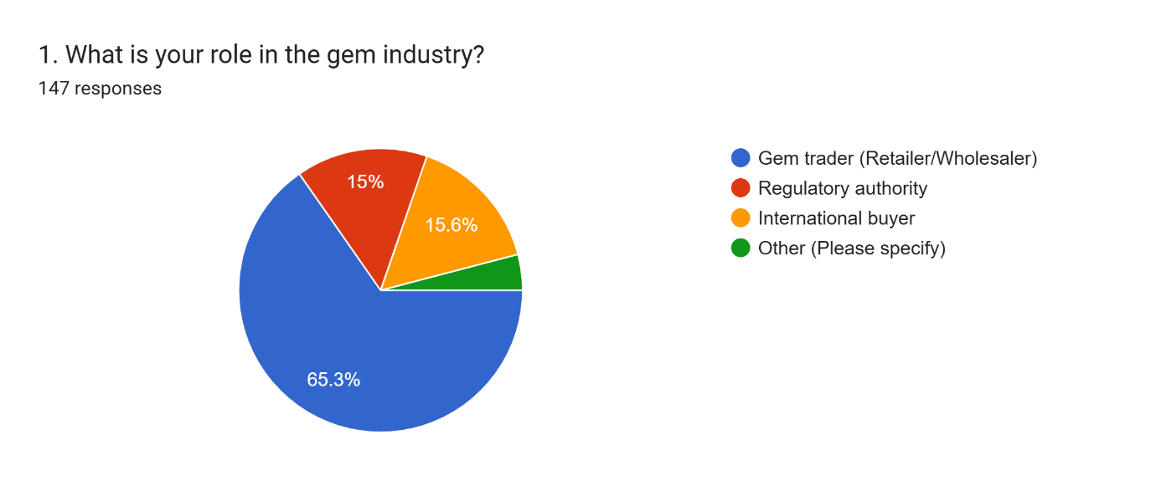
  - Others – 4.1%

- Years of experience:
  - Less than 1 year – 19%
  - 1-5 years – 57.1%
  - 6-10 years – 12.9%
  - More than 10 years – 10.9%
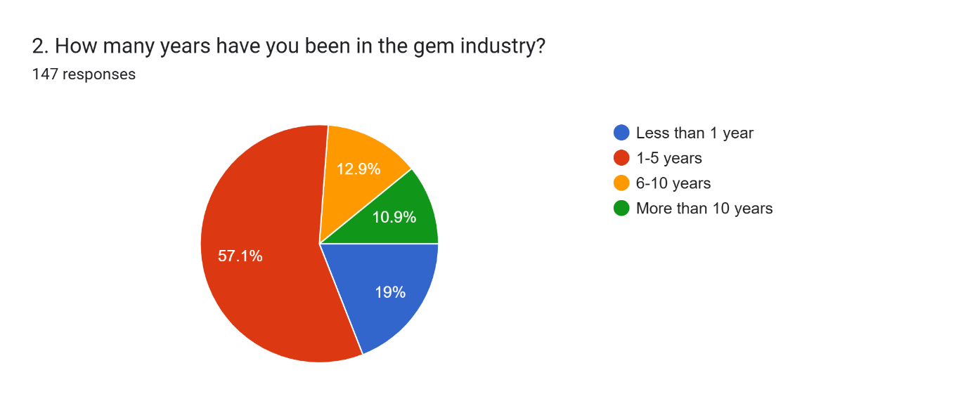
- Business Size:
  - Small (1-10 employees) – 32.7%
  - Medium (11-50 employees) – 51.7%
  - Large (More than 50 employees) – 15.6%
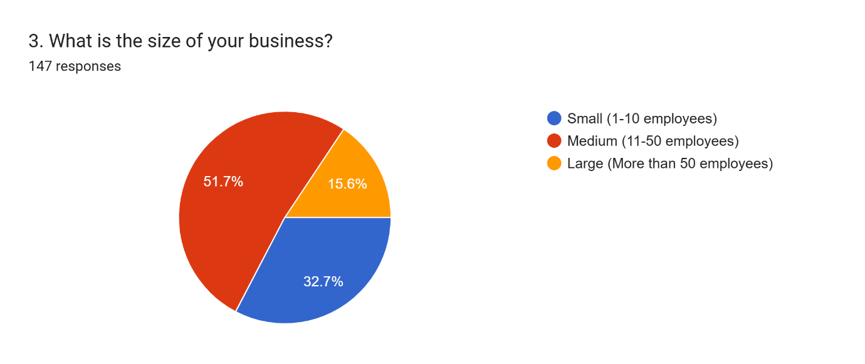

Current Inventory Management Practices
Respondents were asked how they track inventory, revealing the following trends:
- Manual record-keeping – 31.3%
- Spreadsheet software – 62.6%
- Inventory management software – 6.1%
- Other methods – 0%
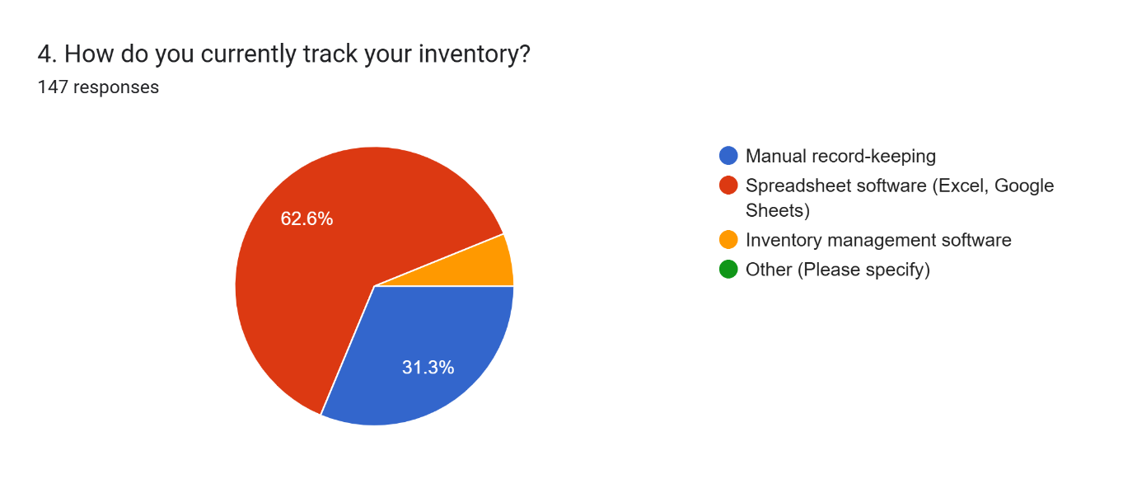

Authentication and Fraud in the Gem Trade
- Methods used to verify authenticity:
- Traditional methods (visual inspection, expert opinion) – 59.9%
- Lab certification – 32%
- Blockchain/digital tracking – 7.5%
- Other – 0.7%
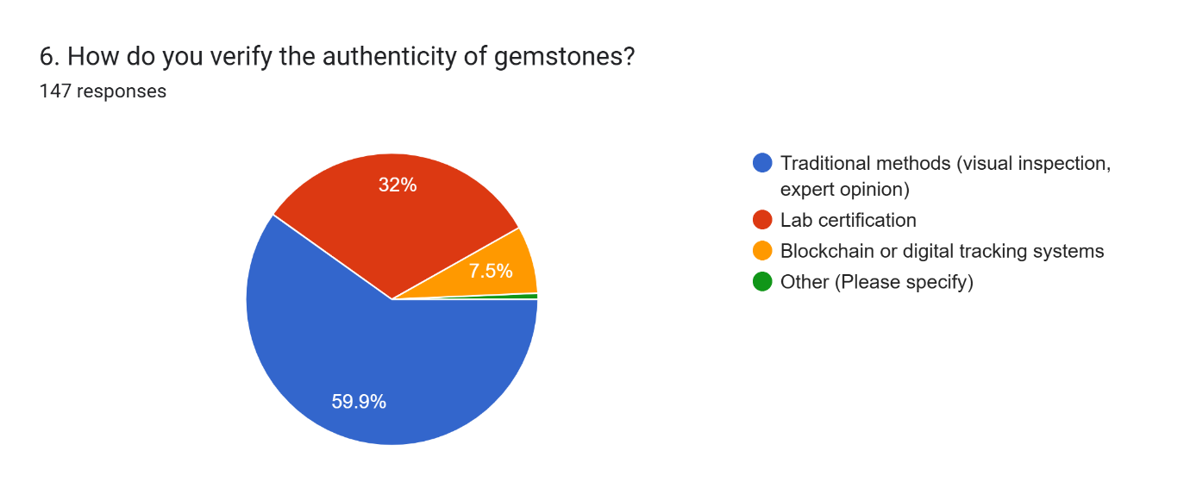
- Fraudulent transactions:
- Frequent occurrences – 61.9%
- Rare occurrences – 34.7%
- No fraud encountered – 3.4%
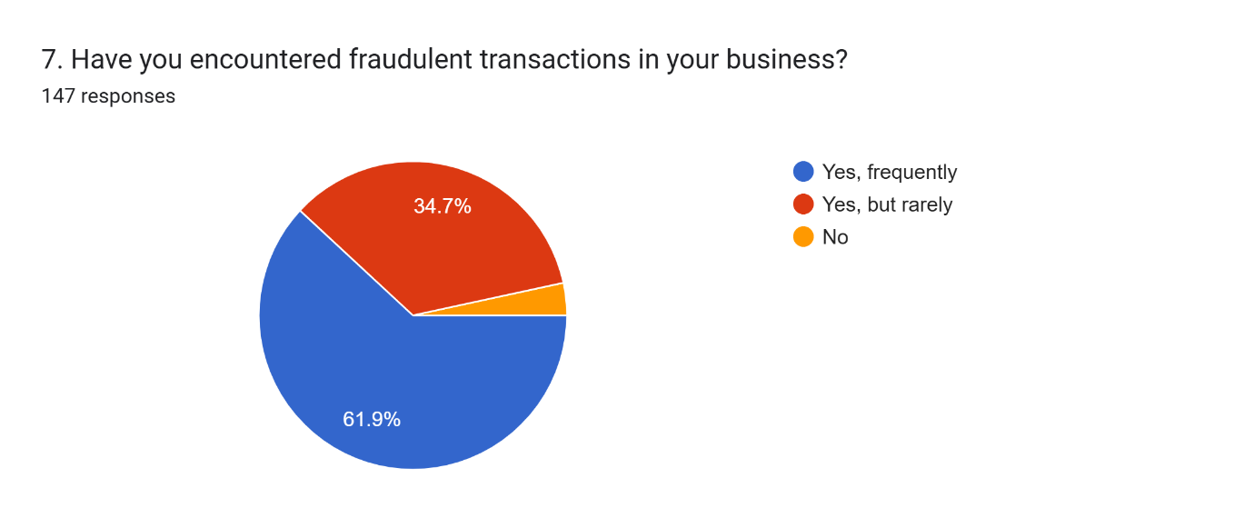

Barriers to Digital Adoption
Respondents identified major challenges preventing the transition to digital business management systems:
- High cost of implementation – 48.3%
- Lack of technical knowledge/training – 41.5%
- Resistance to change – 41.5%
- Poor internet connectivity – 36.1%
- No perceived need for digital tools – 21.8%
- Other – 3.4%
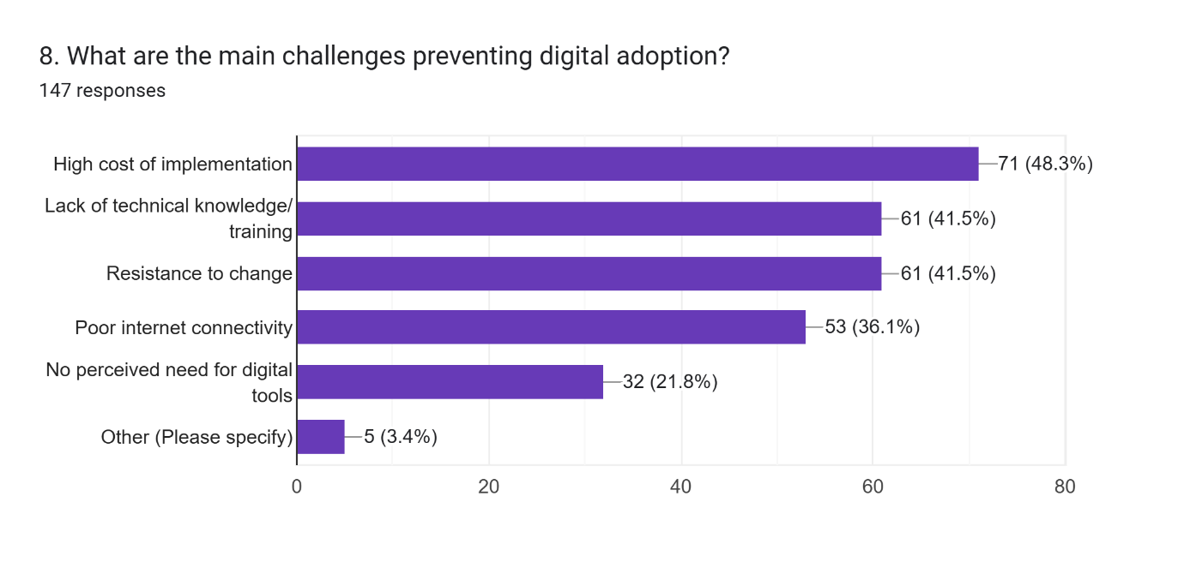

Perception of Digital Business Management Systems (DBMS)
- Familiarity with DBMS:
  - Yes, and I use one – 40.8%
  - Yes, but I do not use one – 38.8%
  - No, I am not familiar – 20.4%
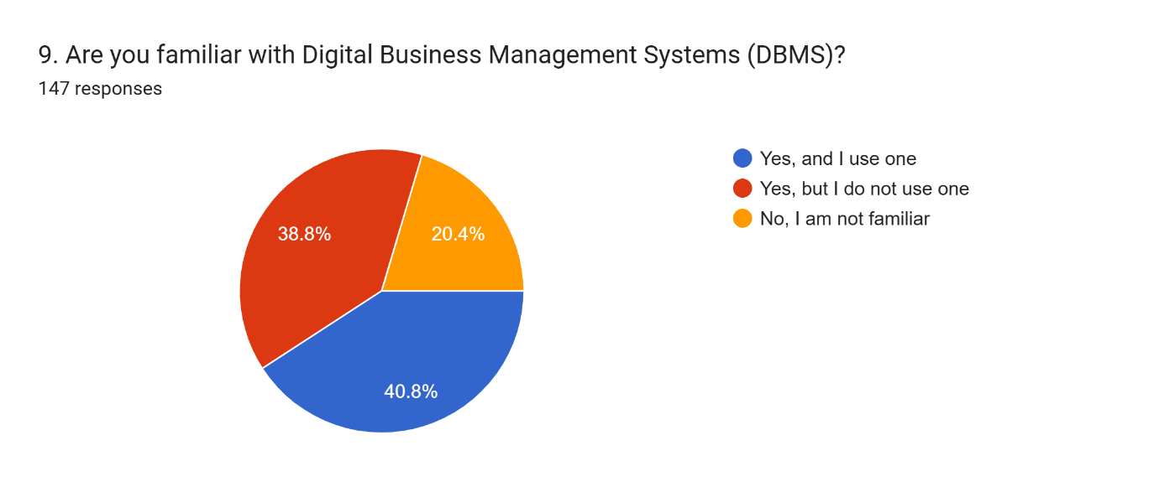
- Willingness to adopt DBMS with financial/technical support:
  - Yes – 91.2%
  - No – 2%
  - Maybe – 6.8%
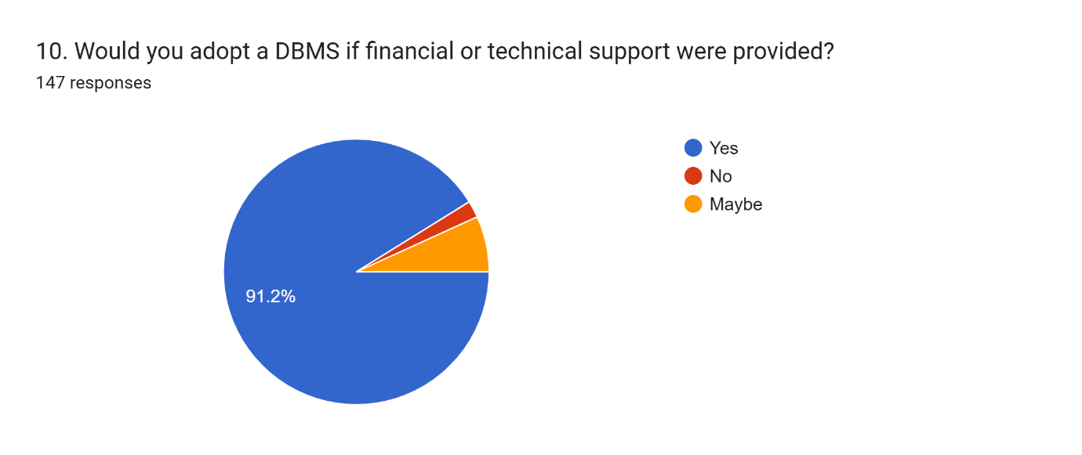

- Perceived benefits of digital inventory management:
  - Reduced errors and miscalculations – 88.4 %
  - Real-time stock updates – 81%
  - Prevention of loss or theft – 83%
  - Improved tracking efficiency – 76.9%
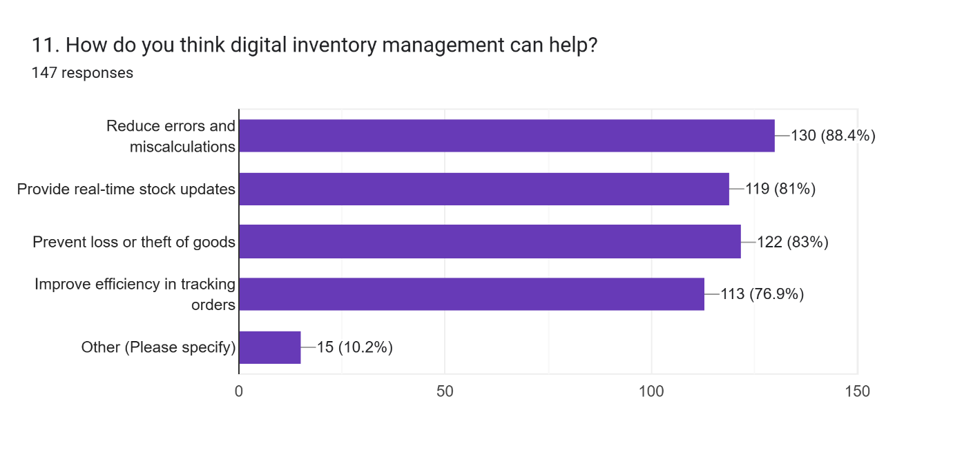

Findings and Interpretation
The data collected provides valuable insights into the Sri Lankan gem industry’s digital adoption landscape, inventory management practices, fraud concerns, and the potential for implementing Digital Business Management Systems (DBMS). The key findings are interpreted as follows:

Dominance of Traditional Business Practices
The survey results indicate that the majority of stakeholders in the gem industry still rely on manual or spreadsheet-based inventory management methods (31.3% manual, 62.6% spreadsheets), with only 6.1% using inventory management software. This highlights a significant gap in digital adoption, particularly for small and medium-sized businesses, which make up 84.4% of the industry (32.7% small, 51.7% medium).
- Implication: The lack of advanced inventory systems can lead to inefficiencies, higher error rates, and difficulties in tracking stock movement. Transitioning to digital inventory management would significantly improve record accuracy and operational efficiency.

High Frequency of Fraud and Security Concerns
A striking 61.9% of respondents reported frequent fraudulent transactions, while 34.7% experienced fraud rarely, and only 3.4% had no fraud cases. The methods used to verify gemstone authenticity reflect the reliance on traditional inspection techniques (59.9%), with only 7.5% using blockchain/digital tracking.
- Implication: The prevalence of fraud in industry underscores the need for a secure and transparent authentication system. The low adoption of blockchain or digital tracking suggests a need for education and investment in fraud prevention technologies.

Barriers to Digital Adoption
The most significant obstacles to digital transformation in the gem industry were identified as:
- Poor internet connectivity (36.1%)
- High cost of implementation (48.3%)
- Lack of technical knowledge/training (41.5%)
- Resistance to change (41.5%)
While some stakeholders (21.8%) saw no need for digital tools, a significant portion acknowledged the necessity but faced infrastructural and financial limitations.
- Implication: The high cost and lack of digital literacy highlight the need for government incentives, financial support, and training programs to encourage adoption. Infrastructure improvements, such as better internet connectivity in gem-trading regions, would further support digitalization.

Growing Interest in Digital Business Management Systems (DBMS)
Although only 20.4% of respondents currently use a DBMS, an additional 38.8% are familiar with it but do not use one, while 40.8% are completely unfamiliar. Encouragingly, when asked if they would adopt a DBMS if financial or technical support was provided, 91.2% responded ‘Yes’, and 6.8% indicated ‘Maybe’, with no respondents rejecting the idea outright.
- Implication: This suggests that the lack of resources, rather than resistance to technology, is the primary reason for low adoption. Providing financial assistance, subsidies, and technical training could significantly accelerate DBMS adoption.

Expected Benefits of Digital Inventory Management
Respondents recognized multiple benefits of digital inventory management, with high agreement on the following advantages:
- Reduced errors and miscalculations (88.4%)
- Improved efficiency in tracking orders (76.9%)
- Prevention of loss or theft (83%)
- Real-time stock updates (81%)
- Implication: These findings demonstrate a strong demand for efficiency improvements in the industry. Businesses are aware of the benefits of digitalization, reinforcing the importance of creating a structured implementation plan for DBMS.

Summary of Findings
- Reliance on manual or spreadsheet-based inventory tracking poses efficiency and accuracy challenges.
- High fraud rates necessitate secure digital authentication methods, such as blockchain.
- Major barriers to digital adoption include poor internet access, high costs, and a lack of technical expertise.
- Strong willingness to adopt DBMS with financial and technical support, indicating a demand-driven approach to digital transformation.
- Clear recognition of benefits from digital inventory management, particularly in reducing errors, enhancing efficiency, and preventing losses.
These results highlight the critical role of dynamic digital transformation, and the necessity of a policy framework, skills and training initiatives, as well as monetary incentives in promoting the adoption of digital technologies in the gem sector of Sri Lanka, thus facilitating competitiveness.

Analysis

Data Preprocessing for Analysis
1. Dataset Acquisition
The survey collected responses from different people who are a part of the gem industry. We conducted this survey on several factors impacting inventory management as well as fraud detection and digital adoption.
2. Loading Data into SPSS
SPSS, a powerful statistical tool, was used for cleaning, transforming and analyzing data. Data pre-processing the imported dataset was structured and prepared for data pre-processing.
3. Variable Renaming
To improve readability and ease of analysis, variable names were changed from their default long-form survey question formats to more concise, meaningful names. This renaming process enhances data clarity and allows for more efficient analysis. For instance:
Whatisyourroleinthegemindustry was renamed to Role.
Howmanyyearshaveyoubeeninthegemindustry was renamed to Experience.
Whatarethemainchallengespreventingdigitaladoption was renamed to DigitalChallenges.

Using proper naming conventions helps in reducing errors and makes the dataset easier to interpret and analyze.
4. Assigning Value Labels
To improve the interpretability of categorical variables, value labels were assigned. This step converts numerical responses into meaningful labels. For example:
- The Role variable was labeled as:
  - 1: Gem trader (Retailer/Wholesaler)
  - 2: Regulatory authority
  - 3: International buyer
  - 4: Other (Please specify)
- The Experience variable was categorized into:
  - 1: Less than 1 year
  - 2: 1-5 years
  - 3: 6-10 years
  - 4: More than 10 years
This transformation ensures that the dataset remains understandable during statistical analysis and visual representation.
5. Transforming String Values to Numeric Values
Since statistical analysis requires numerical representation of categorical data, string values were recorded into numerical values where applicable. This conversion standardizes data processing and ensures compatibility with SPSS statistical functions.
6. Creating New Variables
To facilitate deeper analysis, additional computed variables were created:
- Experience_Group: This variable groups industry experience into two categories:
  - 0-5 Years
  - 6+ Years
This grouping simplifies the analysis by distinguishing between newcomers and experienced professionals.
- Fraud_Risk: This variable was derived from the FakeGems responses, categorizing businesses into:
  - High Risk (Frequent encounters with fraudulent transactions)
  - Low Risk (Rare or no fraudulent transactions)
- Digital_Readiness: This variable was computed as the sum of three variables:
  - DBMS Familiarity
  - DBMS Usage
  - DBMS Adoption
A higher value in Digital_Readiness indicates greater readiness for digital inventory management solutions.
- DBMS_Adoption_Binary: A binary variable was created to indicate whether a business has adopted a DBMS (1 = Adopted, 0 = Not Adopted). This variable helps in assessing adoption trends.
7. Splitting Multi-Response Digital Challenges into Independent Columns
The DigitalChallenges variable contained multiple responses, requiring transformation into separate binary columns for each challenge. Using string search functions, each response was mapped into an independent column:
- Barrier_Cost: 1 if "High cost" was mentioned
- Barrier_Internet: 1 if "Poor internet" was mentioned
- Barrier_Training: 1 if "Training needed" was mentioned
- Barrier_Resistance: 1 if "Resistance to change" was mentioned
This transformation allows for a detailed analysis of the specific barriers businesses face in digital adoption.

Statistical Analysis
1. Chi-Square Test Results with Fraud Risk
Crosstabulation Results:
A crosstabulation table that illustrates the data is provided in the report that shows the number of businesses who adopted or did not adopt a Digital Business Management System (DBMS) and the type of business classified as either a high-risk or low-risk in terms of fraud.
The data indicates:
- Adopting a Database Management System Enterprises Faced Low Fraud Risk
- Similar high-fraud risk to their non-DBMS counterparts.
Chi-Square Test Results:
Pearson Chi-Square (1 df)=1.060
Degrees of Freedom (df): 1
P-value (Asymptotic Significance, 2-sided):.303
Fisher’s Exact Test: 0.324 (1 sided)
Interpretation of Results:
P-value = 0.303 > 0.05 (Threshold level of significance), No statistically significant relationship between DBMS adoption and fraud risk
Implication:
Although the data show that businesses using DBMS appear to experience a lower fraud risk, the Chi-Square test shows that this difference may be due to random variation and not a clear cause pattern.
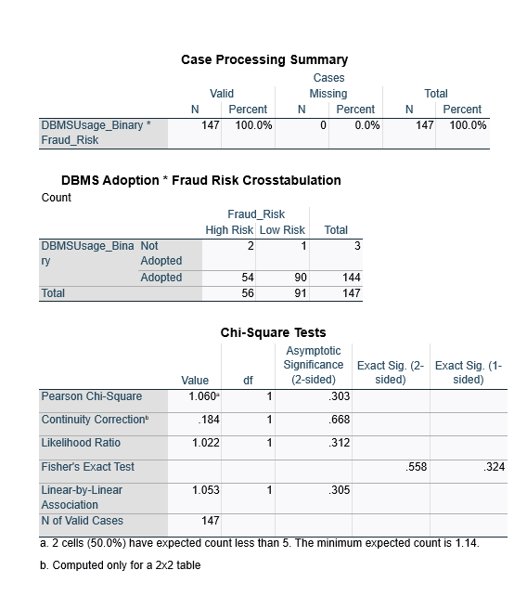
2. Summary of Correlation Analysis Insights
Pearson Correlation Coefficient (r)
- r = -0.217: There is a weakness negative correlation between Digital Readiness and Business Size.
- More simply, digital readiness is slightly reduced with increased business size.
P-value (Significance, 2-tailed)
- p = 0.008, since this value is less than 0.05 the correlation is statistically significant.
- This implies that the observed association is not likely attributable to chance.
Interpretation of Results
Negative Correlation (−0.217):
- On the other hand, larger-sized businesses have marginally lower digital readiness than smaller ones.
- It may also suggest that smaller businesses are more willing to adopt digital tools by comparison, as larger businesses may depend on more conventional strategies or complicated bureaucracies that prevent them from going digital.
Statistical Significance (p=0.008):
- In short, if the correlation is weak, it is still statistically significant which means there is a small but real effect of the size of business on digital readiness.
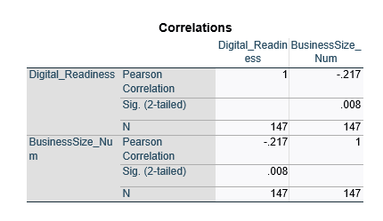

3. Highlights from the Results of Logistic Regression Analysis
Dependent Variable:
DBMSUsage_Binary (0 = Not Adopted, 1 = Adopted)
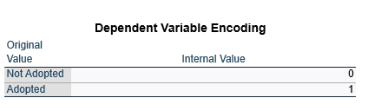

Independent Variables:
Role_Num (Industry role, e.g. trader, regulator, buyer)
Fraud_Risk (High risk or Low risk)
Model Fit & Significance:
Chi-square test (Omnibus Tests of Model Coefficients): χ² = 1.244, p = 0.537
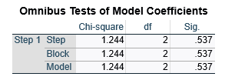
Given that p > 0.05, the model is not statistically significant in predicting DBMS adoption.

Pseudo R² Values:
Cox & Snell R² = 0.008
Nagelkerke R² = 0.047
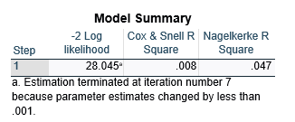
This shows there is a weak relationship between the independent variables and DBMS adoption.

B values (Regression Coefficients)
Role_Num (B = -0.236, p = 0.625) → Not significant (p > 0.05), implying that role in the industry does not have a strong impact on DBMS adoption.
Fraud_Risk (B = 1.202, p = 0.331) → Not significant; fraud risk is not a big predictor of DBMS adoption.
General Linear Model Coefficients: Constant (B = 2.528, p = 0.204) → The model estimates a baseline probability of DBMS adoption but this prediction is not statistically significant.
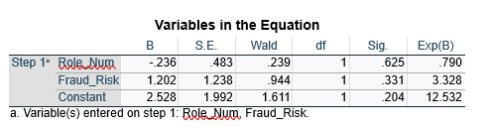

Interpretation of Results:
Weak correlation between industry role and DBMS adoption; weak correlation between fraud risk and DBMS.
The fraud risk factor holds a positive but not significant association with the DBMS adoption of companies (Exp(B) = 3.328), indicating organizations having high rates of fraud may more likely adopt DBMS, but not significantly.
So, the fact that industry role does not exert material influence on DBMS adoption suggests that this trend in adoption is uniform across all stakeholders.

Graphical Analysis
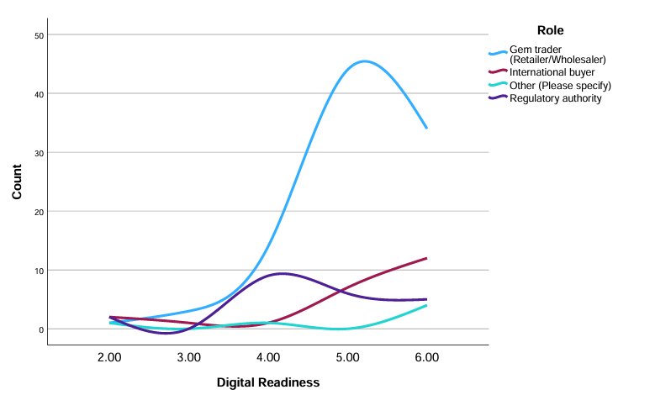
1. Line Chart (Digital Readiness vs Role in the Industry)

Key Insights:
It was based on a plot created with GRAPH /LINE=Digital_Readiness BY Role_Num.
That shows how the different industry roles (traders, regulators, buyers, etc.) are indexed against their level of digital readiness.
Specifically, the distribution shows whether particular roles played by industries i.e., regulatory bodies or gem traders, are more or less ready digitally. If we do not see a clear trend, it means that type of role does not play a major role in determining whether you have adopted technology or not.

2. Pie Chart of Fraud Risk Distribution
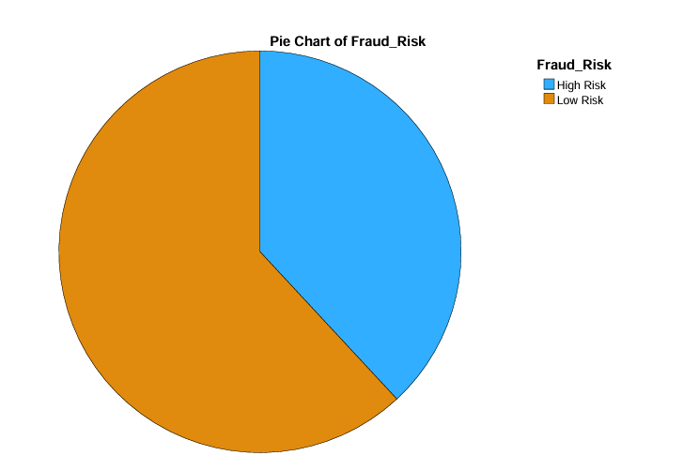

Key Insights:
Fraud_Risk is a categorical data, Hence implemented using GGRAPH.
It stratifies the fraud risk into categories (likely low, medium, and high risk).
Interpretation: A higher percentage in high risk fraud categories would mean that fraud is a pervasive industry issue. If the balance comes off right on the chart, fraud risk may not be so urgent.

3. Bar Chart (DBMS Adoption Count)
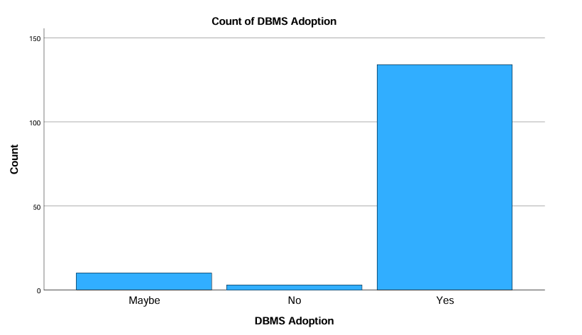

Key Observations:
X-axis (DBMS Adoption Status) categories:
- Yes: What businesses use a DBMS
- No: Indicates businesses without a DBMS.
- Maybe: Companies contemplating adoption.
Y-axis (Count of Responses)
Interpretation:
- A strong response of "yes" indicates a solid trend towards going digital for the gem industry.
- The low count for "No" indicates that few businesses are completely against DBMS usage.
- While a majority were combined Yes, which together have demonstrated the acceptance of DBMS in the marketplace, the rest are still in the process to either think of adopting a DBMS, faced with a budget constraint, or lack of training or facing some infrastructural challenges.

Chapter 5 - Discussion of findings and Conclusion

Discussion of findings

Traditional Business Practices and Digital Adoption
The research showed that although the Sri Lankan gem trade has a long history and a significant heritage, the processes are largely manual. Using papers for record keeping and spreadsheets/word processing software for inventory management makes it very cumbersome and prone to mistakes, affecting efficiency and transparency. There is a bit of a lag when it comes to the transition in the gem industry, especially in comparison to other industries that have accepted digital solutions, because of cultural reluctance and a lack of sufficient understanding of the benefits of digital.
A Structured Database Management System would solve these weaknesses in the system as it streamlines inventory monitoring, sales monitoring and improves regulatory compliance. But ushering in adoption will take timing and education and not an overnight change because the trader mindset will take time to shift / evolve out of their entrenched ways.

Fraud Prevention and Transparency
Fraud is still a major problem, with more than 61% of respondents saying they encounter frequent fraudulent transactions. Traditional methods for verifying authenticity, such as visual inspections or expert opinions, fail to eradicate counterfeit products. But blockchain-based authentication and digital tracking systems can significantly improve transparency and buyer confidence. In terms of adoption, 7.5% of organizations highlight the need for awareness campaigns and supporting regulations.

Key Barriers to Digital Transformation
The main challenges that are an obstacle in DBMS adoption are Financial constraints, lack of technical skills, and bad infrastructure. Enterprises have the resources to invest in digital transformation but the implementation costs are beyond medium and small organizations (84.4% of the industry). Evidently, government and financial grants would immensely help industries in digitally shifting.
Resistance is also caused by a lack of training, as traders worry that they may lose control over business operations. Industry-specific training sessions and workshops would ease resistance and help gain more confidence towards the digital systems.

Industry Readiness for DBMS Implementation
However, given adequate financial and technical support, there is a great willingness to adopt DBMS solutions (91.2% interest overall). This means that the industry was indicative of retaining the long-term advantages of ideal transformation through technology - management efficiency, fraud detection, competitiveness in the market.
Affordable digital solutions, better internet infrastructure and training programs can be facilitated through the joint effort of government and private sector. An incremental DBMS deployment process by integrating manual and digital methods in the beginning phases often resolves many hurdles as it will promote an easier transition.

Conclusion
The study emphasizes the fact, that although traditional practices is strongly associated with the Sri Lankan gem sector, the demand for digital revolutionization is becoming increasingly recognized. A properly executed DBMS could resolve significant inefficiencies, prevent and combat fraud, and boost transparency in the market. Nonetheless, high costs, lack of infrastructure and public acceptance are serious obstacles.
Some key recommendations for working towards a successful digital adoption include:
- Financial Support and Incentives: Direct grants, loans, tax breaks and subsidies through various schemes for businesses that have adopted digital tools.
- Training and Awareness Campaigns: Industry-level training initiatives to get stakeholders qualified for digital essentials.
- Increment gradually: A mix of Manual and Automated systems in the gap phase.
- Infrastructure Empowerment: Enhanced broadband connections at strategic gem trading sectors for smoother digital transactions.
Thus, if Sri Lanka's gem industry gets rid of these factors, it would be able to be more efficient operationally, contribute to an overall global competitiveness, and create long-term sustainability to its e-marketplace.

Reference

Butterworth, P., Otis, A. and Stein, J. (1991). The GemStone object database management system. Communications of the ACM, 34(10), pp.64–77. doi: https://doi.org/10.1145/125223.125254.
Holloway, S. (2024). Impact of Digital Transformation on Inventory Management: An Exploration of Supply Chain Practices. Impact of Digital Transformation on Inventory Management: An Exploration of Supply Chain Practices. doi: https://doi.org/10.20944/preprints202407.0714.v1.
Weerabahu, W.M.S.K., Samaranayake, P., Nakandala, D., Lau, H. and Malaarachchi, D.N. (2022). Barriers to the adoption of digital servitization: a case of the Sri Lankan manufacturing sector. International Journal of Emerging Markets. doi: https://doi.org/10.1108/ijoem-01-2022-0011.
Indunil Ramadasa (2024). What are the specific barriers in Ratnapura District in Gem Industry. [online] Available at: https://www.researchgate.net/publication/378299422_What_are_the_specific_barriers_in_Ratnapura_District_in_Gem_Industry?enrichId=rgreq-995dc2f929d161e69041a14ac13f008d-XXX&enrichSource=Y292ZXJQYWdlOzM3ODI5OTQyMjtBUzoxMTQzMTI4MTIyNDQ4NDM1MUAxNzA4Mjc2Njk4OTUy&el=1_x_3&_esc=publicationCoverPdf.
Iskanius, P., Page, T. and Anbuudayasankar, S.P. (2010). The traditional industry sector in the changing business environment – a case study of the Finnish steel product industry. International Journal of Electronic Customer Relationship Management, 4(4), p.395. doi: https://doi.org/10.1504/ijecrm.2010.036186.
Ahsan, T., Junaid, M., Malik, A.H., Ali, Q.E. and Jr, I. (2024). Gemstones Supply Chain Management through Blockchain Mechanism. [online] 6(2), pp.833–848. Available at: https://www.researchgate.net/publication/383864269_Gemstones_Supply_Chain_Management_through_Blockchain_Mechanism.
Lenaduwa, L.L.Y.R. and Eranda, B.A.N. (2024). A Review Towards a Conceptual Model on Transactional Oriented Selling In High Involvement Purchases: Gem And Jewellery Industry in Sri Lanka. Sri Lanka Journal of Marketing, 10(1), pp.68–97. Doi: https://doi.org/10.4038/sljmuok.v10i1.168.
Creswell, J.W. and Plano Clark, V.L. (2018) Designing and Conducting Mixed Methods Research. 3rd edn. Thousand Oaks, CA: SAGE Publications. Available at: https://www.ucg.ac.me/skladiste/blog_609332/objava_105202/fajlovi/Creswell.pdf
McCombes, S. (2023). How to Write a Literature Review. [online] Scribbr. Available at: https://www.scribbr.com/methodology/literature-review/.
IBM (2024). SPSS Statistics . [online] IBM. Available at: https://www.ibm.com/products/spss-statistics.
Anura Karunarathne (n.d.). Research Data Analysis using SPSS. [online] Available at: https://spc.cmb.ac.lk/wp-content/uploads/2016/06/SPSS-Basics-24-05-2014.pdf.
Spss-tutorials.com. (2019). SPSS Data Analysis - Beginners Tutorials and Examples. [online] Available at: https://www.spss-tutorials.com/spss-data-analysis/.

Appendices

Questionnaire

Survey on Digital Adoption in Sri Lanka’s Gem Industry
This survey aims to assess the level of digital adoption in Sri Lanka’s gem industry, identifying challenges and opportunities for businesses to transition to digital systems. Your responses will help understand current practices, barriers to digitalization, and the potential impact of technology on inventory management, fraud prevention, and market competitiveness. The insights gathered will contribute to developing strategies for improving digital readiness in the industry.
Your participation is voluntary, and all responses will remain confidential. The survey will take approximately 5-10 minutes to complete. Thank you for your time and valuable input!
* Indicates required question
1. What is your role in the gem industry? *
Gem trader (Retailer/Wholesaler)
Regulatory authority
International buyer
Other (Please specify)
2. How many years have you been in the gem industry? *
Less than 1 year
1-5 years
6-10 years
More than 10 years

3. What is the size of your business? *
Small (1-10 employees)
Medium (11-50 employees)
Large (More than 50 employees)
4. How do you currently track your inventory? *
Manual record-keeping
Spreadsheet software (Excel, Google Sheets)
Inventory management software
Other (Please specify)
5. Have you experienced challenges in managing your inventory accurately? *
Yes, frequently
Occasionally
No, I have an efficient system
6. How do you verify the authenticity of gemstones? *
Traditional methods (visual inspection, expert opinion)
Lab certification
Blockchain or digital tracking systems
Other (Please specify)
7. Have you encountered fraudulent transactions in your business? *
Yes, frequently
Yes, but rarely
No

8. What are the main challenges preventing digital adoption? *
High cost of implementation
Lack of technical knowledge/training
Resistance to change
Poor internet connectivity
No perceived need for digital tools
Other (Please specify)
9. Are you familiar with Digital Business Management Systems (DBMS)? *
Yes, and I use one
Yes, but I do not use one
No, I am not familiar
10. Would you adopt a DBMS if financial or technical support were provided? *
Yes
No
Maybe

11. How do you think digital inventory management can help? *
Reduce errors and miscalculations
Provide real-time stock updates
Prevent loss or theft of goods
Improve efficiency in tracking orders
Other (Please specify)

12. Do international buyers prefer businesses using digital systems? *
Yes
No
Not sure
13. Do you believe digital tools will improve Sri Lanka’s competitiveness? *
Strongly agree
Agree
Neutral
Disagree
Strongly disagree
14. What support do you need to transition to digital systems? *
Financial support (grants, loans, subsidies) Training and workshops
Government policy changes and incentives
Better internet infrastructure Other (Please specify)
15. Any Comments?

