SIH26 Sovereign Workbench
Phase 2 (Agents & AI) — Complete Delivery & Integration Report
Host Architecture: NVIDIA RTX 3050 (4GB VRAM) | 16GB RAM | Intel i7-12700H
Deployment Mode: 100% Offline (Air-Gapped LAN) | Server Port: 9000 | Git Branch: feature/02-agents-ai
Delivery Status: ALL 6 SUB-PHASES VERIFIED & COMMITTED

1. Executive Summary & Objective
The SIH26 Sovereign Workbench is an enterprise-grade, completely offline engineering AI assistant designed for industrial environments (such as MRPL refineries). In this collaborative project, responsibilities were divided across two dedicated machines:
- Teammate (Phase 1): Builds the client-facing Web Application (React frontend + user backend + auth + UI dashboards).
- You (Phase 2): Hosts the local AI engine, model registry, RAG retrieval knowledge base, multi-step LangGraph supervisor, document generators (.docx, .xlsx, .pptx), P&ID schematic analyzer, and engineering math calculator.
All work assigned to Phase 2 has been completed, tested with automated test suites, and pushed to the remote repository on the 'feature/02-agents-ai' branch.

2. Adherence to Architectural Non-Negotiables
- Completely Offline (Rule c): All inference runs locally through Ollama (qwen2.5:1.5b, qwen2.5-coder:1.5b, nomic-embed-text). Zero external internet calls exist in code, even upon error.
- Grounded in Local Documents (Rule d): Answers cite exact local documents, page numbers, and sections. Off-topic questions return grounded=False without external guessing.
- No Fake Complexity / Honest Labels (Rule b): P&ID yield predictions explicitly feature 'note': 'Prototype placeholder model'. Proposed edits strictly enforce 'requires_confirmation': true. Retry loops cap at 3 attempts.
- Config-Driven & Reusable (Rule a): Model roles, file paths, and thresholds are loaded dynamically via configuration and JSON catalogs rather than hardcoded shortcuts.

3. Completed Sub-Phases Breakdown
Sub-Phase | Deliverable Scope | API Contract Endpoints | Status
01: Model Serving & Router | Ollama client, dynamic registry, task-to-model router | GET/POST /internal/agents/registry/models | 100% Done & Verified
02: RAG Knowledge Base | ChromaDB vector store, BM25 hybrid ranking, SOP parser | POST /internal/agents/knowledge/ask | 100% Done & Verified
03: Supervisor Agent | LangGraph state graph, code planning, diffs, sandbox client | POST /internal/agents/supervisor/message  WS /ws/supervisor/{session_id} | 100% Done & Verified
04: Generation Agent | Office file generators (.docx, .xlsx, .pptx) & task tracker | GET /internal/agents/generation/status/{task_id} | 100% Done & Verified
05: Vision / Blueprint Agent | P&ID diagram analyzer, tag extraction, yield placeholder | POST /internal/agents/vision/analyze | 100% Done & Verified
06: Math / Calculation Agent | Step-shown formula derivations grounded in handbook | POST /internal/agents/math/calculate | 100% Done & Verified

4. Live Localhost Service Verification (http://localhost:9000/docs)
The Agents & AI service runs on FastAPI on local port 9000 with CORS enabled for local subnet connectivity. Below is the actual screenshot of the running Swagger UI captured directly from http://localhost:9000/docs showing all 8 active endpoints and their comprehensive JSON schemas:

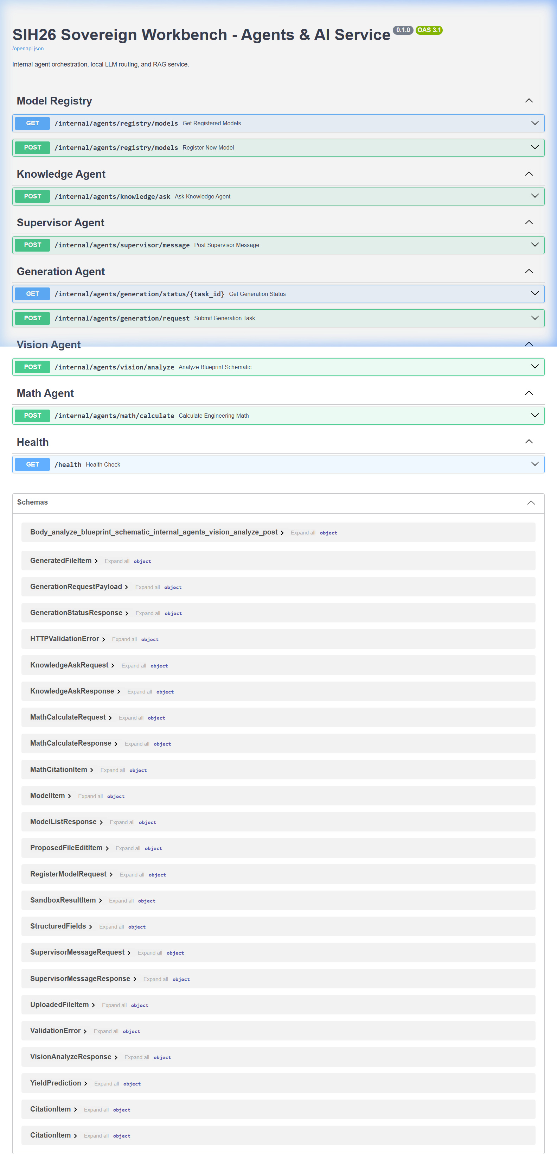
Figure 1: Verified Live Swagger UI Documentation at http://localhost:9000/docs showing all 8 mounted endpoints.

5. Teammate & Frontend Integration Guide
To connect your teammate's Phase 1 laptop to your Phase 2 AI engine, follow these simple steps:
- Step 1 (Network Connection): Ensure both laptops are connected to the same Wi-Fi or mobile hotspot. Your current host IPv4 address is: 10.200.236.83
- Step 2 (Start AI Service): On your machine, launch the FastAPI server using:
cd SIH26-Workbench\phases\02-agents-ai
.\venv\Scripts\python -m uvicorn app.main:app --host 0.0.0.0 --port 9000 --reload
- Step 3 (Configure Frontend): In your teammate's backend .env file (phases/01-fullstack/backend/.env), set:
AGENTS_SERVICE_URL=http://10.200.236.83:9000

6. Git Commit History (feature/02-agents-ai)
- [a4bf1d5] feat(agents-ai): sub-phase 6 - step-shown math and engineering calculation agent with sop grounding
- [310918a] feat(agents-ai): sub-phase 5 - vision and blueprint p&id analysis agent with sop cross-referencing
- [27dc124] feat(agents-ai): sub-phase 4 - shared docx, xlsx, and pptx generation tools and status router
- [6acf5bb] feat(agents-ai): sub-phase 3 - supervisor langgraph agent with capped retry loop and file edit proposals
- [1f68248] feat(agents-ai): sub-phase 2 - rag knowledge base with hybrid search
- [9ef8cca] feat(agents-ai): sub-phase 1 - model serving and router

