|  |  |
| --- | --- |
| **Assignment #** | **4** |

**Pandas and DataSet**

**By**

**NAME: Ali Raza Asim**

**ROLL NO #:1220100037**

**BS.SE (4th)**

**Fall 2024**

**COURSE TITLE: Artificial Intelligence**

**SUBMITTED TO : Mr. Zubair**



**Department of COMPUTER SCIENCE**

**International Institute of Science, Arts and Technology (IISAT), Gujranwala**

1. Import Libraries and Load Data:

## 

## Data Exploration

### Over-view of data

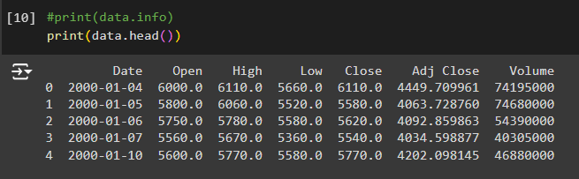

### Exploring specific aspects:

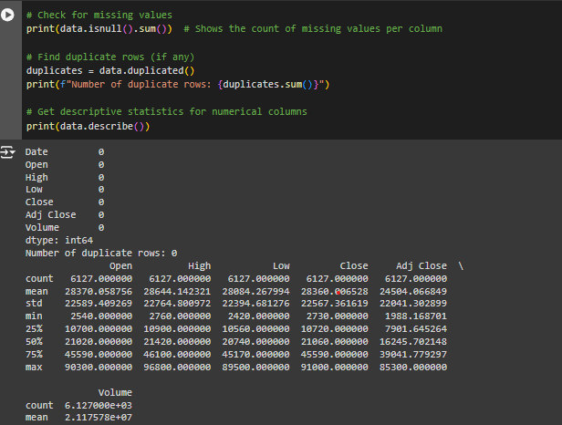

## Visualization:

### Histogram

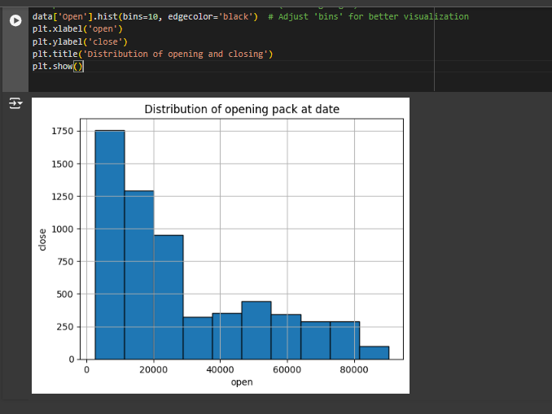

### Scatter plot

