Table of Contents
1. Introduction 2
1.1 Background of the System 2
1.2 Objectives of the Report 4
2. Stakeholder Analysis 6
3. Requirements Elicitation and Documentation 6
4. Use Case Modelling 8
4.1 Use Case Diagram 8
4.2 Use Case Descriptions 9
5. Requirements Prioritization (MoSCoW) 11
6. Traceability Matrix 13
7. Tool Usage Explanation 14
7.1 Tool Screenshots 15
8. Conclusion 17
9. Reflection 18
10. References 19

1. Introduction

1.1 Background of the System
The AIU Moodle LMS is a centralized and web-based learning management system utilized in Albukhary International University (AIU) located in Kedah, Malaysia. The learning management system is constructed based on the open-source Moodle framework. It acts as the primary digital learning platform for conducting various activities in all programs offered by Albukhary International University (AIU). Direct observation from the live system shows that the login page of the AIU Moodle LMS enables user authentication either through their username/password or Google account for federated identity management (Figure 1). After logging in, students gain access to a personalized dashboard showing various information such as Timeline of the upcoming deadlines, Calendar, and Latest Announcements (Figure 2). During my observation session, deadlines for upcoming courses were shown which include CCE2233 and CCS2263; hence, the LMS is capable of managing the deadlines (Moodle HQ, 2024).

The AIU Moodle LMS Course Overview page (Figure 3) shows an overview of the enrolled course such as CCE2233, CCS2213, CCS2223, CCS2263, and BBC1043, which has been indicated with a course banner, course name, and percentage of completion. On navigating through the CCE2233 course page (Figure 4), it consists of sections such as Announcements, Course Information, and module-based information. Moreover, the course page displays various labs based on the respective lecturers' group: Mdm Nadiah (Group A & C) and Ts Mohd Zulkifli (Groups B, D, BCS3B). The Assignment section (Figure 5) of the CCE2233 course contains links to assignment instructions, cover page template, submission portal, and a notification regarding the deadline of 15 May 2026, 3:00 PM. Moreover, the Moodle LMS enables tracking the completion status of all activities in a course as shown in Figure 5.


Figure 1: AIU Moodle LMS — Login Page showing username/email, password, and Google authentication options
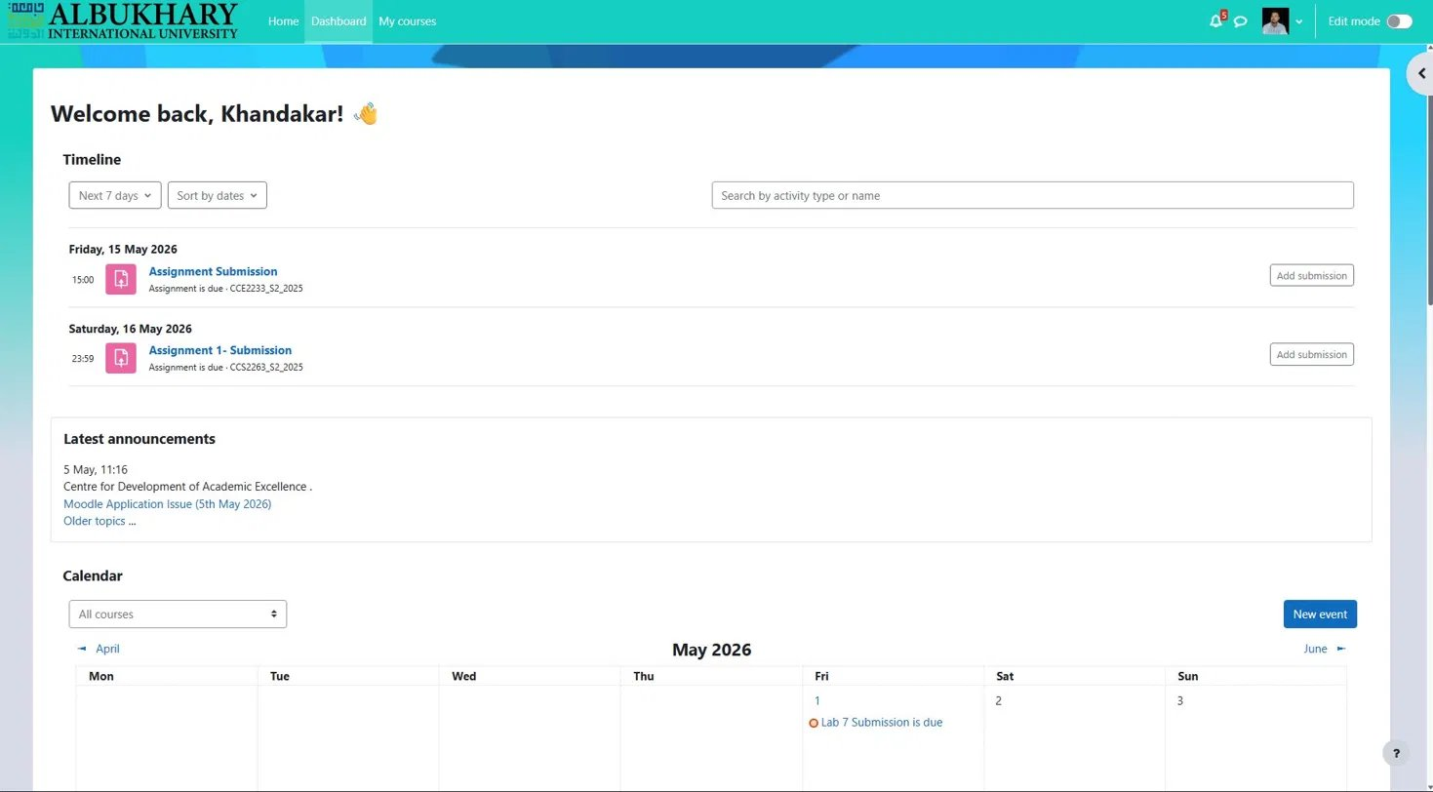
Figure 2: AIU Moodle LMS — Student Dashboard showing Timeline, upcoming deadlines, Announcements, and Calendar
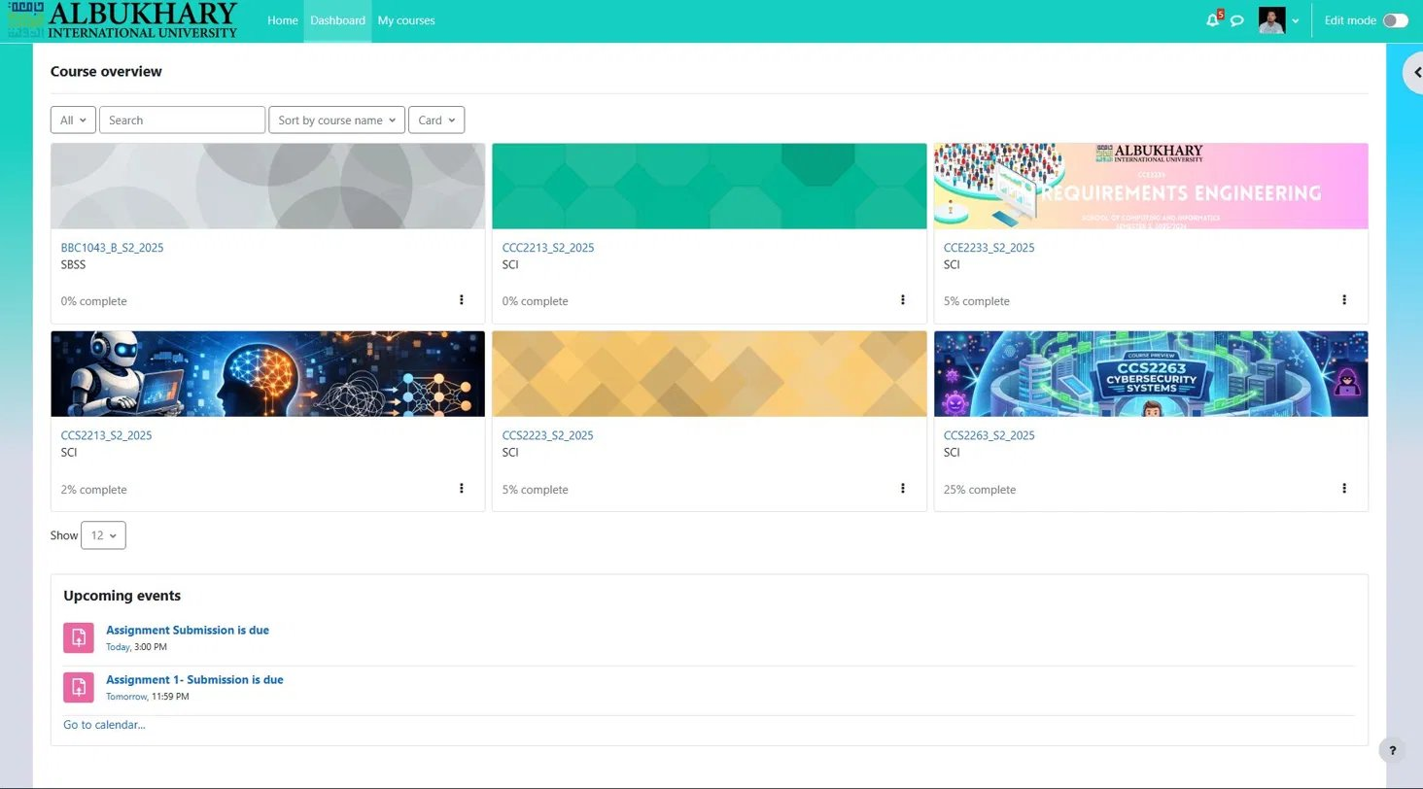
Figure 3: AIU Moodle LMS — Course Overview showing enrolled courses with completion percentages and upcoming events
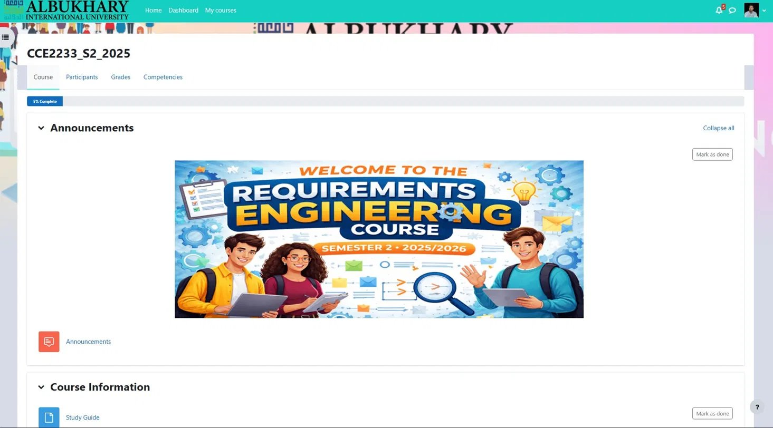
Figure 4: AIU Moodle LMS — CCE2233 Course Page showing Announcements, module sections, and lab submission groups
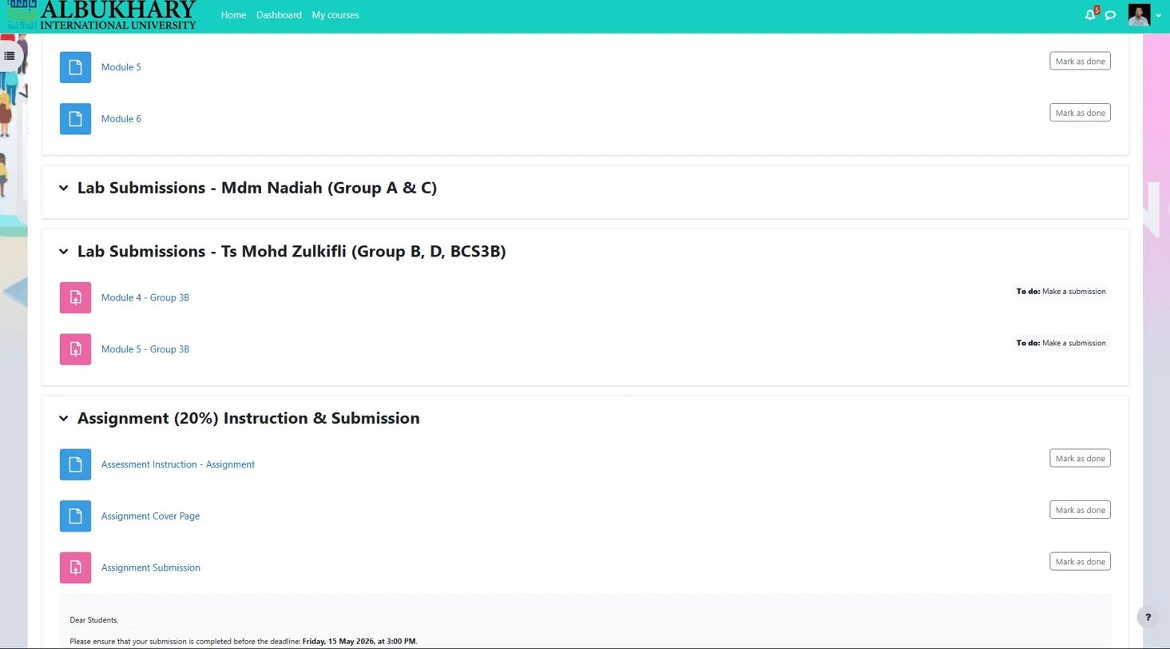
Figure 5: AIU Moodle LMS — Assignment Submission section showing submission portal and deadline notice

1.2 Objectives of the Report
This report has the following three objectives:
- To identify and analyse the stakeholders and their requirements for the AIU Moodle LMS.
- To document functional and non-functional requirements using structured requirements engineering techniques (Sommerville, 2016).
- To model and prioritise the identified requirements using use case diagrams and the MoSCoW technique (Nuseibeh & Easterbrook, 2000).

2. Stakeholder Analysis
A stakeholder can be defined as any person or organization that is affected by or has some kind of interest in the development and use of a software product (Sommerville, 2016). It is important to identify all stakeholders at the beginning of the process in order to capture their requirements. The stakeholders in this project are:

Stakeholder | Role | Responsibilities | Needs & Interests
Students | Primary end-users | Access course materials, submit assignments, view grades, track deadlines, receive announcements | Reliable 24/7 access, intuitive navigation, timely deadline reminders, secure grade visibility
Lecturers | Course content managers | Upload modules, manage lab submissions, post announcements, grade student work | Easy file upload, submission management panel, announcement tools, grade management
IT / Admin Staff | System maintainers | Manage user accounts, maintain system uptime, resolve technical issues, manage backups | System monitoring tools, error logs, user management panel, maintenance scheduling
University Management | Institutional overseers | Monitor academic activity, ensure policy compliance, review system usage reports | Analytics dashboard, compliance reports, course completion statistics
Students' Parents / Sponsors | Indirect stakeholders | Track student academic standing and course engagement (where applicable) | Accessible academic summary reports, progress indicators

As can be seen from the screenshots, there are two particular lecturers who appear to be stakeholders; these include Ms Nadiah Arsat and Mr Ts Mohd Zulkifli Mohd Zaki. Both are responsible for particular student groups in one and the same course. 'Khandakar' is the name of the particular student account whose deadlines for CCE2233 and CCS2263 can be found active. In terms of the particular announcement by the Centre for Development of Academic Excellence of the 'Moodle Application Issue' on 5 May 2026, IT/Admin Staff is an active stakeholder group which takes care of resolving system issues (Moodle HQ, 2024).

3. Requirements Elicitation and Documentation
Requirements elicitation can be defined as a method whereby the requirements of a system are established through interactions with the client(s), system users, and other stakeholders (Sommerville, 2016, p. 100). In this report, requirements have been elicited by observation of the live AIU Moodle LMS system. Every functional requirement listed here has been elicited based on features found in the screen shots of the system.

Req ID | Type | Title | Description
FR01 | Functional | User Login | The system shall allow users to log in using their username/email and password, or via Google account authentication.
FR02 | Functional | Personalised Dashboard | The system shall display a personalised dashboard showing upcoming deadlines, a course timeline, calendar events, and latest announcements.
FR03 | Functional | Course Access | The system shall allow students to view and access all courses in which they are enrolled, along with course materials and modules.
FR04 | Functional | Assignment Submission | The system shall allow students to submit assignments online through a dedicated submission portal within the course page.
FR05 | Functional | Announcements | The system shall display university and course-specific announcements to all enrolled users.
FR06 | Functional | Course Completion Tracking | The system shall track and display each student's course completion progress, including 'Mark as done' functionality for individual activities.
FR07 | Functional | Lecturer Material Upload | The system shall allow lecturers to upload course modules, documents, and lab materials, organised by groups or sections.
FR08 | Functional | Admin User Management | The system shall allow administrators to create, modify, suspend, or delete user accounts across the platform.
NFR01 | Non-Functional | Availability | The system shall be accessible 24 hours a day, 7 days a week to support students and staff across different time zones.
NFR02 | Non-Functional | Performance | The system shall load the dashboard and all course pages within 3 seconds under normal network conditions.
NFR03 | Non-Functional | Security | The system shall ensure that all student login credentials and personal academic data are encrypted and protected from unauthorised access.

The functional requirements FR01-08 refer to the visible behaviors of the system that can be clearly related to the functionalities depicted in Figures 1-5. On the other hand, non-functional requirements NFR01-NFR03 set the quality criteria that the system should fulfill during all its processes. The 'Mark as done' functionality (FR06) and the creation of distinct submission groups for each lecturer (FR07, FR08) were clearly identified from the interface of the course (Moodle HQ, 2024).

4. Use Case Modelling

4.1 Use Case Diagram
The use case diagram depicted below illustrates how the actors interact with the main use cases in the system using UML notation conventions (Sommerville, 2016). The “Student” actor links with use cases based on the functionalities that have been identified through the students. “Lecturer” actor deals with content submission while the “Administrator” manages user accounts. “Include” relationship shows mandatory behaviour while “extend” is conditional.

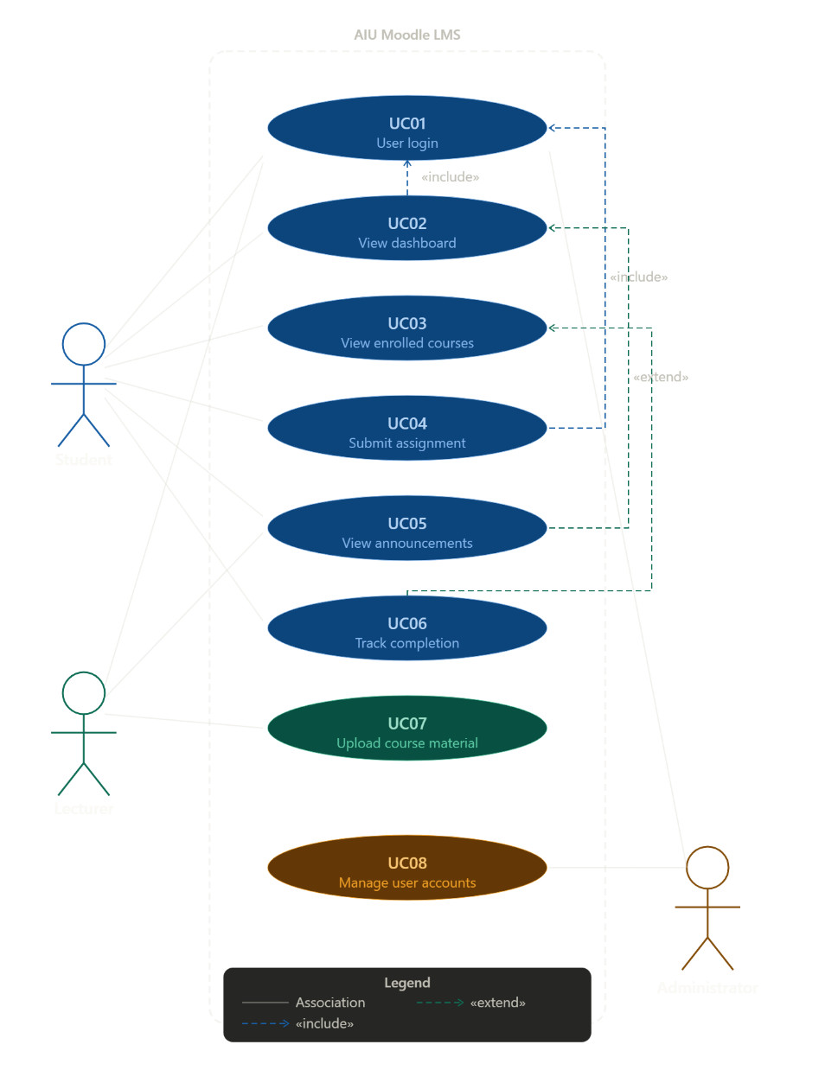
Figure 6: Use Case Diagram — AIU Moodle LMS

4.2 Use Case Descriptions
Detailed use case descriptions are provided below for six major use cases. Each follows a standardised format aligned with requirements engineering best practice (Sommerville, 2016).

UC01 — User Login
Use Case ID | UC01
Use Case Name | User Login
Actor | Student, Lecturer, Administrator
Precondition | User has a valid AIU account. The Moodle login page is accessible.
Main Flow | 1. User navigates to the AIU Moodle URL. 2. User enters username/email and password, or selects 'Log in using Google'. 3. System validates credentials. 4. System redirects user to their personalised dashboard.
Postcondition | User is authenticated and the personalised dashboard is displayed with timeline, deadlines, and announcements.
Alternative Flow | 3a. Invalid credentials → System displays an error message and prompts retry. 3b. Google authentication fails → System prompts manual login.

UC02 — View Dashboard
Use Case ID | UC02
Use Case Name | View Dashboard
Actor | Student
Precondition | Student is logged in (UC01).
Main Flow | 1. Load personalized dashboard system. 2. Dashboard shows the Timeline of deadlines arranged in order of date. 3. Recent announcements from the university appear on the dashboard. 4. Calendar shows deadlines for events. 5. The student may click on the respective deadline and proceed to the specific course.
Postcondition | Student has a centralised view of all upcoming tasks, deadlines, and announcements.
Alternative Flow | 5a. No upcoming deadlines in the next 7 days → Timeline shows 'No activities due'.

UC03 — View Enrolled Courses
Use Case ID | UC03
Use Case Name | View Enrolled Courses
Actor | Student
Precondition | Student is logged in and is enrolled in at least one course.
Main Flow | Step 1: The user clicks on the ‘My Courses’ option present in the navigation panel. Step 2: The system then displays the ‘Course Overview’ section displaying all the courses that the user has enrolled in by showing their names, codes, banner images, and percentage completion rate.
Postcondition | Student can see all enrolled courses and their completion status, and navigate into any course.
Alternative Flow | 3a. No courses found → System shows 'No courses' message.

UC04 — Submit Assignment
Use Case ID | UC04
Use Case Name | Submit Assignment
Actor | Student
Precondition | Student is logged in (UC01). The assignment deadline has not yet passed.
Main Flow | Step 1: The student goes to the correct course page. Step 2: The student scrolls down to the Assignment (20%) Instructions and Submissions tab. Step 3: The student clicks on “Assignment Submission.” Step 4: The student uploads his/her PDF document. Step 5: The student confirms and clicks on “Submit.”
Postcondition | Assignment is stored and timestamped. The activity is marked as done in the completion tracker.
Alternative Flow | 4a. Wrong file format → System rejects file and lists accepted formats. 5a. Submission after deadline → System blocks submission and displays deadline passed notice.

UC05 — View Announcements
Use Case ID | UC05
Use Case Name | View Announcements
Actor | Student, Lecturer, Administrator
Precondition | User is logged in. At least one announcement has been posted.
Main Flow | 1. System displays Latest Announcements on the dashboard. 2. User clicks an announcement link to read the full message. 3. User can navigate to older announcements via 'Older topics...' link.
Postcondition | User has read the latest institutional or course-specific announcement.
Alternative Flow | 1a. No announcements available → Dashboard shows an empty announcements block.

UC07 — Upload Course Material
Use Case ID | UC07
Use Case Name | Upload Course Material
Actor | Lecturer
Precondition | Lecturer is logged in and is assigned to a course as teaching staff.
Main Flow | Step 1: The lecturer will access their respective course. Step 2: The lecturer will scroll to the required section (Lab submissions, for example). Step 3: The lecturer will click on ‘Add an activity or resource’. Step 4: The lecturer will select the file type and upload the document. Step 5: The lecturer will assign the resource to the right student group (Group B, D, BCS3B, for instance).
Postcondition | Course material is stored and visible to the assigned student group in the relevant course section.
Alternative Flow | 4a. File size exceeds system limit → System rejects upload and displays maximum allowed file size. 5a. Incorrect group selected → Lecturer can edit and reassign the material.

5. Requirements Prioritization (MoSCoW)
The MoSCoW approach defines the requirements' priorities as follows: Must Have, Should Have, Could Have, and Won't Have (Nuseibeh & Easterbrook, 2000). It allows for a structured process in deciding which functionalities are necessary to develop an MVP and which are non-essential to its core functions. The following table provides each requirement along with its classification and rationale.

Priority | Req ID | Requirement | Justification
Must Have | FR01 | User Login | Core authentication gate — without it, no user can access any part of the system. All other functions are unreachable.
Must Have | FR04 | Assignment Submission | The primary academic function students use the system for. Failure to deliver this renders the LMS academically non-functional.
Must Have | FR08 | Admin User Management | Administrators must be able to create and manage accounts before any user can interact with the system.
Must Have | NFR01 | 24/7 Availability | Academic deadlines and course access requirements span all hours. Downtime directly impacts student academic outcomes.
Must Have | NFR03 | Data Security | Student academic records are legally and institutionally confidential. Encryption is a baseline compliance requirement.
Should Have | FR02 | Personalized Dashboard | Significantly enhances usability by centralizing deadlines and course access, but users can navigate directly via the course list temporarily.
Should Have | FR03 | Course Access | Essential for content delivery, but courses can be accessed via direct URL in the short term if the overview page is unavailable.
Should Have | FR07 | Lecturer Upload | Lecturers must be able to upload materials, but alternative delivery methods (email, external links) are possible as a temporary measure.
Should Have | NFR02 | Page Load < 3s | Poor performance frustrates users and reduces engagement. However, the system remains functional even with degraded speed.
Could Have | FR05 | Announcements | Improves communication but can be replicated via university email systems if the feature is temporarily unavailable.
Could Have | FR06 | Completion Tracking | Useful for student self-monitoring but non-critical to the core academic submission process.
Won't Have | — | Mobile App | A dedicated native mobile app is not in scope for this version. The responsive web interface covers mobile browser access.

The analysis shows five Must Have requirements forming the minimum viable AIU Moodle LMS. The Should Have requirements deliver significant usability improvements and should The evaluation reveals that there are five Must Have requirements that make up the MVP of AIU Moodle LMS. The Should Have requirements provide substantial improvements in terms of usability and must be included in the initial product release. The Could Have requirements are not essential but would improve the system beyond the basic needs. The Won’t Have requirement (specific mobile application) is deliberately excluded from the project to prevent scope creep because the existing responsive website design can be used on mobile browsers — a decision consistent with agile requirements prioritization practice (Nuseibeh & Easterbrook, 2000).

6. Traceability Matrix
A requirements traceability matrix maps each requirement to its corresponding use case, ensuring complete requirements coverage and verifying that no use case exists without a backing requirement (Sommerville, 2016). The status column indicates whether the requirement-use case link has been verified through system observation, is pending testing, or is still in progress.

Req ID | Requirement | UC ID | Use Case | Priority | Status
FR01 | User Login | UC01 | User Login | Must Have | Verified
FR02 | Personalized Dashboard | UC02 | View Dashboard | Should Have | Verified
FR03 | Course Access | UC03 | View Enrolled Courses | Should Have | Verified
FR04 | Assignment Submission | UC04 | Submit Assignment | Must Have | Verified
FR05 | Announcements | UC05 | View Announcements | Could Have | Verified
FR06 | Completion Tracking | UC06 | Track Course Progress | Could Have | In Progress
FR07 | Lecturer Upload | UC07 | Upload Course Material | Should Have | Verified
FR08 | Admin User Management | UC08 | Manage User Accounts | Must Have | Verified
NFR01 | 24/7 Availability | UC01–UC08 | All Use Cases | Must Have | Pending
NFR02 | Page Load < 3s | UC01–UC08 | All Use Cases | Should Have | Pending
NFR03 | Data Security | UC01, UC04 | Login, Submit | Must Have | Verified

All eleven requirements are covered by at least one use case. These include availability (NFR01), performance (NFR02), and other system-level quality requirements (NFRs), which cover all use cases (UC01-UC08) in general since they apply to all cases. The mapping does not contain any gaps, indicating that full coverage of requirements is achieved. The presented traceability matrix can be used as a starting point for test case generation. This traceability matrix will serve as a baseline for test case derivation and system validation in subsequent development phases (Sommerville, 2016).

7. Tool Usage Explanation
Six tools were used throughout this requirements engineering process. Each was selected to support a specific task, and screenshots of each tool in use are provided as evidence below.

Tool | Purpose | Justification | How It Was Used
Draw.io | Use Case Diagram Creation | Free, browser-based diagramming tool with native UML notation support. No installation required, exports directly to PNG for embedding in reports. | Used to draw the main use case diagram showing all actors (Student, Lecturer, Administrator), use cases, and their include/extend relationships.
ReqView | Requirements Documentation | Purpose-built requirements engineering tool that enforces structured requirement IDs, types, and descriptions. Prevents the informal, ad-hoc documentation that plain word processors produce. | Used to enter and organise all FR and NFR requirements with proper IDs, categories, and descriptions. Requirements were then exported for inclusion in this report.
Trello | MoSCoW Prioritisation | Visual Kanban-style project management board. The four-column layout (Must / Should / Could / Won't) maps directly to the MoSCoW categories, making prioritisation decisions visual and intuitive. | Created a board titled 'MoSCoW — AIU Moodle LMS' with four lists. Each requirement was added as a card and dragged into the appropriate priority column.
GitHub | Version Control | Industry-standard version control platform. Provides full history of document changes, rollback capability, and a professional record of iterative development. | Used to commit and track versions of the report draft throughout the assignment, providing a clear development history and backup.
Microsoft Word | Report Writing | Rich academic document formatting support including auto-generated table of contents, consistent heading styles, page numbering, and table formatting tools. | Used to write, structure, and format the final report in accordance with the required Century Gothic 11pt 1.15 spacing formatting guidelines.

7.1 Tool Screenshots
The following screenshots provide evidence of each tool being used. Insert your actual screenshots in the placeholders below.

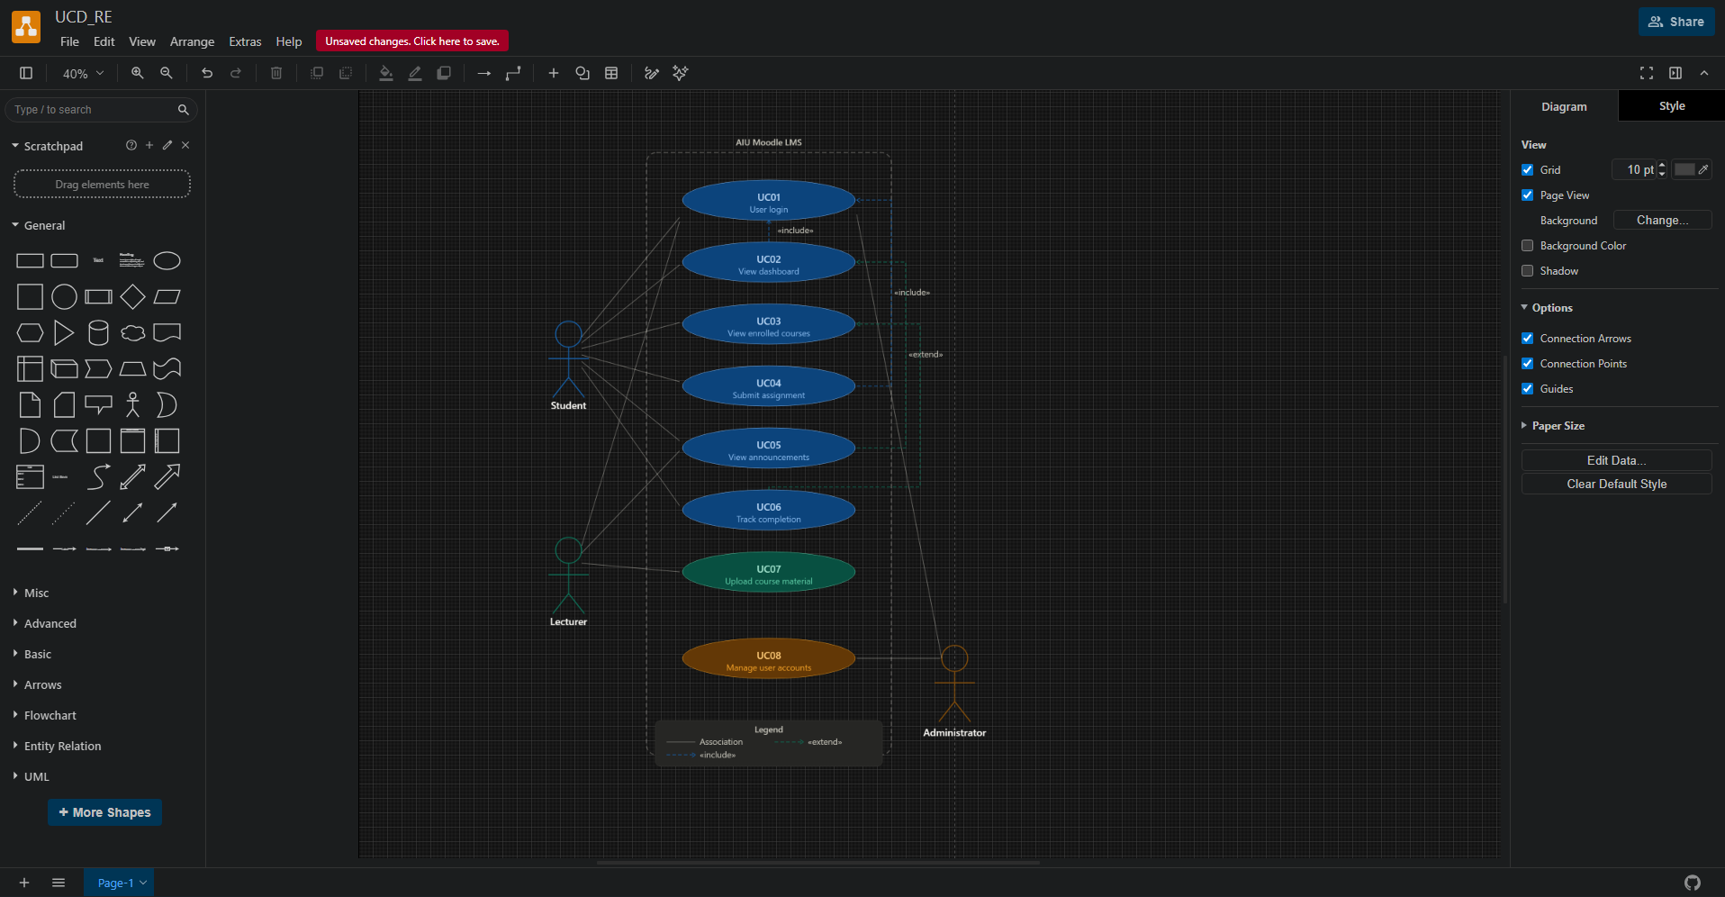
Figure 7: Draw.io — Use Case Diagram in Progress
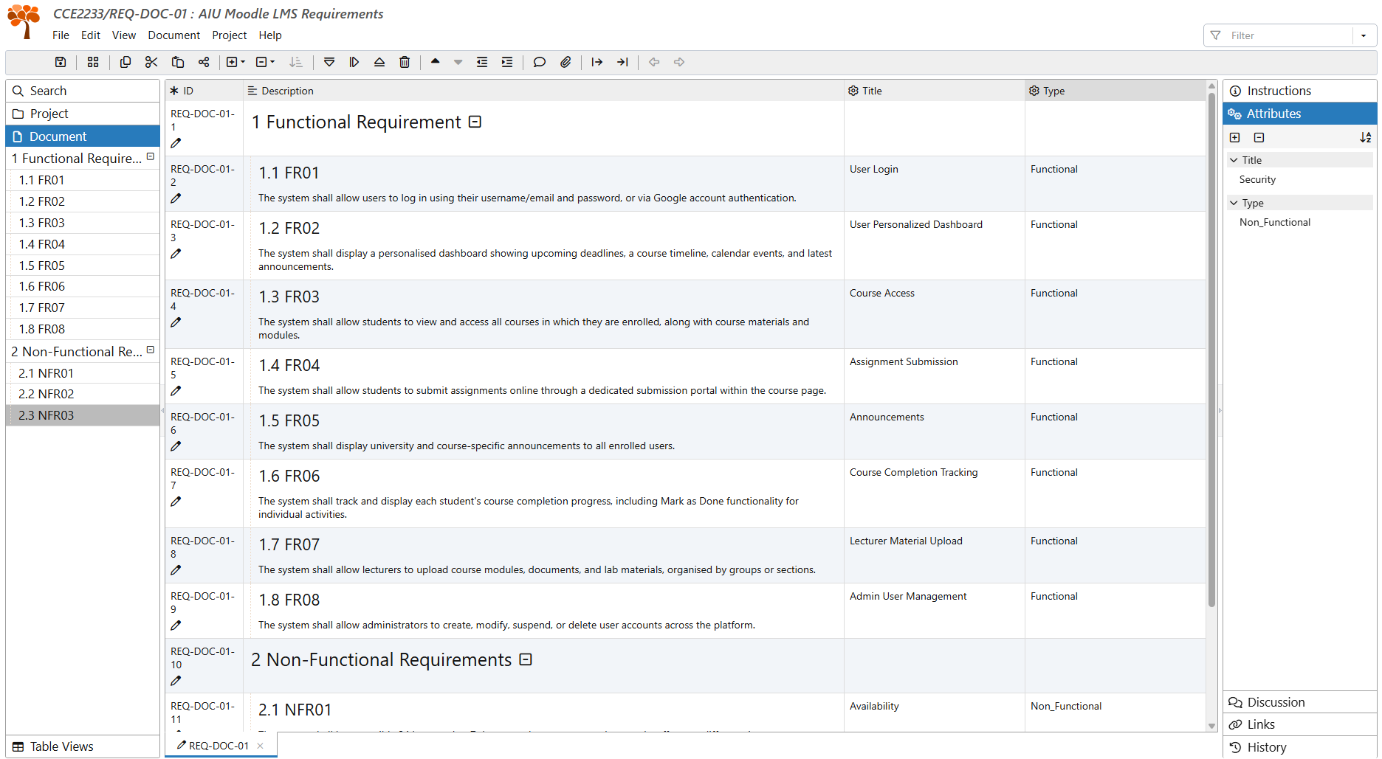
Figure 8: ReqView — Requirements List with IDs and Descriptions
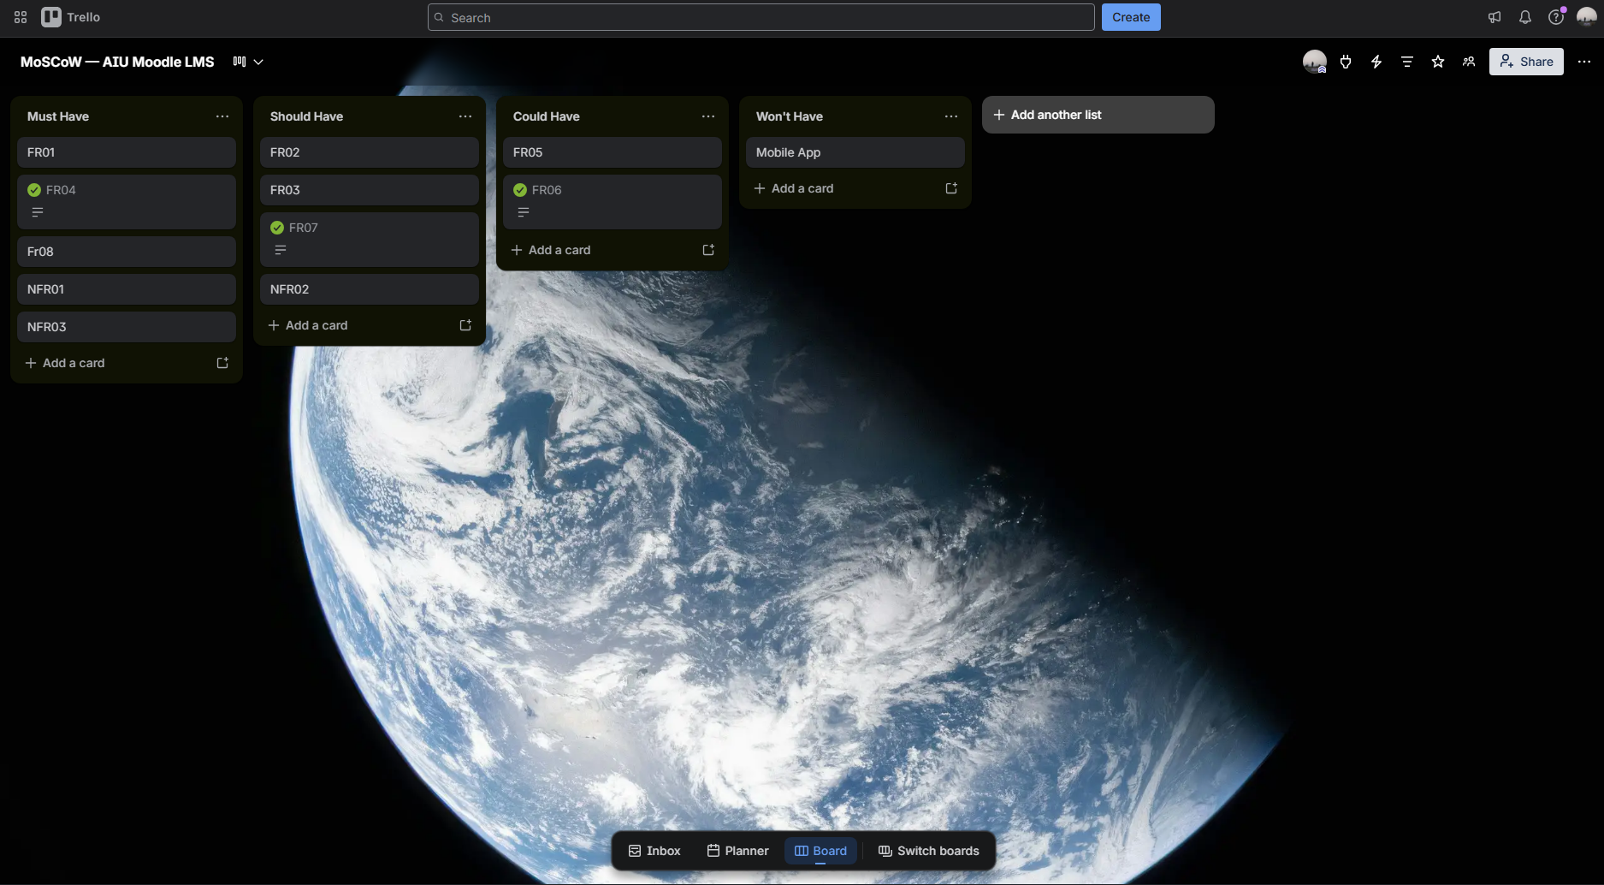
Figure 9: Trello — MoSCoW Kanban Board (Must / Should / Could / Won't columns)
[ SCREENSHOT: GitHub — Repository with Report Commits ]
Take a screenshot of this tool and paste it here.
Figure 11: GitHub — Repository with Report Commits
[ SCREENSHOT: Microsoft Word — Report Formatting (Century Gothic, 11pt, 1.15 spacing) ]
Take a screenshot of this tool and paste it here.
Figure 12: Microsoft Word — Report Formatting (Century Gothic, 11pt, 1.15 spacing)

8. Conclusion
In the current paper, a full-scale requirements engineering study of AIU Moodle LMS was provided based on the actual system observation. By means of proper elicitation, documentation, and identification of requirements, 11 requirements were collected, namely, 8 functional and 3 non-functional, which describe what is done by the system and the qualities it should provide. Those requirements were supported by the observed functions in screenshots of the system, including Login Page, Dashboard, Course Overview, Course Content Page, and Assignment Submission Portal (Moodle HQ, 2024).

A use case diagram and 6 use cases, related to 3 actors, Students, Lecturers, and Administrators, were provided to demonstrate how the system acts from the actor's point of view. In addition, MoSCoW prioritization resulted in the five Must Have requirements, which represent the core requirements for the minimum viable system, and all the other requirements being stratified properly in accordance with their importance (Sommerville, 2016). Finally, the traceability matrix indicated the presence of complete coverage and the absence of unmapped requirements.

For carrying out the analysis, 6 professional tools, namely, Draw.io, Lucidchart, ReqView, Trello, GitHub, and Microsoft Word were utilized, which demonstrates the use of several tools in the requirements engineering process. Thus, an appropriate ground for the design and development processes was created.

9. Reflection
Working on this requirements engineering report was a difficult process because of some key challenges that helped me develop my knowledge of this theory much more deeply. First of all, observing Moodle as part of a structured process of requirements elicitation became especially interesting after I started using the tool in a more sophisticated way. At first, I only interacted with Moodle as its user and logged in to check due dates and submit my assignments. After analyzing the same screens from a new perspective, I suddenly noticed some features that were obvious before but somehow remained unnoticed – such as Google authentication in the login screen, separate groups for labs submitted to various lecturers, tracking progress percentage, and an important message from the Centre for Development of Academic Excellence on Moodle Application Issue of 5 May. Thus, requirements elicitation should not be considered as passive observation of the system being analyzed (Sommerville, 2016).

Another challenge that I faced when working on the report was distinguishing functional from non-functional requirements. In the beginning of the process, I used very general statements to describe the latter type of requirements, without making it clear how I will measure them. Reading about the properties of non-functional requirements that should be considered while performing elicitation in Sommerville (2016), I realized that I need to add specific metrics to my report – hence, NFR02 refers to a page loading time equal to '3 seconds', and NFR01 specifies '24/7 availability'. ReqView tool facilitated the process of completing this task by requiring unique ID, type, and description for each requirement in order to avoid unstructured notes. Trello made the MoSCoW prioritization exercise much more clear by making it visually obvious whether to move a requirement card to 'Must Have' or 'Should Have' category. Finally, Draw.io saved me a lot of time while preparing the UML diagram by automatically generating all necessary actors and use cases.

Overall, it appears that the task of requirements elicitation is much more complicated than one can think at first sight because it involves not only listing all functions of the system, but also explaining why certain features are critical for stakeholders, establishing connections between requirements, and prioritizing them into must-haves and nice-to-haves.

10. References

- Moodle HQ. (2024). Moodle documentation. Moodle. https://docs.moodle.org
- Nuseibeh, B., & Easterbrook, S. (2000). Requirements engineering: A roadmap. Proceedings of the Conference on the Future of Software Engineering, 35–46. https://doi.org/10.1145/336512.336523
- Sommerville, I. (2016). Software engineering (10th ed.). Pearson Education Limited.

