PROJECT SYNOPSIS
Group ID : 6
Project Title : "NextGen Rakshak: Edge-AI Powered Lost Child Recovery System for
Mass Gatherings"

1. Project Definition
NextGen Rakshak is a hybrid edge-AI system engineered for the rapid recovery of lost children at mass gatherings such as festivals, fairs, and religious congregations (e.g. Kumbh Mela, Ganesh Chaturthi visarjan processions, Dussehra grounds, and urban temple fairs). The system is built around a three-component architecture in which the heavy computational work of face recognition happens on the edge — on ordinary volunteer smartphones — rather than on a central server, while a resilient cloud backend coordinates alert distribution.
The project directly addresses the “golden hour” problem repeatedly highlighted by child-rights experts: the first sixty to ninety minutes after a child goes missing in a crowd are the most critical for recovery, yet this is precisely when cellular networks at large events become congested and existing government portals (which are built for post-incident record-keeping rather than live search) are least useful.
Component A — Police Kiosk Portal (Next.js Web Application):
A lightweight web application deployed on a tablet or laptop at a festival police-assistance booth. When a parent reports a missing child, the officer captures or uploads the child's photograph, enters brief identifying details (name, age, clothing description, last-seen location), and presses “Send Alert” to trigger an instant, multi-channel broadcast.
Component B — Volunteer Android Application (Kotlin):
Registered volunteers — festival security staff, NCC/NSS cadets, on-duty police personnel, and designated community volunteers such as shopkeepers — install the app. On receiving an alert (via an internet push notification or a relayed Nearby Connections mesh packet), the volunteer opens the app and the rear camera activates to scan the surrounding crowd in real time. On-device TensorFlow Lite face detection and MobileFaceNet-based embedding extraction run locally on the phone; the extracted embeddings are compared against the embeddings of all currently active missing-child alerts using cosine similarity. No image, video frame, or biometric fingerprint of a bystander ever leaves the device.
Component C — Raspberry Pi Fixed-Camera Node (Optional Extension):
For festival exit gates and other strategic choke points, a Raspberry Pi 4 fitted with a Pi Camera Module runs the same detection-and-matching pipeline continuously. It fetches the embeddings of active alerts from the police kiosk over the local Wi-Fi network and scans every passing face; on a high-confidence match it immediately notifies the kiosk, covering the scenario in which a child is moved past a fixed point without a volunteer nearby.

2. Scope

2.1 In-Scope
Aspect | Description
Target environment | Mass gatherings including Kumbh Mela, Dussehra grounds, Ganesh Chaturthi visarjan routes, local temple fairs, and city-level celebrations
Target users | Police officers (kiosk portal); registered volunteers (Android app); festival organisers
Core functionality | Instant multi-channel alert broadcast; on-device face detection and recognition; offline Nearby Connections mesh with custom multi-hop store-and-forward routing; human-verified match confirmation
Geographical scope | Geofenced radius of approximately 2 km around the reporting kiosk
Volunteer network | Pre-registered, credible volunteers — police personnel, NCC/NSS cadets, private security staff, shopkeepers, and NGO partners
Privacy architecture | All face matching performed on-device; no biometric data uploaded to central servers; alert data is ephemeral and auto-expires

2.2 Out-of-Scope
Aspect | Description
Legal enforcement | Does not replace formal police investigation, FIR procedures, or judicial processes
Long-term missing-person cases | Designed for “golden hour” recovery at a bounded event; not intended for open-ended, long-term missing-person searches
Background surveillance | The volunteer's camera activates only after an alert is received and the app is opened; there is no continuous or passive crowd surveillance
Autonomous declaration | The system never autonomously declares a child “found” — a human volunteer must visually confirm every candidate match before it is reported
Mass public adoption | Targets pre-registered, duty-bound volunteers; the design does not assume spontaneous participation from unregistered festival attendees

2.3 Key Performance Indicators
Metric | Target
Face recognition accuracy | ≥ 90% on frontal faces under typical festival lighting
Inference time per face | < 200 ms on a mid-range Android device
Alert delivery time | < 5 seconds in internet mode; < 30 seconds over the offline Nearby Connections mesh
Volunteer scan throughput | 200+ faces per hour per volunteer
Concurrent alert capacity | 50 simultaneous active alerts with no measurable performance degradation

3. Objectives
The primary objectives of the NextGen Rakshak project are:
- To design and develop a hybrid edge-AI system for rapid lost-child recovery at mass gatherings, addressing the critical “golden hour” gap identified by child-rights activists and law-enforcement experts.
- To implement on-device face detection using Google ML Kit and face recognition using MobileFaceNet with TensorFlow Lite, achieving real-time performance on standard Android devices without any cloud round-trip.
- To enable both internet-based push notifications (via Firebase Cloud Messaging) and a fully offline, custom multi-hop store-and-forward mesh built on the Google Nearby Connections API (Bluetooth LE for discovery, Wi-Fi Direct for high-speed transfer) for alert distribution, so the system keeps working when cellular networks are congested.
- To develop a police kiosk web application using Next.js with Firebase integration for rapid alert creation, volunteer coordination, and real-time match-alert display.
- To build a volunteer Android application using Kotlin, CameraX, ML Kit, and TensorFlow Lite that enables real-time crowd scanning for multiple missing children simultaneously.
- To design an optional Raspberry Pi-based fixed-camera node for unattended scanning at festival exit gates and other choke points.
- To ensure a privacy-by-design architecture in which all face matching occurs on-device, no biometric data is uploaded to central servers, and alert data is automatically purged after resolution or expiry.
- To validate the system's effectiveness against existing government and NGO solutions and demonstrate a meaningful improvement in search capacity over manual, human-only methods.

4. Review of Conference/Journal Papers and Relevant Theory

4.1 The Scale of Missing Children in India
The National Crime Records Bureau's (NCRB) most recent “Crime in India” report (2024 data, released 2025) records 98,375 children reported missing in a single year — an increase of nearly 8% over 2023 — averaging 269 children every day. Of the 1,47,175 children on record as missing when previous-year backlogs are included, 98,826 were traced during 2024 (a 67.1% recovery rate), leaving 48,349 children unrecovered nationally. Kidnapping and abduction remain the largest contributor to crimes against children: NCRB's 2023 figures record 79,884 such cases, victimising 82,106 children, out of 1,77,335 total crime-against-children cases that year (a 9.2% rise over 2022).
The trajectory over recent years has been persistently upward — the Supreme Court itself took note of the oft-cited claim that “a child goes missing in India every eight minutes,” with Justice B.V. Nagarathna remarking on the seriousness of the issue in November 2025. While national recovery rates (around two-thirds of children eventually traced) are not as bleak as sometimes reported, they represent recovery over months or years — not the tight, one-to-two-hour window in which a child lost in a crowd of lakhs of people is at greatest risk and is genuinely findable by a human eye or a camera.

4.2 Existing Solutions: A Comparative Analysis

4.2.1 National-Level Government Platforms
Platform | Year | Key Features | Limitations
TrackChild Portal | 2012 | Central database of missing and found children; inter-state coordination | Reactive, post-incident record entry; not built for live, real-time search; internet-dependent
Khoya-Paya Portal | 2015 | Citizen-facing portal for reporting missing and found children | Manual search only; no instant push alerts; no automated face matching
GHAR Portal (NCPCR) | 2023 | Restoration and repatriation of institutionalised children | Focused on institutional case management, not a real-time festival/crowd solution

4.2.2 NGO, Corporate, and Police Initiatives
ReUnite (Bachpan Bachao Andolan + Capgemini): Launched on 29 June 2018 by then-Commerce Minister Suresh Prabhu and Kailash Satyarthi, ReUnite uses Amazon Rekognition — a cloud-based facial recognition service — to match photographs of missing children uploaded by citizens against a database, without storing the images in the phone's local memory. While a significant step, its architecture depends on active internet connectivity and centralised cloud processing (a genuine privacy consideration), and it remains a reactive, upload-and-wait model rather than a proactive crowd-scanning tool.
Garuda Rakshak (DSP Mutual Fund + Falco Robotics): Deployed at the Purna Maha Kumbh, this drone-based system issues low-cost wristbands to children; when a child is separated, guardians tap the ID band at a Lost-and-Found centre and a drone locates the child using real-time geo-data. It requires physical wristbands and drone infrastructure per event, which limits its scalability to everyday, smaller festivals.
Digital Khoya-Paya Kendra, Maha Kumbh 2025: The Uttar Pradesh government set up ten AI-enabled “lost-and-found” centres equipped with facial recognition at the 2025 Maha Kumbh, which drew over 60 crore pilgrims. The initiative helped reunite roughly 54,357 separated people (mostly adults; all 18 children who were reported separated were also safely reunited). This is the closest large-scale Indian precedent for AI-assisted reunification, but it remains a centralised, centre-based system in which a person must physically reach — or be brought to — one of the ten fixed kendras for the AI matching to run; it does not push the search out into the moving crowd via ordinary citizens' or volunteers' phones.
Closed-network photo sharing by police (e.g. Delhi Police WhatsApp groups): Delhi Police constables have used dedicated WhatsApp groups to instantly circulate photographs of missing children among on-duty officers, leading to several rapid recoveries. This demonstrates the real-world value of instant photo distribution across a trusted, closed network of duty-bearers — the same principle NextGen Rakshak formalises and automates with computer vision, rather than relying on an officer's eyes on a WhatsApp thread.

4.2.3 International Benchmark: AMBER Alert (United States)
The AMBER Alert system is the global benchmark for rapid child-abduction alerts. As of 31 December 2025, 1,312 children have been recovered following an AMBER Alert activation, of which at least 252 were a direct result of a Wireless Emergency Alert reaching a bystander's phone. However, AMBER Alerts are issued only for a small fraction of missing-child cases that meet strict abduction criteria, depend on cellular/broadcast infrastructure, and are a passive, one-way broadcast — citizens receive a description but have no automated tool to actively scan the faces around them for a match.

4.3 Relevant Theory and Technology

4.3.1 Face Recognition on Edge Devices
MobileFaceNet is a lightweight convolutional neural network architecture purpose-built for mobile deployment, with fewer than one million parameters while reporting accuracy above 99% on the standard LFW face-verification benchmark. It produces a compact 128–192 dimensional embedding vector per face using depthwise separable convolutions and a global depthwise convolution layer to minimise computation without sacrificing discriminative power.
TensorFlow Lite enables such models to run efficiently on mobile and edge hardware; converting a model to the .tflite format with dynamic-range quantisation shrinks its size considerably while largely preserving accuracy, and typical per-face inference on a mid-range Android device falls in the 100–200 ms range. Google ML Kit's on-device Face Detection API complements this by locating faces and facial landmarks in real time (roughly 30 frames per second) fully offline, and by reporting head-pose (Euler) angles that let the app discard non-frontal faces before running the heavier recognition step.

4.3.2 Peer-to-Peer Offline Communication
The Google Nearby Connections API is an actively maintained (Google Play services) peer-to-peer networking API that lets apps discover, connect to, and exchange data with nearby devices without any internet access. It automatically uses Bluetooth Low Energy for low-power discovery and switches to Wi-Fi Direct (or classic Bluetooth as a fallback) for the actual high-speed data transfer, hiding this negotiation from the application. It is important to be precise about what the API does and does not provide: Nearby Connections establishes direct, authenticated connections between pairs of nearby devices (or a small CLUSTER of them) — it is not itself a multi-hop mesh-routing protocol. Reaching a volunteer two, three, or ten hops away from the kiosk therefore requires an application-level store-and-forward routing layer built on top of it.
NextGen Rakshak implements this routing layer itself: every alert packet carries a unique message ID (UUID), a hop-count/time-to-live (TTL) field that is decremented at each relay and caps how far a packet can travel, and each device keeps a short-lived “seen-IDs” set so it relays a given packet at most once, preventing duplicate storms and infinite loops. Packets expire and are silently dropped once the parent alert's own lifetime elapses. Byte payloads of up to 32 KB can be exchanged per Nearby Connections message — far more than is actually needed, since an alert packet (a UUID, short text fields, and a 512-byte MobileFaceNet embedding) totals under 1 KB; the full-resolution child photo is deliberately never sent over the mesh, only its embedding and a few lines of text, which keeps every hop fast even on a busy, moving crowd.
Cosine similarity is used to compare face embeddings because it measures the angle between two vectors rather than their magnitude, which makes it robust to brightness and pose variation. It yields an interpretable score between 0 (completely dissimilar) and 1 (identical), and computing it against a modest number of active alerts (fewer than 50) takes a negligible fraction of a millisecond.

4.3.3 Raspberry Pi Edge Computing
A Raspberry Pi 4 (4 GB) paired with a Pi Camera Module V2 provides a low-cost, always-on edge-AI node. Multiple published and community projects have demonstrated real-time face recognition on this hardware using OpenCV for capture/pre-processing and the tflite-runtime package for efficient on-device inference, confirming the platform's suitability as an unattended camera node at a fixed choke point such as an exit gate.

4.4 Research Gap
Taken together, the existing systems reviewed above — TrackChild, Khoya-Paya, ReUnite, Garuda Rakshak, the Maha Kumbh Digital Khoya-Paya Kendras, and AMBER Alert — share one or more of the following structural limitations: they are reactive (someone must upload a photo and wait), centralised (matching happens on a remote server), internet-dependent (they fail exactly when festival networks are most congested), or centre-bound (a person must be brought to a fixed physical location for AI matching to run).
No existing system reviewed combines all of the following, which together form the core contribution of NextGen Rakshak:
- Instant, decentralised push of a missing child's photograph and embedding to every registered volunteer within a geofenced radius, the moment an alert is filed.
- Automated, on-device face matching using the volunteer's own smartphone camera as they move through the crowd — with no central server in the recognition loop and no biometric data ever uploaded.
- A fully offline fallback via a custom multi-hop store-and-forward mesh built on the Nearby Connections API, so the system keeps functioning when festival-grade crowds saturate the local cellular network.
- A trusted, pre-registered volunteer model that targets people who already have a duty or strong motivation to help (police, NCC/NSS cadets, security staff, shopkeepers) rather than assuming spontaneous cooperation from anonymous attendees.

5. System Architecture
NextGen Rakshak follows a hybrid cloud–mesh–edge architecture built on three pillars: a Cloud layer (Firebase) for centralised case management and alert distribution, an Edge layer (volunteer phones and the optional Raspberry Pi node) where all face recognition actually happens, and a Mesh layer — the Google Nearby Connections API plus a custom application-level multi-hop store-and-forward routing scheme — that keeps alerts flowing when the internet cannot be relied upon.
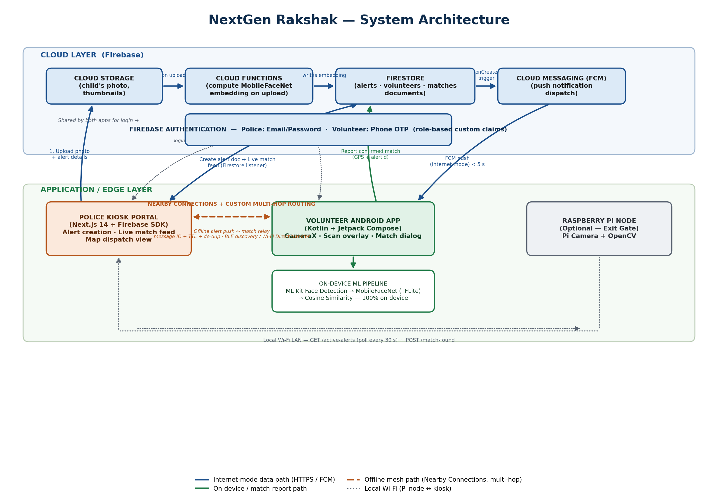
Figure 1: NextGen Rakshak — System Architecture

5.1 Component Architecture

5.1.1 Police Kiosk Portal (Next.js)
Layer | Technology | Description
Frontend | Next.js 14, React 18, Tailwind CSS, TypeScript | Responsive, server-rendered web UI with API routes; runs on any laptop/tablet browser at the kiosk
Backend | Firebase (Firestore, Auth, Storage, Cloud Functions) | Real-time database, role-based authentication, photo storage, and serverless embedding computation
Real-time updates | Firestore listeners | Dashboard and match feed update automatically the instant a volunteer reports a match
Push notifications | Firebase Cloud Messaging (FCM) | Delivers the alert to every registered volunteer device within the geofence in a few seconds

5.1.2 Volunteer Android Application (Kotlin)
Layer | Technology | Description
Language | Kotlin | Modern, null-safe language for Android; concise coroutine-based async code
Architecture | Android Jetpack (ViewModel, Navigation, Compose) | Clean separation between UI, business logic (use-cases), and data sources
Camera | CameraX | Consistent, lifecycle-aware camera access across device manufacturers
Face detection | Google ML Kit Face Detection | Fully offline; real-time (≈ 30 FPS); reports bounding boxes and head-pose angles
Face recognition | TensorFlow Lite (MobileFaceNet) | < 1M parameters; produces a 128-dimensional embedding per detected face
Similarity scoring | Cosine similarity | Microsecond-scale comparison against every active alert, robust to lighting/pose variation
Offline mesh | Google Nearby Connections API + custom store-and-forward routing | Peer-to-peer, encrypted; multi-hop relay via message ID, TTL, and duplicate suppression; works with zero internet or cellular signal
Local persistence | Room database | Queues match reports offline; a WorkManager job syncs them once connectivity returns

5.1.3 Raspberry Pi Fixed-Camera Node (Optional)
Component | Specification
Hardware | Raspberry Pi 4 (4 GB RAM) + Pi Camera Module V2
OS / runtime | Raspberry Pi OS Lite, Python 3, OpenCV, TFLite Runtime
Face detection | OpenCV Haar Cascade / lightweight MobileNet-SSD detector
Face recognition | Same MobileFaceNet TFLite model used on the volunteer app, for consistent embeddings
Alert sync | Polls the kiosk's local API (GET /api/active-alerts) over Wi-Fi every 30 seconds
Match reporting | HTTP POST to the kiosk with the match image, confidence score, camera ID, and timestamp
Power | USB power bank (5 V, 2.5 A) for portable, mains-independent deployment at a gate

5.1.4 Offline Mesh Networking Design (Nearby Connections + Custom Routing)
Google Nearby Connections is a peer-to-peer connection API, not a ready-made multi-hop mesh protocol — it establishes an authenticated link between nearby devices using BLE for discovery and Wi-Fi Direct for fast transfer, but reaching a volunteer several hops away from the kiosk is the application's own responsibility. NextGen Rakshak therefore implements a thin, custom store-and-forward routing layer on top of Nearby Connections, using the following controls:
Routing Control | Purpose
Message ID (UUID) | Uniquely identifies every alert and match packet so it can be recognised across multiple hops
Hop-count / TTL | Decremented at every relay; once it reaches zero the packet is no longer re-broadcast, preventing unbounded flooding
Duplicate suppression (seen-ID cache) | Each device keeps a short-lived set of message IDs it has already relayed and forwards a given packet at most once
Expiration timestamp | A packet tied to an already-expired or resolved alert is dropped rather than relayed
Payload minimisation | Only the face embedding (≈ 512 bytes), a small text payload, and an optional low-resolution thumbnail are sent — never the full-resolution photo — keeping each hop fast even on a congested, moving crowd
Transport security | Nearby Connections encrypts the link automatically; alert payloads are additionally signed so a relaying device cannot tamper with alert content

5.2 Technology Stack Summary
Layer | Technology | Version / Specification
Mobile app | Kotlin + Jetpack Compose | Kotlin 1.9+, Compose BOM 2024.02+
Mobile ML | Google ML Kit (Face Detection) | com.google.mlkit:face-detection:16.1.5
Mobile TFLite | TensorFlow Lite (MobileFaceNet) | org.tensorflow:tensorflow-lite:2.14.0
Offline mesh | Google Play services Nearby Connections | com.google.android.gms:play-services-nearby:18.7.0
Camera | AndroidX CameraX | androidx.camera:camera-camera2:1.3.0
Web portal | Next.js 14 + TypeScript + Tailwind CSS | React 18, App Router
Backend / DB | Firebase (BaaS) | Firestore, Cloud Storage, Cloud Functions, Cloud Messaging, Auth
Fixed camera node (optional) | Raspberry Pi 4 + Pi Camera V2 | Python 3.9+, OpenCV, TFLite Runtime
Version control | Git + GitHub | Standard feature-branch workflow

6. Module-Wise Functional Description
This section breaks each of the three components down into its constituent screens/modules, describing the functionality targeted for the final-year MVP submission and the enhancements planned beyond it.

6.1 Police Kiosk Portal (Next.js)

6.1.1 Login / Authentication
Core Functionality (MVP)
- Officer signs in with an email and password issued for the kiosk; Firebase Authentication validates credentials and attaches a role: "police" custom claim.
- Firestore security rules use this claim to gate write access to the alerts collection.
Planned Enhancements (Post-MVP)
- Multi-factor authentication (OTP + password) for kiosk logins.
- Session-based audit log of which officer created or resolved which alert.

6.1.2 Dashboard
Core Functionality (MVP)
- Shows count of currently active alerts and a simple map placeholder for recent match locations.
- Quick-access buttons to create a new alert or jump to the live matches feed.
Planned Enhancements (Post-MVP)
- Live heat-map of volunteer density across the geofenced area.
- Historical analytics: alerts raised vs. resolved, average time-to-match, per-event summary reports.

6.1.3 New Alert Page
Core Functionality (MVP)
- Form to capture the child's photo (upload or camera capture), name, age, gender, clothing description, parent's contact number, and last-seen location (map pin).
- On submit: photo uploads to Cloud Storage, a Cloud Function computes the MobileFaceNet embedding, and the alert document is written to Firestore with status "active".
Planned Enhancements (Post-MVP)
- Multi-photo upload (front + side profile) to improve embedding robustness.
- Auto-suggested clothing-colour tags using a lightweight on-image colour classifier.

6.1.4 Live Matches Page
Core Functionality (MVP)
- Real-time list of incoming matches (Firestore listener on the matches collection), each showing the child's photo, the volunteer's GPS location, and elapsed time.
- "Dispatch" button opens Google Maps with turn-by-turn directions to the reported location.
Planned Enhancements (Post-MVP)
- One-tap SMS/WhatsApp notification to the parent's registered contact number on match confirmation.
- Match confidence trend graph across multiple volunteer sightings of the same child.

6.2 Volunteer Android Application (Kotlin)

6.2.1 Registration & Login
Core Functionality (MVP)
- Volunteer enters a phone number and receives an OTP (mocked for the MVP demo, Firebase Phone Auth in production) to register a role: "volunteer" profile.
- App requests Camera, Location, and Nearby Devices (Bluetooth) runtime permissions with a rationale dialog explaining why each is needed.
Planned Enhancements (Post-MVP)
- Verification step tying a volunteer's registration to an organisation ID card (NCC, NSS, police) for stronger trust.
- Volunteer leaderboard / recognition badges to encourage sustained participation across events.

6.2.2 Home Screen
Core Functionality (MVP)
- Lists all currently active alerts the volunteer's device has received, each with the child's name, age, and time elapsed.
- "Start Scanning" button, enabled only when at least one alert is active.
Planned Enhancements (Post-MVP)
- Filter/sort alerts by distance from the volunteer's current location.
- Push-to-refresh manual sync with the mesh cache for volunteers who briefly lost connectivity.

6.2.3 Scan Screen
Core Functionality (MVP)
- Rear camera opens automatically via CameraX with an overlay reading “Scanning for [names]…”.
- Every frame: ML Kit detects faces → non-frontal faces are discarded using the head-Euler-angle check → MobileFaceNet extracts a 128-d embedding for each remaining face → cosine similarity is computed against every active alert's stored embedding.
Planned Enhancements (Post-MVP)
- Multi-face tracking overlay showing bounding boxes and live similarity scores for debugging/demo purposes.
- Battery-aware throttling that pauses scanning when the phone is stationary for an extended period (detected via the accelerometer).

6.2.4 Match Confirmation Dialog
Core Functionality (MVP)
- On a similarity score above the 0.75 threshold, the phone vibrates and shows a side-by-side comparison: the parent-submitted photo alongside the live camera frame.
- Volunteer taps “Confirm” or “Not a match”; on confirmation, GPS coordinates and a timestamp are attached and the match is sent to Firestore (or queued locally via Room if offline) and simultaneously relayed via the Nearby Connections mesh using the app's custom store-and-forward routing.
Planned Enhancements (Post-MVP)
- Optional short video clip (2–3 seconds) attached to the match report for faster officer verification.
- In-app secure chat between the confirming volunteer and the dispatching officer.

6.3 Raspberry Pi Fixed-Camera Node (Optional Extension)

6.3.1 Continuous Gate Scanning
Core Functionality (MVP)
- Polls the kiosk's local-network API for active alert embeddings every 30 seconds.
- Runs the same detection-and-matching pipeline on every frame from the Pi Camera, independent of any human volunteer being present.
Planned Enhancements (Post-MVP)
- Multiple synchronised Pi nodes across several gates with a unified dashboard view.
- Low-light / IR camera support for night-time festival sessions.

7. System Flow Diagram
The diagram below traces a single missing-child case end to end — from the moment a parent reports the child at the kiosk to the moment the alert is closed after reunion — showing exactly where the internet-mode and offline-mesh paths diverge and converge.
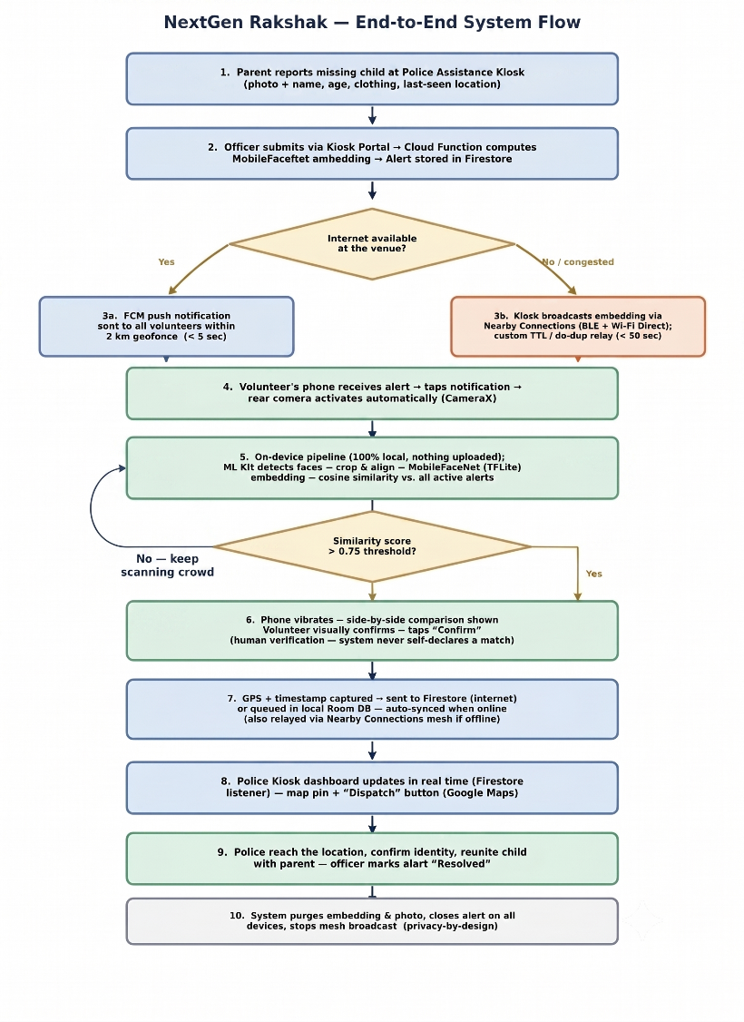
Figure 2: NextGen Rakshak — End-to-End System Flow

7.1 Data Flow — Step-by-Step Summary
- Alert creation: the parent reports the missing child; the officer opens the Kiosk Portal and uploads the child's photo and details.
- Embedding extraction: a Firebase Cloud Function computes the MobileFaceNet embedding server-side (once, at alert creation) and stores the alert document in Firestore with geolocation, embedding, and timestamp.
- Alert distribution (internet mode): an FCM push notification reaches every registered volunteer device inside the geofenced radius.
- Alert distribution (offline mode): simultaneously, the kiosk device broadcasts the alert's embedding and metadata (never the full photo) via the Nearby Connections API (BLE discovery, Wi-Fi Direct transfer); receiving volunteer phones apply the app's custom store-and-forward routing — tagging the packet with a message ID and TTL and relaying it at most once each — to flood it hop-by-hop across the venue.
- Volunteer scanning: on receiving the alert, the volunteer's phone shows a notification; tapping it opens the app directly into the camera scan screen.
- Face detection & recognition: the live camera loop runs ML Kit detection, MobileFaceNet embedding extraction, and cosine-similarity comparison against all active alerts — entirely on-device.
- Match confirmation: on a high-confidence match, the phone vibrates and displays the side-by-side comparison; the volunteer visually confirms before anything is reported.
- Match reporting: the confirmed match (GPS + timestamp + alert ID) is sent to Firestore over the internet, or queued in the local Room database and auto-synced later, or relayed via the Nearby Connections mesh back toward the kiosk.
- Police response: the Kiosk Portal's real-time Firestore listener updates the dashboard within one to two seconds, dropping a map pin and enabling one-tap dispatch via Google Maps.
- Resolution & cleanup: once the child is safely reunited, the officer marks the alert “Resolved”; the system removes the active alert from all volunteer devices, deletes the stored embedding and photo from Firestore/Storage, and stops the mesh broadcast.

8. Requirements

8.1 Functional Requirements
ID | Requirement | Priority
FR-01 | Police officer shall be able to create a missing-child alert with a photo and identifying details | High
FR-02 | System shall compute a face embedding from the uploaded photo and store it in Firestore | High
FR-03 | System shall send push notifications to all volunteers within the geofenced radius | High
FR-04 | Volunteer app shall detect faces in real time using the smartphone camera | High
FR-05 | Volunteer app shall extract face embeddings on-device using TensorFlow Lite | High
FR-06 | Volunteer app shall compare detected faces against all active alerts using cosine similarity | High
FR-07 | Volunteer app shall display a match notification with a side-by-side photo comparison | High
FR-08 | Volunteer shall be able to explicitly confirm or dismiss a potential match | High
FR-09 | System shall send a confirmed match alert to the police kiosk with GPS coordinates | High
FR-10 | System shall relay alerts over a custom multi-hop store-and-forward mesh built on the Nearby Connections API when internet is unavailable | Medium
FR-11 | System shall support multiple simultaneous active alerts with no performance degradation | Medium
FR-12 | System shall automatically expire an alert after a configurable period (default: 8 hours) | Medium
FR-13 | Raspberry Pi node shall autonomously detect and match faces at an exit gate | Low (Optional)
FR-14 | Mesh routing layer shall tag every relayed packet with a message ID and TTL, and each device shall relay a given packet at most once | Medium

8.2 Non-Functional Requirements
ID | Requirement | Target
NFR-01 | Face detection accuracy | ≥ 95% on frontal faces
NFR-02 | Face recognition accuracy | ≥ 90% on frontal faces under festival lighting
NFR-03 | Inference time per face | < 200 ms on a mid-range device
NFR-04 | Alert delivery time (internet) | < 5 seconds
NFR-05 | Alert delivery time (offline mesh) | < 30 seconds
NFR-06 | Volunteer scan throughput | 200+ faces per hour per volunteer
NFR-07 | Concurrent active alerts | 50 alerts with zero measurable performance loss
NFR-08 | Privacy | Zero biometric data uploaded to servers; all matching on-device
NFR-09 | Battery impact | Camera active only during an alert; scanning stops on match/timeout
NFR-10 | Device compatibility | Android 5.0+ (API 21+)

8.3 Hardware Requirements
Component | Specification | Quantity | Estimated Cost (₹)
Police kiosk device | Laptop or tablet with a modern web browser | 1 | Existing / departmental
Volunteer devices | Android smartphones (5.0+), 2 GB+ RAM | 5+ | Team-owned
Raspberry Pi node | Raspberry Pi 4 (4 GB) + Pi Camera V2 | 1 (optional) | ≈ 5,000
Power bank | 5V 2.5A USB power bank | 1 (optional) | ≈ 500

8.4 Software Requirements
Component | Technology | Version
Web application | Next.js / React / Tailwind CSS / TypeScript | 14.x / 18.x / 3.x / 5.x
Backend | Firebase (Firestore, Auth, Storage, Functions, FCM) | Latest
Android application | Kotlin / Android SDK / CameraX | 1.9.x / API 21+ / 1.3.x
Android ML | ML Kit Face Detection / TensorFlow Lite / Nearby Connections | Latest / 2.x / Latest
Raspberry Pi | Raspberry Pi OS Lite / Python / OpenCV / TFLite Runtime | Latest / 3.x / 4.x / Latest

8.5 Tools for Implementation
Tool | Purpose
Android Studio | Android application development and debugging
Visual Studio Code | Web (Next.js) and Python (Raspberry Pi) development
Firebase Console | Backend configuration, Firestore data, and Cloud Function monitoring
Git / GitHub | Version control and team collaboration
Postman | API and Cloud Function endpoint testing
Figma | UI/UX wireframing for the kiosk portal and volunteer app

9. Conclusion
NextGen Rakshak addresses a pressing societal challenge: the National Crime Records Bureau's 2024 data recorded 98,375 missing-children reports in a single year, with tens of thousands still untraced at year end. Existing government portals are built for post-incident record-keeping rather than live search, and even the best current AI-assisted deployment — the Maha Kumbh 2025 Digital Khoya-Paya Kendras — remains centre-bound rather than pushed out into the moving crowd through ordinary citizens' devices.
The proposed system offers several concrete innovations over this landscape:
- Privacy-preserving edge AI: all face matching runs on-device using TensorFlow Lite and MobileFaceNet, with zero biometric data uploaded to a central server — addressing the privacy concerns inherent in cloud-based approaches such as ReUnite's use of Amazon Rekognition.
- Offline-first architecture: a custom multi-hop store-and-forward routing layer built on the Google Nearby Connections API (BLE discovery, Wi-Fi Direct transfer) keeps alerts moving hop-by-hop when cellular networks are saturated — a very real infrastructure constraint at large Indian festivals.
- Proactive crowd scanning: unlike upload-and-wait solutions, Rakshak turns every volunteer's smartphone into an active scanner as they move through the crowd.
- A modern, maintainable technology stack: Next.js for a scalable web portal and Kotlin/Jetpack for a robust Android application.
- A credible, realistic volunteer model: by targeting pre-registered duty-bearers (police, NCC/NSS, festival staff) rather than assuming mass public participation, the system is deployable without relying on spontaneous cooperation.
- A near-zero recurring cost footprint: Firebase's free tier, open-source ML models, and team-owned devices keep the MVP's operating cost minimal.
The system is technically feasible within a student project timeline using production-ready, well-documented technologies. The MVP scope — the Police Kiosk Portal and the Volunteer Android Application — is achievable within the available timeframe, with the Raspberry Pi node positioned as an optional, valuable extension. By enabling instant, automated, wide-area crowd scanning at the moment a report is filed, NextGen Rakshak directly targets the golden-hour gap that separates the country's current missing-children infrastructure from the moment-to-moment reality of a lost child in a festival crowd.

10. References
- National Crime Records Bureau (NCRB), “Crime in India 2024,” as reported by ThePrint, ‘98,375 kids went missing in India in 2024, an 8% jump from 2023,” 2025. [Online]. Available: https://theprint.in/india/98375-kids-went-missing-in-india-in-2024-an-8-jump-from-2023-but-theres-a-silver-lining/2924633/
- National Crime Records Bureau (NCRB), “Crime in India 2023” — data on crime against children reported via Daily Pioneer, 2025. [Online]. Available: https://www.dailypioneer.com/2025/india/crime-against-children-records-9-2--rise-in-2023--says-ncrb-report.html
- ThePrint, “More than 47,000 children missing in India, 71% are girls, shows NCRB data,” 2025. [Online]. Available: https://theprint.in/india/more-than-47000-children-missing-in-india-71-are-girls-shows-ncrb-data/1880048/
- Business Standard, “Kumbh Mela: ‘Lost and found’ centres reuniting children with their families,” 2025. [Online]. Available: https://www.business-standard.com/india-news/kumbh-mela-lost-and-found-centres-reuniting-children-with-their-families-125012001062_1.html
- ETV Bharat, “Maha Kumbh 2025: Nearly 50,000 Missing Pilgrims Reunited With Their Families,” 2025. [Online]. Available: https://www.etvbharat.com/en/!state/uttar-pradesh-prayagraj-mahakumbh-2025-missing-persons-reunited-enn25030203144
- Business Standard, “Suresh Prabhu launches Mobile App ‘ReUnite’,” 2018. [Online]. Available: https://www.business-standard.com/article/current-affairs/prabhu-launches-reunite-mobile-app-to-trace-missing-abandoned-children-118062900509_1.html
- The Better India, “How WhatsApp Helped Delhi Police Find 3 Missing Children,” 2015. [Online]. Available: https://thebetterindia.com/34292/whatsapp-helps-delhi-police-find-missing-children/
- U.S. Department of Justice, Office of Justice Programs, “AMBER Alert — Statistics,” accessed 2026. [Online]. Available: https://amberalert.ojp.gov/statistics
- Google for Developers, “Nearby Connections — Overview,” Google Play services documentation. [Online]. Available: https://developers.google.com/nearby/connections/overview
- Google for Developers, “ML Kit — Face Detection,” on-device face detection API documentation. [Online]. Available: https://developers.google.com/ml-kit/vision/face-detection
- TensorFlow, “TensorFlow Lite — On-device machine learning,” official documentation. [Online]. Available: https://www.tensorflow.org/lite
- Firebase, “Firebase Documentation — Firestore, Cloud Messaging, Cloud Functions,” official documentation. [Online]. Available: https://firebase.google.com/docs
- Next.js, “Next.js Documentation — The React Framework for the Web,” official documentation. [Online]. Available: https://nextjs.org/docs
- Android Developers, “CameraX overview,” official documentation. [Online]. Available: https://developer.android.com/training/camerax
- Kotlin, “Kotlin Documentation,” official language documentation. [Online]. Available: https://kotlinlang.org/docs/home.html

Group Members
Sr. No. | Roll No. | Student Name | Signature
1 | 09 | BANKAR SMITRAJ DINKAR
2 | 11 | BHAKARE TANISHKA SHARAD
3 | 34 | DHADGE VEDANT SANJAY
4 | 94 | NARKHEDE ATHARVA ANANTKUMAR

Project Guide | Project Coordinator | HOD, Computer Department
Dr. A. B. Pawar | Dr. S. R. Deshmukh | Dr. M. A. Jawale

