**Top Coolest Spring/Summer/Winter Women Fashion trends in 2020**

**-------------------------------------------------------------------------------------------------------------**

**By Prachi Jain**

**-------------------------------------------------------------------------------------------------------------**

As the life progresses, so do the coolest styles. From malls to street style fashion, there have been plenty of cool and fresh looks to try this year. From cool crochet to the return of hot pants, this is your official guide to spring's/summer top trends.

*Spring*

These are the top fashion trends from Spring 2020 Fashion Weeks that are coming our way this season...!

                                                                                                           SOME LIKE IT HOT SKIRTS                                                                            ABOVE THE KNEES ON THE            LONG HOT DRESS                                                                STREET

*[](https://draft.blogger.com/blog/post/edit/918396549083998772/6383638387820591481)*

*[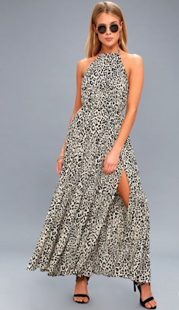](https://draft.blogger.com/blog/post/edit/918396549083998772/6383638387820591481)*

LONG ON HEALS

*[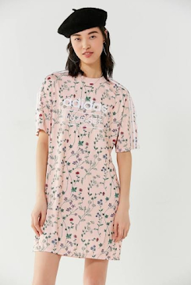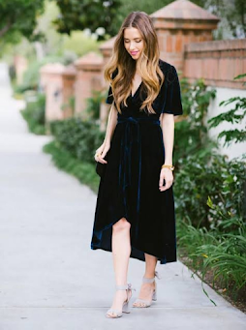](https://draft.blogger.com/blog/post/edit/918396549083998772/6383638387820591481)*

                                                   THE CASUALS

*[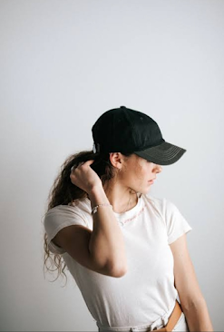](https://draft.blogger.com/blog/post/edit/918396549083998772/6383638387820591481)*

*Summer*

These are the top fashion trends from Summer 2020 Fashion Weeks that are coming our way this season...

**THE CASUALS                                                           THE   LONG  DRESS**

[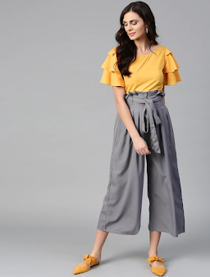](https://draft.blogger.com/blog/post/edit/918396549083998772/6383638387820591481)                      [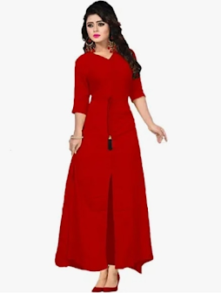](https://draft.blogger.com/blog/post/edit/918396549083998772/6383638387820591481)

           THE CROP TOP/JEANS                                                       HIGHER HEALS

[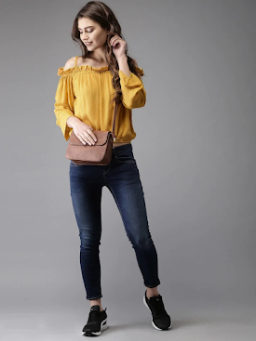](https://draft.blogger.com/blog/post/edit/918396549083998772/6383638387820591481)               [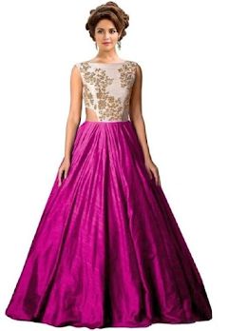](https://draft.blogger.com/blog/post/edit/918396549083998772/6383638387820591481)

***THE PARTY WEAR***

[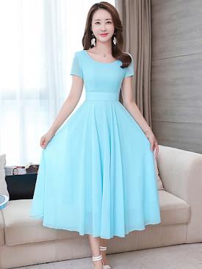](https://draft.blogger.com/blog/post/edit/918396549083998772/6383638387820591481)                     [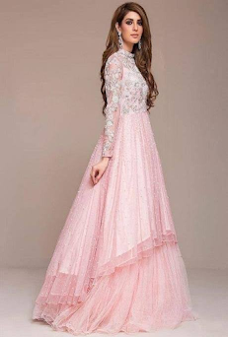](https://draft.blogger.com/blog/post/edit/918396549083998772/6383638387820591481)

                       THE CASUALS                                            THE KURTI-JEANS

[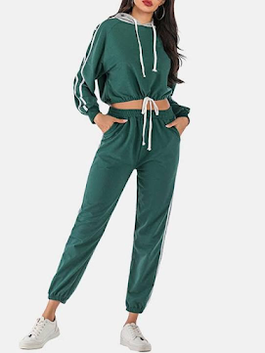](https://draft.blogger.com/blog/post/edit/918396549083998772/6383638387820591481)                      [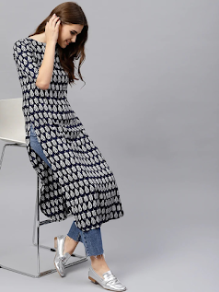](https://draft.blogger.com/blog/post/edit/918396549083998772/6383638387820591481)

    THE DISCO COLOUR ON THE PARTY                                      **THE  DISCO  COLOUR**

[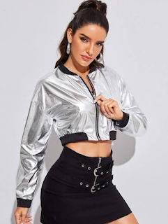](https://draft.blogger.com/blog/post/edit/918396549083998772/6383638387820591481)                              [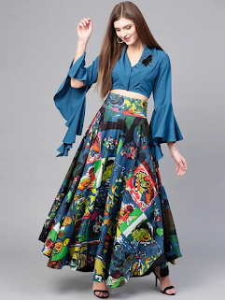](https://draft.blogger.com/blog/post/edit/918396549083998772/6383638387820591481)

[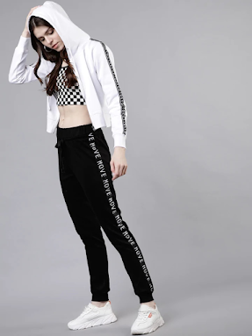](https://draft.blogger.com/blog/post/edit/918396549083998772/6383638387820591481)

***Winter***

These are the top fashion trends from Autumn/winter 2020 Fashion Weeks that are coming our way this season!

               THE FASHION TREND                                            THE  DISCO  COLOUR

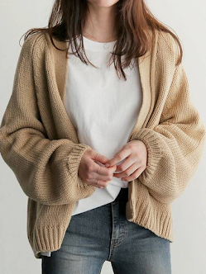                        [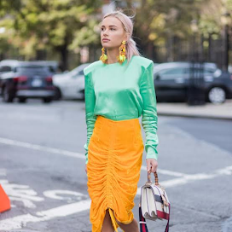](https://draft.blogger.com/blog/post/edit/918396549083998772/6383638387820591481)

     THE HOTTIE ON THE STREET

                                                                                      THE GUMBOOTS

[](https://draft.blogger.com/blog/post/edit/918396549083998772/6383638387820591481)

[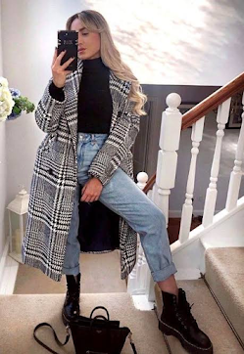](https://draft.blogger.com/blog/post/edit/918396549083998772/6383638387820591481)

               THE DISCO COLOUR

[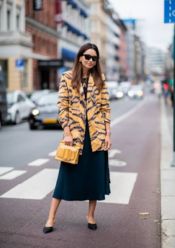](https://draft.blogger.com/blog/post/edit/918396549083998772/6383638387820591481)

[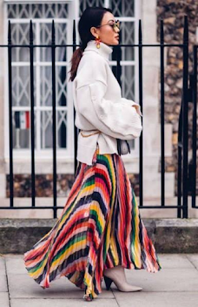](https://draft.blogger.com/blog/post/edit/918396549083998772/6383638387820591481)

         BUSINESS IN BERMUDA

      SHORTS OF THE STREET                                      THE SHRUG-GUMBOOTS

[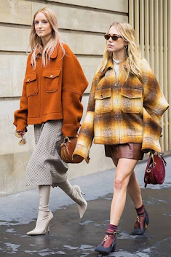](https://draft.blogger.com/blog/post/edit/918396549083998772/6383638387820591481)                                                [](https://draft.blogger.com/blog/post/edit/918396549083998772/6383638387820591481)

                                                                  THE WINTER

[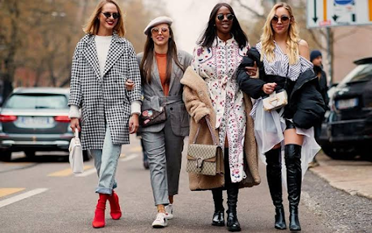](https://draft.blogger.com/blog/post/edit/918396549083998772/6383638387820591481)

Once received strictly for summer and winter, leather is ready to have its moment during season too.

The material was spotted on winter 2020 runaways from New York to Paris, from colorful dresses/jackets at coach 1941 even from skirts to pants.