PS-03: AI Hallucination and Citation Verification System

What is AI hallucination and citation verification system
- Focuses on detecting AI hallucinations and fake citations
- Targets unreliable facts generated by AI models
- Aims to improve trust, transparency, and reliability of AI-generated content
- Requires a verification system, not training a new AI model

What is AI Hallucination?
- AI generates confident-looking but factually incorrect information
- Occurs due to lack of real-time verification
- AI predicts text based on probability, not truth

What is a Factual Claim?
- A statement that can be verified as true or false
- Based on real-world evidence or data

What is a Citation?
- A reference that supports a factual claim
- Must exist, be accessible, and be relevant

Why Fake Citations Are Dangerous
- Create false credibility
- Mislead users and spread misinformation
- Cause academic, legal, and ethical risks

Why Existing AI Tools Fail
- Focus on fluency over accuracy
- Lack fact and citation validation mechanisms

Why Our Approach?
- Verification-first approach
- Works independently of AI generation models
- Scalable and domain-agnostic

Proposed Solution
- Extracts claims and citations from AI output
- Verifies facts using trusted sources
- Validates citations and assigns confidence scores

System Workflow (Visual Flowchart)
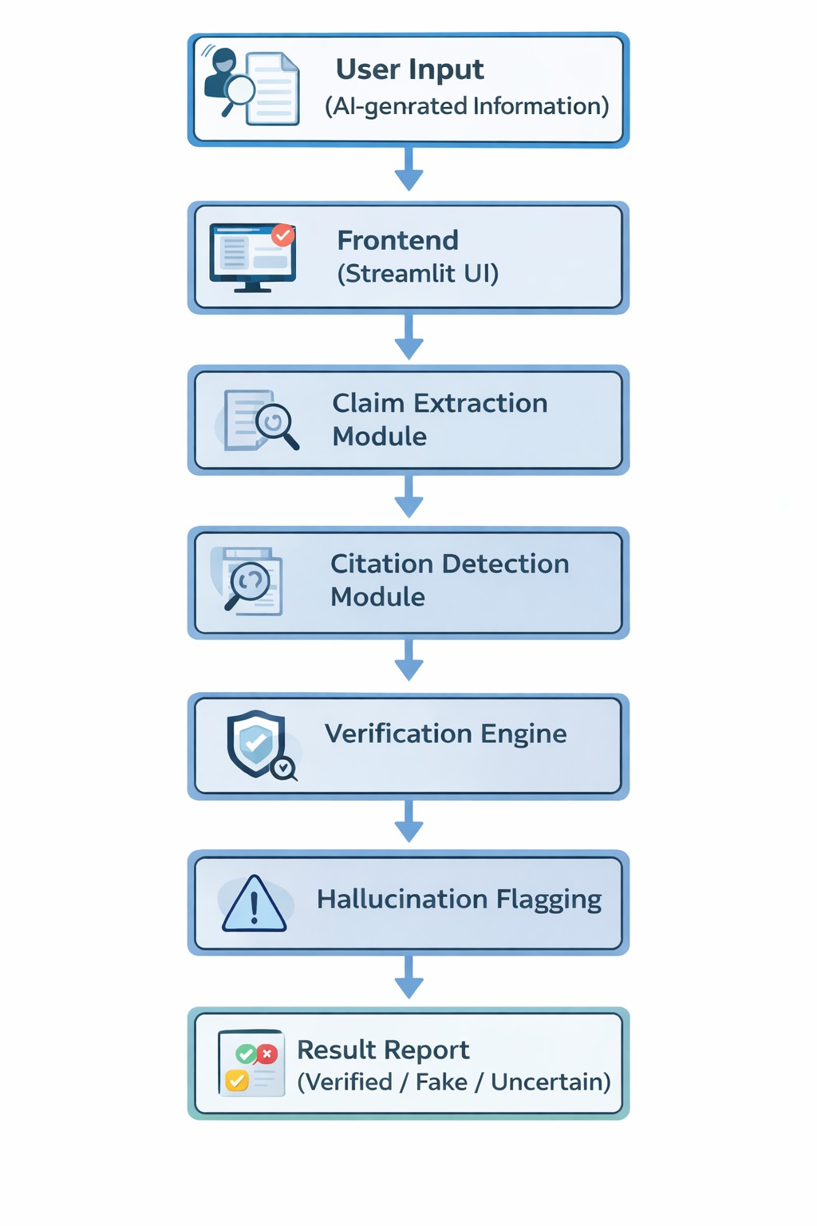
The following flowchart represents the end-to-end working of the proposed system.

Clear Scope Definition
- The system will verify AI generated information.
- Verification will be done using public trusted sources.
- The solution focuses on detection and flagging, not correction.
- Designed as a prototype, not a full-scale product.

Solution Structure
- Input Layer – accepts AI-generated content
- Extraction Layer – identifies claims and citations
- Verification Layer – checks factual correctness
- Citation Layer – validates references
- Scoring Layer – assigns reliability scores
- Output Layer – displays verified results

Real-World Utilisation
- Education & Academia – verify assignments and detect fake citations
- Research & Journalism – fact-check AI-assisted content
- Enterprises & Legal – reduce compliance and reputational risks
- AI Platforms – improve chatbot reliability and user trust

