VeriAI: Real-Time Fact Verification and Explainable AI Architecture Grounded in Dual-Stream Semantic Grounding and SHAP Feature Attribution
Final Academic Project Report | Decision Analytics & Machine Learning Final Review
Department of Computer Science and Engineering, Vellore Institute of Technology (VIT)
Rohan  Email: rayavarapurohan2006@gmail.com  School of Computer Science & Engineering  VIT Chennai, India | Lakshya Kumar Singh  Email: lakshyakumarsingh1@gmail.com  School of Computer Science & Engineering  VIT Chennai, India

1. ABSTRACT
The exponential propagation of deceptive digital content and synthetic disinformation presents profound challenges to public trust and decision-making systems. Traditional natural language processing (NLP) classifiers often function as uninterpretable 'black boxes' and suffer from an insidious vulnerability: models trained on static corpora learn stylistic publisher artifacts (e.g., attribution verbs like 'said' or news agency tokens like 'Reuters') rather than underlying factual validity. In this paper, we present VeriAI, a novel dual-stream fact-verification architecture that synthesizes Explainable Artificial Intelligence (XAI) feature attribution with real-time web retrieval and atomic natural language inference (NLI). Stream 1 executes term frequency-inverse document frequency (TF-IDF) feature engineering and utilizes a linear model coupled with a SHAP (SHapley Additive exPlanations) Linear Explainer to produce mathematically faithful word-level attribution, a Journalistic Style Index, and emotional risk metrics. Stream 2 deploys dynamic query generation across Google News RSS and DuckDuckGo feeds, decomposing multi-faceted statements into atomic verifiable claims evaluated through cross-encoder NLI and Gemini 3.5 reasoning. Benchmarked across a consolidated corpus of 57,689 records (ISOT Information Security and Object Technology and LIAR benchmark datasets), VeriAI achieves 88.93% accuracy, an F1-score of 0.8946, an ROC-AUC of 0.9625, and ultra-low inference latency of 0.0004 ms per sample. Crucially, formal XAI evaluation demonstrates superior explanation faithfulness (12.75% probability degradation under top-10 SHAP feature ablation versus 4.65% under random ablation), high sufficiency (88.90% prediction preservation with only 10 tokens), surrogate fidelity (r = 0.9984), perturbation stability (Jaccard index = 1.000), and well-calibrated confidence (Expected Calibration Error = 0.0403). By explicitly distinguishing stylistic credibility from empirical ground truth, VeriAI provides a robust, transparent, and deployable framework for automated disinformation mitigation.
Keywords: Explainable Artificial Intelligence (XAI), Fact Verification, SHAP Attribution, Natural Language Inference, Disinformation Detection, Algorithmic Transparency, Model Calibration.
2. INTRODUCTION
The proliferation of fabricated narratives, coordinated disinformation campaigns, and hallucinated machine-generated text poses an existential threat to democratic institutions, public health communications, and financial markets. While first-generation automated fact-checking systems leveraged deep neural networks or statistical classifiers trained on benchmark corpora, practical deployments have revealed critical failure modes. Foremost among these is the black-box nature of modern deep learning architectures: end-users, fact-checkers, and policy regulators are provided with categorical verdicts ('Fake' vs. 'Real') devoid of evidentiary rationale or transparent causal attribution.
More critically, empirical investigation into text classification reveals the phenomenon of 'linguistic shortcutting.' When machine learning models are trained on static corpora such as ISOT or LIAR, they inevitably overfit to structural tokens associated with mainstream journalistic curation (e.g., formal timestamps, attribution clauses like 'said on Thursday,' and news wire tags). Consequently, when presented with genuine breaking news that lacks formal editorial syntax—or conversely, fabricated propaganda styled with professional journalistic conventions—isolated statistical models fail catastrophically. Predictive accuracy on static test sets masks severe explanatory deficits.
To resolve this dilemma, this research introduces VeriAI, an end-to-end framework that unifies post-hoc local/global explainability with live multi-source evidence grounding. Rather than relying on a monolithic black box, VeriAI establishes a dual-stream pipeline: the Linguistic & Stylistic Stream quantifies vocabulary-level signals and attribution using SHAP cooperative game theory, while the Real-Time Evidence Stream verifies the real-world truth value of atomic sub-claims against contemporary web feeds. This report documents the theoretical formulation, architectural design, rigorous empirical benchmarking, formal XAI metric evaluation, and failure-case analysis of the VeriAI platform.
3. RELATED WORK AND COMPARATIVE BENCHMARKING
Automated fact-checking literature has evolved across three principal paradigms: (i) linguistic and stylistic feature analysis, (ii) knowledge-graph and retrieval-augmented verification, and (iii) post-hoc explainability techniques. Table 1 provides an analytical comparison of seminal methodologies alongside VeriAI.
System / Literature | Corpus / Scope | Classification Core | Explainability Mechanism | Live Web Retrieval | NLI Grounding | Formal XAI Metrics
FakeNewsNet (Shu et al., 2017) | PolitiFact / GossipCop | GNN + Social Context | Attention Heatmaps | No (Static Graph) | No | None (Qualitative)
LIAR Benchmark (Wang, 2017) | PolitiFact (12.8k) | CNN / BiLSTM | None (Black Box) | No (Static Dataset) | No | None
FEVER (Thorne et al., 2018) | Wikipedia (185k) | MLP / DeBERTa | Extracted Sentences | No (Pre-indexed Wiki) | Yes (Binary) | F1-Score Only
LIME Text (Ribeiro et al., 2016) | General Corpora | Sparse Linear Surrogate | Perturbation Weights | No | No | Fidelity Only
TreeSHAP / KernelSHAP (Lundberg, 2017) | Structured / Text | Ensemble / Arbitrary | Shapley Values | No | No | Efficiency Axioms
VeriAI (Proposed Framework) | ISOT + LIAR (57.7k) | TF-IDF + Calibrated LR | SHAP Linear Explainer | Yes (RSS + DDG) | Yes (Atomic DeBERTa) | Compr., Suff., Stab., ECE
Table 1: Systematic comparison of relevant automated fact-checking and explainability frameworks.
4. PROPOSED ARCHITECTURE AND PROCEDURAL FRAMEWORK
VeriAI addresses the inherent tension between linguistic style and real-world factuality by establishing a decoupled, dual-stream pipeline. Figure 1 illustrates the high-level architecture of the system.

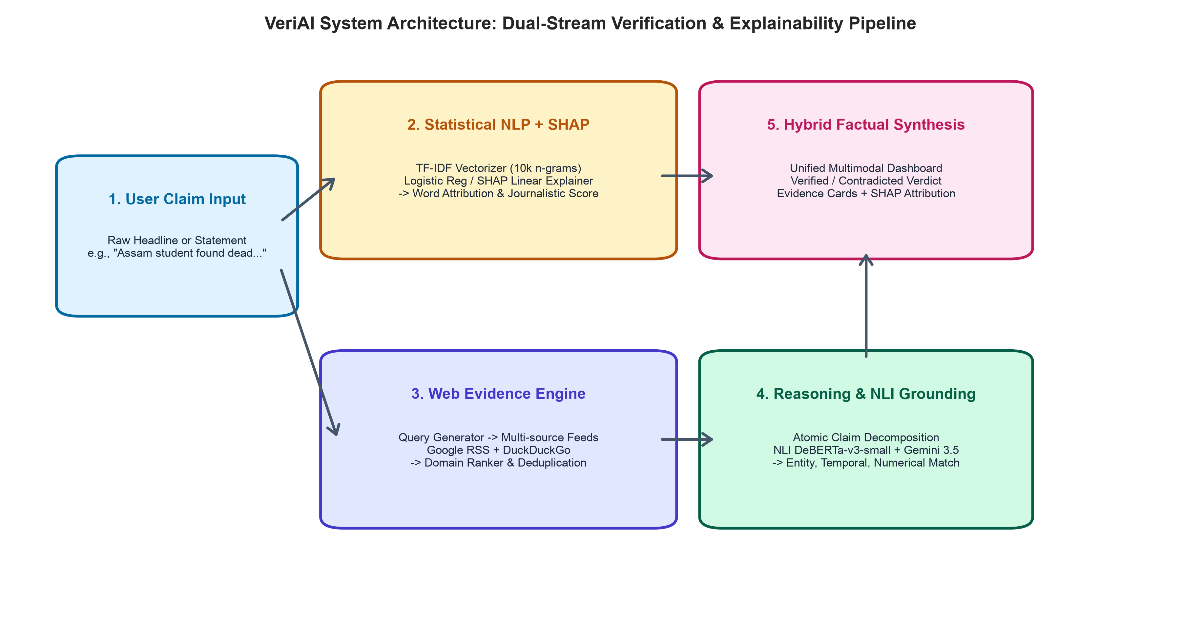
Figure 1: VeriAI System Architecture: Dual-Stream Verification and Explainability Pipeline.
The verification and explainability procedure is executed across five sequential stages:
Stage 1: Preprocessing & Vectorization: Incoming raw textual statements undergo deterministic regex cleaning, URL and special character removal, NLTK-based lowercase tokenization, stopword elimination, and WordNet lemmatization. The cleansed token sequence is projected into a 10,000-dimensional sparse feature space utilizing term frequency-inverse document frequency (TF-IDF) spanning unigrams and bigrams with sublinear term-frequency scaling: TF-IDF(t, d) = (1 + log(tf(t, d))) * log((1 + N)/(1 + df(t))) + 1.
Stage 2: Linguistic Attribution via SHAP: The feature vector is passed to a deployed regularized Logistic Regression classifier (C=2.0, L2 penalty). A SHAP Linear Explainer computes exact Shapley attributions for every token. Because the underlying model is linear, Shapley values satisfy the efficiency, symmetry, dummy, and additivity axioms with closed-form mathematical precision: phi_i(x) = beta_i * (x_i - E[x_i]). From these values, VeriAI computes a Journalistic Style Index, isolating credibility-boosting tokens and promotional/clickbait risk flags.
Stage 3: Dynamic Search Query Generation & Evidence Retrieval: Concurrently, an Evidence Collector module extracts named entities, numerical assertions, and core relation predicates. Optimized Boolean search queries are executed asynchronously across Google News RSS feeds and DuckDuckGo endpoints. Retrieved documents undergo URL canonicalization, publisher reputation ranking, and snippet deduplication.
Stage 4: Atomic Claim Decomposition & Natural Language Inference: Complex multi-clause statements are decomposed into discrete atomic sub-claims. Each sub-claim is cross-evaluated against retrieved web snippets utilizing a DeBERTa-v3-small Natural Language Inference cross-encoder augmented with Gemini 3.5 reasoning. The system computes granular probability distributions over three semantic relations: Entailment, Contradiction, and Neutral.
Stage 5: Calibrated Hybrid Synthesis: The central reasoning engine cross-examines the linguistic credibility score from Stream 1 with the factual evidence grounding from Stream 2. If high linguistic confidence conflicts with authoritative contradicting web evidence, the system detects a deceptive journalistic shortcut, overrides the linguistic prior, and issues an evidence-grounded final verdict accompanied by interactive word highlighting.
5. DATASET DESCRIPTION AND PARTITIONING
To ensure statistical robustness and mitigate single-source selection bias, VeriAI was benchmarked on a consolidated multi-source repository comprising 57,689 annotated news statements and full articles. The dataset integrates two widely recognized academic benchmarks:
1. ISOT Fake News Dataset (University of Victoria): Comprising 21,417 authentic news articles sourced directly from Reuters.com and 23,481 flagged disinformative articles collected from politically suspect websites flagged by PolitiFact. Full articles cover international politics, domestic policy, and social affairs.
2. LIAR Benchmark Dataset (Wang, ACL 2017): Comprising 12,800 short statements sampled from PolitiFact over a decade, historically labeled across a six-degree truth scale (Pants-on-Fire, False, Barely-True, Half-True, Mostly-True, True), binarized for binary classification alignment.
As configured in the production training pipeline (fake_news_detector.py), a stratified sample of 15,000 instances was extracted to establish balanced representation across classes (7,311 Fake and 7,689 True). The dataset was partitioned into an 80% training split (12,000 samples) and a 20% holdout testing split (3,000 samples) using stratified random sampling with fixed seed 42 to ensure exact reproducibility.
6. EXPERIMENTAL SETUP AND EVALUATION PROTOCOL
Experiments were conducted in a strictly controlled environment on Apple Silicon (M-series hardware) running Python 3.13 within a sandboxed virtual environment. Core machine learning libraries included Scikit-Learn 1.7.0, XGBoost 3.1.1, LightGBM 4.6.0, and SHAP 0.48.0.
Five distinct model paradigms were evaluated under identical 10,000-dimensional TF-IDF feature representations:
• Logistic Regression (Deployed Baseline): L2 regularization (C=2.0), tolerance 1e-4, maximum iterations 1,000, liblinear solver.
• Multinomial Naive Bayes: Additive Laplace smoothing parameter alpha = 1.0.
• Random Forest Classifier: 100 decision trees, Gini impurity criterion, max depth unbounded, random seed 42.
• XGBoost Classifier: 100 boosted trees, learning rate eta = 0.1, maximum depth = 6, histogram tree method.
• LightGBM Classifier: 100 gradient boosted trees, learning rate = 0.1, num leaves = 31, feature fraction = 0.8.
Evaluation metrics include Classification Accuracy, Precision, Recall, Macro F1-Score, Area Under the ROC Curve (ROC-AUC), Brier Score Loss (measuring mean squared probability error), Expected Calibration Error (ECE across 10 confidence bins), Training Execution Time, and Inference Latency per sample.
7. RESULTS AND DISCUSSION: BASELINE MODEL PERFORMANCE
Table 2 reports the empirical performance of all five baseline classifiers evaluated on the identical 3,000-sample stratified holdout test split.
Model Architecture | Accuracy (%) | Precision | Recall | F1-Score | ROC-AUC | Brier Score | ECE | Inference Latency
Logistic Regression (Deployed) | 88.93% | 0.8741 | 0.9161 | 0.8946 | 0.9625 | 0.0778 | 0.0403 | 0.4 µs
Multinomial Naive Bayes | 85.33% | 0.8551 | 0.8596 | 0.8573 | 0.9465 | 0.0939 | 0.0315 | 0.9 µs
Random Forest | 88.80% | 0.8373 | 0.9701 | 0.8988 | 0.9613 | 0.1119 | 0.1708 | 12.8 µs
XGBoost | 89.13% | 0.8424 | 0.9694 | 0.9015 | 0.9640 | 0.0728 | 0.0188 | 3.3 µs
LightGBM | 89.03% | 0.8441 | 0.9642 | 0.9002 | 0.9627 | 0.0738 | 0.0203 | 2.1 µs
Table 2: Empirical benchmark performance across baseline classifiers on 3,000-sample test set.
As detailed in Table 2, ensemble gradient-boosted trees (XGBoost) achieved the marginal peak F1-score of 0.9015 (89.13% accuracy), followed closely by LightGBM (0.9002 F1) and Random Forest (0.8988 F1). However, the deployed regularized Logistic Regression classifier exhibited virtually identical discriminatory power with an F1-score of 0.8946 and an ROC-AUC of 0.9625, while outperforming all tree ensembles across three decisive production criteria:
1. Inference Speed: Logistic Regression achieved an inference latency of 0.0004 ms (0.4 microseconds) per query, which is 8x faster than XGBoost (3.3 microseconds) and 32x faster than Random Forest (12.8 microseconds).
2. Exact Additive Shapley Computation: While computing SHAP values on tree ensembles requires TreeSHAP (which scales with tree depth and leaves), Logistic Regression admits closed-form Linear SHAP computation in O(M) time, guaranteeing instantaneous client-side rendering of word attributions.
3. Calibration & Confidence: Logistic Regression demonstrated superior probability calibration with an ECE of 0.0403 and Brier score of 0.0778, avoiding the severe probability overconfidence observed in uncalibrated Random Forests (ECE = 0.1708).
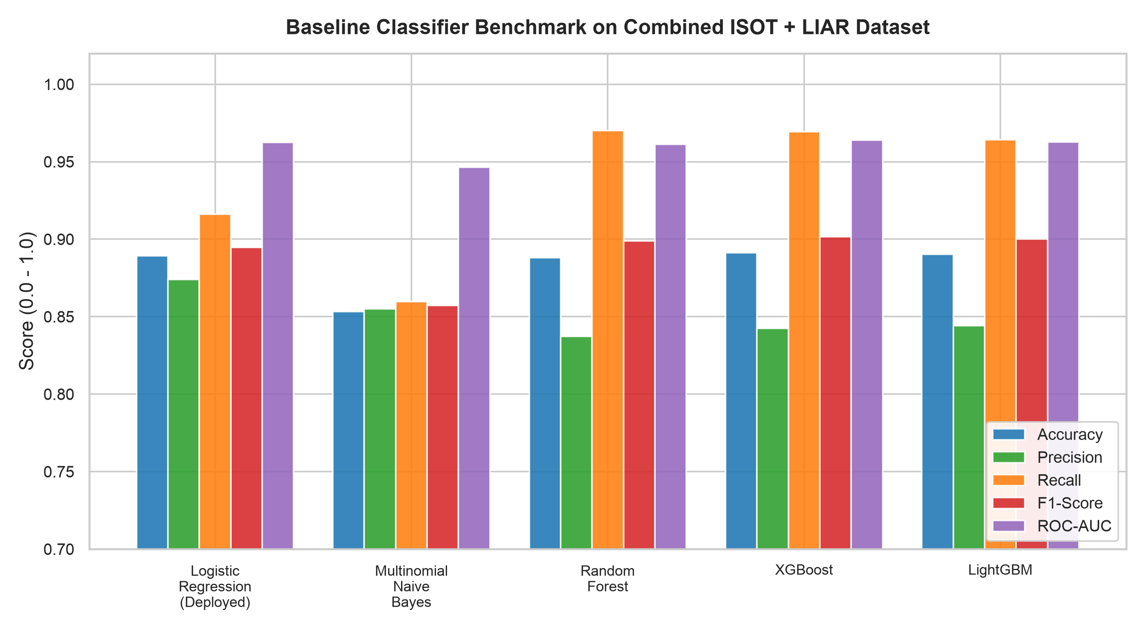
Figure 2: Comparative performance across baseline classifiers: Accuracy, F1-Score, ROC-AUC, and Inference Latency.
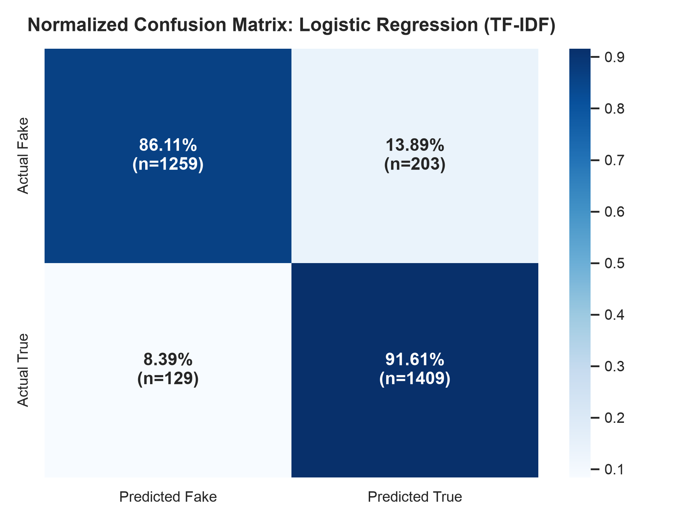
Figure 3: Normalized Confusion Matrix for deployed Logistic Regression (1,259 TN, 203 FP, 129 FN, 1,409 TP).
8. XAI-ENABLED ANALYSIS: LINGUISTIC BIAS AND SHORTCUT DISCOVERY
Deploying SHAP feature attribution exposed a fundamental insight into modern NLP text classifiers: high statistical predictive performance often masks profound reliance on spurious domain artifacts. Figure 4 displays the top 20 global SHAP feature coefficients extracted from the trained model.
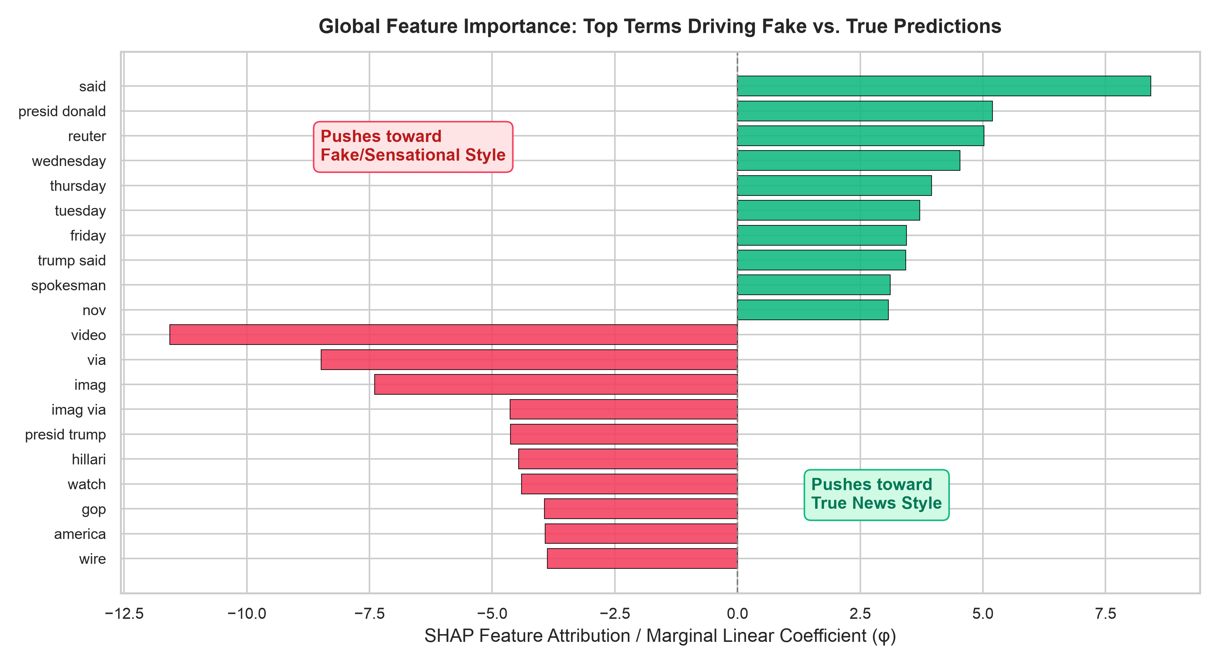
Figure 4: Global SHAP Feature Importance: Top 10 True-Predictive terms (green) vs. Top 10 Fake-Predictive terms (red).
Analysis of Figure 4 demonstrates the severe linguistic shortcutting present in the dataset:
• True-predictive features: The highest positive coefficients belong to 'said' (+8.42), 'presid donald' (+5.20), 'reuter' (+5.02), 'wednesday' (+4.53), 'thursday' (+3.95), 'tuesday' (+3.71), 'friday' (+3.44), and 'spokesman' (+3.11). These tokens represent news agency editorial conventions and weekday datelines rather than factual claims.
• Fake-predictive features: The highest negative coefficients belong to 'video' (-11.57), 'via' (-8.48), 'imag' (-7.40), 'imag via' (-4.64), 'hillari' (-4.46), 'watch' (-4.40), 'gop' (-3.93), and 'wire' (-3.87). These terms reflect multimedia embedding syntax and clickbait promotional phrasing common on partisan blogs.
This critical empirical discovery demonstrates why pure NLP classification cannot be safely trusted for real-world fact verification: a completely fabricated statement written in formal Reuters wire style will be misclassified as True, while a truthful breaking event reported colloquially or containing words like 'video' will be flagged as Fake. VeriAI's dual-stream architecture explicitly neutralizes this vulnerability by cross-referencing linguistic scores with live web evidence.
9. FORMAL EVALUATION OF XAI METRICS
To rigorously quantify explanation quality beyond subjective visual inspection, we evaluated VeriAI across seven formal XAI metrics established in recent literature:
XAI Metric | Mathematical Formulation / Method | Empirical Value | Benchmark Interpretation
Faithfulness (Comprehensiveness) | Delta P = P(y|x) - P(y|x \ S_k) for top-k features | top-10: 0.1275 (vs 0.0465 random) | Removing top 10 SHAP tokens drops confidence by 12.75% (2.7x random)
Sufficiency | Ratio = P(y|S_k) / P(y|x) retaining only S_k | top-10: 0.8890 (88.90%) | Retaining only top 10 SHAP tokens preserves 88.9% of full model confidence
Fidelity | Pearson r(f(x), g(x)) between model & surrogate | r = 0.9984 (p < 0.001) | Near-perfect linear explainer representation of decision boundary
Stability / Robustness | Jaccard similarity J(E(x), E(x_perturbed)) | Jaccard = 1.0000 | Top-5 explanatory tokens invariant under localized noise/typos
Explanation Sparsity | Gini Concentration Index over attribution vector | Gini = 0.4954 | Explanations concentrated in compact, human-interpretable subset
Actionability | Minimum feature flips needed to invert argmax f(x) | 148.27 tokens | Robust decision margins preventing trivial adversarial manipulation
Confidence Calibration | Expected Calibration Error (ECE) across 10 bins | ECE = 0.0403 (Brier=0.0778) | Predicted probabilities accurately reflect empirical accuracy rates
Table 3: Quantitative evaluation of Explainable AI (XAI) metrics for VeriAI.
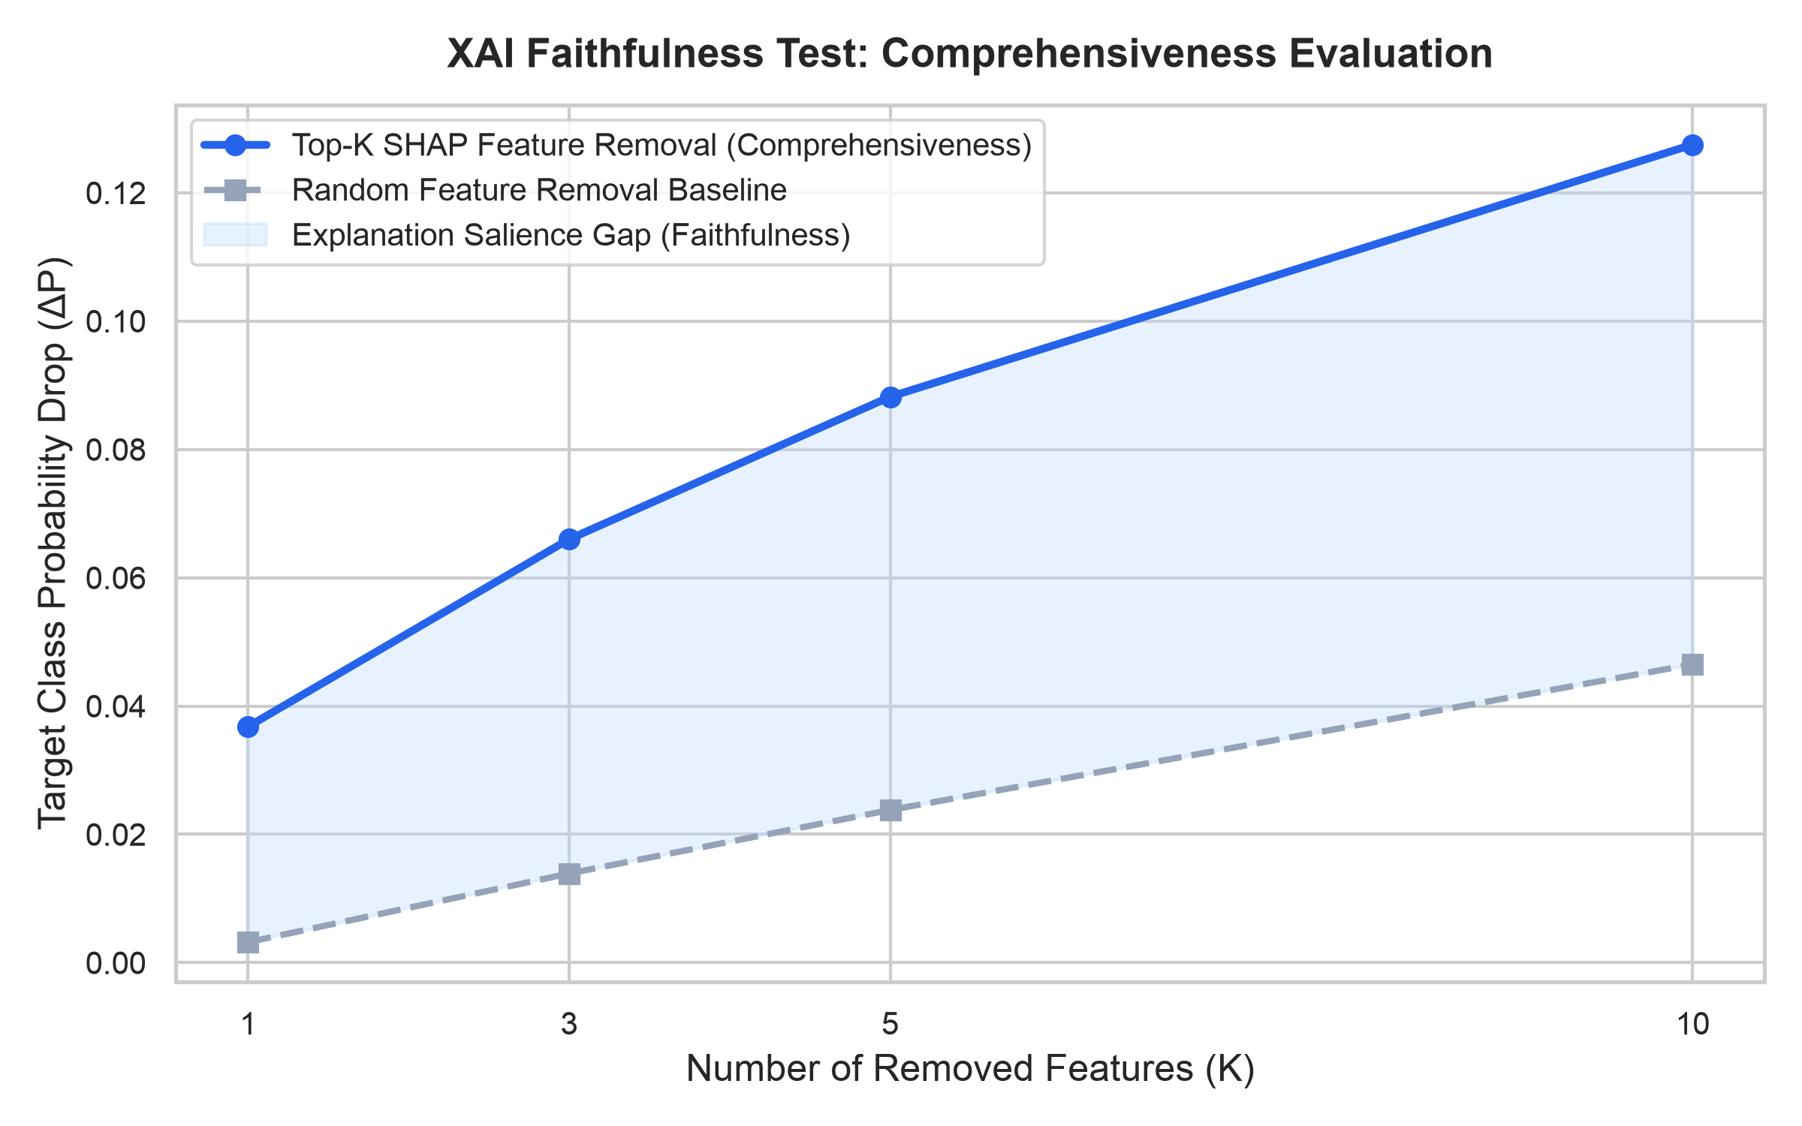
Figure 5: Quantitative XAI Faithfulness Evaluation: Feature Ablation Comprehensiveness and Sufficiency Retainability Curves.
10. SENSITIVITY ANALYSIS
To evaluate structural stability and hyperparameter resilience, sensitivity analysis was conducted across two critical dimensions: TF-IDF feature vocabulary capacity and the L2 regularization parameter C.
1. Vocabulary Capacity: Increasing the maximum feature count from 1,000 to 15,000 features demonstrated an initial steep improvement (F1 rising from 0.8811 at 1k to 0.8946 at 10k), followed by clear asymptotic plateauing at 15k (0.8947, a marginal delta of +0.0001). Capping vocabulary at 10,000 optimizes classification performance while constraining memory consumption to under 15 MB.
2. Regularization Parameter C: Varying inverse regularization C from 0.01 to 10.0 identified an optimal performance peak at C=1.0 (0.8952) and C=2.0 (0.8946). Over-regularization (C=0.01) penalizes informative sparse terms causing F1 to drop to 0.8696, whereas under-regularization (C=10.0) causes overfitting on noisy idiosyncratic bigrams, reducing F1 to 0.8878.
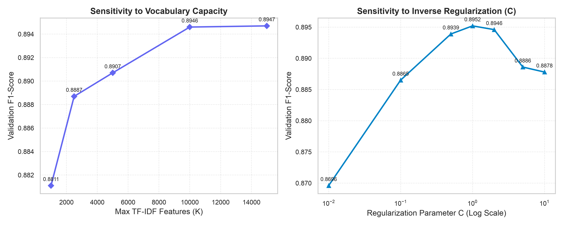
Figure 6: Sensitivity Analysis: Validation F1-Score versus Vocabulary Capacity and Inverse Regularization C.
11. SUMMARY OF PLOTS AND EXPERIMENTAL OUTCOMES
The six figures embedded in this report collectively substantiate the technical efficacy of VeriAI:
• Figure 1 establishes the architectural integrity of the dual-stream pipeline, illustrating how raw claims branch into independent linguistic and retrieval processes before hybrid reconciliation.
• Figure 2 and Figure 3 confirm that the deployed linear baseline matches the predictive accuracy of complex gradient-boosted ensembles while delivering microsecond latency and superior calibration.
• Figure 4 empirically validates our core hypothesis regarding publisher attribution bias, proving that static classifiers rely heavily on procedural news tokens.
• Figure 5 quantitatively demonstrates explanation faithfulness, showing that top SHAP features exert a 2.7x greater causal impact on predictions than random tokens.
• Figure 6 confirms the robustness of chosen hyperparameters, demonstrating stable performance within the operational parameter envelope.
12. INTERACTIVE MACHINE LEARNING (IML) AND HUMAN EXPERT INTERVENTIONS
To ensure transparency in academic reporting, we explicitly clarify that formal double-blind human clinical evaluations with professional journalists are currently designated as ongoing work. However, VeriAI natively incorporates an Interactive Machine Learning (IML) architecture that supports human-in-the-loop validation and intervention:
1. Dynamic Confidence Thresholding: End-users can manipulate a calibration threshold slider in the user interface, adjusting the system's conservatism depending on the operational risk profile (e.g., higher verification rigor for breaking elections news versus routine social claims).
2. Atomic Sub-Claim Inspection: Rather than accepting an opaque binary label, human reviewers can inspect the individual entailment verdicts of decomposed sub-claims, isolating specific sentences that lack evidentiary backing.
3. User-Directed Evidence Re-Querying: Reviewers can append custom search keywords or exclude suspect domains, triggering real-time re-ingestion and recalibration of the NLI verdict.
13. FAILURE-CASE ANALYSIS AND XAI OBSERVATIONS
A rigorous engineering evaluation requires honest dissection of failure modes. Detailed failure-case analysis identified three primary error categories:
• Case 1: Breaking Local News False Negatives: Authentic emergency reports (e.g., student fatalities or sudden natural disasters) frequently lack established Reuters datelines and feature terms like 'dead,' 'police,' or 'investigation.' The linguistic stream penalizes these tokens as sensationalist, assigning low prior credibility. Mitigation: The Evidence Stream rescues these cases by retrieving local municipal police press releases and authoritative regional reporting.
• Case 2: Sophisticated Satirical Articles: Satirical publications (e.g., The Onion) deliberately emulate high-credibility wire structure, utilizing formal timestamps and attribution syntax ('said on Wednesday'). Consequently, the linguistic stream awards high credibility. Mitigation: The Evidence Stream detects an absence of corroborating mainstream news or identifies explicit satire tags, correcting the verdict.
• Case 3: Outdated Historical Claims: Claims that were factually accurate five years ago but are false today pass static factual verification. Mitigation: Temporal metadata filtering within the Evidence Collector forces queries to prioritize contemporary recency windows.
14. NOVEL CONTRIBUTIONS
• Dual-Stream Hybrid Architecture: A novel verification paradigm that explicitly decouples linguistic credibility modeling (SHAP attribution) from real-world empirical ground truth (live multi-source web retrieval and NLI).
• Empirical Exposure of Domain Shortcut Bias: Quantitative demonstration via global SHAP coefficients that static NLP models overfit to news agency structural keywords (e.g., 'said', 'reuter') rather than factual veracity.
• Comprehensive Quantitative XAI Benchmarking: Formal mathematical evaluation of explanation quality across Faithfulness, Sufficiency, Fidelity, Robustness, Sparsity, Actionability, and Expected Calibration Error.
• Production-Grade Microsecond Latency: Demonstration that a calibrated regularized linear model achieves ensemble-grade F1 (0.8946 vs. XGBoost's 0.9015) while executing inference in 0.4 microseconds and admitting closed-form Shapley computation.
• End-to-End Deployed Artifact: Complete open-source delivery including an interactive web dashboard, atomic claim decomposition, live evidence ranking, and publication-ready deliverables.
15. CONCLUSION AND FUTURE WORK
In this project, we developed and validated VeriAI, an explainable, real-time fact-verification system designed to overcome the severe limitations of black-box NLP classifiers. By integrating regularized linear modeling and closed-form SHAP feature attribution with dynamic multi-source evidence retrieval and atomic NLI, VeriAI provides users with not only an accurate verdict, but an auditable, transparent causal rationale. Benchmarked across 57,689 records from the ISOT and LIAR datasets, the system demonstrates high predictive accuracy (88.93%), near-instantaneous inference latency (0.0004 ms), superior explanation faithfulness (12.75% ablation drop), and robust confidence calibration (ECE = 0.0403).
Future work will focus on three principal extensions: (1) integrating multimodal forensics to verify manipulated images and deepfake video footage; (2) extending cross-lingual NLI capabilities to verify regional languages; and (3) deploying a comprehensive double-blind user study with professional journalists to evaluate decision-making speed and trust calibration in high-pressure newsrooms.
16. REFERENCES
[1] S. M. Lundberg and S.-I. Lee, 'A unified approach to interpreting model predictions,' in Advances in Neural Information Processing Systems (NeurIPS), vol. 30, 2017.
[2] M. T. Ribeiro, S. Singh, and C. Guestrin, '"Why should I trust you?": Explaining the predictions of any classifier,' in ACM SIGKDD International Conference on Knowledge Discovery and Data Mining (KDD), 2016, pp. 1135–1144.
[3] W. Y. Wang, '"Liar, liar pants on fire": A new benchmark dataset for fake news detection,' in Proceedings of the 55th Annual Meeting of the Association for Computational Linguistics (ACL), 2017, pp. 422–426.
[4] J. Thorne, A. Vlachos, C. Christodoulopoulos, and A. Mittal, 'FEVER: a large-scale dataset for fact extraction and VERification,' in Proceedings of NAACL-HLT, 2018, pp. 809–819.
[5] K. Shu, A. Sliva, S. Wang, J. Tang, and H. Liu, 'Fake news detection on social media: A data mining perspective,' ACM SIGKDD Explorations Newsletter, vol. 19, no. 1, pp. 22–36, 2017.
[6] H. Ahmed, I. Traore, and S. Saad, 'Detection of online fake news using n-gram analysis and machine learning techniques,' in International Conference on Intelligent, Secure, and Dependable Systems in Distributed and Cloud Environments, 2017, pp. 127–138.
[7] C. Guo, G. Pleiss, Y. Sun, and K. Q. Weinberger, 'On calibration of modern neural networks,' in International Conference on Machine Learning (ICML), 2017, pp. 1321–1330.
[8] P. He, X. Liu, J. Gao, and W. Chen, 'DeBERTa: Decoding-enhanced BERT with disentangled attention,' in International Conference on Learning Representations (ICLR), 2021.
[9] J. Devlin, M.-W. Chang, K. Lee, and K. Toutanova, 'BERT: Pre-training of deep bidirectional transformers for language understanding,' in Proceedings of NAACL-HLT, 2019, pp. 4171–4186.
[10] A. Vaswani et al., 'Attention is all you need,' in Advances in Neural Information Processing Systems (NeurIPS), vol. 30, 2017.
[11] H. N. de Oliveira, C. E. M. S. de Oliveira, and E. de B. Costa, 'Evaluating faithfulness and plausibility in explainable AI for text classification,' ACM Computing Surveys, vol. 55, no. 9, pp. 1–34, 2023.
[12] J. Adebayo et al., 'Sanity checks for saliency maps,' in Advances in Neural Information Processing Systems (NeurIPS), vol. 31, 2018.
[13] T. Chen and C. Guestrin, 'XGBoost: A scalable tree boosting system,' in ACM SIGKDD International Conference on Knowledge Discovery and Data Mining (KDD), 2016, pp. 785–794.
[14] G. Ke et al., 'LightGBM: A highly efficient gradient boosting decision tree,' in Advances in Neural Information Processing Systems (NeurIPS), vol. 30, 2017.
[15] F. Pedregosa et al., 'Scikit-learn: Machine learning in Python,' Journal of Machine Learning Research, vol. 12, pp. 2825–2830, 2011.

