STANDARD OPERATING PROCEDURE

Petrios Platform SOP
  - Role-based operating guide
Sessions, attendance, feedback, Recall and reporting

A practical guide to running a teaching programme in Petrios, from creating the first draft session to governed attendance, recognition and service oversight.
Version 1.0 • 21 August 2026
For organization administrators, department moderators, faculty and trainees

Document control
Control | Value
SOP identifier | PET-OPS-001
Version / status | 1.0 / Operational guide
Owner | Akanimoh Osutuk
Primary audience | Organization administrators and department moderators
Secondary audience | Faculty, trainees and support staff
Effective date | 1 August 2026
Review trigger | Material UI or workflow change, or at least annually
Classification | Internal operational guidance
Screenshots show the interface available on 21 August 2026. Example form values were entered only to illustrate the workflow and were not submitted.

How to use this SOP
Use the numbered procedures when performing a task. The notes explain why Petrios behaves as it does; the warnings identify actions that can affect records, recipients or privacy. Interface labels may move over time, so follow the workflow outcome as well as the exact button position.
PRIMARY AUDIENCE This is a moderator-first guide. Sections 15 and 16 provide shorter pathways for faculty, trainees and external teachers.

Contents
- 1. Platform model, roles and navigation
- 2. Work from the moderator dashboard
- 3. Create a session
- 4. Manage, edit and publish a session
- 5. Assign registered and external teachers
- 6. Upload and manage session documents
- 7. Run check-in and govern attendance
- 8. Collect, review and release feedback
- 9. Create and approve an Audio Recap and Recall questions
- 10. Generate certificates
- 11. Publish teaching slots
- 12. Use Audit and Governance reporting
- 13. Review Petrios Ops drafts
- 14. Manage settings and onboarding
- 15. Faculty and external-teacher quick guide
- 16. Trainee quick guide
- 17. Troubleshooting and safe-operation rules
- 18. End-to-end checklists

1. Platform model, roles and navigation
Petrios runs the operational lifecycle around clinical teaching. A session is the anchor: it connects scheduling, teachers, private learning material, attendance evidence, feedback, Recall, certificates, communications and reporting inside one organization and department.
Stage | Operator action | What Petrios does
1. Plan | Create a session or publish open teaching slots. | Stores a draft session or claimable opportunities inside one department.
2. Prepare | Assign teachers and upload learning material. | Tracks invitation status and protects session files in private storage.
3. Publish | Publish the session when its details are ready. | Makes it visible to members and eligible for reminders, calendar and downstream workflows.
4. Deliver | Run the session; attendees check in and submit feedback. | Appends attendance evidence and stores identified feedback separately.
5. Govern | Review the complete roster and finalize attendance. | Creates an explicit, revisioned attendance result for every expected participant.
6. Recognize | Generate certificates and release reviewed teacher feedback. | Issues verifiable recognition only through the relevant eligibility and approval gates.
7. Improve | Review Audit, Recall and Ops outputs. | Supports reporting and catch-up learning without rewriting the original evidence trail.
KEY PRINCIPLE Attendance, feedback and teaching responsibility are separate records. Feedback does not prove attendance, accepting a teaching invitation does not prove physical presence, and certificates require the correct finalized governance state.

1.1 Roles
Role | What they normally do | Key boundary
Organization administrator | Manages the organization, departments, members and organization-wide settings. | Has broad organization authority; still works within the current organization.
Department moderator | Creates and publishes sessions, manages teachers, attendance, feedback, documents, Recall and certificates. | Authority is department-scoped unless another rule explicitly elevates it.
Faculty / registered teacher | Accepts assignments, teaches, accesses authorized session material and receives teaching recognition. | Faculty status alone does not grant moderator powers.
Trainee | Views published sessions, checks in, submits feedback, records reflections and accesses earned evidence. | Cannot manage sessions or finalize attendance.
External teacher | Accepts an email invitation or claims a published slot without requiring a Petrios account. | Acceptance establishes teaching responsibility, not physical attendance.

1.2 Main navigation
Area | Use it for
Dashboard | Calendar, sessions, open slots and the main create/manage actions.
Audit | Date-filtered session, certificate, member and equity reporting; PDF export.
Ops | Human review of AI-assisted email/newsletter drafts and the newsletter workspace.
Settings | Invite links, members, address book, contact groups, feedback form and certificate defaults.
Approvals bell | Pending Ops drafts that require an explicit approve or reject decision.
Notifications bell | In-app lifecycle notices such as teacher responses and attendance changes.

2. Work from the moderator dashboard
The dashboard is the moderator's starting point. It combines the teaching calendar with direct links to create sessions, publish teaching opportunities and manage the department's session list.
- Open Dashboard. Confirm the department name and that your role is shown as Moderator.
- Review the calendar. Use the view and date controls to inspect published sessions, drafts and available teaching slots.
- Choose the next action. Select Create Session for a confirmed event, Schedule Slots when teachers should claim availability, or Manage Sessions to work on existing records.
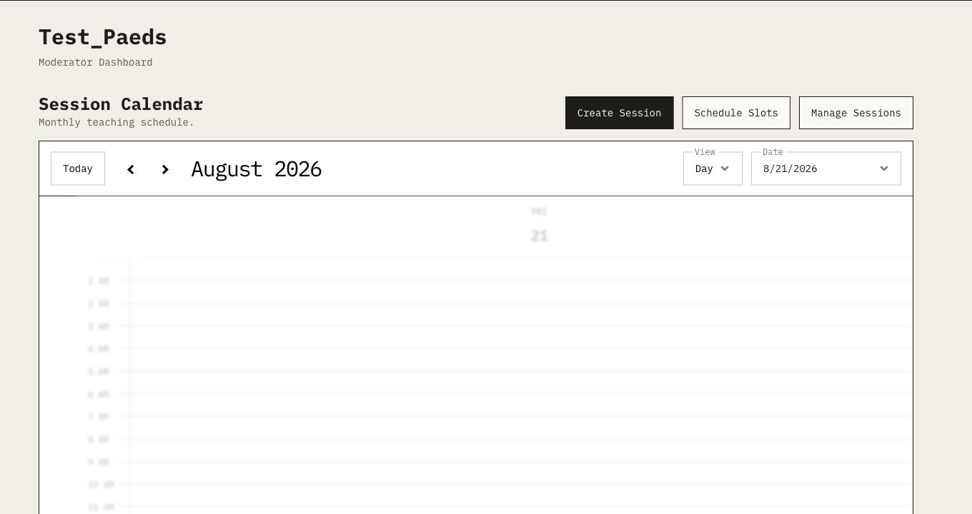
Figure 1. The moderator dashboard is the operational home for sessions and open teaching slots.
STATUS CUES Published, draft/cancelled and available-slot entries use different calendar cues. A draft is not visible to ordinary department members and is not ready for reminders or downstream reporting.

3. Create a session
WHO CAN DO THIS A department moderator may create a session for a department they manage. New interactive sessions are created as independent draft records.

3.1 Open the form
- Start on Dashboard. Select Create Session. The same action is available from the department sessions list.
- Confirm the form. Check that the page title is Create Session and that the fields shown in Figure 2 are available.
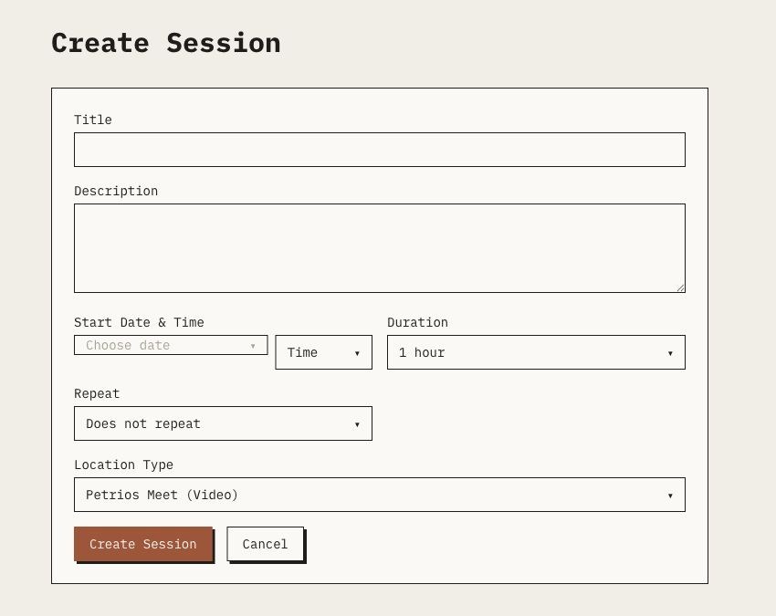
Figure 2. The blank Create Session form. Required scheduling controls are grouped below the description.

3.2 Complete the scheduling details
- Enter a clear title. Use a title that members and external teachers will recognize in calendars, reminders and reports.
- Add a useful description. State the topic, intended audience, preparation and any joining instructions that are safe to share with authorized session users.
- Choose the start date. Open the date picker and select the intended local calendar date.
- Choose the start time. Interactive choices run in 15-minute steps from 08:00 to 17:30.
- Choose the duration. Select 30 to 240 minutes in 30-minute steps, or Full day (08:00–17:30).
- Choose repetition. Use no repeat, weekly, every two weeks or monthly. Interactive creation can create up to 52 draft sessions.
- Choose the location. Use Petrios Meet, MS Teams, Hybrid or In person. Teams and Hybrid require a valid HTTPS meeting URL when prompted.
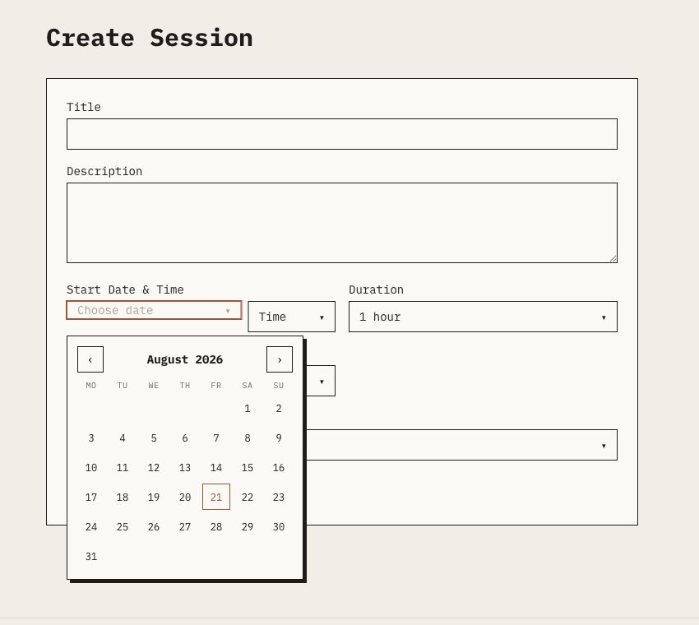
Figure 3. The date picker keeps local wall-clock scheduling visible to the moderator.
REPEATING SESSIONS Repeated creation produces ordinary, independent draft sessions. There is no stored series rule or one-click update/cancel for the whole series; manage each generated session separately.

3.3 Create the draft
- Review every field. Check title, date, time, duration, repeat pattern and location before continuing.
- Select Create Session. Petrios validates the dates and creates the session as a draft. Select Cancel to leave without creating a record.
- Open Manage Session. Add teachers, documents and any meeting details, then publish only when the session is ready for members.
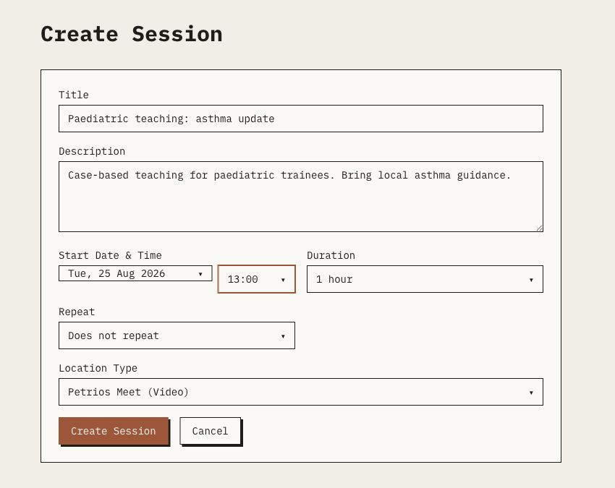
Figure 4. A completed example form immediately before Create Session. The example was not submitted.
DATE VALIDATION The session end must be later than the start. A session that has already ended cannot be published.

4. Manage, edit and publish a session
Open the department's Manage Sessions list and select Manage beside the session. The management workspace keeps preparation, governance and recognition in separate tabs.
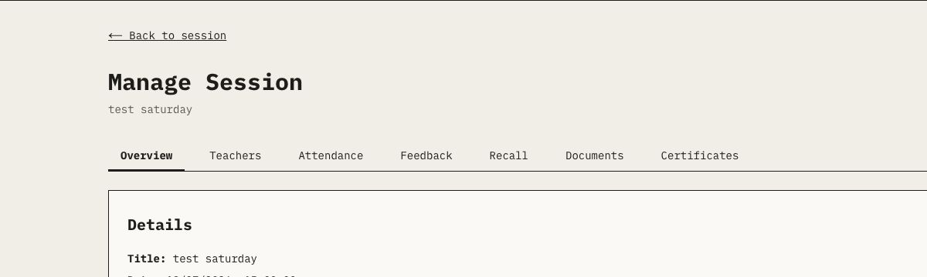
Figure 5. The Manage Session workspace. Use the tabs to keep each operational record in its correct subsystem.

4.1 Overview and lifecycle
- Review Details. Confirm title, date, duration, location, status and description.
- Edit when needed. Select Edit, make the change and save. Existing historical off-grid times or durations remain available so unrelated edits do not silently alter them.
- Check the meeting control. Petrios Meet uses a room derived from the session identifier. Teams and Hybrid use the stored HTTPS meeting URL.
- Publish. Publish only when the session is ready to be visible and eligible for reminders, feedback, calendars and downstream jobs.
- Use Unpublish or Cancel deliberately. Unpublishing returns a session to draft; cancelling changes its status. Previously sent messages or cached calendar entries are not automatically recalled.
DELETE VS CANCEL Delete is a hard lifecycle action and can cascade dependent data. Use Cancel when the record must remain for audit. A session with issued certificates cannot be deleted through the normal action.

5. Assign registered and external teachers
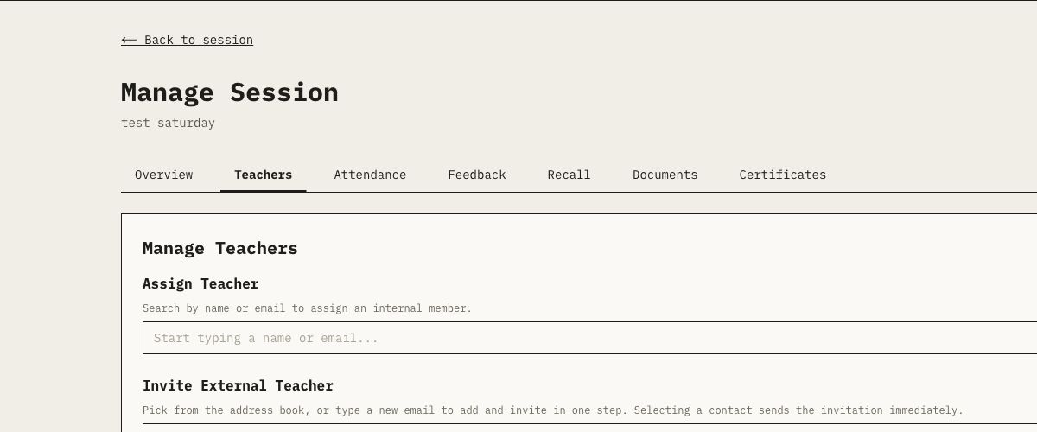
Figure 6. The Teachers tab provides separate paths for registered members and external invitees.

5.1 Registered teacher
- Open Teachers. In Manage Session, select the Teachers tab.
- Search the department. Under Assign Teacher, search by name or email.
- Select the member. Petrios creates a pending assignment. The member must accept or decline it.
- Monitor status. Use accepted assignments for teaching responsibility, teacher reports and teaching-certificate eligibility after attendance governance is finalized.

5.2 External teacher
- Search the address book. Choose a known external contact, or enter a new email and optional names.
- Send the invitation. Selecting the contact creates a durable invitation and immediately attempts the core invitation email.
- Confirm the outcome. The invitation may exist even if the provider reports an email failure. Use the displayed status and support information rather than recreating it blindly.
- Wait for RSVP. The teacher accepts or declines from the capability link. An accepted external teacher does not become an internal member.
IMPORTANT Teacher acceptance proves teaching responsibility, not physical attendance. Do not mark attendance merely because an assignment or RSVP was accepted.

6. Upload and manage session documents
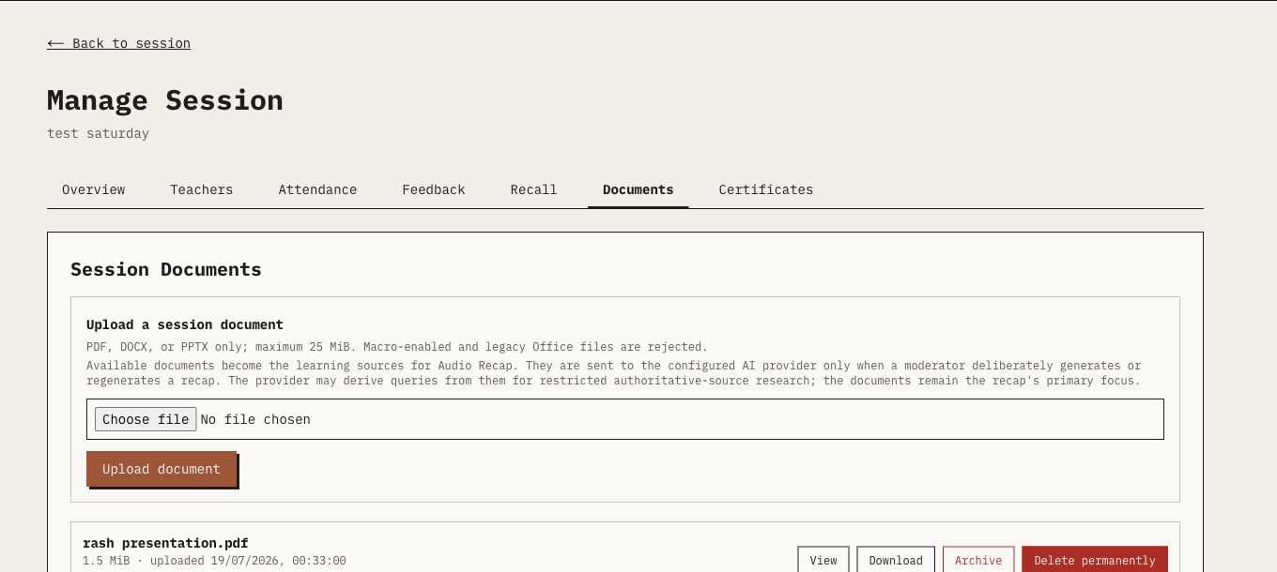
Figure 7. The Documents tab explains file limits and how uploaded material can become an Audio Recap source.
- Open Documents. Select the Documents tab from either the member session page or Manage Session.
- Choose a supported file. Upload PDF, DOCX or PPTX only, up to 25 MiB per file. Legacy and macro-enabled Office files are rejected.
- Check the content. Remove patient-identifiable, confidential or unnecessary special-category information before upload.
- Upload. Select Upload document and wait for the available state. Basic package validation is not antivirus or content-disarm scanning.
- Use the correct removal action. Archive hides the live download but retains the object. Delete permanently removes the live object and metadata and cannot be undone from the interface.
AI DISCLOSURE Available documents leave private storage only when a moderator deliberately generates or regenerates an Audio Recap or supported newsletter. The configured AI provider receives the file contents; hosted research may issue queries derived from that material.

7. Run check-in and govern attendance

7.1 Member check-in
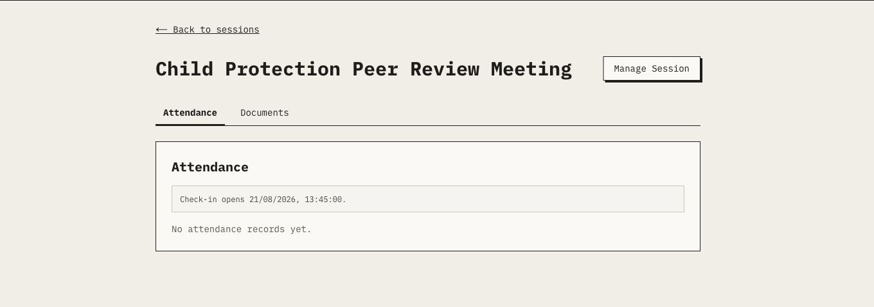
Figure 8. The member session view reports when check-in opens and keeps documents alongside attendance.
- Open the session. Members use the published session page and select Attendance.
- Check the window. By default check-in opens 15 minutes before the start and closes 45 minutes after the start; the session can override these values.
- Use the active method. If no secure group code is active, the member uses self check-in. When a moderator activates a group code, the member must enter that code instead.
- Confirm success. Joining a Petrios Meet room attempts self check-in, but meeting access is not proof that the attendance action succeeded.

7.2 Moderator review and finalization
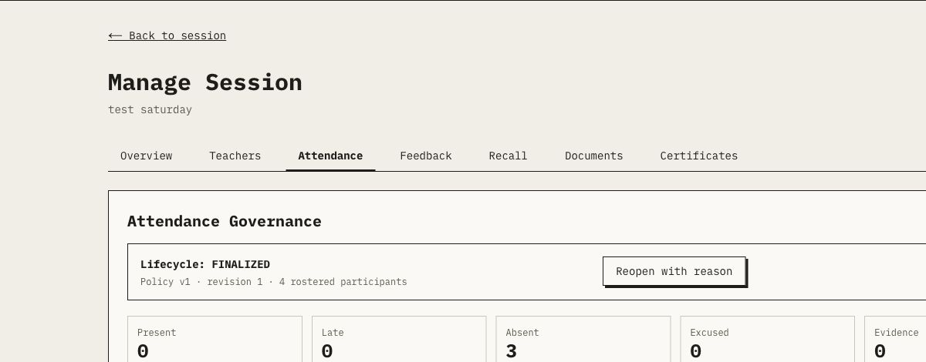
Figure 9. Finalized attendance displays the lifecycle, policy version, revision, roster count and result totals.
- Open Attendance after the session. The session must be published and ended before finalization.
- Review the complete roster. Check expected members, accepted teachers, evidence sources and provisional results. Missing evidence must not be treated as presence.
- Correct with a reason. Use the moderator marking control to append a PRESENT, LATE, ABSENT or EXCUSED decision with a meaningful reason.
- Finalize. Petrios creates the next attendance revision, locks the results and gives every expected subject an explicit outcome.
- Export when required. Use Export CSV for an authorized operational record. Treat the file as personal data.
- Reopen only for a genuine correction. Select Reopen with reason, append the correction and finalize again as a new revision.
REOPENING EFFECT Reopening immediately revokes current valid certificates for the session and clears the post-session report watermark. A replacement certificate can be issued only after the corrected revision is finalized and eligibility is re-established.
EVIDENCE RULE Attendance evidence is append-only. Never delete or rewrite an earlier observation to make a correction look like the original event.

8. Collect, review and release feedback
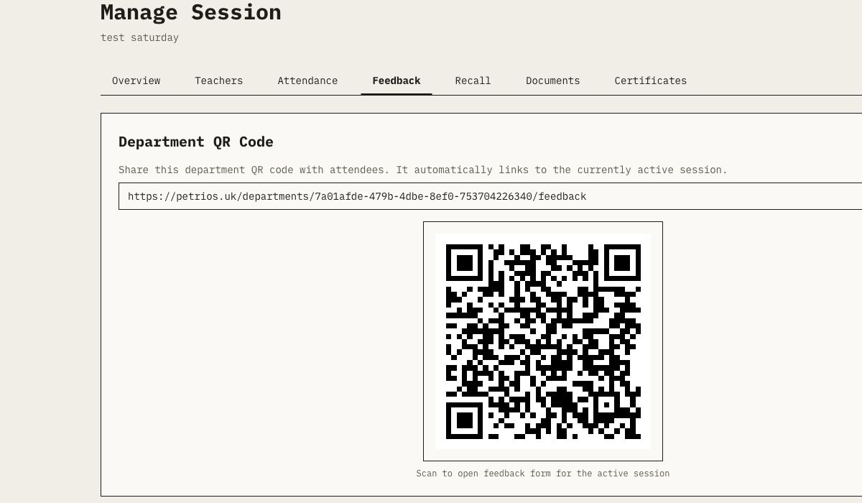
Figure 10. The department QR code automatically routes the user to the active published session's feedback form.

8.1 Collect feedback
- Open Feedback. In Manage Session, select Feedback and display the department QR code or copy its link.
- Share during the valid window. By default the form opens 15 minutes before the session and closes 120 minutes after it ends.
- Explain identification. The public form does not require an account, but it stores the respondent's first name, last name and email. Do not describe it as anonymous.
- Keep attendance separate. Submitting feedback never checks a person in and never creates a certificate.

8.2 Review and release teacher feedback
- Review aggregate analysis. Use score and question summaries as programme evidence. Treat cohorts below five as limited and directional.
- Inspect raw responses carefully. The moderator audit view is identified and may contain sensitive free text. Use least-privilege access.
- Generate an optional AI draft. Petrios omits identity fields and applies safety processing, but the output still requires human checking.
- Edit and approve. Remove unsupported or identifying wording and approve the exact reviewed narrative.
- Release to accepted teachers. The release action sends the frozen aggregate report to accepted teachers. A later click may deliberately resend the same approved snapshot.
EMAIL MEANING A provider receipt means the configured transport accepted the submission; it does not prove final inbox delivery, and Petrios does not currently ingest bounce or complaint status.

9. Create and approve an Audio Recap and Recall questions
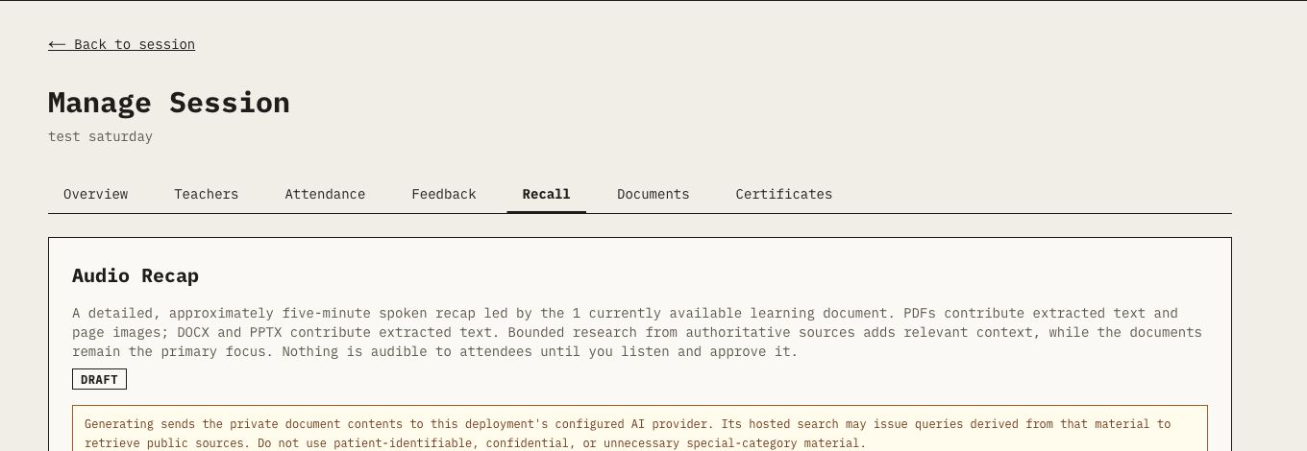
Figure 11. The Recall tab keeps the document-led Audio Recap draft behind a moderator review and approval gate.
- Prepare learning sources. Upload at least one current available PDF, DOCX or PPTX. Combined source input is capped at 50 MiB.
- Generate the recap. On the Recall tab, request the script. Petrios verifies the source set, sends the documents to the configured AI provider and requires bounded research from approved authoritative domains.
- Review provenance. Read the script and expand the research-source list. Documents must remain the primary focus; conflicts should be surfaced rather than silently overwritten.
- Edit when necessary. Saving a script edit clears any audio so speech cannot become stale relative to the words.
- Create or recreate audio. Only the reviewed draft script—not the document files—is sent to the configured speech provider.
- Listen before approval. Preview the complete audio, confirm it matches the script and check that no identifying or unsupported content remains.
- Approve and publish. The moderator approves the exact audio they heard. Recall questions must match the current script digest and remain inert until publication.
CATCH-UP RESULT For an expected finalized absentee, a matching signed-in account and a perfect 5/5 on the current published question revision can create transparent Audio Recap catch-up recognition. It is not recorded as physical attendance.
SOURCE CHANGES Uploading, archiving, deleting or replacing an available learning document makes the old recap stale and unavailable until it is regenerated, listened to and approved again.

10. Generate certificates
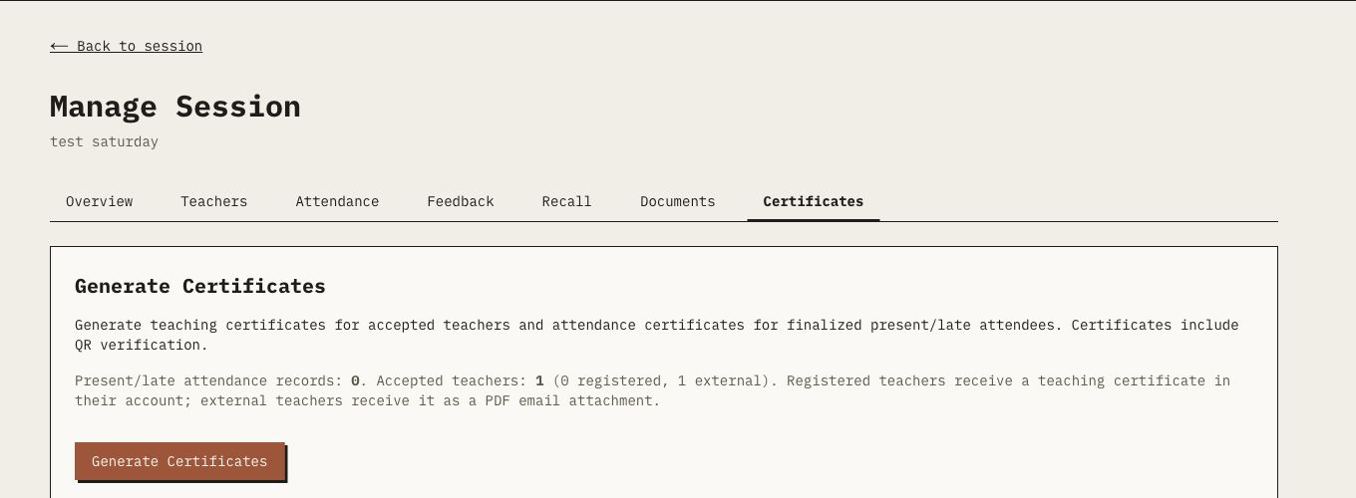
Figure 12. Certificate generation shows separate attendee and accepted-teacher eligibility before issuance.
- Confirm prerequisites. The session must be published, ended and have finalized attendance governance.
- Open Certificates. Review the present/late attendance count and the accepted registered/external teacher count.
- Select Generate Certificates. Petrios creates or reuses the correct valid certificate for each eligible role and reports partial failures.
- Check recipient pathways. Registered recipients access certificates in their account. External teachers receive a PDF email attachment.
- Use public verification. Each certificate has a human-readable code and QR verification URL. Revoked codes remain visible as revoked records.
ROLE SEPARATION An accepted teacher receives teaching recognition from the assignment; they are excluded from attendee recognition for the same session. Teaching recognition is not a physical-attendance claim.

11. Publish teaching slots
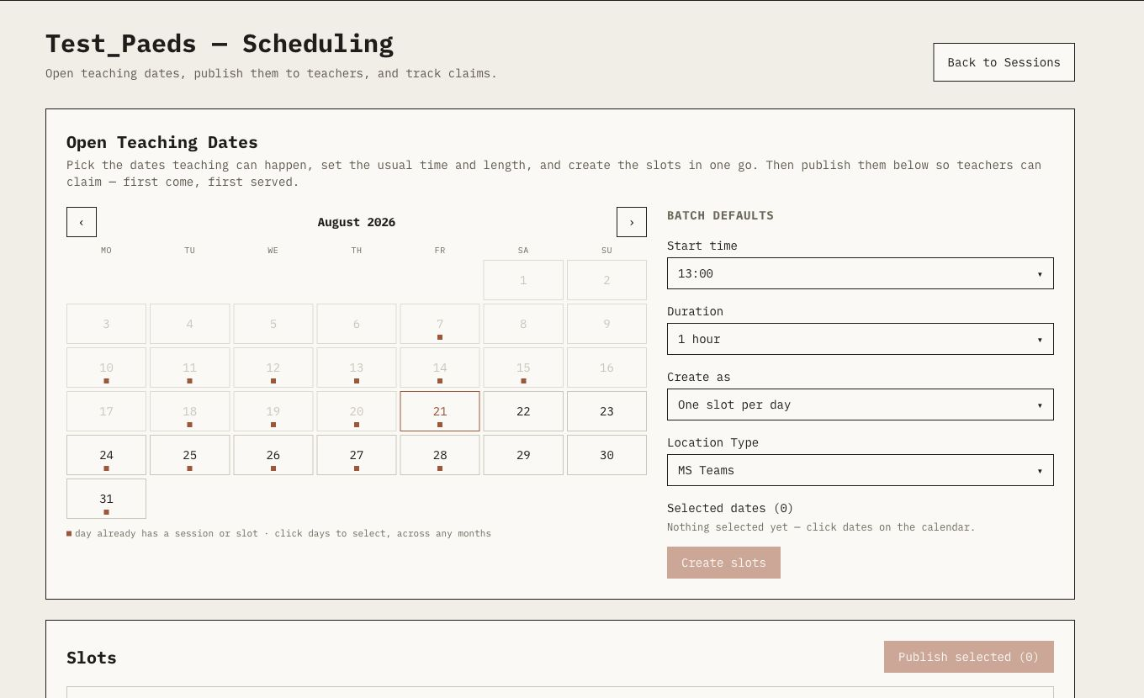
Figure 13. The scheduling workspace lets moderators select dates, apply batch defaults and publish open slots to defined audiences.
- Open Schedule Slots. From Dashboard, select Schedule Slots.
- Select one or more dates. Dates already occupied by a session or slot are marked and unavailable.
- Set batch defaults. Choose start time, duration, one slot per day or 10/15/20-minute lightning slots, and location.
- Create slots. Review the selected-date count and create the slots. They remain open until published, claimed, closed or expired.
- Select open future slots. Use the checkboxes beside the slots that should be included in one publication.
- Choose an audience. Publish to selected contact groups, department members and/or organization members.
- Track claims. The first eligible recipient to claim wins. Petrios creates a draft session and attaches the claimer as an accepted registered or external teacher.
AUDIENCE SNAPSHOT Slot publication stores the recipient snapshot at publication time. Later group membership changes do not alter who was offered that publication.

12. Use Audit and Governance reporting
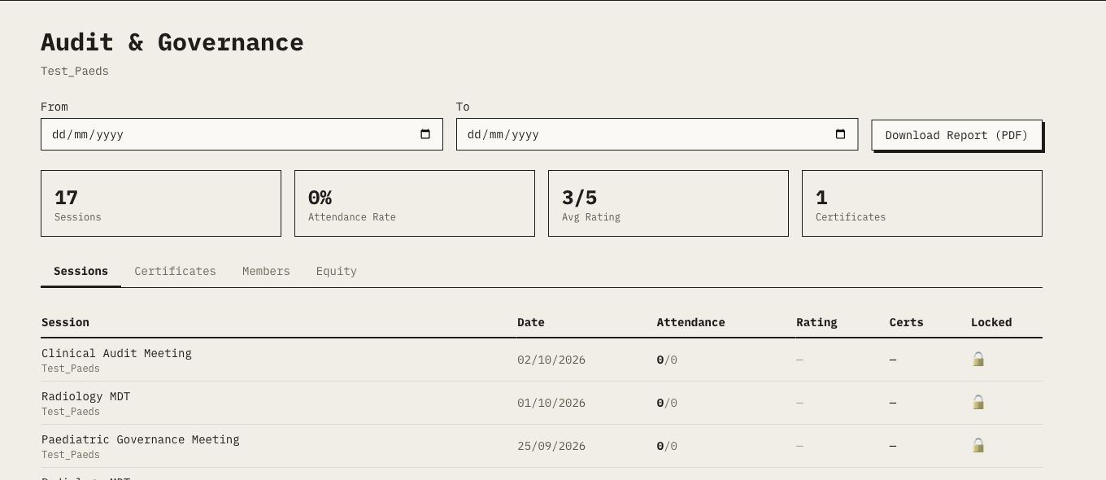
Figure 14. Audit and Governance combines date filtering, headline measures, detailed tabs and PDF export.
- Open Audit. Use the main navigation and confirm the department or organization scope.
- Set the date range. Enter From and To dates when the report should cover a defined period.
- Review the headline measures. Check session count, attendance rate, average rating and certificate count with the displayed denominator/context.
- Inspect each tab. Sessions, Certificates, Members and Equity answer different governance questions; do not treat one tab as a substitute for the others.
- Download Report (PDF). Use the export for a controlled reporting need and store it according to local information-governance policy.
INTERPRETATION A zero, dash or unlocked indicator may reflect lifecycle state or missing finalized evidence rather than poor performance. Investigate the underlying session before drawing conclusions.

13. Review Petrios Ops drafts
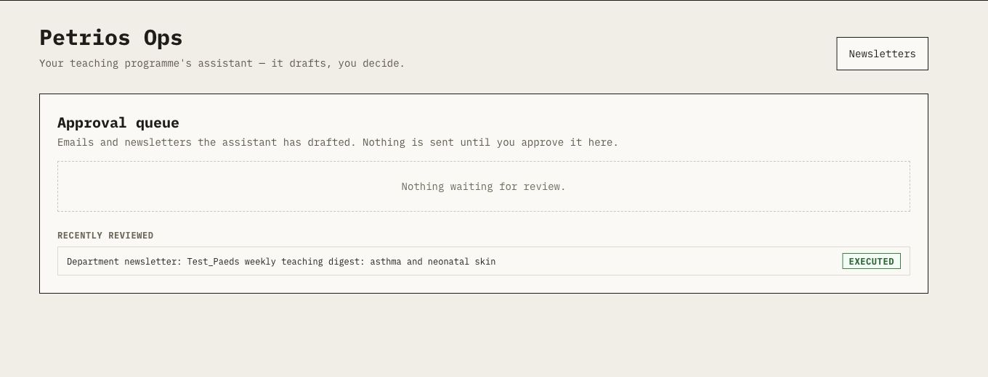
Figure 15. Petrios Ops separates drafted communications from the human decision to execute them.
- Open Ops or Approvals. Review the approval queue for speaker chases, thank-yous, custom emails or newsletter issues.
- Read the exact recipient and content. Treat AI output as a draft. Check names, dates, session facts, tone, privacy and whether sending is still appropriate.
- Approve or reject. Approval is the explicit human decision to execute the pending action. Reject unsuitable or stale drafts.
- Check the result. Executed and failed actions remain distinguishable. Approval followed by an executor error does not return the item to pending.
NON-NEGOTIABLE Petrios Ops cannot send outbound email before a human approves the corresponding pending action. Crons and the assistant may draft; only the approved executor path may send.
Core deterministic email such as authentication, invitations, reminders, certificates and Recall follows its own workflow and is outside the Ops pending-action queue.

14. Manage settings and onboarding
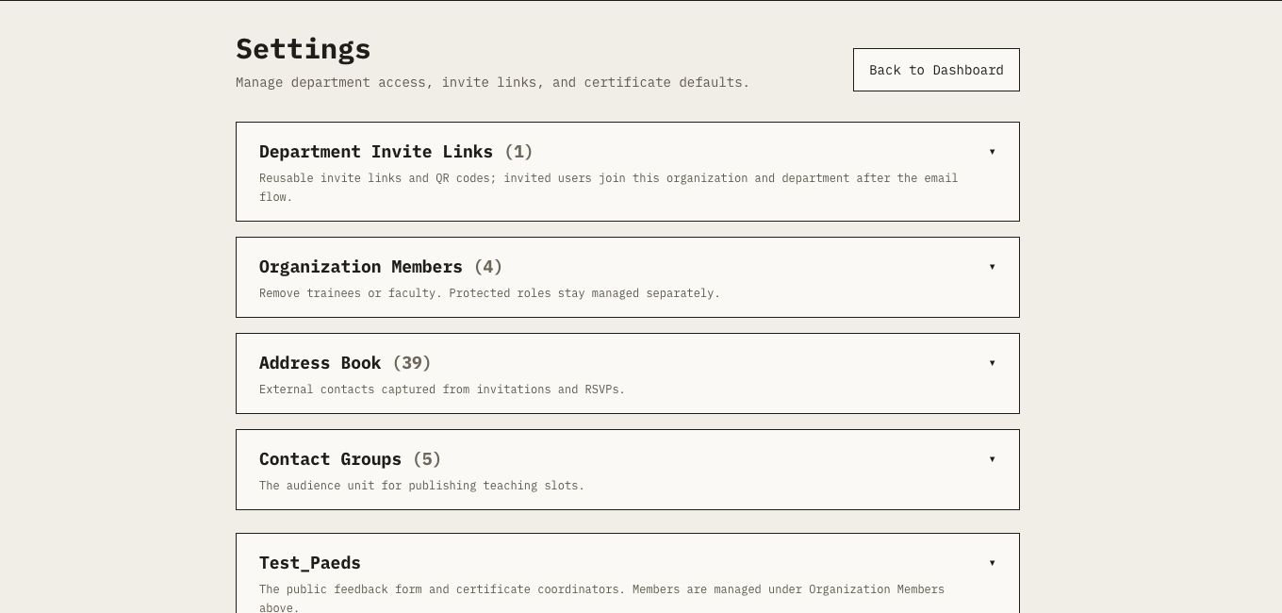
Figure 16. Settings groups member access, external contacts and department defaults into expandable sections.
- Department Invite Links. Create, display or rotate reusable invite links/QR codes. Rotation invalidates the previous invite URL.
- Organization Members. Review membership and remove ordinary trainees or faculty only when authorized. Protected roles are managed separately.
- Address Book. Maintain external contacts captured from teacher invitations and RSVPs. Archiving is not a consent model.
- Contact Groups. Build reusable external audiences for teaching-slot publication.
- Department section. Configure the public feedback form and up to four ordered teaching-coordinator names for future certificate snapshots.
CAPABILITY LINKS Department codes, invite links, teacher RSVP links and external slot-claim links grant access to a specific workflow. Do not place them in public logs, analytics or unrelated documents.

15. Faculty and external-teacher quick guide

15.1 Registered faculty
- Sign in. Use the organization's supported passwordless, password or Microsoft sign-in method.
- Respond to assignments. Accept or decline a pending teaching assignment from the notification or session workflow.
- Prepare. Open the authorized session, review details and access available documents.
- Teach. Join the configured meeting or attend in person. Assignment acceptance alone does not check you in.
- Review evidence. After attendance finalization, use the Teaching area for accepted-session recognition and released privacy-safe feedback.

15.2 External teacher
- Open the invitation or claim link. Treat the emailed capability as private.
- Confirm identity. Supply the requested name details and accept or decline the invitation, or claim the offered slot.
- Use the session information. Follow the emailed/reminder details. An external account is not required for the RSVP or claim flow.
- Receive recognition. After the session ends and governance is finalized, eligible teaching certificates are emailed as PDF attachments.

16. Trainee quick guide
- Join the correct department. Use the six-digit department code or invite URL provided by the teaching programme and complete email ownership verification.
- Open Dashboard. Review published upcoming sessions and select the relevant session.
- Check in. Use self check-in or the moderator's active secure group code inside the displayed window. Confirm the success message.
- Access documents. Download authorized PDF/DOCX/PPTX material. Treat downloaded Office content as untrusted.
- Submit feedback. Use the session or department feedback link. The form stores your supplied identity even though no login is required.
- Review your record. After finalization, check attendance notifications, eligible certificates, reflections and portfolio evidence.
- Use Recall when invited. Listen to the approved recap and complete the current five-question revision. A perfect catch-up result is labelled as Audio Recap catch-up, not physical attendance.

17. Troubleshooting and safe-operation rules

17.1 Common problems
Problem | Check first | Do not do
Session is invisible to members | Confirm its status is PUBLISHED and its department is correct. | Do not recreate it before checking for an existing draft.
Cannot publish | Check that the session has not ended and that end is later than start. | Do not alter historical times only to bypass validation.
Check-in is unavailable | Check the displayed window and whether a secure group code is active. | Do not use feedback or teacher status as substitute attendance.
Certificate count is zero | Confirm the session ended, is published, attendance is finalized and eligible roles/results exist. | Do not hand-create recognition outside the certificate action.
Audio Recap is stale | Compare the available document set with the sources used for the current draft. | Do not publish audio made from an earlier source digest.
Email shows sent but recipient has nothing | Use the provider receipt and recipient address to investigate downstream delivery. | Do not assume transport acceptance proves inbox delivery.
Correction is needed after finalization | Reopen with a reason, append the corrected decision and finalize a new revision. | Do not delete or rewrite attendance evidence.

17.2 Safe-operation rules
- Work only inside the current organization and the department you are authorized to manage.
- Keep patient-identifiable and unnecessary special-category information out of session documents, prompts, feedback exports and screenshots.
- Treat attendance CSVs, raw feedback, membership lists and exported reports as personal data.
- Use Cancel rather than Delete when the record must remain auditable.
- Review every AI-assisted output; never treat generated text or audio as an automatic clinical-quality decision.
- Check the visible lifecycle status after any partial provider, upload or delivery error before retrying.
- Escalate suspected cross-tenant access, unintended disclosure, certificate inconsistency or evidence corruption immediately.

18. End-to-end checklists

18.1 Before the session
- Session details, local date/time, duration and location are correct.
- Session is published only after preparation is complete.
- Registered/external teachers have accepted or outstanding invitations are understood.
- Meeting URL or Petrios Meet room is correct.
- Learning documents are available, appropriate and free of unnecessary sensitive information.
- Feedback QR/link and attendance method are ready.

18.2 During the session
- Attendees can access the session and check-in method inside the valid window.
- The moderator displays the current secure group code only when that stronger signal is intended.
- Feedback QR/link is available and described accurately as identified, accountless feedback.
- Technical problems and any reasoned moderator observations are recorded without deleting prior evidence.

18.3 After the session
- The complete roster and evidence trail have been reviewed.
- Every expected participant has an explicit result and attendance is finalized.
- Eligible certificates have been generated and partial failures reviewed.
- Feedback has been reviewed; any teacher report is edited and explicitly approved before release.
- Any Audio Recap has been listened to, checked against its sources and explicitly approved before publication.
- Audit/reporting outputs are stored only where authorized and retained according to policy.

Revision record
Version | Date | Change | Owner
1.0 | 21 August 2026 | Initial platform operating guide with verified interface screenshots. | Petrios service owner

