TRAINEE QUICK SOP

Using Petrios as a trainee
  - Find sessions, check in and keep your learning evidence together

Version 1.0 • 21 August 2026 • PET-TRAINEE-001
PURPOSE Use this guide for the everyday trainee workflow. Moderator and administrator controls are intentionally omitted.

1. Find and open a session
- Join the correct department. Use the invite URL or six-digit department code supplied by your teaching programme, then complete email ownership verification.
- Open My Dashboard. The Sessions tab is the default trainee view. Upcoming and past sessions are listed separately.
- Choose the session. Check its date, time, location and department, then select the session title.
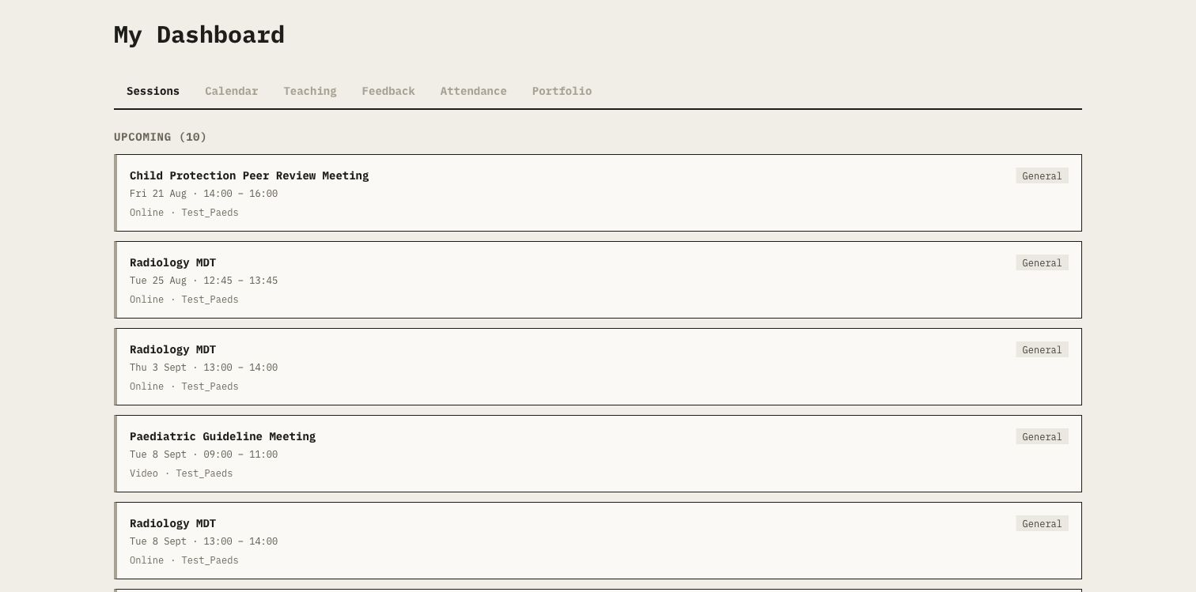
Figure 1. My Dashboard lists the sessions available to the signed-in trainee.
Screenshots show test training data. Interface wording may move, but the workflow outcome stays the same.

2. Check in and access documents

2.1 Check in
- Open Attendance. Select Attendance on the session page.
- Check the displayed window. Petrios tells you when check-in opens. A session may use its own timing.
- Use the active method. Complete self check-in or enter the moderator's current secure group code, as shown on screen.
- Confirm success. Do not leave the page until Petrios confirms that check-in succeeded.
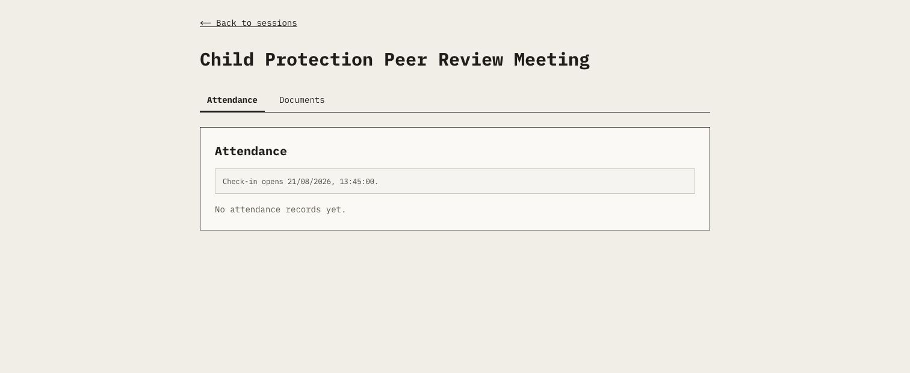
Figure 2. The Attendance tab shows when check-in becomes available.
IMPORTANT Joining a Petrios Meet room attempts check-in, but meeting access alone is not proof. Confirm the Petrios success message.

2.2 Use session documents
- Open Documents. Select the Documents tab beside Attendance.
- View or download. Open the authorized learning file using the displayed action.
- Handle files safely. Treat downloaded PDF, DOCX and PPTX content as untrusted and keep it within approved storage.
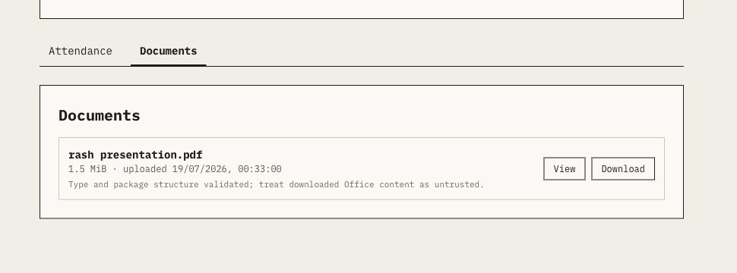
Figure 3. Available learning material has separate View and Download actions.

3. Submit feedback and review your record

3.1 Submit feedback
- Open the current link. Use the session or department QR code/link shared during the feedback window.
- Complete the form. Enter the requested identity details and answer the displayed questions.
- Submit once. Wait for confirmation before closing the form.
FEEDBACK IS SEPARATE The form is accountless but identified. Submitting feedback does not check you in and does not create a certificate.

3.2 Review attendance and certificates
- Open Dashboard > Attendance. Review your attendance percentage, attended total, streak and each finalized session result.
- Check status and source. PRESENT, LATE, ABSENT or EXCUSED is shown with the primary evidence source when one exists.
- Raise genuine corrections. Contact the session moderator if a finalized result needs review; moderators correct records with a reason and a new revision.
- Download eligible certificates. Use the certificate action shown for eligible PRESENT/LATE sessions or open My Certificates from the relevant notification or link.
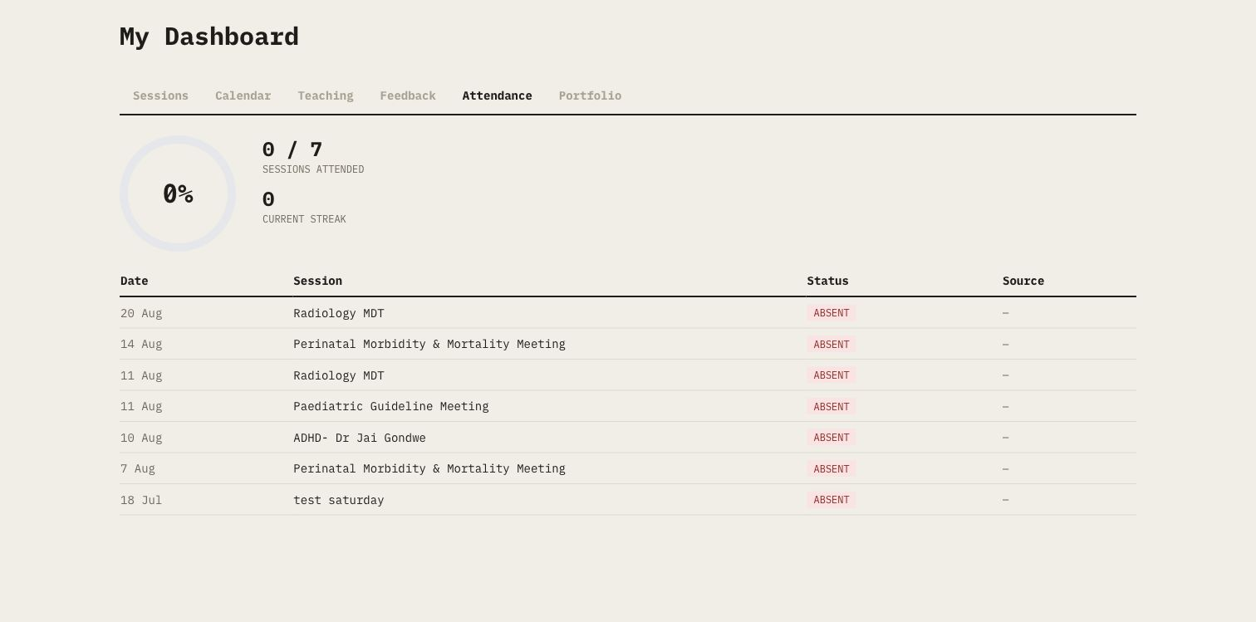
Figure 4. Attendance keeps the headline measure and per-session outcomes together.

4. Build your portfolio and use Recall
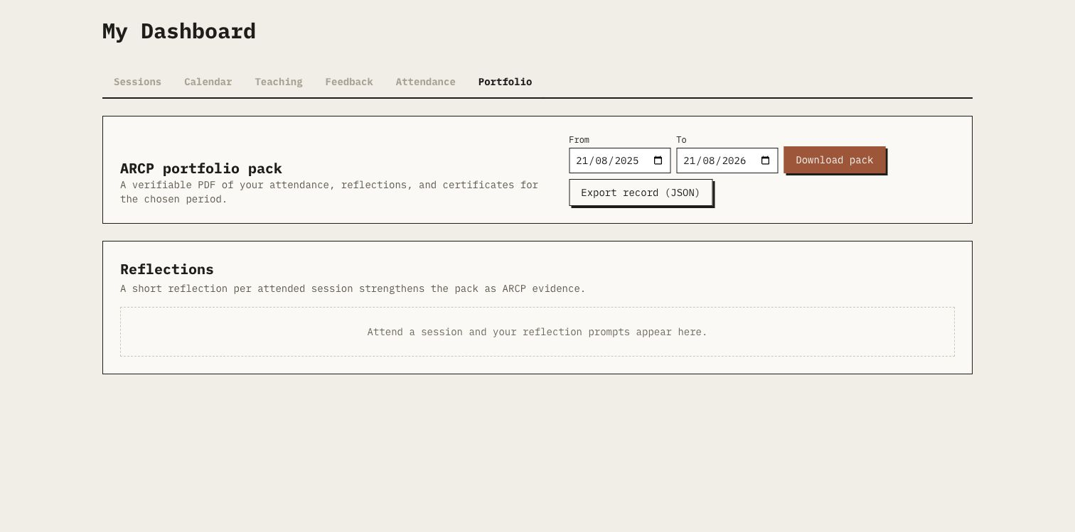
Figure 5. Portfolio combines reflections with a date-filtered, verifiable ARCP pack.
- Open Dashboard > Portfolio. Choose the period that your evidence should cover.
- Add reflections. After an attended session, use Add reflection to record what you learned and what you will do differently.
- Download the pack. Select Download pack for a verifiable PDF of attendance, reflections and certificates. Export record (JSON) is an optional portable record.
- Use Recall when invited. Open the private invitation, listen to the approved recap and answer the current five questions.
RECALL IS CATCH-UP A perfect current Recall result may create Audio Recap catch-up recognition. It is never recorded as physical attendance.

Need help?
Contact the session moderator for a check-in or finalized attendance issue. Contact your programme administrator for access problems. Keep invite and Recall links private, and sign out on shared devices.

