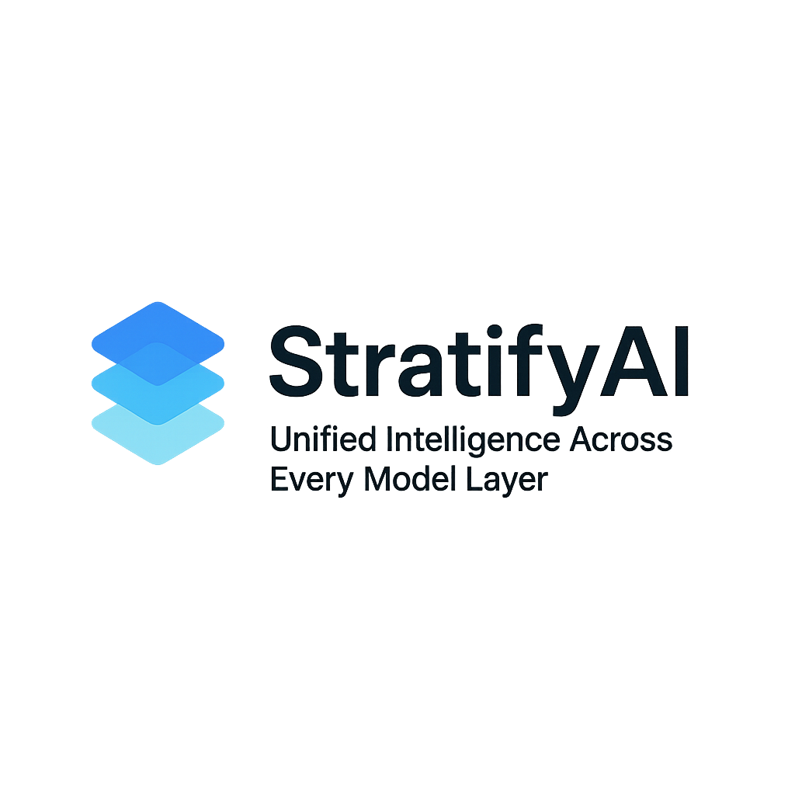
stratifyai

StratifyAI Overview for Stakeholders

What Is StratifyAI?
StratifyAI is a platform that helps organizations use artificial intelligence more effectively by connecting them to many different AI providers—such as OpenAI, Google, Amazon, and others—through one unified system. Instead of learning each provider’s tools separately, StratifyAI gives you a single, simple way to work with all of them.
Think of it as a universal adapter for AI.

Why It Matters
Most companies rely on AI for tasks like summarizing documents, analyzing data, generating content, or answering questions. But every AI provider has different strengths, costs, and limitations.
StratifyAI solves this by:
- Choosing the best AI model for each task
- Reducing costs by selecting cheaper options when appropriate
- Improving performance by routing work to faster or more accurate models
- Avoiding vendor lock‑in, so you’re never stuck with one provider
- Simplifying the entire AI workflow for teams and developers
It helps organizations use AI more strategically and efficiently.

Key Features

Unified Access
A single interface that works with all major AI providers.

Smart Model Selection
StratifyAI automatically picks the best model based on:
- Cost
- Speed
- Accuracy
- Capabilities (like vision or reasoning)

Cost Tracking
The platform monitors spending so teams can stay within budget.

Caching
StratifyAI saves previous answers so repeated requests don’t cost extra.

Streaming Responses
Supports real‑time, token‑by‑token output from AI models.

Large File Processing
Handles big documents by breaking them into smaller, manageable pieces.

Document Extraction
Understands and summarizes:
- Spreadsheets
- JSON files
- Logs
- Code
- Long text documents

RAG (Retrieval‑Augmented Generation)
Combines AI with search to produce more accurate, grounded answers.

Command Line Tool
Developers can use StratifyAI directly from their terminal.

Optional Web Interface
A visual dashboard for interacting with the system.

Who Should Use StratifyAI
StratifyAI is ideal for:
- Businesses wanting flexible, cost‑efficient AI usage
- Developers building AI‑powered applications
- Data teams working with large documents or multiple AI tools
- Organizations that want to avoid being tied to a single AI vendor
- Teams looking to improve reliability and reduce AI costs

Summary
StratifyAI makes AI easier, smarter, and more cost‑effective.
It connects to multiple AI providers, chooses the best model for each task, tracks spending, handles large documents, and improves accuracy—all through one unified platform.
Whether you’re building an AI product, analyzing data, or scaling AI across your organization, StratifyAI helps you do it more efficiently and with greater control.

