Operating System Assignment 3
Name: Vira Shah Class: AIDS_F Roll no: 70

Task 1: Create a Parent Process and Child Process
Aim
To create a parent process and a child process using the fork() system call and display their Process IDs (PID) and Parent Process ID (PPID).
Theory
The fork() system call creates a new child process by duplicating the parent process. After the fork, both parent and child execute independently. The parent receives the child's PID, while the child receives 0 as the return value of fork(). The functions getpid() and getppid() are used to obtain the Process ID and Parent Process ID respectively.
Program
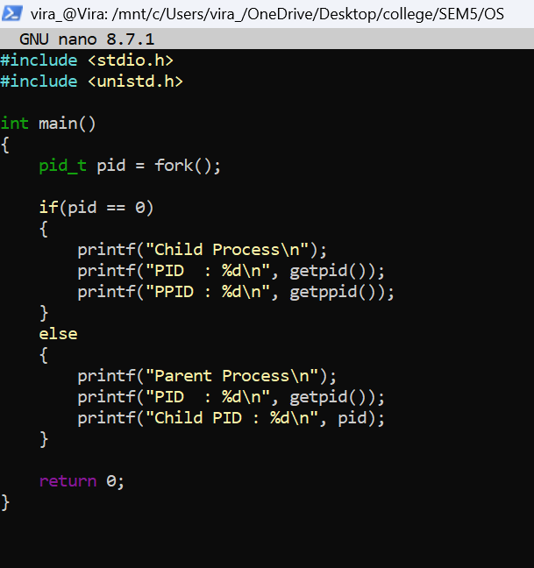
Output
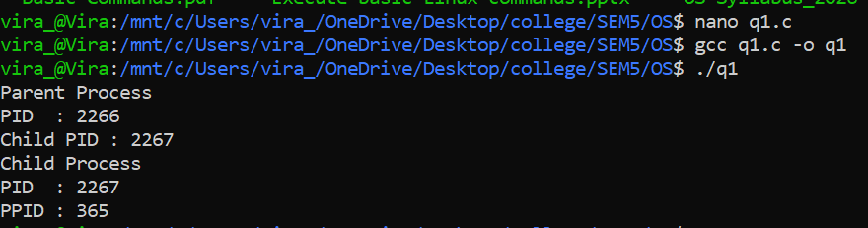

Task 2: Create 10 Child Processes
Aim
To create ten child processes using the fork() system call.
Theory
Multiple child processes can be created by repeatedly calling the fork() system call. Each child process receives a unique Process ID (PID) while sharing the same parent process. This demonstrates process creation in Linux.
Program
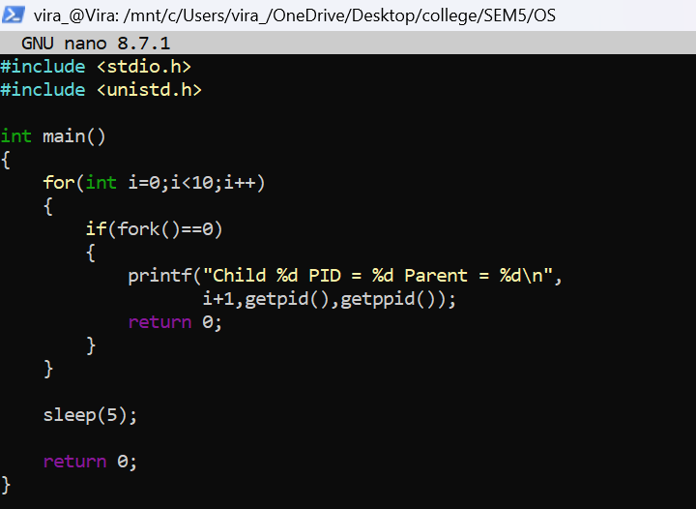
Output
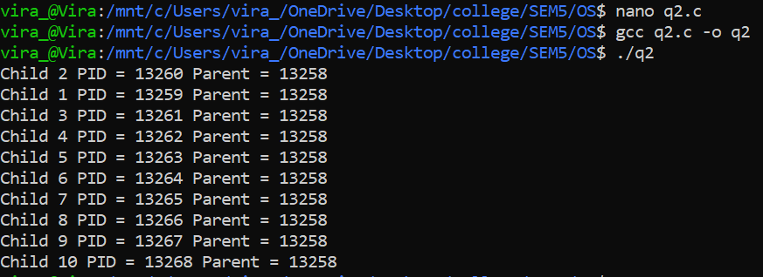

Task 3: Create Orphan Processes and Identify the New Parent
Aim
To create orphan processes by terminating the parent process and identify the new parent of the orphan processes.
Theory
An orphan process is created when its parent process terminates before the child process. The operating system automatically assigns a new parent to the orphan process. On a normal Linux system, the orphan is adopted by init/systemd (PID 1). In WSL, the orphan is adopted by the WSL /init process.
Program
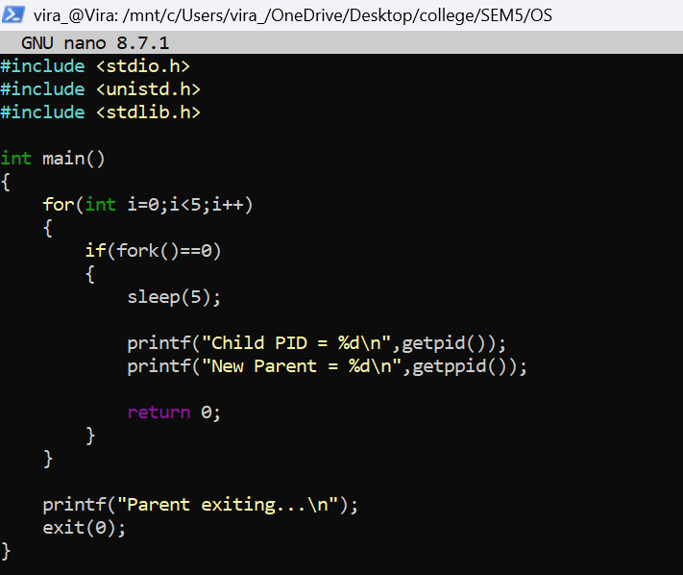
Output
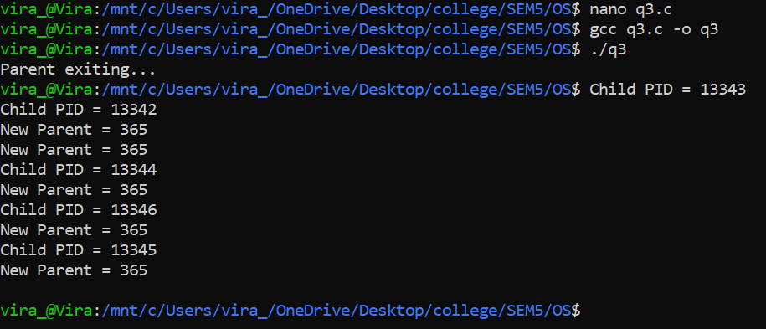

Task 4: Find the Priority of Running Processes
Aim
To determine the priority and scheduling information of running processes.
Theory
Linux assigns a priority to every process for CPU scheduling. The ps -el command displays process information such as Process ID (PID), Parent Process ID (PPID), Process State (S), Priority (PRI), and Nice Value (NI). These values are used by the scheduler to manage process execution.
Program
Command:
ps -el
Output
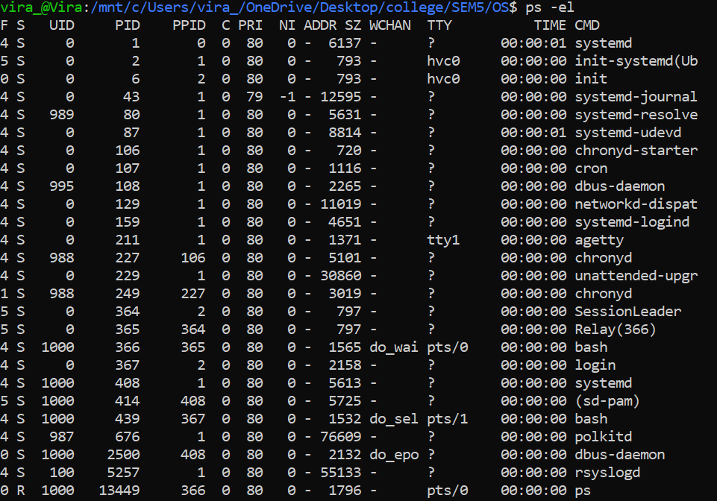

Task 5: Create and Identify a Zombie Process
Aim
To create a zombie process and identify it using Linux commands.
Theory
A zombie process is a process that has completed execution but still has an entry in the process table because its parent process has not called the wait() system call to collect its exit status. Zombie processes are identified by the process state Z.
Program
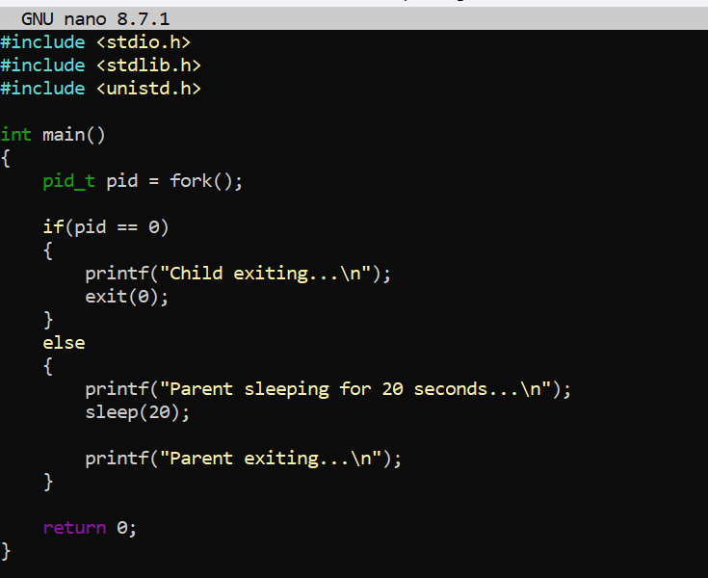
Output
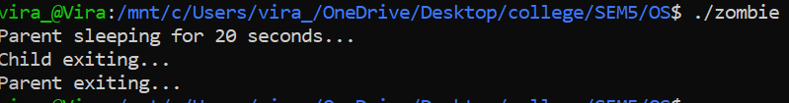
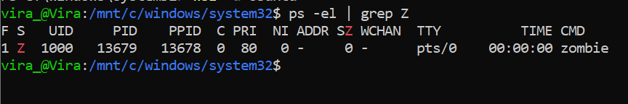

Task 6(a): Demonstrate the wait() System Call
Aim
To demonstrate the working of the wait() system call.
Theory
The wait() system call suspends the execution of the parent process until one of its child processes terminates. It is used for process synchronization and prevents the creation of zombie processes by collecting the child's exit status.
Program
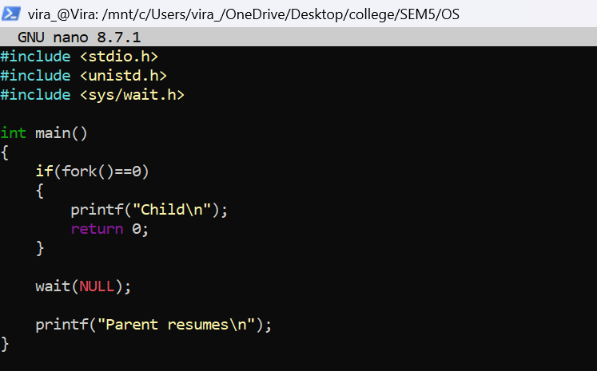
Output
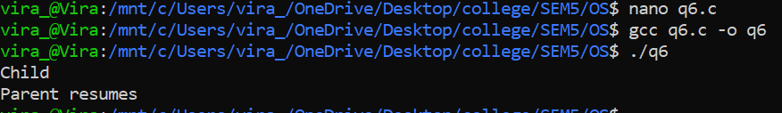

Task 6(b): Demonstrate the execv() System Call
Aim
To demonstrate the working of the execv() system call.
Theory
The execv() system call replaces the currently executing process with a new program. It does not create a new process; instead, it loads and executes another program within the same process while retaining the same Process ID (PID).
Program
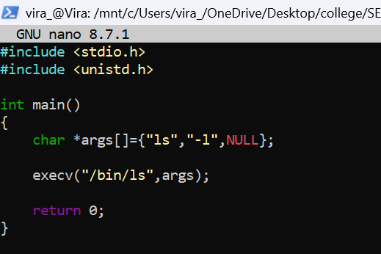
Output
