

Introductory Assignment

Data visualisation

Arnav Malhotra | 17317424 | 30-01-2019

# Minard's map of the retreat of Napoleon's army from Russia:

The visualisation of the data is done through the use of D3.js JavaScript library.

The map shows the (approximate) position of Napoleon's army as it invades and retreats from Russia in the 1812 campaign; the width of the lines show the size of the army as it dwindles from a maximum of 340,000 to an end value of 4,000. No scale is displayed for concision. The line colors Blue, Orange and Green represent the 3 Army Divisions.

There are minor improvements in this visualisation as compared to the original such as different branches of the army have been given their own colour.

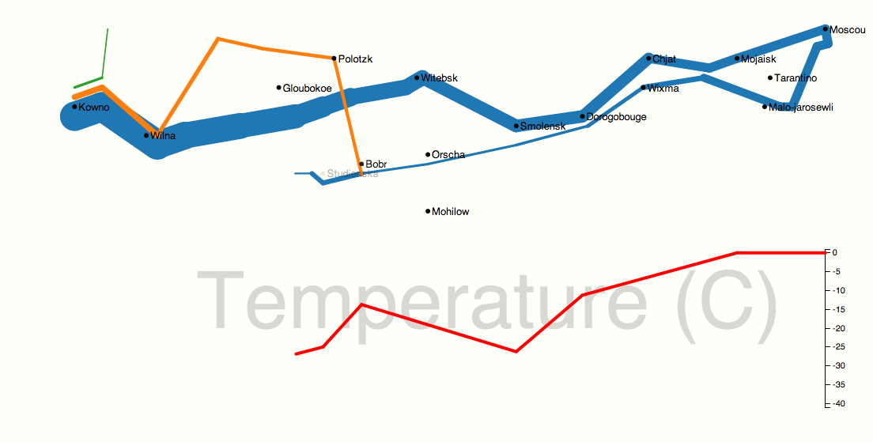

Figure 1: A reimplementation of Charles Joseph Minard’s map for Napoleon’s Army Campaign

Usage for D3 trail layout – It is instantiated by calling the function: once parameters are set, the layout() method is run to get values back.

# Taxonomy and Tracking of Flora and Fauna:

This process not just involves cataloging data about all the types of living beings on the planet but also their numbers.

The data collected from this process apart from being important for acknowledging diversity also helps us keep track of endangered species. In order to make the representation better than just a simple bar graph (as shown below), the concerned species is shown in the form of a clip art and colour coded according to its respective category (Abundant, Near Threatened, Vulnerable, Endangered or Critically Endangered).

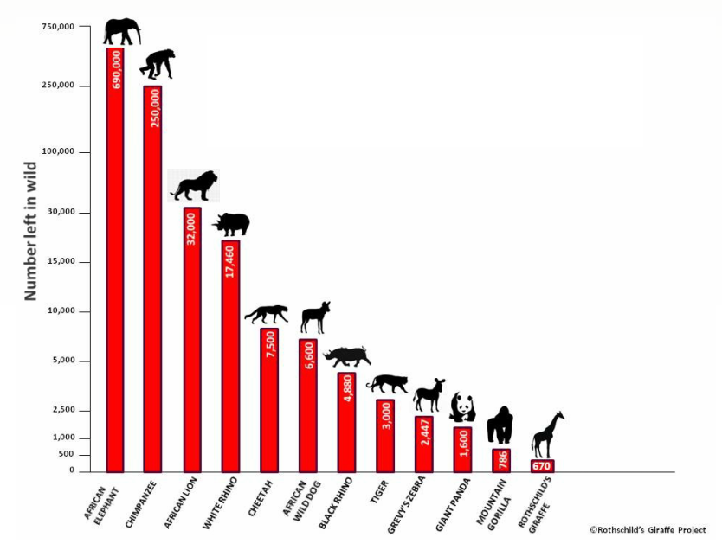

Figure 2: Simple Bar Graph of Wildlife in Africa

The visualisation would be done using D3.js JavaScript Library.

Since representing the species in the form of just numbers does not help without any frame of reference (i.e., how many individuals of a particular species are enough to sustain a population), this kind of a representation of the data would impart information more coherently and be more appealing especially when being displayed publicly, say, in a National Park.

# References:

1. <https://en.wikipedia.org/wiki/Charles_Joseph_Minard>
2. <http://benschmidt.org/D3-trail/minard.html>
3. <http://www.datavis.ca/gallery/minard/minard.txt>
4. <http://mbostock.github.io/protovis/ex/napoleon.html>
5. <https://github.com/awesomedata/awesome-public-datasets#biology>
6. <https://www.ncbi.nlm.nih.gov/taxonomy>
7. <https://www.pinterest.ie/pin/461056080578214929/>