

Assignment 2

Data visualisation

Arnav Malhotra | 17317424 | 03-03-2019

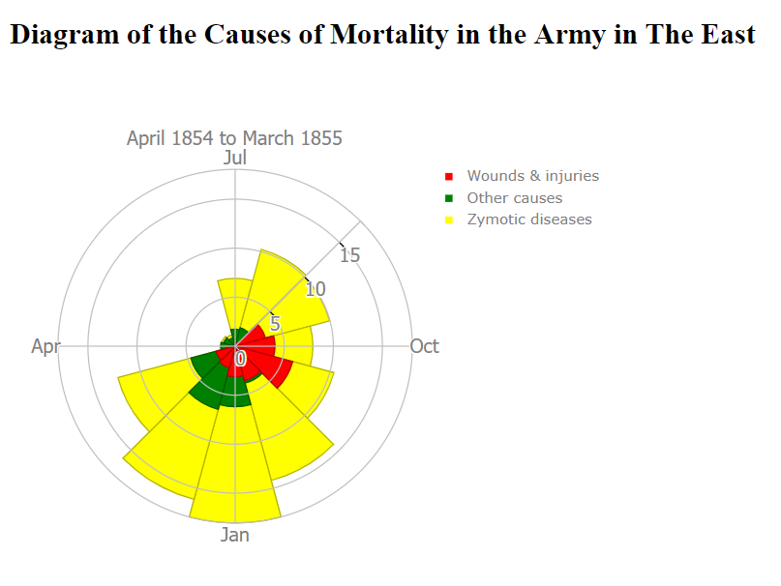

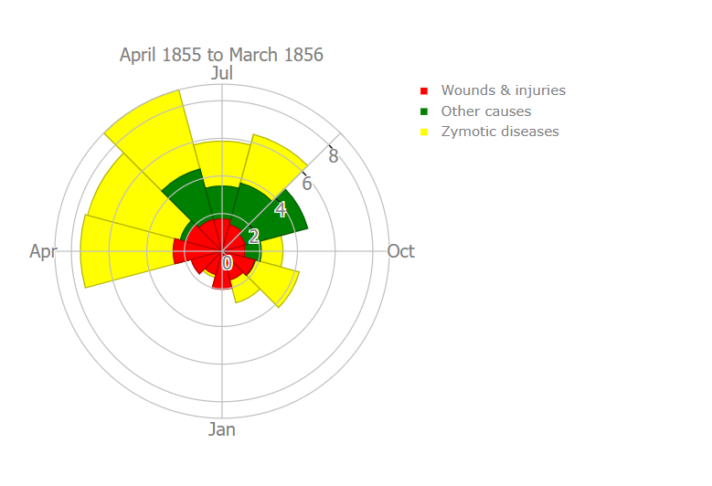

The above visualisation was made by using Plotly.js javascript library. Bright colours have been used to enhance the contrast so that it is easy to discern different factors responsible for the deaths.

# **Minard's map of the retreat of Napoleon's army from Russia:**

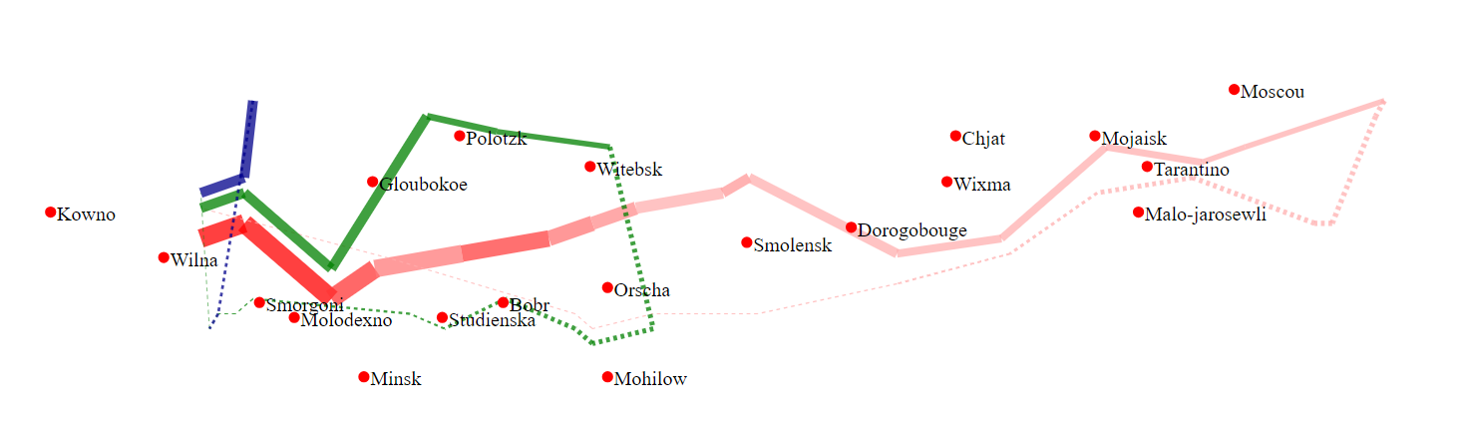

Figure: A reimplementation of Charles Joseph Minard’s map for Napoleon’s Army Campaign

In this visualisation of Charles Minard’s map, the different coloured lines represent the three divisions of Napoleon’s army. The journey, having two stages, is shown by solid line for outwards and hatched for return. The colour gradient shows the change in temperature.

It was generated through D3.js javascript library. Data from Excel document was converted to GeoJSON using a user-defined projection which makes it easier to convert longitude and latitude values to pixel format.

Usage for D3 trail layout – It is instantiated by calling the function: once parameters are set, the layout() method is run to get values back.

# **References:**

1. <https://datavizcatalogue.com/methods/nightingale_rose_chart.html>
2. <https://understandinguncertainty.org/node/214>
3. <https://plot.ly/javascript/wind-rose-charts/>
4. <https://en.wikipedia.org/wiki/Charles_Joseph_Minard>
5. <http://benschmidt.org/D3-trail/minard.html>
6. <http://www.datavis.ca/gallery/minard/minard.txt>
7. <http://mbostock.github.io/protovis/ex/napoleon.html>