

Assignment 4.2

Data visualisation

Arnav Malhotra | 17317424 | 07-04-2019

Spatial Data Visualisation

# Simple Online Volume Renderer

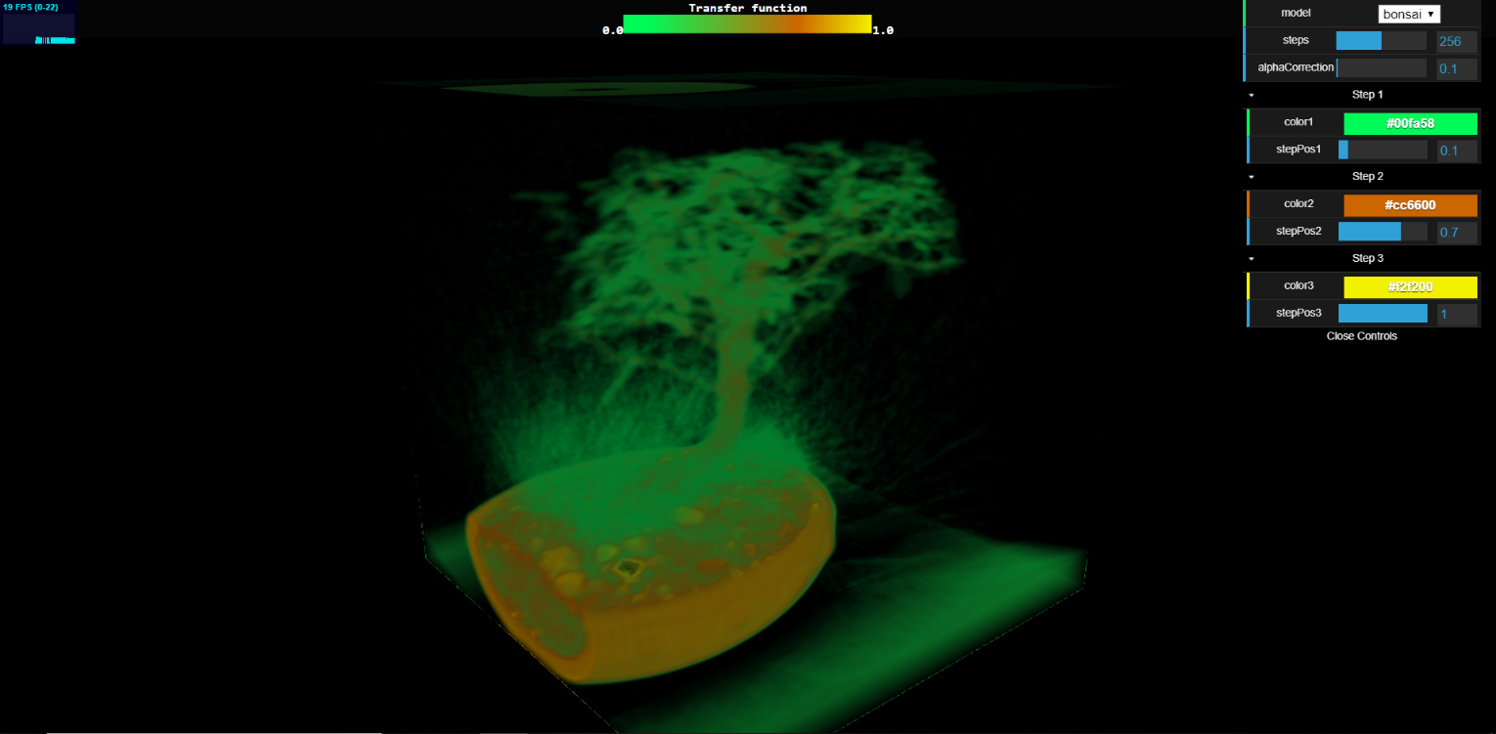

Figure 1: Running the WebGL based online volume renderer

# Use of the above program:

This program helps emulate the 3D texture by sampling a 2D texture instead of using traditional rendering technique which uses triangles to display 3D graphics. This is known as Volume rendering done by Volume Ray Casting. Every pixel seen on the screen results from a ray going through the object while fetching intensity samples at regular intervals.

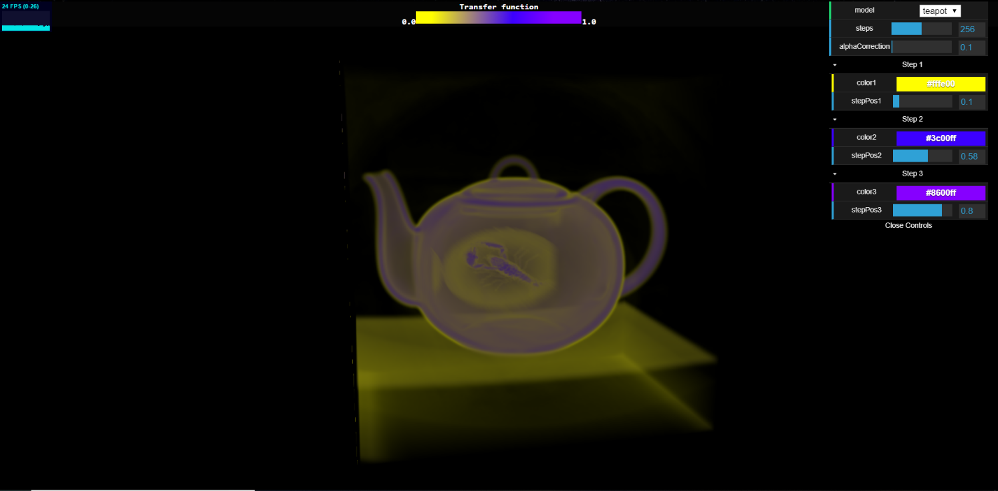

Figure 2: Render after changing dataset, view and encoding parameters

Information Visualisation

# Zoomable Treemap:

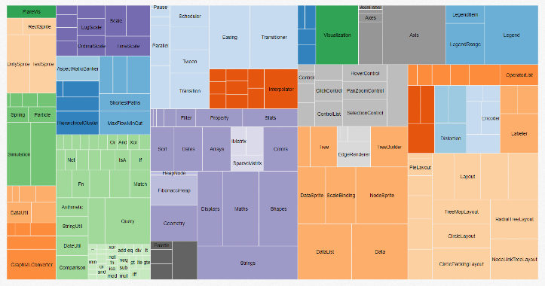Dataset type –

1. Categorical
2. Nominal

Visualisation Tasks –

1. Identify
2. Locate
3. Distinguish
4. Categorise

Encoding Channels –

1. Size
2. Colour
3. Position

# Force Directed Graph:

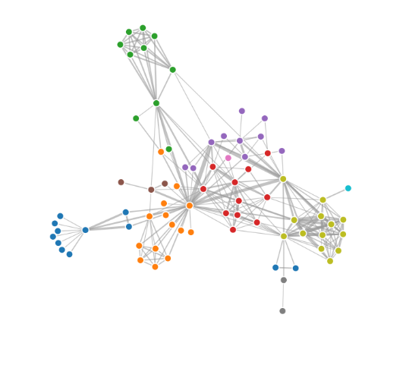Dataset type –

1. Network
2. Categorical
3. Nominal

Visualisation Tasks –

1. Identify
2. Locate
3. Distinguish
4. Cluster
5. Correlate

Encoding Channels –

1. Position
2. Colour
3. Orientation