

**ACADEMIC YEAR 2024**

BIT 1201Database Design **CAT1(15MARKS)**

**Stream: BEDS**

**Session: May August 2024**

***Instructions:***

1. ***Answer all questions***
2. ***Write your answers on the same form***
3. ***Do not miss the submission deadline***

Questions:

In a Library, Books and borrowers are identified as follows:

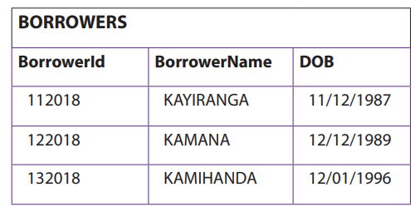

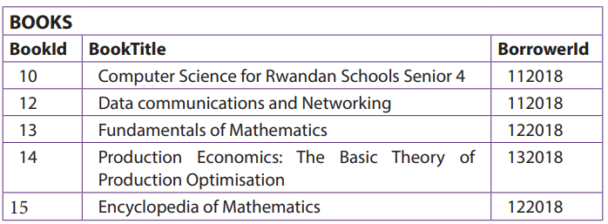

**Questions:**

1. **Create these tables in MS Access and share the dashboard. (5marks)**
2. **Write SQL command and share the screen: (10marks)**
3. **Which created a similar table to the table Books as Books1**
4. **Which inserted the first row of the table Books**
5. **Which generated the table below from the table Books:**

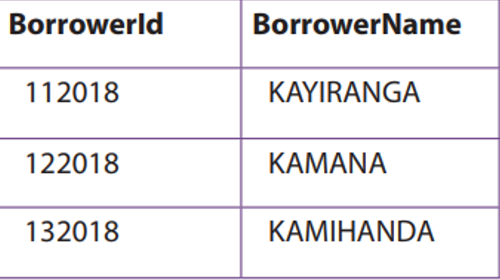

1. **Which generated all information from both the tables about borrowers and Books.**
2. **Which will add a new column (BorrowedDate) to Borrowers.**

******************************************************************************