COMP 7003

Assignment 2

Testing

William He
A01025515
Oct 6, 2024

Tests 4
Test 1 4
Test 2 5
Test 3 6
Test 4 7
Test 5 8
Test 6 9
Test 7 10

Test | Expected | Actual | Screenshot
No arguments | fail | fail | Test 1
Too few arguments | fail | fail | Test 2
Too many arguments | fail | fail | Test 3
Correct number of arguments, invalid interface | fail | fail | Test 4
Correct number of arguments, invalid BPF | pass | pass | Test 5
Correct number of arguments, invalid packet count | fail | fail | Test 6
Correct number of arguments, valid interface, BFC, and packet count | pass | pass | Test 7

Tests

Test 1
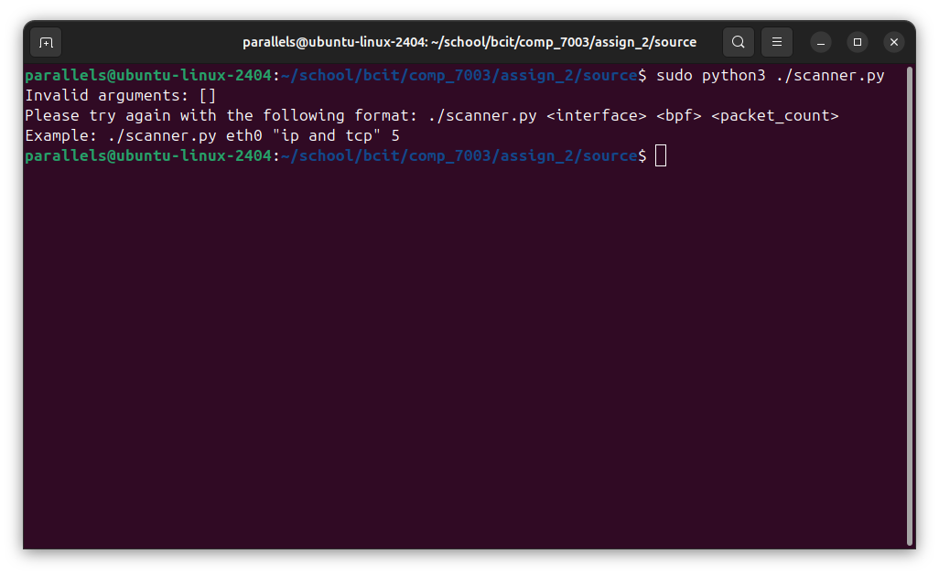

Test 2

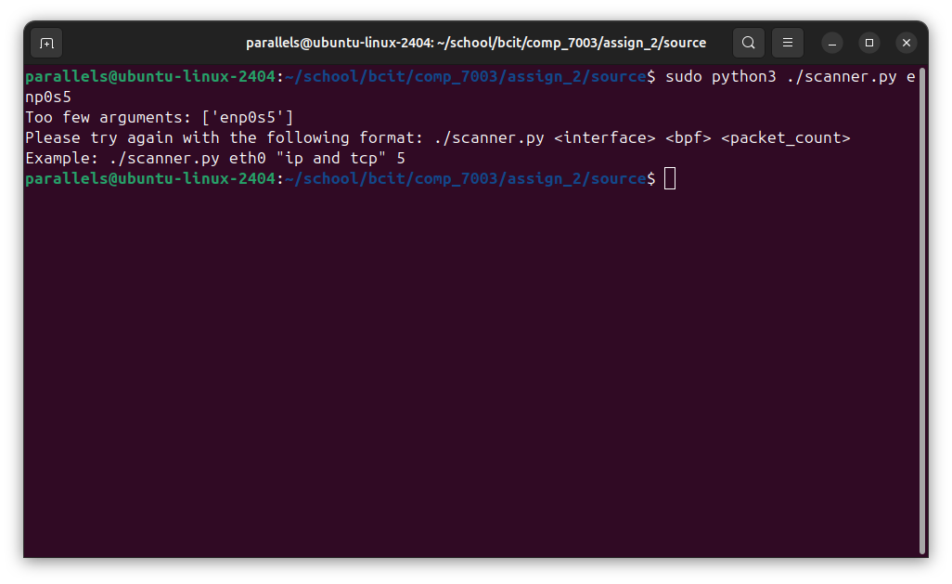

Test 3
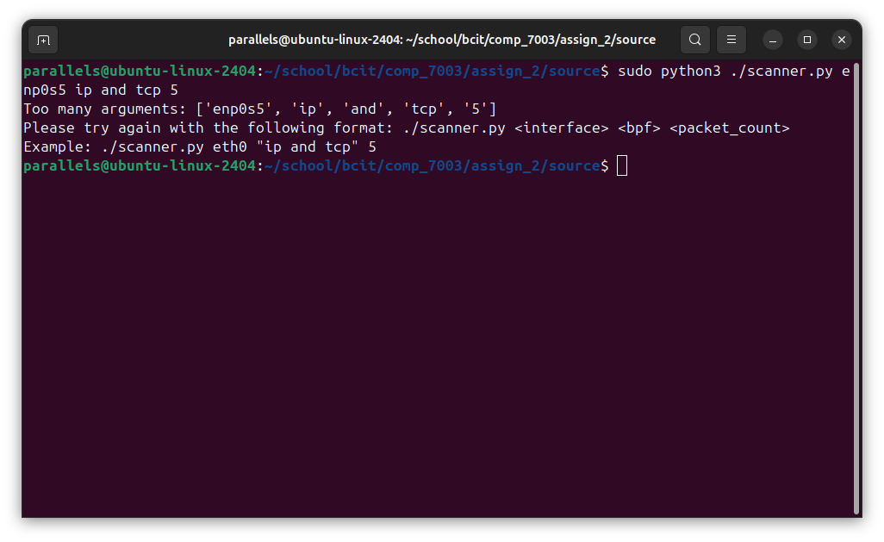

Test 4
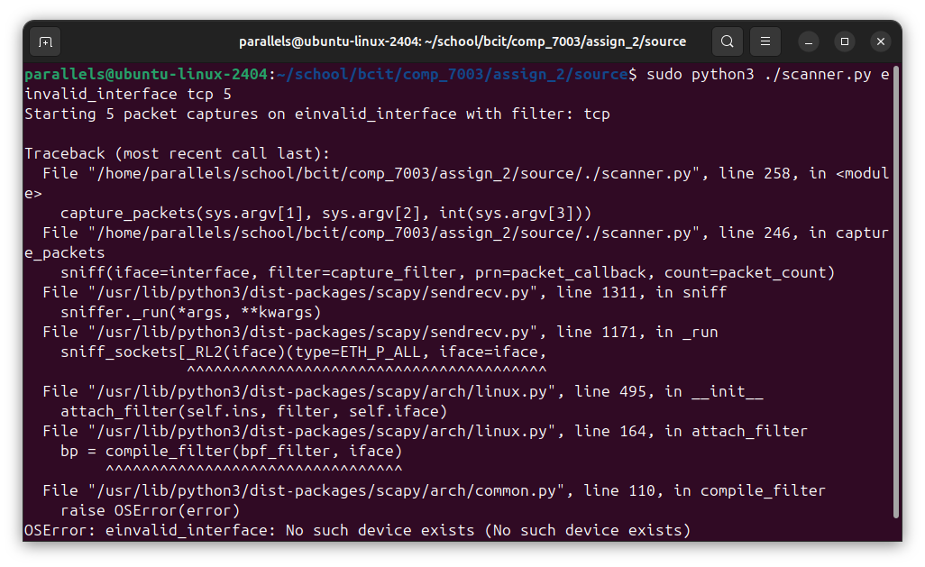

Test 5
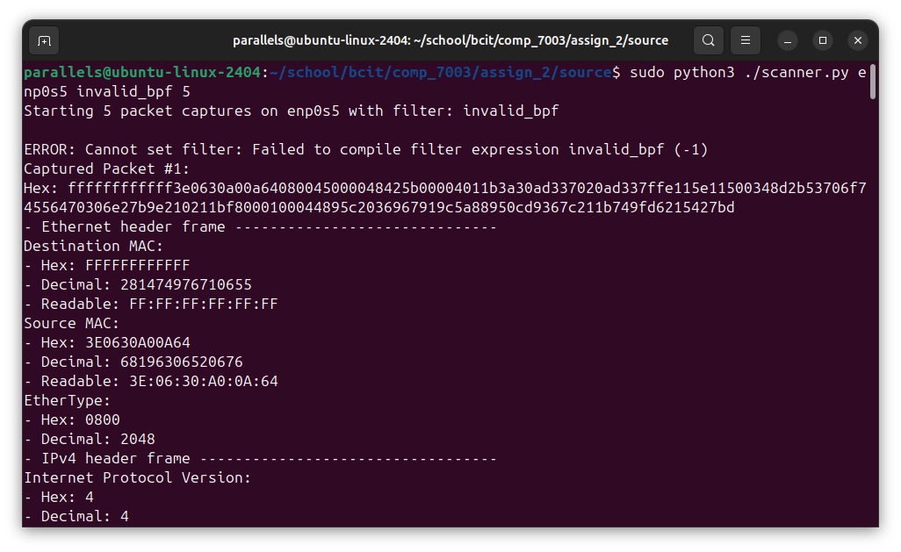

Test 6
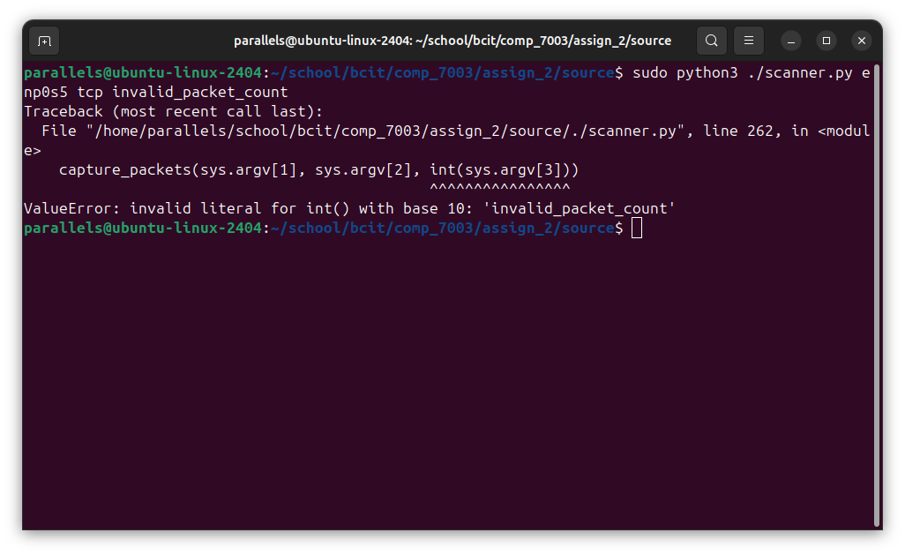

Test 7
