ShopAssistant – solution & workflows
ShopAssistant is a smart back-end solution that helps online stores deliver fast, friendly, and reliable customer support, with built-in multi-language capabilities.
Customers receive instant answers and product suggestions, while store owners and staff can easily keep store information up to date.
ShopAssistant is a lightweight system that uses advanced technology to understand what buyers are looking for without the need for expensive or complex systems, and smoothly guides them to the right products or information.

What can ShopAssistant do?
• Instant FAQ answers: Quickly responds to user questions on a wide range of configured topics—such as store policies, processes, and general information—by searching the knowledge base.
• Guided conversations: Leads users through interactive, step-by-step dialogs for more complex requests, collecting all required information efficiently—even if the user pauses and resumes later.
• Real-time status information: Provides up-to-date responses about the status of user requests or ongoing processes (such as order status or progress on multi-step scenarios).
• Multi-language support: Delivers answers and dialogs in both English and Norwegian, with a structure designed for easy addition of further languages as needed.
• Config-driven: All knowledge base content, intent patterns, clarification alternatives, and dialog scenarios are defined in external JSON files. Updates to these files (such as adding new clarification options or editing prompts) require no code changes or redeployment. Admins can apply changes instantly using the cache refresh endpoint.
• Easy knowledge management: Enables business users to update FAQ content and dialog flows via configuration files (such as JSON), with no coding or redeployment required.
• Role-based access control: Ensures that sensitive topics and information are accessible only to users with the appropriate permissions, enforcing security and compliance.
• Flexible integration: Designed to connect with other business systems and APIs to support current and future operational needs.

How ShopAssistant works
ShopAssistant can handle both simple and complex requests. For simple FAQs, it returns answers instantly from its knowledge base. For more complex scenarios—like product searches, order status, or delivery address changes—it guides the user with a sequence of clarifying questions, remembering context throughout the conversation.
All responses are provided in the user’s preferred language, and the system is designed for easy expansion as business needs change.

How a user message is processed (workflow)

- Message reception & authentication
The user’s message is securely received by the ShopAssistant API, which verifies the user’s identity and permissions.
- FAQ cache lookup
If the message matches a frequently asked question stored in the cache, ShopAssistant instantly returns the answer.
- Ongoing multi-turn dialog
If the user is in the middle of a guided conversation (such as product search), ShopAssistant continues the dialog, asking only the next relevant question.
- Intent detection
If not in a dialog, ShopAssistant determines intent in several stages:
- Pattern-based regex matching: Checks if the message fits any known patterns (highest confidence).
- Stemming-based keyword matching: Searches for key concepts using root word forms.
- Semantic embedding similarity: Converts the message into a vector (“embedding”) and checks for the closest match among allowed intents.
- Clarification (if needed)
If multiple possible intentions, product categories, or other things are detected, ShopAssistant displays a clarification question with a set of likely alternatives. After user selection, the conversation continues without interruption.
- Role-based topic filtering
When semantic search is performed, only knowledge base topics the user is authorized to access (based on their role/permissions) are included in the search. No restricted content is ever considered or returned—even if a close match exists.
- Semantic knowledge base search
If no intent is found, or for general questions, ShopAssistant:
- Searches for answers only within the topics allowed for the user’s role.
- Uses a hybrid method combining semantic similarity (vector search) with BM25 keyword matching to handle both meaning and exact wording of FAQ questions.
- If a match is found, returns it; if not, responds with a fallback (“Sorry, I couldn't find a relevant answer.”) message.
8. Response construction
Returns the answer or next dialog step to the user.
9. Analytics
All key interactions -including FAQ, detected intents, clarifications, dialog steps, and fallbacks -are logged and available for review in the dashboard. Admins can trigger a cache refresh to reload updated config, knowledge, and embeddings live.

Understanding intent: How ShopAssistant knows what you need
ShopAssistant is designed to truly “understand” what users want—no matter how they phrase their question. This is achieved by combining several advanced techniques that work together to interpret the intent behind every message.
- Pattern matching: ShopAssistant leverages configurable templates and regular expressions to instantly recognize well-known question formats. This allows for rapid identification of routine requests, such as asking for store hours, return policies, or order tracking.
- Semantic similarity search: The system uses a pre-trained sentence embedding model to analyze the meaning of each message, not just its keywords. By converting both user queries and stored example phrases into vector embeddings, ShopAssistant can accurately identify the intent even if the user’s wording is unfamiliar or unique. This ensures that a wide variety of questions—regardless of phrasing, synonyms, or language—are correctly understood and routed.
- Configurable intent patterns: Supported business scenarios (“intents”), such as tracking an order, finding a product, requesting recommendations, or changing account details, are all defined in easily updatable JSON files. Each intent includes a set of example user phrases and associated parameters. These patterns can be expanded or modified at any time to support new business processes, seasonal campaigns, or emerging customer needs—without the need for backend code changes.
- Multi-layered analysis: ShopAssistant applies these techniques in layers—first looking for exact pattern matches, then analyzing for semantic similarity, and finally checking configurable intent patterns. This layered approach balances speed and flexibility, delivering accurate results with minimal effort from the user.
- Continuous improvement: Because intents and example phrases are stored in external files, your team can continually refine and expand what ShopAssistant understands. New question types, alternative phrasings, and business rules can be added on-the-fly, ensuring the assistant always stays aligned with your evolving business needs.

Semantic Knowledge Base Search
The system uses a hybrid search method to retrieve answers from the knowledge base. This method combines two complementary techniques: vector search and BM25 keyword search.
- Vector search (semantic understanding):
A large language model (LLM) converts each question and answer into a numerical representation (embedding) that captures its meaning. This allows the system to recognize when two questions mean the same thing, even if they are worded differently.
Example: A query like “Where is my package?” can match with “How do I track my order?” because both express the same intent.
- BM25 keyword search (precise matching of question wording):
BM25 focuses on the actual words in the query. It ranks stored questions based on how many words overlap with the query, how often those words appear, and how common they are across the whole knowledge base. This makes BM25 especially effective for FAQs where users phrase questions in many slightly different ways.
Example: A query like “do you accept credit cards” will directly match stored questions such as “what cards are allowed” or “is Visa accepted.”
- Hybrid combination (best of both worlds):
The system merges the results from both methods. Vector search ensures semantically similar questions are found, while BM25 ensures that common customer phrasings and exact wording variations are not missed. A weighted scoring process blends the two, and the system applies role-based access rules so restricted topics (like Portal) are only shown to authorized users.
The hybrid approach blends these two methods into a single result set. Vector search ensures semantic coverage, while BM25 ensures that important keywords and identifiers are not missed. A weighted scoring process merges the results, and additional safeguards give preference to answers that share direct word overlap with the query. Role-based access rules are also enforced, so restricted topics (such as Portal) are only shown to authorized users.
By combining these approaches, the system delivers answers that are accurate, flexible, and secure - handling conversational language naturally, while also covering the many ways customers may phrase the same FAQ question.

Multi-turn dialogs
ShopAssistant handles complex workflows- such as product search, order tracking, or address changes - using multi-turn dialogs that guide users through a step-by-step process.
- Intent-driven workflow: When a user’s request matches an intent that requires more information, ShopAssistant dynamically determines which details are missing and asks follow-up questions, one at a time.
- Clarification (if needed): If several possible categories of products or other things are found, ShopAssistant displays a clarifying question with a set of possible alternatives. After the user makes a selection, the conversation continues without interruption.
- Stateful interaction: The assistant remembers each answer in a session context, allowing the user to pause and resume the conversation without losing progress.
- Dialog completion: Once all required information is collected, ShopAssistant executes the relevant business logic by calling the specific intent handler, such as looking up order status or searching for products.
- Custom handlers: Each type of dialog (intent) is powered by a specialized handler class that defines what information is needed, how to validate it, and how to produce the final answer.
- Scenario configuration: The sequence of questions is defined in the configuration file and enabled customization as business needs change.
The sequence of questions is defined in the configuration file and can be changed in accordance with changes in business needs.

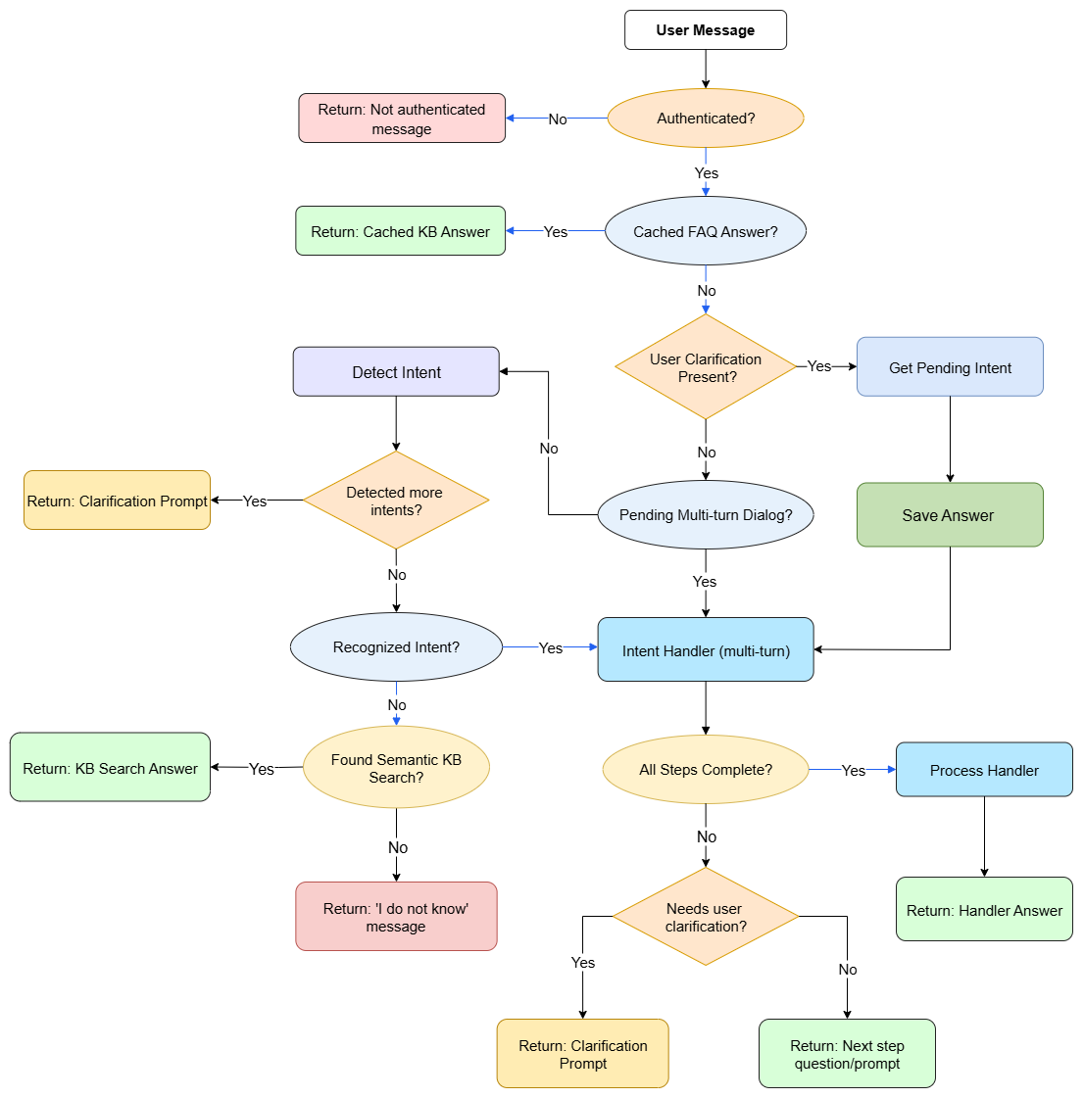
Main workflow diagram

Security and role management
ShopAssistant uses JWT tokens for secure authentication and authorization. Some topics or answers are restricted based on user role (e.g., customer, staff, admin). These restrictions are enforced automatically, and semantic search only considers answers within the allowed topics for each user.

Performance and extensibility

- All embeddings and knowledge entries are preloaded into memory at application startup, ensuring instant access and low-latency responses.
- Use effective memory caching and the HNSW.Net library to find nearest neighbors guarantees fast responses even to semantic queries, regardless of the size of the dataset.
- Supports rapid business-driven changes: new FAQs, knowledge, or dialog flows can be added or updated in JSON configuration files without redeploying or restarting the service.
- System resources (like embedding models and vocab files) are organized for fast loading and minimal application downtime during updates.
- All knowledge base content, intent patterns, message translations are defined in external JSON files. Updates to these files require no code changes or redeployment. Admins can apply changes instantly using the cache refresh endpoint.

Appendix: Technical workflow (for developers and IT)

• User messages are processed by the Chat API controller (secure, JWT-protected).
• Intent detection uses a hybrid approach: regex/pattern match, stemming, and finally embedding similarity (using LaBSE and OnnxRuntime).
• Embeddings are cached and compared using HNSW.Net for rapid semantic search. When performing semantic search, only topics allowed for the user's role are considered—enforcing strict authorization at search time.
• Multi-turn dialog handlers are invoked based on intent.
• All system components (intent detectors, handlers, vector store) are modular and easily swapped or extended.
• Authorization logic enforces topic-level restrictions both before and during all searches and responses.

