Please make sure you have the Ultimate version of IntelliJ IDEA 2016.3 or higher installed.
If you don’t have a copy of IntellJ IDEA Ultimate you can apply for a free student licence from the following link: https://www.jetbrains.com/student/
You also need to have JDK 8 installed.
To install and run the semantic spreadsheets in IntelliJ IDEA:
- First make sure that the Scala plugin is installed.
- If not, click on Configure -> plugins
- Click on “install JetBrains Plugin…”
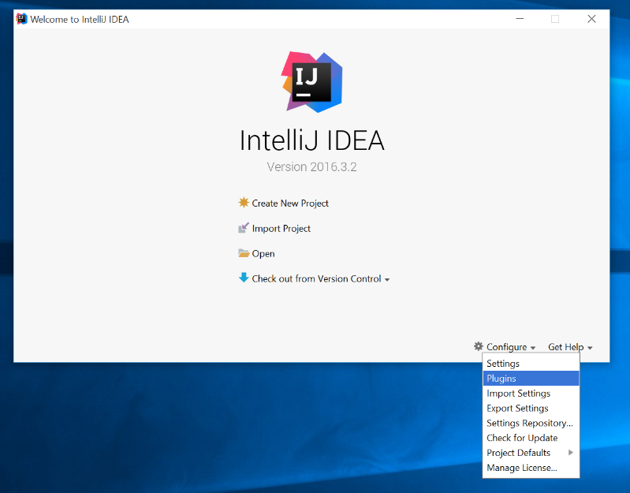
- In the menu that appears search for Scala and click install
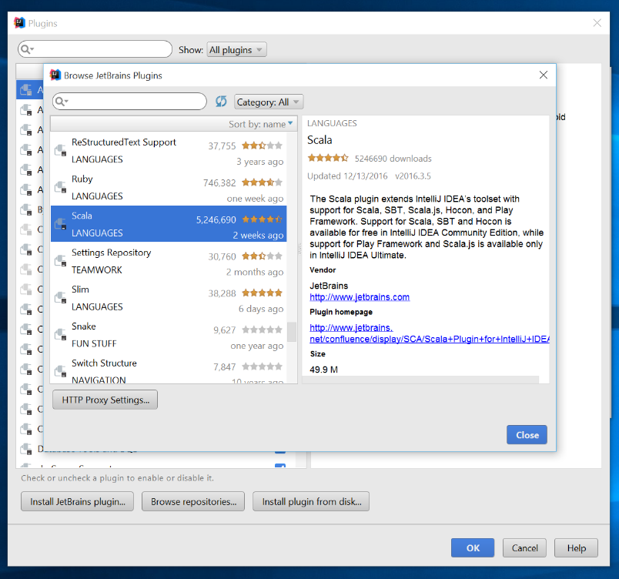
- Wait for the plugin to be installed
- Go back to the main menu and select “Import Project”
- Select the repository directory

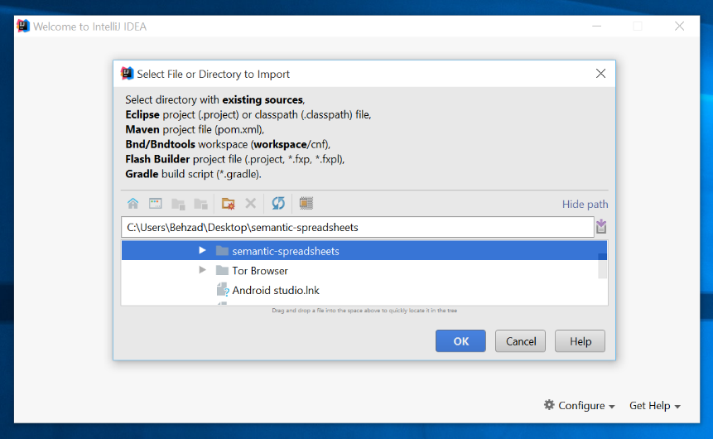

- In the “import project” menu select “import project from external model” and then select “SBT”
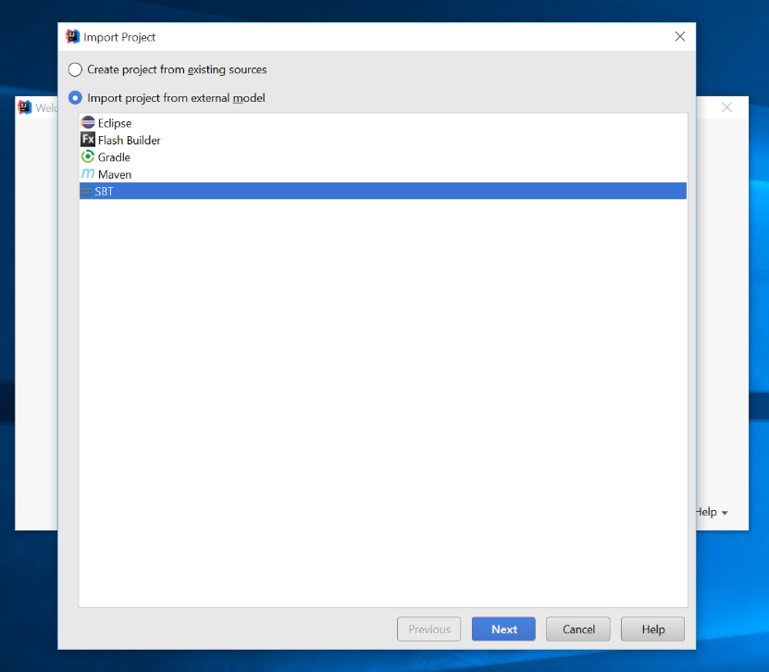

- Change “Project SDK” to your locally installed java SDK
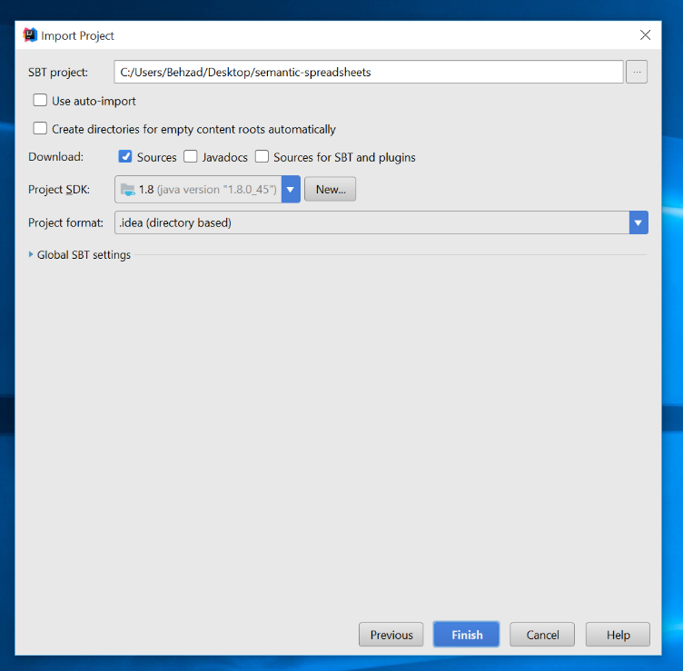

- In “SBT Project Data To Import” select both “root” and “root-build” folders
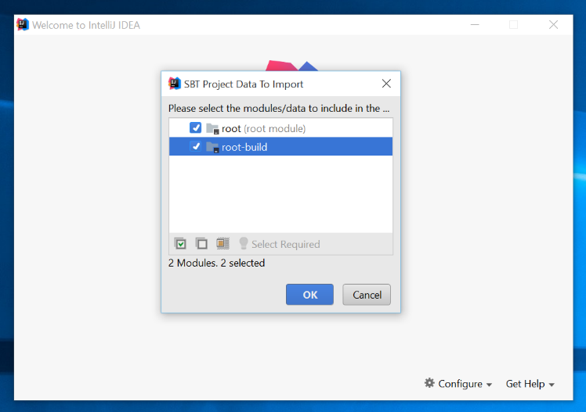

- After the import is done go to file -> Setting
- Under “Languages & frameworks” select “Play2”
- In the “Play2” menu check “Use Play 2 compiler for this project”
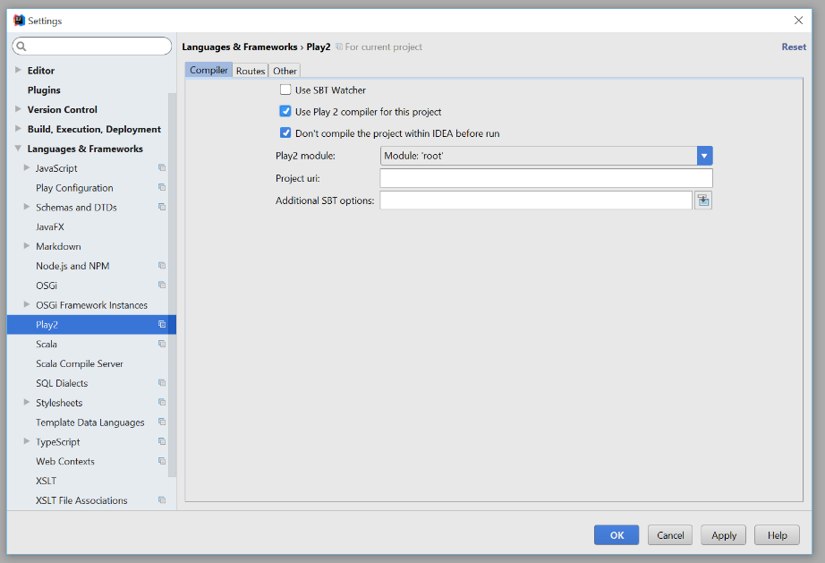

- Hit Ok, and go back to the main page
- From the “Build” menu select ”Rebuild project”
- Project must be built successfully with some warnings but no errors
- To run the project select “run” from “run” menu
- In the run menu that appears select “edit Configurations…”

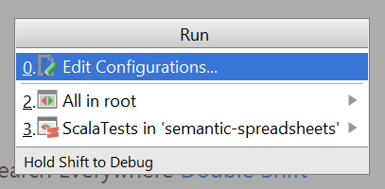

- Click on the plus button on the top left corner to add a new configuration (alternatively you can hit Alt+Insert)

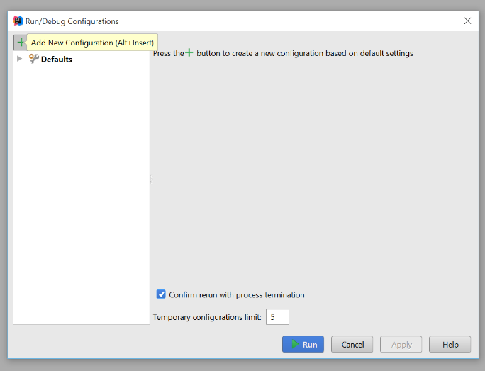

- In “Run/Debug Configurations” menu select “Play 2 App”

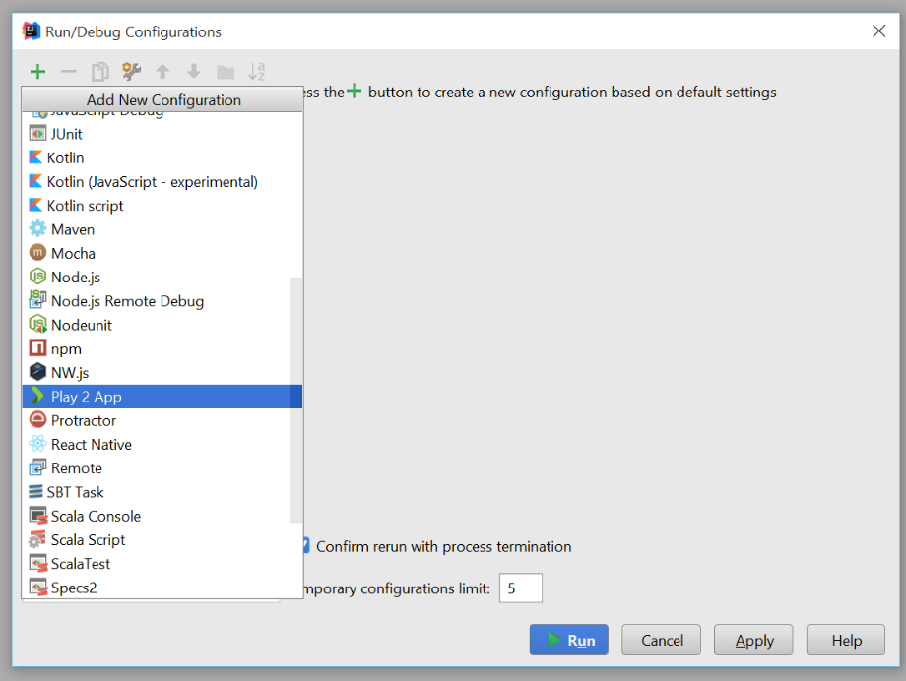

- An “unnamed” configuration will be added to run menu under “Play 2 app”

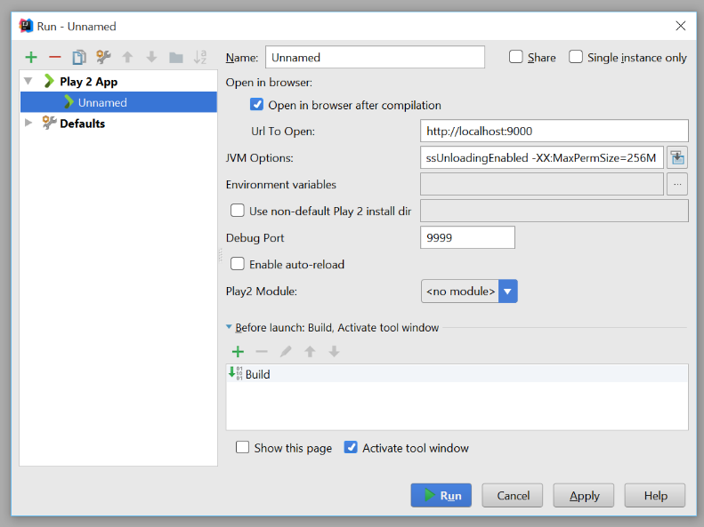

- Hit “Run” and wait for IntelliJ to run the app.
- If the browser is not automatically opened, open the browser and go to address “localhost:9000” where you should be able to see Project’s login page.
- You can login with any username and password

