Perl大作业实验报告

一、下载数据
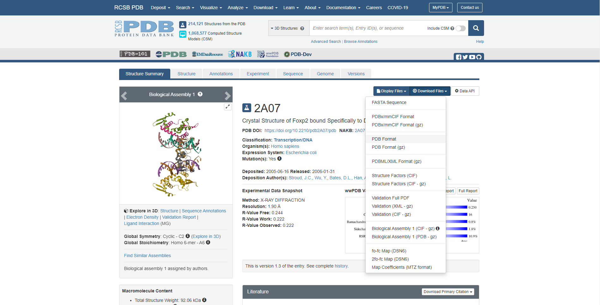

二、从完整的复合物文件抽取蛋白坐标文件和DNA坐标文件
蛋白质：
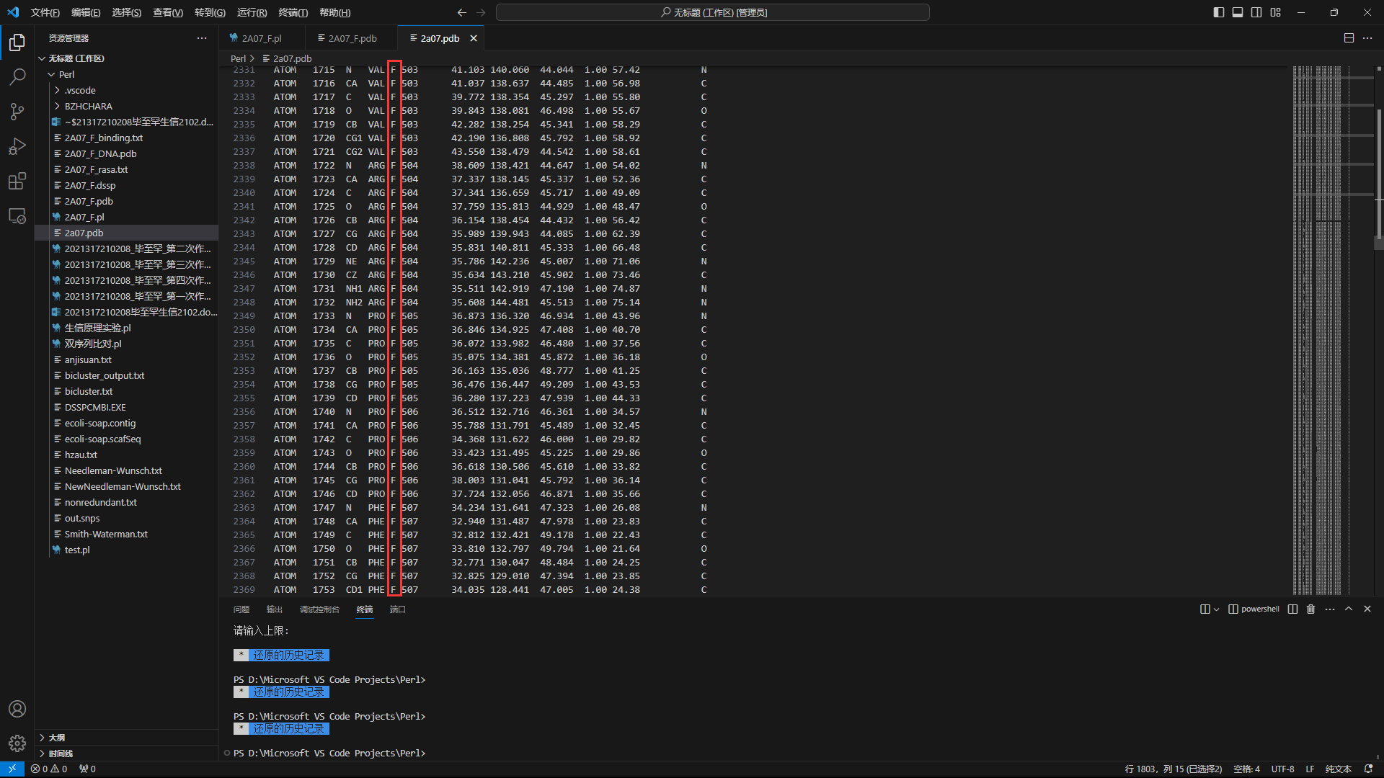
DNA:
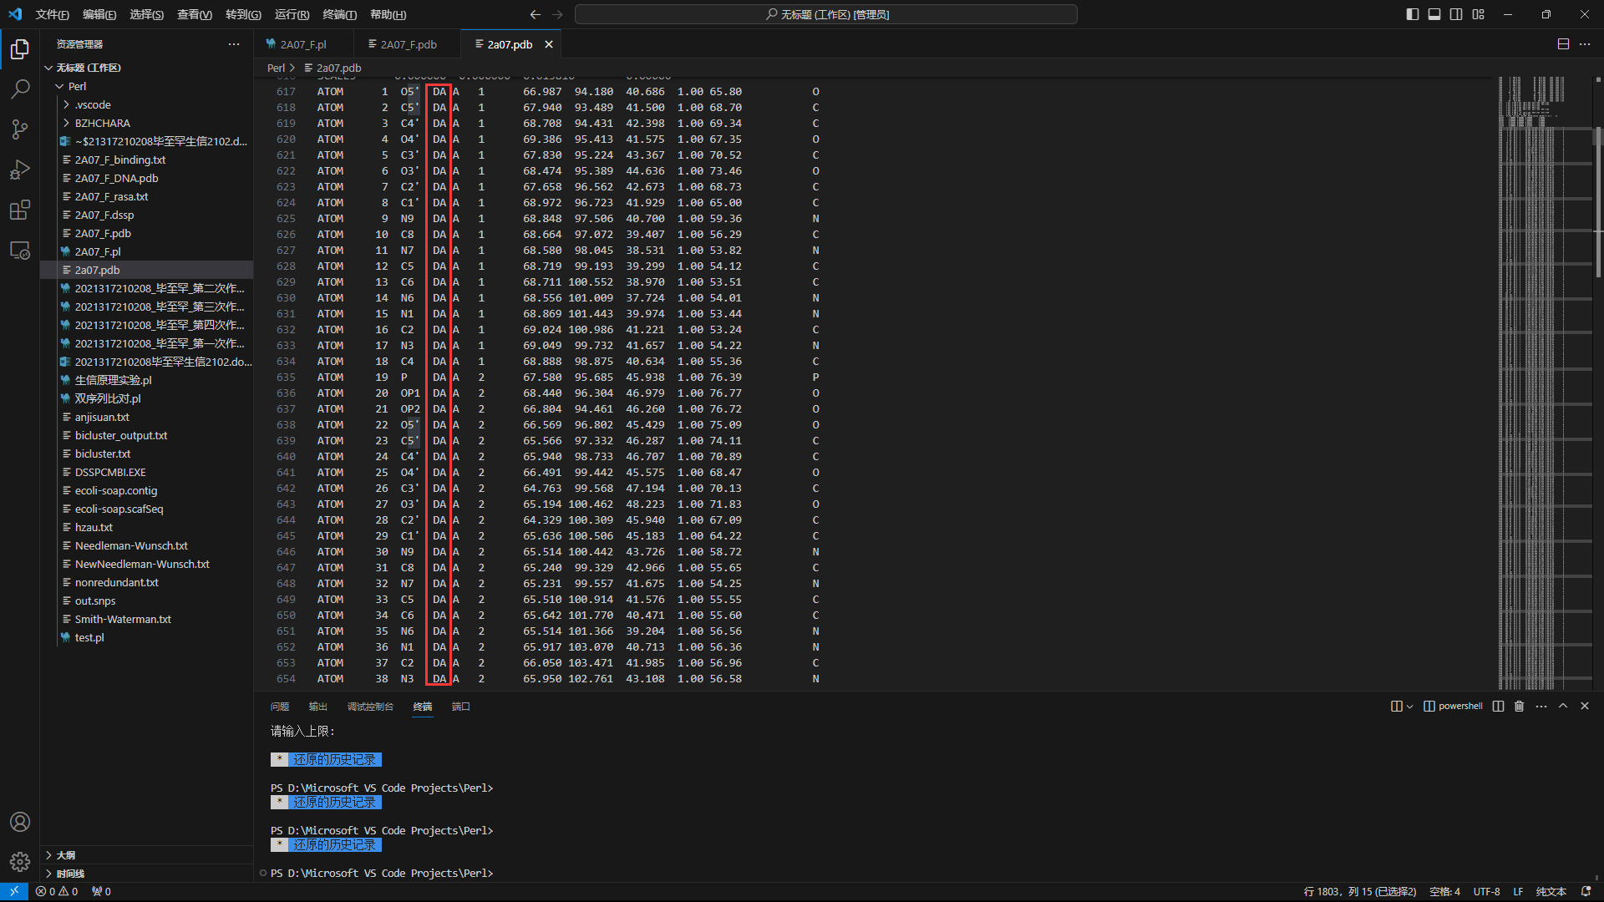
代码实现：
use utf8;
use open ":encoding(gbk)",":std";

#查看数组内容
sub test
{
foreach $i(0..$#_)
{
print("@{$_[$i]}\n");
}
}

open IN,"<","2a07.pdb";
open OUT_F,">","2A07_F.pdb";
open OUT_F_DNA,">","2A07_F_DNA.pdb";
while (<IN>)
{
chomp;
if ($_=~/(ATOM\s+\d+\s+[\w\d]{1,3}\s+\w{3}\s+F.+\w)/)
{
print{OUT_F}("$1\n");
}
if ($_=~/(ATOM\s+\d+\s+[\w\d\']{1,3}\s+D[A|G|C|T].+\w)/)
{
print{OUT_F_DNA}("$1\n");
}
}
close IN;
close OUT_F;
close OUT_F_DNA;
提取文件：
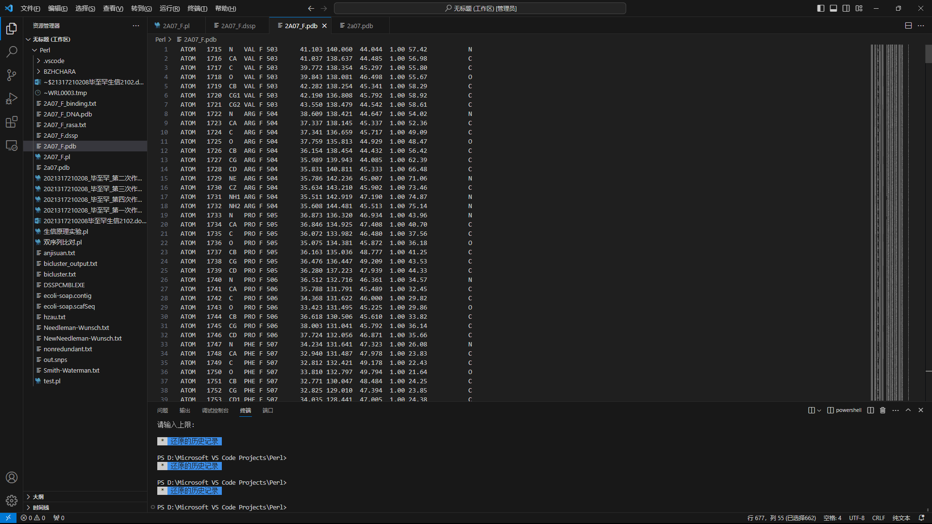
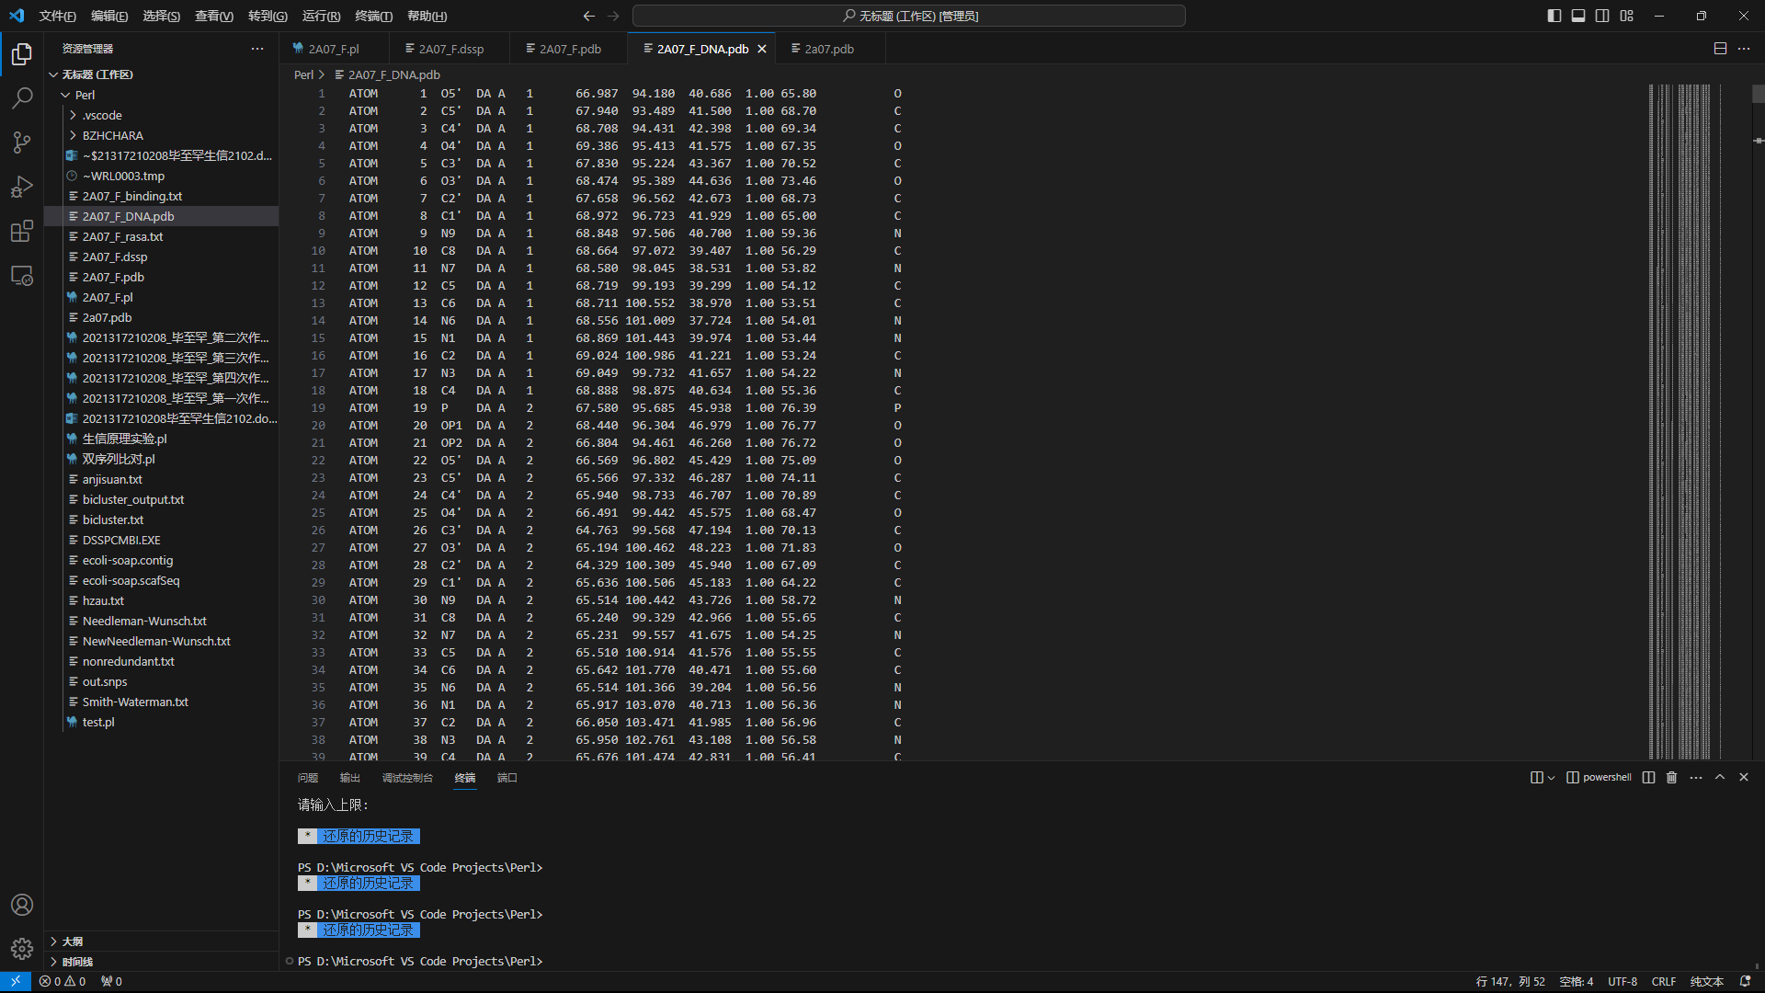

三、利用DSSP程序计算蛋白残基的溶剂可及表面积
命令：
DSSPCMBI.EXE 2A07_F.pdb 2A07_F.dssp
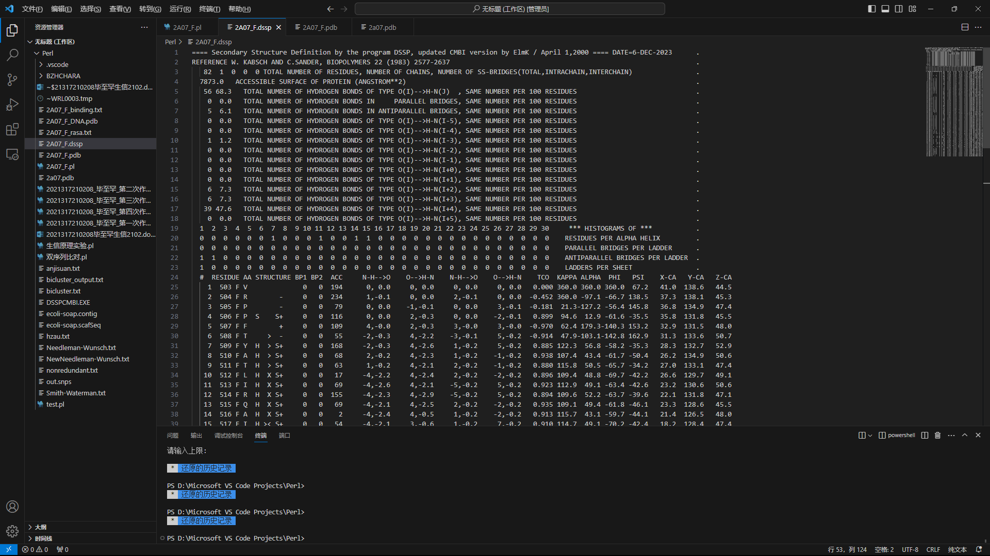

四、计算残基的相对溶剂可及表面积并定义表面残基
公式：RASA=ASA/NMA
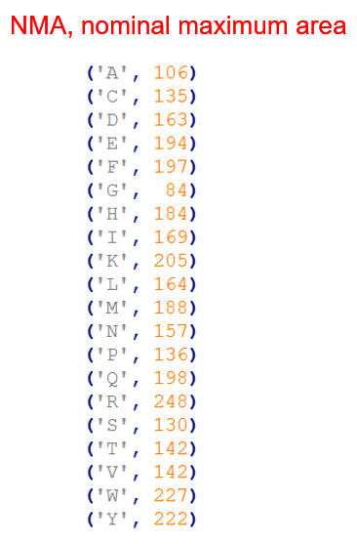
代码实现：
$tmp=();
%hash=('A'=>106,'C'=>135,'D'=>163,'E'=>194,'F'=>197,'G'=>84,'H'=>184,'I'=>169,'K'=>205,'L'=>164,'M'=>188,'N'=>157,'P'=>136,'Q'=>198,'R'=>248,'S'=>130,'T'=>142,'V'=>142,'W'=>227,'Y'=>222);
open IN,"<","2A07_F.dssp";
open OUT,">","2A07_F_rasa.txt";
while (<IN>)
{
chomp;
if ($_=~/\s+\d+\s+(\d{3})\s+F\s+(\w).{20}\s+(\d+)/)
{
$tmp=$3/$hash{$2};
print{OUT}("$1 $2 $tmp\n");
}
}
close IN;
close OUT;
计算结果：
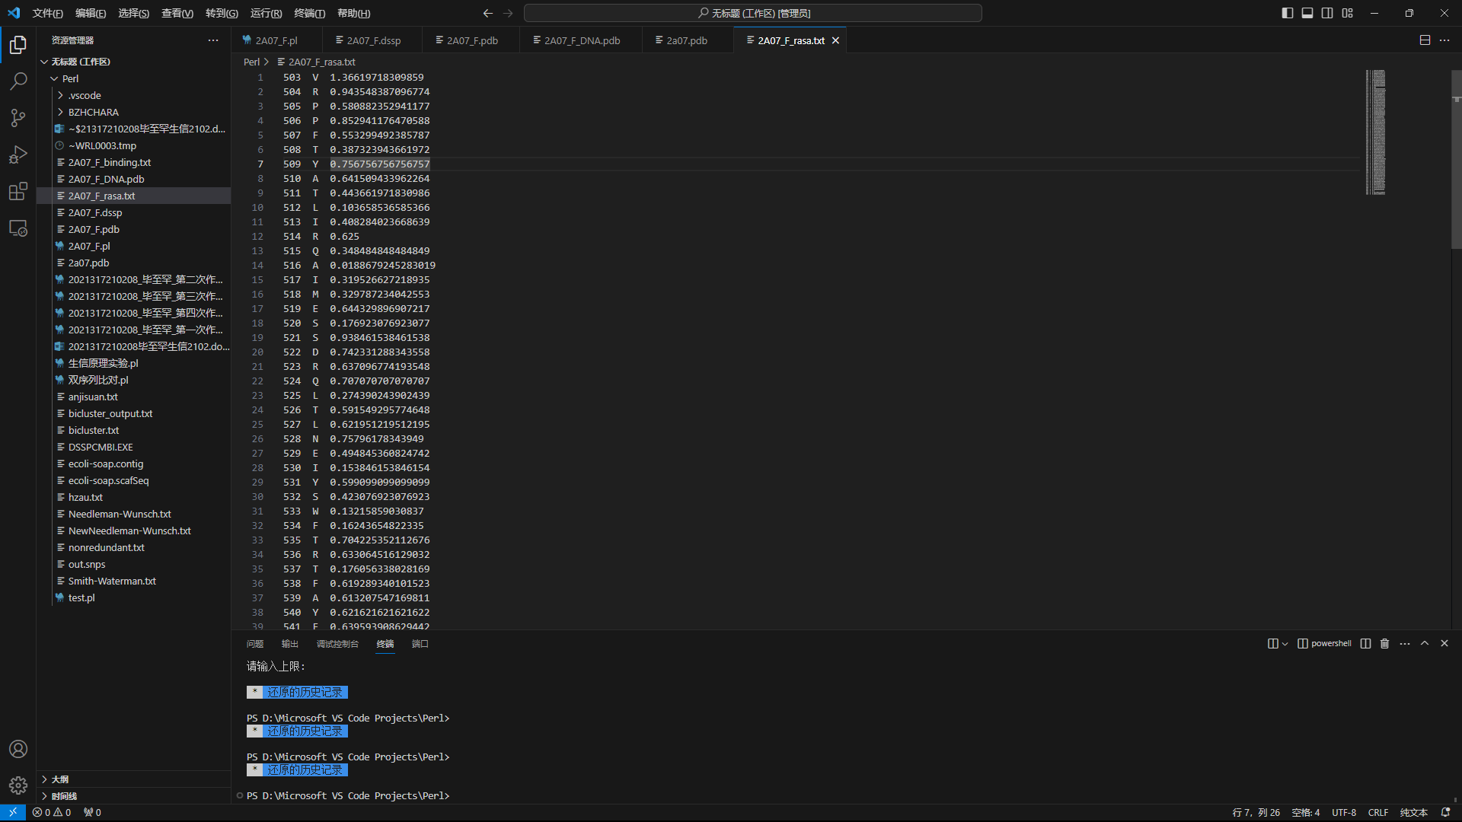

五、利用蛋白坐标文件和DNA坐标文件计算蛋白结合位点
步骤：
1.从2A07_F_rasa.txt读入表面残基并存放于数组(表面残基数组)
2. 从2A07_F_DNA.pdb读入DNA坐标存放于二维数组
3. 遍历表面残基数组，从2A07_F.pdb抽出相应残基坐标，与DNA坐标进行计算。若一对原子间距离小于4.5埃，可以提前跳出循环进行下一个残基。
代码实现：
open IN_1,"<","2A07_F_rasa.txt";
open IN_2,"<","2A07_F.pdb";
open IN_3,"<","2A07_F_DNA.pdb";
open OUT,">","2A07_F_binding.txt";
@data_1=();
@data_2=();
@data_3=();
while (<IN_1>)
{
chomp;
push(@data_1,[split('\s+',$_)]);
}
#test(@data_1);

while (<IN_2>)
{
chomp;
push(@data_2,[split('\s+',$_)]);
}
#test(@data_2);

while (<IN_3>)
{
chomp;
push(@data_3,[split('\s+',$_)]);
}
#test(@data_3);

while ($x<=$#data_1)
{
if ($data_1[$x][2]>0.1)
{
foreach $y(0..$#data_2)
{
if ($data_1[$x][0]==$data_2[$y][5])
{
foreach $z(0..$#data_3)
{
$length=sqrt((($data_2[$y][6]-$data_3[$z][6])**2)+(($data_2[$y][7]-$data_3[$z][7])**2)+(($data_2[$y][8]-$data_3[$z][8])**2));
if ($length<4.5)
{
print{OUT}("1\t$data_1[$x][0]\t$data_1[$x][1]\n");
goto part1;
}
}
}
}
print{OUT}("0\t$data_1[$x][0]\t$data_1[$x][1]\n");
}
else
{
print{OUT}("0\t$data_1[$x][0]\t$data_1[$x][1]\n");
}
part1:$x++;
}
close IN_1;
close IN_2;
close IN_3;
close OUT;
计算结果：
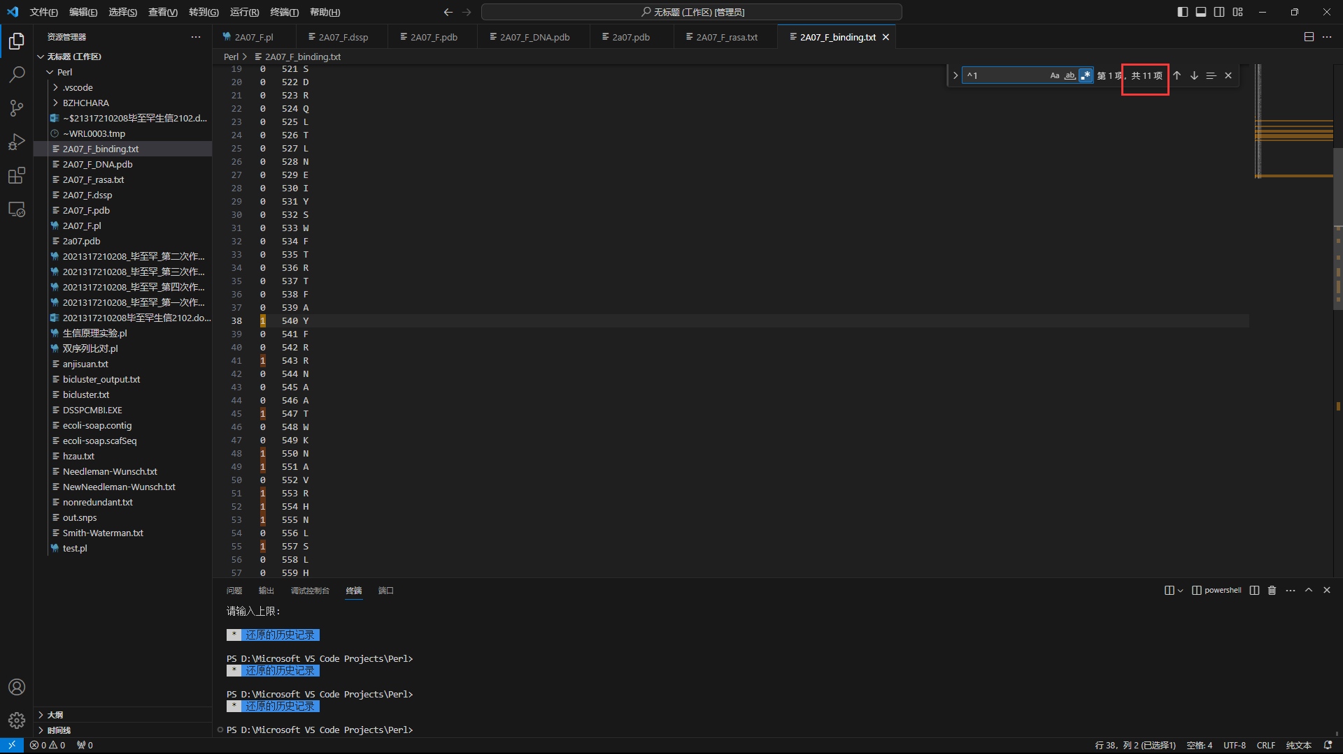

六、利用RasMol对原始复合物文件中的绑定位点进行可视化
打开原pdb文件：
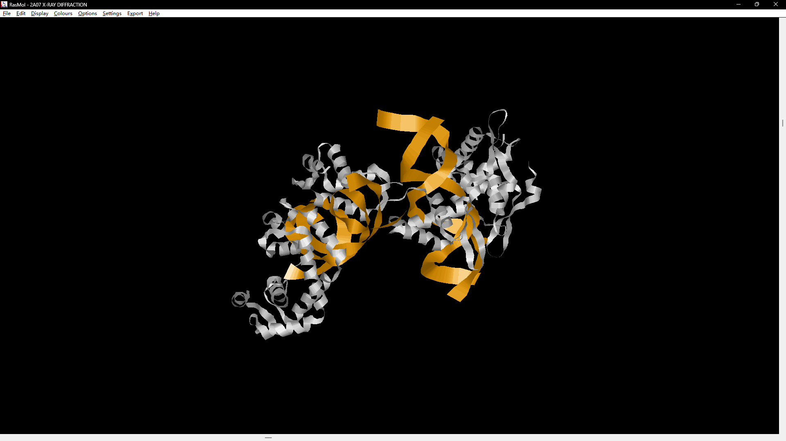
标出符合数据：
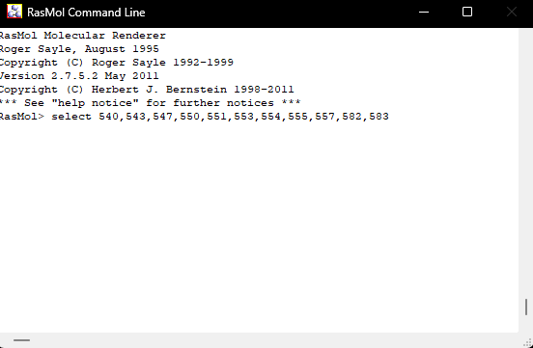
上色：
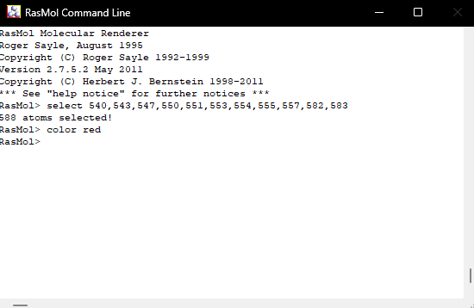
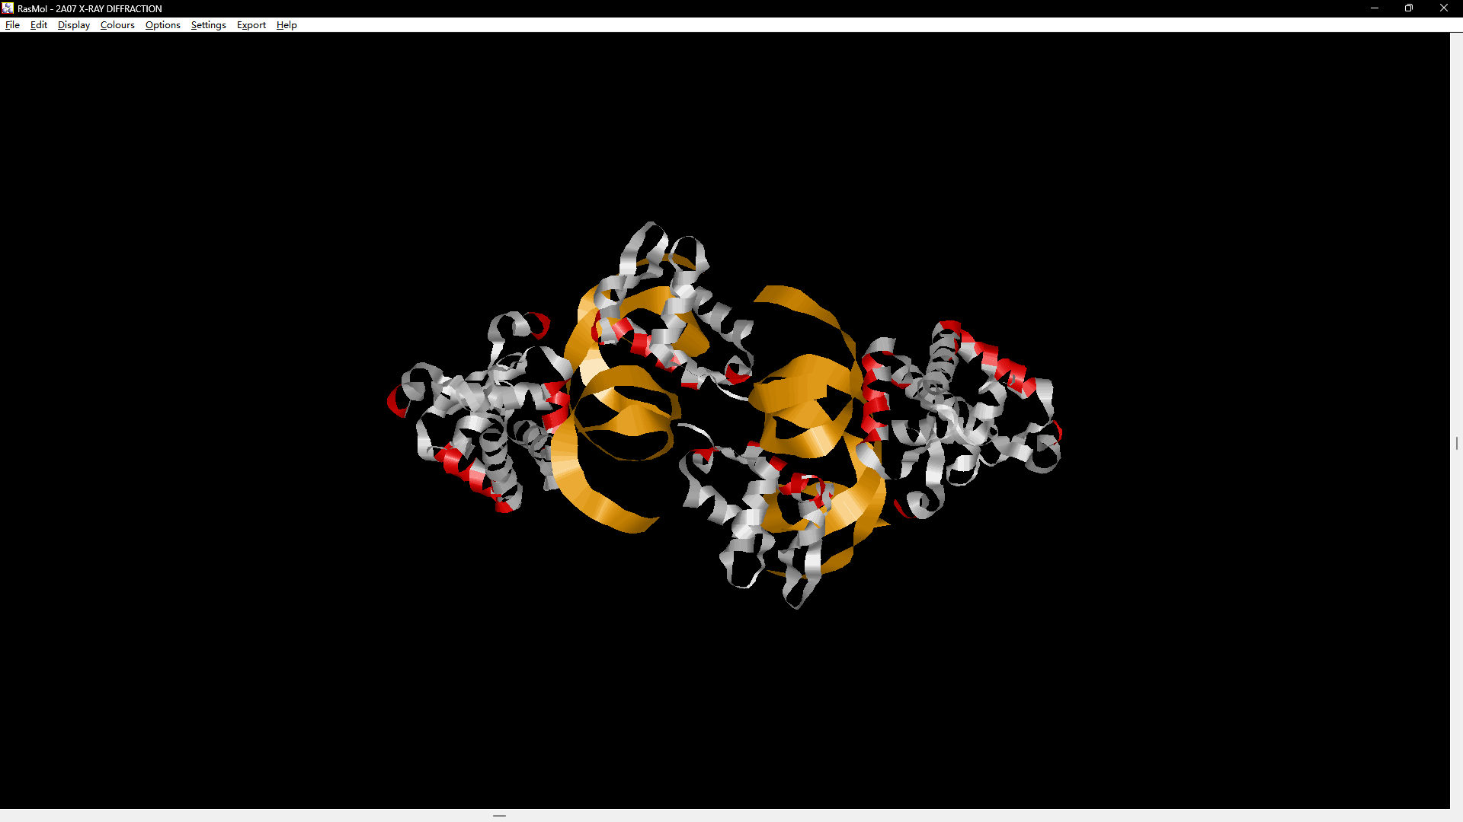

完整代码
use utf8;
use open ":encoding(gbk)",":std";

#查看数组内容
sub test
{
foreach $i(0..$#_)
{
print("@{$_[$i]}\n");
}
}

open IN,"<","2a07.pdb";
open OUT_F,">","2A07_F.pdb";
open OUT_F_DNA,">","2A07_F_DNA.pdb";
while (<IN>)
{
chomp;
if ($_=~/(ATOM\s+\d+\s+[\w\d]{1,3}\s+\w{3}\s+F.+\w)/)
{
print{OUT_F}("$1\n");
}
if ($_=~/(ATOM\s+\d+\s+[\w\d\']{1,3}\s+D[A|G|C|T].+\w)/)
{
print{OUT_F_DNA}("$1\n");
}
}
close IN;
close OUT_F;
close OUT_F_DNA;

$tmp=();
%hash=('A'=>106,'C'=>135,'D'=>163,'E'=>194,'F'=>197,'G'=>84,'H'=>184,'I'=>169,'K'=>205,'L'=>164,'M'=>188,'N'=>157,'P'=>136,'Q'=>198,'R'=>248,'S'=>130,'T'=>142,'V'=>142,'W'=>227,'Y'=>222);
open IN,"<","2A07_F.dssp";
open OUT,">","2A07_F_rasa.txt";
while (<IN>)
{
chomp;
if ($_=~/\s+\d+\s+(\d{3})\s+F\s+(\w).{20}\s+(\d+)/)
{
$tmp=$3/$hash{$2};
print{OUT}("$1 $2 $tmp\n");
}
}
close IN;
close OUT;

open IN_1,"<","2A07_F_rasa.txt";
open IN_2,"<","2A07_F.pdb";
open IN_3,"<","2A07_F_DNA.pdb";
open OUT,">","2A07_F_binding.txt";
@data_1=();
@data_2=();
@data_3=();
while (<IN_1>)
{
chomp;
push(@data_1,[split('\s+',$_)]);
}
#test(@data_1);

while (<IN_2>)
{
chomp;
push(@data_2,[split('\s+',$_)]);
}
#test(@data_2);

while (<IN_3>)
{
chomp;
push(@data_3,[split('\s+',$_)]);
}
#test(@data_3);

while ($x<=$#data_1)
{
if ($data_1[$x][2]>0.1)
{
foreach $y(0..$#data_2)
{
if ($data_1[$x][0]==$data_2[$y][5])
{
foreach $z(0..$#data_3)
{
$length=sqrt((($data_2[$y][6]-$data_3[$z][6])**2)+(($data_2[$y][7]-$data_3[$z][7])**2)+(($data_2[$y][8]-$data_3[$z][8])**2));
if ($length<4.5)
{
print{OUT}("1\t$data_1[$x][0]\t$data_1[$x][1]\n");
goto part1;
}
}
}
}
print{OUT}("0\t$data_1[$x][0]\t$data_1[$x][1]\n");
}
else
{
print{OUT}("0\t$data_1[$x][0]\t$data_1[$x][1]\n");
}
part1:$x++;
}
close IN_1;
close IN_2;
close IN_3;
close OUT;

