5.1

#include<iostream>

using namespace std;

class Time

{

private:

int hour;

int minute;

int sec;

public:

void SetTime(void){

cin >> hour;

cin >> minute;

cin >> sec;

}

void ShowTime(void) {

cout << hour << ":" << minute << ":" << sec;

}

};

int main() {

Time t1;

t1.SetTime();

t1.ShowTime();

return 0;

}

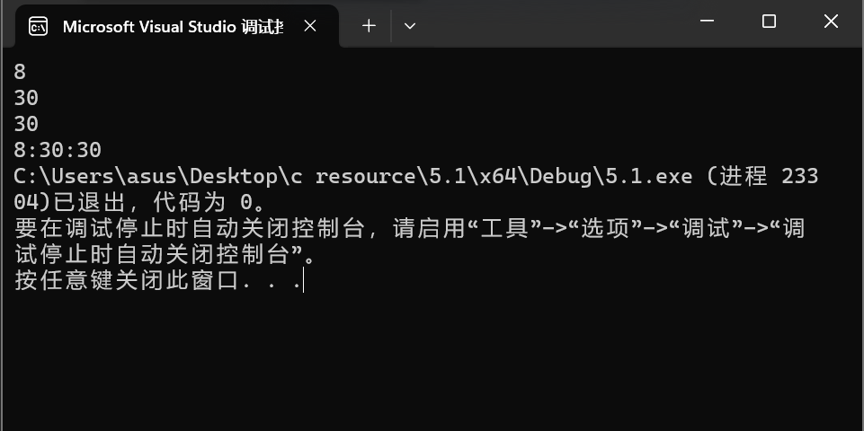

5.2

//student.h

class Student {

public:

void display();

Student() {

set_value();

}

Student(int _num, const char _name[20], char _sex);

void set_value();

private:

int num;

char name[20];

char sex;

};

//student.cpp

#include<iostream>

#include"student.h"

using namespace std;

void Student::display() {

cout << "num:" << num << endl;

cout << "name:" << name << endl;

cout << "sex:" << sex << endl;

}

void Student::set_value() {

cout << "num:";

cin >> num;

cout << "name:";

cin >> name;

cout << "sex:";

cin >> sex;

}

Student::Student(int _num, const char _name[20], char _sex) {

num = _num;

sex = _sex;

for (int i = 0;i < 20;i++)

name[i] = _name[i];

}

//main.cpp

#include<iostream>

#include"student.h"

int main()

{

Student stud;

Student stud1(007, "tcg", 'm');

stud.display();

return 0;

}

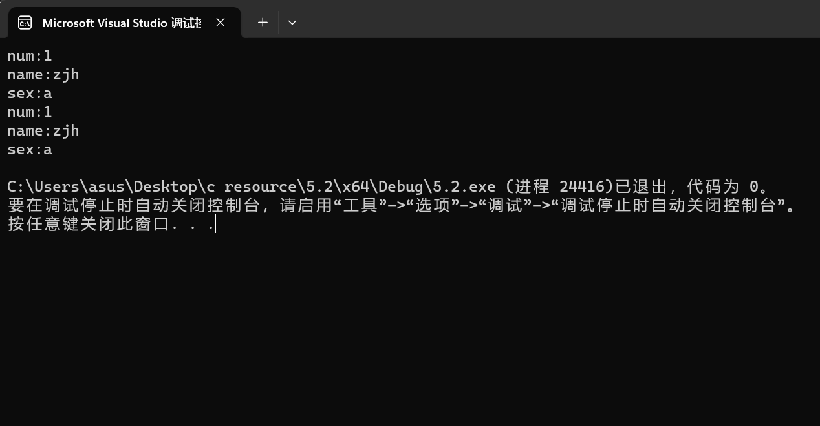

5.3

#include<iostream>

using namespace std;

class Box {

private:

float length;

float width;

float height;

public:

float volume() {

return length * width * height;

}

void set_value() {

cout << "Enter the length,width and height of the box:" << endl;

cin >> length;

cin >> width;

cin >> height;

}

void display() {

cout << volume() << endl;

}

};

int main() {

Box box1, box2, box3;

box1.set_value();

cout << "The volume of box1 is:";

box1.display();

box2.set_value();

cout << "The volume of box2 is:";

box2.display();

box3.set_value();

cout << "The volume of box3 is:";

box3.display();

return 0;

}

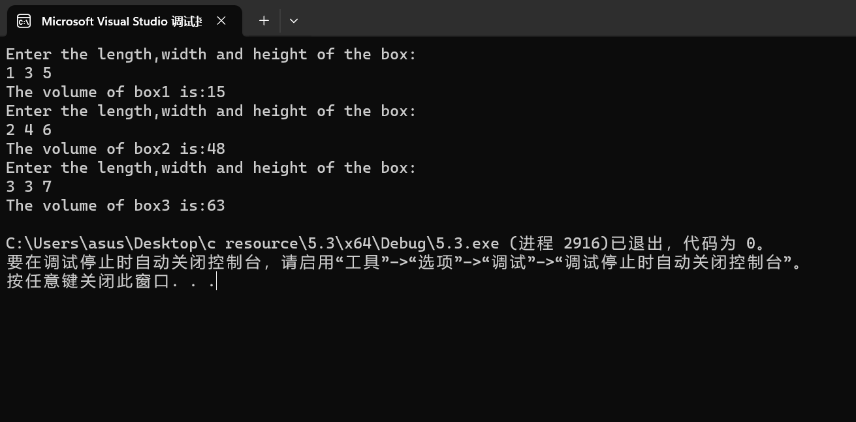

5.4

#include<iostream>

using namespace std;

class Student {

public:

Student(int n, float s) {

num = n;

score = s;

}

int num;

float score;

};

int main() {

Student student[5] = { Student(100001,99.0),Student(100002,73.5),

Student(100003,84.0),Student(100004,100.0),Student(100005,69.5) };

void max(Student*);

Student* S = &student[0];

max(S);

return 0;

}

void max(Student* a) {

float max_score = a[0].score;

int i = 0;

for(int k=0;k<5;k++)

if (a[k].score > max_score) {

max_score = a[k].score;

i = k;

}cout << a[i].num << " " << max_score << endl;

}

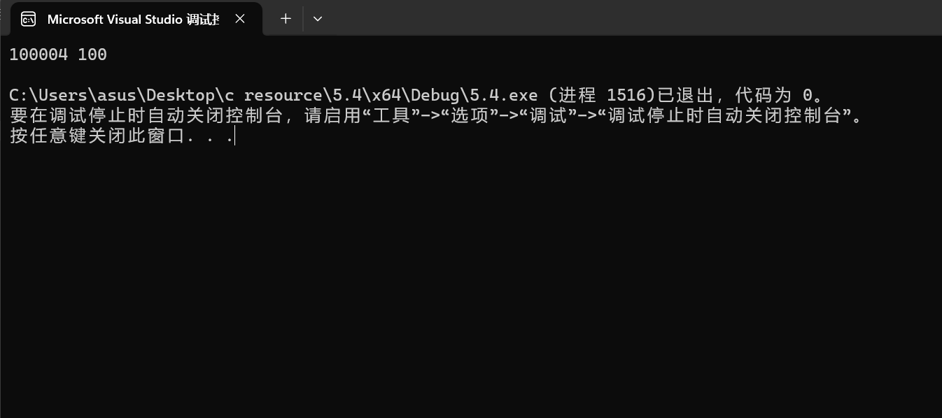

5.5

#include<iostream>

using namespace std;

class Point {

private:

int x;

int y;

public:

void setPoint(int i, int j);

void display();

Point(int x, int y) {

this->x = x;

this->y = y;

}

};

int main() {

Point cpoint(60, 80);

int i, j;

cout << "Enter dx:" << endl;

cin >> i;

cout << "Enter dy:" << endl;

cin >> j;

cpoint.setPoint(i, j);

cpoint.display();

}

void Point::setPoint(int i, int j){

this->x = x + i;

this->y = y + j;

}

void Point::display() {

cout << "(" << x << "," << y << ")" << endl;

}

