# Setup Guide for Creating a Test Environment for Power BI Projects

**Overview**: In July of 2015, Microsoft released the second generation of the Power BI platform which has an underlying architecture that is very different from the initial release of the Power BI platform. The initial release of the Power BI platform is known as **Power BI for Office 365** and it relies on SharePoint Online and a dedicated SharePoint site template for creating Power BI sites. With the second generation release of the Power BI platform known simply as **Power BI**, Microsoft has removed the underlying Power BI dependencies on SharePoint sites replacing them with Power BI workspaces that are implemented using the new Unified Group feature that was recently introduced in Office 365.

This setup guide covers how to get up and running with the latest release of the Power BI platform which Microsoft refers to these days as the “New Experience”. You will learn the steps of creating a new Office 365 tenant which has trial subscriptions to Office 365 and Power BI Pro. The main purpose of creating this new Office 365 tenant is that it will provide a new and isolated testing environment for working with the Power BI service and using Microsoft’s self-service BI tools such as Power BI Desktop and Microsoft Excel 2016. One valuable aspect of creating a new Office 365 tenant in this manner is that you will have tenant-level administrative permissions allowing you to configure the Office 365 tenant with multiple user accounts for testing your Power BI projects in isolation from any existing Office 365 tenancy.

**Setup Time**: 1 to 2 hours

### Setup Task 1: Create a new Office 365 Trial Tenant

In this step you will create a trial tenant in the Office 365 environment which allows you to create up to 25 user accounts with Enterprise E3 trial subscriptions. Being able to create multiple Office 365 user accounts in your Power BI testing environment will be important so that you can test the effects of sharing Power BI dashboards between users.

1. Navigate to the following URL:

<https://go.microsoft.com/fwlink/p/?LinkID=403802&culture=en-US&country=US>

1. Fill out the form with your personal information and click **Next**.

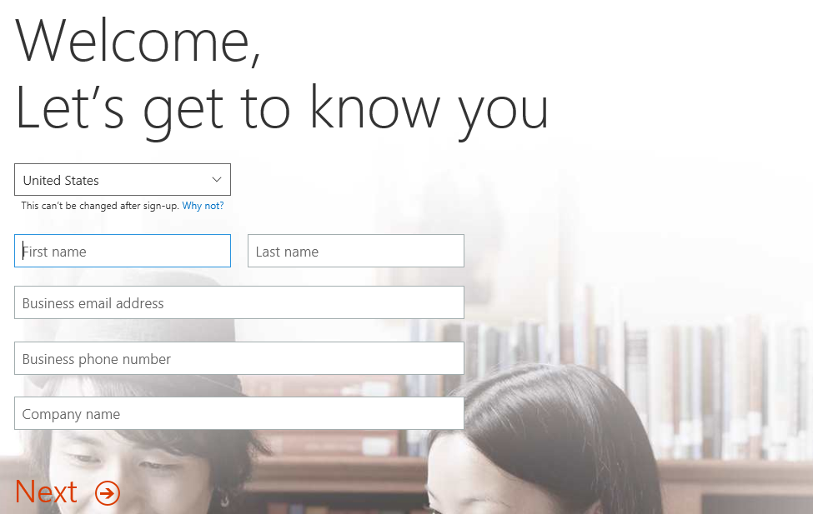

The information you provide here will be used throughout your tenant so if you do not wish to use your actual company name then provide humorous and fictitious company name.

1. On the next page, you are prompted to provide a user ID, company name and password.

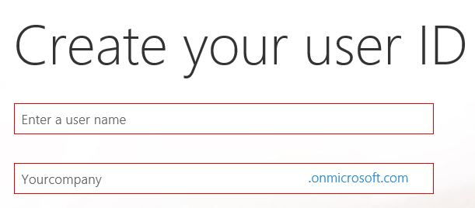

Note that the company name you enter on this page will be used to create the domain name for your new Office 365 trial tenant. For example, if you were to enter a company name of **CptBiLabs**, it would result in the creation of a new Office 365 tenant within a domain of **CptBiLabs.onMicrosoft.com**. The user name you enter will be used to create the first user account which will be given administrative rights within the trial tenant. If you enter a user name of **Student**, then the email address as well as user principal name for this account will be **Student@CptBiLabs.onMicrosoft.com**.

1. Enter a user name and a company name for your new Office 365 trial tenant. For the company name, you may wish to simply use your first and/or last name with a number which you can increment each time you have to create a new trial account (e.g. EricClapton1.onmicrosoft.com).

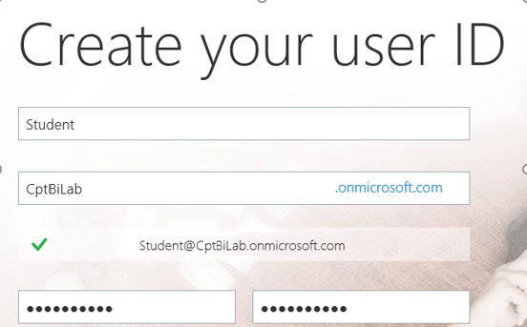

Don’t use your actual company name as that may cause some conflict when your company decides to create their own official tenant. Throughout the remainder of this guide you will see a company domain name of **CptBiLab** which you should replace with the value specified for your company name.

1. Click **Next** to continue to step 3.
2. Complete the validation form in step 3 by proving you are not a robot.
   1. Select the **Text me** option and provide the number of your mobile phone.
   2. When you go through this process, a Microsoft service will send you a text message that contains an access code.
   3. You retrieve the access code form your mobile device and use it to complete the validation process.



1. Once you have completed the validation process, click the **You’re ready to go…** link to navigate to the portal welcome page for your new Office 365 trial tenant. Note that you should already be logged on using the user account that was created during the sign up process.

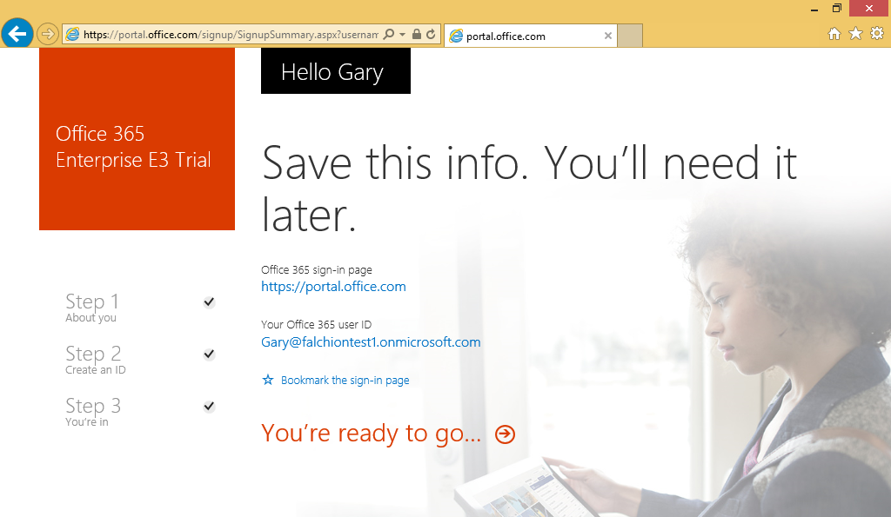

At this point, you have already created your new Office 365 tenant which can support creating up to 25 user accounts with Office 365 Enterprise E3 trial licenses. Note that some Office 365 services within your new Office 365 tenant such as the Office 365 admin center can be accessed immediately. Other services within your Office 365 tenant such as SharePoint Online are not ready immediately and will take some time to provision.

1. At this point, you should be located on the portal welcome page of Office 365. You will notice that this page shows the progress of the Office 365 environment in setting up each of the individual services that make up your new Office 365 tenant. Click the **Admin** tile to proceed to the Office **365 admin center**.

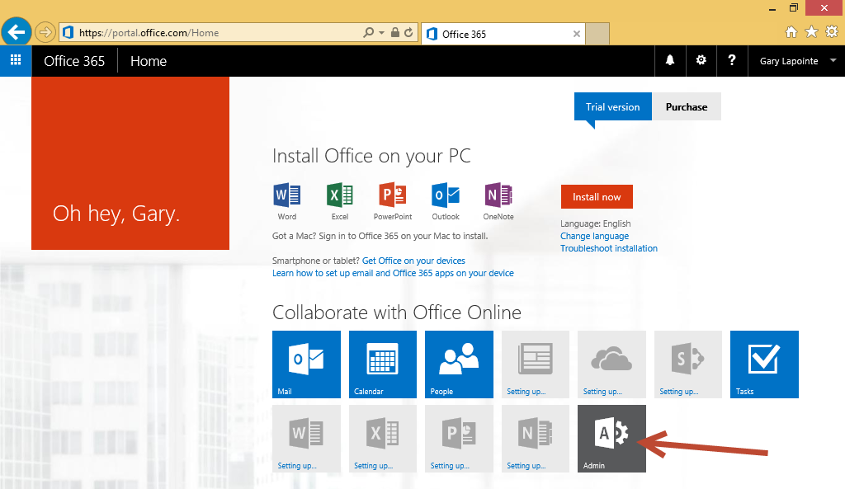

1. Verify that you are able to access the home page of the **Office 365 admin** center.

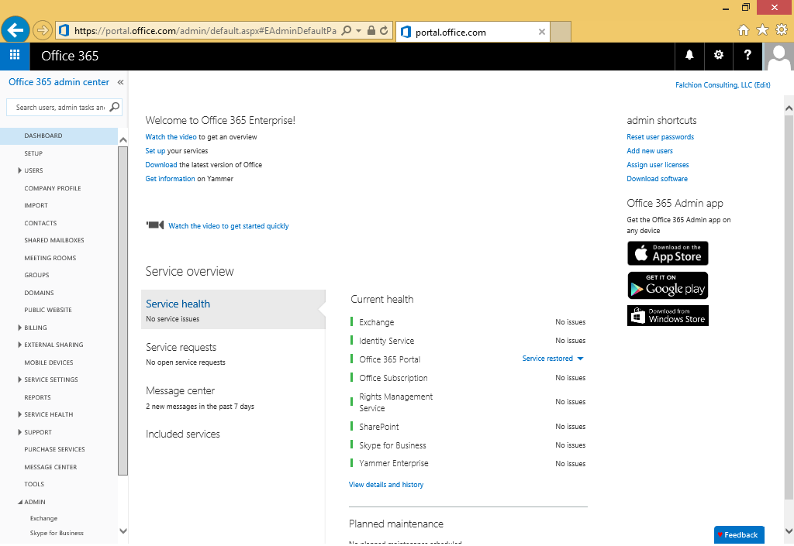

If you are interested in getting more familiar with the **Office 365 admin center**, take a minute to explore the administrative pages behind each of the links in the Office 365 admin center navigation menu on the left-hand side of the page.

### Setup Task 2: Verify You Have Access to Office 365 Mail

In this setup task you will verify that you have access to the Outlook Web Access client for Office 365 mail.

1. Open the Outlook web access client by navigating to [**https://outlook.office365.com**](https://outlook.office365.com)or clicking the **Mail** icon in the Application Launcher accessible via the **Waffle** **Button**.

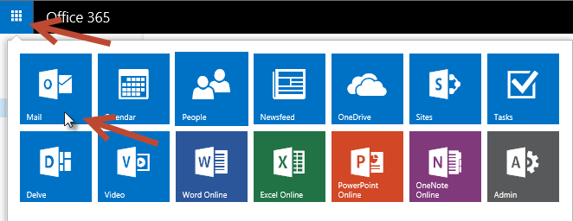

1. If prompted, specify your language and time zone for Outlook.

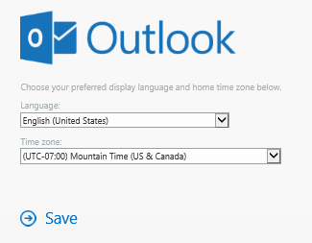

1. You should now see a web page with the Office 365 Outlook web access client and a view the Exchange inbox that is associated with the primary user account that was created when you created the Office 365 tenancy.

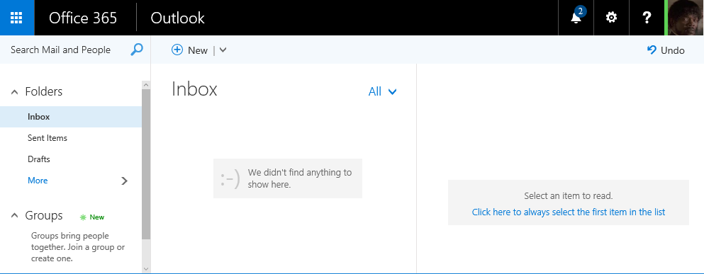

1. Test email by sending a message to one of your other email addresses,
   1. Display the form to create a new email clicking the **New** button. If the **New** button is not showing, it’s probably because the form to create a new email is already showing.

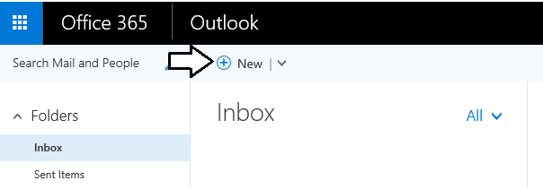

1. At this point, you should see the Outlook form to create new email on the right side of the page.

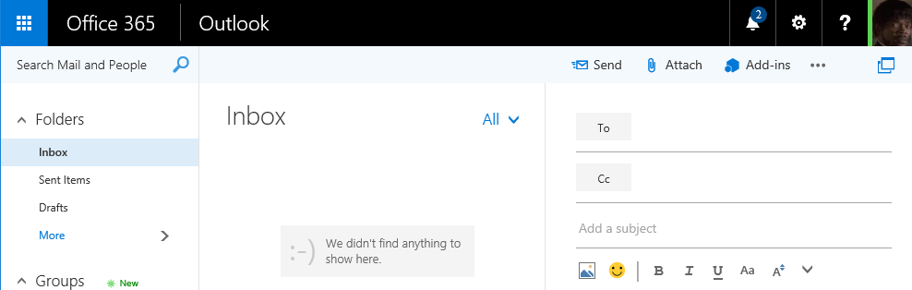

1. Fill out the new email form using sample data (see example below) to send a test message. Be sure to send the test message to an email address that is yours. Click **Send** when it’s ready to go.

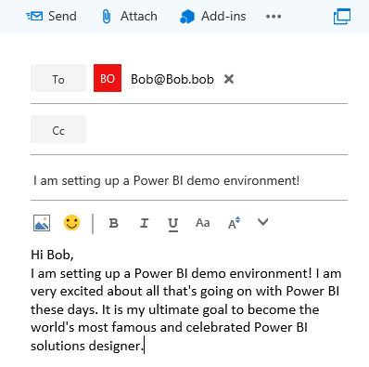

1. Click **Send** to send the email.
2. Check the email account you sent the email to and verify that you received the email.
3. Reply to the email to verify that you can send an email to your new account.
4. Return to the Outlook Web Client and verify receipt of your reply.

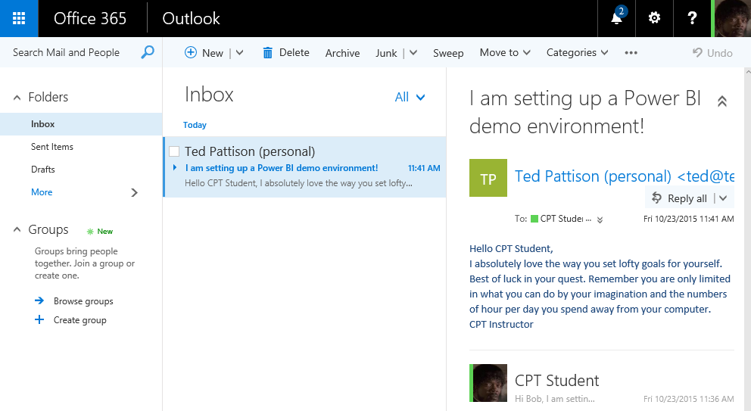

### Setup Task 3: Upload a Workbook with Sample Data to OneDrive for Business

In this setup task, you will upload an Excel workbook file containing sample data to OneDrive for Business. However, the first step will to download a copy of the sample Excel workbook to your local hard drive.

1. Download the sample Excel workbook file from Critical Path Training’s GitHub repository.
   1. In the browser, use the URL below to access and download the Excel workbook named **WingtipSalesData.xlsx** to the Downloads folder in your local machine.

<https://github.com/CriticalPathTraining/PBI365/raw/master/Data/WingtipSalesData.xlsx>

* 1. Ensure that the Excel workbook file has been saved to your local hard drive.

1. Open OneDrive for Business by clicking the **OneDrive** icon in the Application Launcher accessible via the **Waffle** **Button**.

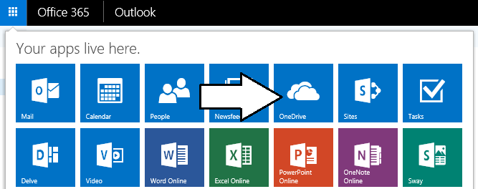

1. You should now be at the main landing page for **OneDrive for Business** which displays the **Documents** library.

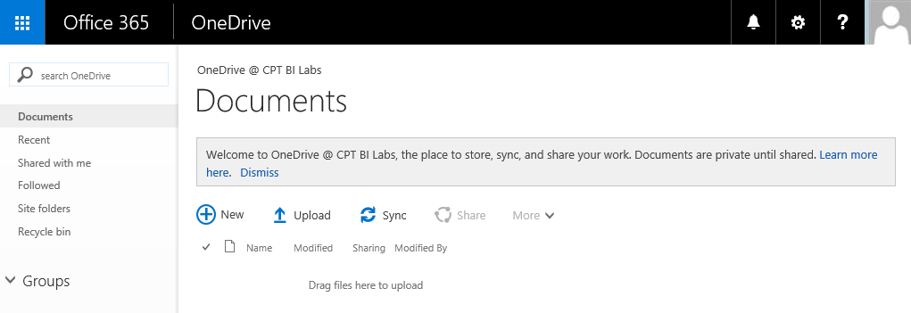

1. Click the **Upload** button and go through the steps to upload the local copy of **WingtipSalesData.xlsx** to the **Documents** library. Once you have completed this step, you should be able to verify that the **Documents** library contains **WingtipSalesData.xlsx**.

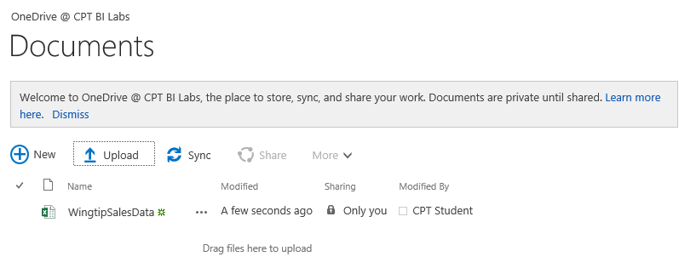

1. Inside the **Documents** library, locate and click on the **WingtipSalesData** link to open the workbook in Excel Online. As you can see, the workbook contains a sample set of tabular data that will be used in later setup tasks.

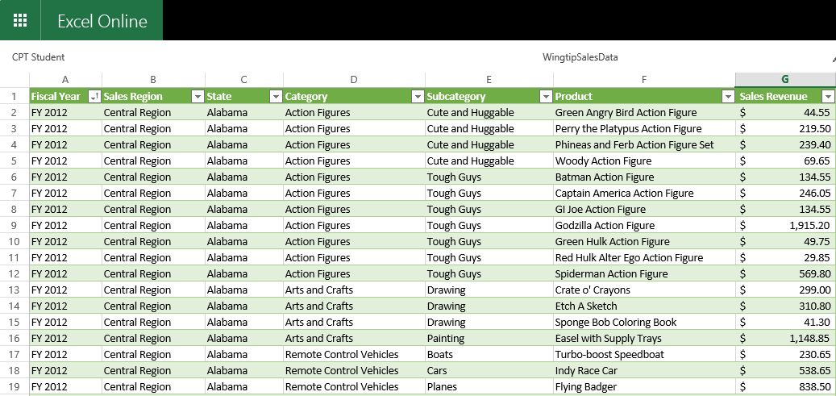

At this point, you have now uploaded an Excel workbook with sample data that you will use in later steps to create a dataset, a report and a dashboard.

### Setup Task 4: Add Trial User Licenses for Power BI Pro

In this task, you will configure your new Office 365 tenant by adding trial subscriptions for Power BI Pro. Once you have completed this task, you will be able to begin working with the Power BI service.

1. Return to Office 365 admin center by clicking the **Admin** icon in the Application Launcher accessible via the **Waffle** **Button**.
2. Start a free trial of Power BI Pro.
   1. In the **Office 365 admin center**, click the **Purchase Services** link in the left column.

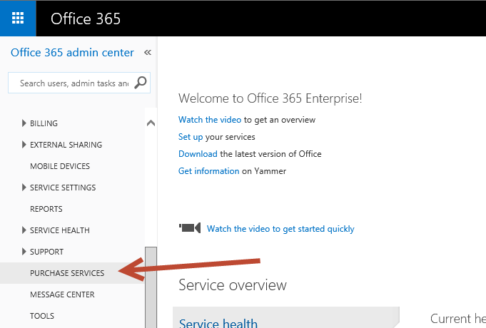

* 1. Scroll down the page of available services and locate the **Power BI Pro** tile. Hover over the ellipses (…) in the bottom of the tile and click **Start free trial**.

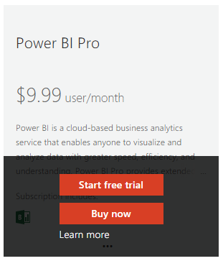

* 1. On the **Check out** page, click **try now** to add the subscription to your tenant.

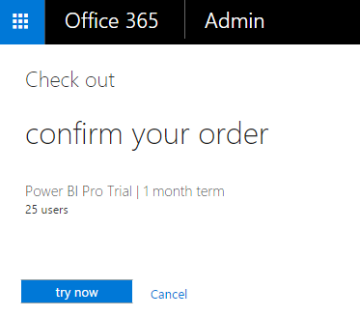

* 1. Click **continue** on the **order receipt** page.

While you have just started the Power BI Pro trial, you cannot use it yet because no trial license has been assigned to a user account. The next step is to configure your user account with a trial license for Power BI Pro.

1. Assign the Power BI license to your account.
   1. In the Office 365 admin center, expand the **Users** node in the left column and click **Active Users**.
   2. Check the box next to your account and click **Edit** next to **Office 365 Enterprise E3** in the tool pane on the right.

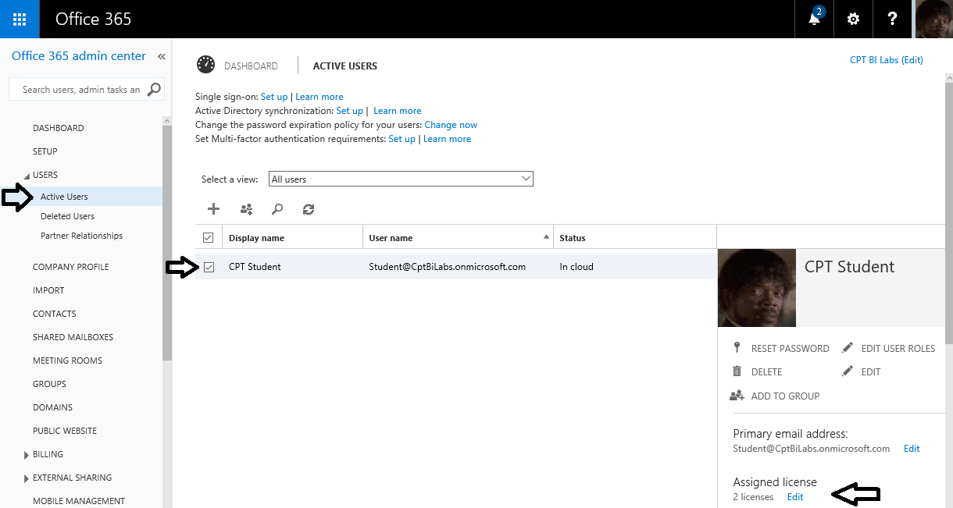

* 1. Expand **Microsoft Power BI for Office 365** and select the checkbox for the Power Bi pro license.

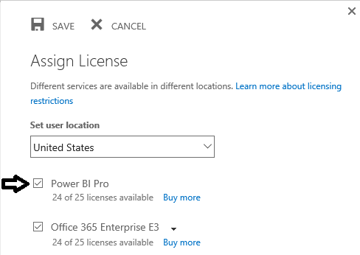

* 1. Click **Save** to complete the assignment.

1. Check the Application Launcher accessible via the **Waffle** button and verify you can see a tile for **Power BI**.

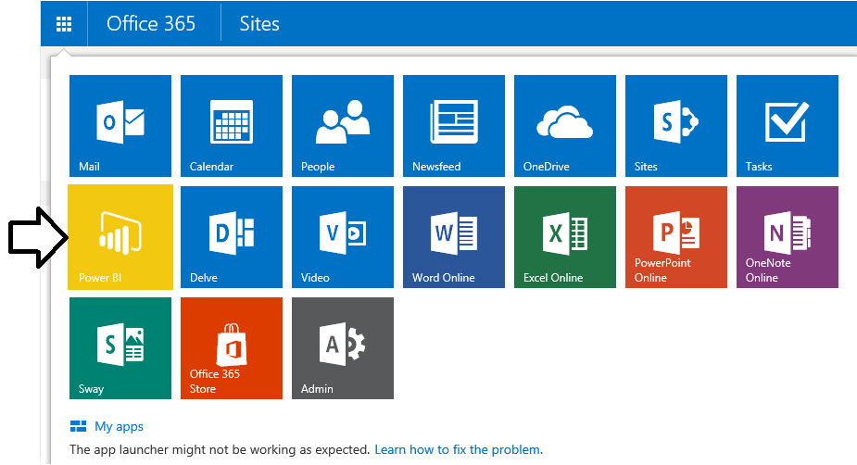

Don’t click on the tile for **Power BI** just yet. You will get to the Power BI environment in just a few more minutes. There is just one more setup task you must first complete in the Office 365 admin center which is to create a second user account. This second user account will be needed when you begin to test the effects of dashboard sharing.

### Setup Task 5: Create a Second User Account for Testing Purposes

In this step you will create a second user account and configure it with a Power BI Pro trial license.

1. In the Office 365 admin center, expand the **Users** node in the left column and click **Active Users**.
2. Click the button with the plus sign (**+**) to create a new user account

.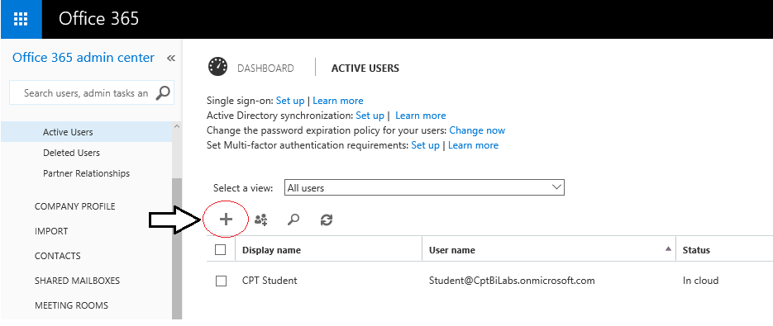

1. Fill in the **Create new user account** form with information for a new user account.
   1. When creating this account, you can use any name you would like.
   2. Click **Type password** and enter a password that you will remember such as **pass@word1**.
   3. For your convenience, uncheck the option to **Make this person change their password the next time they sign in**.

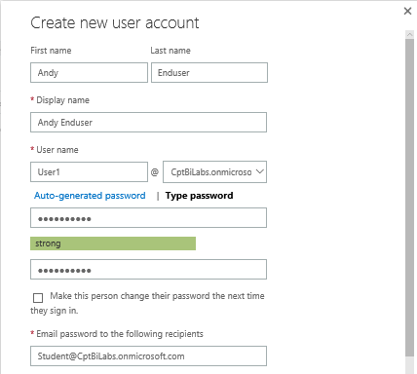

* 1. Make sure to create the new user with trial licenses for **Office 365 Enterprise E3** and **Power BI Pro**. Click the **Create** button to create the new user account.

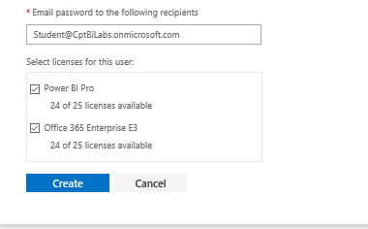

1. Verify that the new user account has been created.

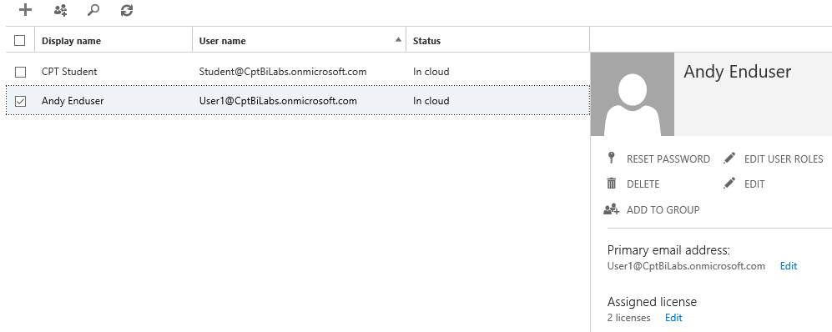

### Setup Task 6: Use the Power BI Service to Import a New Dataset

Now, after all that busy work you are finally ready to begin working with Power BI. In this setup task you will import data from an Excel workbook to create a new dataset. In the setup tasks that follow, you will create a report and a dashboard.

1. Navigate to the Power BI environment by clicking the **Power BI** icon in the Application Launcher accessible via the **Waffle** **Button**.



What usually happens when you click the **Power BI** tile in the Office 365 Application Launcher is that you will navigate to the page that shows the dashboards, reports and datasets in your personal workspace. However, your personal workspace is initially empty so it doesn’t contain any dashboards, reports or datasets yet. Therefore, the Power BI service display a special welcome page that allows you to get started by linking to or importing data.

1. At this point, you should be at the Welcome to Power BI page as seen in the following screenshot.

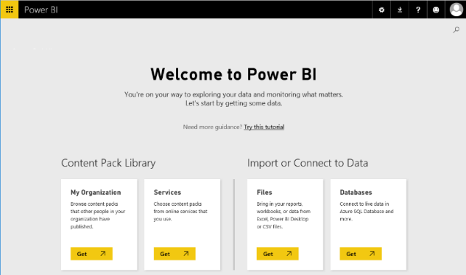

1. Click in the **Get** button in the **Files** tile under the **Import or Connect to Data** section header.

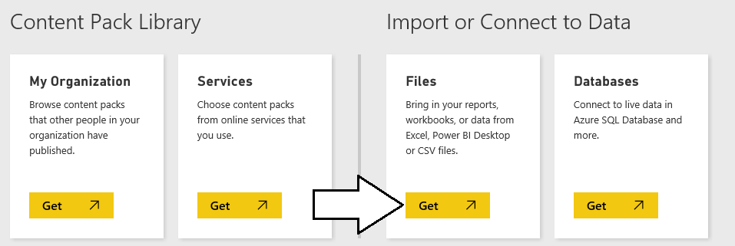

1. On the next page you should see several tiles which indicate your choices for the location of the file you would like to connect to or import. Click on the tile with the caption **OneDrive – Business** so you can import data from the Excel workbook you uploaded to your OneDrive site in a previous setup task.

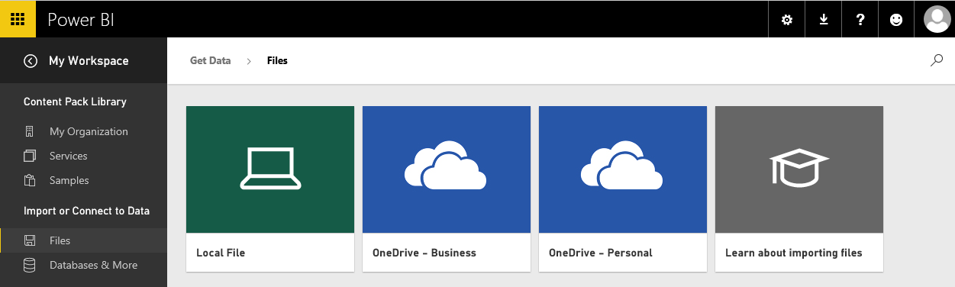

1. One the **OneDrive for Business** page, select the workbook named **WingtipSalesData.xslx** and then click the **Connect** button on the top right-hand side of the page.

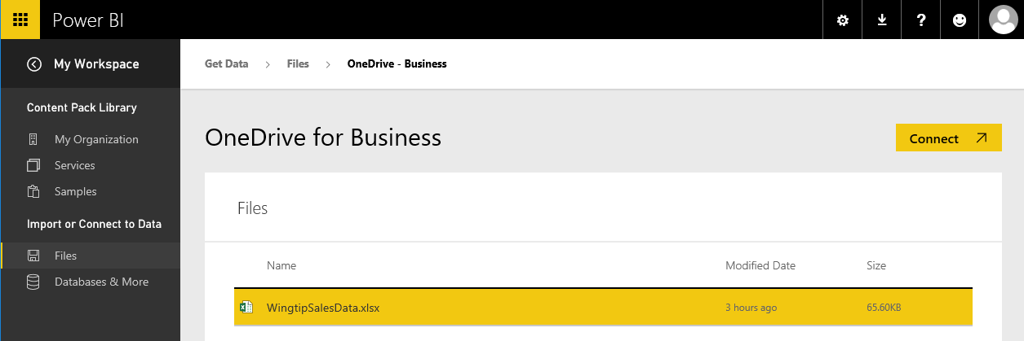

1. After clicking the **Connect** button in the previous step, you are taken to a page which prompts you to **Choose how to connect to your Excel workbook**. Click the **Import** button on the bottom left-hand side of the page to import data from the Excel workbook into the Power BI service to create a new dataset.

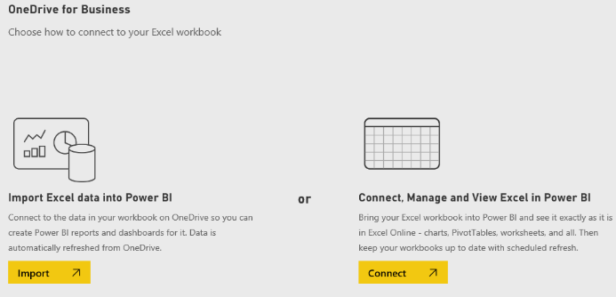

At this point you might make the observation that Microsoft has invested to streamline the user experience in Power BI of working with data files that have been uploaded to OneDrive sites. Once you upload your data files to a OneDrive site, they are very easy to access and integrate into your Power BI workspaces.

1. After the import process has completed, the Power BI service will display the main page that shows the Personal workspace named **My Workspace** for the current user. You should be able to verify that the import process has created a dataset named **WingtipSalesData** and a dashboard named **WingtipSalesData.xslx**.

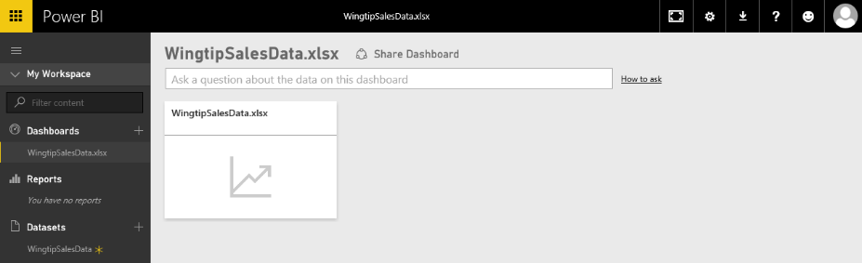

Note that when importing data from an Excel workbook that the Power BI service creates both a new dataset and a new dashboard. However, you might want just the dataset but not the dashboard. Feel free to delete the dashboard if you do not need it.

1. Delete the dashboard named **WingtipSalesData.xslx**. Accomplish this by expanding the ellipse menu to the right of the **WingtipSalesData.xlsx** dashboard and selecting the **DELETE** command.

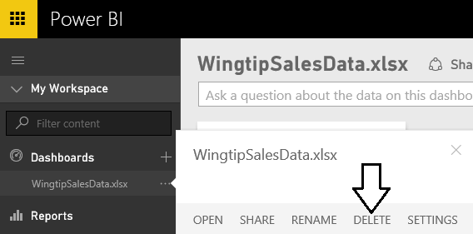

1. Now your Power BI workspace should contain the **WingtipSalesData** dataset but there should not be any dashboards or reports.

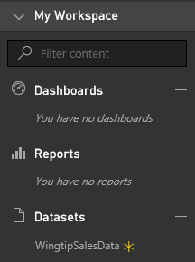

1. Expand the ellipse menu (**…**) to the right of the **WingtipSalesData** dataset link. There is no need to execute any of the commands at this time. However, you should observe the set of commands that you can execute on a dataset that’s been created by importing data from an excel workbook. For example, you have the ability to rename the dataset or to refresh its underlying data in a scenario in which the data in the underlying Excel workbook has changed.

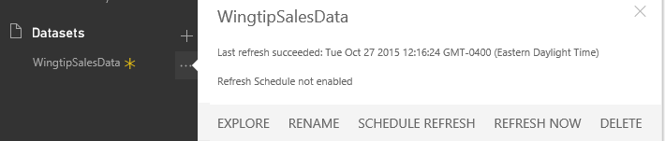

### Setup Task 7: Create a New Power BI Report with Multiple Pages

Now that you have created a dataset, the next setup step involves creating a new report with two pages of visualizations.

1. Click the **WingtipSalesData** link in the **Datasets** section of the navigation menu.

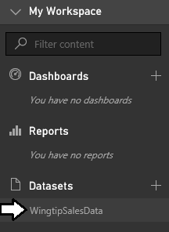

1. When you navigate to a dataset such as **WingtipSalesData**, the Power BI service display a page in report design mode as shown in the following screenshot. Locate the **Fields** list for the dataset on the right-hand side of the page.

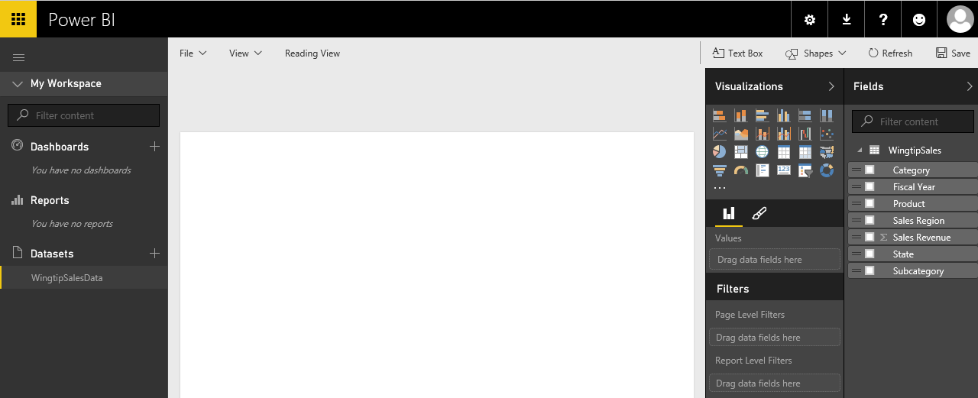

1. In the **Fields** list on the right-hand side of the page, click the checkbox beside **Fiscal Year** and then select the checkbox beside ﻿**Sales Revenue**.

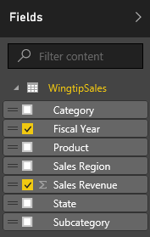

1. This should create a table visualization in the new report as shown in the following screenshot.

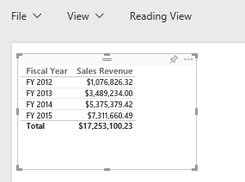

1. ﻿Change the visualization from a table to a line chart by clicking the line chart button in the **Visualizations** list.

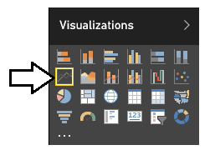

1. At this point, you should see that the visualization on the report should now display a line chart.

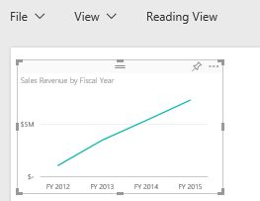

1. Next, you will add a new dimension to your visualization to show how sales revenue is distributed across product categories. First, make sure the visualization with the line chart is selected and then drag-and-drop the **Category** field from the **Fields** list into the **Legend** well in the **Visualizations** pane as shown in the following screenshot.

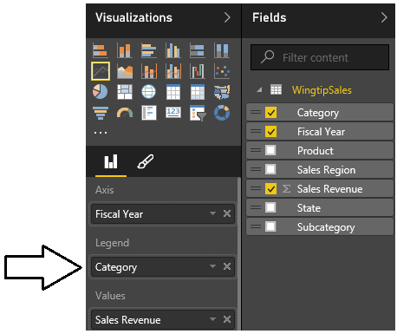

1. At this point, your visualization should match the one shown in the following screenshot.

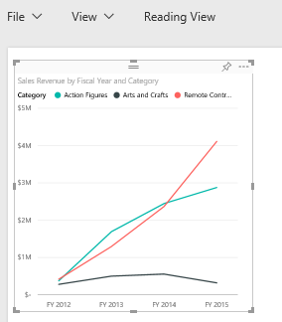

1. Select the handle at the bottom-right corner of the visualization and resize it so it takes up the width of the current report page.

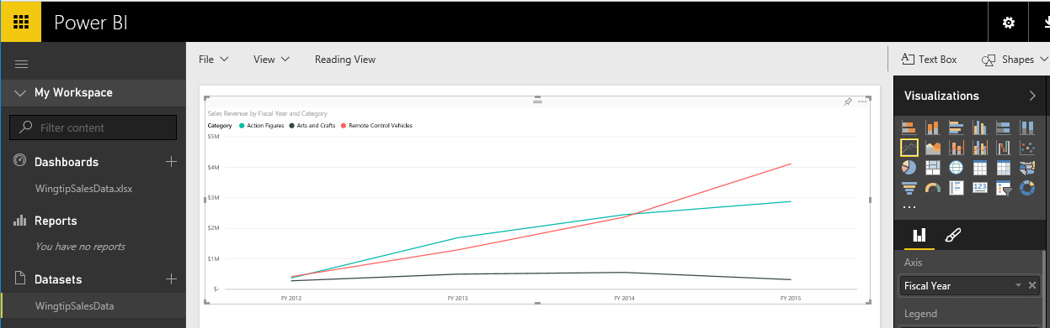

1. Now you will add a second visualization to the current report page. Begin by clicking the white space under the visualization so that the visualization is no longer selected. Next, return to the **Fields** list and select the checkbox beside the **Category** field. Next, select the checkbox beside the **Subcategory** field and then select the checkbox beside the **Sales Revenue** field.

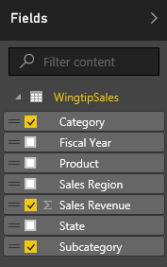

1. Now, the current report page should display a second visualization like the one shown in the following screenshot.

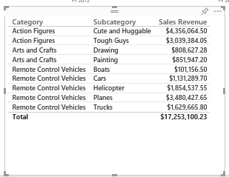

1. Change the type of visualization from table to matrix by clicking the **Matrix** button in the **Visualizations** list.

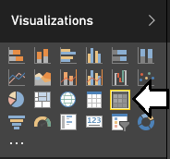

1. Now, the second visualization should display as a matrix instead of a standard table.

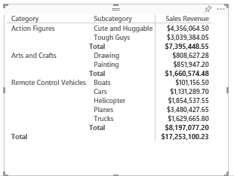

1. Inside the matrix, click on the **Sales Revenue** column header to resort the data in the matrix so that the product categories and subcategories with the highest amounts of sales revenue are sorted to the top of the matrix.

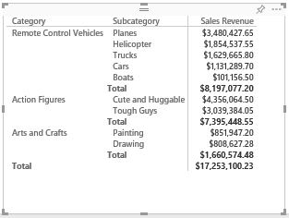

1. Now you will add a third visualization to the current report page. Begin by clicking the white space on the report page outside of the two existing visualizations so that neither visualization is selected. Next, return to the **Fields** list and select the checkbox beside the **Category** field. Next, select the checkbox beside the **Sales Revenue** field. After creating the visualization, change it to a pie chart by clicking the Pie chart button in the **Visualizations** list.

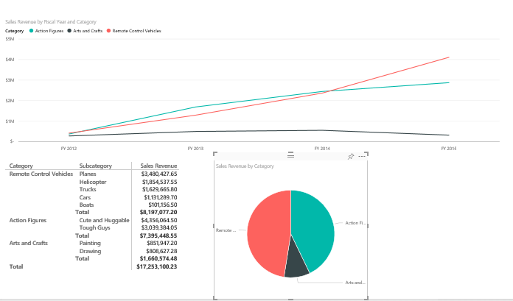

1. With the pie chart visualization selected, click on the pen icon in the **Visualizations** task pane so you can edit the visual properties of the new pie chart visualization.

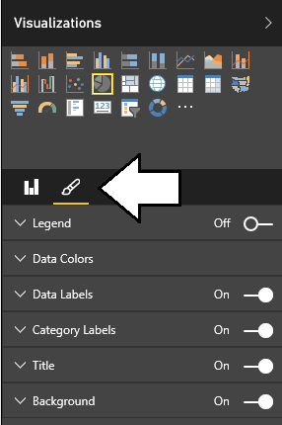

1. Turn on the **Legend** option and then expand the **Legend** section. Set the **Legend Position** to **Top** and turn off the **Title** option as shown in the following screenshot.

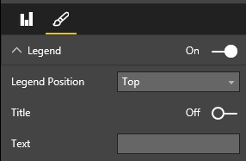

1. At this point, you should see the visual changes you have made to the pie chart.

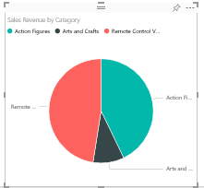

If you have time, you might explore the other options available for editing the appearance of a visualization by examining the other options that are available on the Visualizations task pane when a visualization is selected. Note that the set of available options change depending on what type of visualization is selected.

1. Now it is time to save the report. Begin by changing the name of the current page. Locate the report page name section at the bottom left of the current page and observe that the page has been given an initial name of **Page 1**.

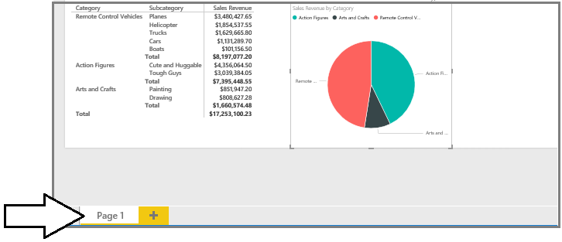

1. Double click on the page name of **Page 1** to enter edit mode and then update the page name to **Sales by Product Category**,



1. Save the report by dropping down the reports **File** menu and selecting the **Save As** menu command.

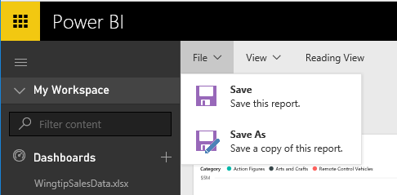

1. When prompted, enter a report name of **Product Sales** and click the **Save** button.

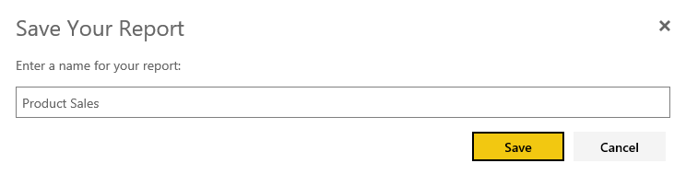

1. After saving the **Product Sales** report, you should be able to see a link for it in the **Reports** section of the left-hand navigation.

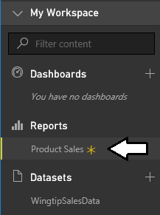

1. Now, add a second page to the **Product Sales** report. Accomplish this by clicking the button with the plus (+) sign to the right of the page name. The Power BI service will respond by creating a second page named **Page 1**.



1. Change the name of the second page from **Page 1** to **Sales by Product**.



1. On the new **Sales by Product** page, add a new visualization by selecting the checkbox beside the **Product** field from the **Fields** list. This should create a simple table visualization with a list of products. Resize the height of the visualization to display all products at once without the need for a scrollbar.

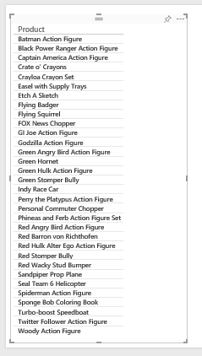

1. Change the type of visualization from a table to a slicer by clicking the Slicer button in the **Visualizations** list.

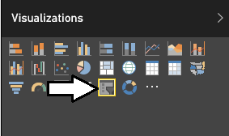

1. Now that the visualization has been changed to a slicer, you should see that each product has an associated checkbox.

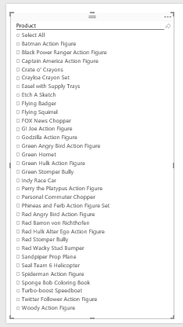

Keep in mind that this slicer visualization adds the ability for the current user to intact with this report by selecting one or more products using these checkboxes. When a user changes the selection of products, the Power BI service will automatically refresh the other visualizations on the page by filtering the results using the selected product or products. Learning how to make reports interactive is a key to creating effective BI solutions with Power BI.

1. Next, you will add a second visualization to **Sales by Product** page. Click whitespace in the report to ensure the first visualization is not selected. Next, create a new visualization by selecting the checkbox for the **Sales Revenue** field and then selecting the checkbox for the **Fiscal Year** field. This should create the second visualization on the page as a bar chart as shown in the following screenshot.

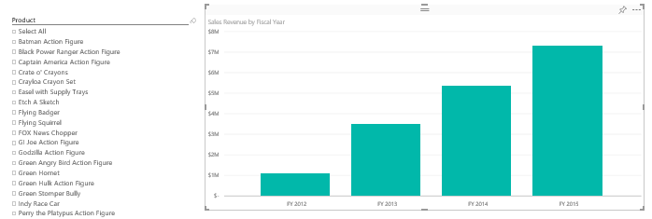

1. Now you will add a third visualization. Click whitespace in the report to ensure the neither of the two visualizations are currently selected. Next, create a third visualization by selecting the checkbox for the **Sales Revenue** field and then selecting the checkbox for the **Sales Region** field. This should create the third visualization as a bar chart as shown in the following screenshot.

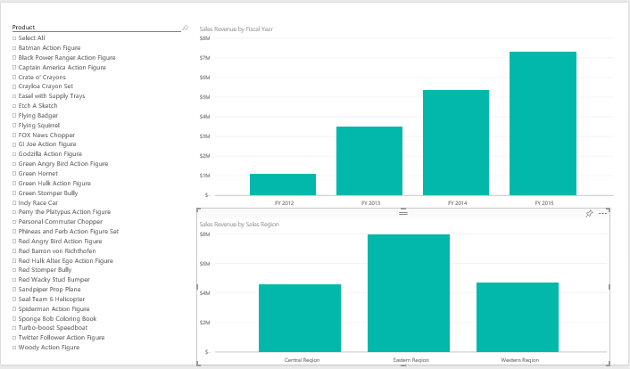

1. Test out the slicer by selecting one product at a time and observing how the two other visualizations on the page automatically refresh to show sales data for one product at a time. Play the role of a business analyst and determine which products have the most positive increases in sales revenue from year to year. Also, find the products with downward trending sales. If you examine the sales data for the **Sponge Bob Coloring Book**, you can sales revenue is trending in the wrong direction over the last four years.

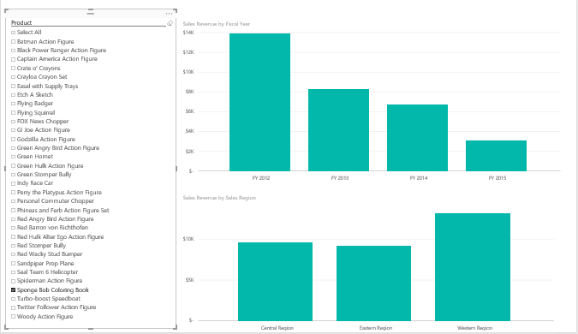

1. Now you are done authoring the report. Save the work you have done authoring the report by dropping down the **File** menu and selecting to **Save** menu command.

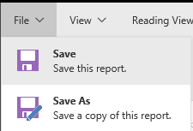

Now that you have created a report with multiple pages, it is time to move on to the last setup task where you will create a new dashboard and test sharing it with another user.

### Setup Task 8: Create and Share a Power BI Dashboard

While you have already created a dataset and a report, you must create a dashboard to effectively share a customized BI solution with other users. This final setup task will walk you through the steps of creating and sharing a Power BI dashboard.

1. Navigate to the **Sales by Product Category** page of the **Product Sales** report.
2. Inspect the pie chart with product categories. Locate and click the button with the thumbtack icon which is used to pin a report visualization to a dashboard.

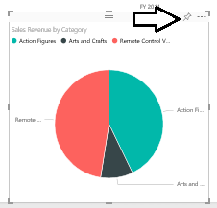

1. When you click the button with the thumbtack icon, you will be prompted with the dialog which asks you where to pin the visualization. Select the option to pin the visualization to a **New Dashboard** and give the new dashboard a name of **Product Sales**. When the **Pin to Dashboard** form is filled out like the one shown in the following screenshot, click the **Pin** button.

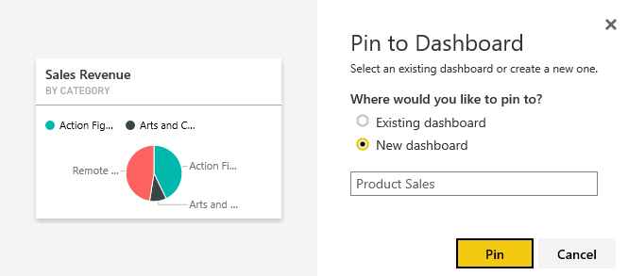

1. At this point, the new **Product Sales** dashboard should be created and a link to it should appear in the left navigation menu.

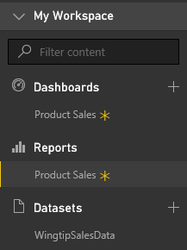

1. Navigate to the **Sales by Product** page of **Product Sales** report and follow the same steps to pin the bar chart visualization showing sales revenue by fiscal year to the **Product Sales** dashboard.

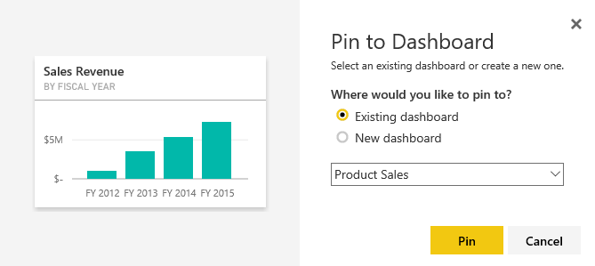

1. Remain on the **Sales by Product** page of **Product Sales** report and follow the same steps to pin the bar chart visualization showing sales revenue by sales region to the **Product Sales** dashboard.

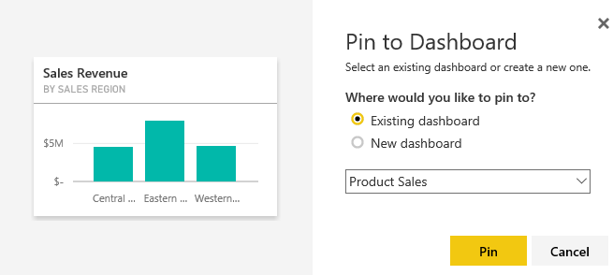

1. Click on the **Product Sales** link in the **Dashboards** section of the left navigation menu to display the **Product Sales** dashboard. You should be able to verify that you see three tiles that have been created from the three report visualization that you pinned to this dashboard.

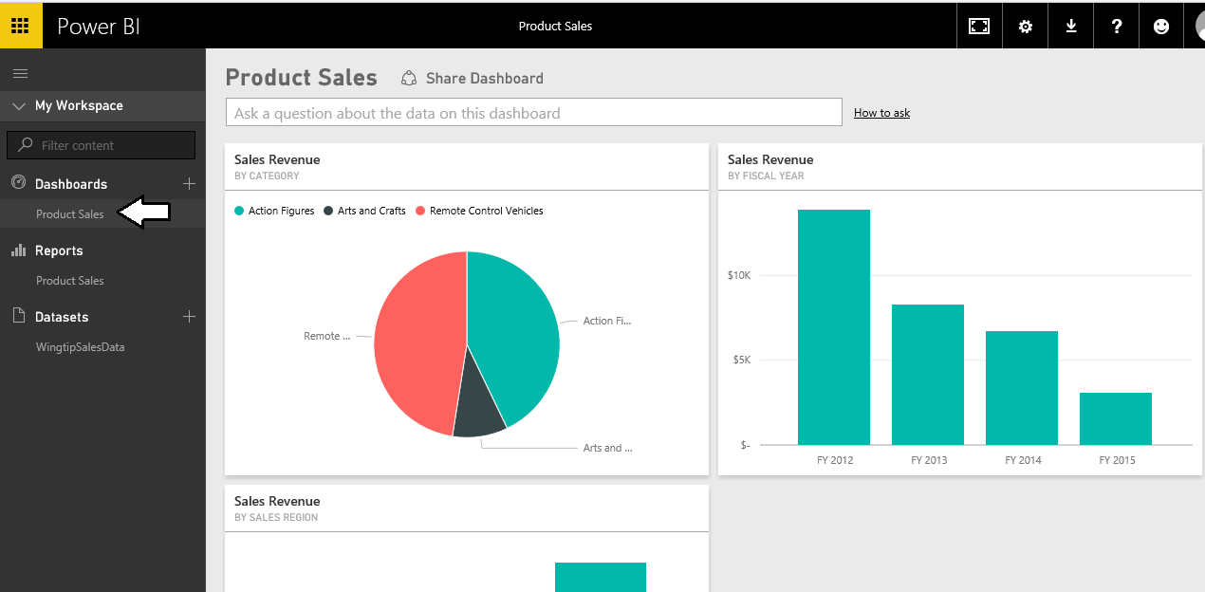

1. Note that you can move or resize the tiles inside the dashboard. This is due to the fact that you are the dashboard author and you are in dashboard edit mode.
2. Experiment by clicking on the tiles in the dashboard. You will find that clicking a tile will navigate the user to the report and page that contains the visualization which was pinned to the dashboard.
3. Now, it is time to test sharing a Power BI dashboard. Start by navigating to the **Product Sale** dashboard and clicking the **Share Dashboard** link at the top of the page.

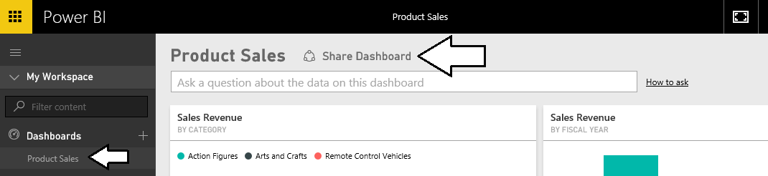

1. At this point, you are prompted with the **Share Dashboard** page where you can enter information about the users and/or groups with which you want to share your new dashboard. Enter the email address of the secondary user account that you created earlier in setup task five. After you have entered the email address, click the **Share** button at the bottom of the page.

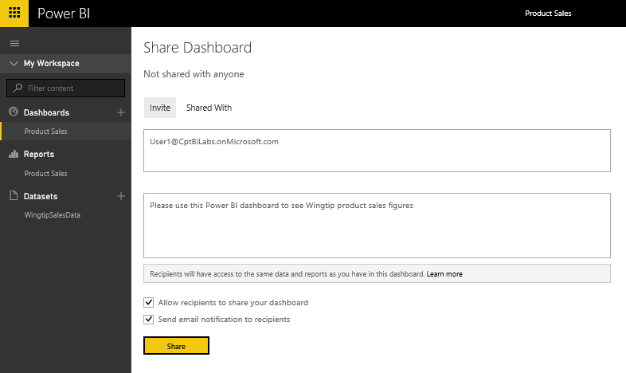

1. Once the dashboard has been successfully shared, you should be able to confirm that the secondary user has access to this dashboard by examining the **Shared With** tab of the **Share Dashboard** page as shown in the following screenshot.

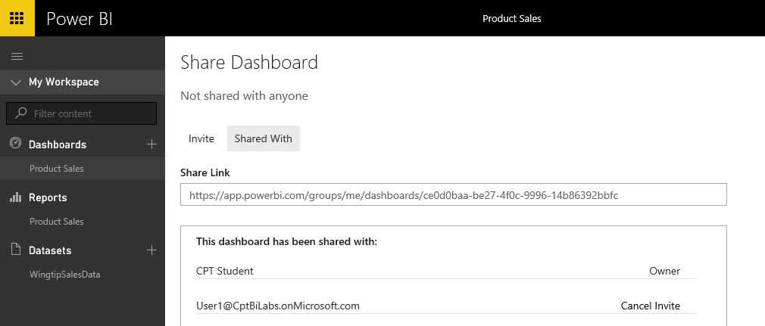

Now you have completed the steps to share the dashboard. The final step is to test the experience of a user who is not the dashboard author, but instead a dashboard consumer. This will require that you sign out of the Power BI service and then sign back in under the identity of the secondary user account. By accessing the shared dashboard in this fashion, you will be able to observe the typical experience of a dashboard consumer when accessing a dashboard that has been shared by another user.

1. Drop down the user menu from the top, right-hand corner of the page and click the Sign out command.

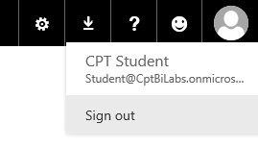

1. Now, sign back in using the account name and the password of the secondary user account you created earlier.

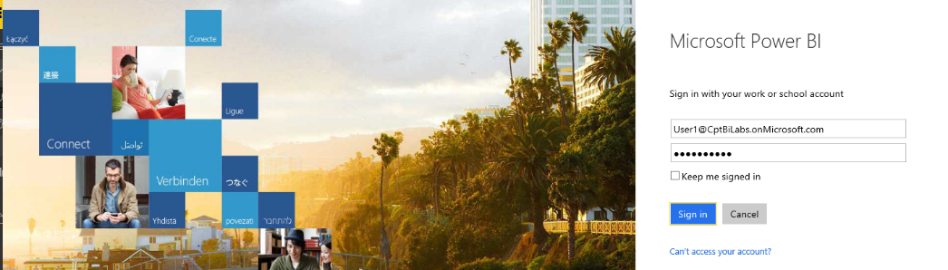

1. Once you have signed in, click the **Mail** tile in the Application Launcher accessible via the **Waffle** **Button**.
2. Once you are able to access the inbox for the secondary user, you should be able to verify that the Power BI service has sent this user a notification email message informing the user that the Product Sales dashboard that has been shared. In the body of the email message, click the **Open Product Sales** link to navigate to the new dashboard.

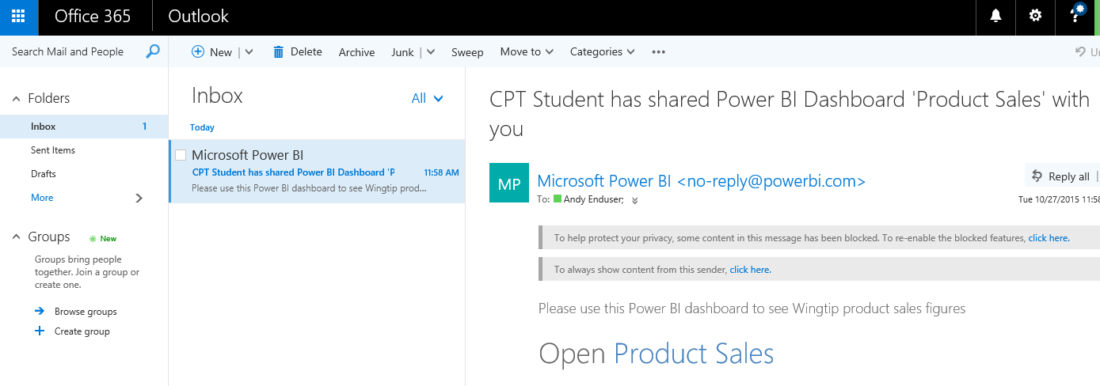

1. At this point, you will be taken to a page which shows the personal workspace for the current user and displays the page for the Product Sale dashboard.

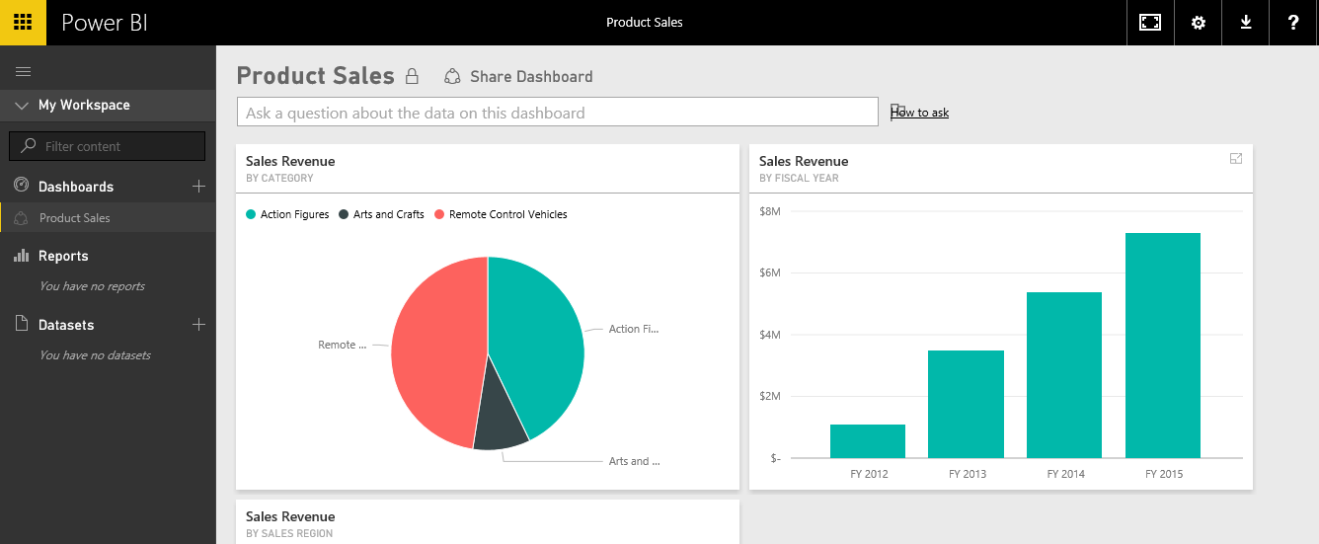

1. Take note that this user can see the **Product Sales** dashboard link in the left navigation menu but there are not links for any reports or datasets.

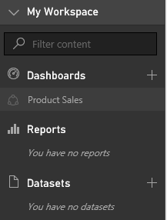

Note that Power BI does not include links to provide the dashboard consumer with direct access to the report or the dataset behind the dashboard. However, Power BI does supply the dashboard consumer with indirect access to the report and the dataset behind the dashboard. It’s just that the dashboard consumer can only access the report and dataset by interacting with the dashboard. One key benefit is that this approach keeps the left navigation less cluttered when the user is accessing many different shared dashboards.

1. Navigate to the **Product Sales** dashboard and observe that the dashboard page is in read-only view. The user is not able to delete, move or resize any of the tiles. Only the dashboard author is able to edit this dashboard page.
2. On the **Product Sales** dashboard, experiment by clicking on the dashboard tile showing sales revenue by fiscal year. This will allow you to navigate to the **Sales by Product** page of the **Product Sales** report. Interact with the report page by using the slicer to filter and analyze the underlying data and see how individual products are selling from year to year..

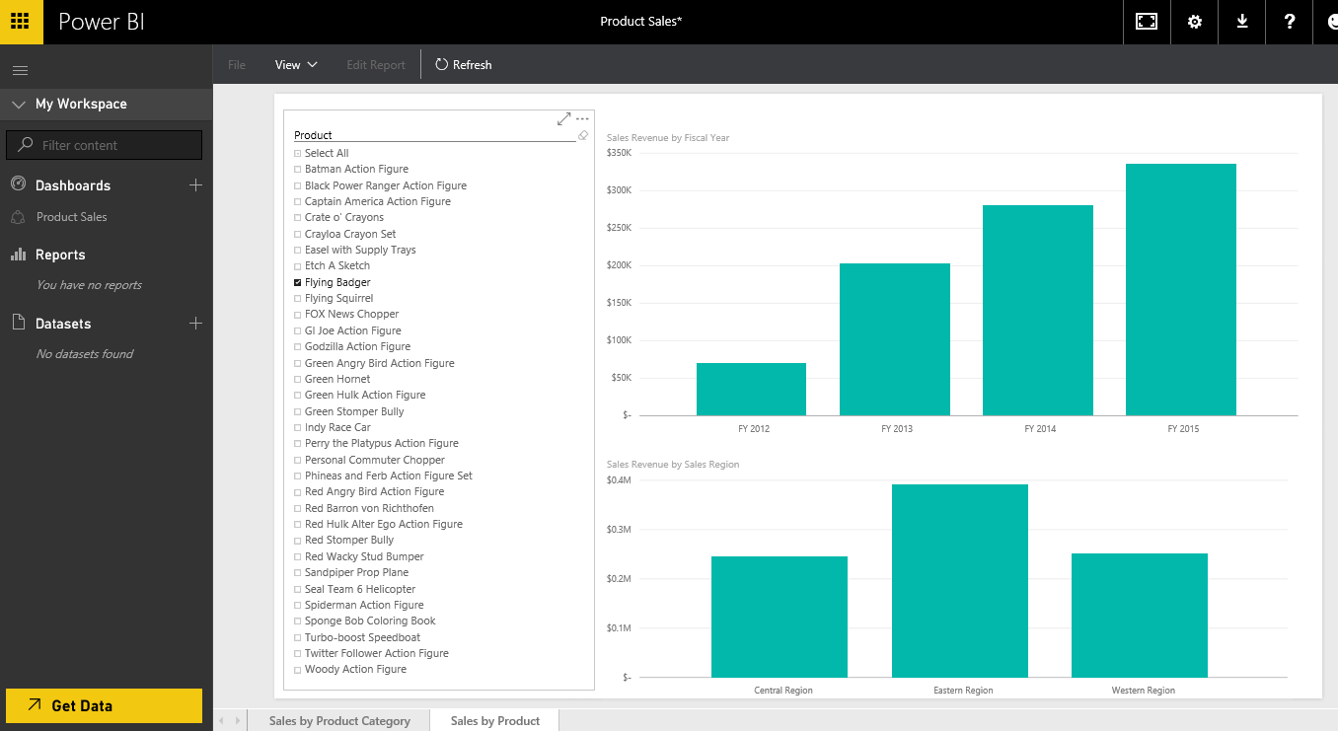

Congratulations. You have made it to the end of this setup guide and you have now created and configured a test environment in which you can begin to create and implement custom BI solutions using the Power BI platform.