Mars Rover Mission

The objectives is develop a software that translate commands sent instructions from earth to instructions that are understood by the rover. That software have a list of requirements.

Requirements

· Rover receive the initial starting point (x,y) of a rover and the direction (N,S,E,W)
· The rover receives a collection of commands. (E.g.) FFRRFFFRL.
· The rover can move forward (f).
· The rover can move left/right (l,r).
· Suppose we are on a really weird planet that is square. 200x200 for example :).
· Implement obstacle detection before each move to a new square. If a given sequence of commands encounters an obstacle, the rover moves up to the last possible point, aborts the sequence and reports the obstacle.

Use Cases

From requirements analysis can deduce three principal uses cases:
1) Rover landing. Where can set starting coordinates (x, y) and rover direction it is facing, called orientation in software.
2) Rover movement. The requirements of receives a collection of commands, move forward, left and right can be group in rover movement use case. It has been decided add move back and the appropriate command (B).
3) Find planet. For get planet coordinates and obstacle detection must exist a planet with that information.

Software Architecture

Software has been designed following DDD principles in Laravel framework. Commonly, Laravel is used following MVC architecture and eloquent is the ORM that follow active record pattern. It means that can become complex isolate layers from framework. Next will see software flow by layers to deepen in software architecture choise.
Application is not decoupled at all like microservices, the most coupled things to framework still original Laravel structure. Most features located in that layer used are Routes, front end (front controllers, views, styles, scripts) and service providers.
At the moment exist shared and space exploration bounded context which in turn is distributed in
planets and vehicles modules that are organized in hexagonal arquitecture.

User Interface

For the user to interact with software is build a user interface properly. Let’s analyze the view in the image. View is structured following the use cases, the number 1 is planet cartography representation with latitude and longitude draw in picture and obstacles painted in black. Part 2 are forms to set rover landing by introducing longitude, latitude and orientation. Planet have a 20x20 matrix and orientation can be the four cardinal points (N, W, S, E). Section 3 are form to introduce the list of commands. One command is a letter and can be F,L,R and B.

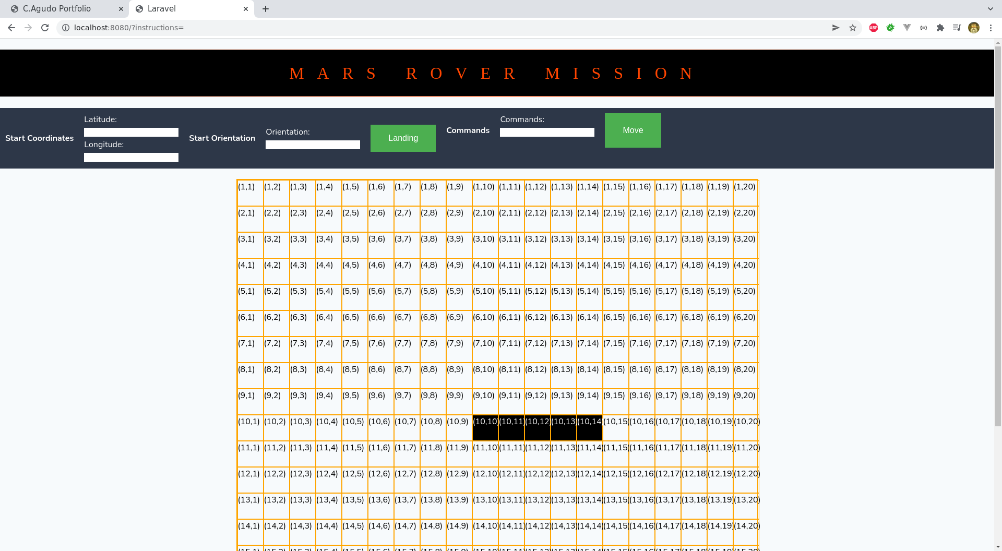
2
3
1
That data are send to routes witch send to api controllers. Api controllers are in infrastructure to decouple Laravel controllers with self controller.

Infrastructure

Infrastructure, principally, have encapsulated framework things like Eloquent models, factories and controllers.

Application

Application layer is organized by use cases with their command/queries and handlers.

Domain

In domain found aggregates, domain exceptions and validators.

