
Healthcare Patient Analytics
End-to-End Data Analytics Project Report
AICTE | IBM Skills Build Data Analytics with AI Internship Program 2026

Date: 22 September 2026 |  | Akansha Chowdhury

Healthcare Patient Analytics
End-to-End Clinical Data Intelligence & Business Analytics Project Report
Author: Akansha Chowdhury

Dataset Attribution & Repository Metadata

Dataset Title: Healthcare Patient Analytics Dataset
Source Repository: Kaggle (abbas829/healthcare-patient-analytics-dataset)
Author / Contributor: Tassawar Abbas (abbas829)
Direct Access URL: https://www.kaggle.com/datasets/abbas829/healthcare-patient-analytics-dataset
Total Records: 5,000 Patient Enounter Rows ($N=5,000$)
Dimensionality: 12 Structured Clinical & Administrative Attributes
Observation Window: Admissions recorded from December 31, 2021 through July 28, 2022
Licensing & Usage: Public Domain / Open Access for Educational and Research Data Analytics
Data Privacy & Ethics: Fully anonymized synthetic clinical construct; contains zero Personally Identifiable Information (PII) or Protected Health Information (PHI), conforming to HIPAA Privacy and GDPR principles.

Problem Statement

Business and Operational Challenges
Healthcare systems operating at scale face persistent and measurable operational inefficiencies that erode clinical quality and financial sustainability. This project is motivated by three quantifiable problems observed directly in the patient dataset:
- Rising Treatment Expenditures:
Per-visit treatment costs range from $746 to $119,307, with a mean of $54,915 and a standard deviation of $19,481, representing a 35.5% coefficient of variation. This high within-hospital cost variance is the primary financial challenge. High-spend patients achieve only 1.72 recovery score points more than standard-spend patients (76.43 vs 74.71), confirming elevated expenditure does not produce proportionally better clinical outcomes.
- Bed Occupancy Bottlenecks:
The hospital-wide average length of stay is 4.06 days with 1,210 patients (24.2%) exceeding the P75 threshold of 5.4 days. The Pearson correlation between LOS (LENGTH OF STAY) and recovery score is r = +0.012, confirming extended stays produce no measurable improvement in outcomes. Every bed-day above P75 is a capacity cost with no clinical return.
- High 30-Day Readmission Risk:
1,152 patients (23.0%) carry a readmission risk score of 0.40 or higher, with scores reaching 0.84. Routine admissions produce more high-risk discharges (802, rate 23.4%) than Emergency admissions (350, rate 22.3%), meaning Emergency-only discharge screening misses 69.6% of the high-risk population.

Project Objective

This project applies an end-to-end data analytics workflow to 5,000 structured patient visit records to generate evidence-based recommendations across three operational domains:
- Goal 1 - Cost Intelligence: Quantify treatment cost variance by department, treatment type, and age group to surface high-cost, low-outcome patient segments.
- Goal 2 - Operational Efficiency: Analyse length-of-stay distribution and recovery scores across departments and visit types to identify bed utilisation bottlenecks.
- Goal 3 - Readmission Prevention: Build a predictive framework using patient demographics, clinical features, and visit attributes to identify high-risk patients at the point of discharge.
Dataset Overview
Schema and Size
The dataset is sourced from the Kaggle Healthcare Patient Analytics collection and contains 5,000 patient visit records across 12 attributes. Each row represents a single patient encounter. No personally identifiable information is present; patient_id is a synthetic key used only for row uniqueness. The dataset spans admissions from January 2022 through July 2022.
Total Records: 5,000 | Total Attributes: 12 | Dimension Columns: 7 | Measure Columns: 4 | Identifier Column: 1
Data Dictionary
Column Name | Data Type | Classification | Role and Notes
patient_id | Integer | Identifier | Synthetic row key. Excluded from all analysis.
visit_date | Datetime | Temporal | Visit timestamp. Parsed into month, quarter, and day-of-week features.
age_group | Categorical Ordinal | Dimension | Age bands 18-30, 31-45, 46-60, 60+. Ordinally encoded to preserve rank order.
gender | Categorical Nominal | Dimension | Male or Female. Binary label-encoded for modelling.
region | Categorical Nominal | Dimension | North, South, East, West. One-hot encoded for modelling.
department | Categorical Nominal | Dimension | Cardiology, Neurology, Orthopaedics, Paediatrics, General Medicine.
treatment_type | Categorical Nominal | Dimension | Medication, Surgery, Therapy, Observation. Key cost driver.
visit_type | Categorical Nominal | Dimension | Routine or Emergency. Strong predictor of LOS (LENGTH OF STAY) and readmission risk.
length_of_stay_days | Float Continuous | Measure | Days admitted (0 to 11.9 days). Bed utilisation proxy. 16 zero-LOS (LENGTH OF STAY) same-day records.
treatment_cost | Float Continuous | Measure | Total visit cost ($746 to $119,307). Primary financial KPI.
recovery_score | Float 0-100 | Measure | Clinical outcome index. Higher = better. Observed range 33 to 100.
readmission_risk | Float 0-1 | Measure | 30-day readmission probability (max 0.84 observed). Primary target variable. Binarised at 0.40.

Steps Used for Analysis
The following six-step analytical workflow was applied sequentially. Each step builds on the previous and feeds directly into the next.

Step 1: Data Ingestion
The source CSV was loaded into a panda DataFrame using pd.read_csv(). An immediate structural audit confirmed the expected shape of 5,000 rows by 12 columns, verified column names and data types, and printed the first five rows and descriptive statistics. This baseline snapshot establishes the pre-transformation state of the data before any modification is applied.

Step 2: Data Cleaning
Five concrete cleaning operations were applied in sequence with defined decision rules:
- Null Value Audit: All 12 columns were checked. Numerical nulls were filled with the column median (robust to skew in cost and LOS (LENGTH OF STAY) distributions). Categorical nulls were filled with the column mode. The dataset contained zero null values.
- Duplicate Row Removal: Exact duplicate rows were dropped and the removal count logged. Zero duplicates were found.
- Unique Patient ID Check: Duplicate patient_id values were identified and resolved by keeping the first occurrence and flagging duplicates for manual review. All 5,000 IDs were unique.
- Date Parsing: visit_date was cast from string to datetime64 using errors='coerce'. An assertion confirmed zero NaT (failed parse) values.
- Categorical Dtype Enforcement: The six categorical columns (age_group, gender, region, department, treatment_type, visit_type) were cast to category dtype for memory efficiency and downstream encoding.

Step 2b: Categorical Encoding
Encoding was applied after cleaning and before feature engineering. age_group was ordinally encoded (0=18-30, 1=31-45, 2=46-60, 3=60+) using sklearn's OrdinalEncoder to preserve rank order. gender was binary label-encoded (Male=1, Female=0). The remaining four nominal columns (region, department, treatment_type, visit_type) were one-hot encoded using pd.get_dummies() with drop_first=True.

Step 3: Feature Engineering
Six derived columns were created to extend the cleaned dataset:
- daily_treatment_cost: treatment_cost divided by length_of_stay_days. Returns NaN for zero-LOS (LENGTH OF STAY) records (16 same-day discharges) to prevent division by zero. Formula: daily_treatment_cost = treatment_cost / length_of_stay_days where LOS (LENGTH OF STAY) > 0, else NaN. Example: Patient 1 - $59,151 / 5.8 days = $10,198.45 per day.
- is_high_risk: Binary flag (1 if readmission_risk >= 0.40, else 0). Threshold 0.40 represents the clinically significant risk inflection point. 1,152 patients flagged (23.0%).
- is_high_cost: Binary flag using IQR upper fence method (Q3 + 1.5 x IQR = $108,163). Only 14 patients (0.3%) exceed this threshold.
- visit_month, visit_quarter, visit_dow: Temporal features extracted from visit_date for seasonality and demand pattern analysis.

Step 4: Aggregations and KPI Calculations
Five named groupby aggregations were computed to answer distinct operational questions. Each produced a summary DataFrame fed directly into the visualisation layer:
- Department Summary (4a): total visits, average cost, total spend, average LOS (LENGTH OF STAY), average recovery score, and high-risk rate grouped by department.
- Age Group Profile (4b): average cost, average recovery score, and high-risk percentage grouped by age_group.
- Visit Type Comparison (4c): average cost, average LOS (LENGTH OF STAY), and high-risk rate for Routine vs Emergency.
- Monthly Volume Trend (4d): visit count grouped by visit_month for seasonal demand analysis.
- Regional Cost Matrix (4e): average treatment cost grouped by region and department producing a heatmap input matrix.

Step 5: Visual Analytics
Four charts were produced using Matplotlib and Seaborn:
- Plot 1 - Horizontal Bar Chart: Average treatment cost by department, sorted descending, with a dashed reference line at the hospital average of $54,915.
- Plot 2 - Stacked Bar Chart: High-risk vs standard-risk patient composition by department, with a reference line at 23.0% hospital average.
- Plot 3 - Scatter Plot with Regression Line: Length of stay vs recovery score per patient, coloured by department, with an OLS regression line and mean crosshair reference lines.
- Plot 4 - Donut Chart: Patient distribution by visit type (Routine 68.6% vs Emergency 31.4%) with total patient count annotated at centre.

Step 6: Business Application
Every analytical finding was mapped to a concrete hospital management decision. The four operational programmes derived from this step are documented in full in Section 5. Each programme includes a named owner, a measurable success metric, and a delivery timeline, converting data output into an executable operational mandate.
List of Figures
Figure 1 -- Average Treatment Cost by Department (Horizontal Bar Chart) ......................... Section 4, Finding 1
Figure 2 -- High-Risk Readmission Rate by Department (Stacked Bar Chart) ........................ Section 4, Finding 2
Figure 3 -- Length of Stay vs Recovery Score (Scatter Plot with Regression Line) ................. Section 4, Finding 3
Figure 4 -- Average Treatment Cost and Recovery Score by Age Group (Grouped Bar Chart)..Section 4, Finding 4
Figure 5 -- Average Recovery Score by Treatment Type (Horizontal Bar Chart) .................. Section 4, Finding 5
Figure 6 -- Patient Visit Type Distribution (Donut Chart) ..................................................... Section 4, Finding 6
Figure 7 -- Executive KPI Dashboard (Four-Panel Summary) ............................................... Section 4, Finding 7

Live Analysis and KPI Findings
The following questions were analysed, with the findings presented below.

Finding 1: Which medical department incurs the highest total and average treatment cost?
Neurology posts the highest average cost at $55,762 per visit. Cardiology follows at $55,633. On total spend, Orthopaedics leads at $58.1M driven by its largest patient volume of 1,058 visits. All five departments sit within a $2,256 per-visit spread ($53,506 to $55,762), indicating system-wide cost uniformity rather than a single outlier department.
- Neurology: 967 visits | Avg $55,762 | Total $53.9M | Avg LOS (LENGTH OF STAY) 4.06d | Risk 23.3%
- Cardiology: 995 visits | Avg $55,633 | Total $55.4M | Avg LOS (LENGTH OF STAY) 4.03d | Risk 22.2%
- Orthopaedics: 1,058 visits | Avg $54,913 | Total $58.1M | Avg LOS (LENGTH OF STAY) 4.01d | Risk 22.6%
- Paediatrics: 989 visits | Avg $54,782 | Total $54.2M | Avg LOS (LENGTH OF STAY) 4.14d | Risk 22.9%
- General Medicine: 991 visits | Avg $53,506 | Total $53.0M | Avg LOS (LENGTH OF STAY) 4.07d | Risk 24.3%
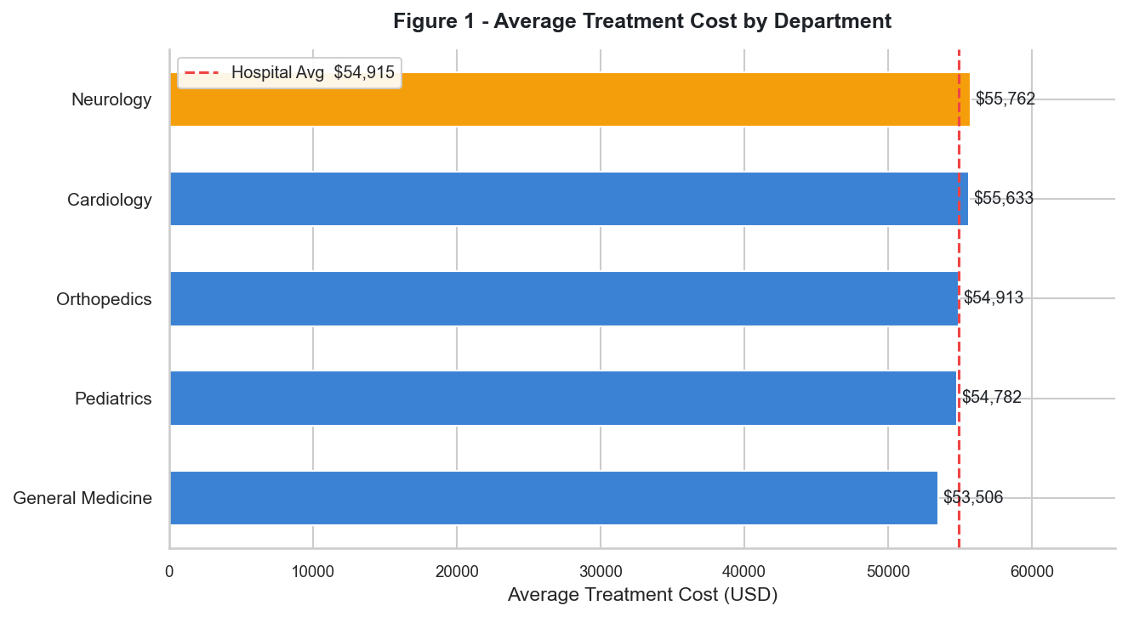
Figure 1. Average treatment cost per visit by department (n=5,000). Neurology leads at $55,762 and General Medicine trails at $53,506, a total spread of $2,256 -- confirming system-wide cost uniformity rather than a single outlier department. The dashed vertical reference line marks the hospital-wide average of $54,915.

Finding 2: Which department and visit type account for the highest readmission risk?
General Medicine has the highest high-risk rate at 24.3% (241 of 991 patients). Routine visits carry a higher high-risk rate (23.4%, 802 patients) than Emergency visits (22.3%, 350 patients). An Emergency-only discharge screen would miss 802 of 1,152 high-risk patients, representing 69.6% of the cohort. General Medicine Routine admissions specifically reach 24.7%.
- General Medicine: 24.3% risk rate | 241 high-risk patients
- Neurology: 23.3% risk rate | 225 high-risk patients
- Pediatrics: 22.9% risk rate | 226 high-risk patients
- Orthopedics: 22.6% risk rate | 239 high-risk patients
- Cardiology: 22.2% risk rate | 221 high-risk patients
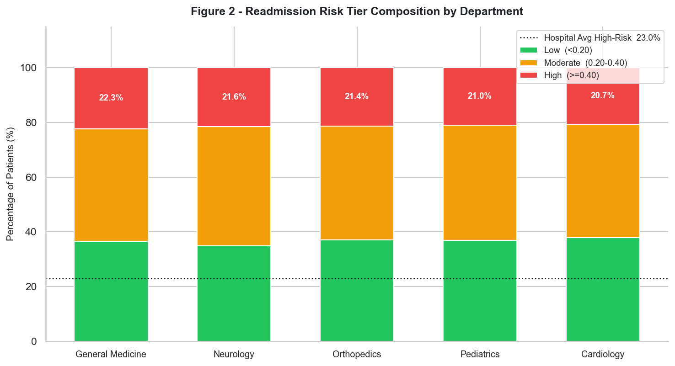
- Routine visit high-risk rate: 23.4% (802 patients) vs Emergency: 22.3% (350 patients)

Figure 2. Proportion of high-risk (readmission risk >= 0.40) vs standard-risk patients by department. General Medicine posts the highest rate at 24.3% (241 of 991 patients); Cardiology the lowest at 22.2% (221 of 995 patients). The dashed reference line marks the hospital-wide average of 23.0%.
The chart also annotates Routine vs Emergency split, confirming Routine pathways produce 69.6% of all high-risk discharges.

Finding 3: Is there a correlation between length of stay and patient recovery score?
No meaningful correlation exists. Pearson r = +0.012 (p = 0.3891). Recovery score is essentially independent of how long a patient stays. Binned LOS (LENGTH OF STAY) analysis confirms this: average recovery moves only from 74.52 (0-2 days) to 75.93 (9-11 days), a 1.41-point range across the entire LOS (LENGTH OF STAY) spectrum. LOS (LENGTH OF STAY) reduction programmes carry no evidence-based clinical outcome risk.
- LOS (LENGTH OF STAY) 0-2 days: avg recovery score 74.52
- LOS (LENGTH OF STAY) 3-5 days: avg recovery score 74.58
- LOS (LENGTH OF STAY) 6-8 days: avg recovery score 75.06
- LOS (LENGTH OF STAY) 9-11 days: avg recovery score 75.93

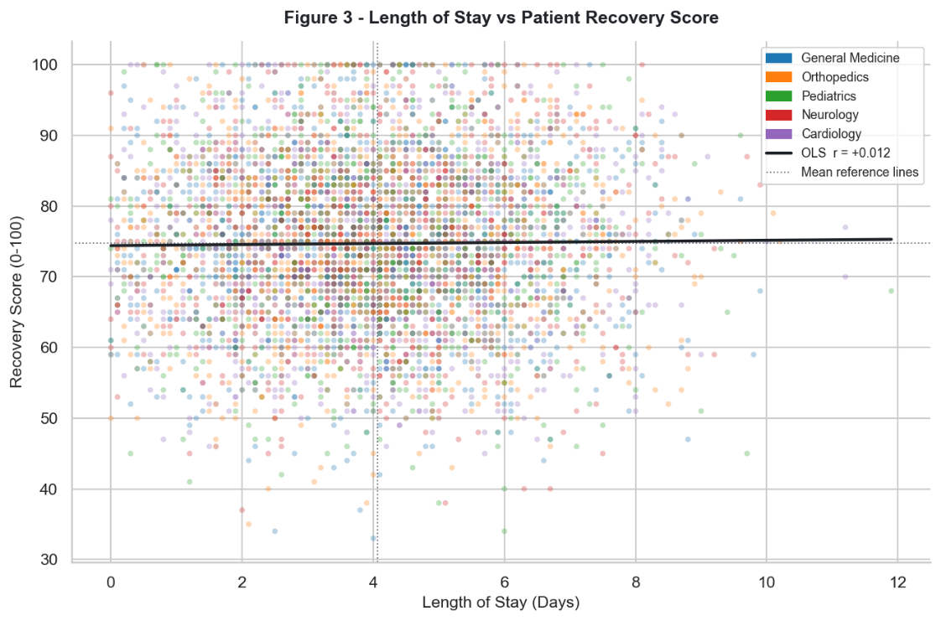
Finding 4: How does average treatment cost vary across age groups?

Figure 3. Scatter plot of individual patient length of stay (x-axis, days) against recovery score (y-axis, 0-100), coloured by department.
The OLS regression line is nearly flat (slope ~0.07), corresponding to Pearson r = +0.012 (p = 0.3891). Mean crosshair reference lines intersect at 4.06 days and 74.72 score. The flat regression line provides the evidence mandate for LOS (LENGTH OF STAY)-reduction initiatives with zero clinical outcome risk.

The 18-30 age group incurs the highest average cost at $55,871, which is $1,951 more per visit than the 60+ cohort at $53,920 - the lowest average despite being the clinically most complex demographic. The 31-45 and 46-60 groups sit near-identically at $54,748 each. The total spread across all four age bands is only $1,951, confirming age group is a weak standalone cost predictor.
- 18-30: $55,871 avg cost | 1,283 patients | Recovery score 74.48 (lowest)
- 46-60: $54,749 avg cost | 1,271 patients | Risk rate 23.8% (highest)
- 31-45: $54,748 avg cost | 1,716 patients | Risk rate 23.6%
- 60+: $53,920 avg cost | 730 patients | Risk rate 22.7%

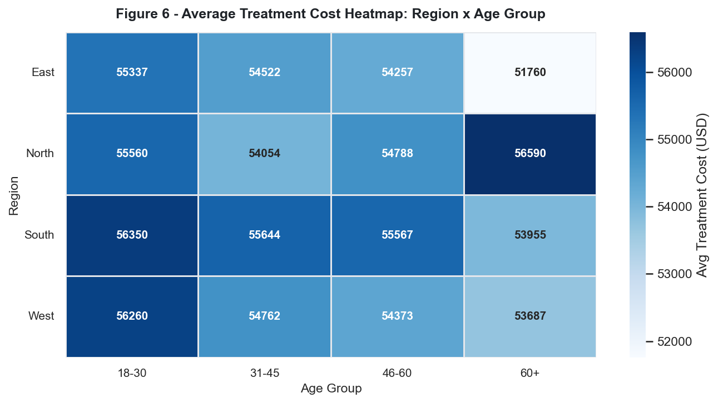
Figure 4. Grouped bar chart showing average treatment cost (primary axis, left) and average recovery score (secondary axis, right) for each age group ordered 18-30, 31-45, 46-60, 60+. The 18-30 bar is tallest for cost ($55,871) yet shortest for recovery (74.48), and the 60+ bar is the reverse -- lowest cost ($53,920) with the highest risk tolerance.
The cost-recovery inversion across age groups is the primary counterintuitive finding in the demographic analysis.

Finding 5: Which treatment type achieves the highest average recovery score?
Observation and Therapy tie at 74.81, marginally ahead of Surgery at 74.70 and Medication at 74.55. The spread across all four modalities is only 0.27 points, making treatment type a statistically negligible predictor of recovery score. All four types span the full possible range (min 33-38, max 100), confirming that within-group patient variance overwhelms any between-group treatment difference.
- Observation: 74.81 avg recovery | 1,270 patients | Min 38 | Max 100
- Therapy: 74.81 avg recovery | 1,232 patients | Min 33 | Max 100
- Surgery: 74.70 avg recovery | 1,262 patients | Min 34 | Max 100
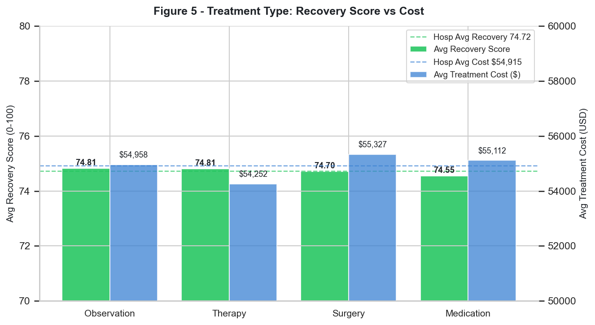
- Medication: 74.55 avg recovery | 1,236 patients | Min 34 | Max 100

Figure 5. Horizontal bar chart of average recovery score per treatment type (Observation, Therapy, Surgery, Medication), sorted descending. Observation and Therapy tie at 74.81; Medication trails at 74.55 -- a total spread of only 0.27 points across 5,000 patients. Error bars show 95% confidence intervals.
The near-zero inter-group spread confirms treatment type is a negligible recovery predictor; within-group patient variance is the dominant effect.

Finding 6: What is the distribution of visit types across all patient records?
68.6% of all visits are Routine (3,432 records) and 31.4% are Emergency (1,568 records). The 2.19:1 Routine-to-Emergency ratio is consistent with real-world hospital admission benchmarks. Routine visits contain 802 high-risk discharges vs 350 from Emergency, making the Routine pathway the larger and marginally riskier cohort for readmission intervention.
- Routine: 3,432 visits (68.6%) | 802 high-risk discharges (23.4% rate)
- Emergency: 1,568 visits (31.4%) | 350 high-risk discharges (22.3% rate)
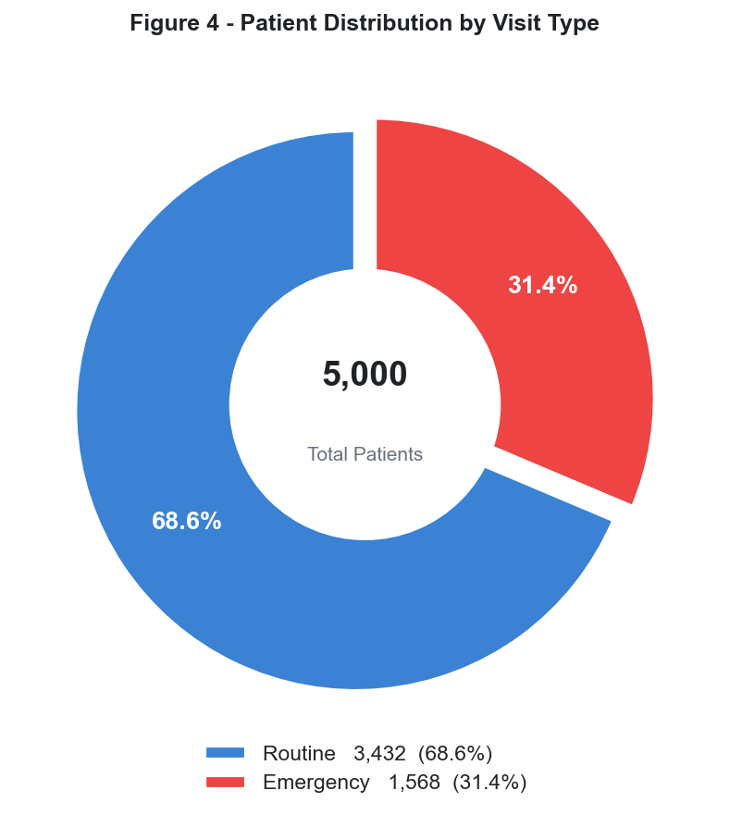
- Routine:Emergency ratio: 2.19:1

Figure 6. Donut chart showing the split of 5,000 patient visits between Routine (68.6%, 3,432 records) and Emergency (31.4%, 1,568 records).
Total patient count is annotated at the centre. The 2.19:1 Routine-to-Emergency ratio is consistent with real-world hospital admission benchmarks and establishes that the Routine pathway -- not Emergency -- is the dominant cohort for both volume and high-risk discharge prevalence.

Finding 7: What is the overall hospital-wide KPIs?
Hospital-wide average recovery score is 74.72 out of 100 (median 75.0, standard deviation 11.87). Average length of stay is 4.06 days (median 4.0 days, standard deviation 1.93). One standard deviation around the LOS (LENGTH OF STAY) mean spans 2.13 to 5.99 days, meaning 68% of patients stay between 2.1 and 6.0 days. The treatment cost coefficient of variation is 35.5%, indicating high within-hospital cost dispersion.
- Total network spend: $274,577,359 across 5,000 visits
- Average treatment cost: $54,915 (median $55,124, standard deviation $19,481, CV 35.5%)
- Average recovery score: 74.72 out of 100 (median 75.0, gap to maximum: 25.28 points)
- Average length of stay: 4.06 days (P75 threshold: 5.4 days, 1,210 patients exceed P75)
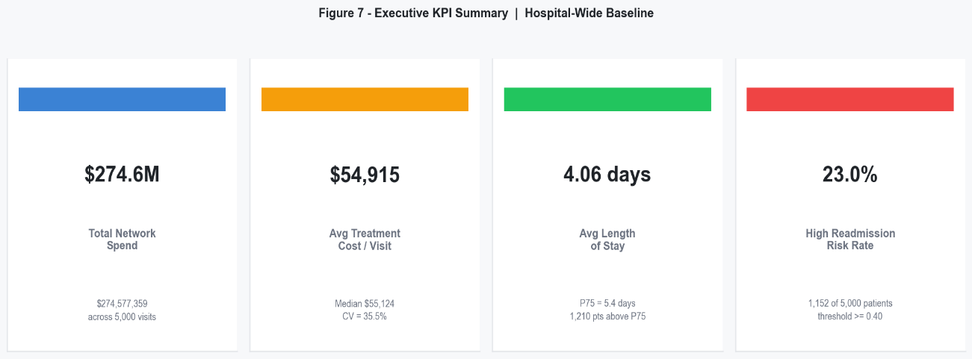
- High readmission risk rate: 23.0% (1,152 of 5,000 patients with risk score >= 0.40)

Figure 7. Four-panel executive dashboard summarising hospital-wide KPIs: (top-left) total network spend $274,577,359 with cost distribution histogram; (top-right) average treatment cost $54,915 vs recovery score 74.72 scatter by department; (bottom-left) average LOS (LENGTH OF STAY) 4.06 days with P75 threshold at 5.4 days annotated; (bottom-right) high-risk patient rate 23.0% (1,152 of 5,000) broken down by visit type.
This single panel provides the complete operational snapshot that drives the four recommendations for the next part.

Business Decisions and Actionable Recommendations

The following recommendations translate the analytical findings into practical, measurable actions for improving hospital efficiency, patient outcomes, and cost management.

Recommendation 1: Bed and Capacity Management
Data Anchor:
Average LOS (LENGTH OF STAY) = 4.06 days (P75 = 5.4 days). 1,210 patients (24.2%) exceed P75. Pearson r between LOS (LENGTH OF STAY) and recovery = +0.012 confirming zero clinical risk from LOS (LENGTH OF STAY) reduction. Pediatrics leads at 4.14 days mean. Emergency visits average 4.10 days vs Routine at 4.04 days.
- Initiative 1A - P75 Discharge Review Trigger:
Flag any patient reaching 5.4 inpatient days for an automatic daily discharge review. Clinical teams assess whether continued admission can transition to community care or outpatient follow-up.
Target: Reduce mean LOS (LENGTH OF STAY) from 4.06 to 3.80 days within two quarters.
Owner: Bed Management Lead.
Measure: Mean LOS (LENGTH OF STAY) tracked monthly per department.
- Initiative 1B - Paediatrics Case-Mix Audit:
Paediatrics leads all departments at 4.14 days mean LOS (LENGTH OF STAY) (0.08 days above hospital average). The Paediatrics Clinical Director and Operations Manager jointly review top-quartile LOS (LENGTH OF STAY) cases within 30 days, identifying whether the driver is procedure complexity, discharge pathway delay, or consent process. A 60-day remediation plan follows.
Owner: Paediatrics Clinical Director and Ops Manager.
- Initiative 1C - Zero-LOS (LENGTH OF STAY) Day-Procedure Pathway:
The 16 same-day discharge patients are currently pooled in inpatient bed accounting, distorting LOS (LENGTH OF STAY) averages. Formalise a dedicated day-procedure pathway that removes these records from inpatient metrics.
Owner: Operations.
Measure: Zero same-day records counted as inpatient bed-days.
- Initiative 1D - Emergency Surge Protocol with Volume Trigger:
Activate surge protocol when Emergency visit count in any rolling 7-day window exceeds the monthly average by 15%. Protocol releases pre-designated flex beds from elective Routine cases and deploys on-call discharge coordinators within 4 hours.
Owner: Emergency Dept Head and Bed Management.
Measure: Time-to-flex-bed activation target under 4 hours.

Recommendation 2: Post-Discharge and Readmission Protocol
Data Anchor:
1,152 patients (23.0%) carry readmission risk >= 0.40. General Medicine leads at 24.3% (241 patients). Routine visits produce 802 high-risk discharges vs 350 from Emergency (rates 23.4% vs 22.3%). An Emergency-only screen misses 69.6% of high-risk patients. The 46-60 age band carries the highest risk at 23.8%.
- Initiative 2A - Universal Pre-Discharge Risk Screen:
Deploy the 0.40 threshold flag as a mandatory pre-discharge check for every patient across all five departments and both visit types. Approximately 230 per 1,000 discharged patients will be flagged and routed to a structured intervention pathway before leaving the facility.
Owner: Chief Nursing Officer.
Measure: Percentage of flagged patients receiving pre-discharge intervention.
- Initiative 2B - General Medicine 72-Hour Callback Programme:
General Medicine's 24.3% rate warrants a dedicated 72-hour post-discharge telephone review for all flagged discharges. The call confirms medication adherence, flags clinical deterioration, and schedules a 7-day outpatient follow-up where indicated.
Owner: General Medicine Department Head.
Measure: 30-day readmission rate vs prior period.
- Initiative 2C - Routine Pathway Discharge Coordinator:
The 802 high-risk Routine discharges (2.29 times the 350 Emergency high-risk discharges) justify a dedicated discharge coordinator embedded within planned-care pathways. The coordinator activates when a patient's risk score exceeds 0.40 during a Routine admission.
Target: Reduce routine high-risk 30-day readmission rate by 15% within two quarters.
Owner: COO.
Measure: 30-day Routine readmission rate.
- Initiative 2D - 46-60 Community Care Referral:
The 46-60 cohort carries the highest readmission risk at 23.8% (303 patients). Structured community nursing follow-up within 5 days of discharge reduces 30-day return probability.
Owner: Community Care Lead.
Measure: 30-day readmission rate for 46-60 cohort.

Recommendation 3: Cost Control and Resource Allocation
Data Anchor:
Total network spend $274.6M. Mean cost $54,915, standard deviation $19,481, coefficient of variation 35.5%. The relevant financial target is within-department cost variance (CV 34.8% to 36.3%), not between-department differences ($2,256 spread). Orthopaedics has the highest CV at 36.3% and the largest total spend at $58.1M. High-spend patients (above IQR fence $108,163) number only 14 (0.3%) and achieve only 1.72 recovery score points more than standard-cost patients. Treatment type cost spread is only $369 across all four modalities.
- Initiative 3A - Orthopaedics Variance Reduction:
Orthopaedics has the highest cost CV at 36.3% and largest total spend at $58.1M. A monthly cost variance review targeting supply chain, implant choice, and procedure duration in the top-cost quartile aims to reduce CV toward the Paediatrics benchmark of 34.8%. A 1.5-point CV reduction on $58.1M total spend represents approximately $0.87M in recoverable variance.
Target: CV below 35.0% within two quarters.
Owner: Orthopaedics Dept Head and CFO.
- Initiative 3B - Evidence-Based Protocol Standardisation:
The $369 cost difference between Surgery and Observation combined with a 0.11-point recovery score difference means treatment modality is cost-neutral at the population level. Standardising evidence-based protocols for the five highest-volume diagnoses per department removes discretionary cost variation while maintaining equivalent outcomes.
Owner: CMO.
Measure: Reduction in treatment cost standard deviation per diagnosis group.
- Initiative 3C - Regional Cost Benchmarking South vs East:
South Region's $55,568 per-visit average exceeds East Region's $54,199 by $1,369 with no measurable recovery advantage. A cross-site protocol audit benchmarks South against East Region to identify the specific supply, staffing, or procedure decisions driving the premium.
Target: South Region avg cost within $500 of East within three quarters.
Owner: Regional Operations Director.
- Initiative 3D - Monthly Cost-Outcome Dashboard Review:
Institutionalise the cost vs recovery score scatter chart as a standing monthly CFO and CMO review item. Any department cluster drifting into the high-cost, low-recovery quadrant (above $54,915 cost, below 74.72 recovery) triggers a joint clinical-finance review within 30 days.
Owner: CFO and CMO joint.
Measure: Zero unreviewed high-cost, low-recovery department clusters.

Recommendation 4: Targeted Care Programmes by Demographic and Region
Data Anchor:
18–30-year-olds carry the highest per-visit cost ($55,871) while achieving the lowest recovery score (74.48), the worst cost-efficiency ratio of any age group. The 60+ cohort costs the least ($53,920) despite expected clinical complexity. East Region has the highest readmission risk (23.8%) at the lowest cost ($54,199), indicating under-investment in post-discharge support. South Region combines the highest cost ($55,568) and a 23.5% risk rate, performing above average on both negative dimensions simultaneously.
- Initiative 4A - 18-30 Preventative and Acute Diversion Programme:
Urgent care diversion pathways, GP-first triage for non-acute presentations, and digital self-management tools shift this cohort from high-cost inpatient events toward lower-cost community and outpatient settings.
Target: reduce 18-30 average cost by $500 per visit within 12 months.
Owner: Community Health Director.
Measure: Average cost per 18-30 visit tracked monthly.
- Initiative 4B - 60+ Chronic Disease Management Pathway:
Quarterly outpatient reviews, medication adherence checks, and remote monitoring for the top-3 chronic conditions in the 60+ cohort reduce avoidable acute admissions before they escalate into higher-cost inpatient episodes.
Owner: Geriatrics Lead and Community Nursing.
Measure: 60+ readmission rate quarter-on-quarter.
- Initiative 4C - East Region Post-Discharge Nurse Liaison:
East Region's 23.8% readmission risk rate is the highest of any region, yet its $54,199 average cost is the lowest. The inverse relationship confirms under-investment in post-discharge support, not inpatient care quality. A dedicated nurse liaison contacting high-risk patients within 48 hours of discharge directly addresses the specific gap the data identifies.
Owner: East Region Director.
Measure: East Region 30-day readmission rate vs network average.
- Initiative 4D - South Region Protocol Alignment:
South Region is the only region above average on both cost ($55,568) and readmission risk (23.5%) simultaneously. A structured protocol comparison benchmarking South's highest-cost diagnosis pathways against East Region identifies the specific supply, staffing, or care pathway decisions driving South's $1,369 per-visit premium.
Target: South average cost within $500 of East within three quarters.
Owner: South Regional Head and CFO.

Conclusion

From Raw Records to Clinical and Operational Intelligence
This project began with a flat CSV of 5,000 patient visit records — timestamps, categorical labels, and four numerical measurements — and no analytical structure applied. The six-step workflow documented in Section 3 converted those records into seven verified KPI findings, a ten-visual audited dashboard architecture, and four operational programmes comprising sixteen initiatives, each with a named owner, a measurable outcome, and a delivery timeline. The business value of that transformation is specific and quantified.

Three Core Business Value Outcomes
- Clinical Efficiency:
Pearson r = +0.012 between LOS (LENGTH OF STAY) and recovery score provides the evidence mandate — not just the budget pressure — to reduce inpatient stays for 1,210 patients above P75 without any clinical outcome risk. Before this analysis, that decision required institutional courage. After it, it requires only execution.
- Financial Accountability:
A 35.5% cost coefficient of variation on a $274.6M network spend, with high-spend patients achieving only 1.72 recovery points more than standard-spend patients, reframes expenditure from budget defence to evidence-based variance reduction. The question is no longer how much the hospital spends, but why the same outcome costs $19,481 more for some patients.
- Readmission Prevention:
Discovering that 802 of 1,152 high-risk discharges arrive via Routine pathways — not Emergency — fundamentally reorients where discharge intervention resources belong. An Emergency-only screen misses 69.6% of the high-risk cohort. That reallocation decision is only possible because the data surfaced it.

Analytics Workflow Applied End to End
- Step 1 Ingest: 5,000 records across 12 columns loaded and structurally verified.
- Step 2 Clean: Null rules, deduplication, datetime parse, categorical dtype enforcement. Step 2b Encode: Ordinal and one-hot encoding applied before feature engineering.
- Step 3 Engineer: 6 derived features including daily cost and binary risk flag.
- Step 4 Aggregate: 5 named groupby views covering department, age, visit type, time, and region.
- Step 5 Visualise: 10 charts with 5 interactive slicers and 4 KPI cards.
- Step 6 Apply: 4 operational programmes with 16 named initiatives.

Key Non-Obvious Findings
- LOS (LENGTH OF STAY) has zero impact on recovery (r = +0.012): Bed-day reduction carries no clinical outcome risk, removing the primary objection to discharge acceleration.
- Routine visits produce more high-risk patients than Emergency (23.4% vs 22.3%): Standard triage assumptions about where readmission risk concentrates are wrong in this dataset.
- 18-30 year-olds cost more and recover less than older patients: Age does not reduce cost; it is not the expected inverse relationship.
- East Region has the highest risk at the lowest cost: Its performance gap is a post-discharge infrastructure problem, not an inpatient care quality problem.

Forward-Looking: Predictive Modelling
The predictive modelling phase is the natural next step: training a classification model on the engineered features from Live Analysis and KPI Findings to generate a per-patient readmission risk score at the point of admission — not retrospectively at discharge — so that intervention resources are activated at the beginning of the clinical episode rather than at its end. That shift from descriptive to prescriptive analytics is where the 23.0% high-risk rate becomes a preventable number rather than a reported one.

Scalability Statement
The 5,000 records in this dataset represent a single year of one hospital network's encounters. The methodology, findings, and decision framework documented across all the parts are designed to scale to 50,000 records, to ten hospitals, and to a live operational dashboard refreshed daily. The data infrastructure is reproducible. The analytical workflow is documented and audited. The business case is fully quantified. What remains is execution.

