horizontal line

## Road Damage Control Department

Government office

Address city

(123) 456-7890

Road damage report

Description : Pothole was found here

# GENERAL DETAILS

|  |  |
| --- | --- |
| Location | Bandra Kurla Complex Road, G Block, H/E Ward, Zone 3, Mumbai, Mumbai Suburban, Maharashtra, 400 051, India |
| Type of Damage | Shallow Pothole |
| Date Reported | 2019-02-10-17:59:39 |
| Priority | Severe |
| Reported by | aniruddh |
| Current Status | Not Fixed |

# IMAGES

First Image :

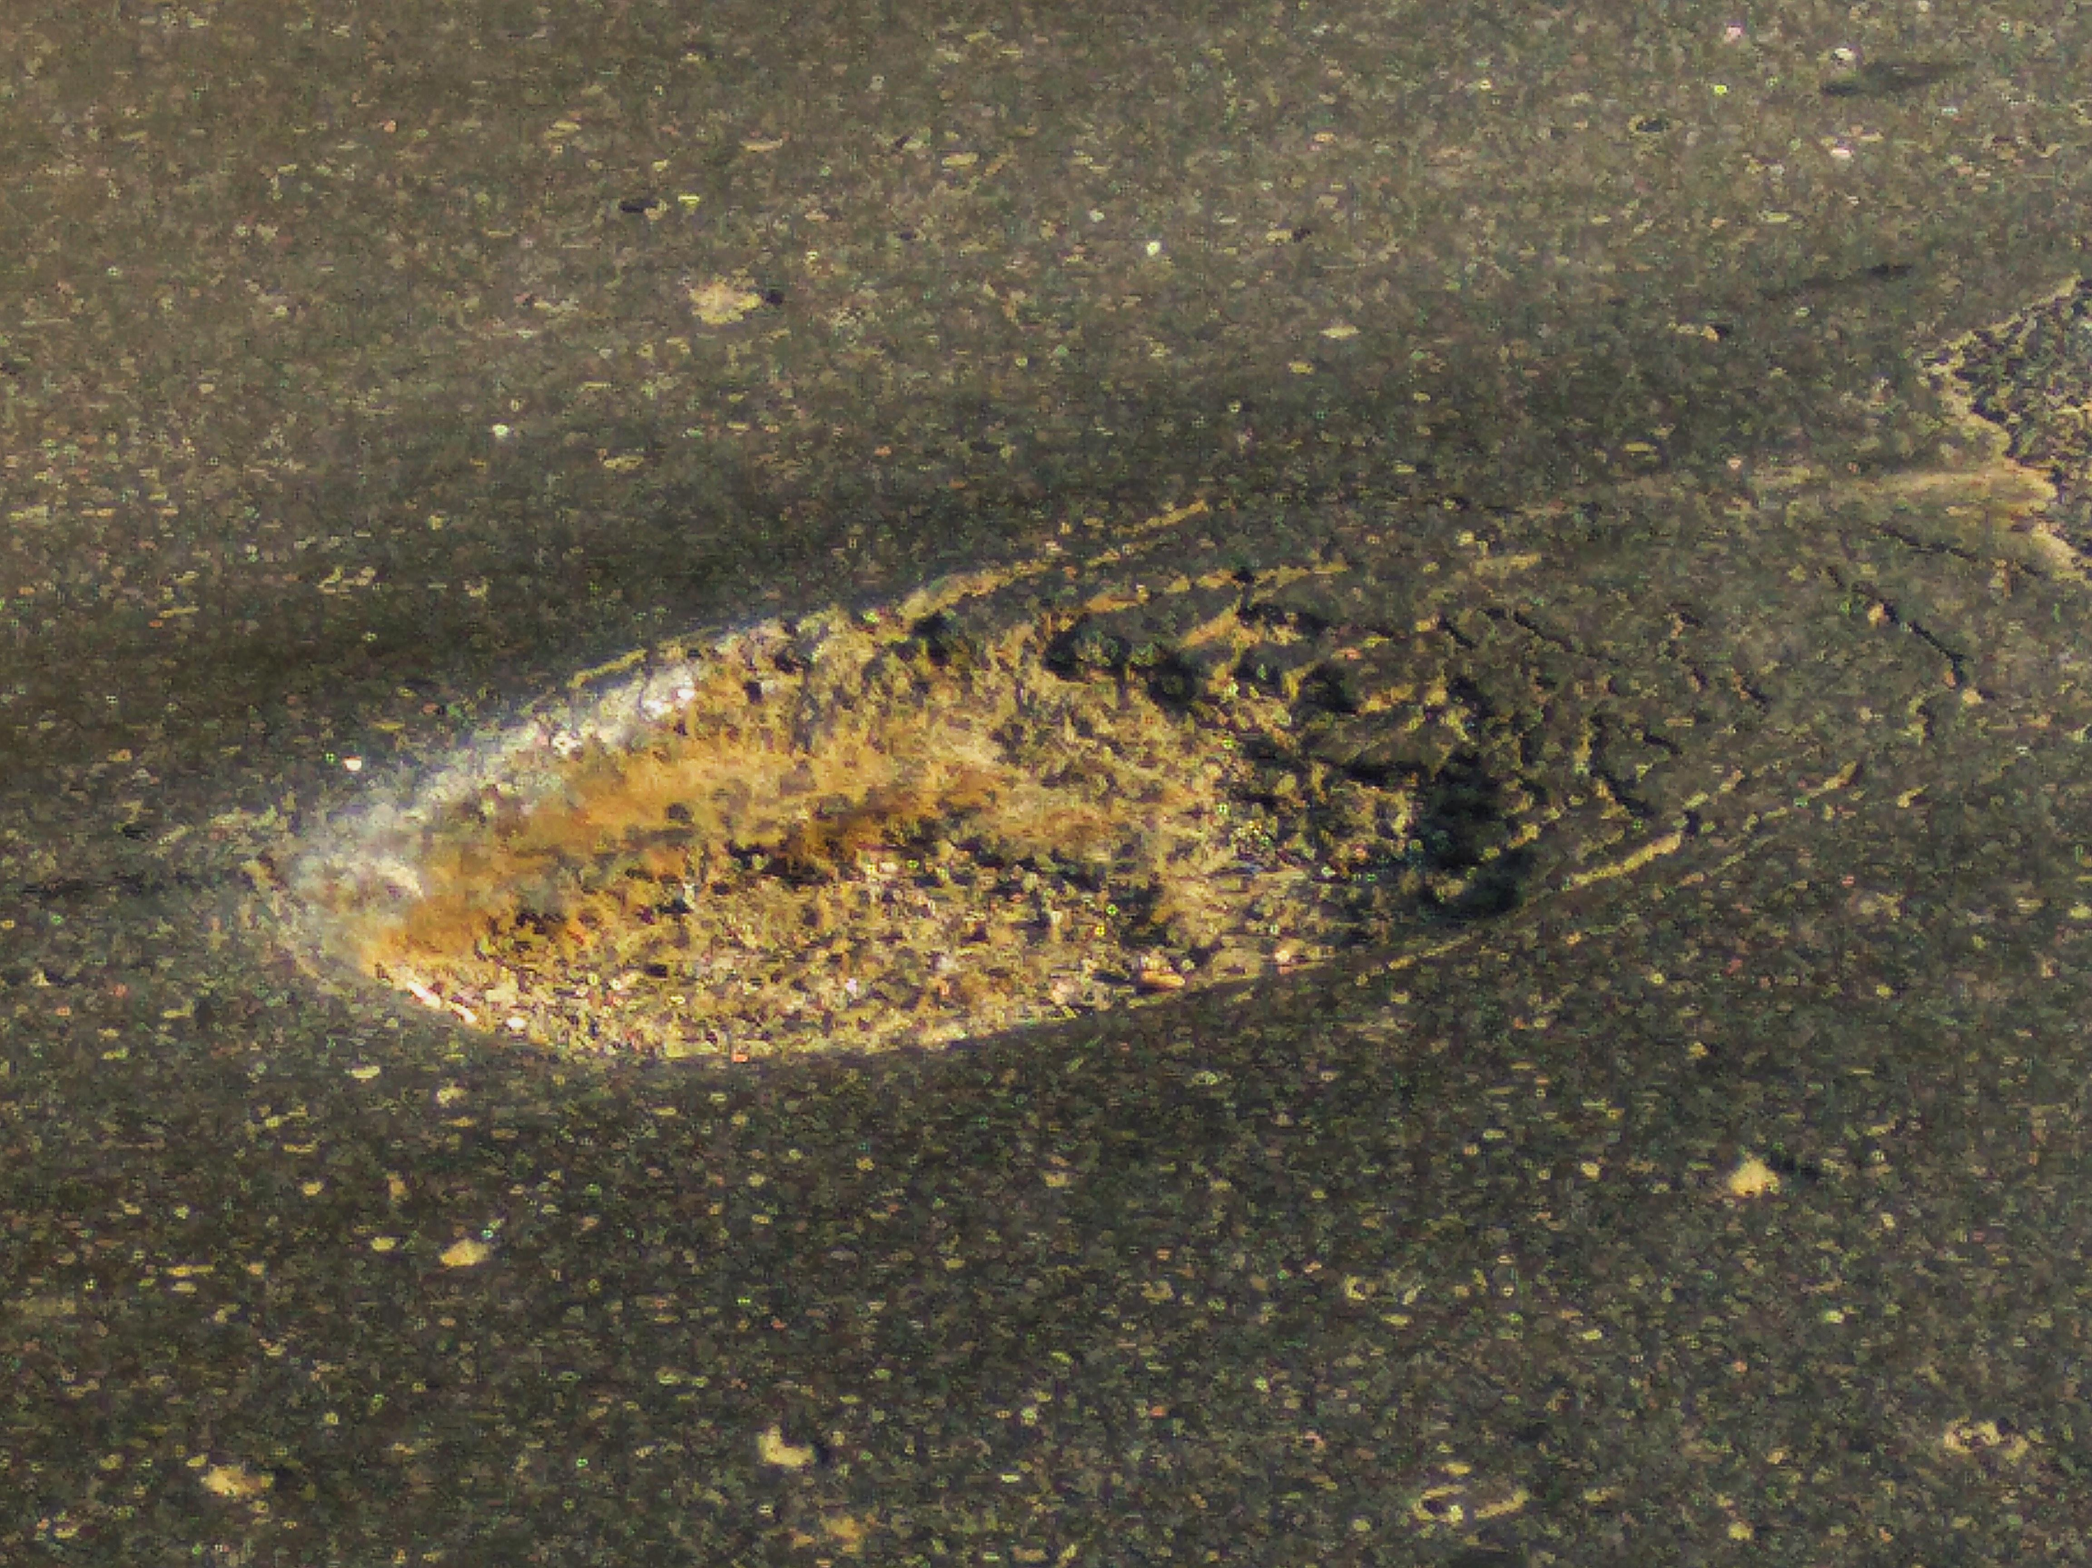

Second Image :

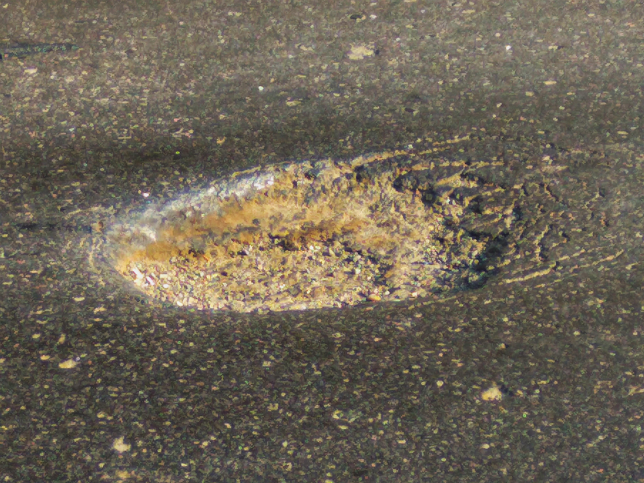

Feedback image :

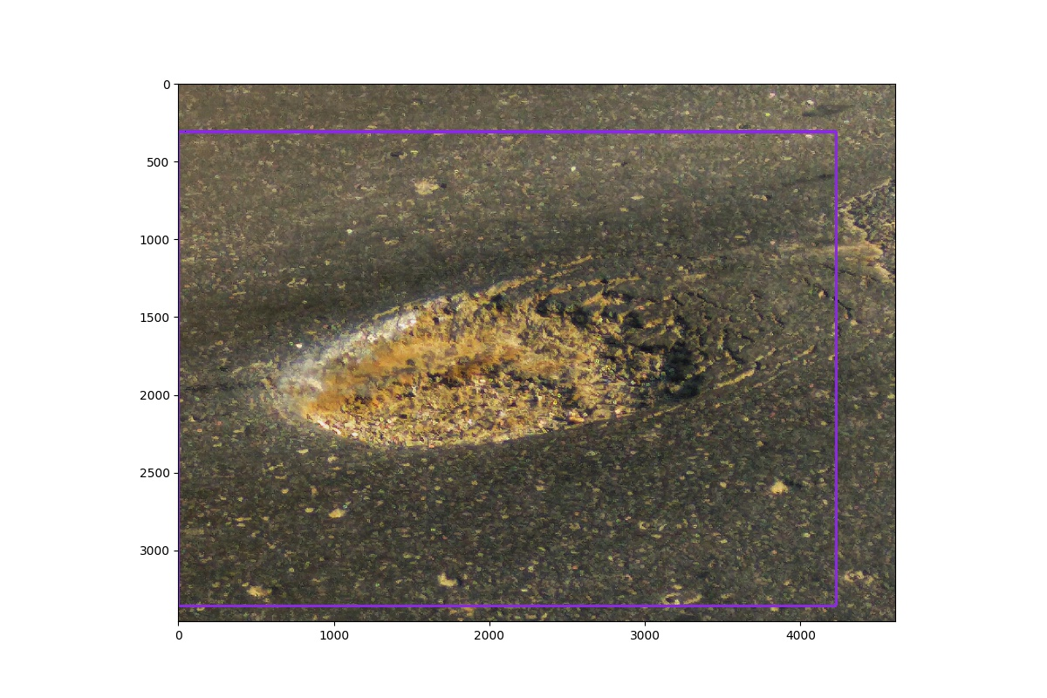

# ENGINEERING PARAMETERS

|  |
| --- |
| **Please note that the parameters calculated in this section are calculated autonomously based on image data given as input.** |

* Invoice generated separately.