**Method Name**

Improving Language Understanding by Generative Pre-Training

Alec Radford, Karthik Narasimhan, Tim Salimans, Ilva Sutskever: Improving Language Understanding by Generative Pre-Training, Preprint 2018

https://s3-us-west-2.amazonaws.com/openai-assets/research-covers/language-unsupervised/language_understanding_paper.pdf

**Original Code**

https://github.com/openai/finetune-transformer-lm

**Description**

The model architecture is OpenAI Transformer. The model is a two step procedure with a generative pre-training step where the transformer is trained on corpus of unlabeled text followed by a discriminative task. The four tasks listed in the paper were text classification, similarity, text entailment and question answering.

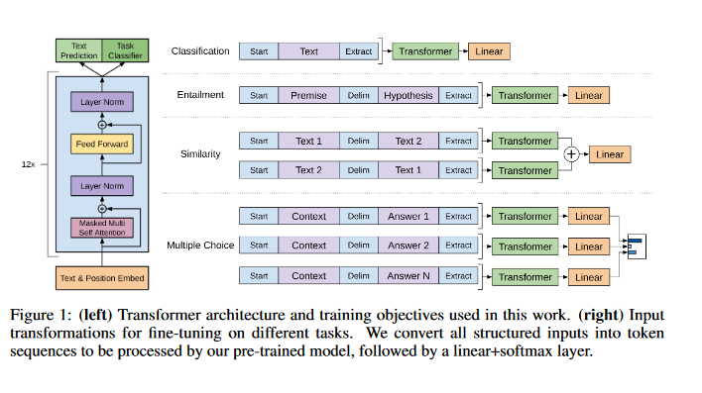

**Input and Output**

Input is two labeled sentences with no ordering so they also reversed the order and ran it again. The output was similarity score between the sentences.

**Evaluation**

Microsoft Paraphrase corpus (MRPC), Quora Question Pairs (QQP), Semantic Textual Similarity (StS-B) were the bench marks

The evaluation metric was similiarity score.

**Demo**