VCA Analysis for Simulated Data Cube Analysis
Developed in 2004, the VCA analysis technique tests a data cube for power-law correlations by testing how the region pictured responds to the thickening of a velocity channel. This then creates a power-law to model the pictured turbulence. Two things were looked at in testing for how applicable this technique is in our research. First, I simply used the verbose option when running the VCA, then I went on to test the consistency across different amounts of pixels being used.

Simulated 1D w/ 50 pixels: -13.54788503326947 +- 1.6175233397526527
Simulated 1D w/ 100 pixels: -13.951725339399948 +- 0.8715907947861478
Simulated 1D w/ 150 pixels: -11.385016910867286 +- 0.4573095882411897
Simulated 1D w/ 200 pixels: -10.313257437999232 +- 0.3539042080415254
Simulated 1D w/ 250 pixels: -8.878540544017445 +- 0.36596687668062233
Simulated 1D w/ 300 pixels: -9.322601089560493 +- 0.3648774877586414
Simulated 1D w/ 350 pixels: -8.866980774380126 +- 0.3600791043610459
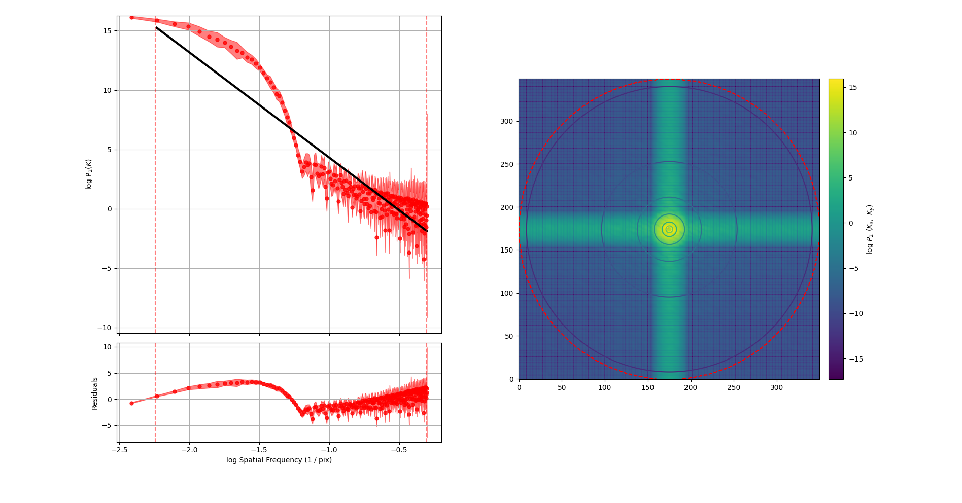Figure 1: Graph showing the model of the turbulence according to the VCA analysis compared to the real data. Additionally a 2D representation of the correlelation is shown.
The residuals shown in the graph are not promising, as they seem to be showing a behavior that doesn’t line up with the linear model being used to predict it, instead taking on the shape of a curve. The resolution dependence doesn’t bother me as much due to the simulation that finds a resolution dependence for some turbulent attributes (forgot which paper this was).

