VCS Analysis for Simulated Data Cube Analysis
Developed in 2004, around the same time as the VCA technique, the VCS analysis technique tests a data cube for power-law correlations by testing how the region pictured responds to the thickening of the spatial dimensions. This then creates a power-law to model the pictured turbulence. The high cut (the highest frequency analyzed over) was set to be the inverse of the beam width due to the smoothing effect of the beam introducing its own effects. This was graphed for the 350 pixel case in figure 1 and the slope of the power law was obtained for different resolutions to check for resolution dependence.

Simulated 1D w/ 50 pixels: -5.831055460321473 +- 0.7022526465155896
Simulated 1D w/ 100 pixels: -5.397946097215868 +- 0.9276116460301784
Simulated 1D w/ 150 pixels: -5.032932409611146 +- 0.7290318225025848
Simulated 1D w/ 200 pixels: -5.530744810473307 +- 0.6722144070704001
Simulated 1D w/ 250 pixels: -5.341781786939018 +- 0.7034641118254914
Simulated 1D w/ 300 pixels: -5.423739771043909 +- 0.7477762772255174
Simulated 1D w/ 350 pixels: -5.785615385057191 +- 0.713241927759096
Figure 1: Graph showing the model of the turbulence according to the VCS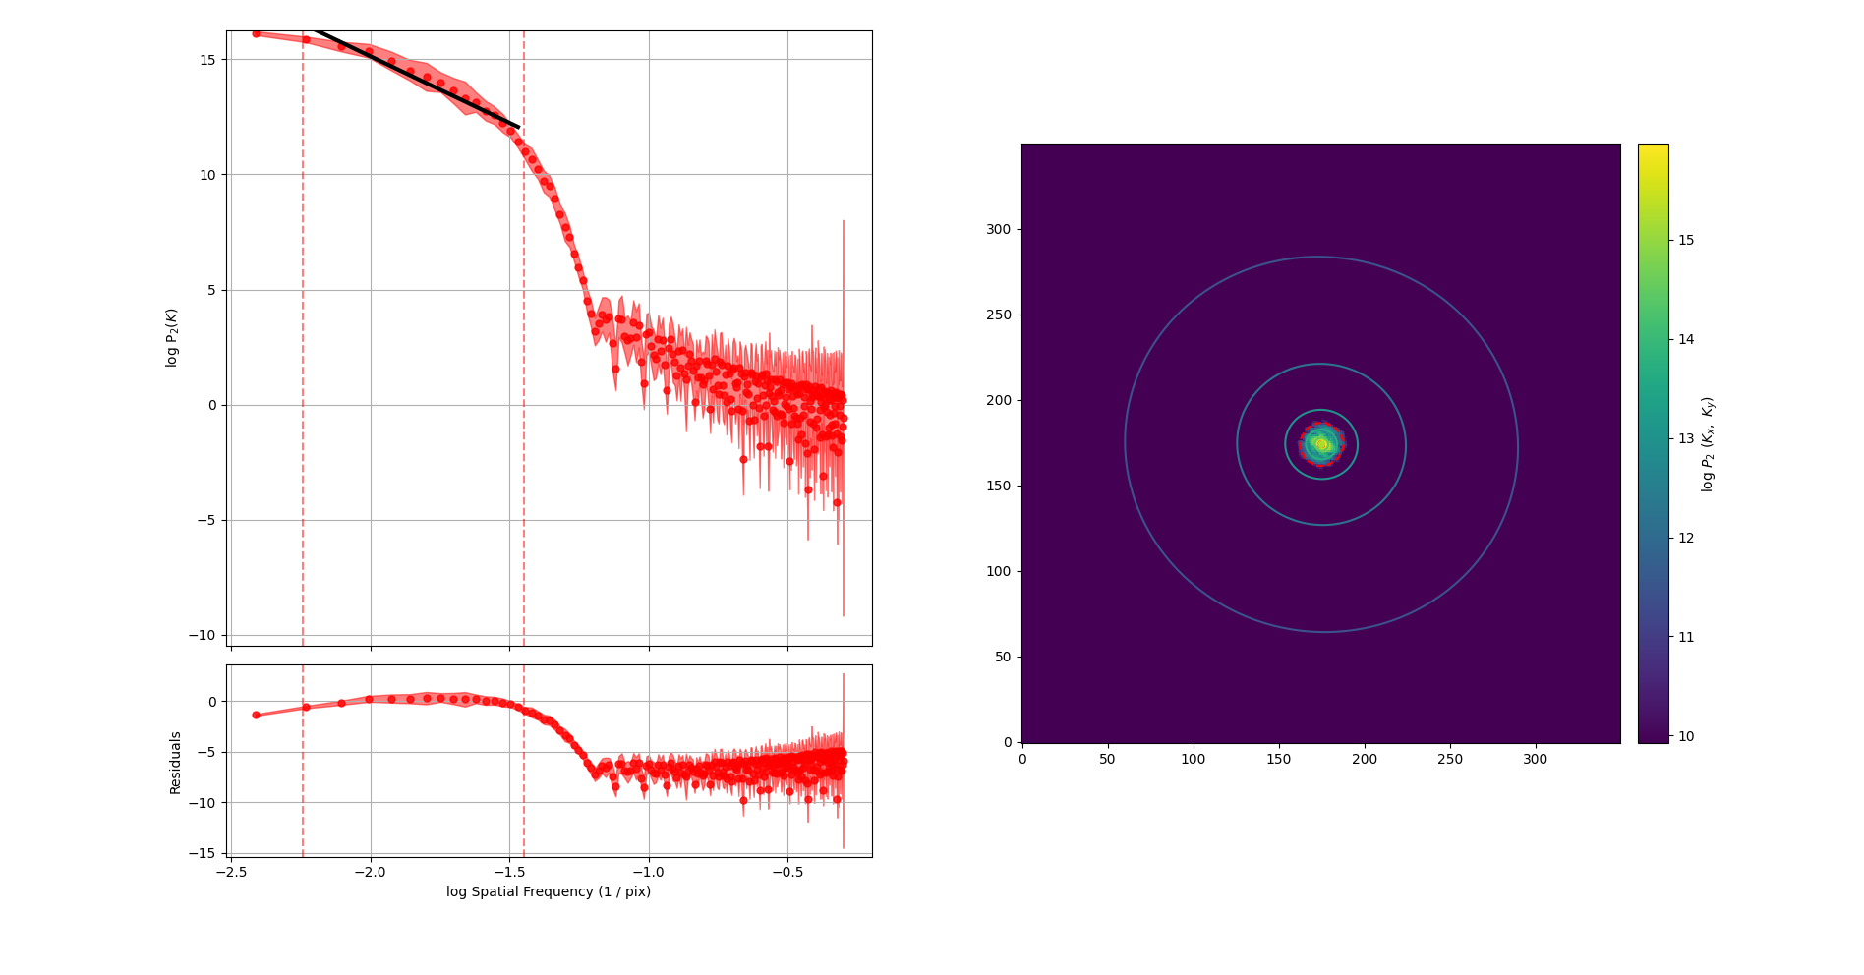 analysis. Additionally a 2D representation of the correlelation is shown.
The results here look good, as the theoretical Kolmogrov power law should be of magnitude 11/3 + 2, which is equal to 17/3 or about 5.7. This agrees with statistics recorded with the VCA technique (not recorded yet).

